Revision History
Date | Version | Description | Author
02/01/2021 | 0.1 | Revised the document and filled the test coverage analysis tab | Demirkan Yılmaz, Hasan Bilgin
03/01/2021 | 0.2 | Updated the test coverage analysis tab | Demirkan Yılmaz, Hasan Bilgin

TABLE OF CONTENTS
Revision History 1
1 Introduction 3
1.1 Document overview 3
2 Static Code Analysis 4
2.1 Tools 4
2.2 Results and Discussion 4
3 Dependency Analysis 5
3.1 Tools 5
3.2 Results and Discussion 5
4 Test Coverage Analysis 7
4.1 Tools 7
4.2 Results and Discussion 7

Introduction

Document overview
This document presents and interprets the code analysis results regarding the JWPL software development project. Code is analyzed by 3 different tools: 1) Static Code Analysis tool 2) Dependency Analysis tool and 3) Test Coverage tool. The first tool is used to reveal potential bugs that might be overseen during the testing process. The second tool is employed for evaluating the design quality based on the amount of coupling among the software modules and to what extent the code reflects the originally envisioned design. The last tool is used for measuring the coverage of unit tests in the project. Each section below is dedicated to each of these 3 analysis.

Static Code Analysis

Tools
Give brief information about the tools that you utilized for this analysis. There are many tools available online. You can choose any of them:
- FindBugs, http://findbugs.sourceforge.net/
- PMD, https://pmd.github.io/
- CheckStyle, https://checkstyle.sourceforge.io/

Results and Discussion
You need to present and discuss the obtained results in this subsection. Analysis of the results should include:
- The number, type and severity of alerts reported
- An analysis of the reported alerts; how many of them are really bugs that were missed during the testing process?

The following is an example:

We used an Eclipse plugin of the tool, which provided as a GUI like the following:

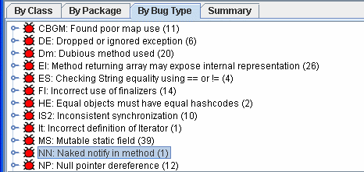

Analysis of alerts that are reported by the tool:

Type | Count of Instances | Severity | Count of Real Bugs
NP: Null pointer reference | 12 | High | 5
ES: Checking String Equality | 4 | High | 4
…

Dependency Analysis

Tools
Give brief information about the tools that you utilized for this analysis. There are many tools available online. You can choose any of them:
- Java Dependency Viewer, available [online],
- http://marketplace.eclipse.org/content/java-dependency-viewer
- JDepend [online] http://clarkware.com/software/JDepend.html
- Dependency Finder [online] http://depfind.sourceforge.net/

Results and Discussion
You need to present and discuss the obtained results in this subsection. Analysis of the results should include:

- a summary of the generated model(s) and observations
- (parts of) the generated dependency graph (i.e., snapshots from the visualization tools)
- calculated values for the metrics edge-to-node ratio and tree impurity
- The list of mostly connected (coupled) nodes and the related elements (classes, methods) in the source code.
- A general evaluation of the results, refactoring suggestions and the pinpointed problematic elements.

The following is an example:

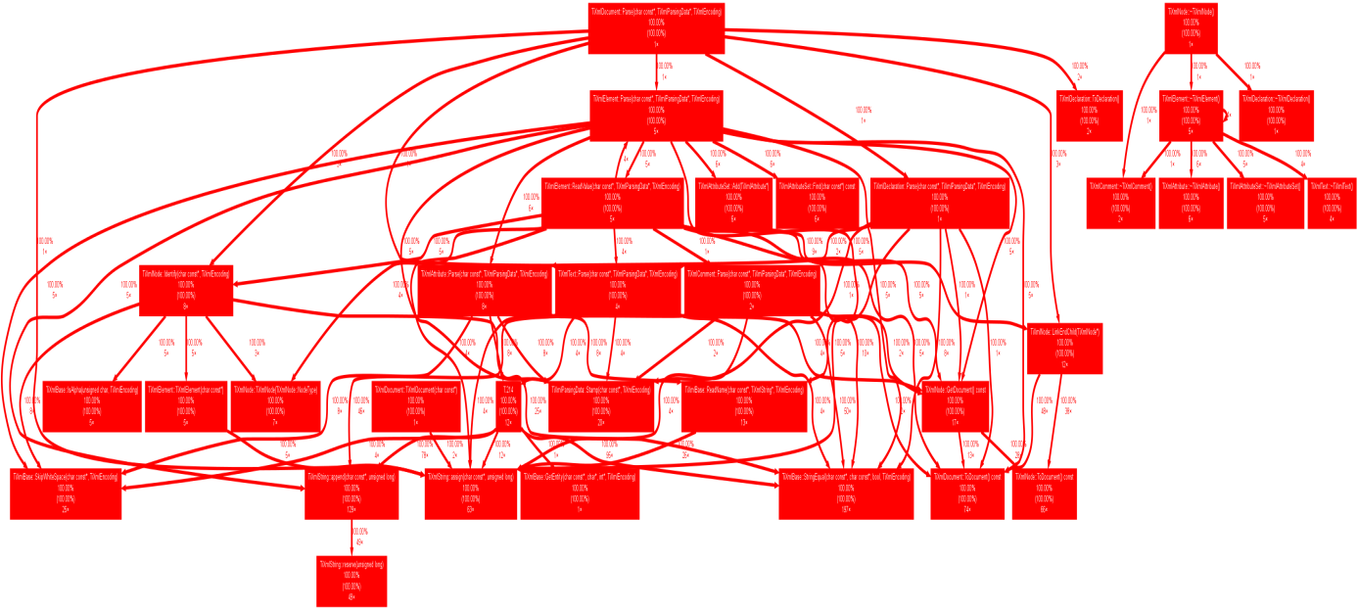

The extracted dependency graph is presented above. We calculated a set of metrics based on this graph as listed below:

# of Edges = 203
# of Nodes = 121
Edge-to-node Ratio = 203 / 121 = 1.67
Tree Impurity = 2 * (203 – 121 + 1) / (121 – 1) * (121 – 2) = 166 / 14280 = 0.01

We have seen that the tree impurity turned out to be quite small. That can be an indication for a good design structure. Edge-to-node ratio is also not very high. On the other hand, we can see that some of the modules are highly coupled with the other modules. For instance, the module TiXmlElement is highly coupled as the majority of the edges are associated with this module. This was not the way this module was originally designed. This module can be refactored and possibly decomposed into several modules to reduce dense coupling at this single module.

Test Coverage Analysis

Tools
- IntelliJ Idea Coverage Runner

Results and Discussion

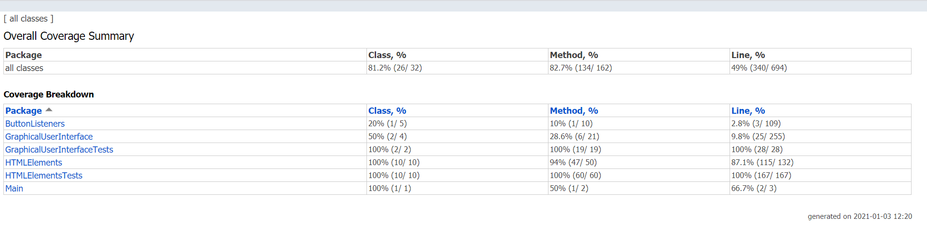

Not covered methods

Button_Listeners/src/ButtonListeners/createButtonLister.java
void actionPerformed(ActionEvent e)
Button_Listeners/src/ButtonListeners/elementButtonLister.java
void actionPerformed(ActionEvent e)
Button_Listeners/src/ButtonListeners/upButtonLister.java
void actionPerformed(ActionEvent e)
Button_Listeners/src/ButtonListeners/downButtonLister.java
void actionPerformed(ActionEvent e)
Graphical_User_Interface/src/GraphicalUserInterface/Frame.java
void addPanel(Jpanel panel)
void removePanel(Jpanel panel)
void swapUp(JPanel panel)
void swapDown(Jpanel panel)
Graphical_User_Interface/src/GraphicalUserInterface/Panel.java
void initializePanels()
void editPanel(Jpanel panel, String id)
void editButton(Jbutton button)
JCheckBox editCheckBox(JCheckBox checkbox)
JTextField editTextField(JTextField textField, int width)
JPanel getElementPanel(String id)

More than half of the classes are covered (81%) by the test cases we prepared. ButtonListeners are not covered by any test case, because we have found out that it is relatively more complicated to prepare test cases for listener classes (especially for button listeners).

