Revision History
Date | Version | Description | Author
19/11/2020 | 0.1 | Reviewed the document as a team and brainstormed details ideas about the classes and distributed the tasks | Egemen İşcan, Demirkan Yılmaz, Hasan Bilgin, Peker Çelik
20/11/2020 | 0.2 | Added a package diagram for Software Architecture Overview tab and an interface class diagram for Graphical User Interface component. | Demirkan Yılmaz
21/11/2020 | 0.3 | Added the interface class diagram for HTML Source component and class diagram for Graphical User Interface component | Hasan Bilgin
21/11/2020 | 0.4 | Added the design of the components as a package diagram for Control Objects component. | Demirkan Yılmaz
22/11/2020 | 0.5 | Added a sequence diagram to workflows and algorithms for HTML source, added satisfied requirements for graphical user interface component and, added component interface for control objects component | Peker Çelik
22/11/2020 | 0.6 | Added a class diagram for HTML source component, a sequence diagram for GUI component and software requirements mapping for Control Objects component. | Egemen İşcan
22/11/2020 | 0.7 | Updated the interface class diagram for HTML Source component and added a sequence diagram for Control Objects component | Hasan Bilgin
22/11/2020 | 0.8 | Updated the interface class diagram for Graphical User Interface component and made the final arrangements. | Demirkan Yılmaz
29/11/2020 | 0.9 | Updated the package diagram for defining the Software Architecture and the class diagrams for newly named Button Listeners package (formerly Control Objects). Updated HTML source’s name to HTML Elements. | Demirkan Yılmaz, Hasan Bilgin

TABLE OF CONTENTS
1 Introduction 3
1.1 References 3
1.1.1 Project References 3
2 Software Architecture overview 3
3 Software design description 4
3.1 HTML Source 4
3.1.1 Component interfaces 4
3.1.2 Component design description 4
3.1.3 Workflows and algorithms 5
3.1.4 Software requirements mapping 5
3.2 Graphical User Interface 5
3.2.1 Component interfaces 5
3.2.2 Component design description 5
3.2.3 Workflows and algorithms 6
3.2.4 Software requirements mapping 6
3.3 Control Objects 6
3.3.1 Component interfaces 6
3.3.2 Component design description 7
3.3.3 Workflows and algorithms 7
3.3.4 Software requirements mapping 7
4 COTS Identification 8

Introduction

This document describes the design of the JWPL software system.

References

Project References

# | Document Identifier | Document Title
[SRS] | JWPL-SRS-0.9 | JWPL Software Requirements Specifications

Software Architecture overview
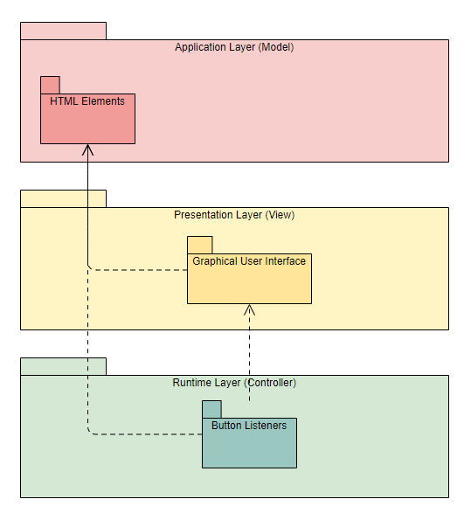

Software design description

HTML Elements

Component interfaces
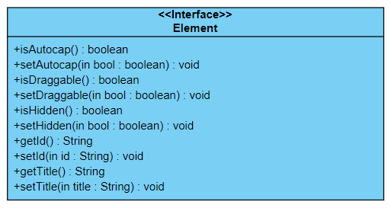

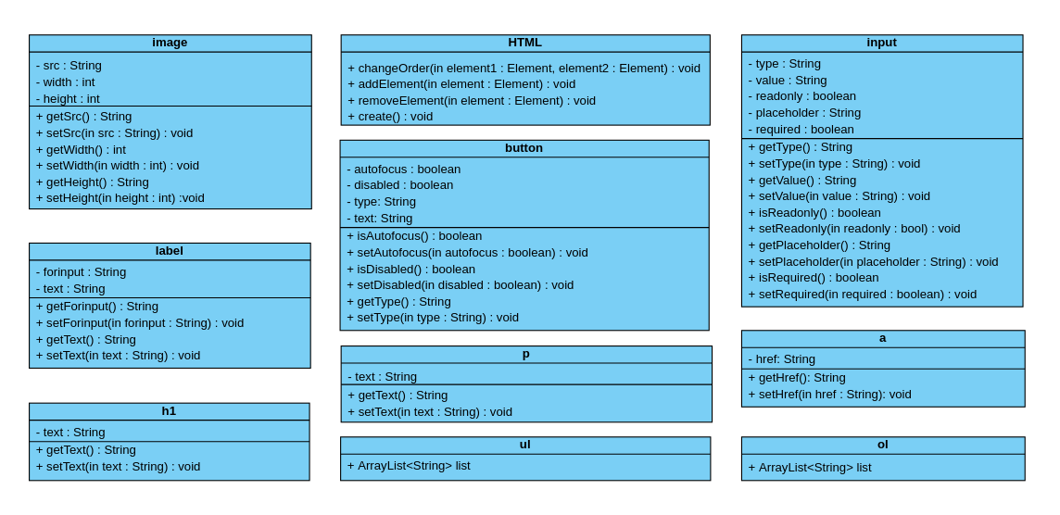
Component design description

Workflows and algorithms
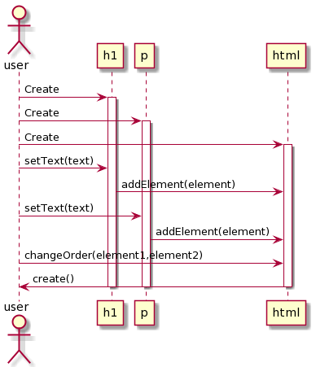

Software requirements mapping
SRS-JWPL-001, SRS-JWPL-002, SRS-JWPL-003, SRS-JWPL-004, SRS-JWPL-005

Graphical User Interface

Component interfaces
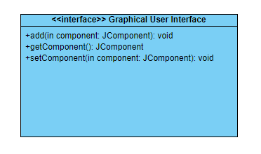

Component design description

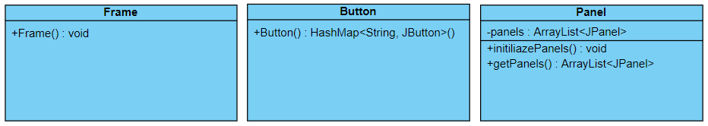

Workflows and algorithms

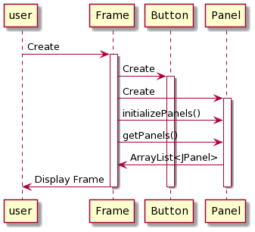

Software requirements mapping
SRS-JWPL-001, SRS-JWPL-002, SRS-JWPL-003, SRS-JWPL-004, SRS-JWPL-005, SRS-JWPL-006

Button Listeners

Component interfaces

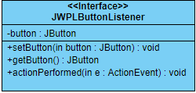

Component design description
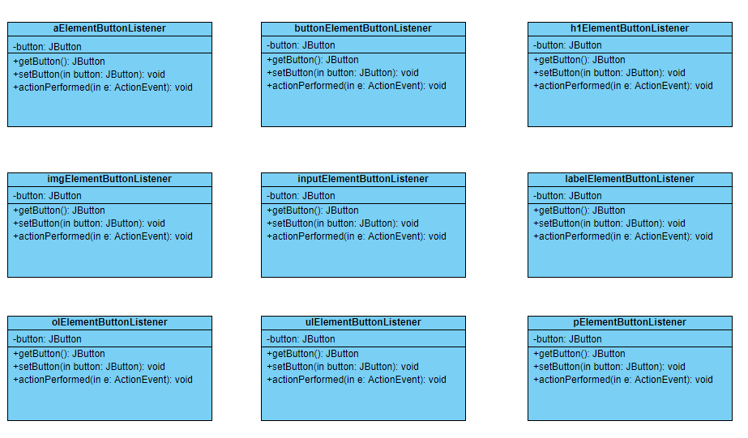

Workflows and algorithms

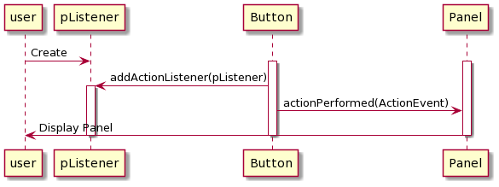

Software requirements mapping
SRS-JWPL-001, SRS-JWPL-002, SRS-JWPL-003, SRS-JWPL-004, SRS-JWPL-005

COTS Identification

No external software/libraries will be used during the production of JWPL.

