Revision History
Date | Version | Description | Author
31/10/2020 | 0.1 | Reviewed the document as a team and brainstormed details ideas about the software and added a few requirements | Egemen İşcan, Demirkan Yılmaz, Hasan Bilgin, Peker Çelik
02/11/2020 | 0.2 | Added Deployment Diagram, Use Case Diagram and Activity Diagram and modified System Overview description | Hasan Bilgin
03/11/2020 | 0.3 | Added a few requirements and adjusted the diagram images | Hasan Bilgin
04/11/2020 | 0.4 | Fixed a user requirement | Hasan Bilgin
13/11/2020 | 0.5 | Adjusted the document according to the feedback by adding more requirements | Hasan Bilgin

TABLE OF CONTENTS
Revision History 1
1 INTRODUCTION 3
1.1 Document overview 3
1.2 System overview 3
1.3 Abbreviations 3
1.4 References 3
1.5 Conventions 3
2 REQUIREMENTS 4
2.1 User Requirements Specification 4
2.2 System Architecture 4
2.3 Use Cases and Usage Scenarios 4
2.4 System Requirements Specification 5

INTRODUCTION

Document overview

This document presents the software requirements specifications of JWPL software development project. It describes functional requirements, quality requirements, constraints, use cases, and usage scenarios. It also provides an overview of the system architecture.

System overview

JWPL (Java Web Page Library) is a Java library which facilitates building relatively simple web pages. Its goal is to provide Java developers with a method where they need very little HTML knowledge beforehand. Even if they do, they can save time and effort by using this library. JWPL creates and edits HTML files in the background which then can be used for web pages. It is a very simple library to use.

Abbreviations

JWPL: Java Web Page Library
HTML: Hypertext Markup Language
XML: Extensible Markup Language
CSS: Cascading Style Sheets
UML: Unified Modeling Language
IDE: Integrated Development Environment
JDK: Java Development Kit
SRS: Software Requirement Specification
STP: Software Test Plan
SDD: Software Design Document
STR: Software Test Report

References

# | Document Identifier | Document Title
R1 | JWPL-SDP-0.8 | Software Development Plan of JWPL software

Conventions
Requirements listed in this document are constructed according to the following structure:

SRS-JWPL-000
Description of JWPL-000 requirement
Version of JWPL-000

Every system requirement id includes the id of the corresponding user requirement as a prefix.

SRS-JWPL-000.1
Description of JWPL-000.1 system requirement, which is related to the user requirement JWPL-000
Version of JWPL-000.1

REQUIREMENTS

User Requirements Specification

SRS-JWPL-001
JWPL shall enable users to create a basic HTML file when the “Create” button is clicked.

SRS-JWPL-002
JWPL shall enable users to add HTML tags to the HTML file by allowing them to select items from the right-side of the GUI.

SRS-JWPL-003
JWPL shall allow users to change the order of the tags by clicking on the arrow buttons.

SRS-JWPL-004
JWPL enables users to modify the attributes of tags in the middle which are added to the file with the help of textfields and radio buttons for each added tag.

SRS-JWPL-005
JWPL shall create the desired HTML file at the target location within 10 seconds after clicking on the “Create” button.

System Architecture

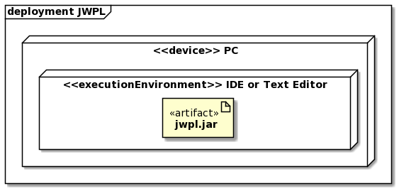

Use Cases and Usage Scenarios

2.3.1 Use Case Diagram
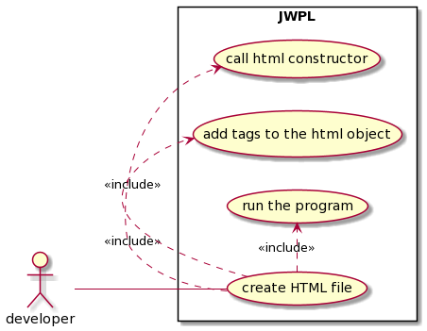
2.3.2 Activity Diagram

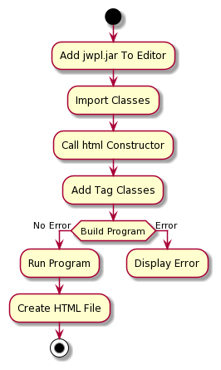

System Requirements Specification

SRS-JWPL-001.1
JWPL shall create a file with .html extension when the user clicks on the “Create” button.

SRS-JWPL-001.2
JWPL shall create the HTML file at the specified location using the absolute path provided by the user.

SRS-JWPL-001.3
JWPL shall create the file at Desktop by default if no path is specified by the user.

SRS-JWPL-001.4
JWPL automatically adds the essential HTML tags such as html, head, title and body tags to the created HTML file.

SRS-JWPL-002.1
JWPL offers users a specific set of HTML tags for use: <a>, <button>, <h1>, <img>, <input>, <label>, <ol>, <ul>, <p>.

SRS-JWPL-002.2
JWPL shall enable users to add HTML tags to the recently created HTML file by allowing them to click on the button for the corresponding tag displayed on the GUI.

SRS-JWPL-002.3
Whenever the user clicks on a tag on the right, JWPL adds a copy of it to the middle of the screen, while adding the tag to the HTML file in the background.

SRS-JWPL-003.1
JWPL lets users to change the order of the tags with the help of arrows on each tag added to the file by the user.

SRS-JWPL-003.2
JWPL offers users carry a selected tag up by one when the user clicks on the arrow pointed upwards next to the tag and down by one when the user clicks on the arrow pointed downwards.

SRS-JWPL-004.1
JWPL lets users to fill in textfields and select items from radio buttons in order to modify tags which are added to the file and adjusts the tags accordingly in the HTML file in the background.

SRS-JWPL-004.2
Users are not required to fill each attribute textfield or select a radio button item as default values will be used if left untouched.

SRS-JWPL-005.1
JWPL is not responsible of hardware issues that may cause any slowness when creating the file.

