Revision History
Date | Version | Description | Author
14/10/2020 | 0.1 | Reviewed the document as a team and came up with ideas about the project, also added a short description | Egemen İşcan, Demirkan Yılmaz, Hasan Bilgin, Peker Çelik
15/10/2020 | 0.2 | Updated the description, added one of the workstation’s specs, added software development rules and standards | Hasan Bilgin
17/10/2020 | 0.3 | Updated risk assessment. Added risk analysis and risk planning charts. | Egemen İşcan
18/10/2020 | 0.4 | Gannt Chart added to the file with two images. | Peker Çelik
18/10/2020 | 0.5 | Added “Activities and Responsibilities” tab on the 5th page. | Demirkan Yılmaz

TABLE OF CONTENTS

Revision History 1
1 Identification 3
1.1 Document overview 3
1.2 Abbreviations 3
1.2.1 Abbreviations 3
1.3 References 3
1.3.1 Project References 3
2 Software Development Activities 3
2.1 Software development process 3
2.1.1 Overview of process phases 3
2.1.2 Technical documentation 4
2.1.3 Deliverables 4
2.2 Software development tools 4
2.2.1 Workstation 4
2.2.2 Requirements management and documentation 4
2.2.3 Software Design 4
2.2.4 Coding and automated tests 4
2.2.5 Configuration management 4
2.3 Software development rules and standards 4
3 Responsibilities 5
3.1 Activities and responsibilities 5
4 Risk Assessment 5
4.1 Risk Analysis 5
4.2 Risk Planning 5

Identification

Document overview

This document contains the software development plan of software JWPL.

JWPL (Java Web Page Library) is Java library which facilitates building relatively simple web pages. Its goal is to provide Java developers with a method where they do not need to have any prior HTML knowledge. Even if they do, they can save time and effort by using this library. JWPL creates and edits HTML files in the background which then can be used for web pages. It is a very simple library to use.

Abbreviations

Abbreviations

JWPL: Java Web Page Library
HTML: Hypertext Markup Language
XML: Extensible Markup Language
CSS: Cascading Style Sheets
UML: Unified Modeling Language
IDE: Integrated Development Environment
JDK: Java Development Kit
SRS: Software Requirement Specification
STP: Software Test Plan
SDD: Software Design Document
STR: Software Test Report

References

Project References

# | Document Identifier | Document Title
[R1] | ID | Add your documents references.  One line per document

Software Development Activities

The section lists and describes the software development activities of JWPL software development project.

Software development process

This is a course project, which adopts the waterfall model as the software development process.

Overview of process phases

The software development process for the project will be composed of the following phases:
- Planning
- Requirements Analysis
- Design
- Implementation
- Testing and Analysis

These phases will follow each other sequentially, where each phase starts just after the completion of the previous one. The following Gantt chart depicts the planned start date and duration for the phases.
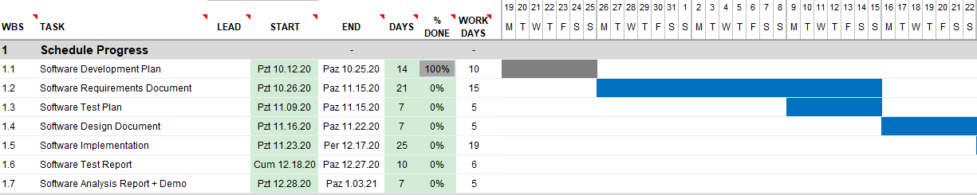
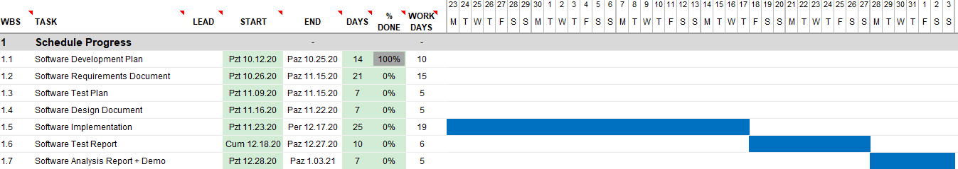

Technical documentation

The following documentation is produced during the software development phases:
- Software specification: SRS, STP
- Software detailed conception: SDD
- Software tests phases: STR
- Software analysis: SAR

Deliverables

The following items will be delivered at the end of the process:
- Technical documentation as outlined in Section 2.1.2
- Software and its configuration files

Software development tools

Workstation

4 laptops will be used in the development of the software. Each system’s specification is listed below:
- 4 core 2.8 GHz CPU, 8 GB RAM, Windows 10 Home
- 6 core 2.6 GHz CPU, 16 GB RAM, Windows 10 Home
- 4 core 2.8 GHz CPU, 16 GB RAM, Windows 10 Home
- 4 core 2.8 GHz CPU, 16 GB RAM, CentOS 8

Requirements management and documentation

Microsoft Word will be used for requirements documentation

Software Design

Describe the tools used for software design:
- JDK (Java Development Kit) Argo UML open-source tool, Microsoft Visio, Rational Rose, Together J, etc.

Coding and automated tests

Describe tools used for coding and automated tests.
- Eclipse + list of plugins
- IntelliJ IDEA Community
- or MS Visual Studio 2010 + list of plugins

Configuration management
GitHub will be used for software configuration management and tracking issues regarding software development. A public repository will be created for this purpose.

Software development rules and standards
UML will be used for software design documentation.

Oracle’s code conventions for Java will be used for the development of this software. It is relatively old but a well-established coding convention. For further information about the convention please refer to http://www.oracle.com/technetwork/java/codeconvtoc-136057.html.

Responsibilities

Activities and responsibilities

Activity | Responsibility | Comment
Project management | Egemen İşcan, Hasan Bilgin | Managing the project in all aspects.
Configuration of the Development tools | Peker Çelik | Configuring the necessary programming environments on the workstations.
Setting up the Development tools | Demirkan Yılmaz, Hasan Bilgin | Setting up the necessary programming environments.
Research and analysis of the implementation | Egemen İşcan, Demirkan Yılmaz | Researching and analyzing the implementation of the project on the programming environments.
Requirements verification and validation | Hasan Bilgin, Peker Çelik | Verifying and validating the requirements.
Implementation of the project on the Development tools | Egemen İşcan, Hasan Bilgin, Peker Çelik, Demirkan Yılmaz | Implementing the project on the pre-specified programming environments.

Risk Assessment

Risk Analysis

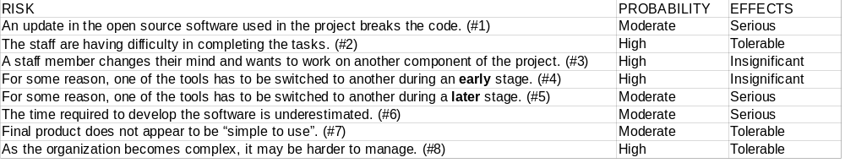

Risk Planning

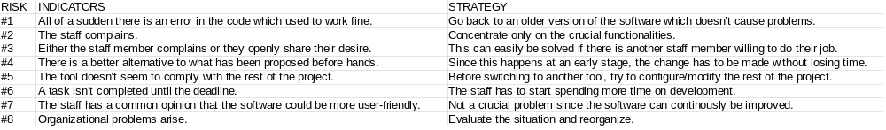

http://www.github.com
http://www.uml.org/

