# **VOLUNTEER MOTIVATION, ENGAGEMENT, & SATISFACTION**

## **Martins et al. (2024)**

**(One of the) Relevant Hypotheses:**

“Volunteer Functions Inventory (VFI) will be positively associated with organizational commitment, engagement, and volunteers’ satisfaction.”

**Relevant Theory:**

Clary et al.(1998)’s Functional Approach

**Results:**

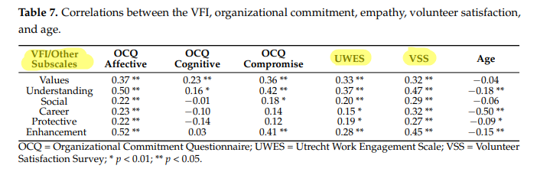

*“The functions with the highest scores were* ***values****,* ***understanding****, and* ***enhancement****”*

**Table 7** shows that volunteers motivated by **Understanding**, **Values**, and **Enhancement** functions have the strongest positive correlations with both engagement (measured by UWES) and satisfaction (measured by VSS). Specifically, **Understanding** motivation has the highest correlations with engagement (0.37) and satisfaction (0.47), indicating that volunteers seeking to learn and grow feel highly engaged and satisfied. Values and Enhancement motivations also show moderate to strong relationships with both outcomes. In contrast, **Social,** **Career,** and **Protective** motivations have weaker links to engagement. The table also shows that age has significant negative correlations with the following motivations: **Understanding (-0.18)**, **Enhancement (-0.15)**, and **Career (-0.50)**. This indicates that younger volunteers are more likely to be motivated by a desire to learn and grow (**Understanding**), personal development (**Enhancement**), and career advancement (**Career**) compared to older volunteers. The negative correlation for **Career** is particularly strong, suggesting that older volunteers are less motivated by career-related reasons for volunteering.

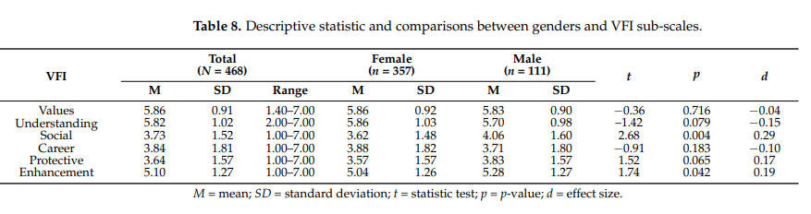

The study also found significant gender differences (Table 8), with **social motivation** being significantly higher for males (M = 4.06) compared to females (M = 3.62), showing a moderate effect size (d = 0.29, p = 0.004), and **enhancement motivation** slightly higher for males (M = 5.28) than females (M = 5.04), with a small effect size (d = 0.19, p = 0.042).

**Please Note:** VFI, Utrecht Work Engagement Scale (UWES), and Volunteer Satisfaction Scale(Index) (by Vecina Jiménez et al., 2009) are the scales we used in our survey (we just left out one subscale of the VSS)

## **Cañas-Lerma, Campos-Vidal, & Verger (2022)**

**Aim:**

“In the quantitative part of the study, the first objective was to determine the levels of compassion satisfaction, volunteer work engagement, self-care, compassion fatigue and motivations in health and social care volunteers and examine the relationship between them.”

**Relevant Theory:**

Clary et al.(1998)’s Functional Approach

**Findings:**

**P.S.:** They also used VFI and UWES (as we did) but they chose to exclude the Values subscale from the VFI due to its low Cronbach's alpha (α = 0.57)

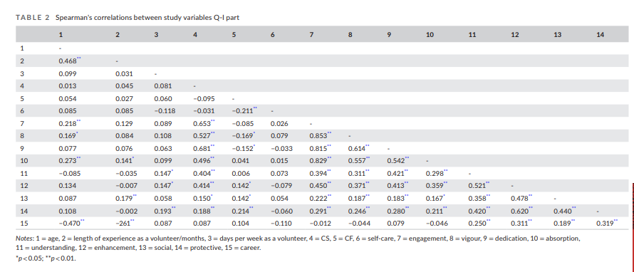

The study found engagement was positively associated with all measured motivational factors but **Career**, with **Enhancement** showing the strongest relationship to engagement (r = 0.450, p < 0.01), followed by **Understanding** (r = 0.394, p < 0.01). In other words, volunteers who sought learning and acquiring new knowledge (Understanding) or personal growth and self-improvement (Enhancement) tended to be more engaged in their roles.

In terms of age, only **Career** motivation demonstrated a significant negative correlation (r = -0.470, p < 0.01), indicating that younger volunteers were more inclined to view volunteer work as a means to advance their careers. No significant age-related differences emerged for other motivational factors.

The study also found that certain volunteer motivations varied significantly with educational background. Participants with lower levels of formal education reported higher **Enhancement**, **Social**, and **Protective** motivations than those with more advanced education, suggesting that these motivations diminish as educational attainment increases. In contrast, **Understanding** and **Career** motivations did not differ significantly by education level. No significant differences in motivations were observed by gender or employment status. These results highlight that educational attainment plays a notable role in shaping the underlying reasons individuals choose to volunteer.

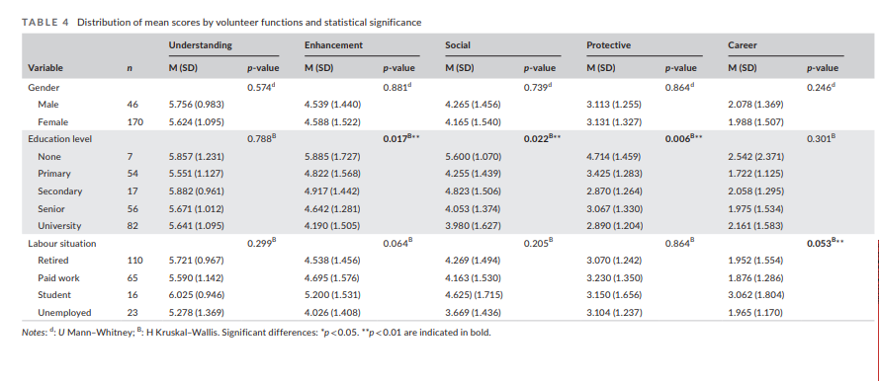

## **Zhou & Muscente (2023)**

Meta-analysis.

Examines the underlying factors that drive individuals to engage in volunteer activities.

**Relevant Theories:**

Clary et al.(1998)’s Functional Approach

**Findings:**

In their meta-analysis of volunteer motives using the Volunteer Functions Inventory (VFI), Zhou, Kodama, and Muscente (2022) synthesised findings across various studies to identify how different motivational functions relate to key volunteer outcomes **(**namely: **satisfaction-commitment, frequency, intention to continue)**. They specifically focused on intention to continue volunteering and frequency of volunteering. They merged satisfaction and commitment into a single construct ***“due to the establishment overlap”***. *“Results demonstrate that all six motivators significantly predicted the three outcome variables (𝜌̅ ranging from .12 to .44)”* with **Values** being consistently the most significant predictor.

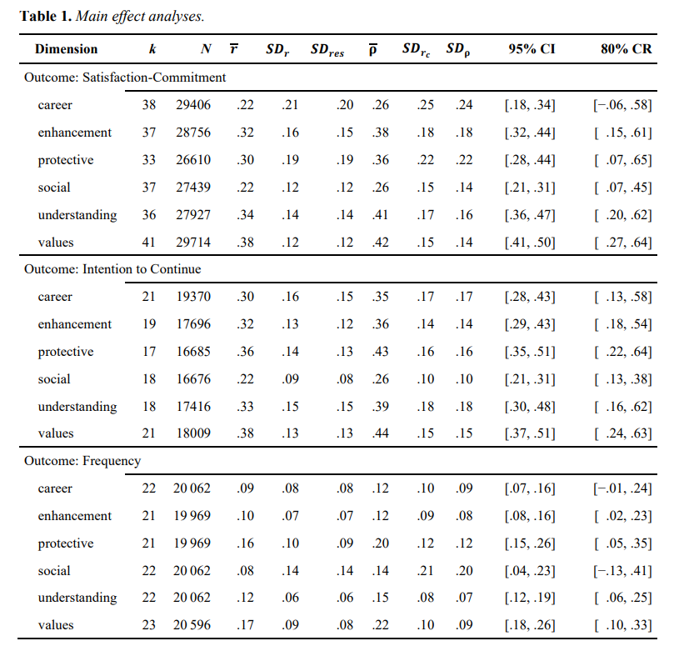

## **Vecina et al. (2012)**

**Hypotheses:**

**H1:** Volunteer engagement will be positively associated with volunteer satisfaction and volunteer satisfaction will be positively associated with intention to remain in a sample of new volunteers (1st Stage).

**H2:** Volunteer engagement will be positively associated with organisational commitment and organisational commitment will be positively associated with intention to remain in a sample of veteran volunteers (2nd Stage)

**Relevant Theories:**

Clary et al.(1998)’s Functional Approach

“According to the Three-Stage Model of Volunteers’ Duration of Service (Chacón et al., 2007), volunteer satisfaction will explain intention to remain during the first stage, while organisational commitment will predict intention to remain during the second stage.”

**Findings:**

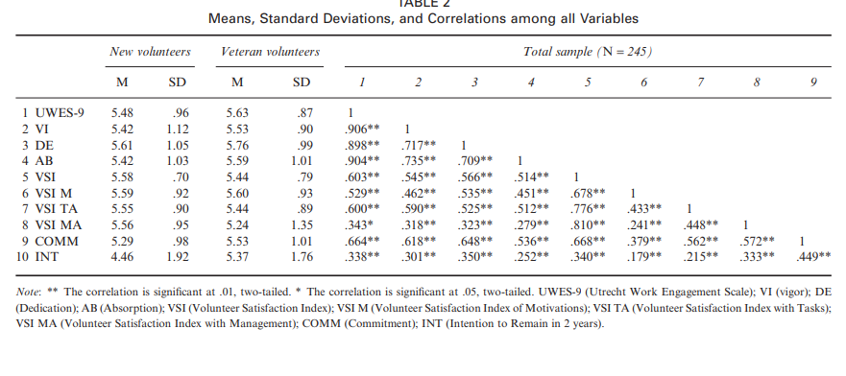

According to the correlation table for the total sample of 245 volunteers, engagement (UWES-9) shows strong positive associations with key outcomes: for example, it correlates at r = .66** with commitment (COMM) and r = .34** with intention to remain (INT). Individual engagement dimensions –vigor (VI), dedication (DE), and absorption (AB)–relate positively to satisfaction measures, such as where absorption (AB) and VSI TA (tasks) are linked at r = .51**. These findings indicate that higher engagement levels and its components strongly align with greater satisfaction and a stronger intention to continue volunteering over time.

**New Volunteers**

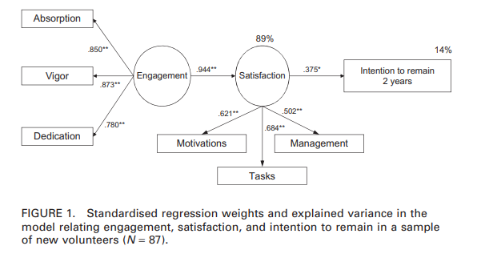

For newcomers, Absorption, Vigor, and Dedication combine into Engagement, which explains almost all of their Satisfaction. Higher Engagement leads to greater Satisfaction with their motivations, tasks, and management, and this in turn boosts their intention to remain volunteering. ***So engagement is crucial for the satisfaction of new volunteers.***

**Veteran Volunteers**

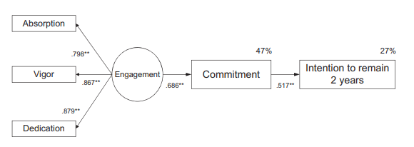

Among experienced volunteers, Engagement fuels their sense of Commitment, which then drives their intention to keep volunteering. Here, Satisfaction is less critical, and it’s the established psychological bond (Commitment) that links Engagement to long-term retention.

# **Some Key Points**

* Motivations are correlated with engagement and satisfaction, and the strength of these correlations varies across different types of motivations.
* Age is relevant in the type of motivation, with motivating factors for younger and older volunteers differ.
* Gender and educational attainment are relevant variables to consider, as they can influence motivational differences.
* Motivations are associated with intention to continue volunteering, frequency of participation, and satisfaction, but the degree of these associations or their predictive strength varies by motivation type.
* Different mechanisms may drive volunteer experiences and outcomes for newcomers and veteran volunteers, with satisfaction playing a larger role for newcomers and commitment being more crucial for veterans.
* Engagement is strongly linked to satisfaction, with engaged volunteers reporting higher satisfaction levels.

# **Suggestions for our Research**

1. **Sample Size, Population, and Reliability Checks**

* Clearly describe the sample size (n=50) and its representativeness of the target volunteer population. Acknowledge the limitations of a small sample for generalizability.
* Conduct reliability checks (e.g., Cronbach’s alpha) for all scales, focusing on:
  + Motivation (VFI 30 items, 6 subscales)
  + Engagement (9 items, 3 subscales)
  + Satisfaction (11 items, 2 subscales)

1. **Overview of Core Constructs**

* Summarize descriptive statistics (means, standard deviations) for the following constructs:
  + Motivation (6 VFI subscales: values, career, social, understanding, protection, enhancement).
  + Engagement (3 subscales: vigor, dedication, absorption).
  + Satisfaction (2 subscales: satisfaction with tasks and management).
  + Commitment (derived from selected questions).

1. **Comparing Scores Across Demographics**
   * Use a respective tecnique like one-way ANOVA, linear regression etc. for group comparisons of motivation, engagement, satisfaction, and commitment across demographic variables (e.g., age, gender, education).
   * Conduct post-hoc tests (e.g., Tukey’s HSD) only when ANOVA results are significant.

* Our measures are as follows an you can find **scoring info** on the Appendix section:
  + **Motivations:** 30 Item VFI measures Motivations
    - Subscales: values, career, social, understanding, protection, enhancement
  + **Engagement:** 9 Item Utrecht Work Scale measures engagement
    - Subscales: vigor, dedication, absorption
  + **Satisfaction:** 11 item satisfaction scale
    - Was normally 3 subscales, we used 2: satisfaction with tasks (4 items), satisfaction with management (7 items)
  + **Commitment:** We don’t have an official scale for the commitment but we could **maybe** use following questions to measure commitment:
    - “For the next six months, do you plan to increase, decrease, or maintain your current level of volunteer hours?”
    - “How long have you been volunteering with Sustainable Merton?”
    - “I would encourage people to volunteer with Sustainable Merton” (1 = Strongly Disagree, 5 = Strongly Agree)
    - Have you ever encouraged someone else to volunteer with Sustainable Merton?

1. **Facilitators and Barriers**

* An overview of **facilitators** and **barriers:** Main facilitators and barriers and their relationships with engagement, satisfaction, and commitment. Introduce clustering or factor analysis to group similar facilitators/barriers into broader themes. Explore the relationship between facilitators/barriers and volunteer demographics using logistic regression.
* Other volunteering demographics overview:
  + Previous experiences and how did they first get into volunteering?
  + What projects are they involved in? relationships with motivations?
  + What kind of projects do they find **most rewarding?** relationships with motivations?
  + Hours of volunteering?
  + Relationships with personal demographics
* Conduct a frequency analysis to identify the most common facilitators and barriers.
* Use logistic regression or chi-square tests to examine relationships between facilitators/barriers and demographic variables or engagement levels.
* Simplify clustering or factor analysis for facilitators/barriers if sample size constraints make these methods impractical.

1. **Volunteering Demographics**
   * **Summarize:**
     + Previous volunteering experience (Yes/No) and how participants started volunteering.
     + Project involvement (e.g., which projects they work on) and most rewarding projects.
     + Hours volunteered (weekly).
   * **Analyze relationships between:**
     + Project involvement and motivations using chi-square tests.
     + Hours volunteered with satisfaction, engagement, and demographic variables using linear regression.
2. **Sustainability Awareness**

* **Sustainability Awareness:** Analysis to explore whether sustainability awareness has a meaningful relationship with motivations, engagement, and satisfaction.
* Use descriptive statistics to summarize sustainability-related responses (e.g., familiarity with sustainability, impact perception).
* Explore relationships between sustainability awareness and motivations, engagement, and satisfaction using correlations or simple regression.
* Frame these analyses as exploratory due to limited survey depth.

1. **Communication Preferences**

* **Communication Preferences:** Regression or correlation analysis to test whether the perceived effectiveness of communication channels predicts satisfaction, engagement, or intent to remain.
* Analyze perceived communication effectiveness as a predictor of satisfaction, engagement, or intent to remain using linear regression.
* Summarize communication challenges (e.g., delayed responses, overwhelming volume) using frequencies and thematic coding.
* Examine relationships between communication preferences and demographic variables using chi-square tests.

1. **Compare new volunteers to old volunteers:**
   * Categorize volunteers into new (<1 year) and old (>1 year) groups.
   * Compare key metrics (satisfaction, engagement, motivations, perceived impact, respect) using:
   * t-tests for two groups (e.g., new vs. old volunteers).
   * ANOVA for more detailed tenure categories (e.g., <6 months, 1-3 years, etc.), supplemented by post-hoc tests if significant.
   * Analyze intent to remain (e.g., "In the next two years, are you likely to continue volunteering?") using logistic regression or chi-square tests.
2. **Decision trees** 
   * Use decision trees to identify demographic predictors of satisfaction or engagement. Simplify models to avoid overfitting.
   * Avoid random forests due to the limited sample size.
   * Present results visually (e.g., feature importance rankings).
3. **Open-Ended Questions**
   * For open-ended questions like "What motivates you in your own words?", you can process responses by first cleaning the text (removing stopwords and standardizing formatting). Use keyword extraction techniques like TF-IDF or word clouds to identify frequently mentioned terms. Apply thematic analysis or clustering methods (e.g., LDA) to group responses into themes such as altruism, career growth, or social connections. Sentiment and emotional analysis tools can gauge emotional tones (positive, neutral, negative), while coding responses into categories enables frequency analysis (e.g., 40% altruism, 30% career). To deepen insights, correlate these themes with variables like engagement or satisfaction using regression or chi-square tests. Finally, visualize findings with bar charts or heatmaps to reveal patterns across demographics or other factors. This approach converts qualitative responses into actionable, quantitative insights.
   * If there are certain limitations like time, prioritise simpler thematic coding and keyword extraction for processing open-ended questions. Start by manually reviewing responses to identify common themes (e.g., "altruism," "career growth," "social connection"). Assign responses to these themes and calculate their frequencies to identify dominant categories. Use basic keyword analysis with tools like Excel or simple Python scripts to extract frequently mentioned words or phrases. This streamlined approach provides meaningful insights without requiring advanced techniques like LDA, making it more practical for immediate analysis and reporting.
4. **Reporting and Practical Implications**
   * Use clear visualizations (bar charts, scatterplots, heatmaps) to present findings.
   * Provide actionable recommendations for:
     + Enhancing facilitators and addressing barriers.
     + Improving communication strategies.
     + Retaining new and old volunteers by targeting motivations and satisfaction.
   * Emphasize limitations (small sample size, lack of validated commitment scale) in your reporting.

**APPENDIX - SCORING INFORMATION**

**APPENDIX A - MOTIVATIONS**

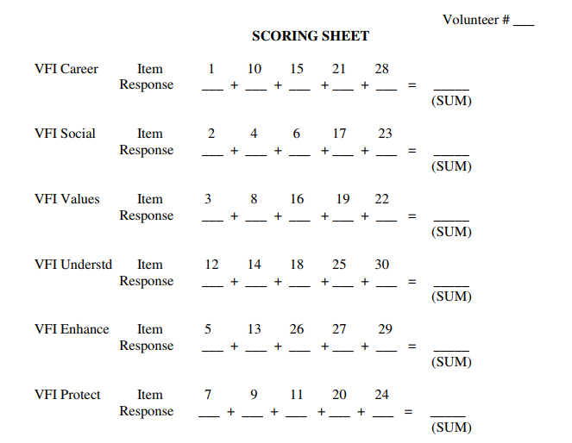

**APPENDIX B - ENGAGEMENT  
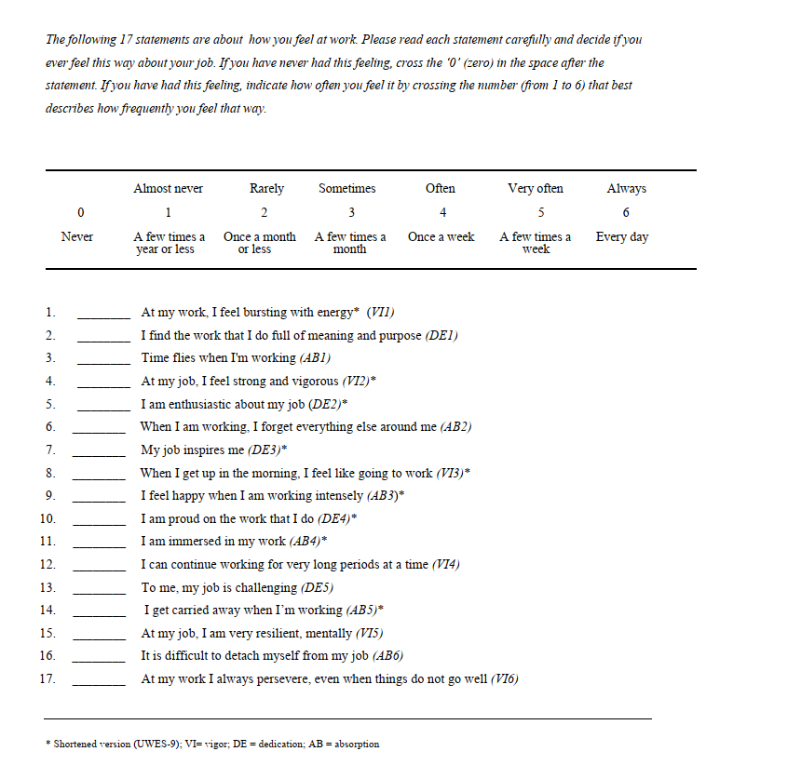**

**Biz short version kullandık - yanında * olanları yani. Burada üç tane subscale var altta yazıyor.**

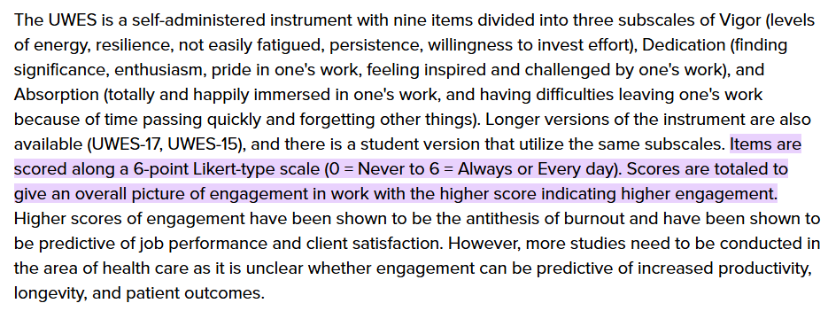

**APPENDIX C - SATISFACTION**

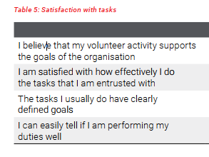

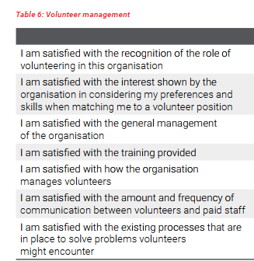

**Task satisfaction ve management satisfaction şeklinde iki subscale var ve onlara denk gelen sorular bu şekilde.**

**APPENDIX D - POTENTIAL QUESTIONS TO MEASURE COMMITMENT**

**How to Make It Work**

**Behavioral Intention:**

* *“For the next six months, do you plan to increase, decrease, or maintain your current level of volunteer hours?”*
  + Captures future-oriented intentions, a critical aspect of commitment.

**Historical Commitment:**

* *“How long have you been volunteering with Sustainable Merton?”*
  + Reflects a volunteer's track record and long-term dedication.

**Advocacy:**

* *“I would encourage people to volunteer with Sustainable Merton” (1 = Strongly Disagree, 5 = Strongly Agree)*
  + Measures willingness to recommend the organization, which signals satisfaction and emotional commitment.
* *“Have you ever encouraged someone else to volunteer with Sustainable Merton?”*
  + Directly assesses past advocacy behavior, adding weight to the advocacy dimension.

#### **Calculating the Composite Commitment Score**

Add the scores from all four questions to create a total commitment score:

**References**

Cañas‐Lerma, A. J., Campos‐Vidal, J. F., & Verger, S. (2022). “Our focus is on illness and loneliness”: Volunteer work engagement, compassion satisfaction, compassion fatigue, self‐care and motivations to volunteer. *Health & Social Care in the Community*, *30*(6), e6631-e6644. https://doi.org/10.1111/hsc.13934

Clary, E. G., Snyder, M., Ridge, R. D., Copeland, J., Stukas, A. A., Haugen, J., & Meine, P. (1998). Understanding and assessing the motivations of volunteers: A functional approach. Journal of Personality and Social Psychology, 74, 1516-1530. <https://doi.org/10.1037/0022-3514.74.6.1516>

Martins, C., da Silva, J. T., de Jesus, S. N., Ribeiro, C., Estêvão, M. D., Baptista, R., ... & Nunes, C. (2024). The Volunteer Functions Inventory (VFI): Adaptation and Psychometric Properties among a Portuguese Sample of Volunteers. *European Journal of Investigation in Health, Psychology and Education*, *14*(4), 823-837. https://doi.org/10.3390/ ejihpe14040053 Academic Editor: Inmaculada Méndez Mateo

Vecina Jiménez, M. L., Chacón Fuertes, F., & Sueiro Abad, M. J. (2009). Satisfacción en el voluntariado: estructura interna y relación con la permanencia en las organizaciones [Volunteer satisfaction: Internal structure and relationship with permanence in organizations]. *Psicothema*, *21*(1), 112–117.

Vecina, M. L., Chacón, F., Sueiro, M., & Barrón, A. (2012). Volunteer engagement: Does engagement predict the degree of satisfaction among new volunteers and the commitment of those who have been active longer? *Applied Psychology, 61*(1), 130-148. <https://doi.org/10.1111/j.1464-0597.2011.00460.x>

Zhou, S., & Kodama Muscente, K. (2022). Meta-analysis of volunteer motives using the Volunteer Functions Inventory to predict volunteer satisfaction, commitment, and behavior. *Nonprofit and Voluntary Sector Quarterly, 52*(5), 1331-1356.<https://doi.org/10.1177/08997640221129540>