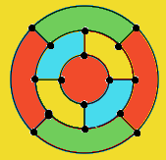
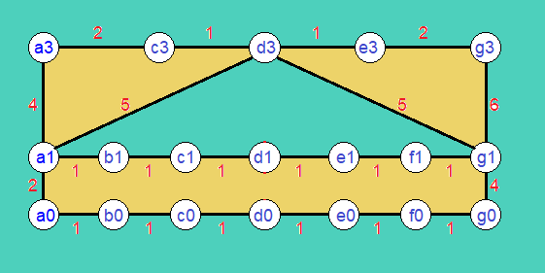
Question 1)
* Decide if 3 colors are sufficient to color G₁ and G₂

_{4 color.} En az 2 renk ile yapılabiliyor.
_{Qustions 2)}
* Find a minimum spanning tree in G1 and G2

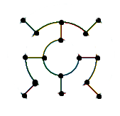
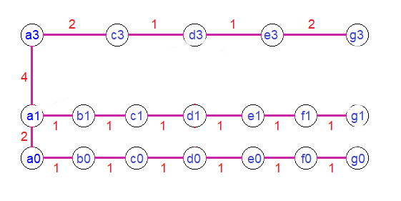

_{Question 3)}
* Find a Hamiltonian circuit (cycle) in G1 and G2
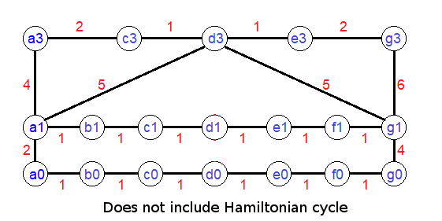
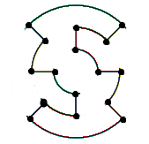

_{Question 4)}
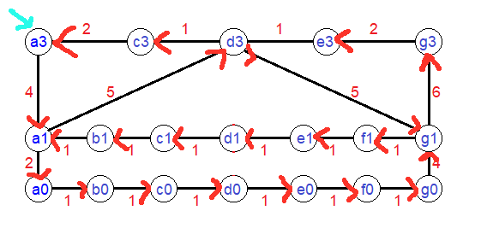
* Decide if G1 and G2 contain an Eulerian circuit
Does not include Eulerian circuit
