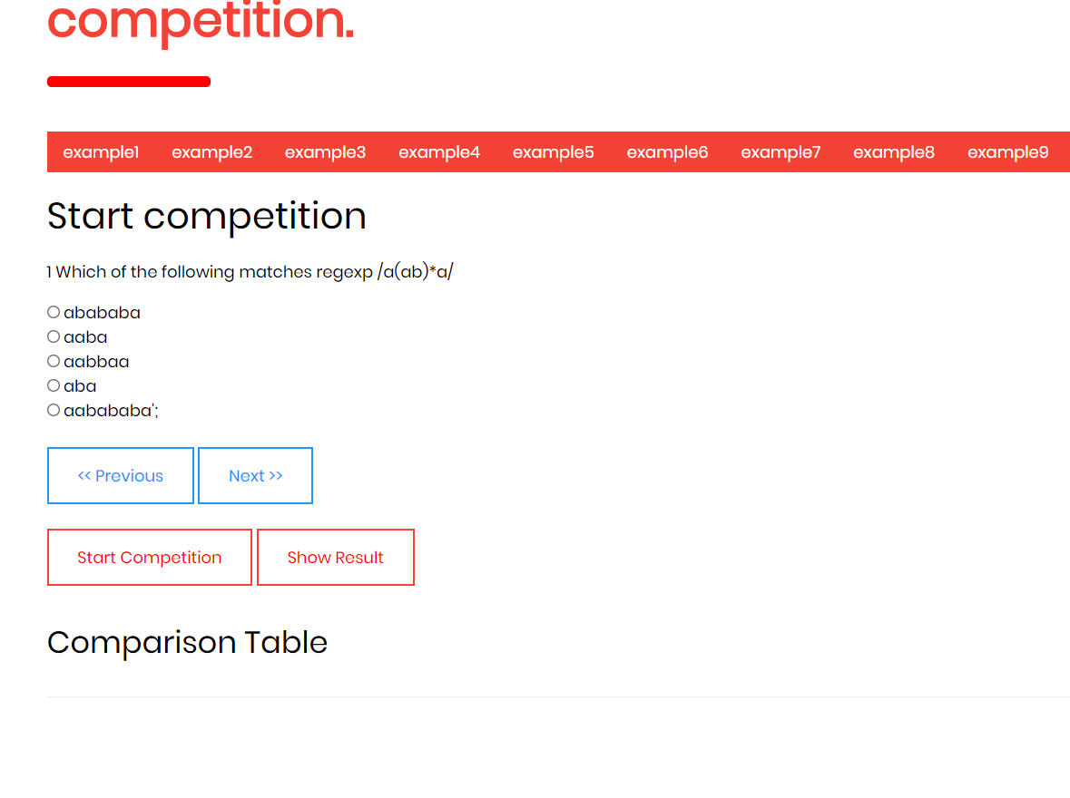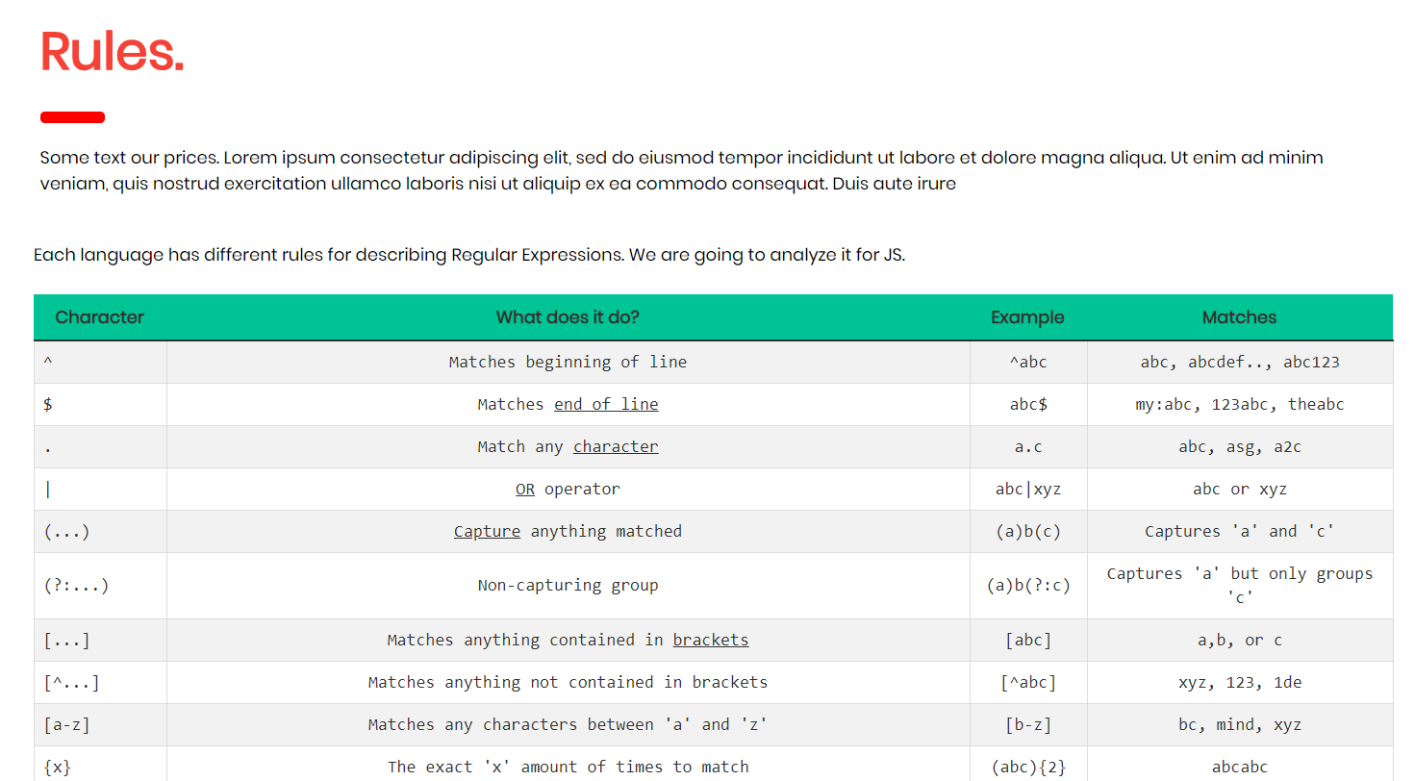

This project is a regular expressinon instruction page.

General information about the page:

The page contains basic information about REGEXP and a table with rules.

Examples include regexp.

There is an application on which we can try regexp patterns.

The main feature of the page is a regexp contest with 9 questions.

Users must answer 9 questions in 120 seconds.

Points are given according to the answers.