|  |  |
| --- | --- |
|  | **DOKUZ EYLÜL UNIVERSITY**  **ENGINEERING FACULTY**  **DEPT. OF COMPUTER ENGINEERING** |

Online Shopping System

# CME 3201 Database Management Systems

# Term Project Report

Phase 3

2019-2020 FALL

2016510097 Hasan Günay

2400000119 Deniz Nergiz

## Introduction

This term project is an online shopping site. Through the website everyone can ordered men or women’s clothes, dress, shoes or home stuff and electronic devices (phone, computer, tablet, etc.). In order to be able to order products from this site, you only needed to be a member. If our site receives your information once, it will save you and give you the opportunity to do all the allowed operations. So why do people need such a site?

Today's most needed and important phenomenon is time. Each action steal time from another action. Every technology to eliminate this situation. While providing convenience to people, it should be in the fastest way. People have basic needs but they want to meet these needs from their homes or even workplaces without sacrificing their work or rest time. With this website they can shopping with their computer. We can think of the most valuable phenomenon of humanity, that is, to save time while designing this system.

The project includes operations such as adding products, updating products, changing product features, increasing the number of product inventory, user authorization, determining the user who wins the promotion and making sales. In order to be able to contact the user in the presence of the membership system, the user will be asked to provide some not null, fields with mandatory names and contact information. The characters in the database tables will be limited to human standards in order to avoid bulging in the database. Since many tables will be added to purchase or similar operations, cascade operations will be considered and added. In some cases trigger functions can also be included in the project. Since the project database is of great importance in order to stretch all these features, a database will be designed in accordance with logical and details normalization standards.

## Overview

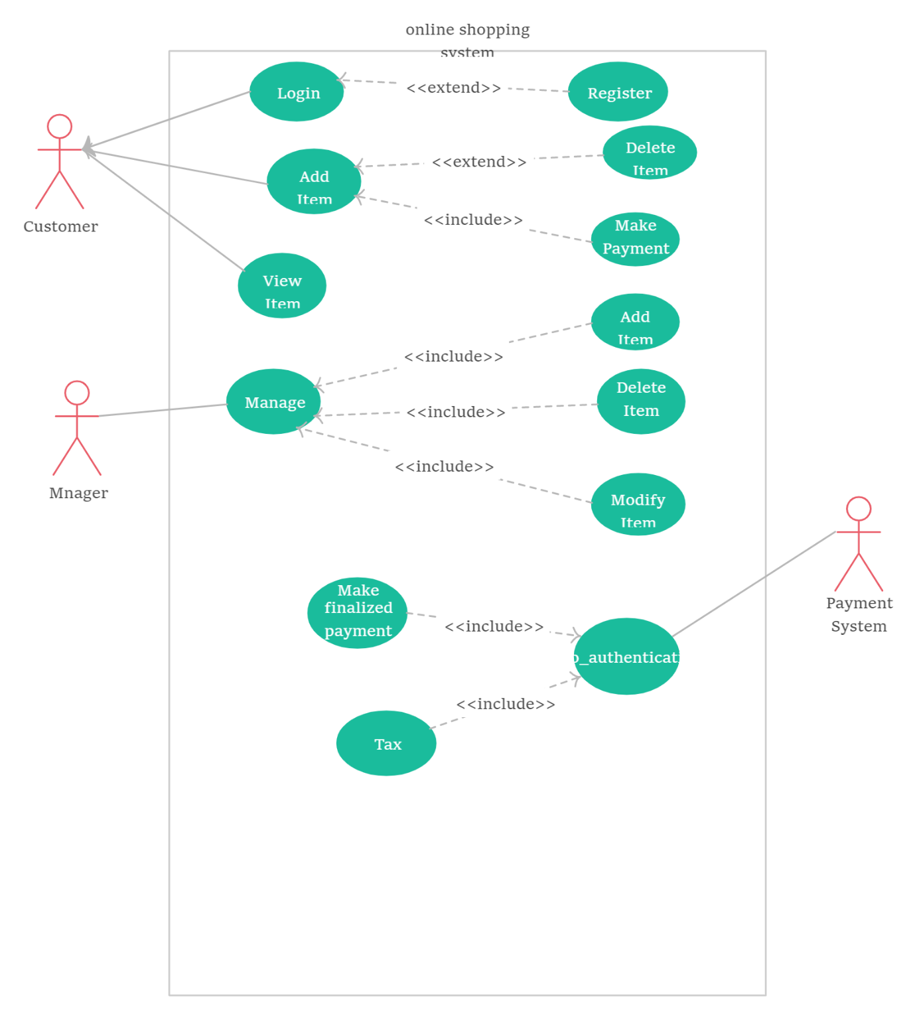

Figure 1 Use Case Diagram for Online Shopping System

The project has several operations. These operations are special for admin and some of them special for users. Admin have to manage this site so admin can add or delete items also can edit some products.

User have to register this site firstly. After that they can see categories of products, they can see products’ pics, their features and their costs. They can add products which they choose to their basket and they can make purchase. Also system can control these payment.

## Assumptions/Constraints/Risks

### Assumptions

Asp.net MVC will use the .mysql database.

It will be created for users who do not have time to shop in stores due to work load and want to follow the discount products in stores more easily.

### Constraints

The user can only access this site from computer, there will not be android or ios app. The site will have 2 categories (clothes and electronic devices) but can be added or subtracted later in the project

### Risks

If the user wishes to buy more than one product, it may be a time problem to repeatedly enter and purchase the pages. In order to avoid this situation, a shopping cart-style system can be developed.

## Software Architecture

Instructions: Show your details of software architecture. Do you use n-tier architecture? How did you design it in your project? You may draw software architecture diagram (It depicts how a typical software system might interact with its users, external systems, data sources, and services.). How did you provide a connection between database and frontend? Give details about your software architecture.

## Detailed System Design

### Entity-Relationship Diagram

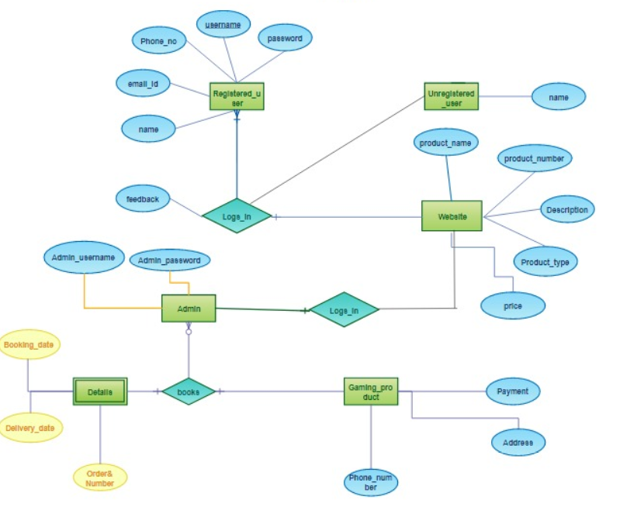

Mail address, name, login password and phone number are determined by the user.

Administrator can login with his own name and password.

Website; view and update product types, prices, product numbers

### Relational Algebra Expressions

Some examples of relation algebra expression for online shopping system. There are two tables. These are Customer and Item tables. Customer has some attributes; name, username, password, phone email. Also item has some attributes; name, id, price, model.

Each table have some examples of about their relational algebra.

**CUSTOMER**

|  |  |  |  |  |
| --- | --- | --- | --- | --- |
| Cname | Cusername | Cpassword | Cphone | Cemail |
| Hasan | hasanG | 1234 | 123456 | hasangunay1 |
| Deniz | denniz | 4321 | 654321 | nergizdeniz |
| Ali | ali56 | 8520 | 526341 | ali5656 |

1. Get all table:

Π Cname, Cusername, Cpassword, Cphone, Cemail (CUSTOMER)

1. Get name column:

Π Cname (CUSTOMER)

1. Find name of phone is 654321:

Π Cname (σ Cphone = 654321(CUSTOMER))

1. Select rows that password is 1234:

σ Cpassword = 1234(CUSTOMER)

1. Get email that phone is 123456:

Π Cemail (σ Cphone = 123456(CUSTOMER))

**ITEM**

|  |  |  |  |
| --- | --- | --- | --- |
| Iid | Iname | Iprice | Imodel |
| 45 | Tablet | 2500 | 2017 |
| 12 | Laptop | 4000 | 2016 |
| 26 | TV | 5000 | 2019 |

1. Get name of price is greater than 3500:

Π Iname (σ Iprice > 3500 (ITEM))

1. Get id and name of model is less than 2019:

Π Iid, Iname (σ Imodel < 2019 (ITEM))

1. Get price of id is 12:

Π Iprice (σ Iid = 12 (ITEM))

### Class Diagram

. 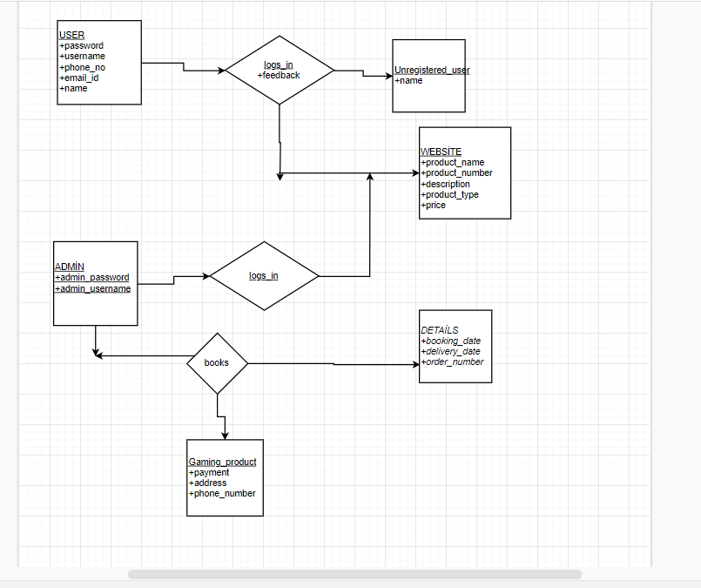

The user can register with the information necessary to log in and list only the products. The system can change the current prices of the products, add or remove new products.

The purchase dates and times of the product purchased by the user, the product codes can send information to the user by the system

### CRUD Matrix

|  |  |  |  |  |
| --- | --- | --- | --- | --- |
| **Relations\Operations** | **Create** | **Read** | **Update** | **Delete** |
| Customer/adding | X |  | X | X |
| Admin/adding | X | X | X | X |
| Add an item | X |  |  |  |
| Calculate price |  | X |  |  |
| schedule shipping | X | X |  |  |
| Order checkout |  | X | X |  |
| Close customer account |  |  |  | X |
| Change customer order | X | X | X | X |

**5.5 Database Schema**

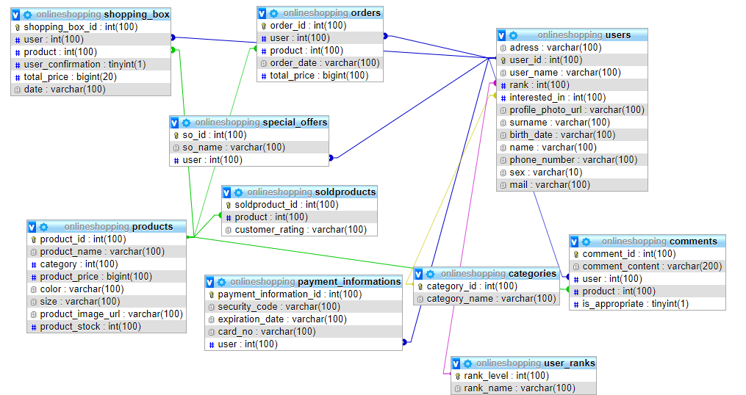

**Appendix A: SQL Statements**

Instructions: Provide all SQL statements (create and insert scripts, basic operations on database, view, complex queries, stored procedure, trigger)

**Appendix B: Screenshots**

Instructions: Screen shots of your interfaces with brief declaration for main operations