

**EE491 / EE492 PROJECT REPORT**

DATE: XX/XX/XXXX

ADVISOR NAME SURNAME

STUDENT NAME, SURNAME AND NUMBER

**DEPARTMENT OF ELECTRICAL AND ELECTRONICS ENGINEERING**

PROJECT TITLE

**ABSTRACT**

**TABLE OF CONTENTS**

**ABBREVIATIONS** 3

**LIST OF FIGURES** 4

**LIST OF TABLES** 5

**1.** **INTRODUCTION** 6

**1.1.** **Sample Subsection** 6

**2.** **PROBLEM DEFINITON** 7

**2.1.** **Sample Subsection for Chapter-2** 7

**2.2.** **Sample Subsection for Chapter-2** 7

**3.** **PROPOSED SOLUTION** 8

**3.1.** **Sample Subsection for Chapter-3** 8

**4.** **RESULTS AND DISCUSSIONS** 9

**5.** **CONCLUSIONS** 10

**REFERENCES** 11

**APPENDIX** 12

# **ABBREVIATIONS**

**IEEE :** Institute of Electrical and Electronics Engineers

**MoM :** Method of Moments

# **LIST OF FIGURES**

**Figure 1** Block Diagram 7

**Figure 2** Radiation Pattern 7

**Figure 3**  Width of the waveguide vs. frequency variation 9

# **LIST OF TABLES**

**Table 1** Dimensions vs Cutoff frequency variation 9

1. **INTRODUCTION**

This section should be devoted to describe related scientific studies (scientific papers, reports, books etc.) which has been published in the literature.

* 1. **Sample Subsection**

The general description of the project and connections of the literature should be mentioned in this section.

1. **PROBLEM DEFINITON**

The detailed project statement has to be explained in this section.

Equations should be written with an editor e.g. Mathtyp. Formulations cannot be inserted as picture format.

Formulas should be written centered with the equation number, e.g.

$∇×\vec{E }=-\frac{∂\vec{B}}{∂t}$ (1)

Figures and Tables should be also centered and have separate captions, and numbers which are listed in List of Figures and List of Tables, respectively.

Information

Transmitter

Receiver

Channel

**Figure 1** Block Diagram

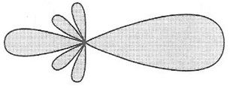

**Figure 2** Radiation Pattern

* 1. **Sample Subsection for Chapter-2**

……………

……………

* 1. **Sample Subsection for Chapter-2**

……………

1. **PROPOSED SOLUTION**

The method which will be used in the project studies should be clarified in this section.

* 1. **Sample Subsection for Chapter-3**

………….

1. **RESULTS AND DISCUSSIONS**

Results obtained during the project study should be presented in this section. Discussions on the scientific findings should be reported in a clear form.

|  |  |  |  |
| --- | --- | --- | --- |
| **Waveguide Type** | **width (cm)** | **height(cm)** | **Cuttoff frequency of TE11 (GHz)** |
| WG-1 | 1 | 1 | 21.213 |
| WG-2 | 2 | 1 | 16.770 |
| WG-3 | 3 | 1 | 15.811 |
| WG-4 | 4 | 1 | 15.461 |

**Table 1** Dimensions vs Cutoff frequency variation

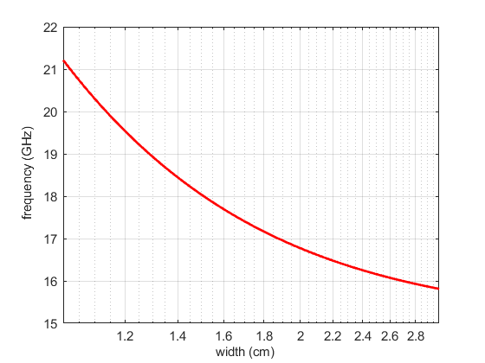

**Figure 3**  Width of the waveguide vs. frequency variation

1. **CONCLUSIONS**

General description of the project, the most interesting contributions and observations, and possible extensions should be emphasized in here.

# **REFERENCES**

**[1]** Einstein, A., Podolsky, B., & Rosen, N. (1935). Can quantum-mechanical description of physical reality be considered complete?. *Physical review*, *47*(10), 777.

**[2]** Cover, T. M., & Thomas, J. A. (2012). *Elements of information theory*. John Wiley & Sons.

**[3]** Grossglauser, M., & Tse, D. (2001). Mobility increases the capacity of ad-hoc wireless networks. In INFOCOM 2001. *Twentieth Annual Joint Conference of the IEEE Computer and Communications Societies*. Proceedings. (Vol. 3, pp. 1360-1369).

# **APPENDIX**