[**SYS-140-04: Systems Fundamentals - Fall 2020 (2020FA)**](https://champlain.instructure.com/courses/1413978)

**Lab #0**

**Hasan Hashim**

**9/8/2020**

On the Lab #0 we tried to connect to the cyber.local remotely. There were two ways to that, the cyber.local VPN or Champlain’s viewportal site. For me it was easy to do it on the Champlain’s viewportal site.

I really like how you added a picture for each step, it’s really helpful.

The only problem that I had was when I tried to connect to the Cyber.Local, I kept trying to log in to the champlain log in and I realized I have to go to the “Use a different account” and log in using my cyber.local email.

* A screenshot of a successful ping of your assigned workstation from within your Viewportal VM?

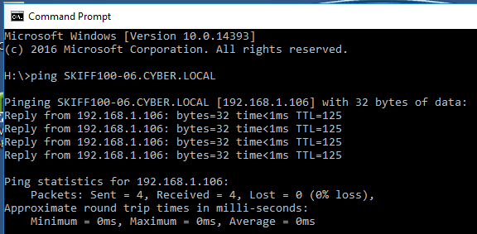

A screenshot showing both the top ribbon identifying the machine being remotely connected to and a command prompt showing the machine's IP address via the ipconfig command?

