

**Exploring Network Tools**

**Assigned Date: Monday, October 21, 2019**

**Due Date: 11:59 pm, Sunday, October 27, 2019**

For this assignment, you will be using the network tools mentioned in class today to answer a few questions:

* **What is the IP address of the champlain.edu web server?**
* **Where is the web server located?**

**Lab Submission**

For this lab, you will be submitting several screenshots to Canvas and answering a question regarding the whereabouts of Champlain College’s web server (the submissions items are **bolded** in the lab below). The most efficient way to submit these is to create a Word document that contains all four requested submissions and submitting that document.

**Part 1: nslookup**

1. Click on the magnifying glass in the Windows taskbar and type ‘cmd’. Open the Command Prompt application that pops up.
2. Type into the command prompt window ‘nslookup champlain.edu’. **Take a screenshot of the output of the program.** This IP address shown in the ‘Non-authoritative answer’ portion is Champlain’s web server.

**Part 2: Ping**

1. Type ‘ping x.x.x.x’ into your command prompt, replacing x.x.x.x with the Champlain.edu IP address you found in Part 1. Let the program run to completion, and **take a screenshot of the results.**

**Part 3: Tracert (Where in the world in Champlain’s web server?)**

1. Now, type ‘tracert x.x.x.x’ in your command prompt, replacing x.x.x.x with the Champlain.edu IP you found in Part 1. Let the program run to completion, and **take a screenshot of the results.**
2. Tracert shows you the path your network traffic takes from your machine to champlain.edu. Analyze the path that tracert returned (take note of the names/IPs returned from each hop in the route!) and **answer the following question: Based on this information, where do you think the Champlain.edu web server lives?**

**What To Submit**

* nslookup screenshot from Step 2 ● Answer to question from Step 5
* ping screenshot from Step 3
* tracert screenshot from Step 4

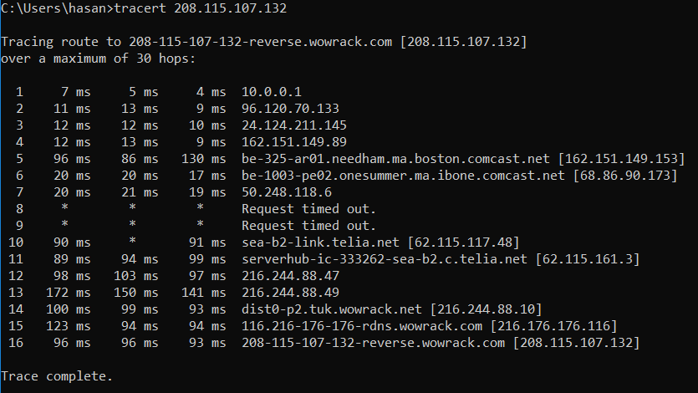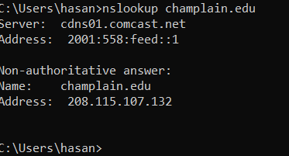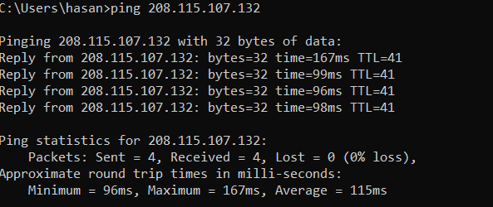

5. **where do you think the Champlain.edu web server lives?**

I think it leaves in the 216.176.176.116