FireRisk AI: Weather-Based Forest Fire Occurrence Prediction
Statistics Mini Project | Python | Supervised Learning

1. Abstract
This mini project investigates whether meteorological conditions and Fire Weather Index (FWI) variables can be used to classify daily observations into fire and not-fire categories. The study uses 122 observations from the Bejaia region of the Algerian Forest Fires dataset. The workflow includes data preprocessing, descriptive statistics, exploratory data analysis, statistical significance testing, Logistic Regression and Random Forest classification, and model evaluation.

2. Problem Statement
Forest fires are affected by environmental and fire-weather conditions. The objective is to determine whether a supervised machine-learning model can classify a daily observation as fire or not fire using measured weather variables and Fire Weather Index components.

3. Dataset Description
Source: Algerian Forest Fires Dataset, UCI Machine Learning Repository. The original dataset contains 244 observations from the Bejaia and Sidi Bel-abbes regions of Algeria during June–September 2012. For this project, the 122 observations from the Bejaia region were used as the working dataset. The target variable is Classes: fire or not fire.
Type | Variable | Meaning | Role
Numeric | Temperature | Maximum daily temperature (°C) | Feature
Numeric | RH | Relative humidity (%) | Feature
Numeric | Ws | Wind speed (km/h) | Feature
Numeric | Rain | Daily rainfall | Feature
Numeric | FFMC/DMC/DC | Fire Weather Index components | Features
Numeric | ISI/BUI/FWI | Fire Weather Index components | Features
Categorical | Classes | Fire / Not Fire | Target

4. Data Preprocessing
- Loaded the CSV data using pandas.
- Removed surrounding whitespace from the class labels.
- Converted the target into binary form: fire = 1 and not fire = 0.
- Checked data types and missing values.
- No missing values were found in the working observations.
- Standardization was applied inside the Logistic Regression pipeline.

5. Exploratory Data Analysis
The fire class contains 59 observations and the not-fire class contains 63 observations. Mean comparisons show that fire observations have higher average temperature, FFMC, DMC, DC, ISI, BUI and FWI, while not-fire observations have higher average relative humidity and rainfall.
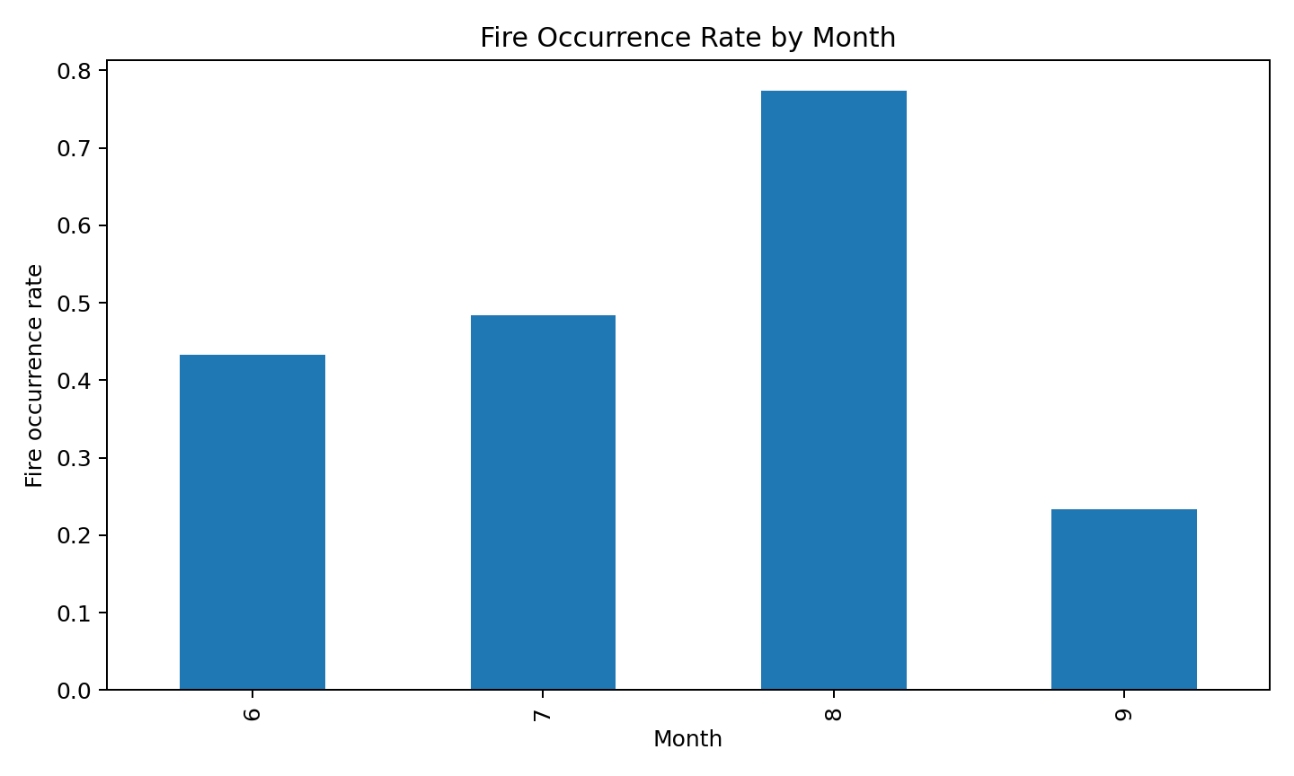
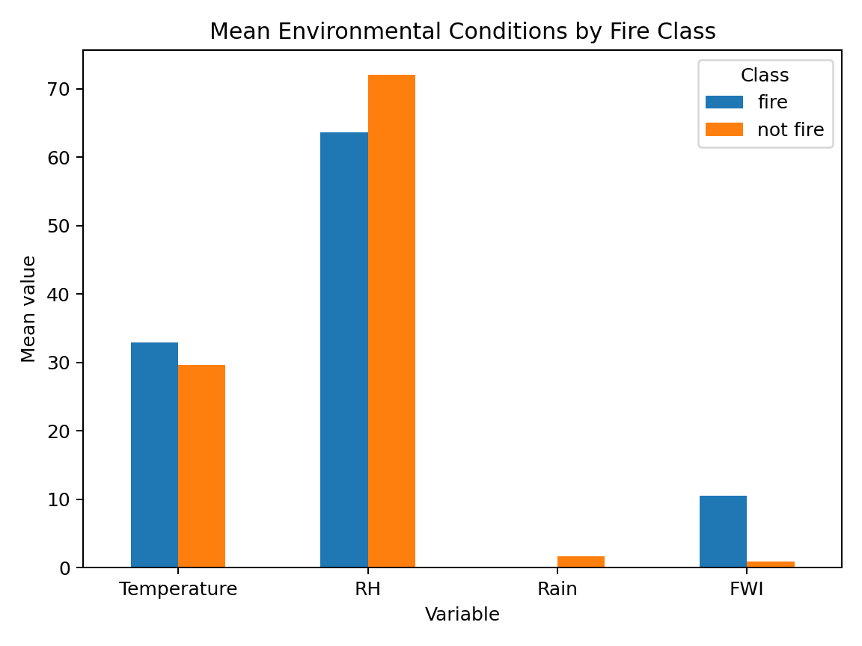

6. Statistical Analysis
Pearson correlations with the binary target were examined as an exploratory measure. The strongest absolute associations in the working sample were observed for ISI, FWI, FFMC, DMC and BUI. Welch two-sample t-tests were also performed to compare the means of fire and not-fire observations.
Variable | t-statistic | p-value
ISI | 16.003 | 2.021e-25
FFMC | 12.567 | 3.261e-19
FWI | 12.412 | 1.919e-18
DMC | 8.381 | 2.405e-12
BUI | 8.296 | 2.734e-12
DC | 7.829 | 1.045e-11
Temperature | 6.355 | 4.591e-09
RH | -4.498 | 1.629e-05
A small p-value indicates evidence of a difference in group means in this sample. It should not be interpreted as proof of causation.

7. Model Building
Two supervised classification algorithms were compared: Logistic Regression and Random Forest. The data was split into 80% training and 20% testing sets using stratification and random_state=42 for reproducibility.
Model | Accuracy | Precision | Recall | F1 | ROC-AUC
Logistic Regression | 0.960 | 1.000 | 0.917 | 0.957 | 0.994
Random Forest | 0.960 | 1.000 | 0.917 | 0.957 | 0.987

8. Interpretation
On the fixed test split, both models achieved 96.0% accuracy, 100% precision, 91.7% recall, 95.7% F1-score and ROC-AUC above 0.98. The confusion matrix contained 13 correctly identified not-fire observations, 11 correctly identified fire observations, no false positives and one false negative. These figures are sample-specific and should not be generalized beyond the dataset.
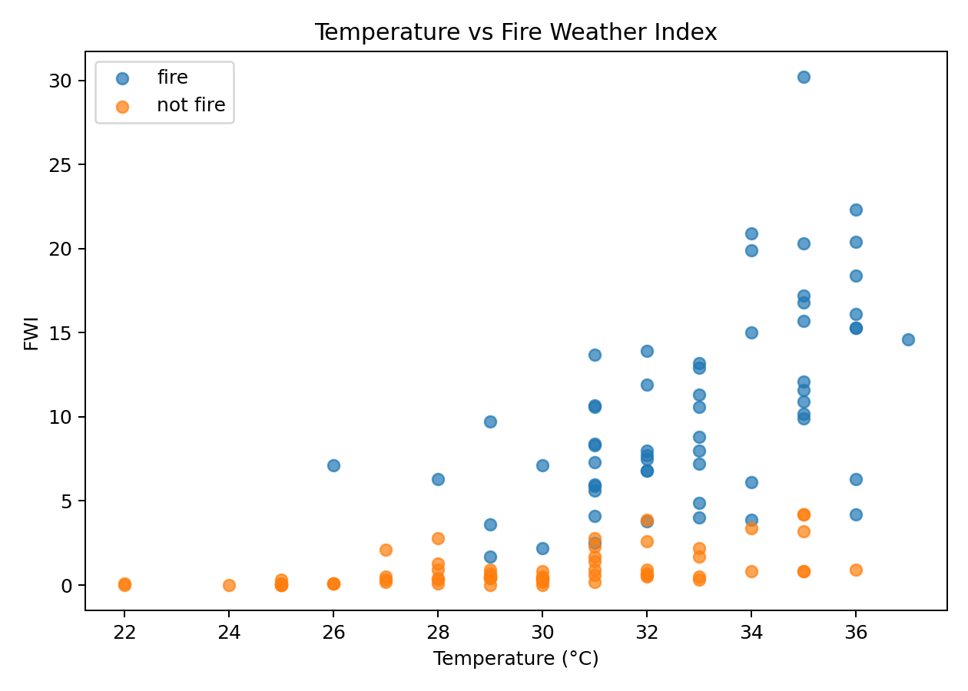

9. Conclusion
The study demonstrates that weather and Fire Weather Index variables contain useful information for distinguishing fire and not-fire observations in the Bejaia dataset. The results support the feasibility of a fire-risk classification prototype. However, the model should be treated as an educational research prototype because the working dataset is small, limited to one region and one fire season, and does not include many real-world factors such as land cover, fuel conditions, human activity, satellite detections or emergency-response data.

10. Future Scope
- Integrate NASA FIRMS satellite-derived active-fire observations.
- Add multi-year weather and air-quality data.
- Extend the study from Algeria to India using geographically matched public data.
- Build a geospatial dashboard showing historical fire hotspots and risk estimates.
- Use time-aware validation and calibration on a larger dataset.

11. References
UCI Machine Learning Repository — Algerian Forest Fires Dataset. https://archive.ics.uci.edu/dataset/547/algerian+forest+fire+dataset
Abid, F. (2019). Algerian Forest Fires Dataset. UCI Machine Learning Repository. DOI: 10.24432/C5KW4N.
Working CSV mirror used for reproducible extraction: https://huggingface.co/spaces/Navneet574/algerian-forest-fire-prediction/blob/main/Algerian_forest_fires_dataset_UPDATE.csv

