Hasan Hut

**HW1**

1. HTTP 1.1

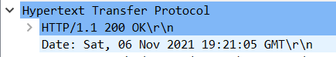

1. TR



1. my computer = 192.168.x.xxx

destination = 128.119.245.12



1. Status Code = 200 OK



1. Last-Modified: Sat, 06 Nov 2021 05:59:02 GMT\r\n



1. 128



1. ..
2. No
3. No, server did not return anything. Status Code = 304

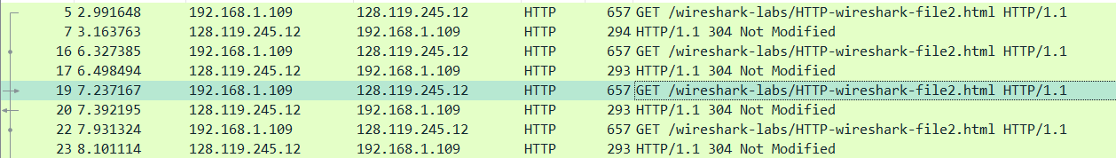

1. If-Modified-Since: Sat, 06 Nov 2021 05:59:02 GMT\r\n

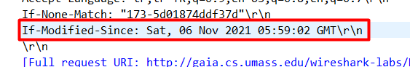

1. Status Code is 304 because when we refresh the page browser return the contents from cache.



1. Only sent 1 http get request. Packet number is 11.



1. Get Message packet number is 19.



1. 200 OK.



1. The data sent 4 TCP segments.



1. I have 3 get request from pearson logo,wireshark and one jpg file.

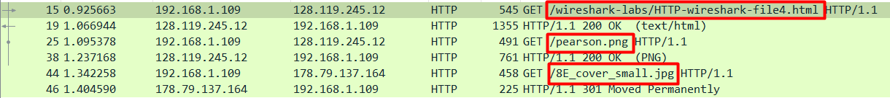

1. Images were downloaded sequentially. First image downloaded then second image is downloaded.
2. Status code = 401



1. Authorization information is added. We send username and password information.

