**Hasan Hut**

**COMPUTER NETWORKS HW2**

**1-**

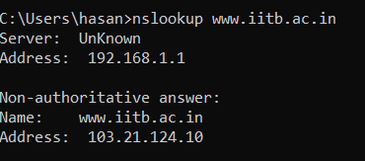

Server IP is 103.21.124.10

**2-** Server IP is Unknown.

**3-** Non-authoritative server

**4-**

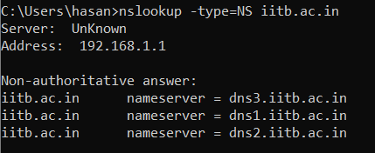

I can’t found any authoritative servers.

**5-**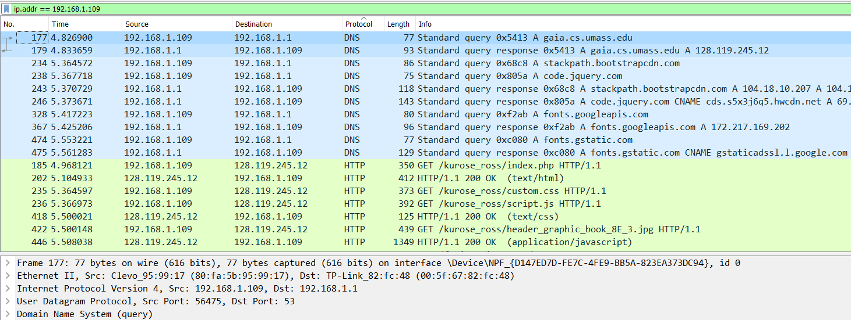

177,UDP

**6-**

179,UDP

**7-** Both of them 53.

**8-** 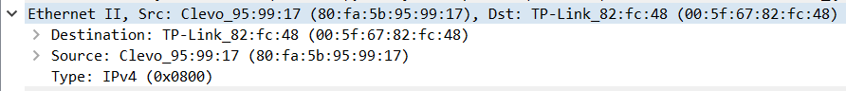

82:fc:48

**9-**

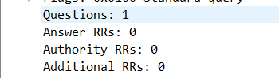

**10-**

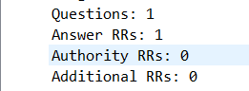

**11-**

**12-**

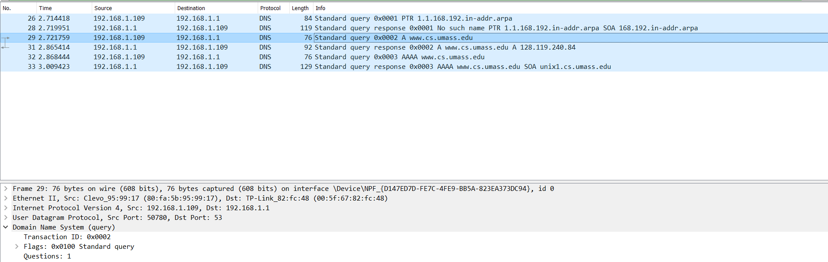

Query destination port : 53

Response source port : 53

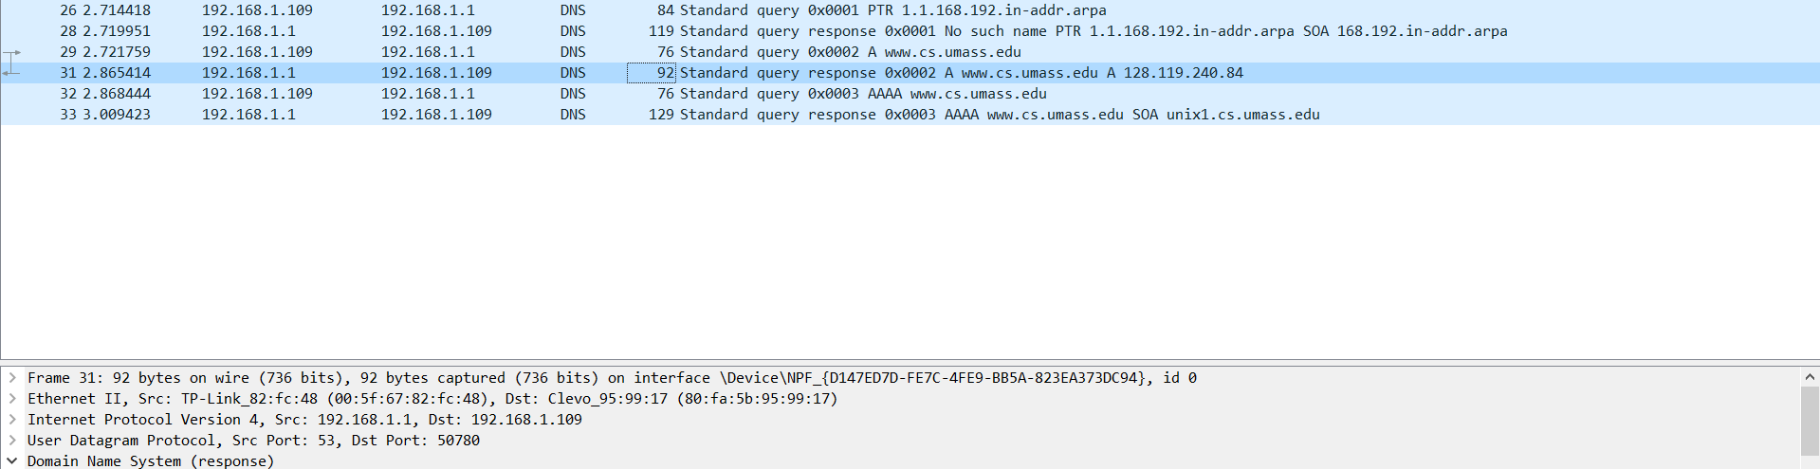

**13-**

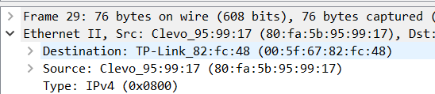

Yes

**14-**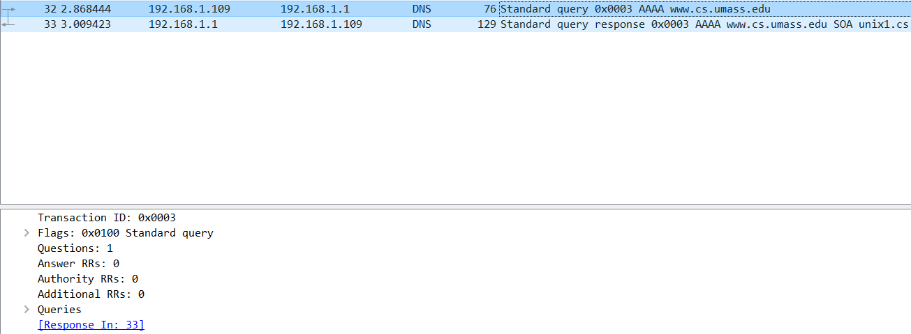

UDP, No

**15-**

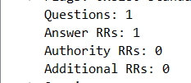

Question = 1, Answers = 1

**16-**

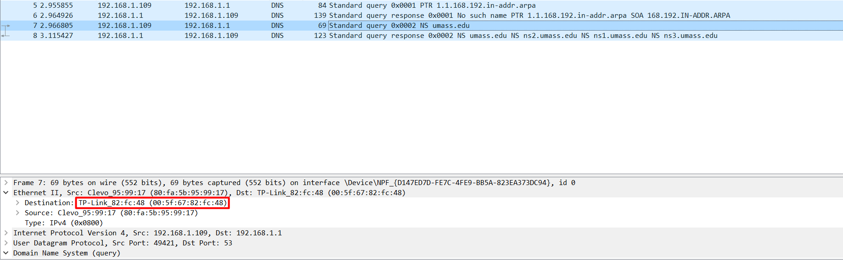

Yes

**17-**

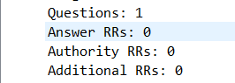

Question = 1, Answer = 0

**18-**

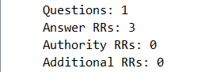

Question = 1,Answer = 3

