CSE4074 Programming Assignment: Peer-to-peer Chat

Hasan Hut Murat Fidan Süleyman Burak Özcan

We designed p2p chat application. It consists of two parts a registry application and a chat application. Registry application keeps track of the peers, and chat application allow peers to communicate with each other. In this project, we developed it with python. We used socket programming and multithreading concepts.

Socket programming enables communication between two different devices in the network by creating a channel over IP and port numbers using the TCP/IP protocol. In this communication, one socket listens to the channel over the specified IP and port, while the other socket tries to reach the other end over the same channel.

Thread is a necessary structure for different processes to run at the same time. It will send messages to many client servers at the same time. If it is in order, there will be a wait and the system will not work regularly. Therefore, when user wants to connect to the server, thread is created for that user.

Registry Side

When we want to run the chat application, we first need to run the registry.py file. When we run it, the registry will always stay open and listen for incoming connections. When a connection will be made by the user, a thread will be created for each user. And each thread sends the message from the user to the other user.

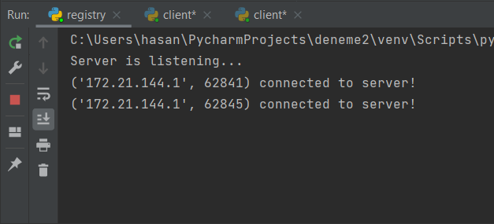

2 users are logged into the system and the registry shows them. When users register of the system and then log in to the system, the registry welcomes them.

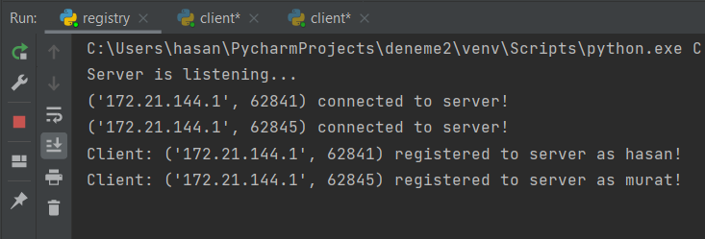

Client Side

The client side only accesses the specified IP address and Port. After making the connection, it checks the inputs from the server or the user and adjusts the outputs accordingly. When the user enters the system, the WELCOME screen welcomes him/her.

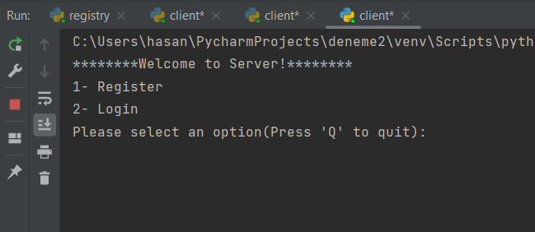

The system gives two options “register” and “login”.In the registration process, the username must be unique. If the registration process is completed,registry send to client “REG_OK”.After this process, the user must log in to the system with a user name and password. If the log in process is completed, registry send to client “LOG_OK”.

Then the user is greeted by the main screen of the application. And the program gives 3 options for users:

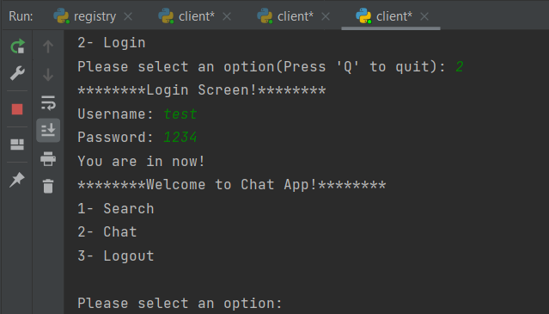

On the Search screen, users can find the IP and PORT numbers of the users by searching for their usernames.

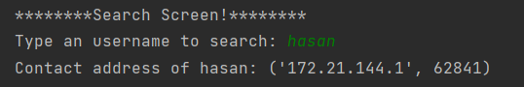

When the user select the Chat options, The system requests IP and Port information with whom the user wants to chat and then the system sends "CHAT REQUEST" to the user to whom the message is wanted to be sent. The user has two options. "OK" and "CHAT_REJECT". If the user sends an "OK" response, the chat will start, but if user sends a "REJECT" response, the chat will not start. And also, a "BUSY" response is sent if the user is in a chat.

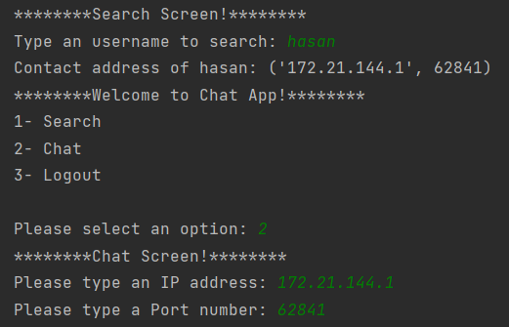

When the user choose logout, the user closes the program and goes offline.

**Unresolved Issues:**

* UDP Port doesnt work completely.
* In the chat section,after entering the IP and Port values ​​of the user, it does not connect to the other user. There is an addresses conflict.
* Logout section does not work properly.