**CSE3033 - Operating Systems Assignment 1 Report**

**Fall 2021**

Hasan Hut

**Q1**. In the first question, we turn the numbers in the txt file into stars. First, we create an empty array. The numbers in each line in the txt file are added to this array. Finally, we take the numbers from the array and multiply by stars.

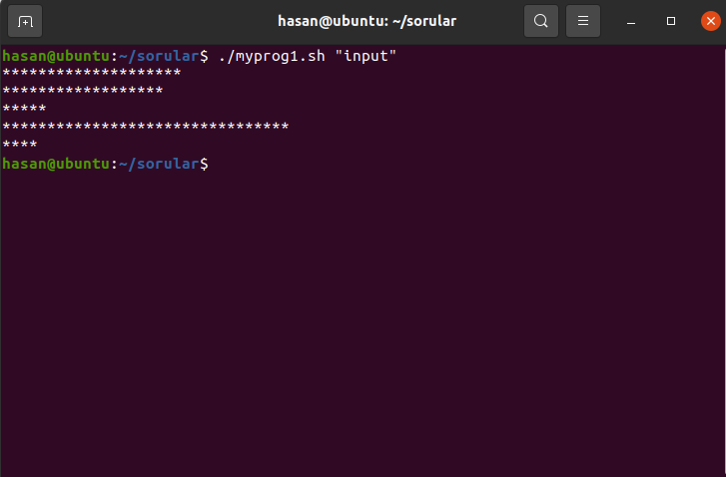

Figure 1. Output of the first program

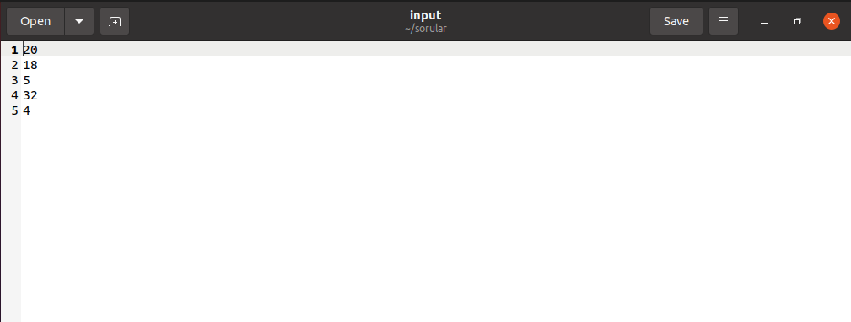

Figure 2. Input File

**Q2**. It asks us to go to the folder specified in this question and delete all the files. Except for *c,*h and makefile files. First of all, it goes to the specified folder and searches for all files one by one. If it sees *c,*h and makefiles, it does nothing but deletes the other files.

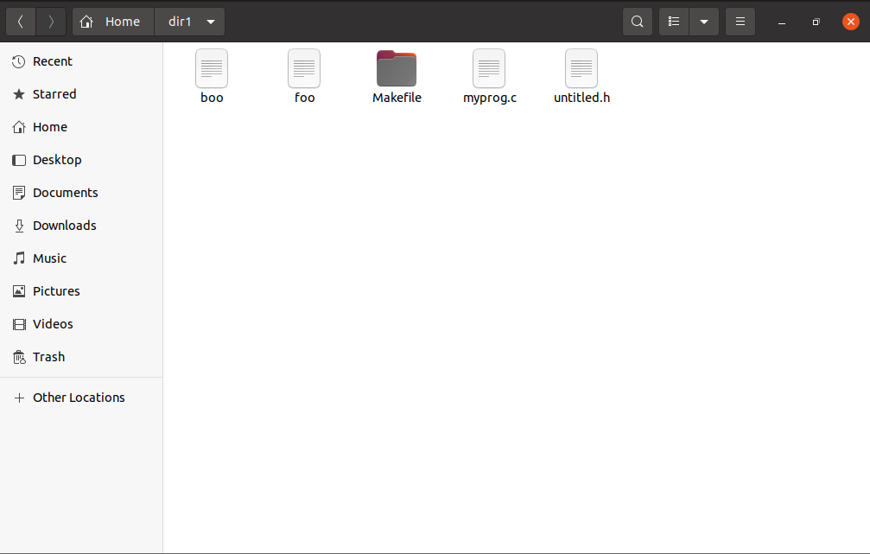

Figure 3. Directory dir1

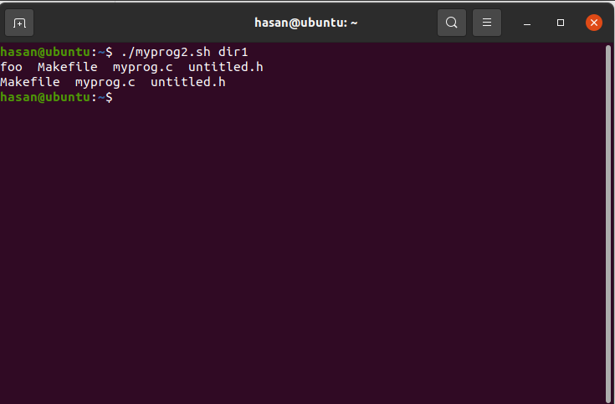

Figure 4. Output of the program

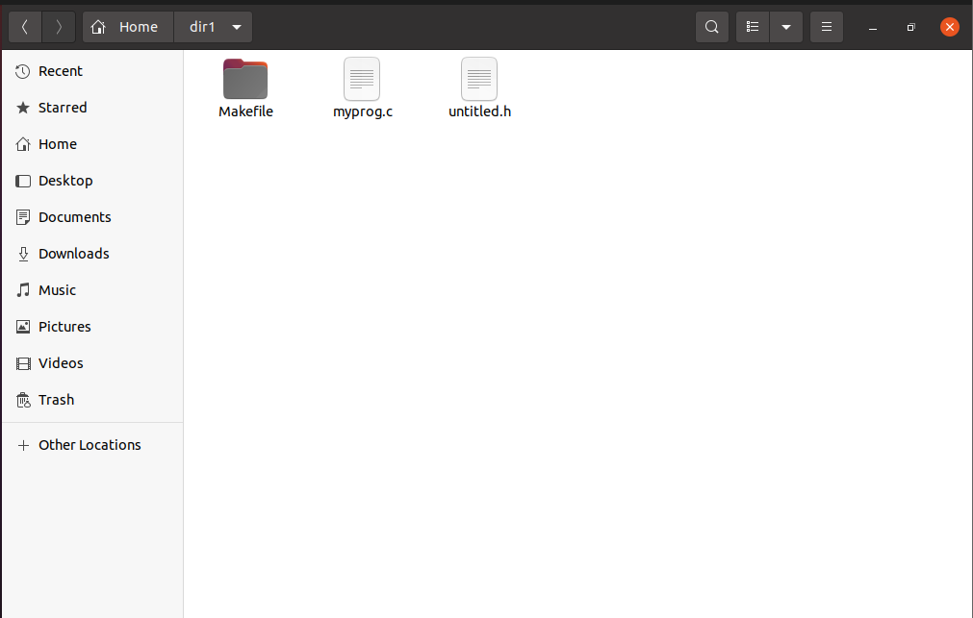

Figure 6. dir1 folder after the program runs

**Q3**. First, the occurrences are found with the grep command. Then, all the words found with the sed command are replaced.

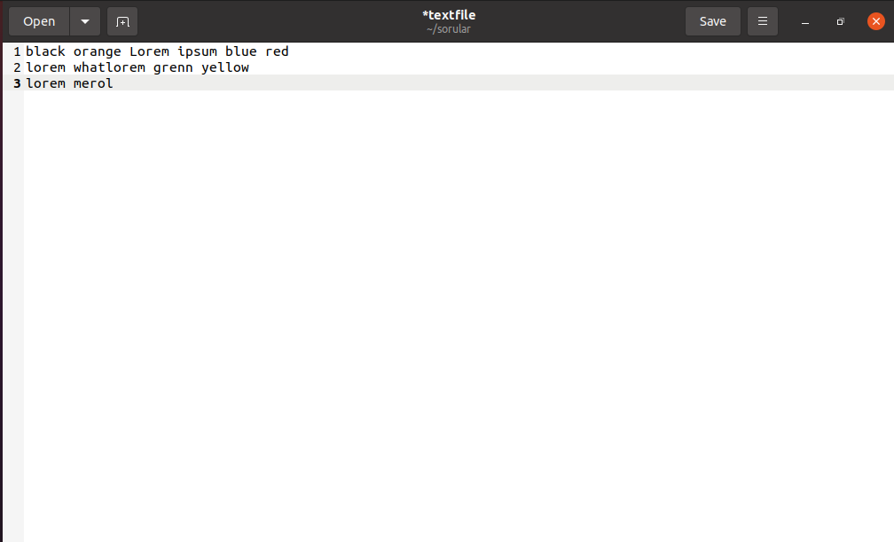

Figure 7. TextFile before program runs

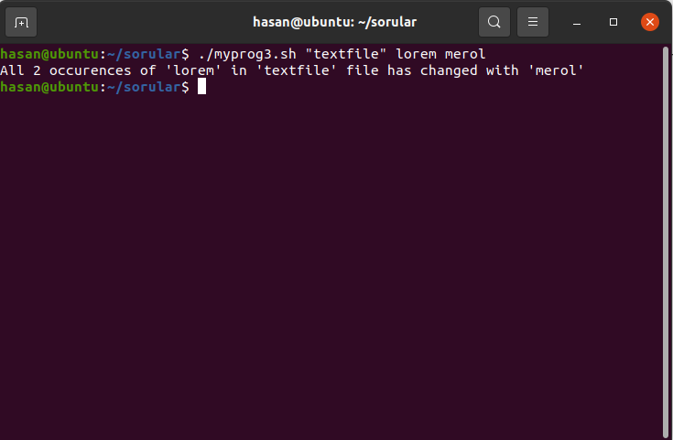

Figure 8. Output of the program

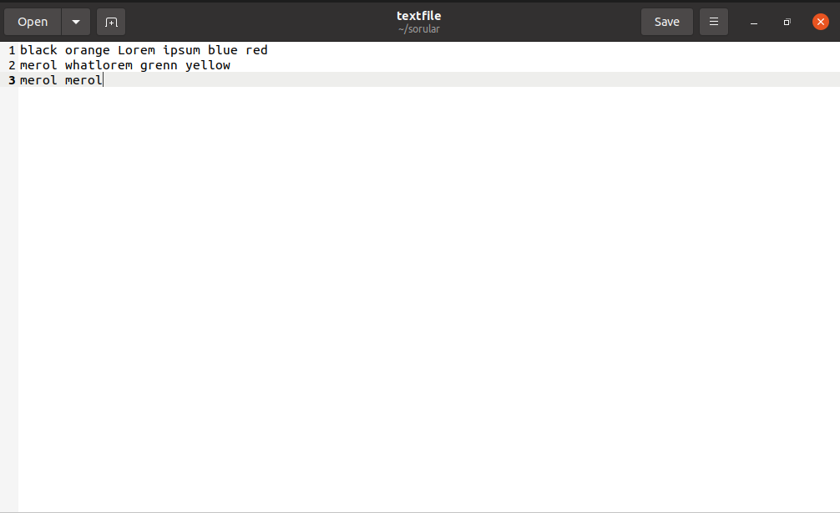

Figure 9. TextFile after the program runs

**Q5**. Firstly, it finds the last digits of the entered value and adds it to an array. then it combines the numbers in the array with each other and adds them to a new array. Finally, we get the result by summing all the numbers in the array.

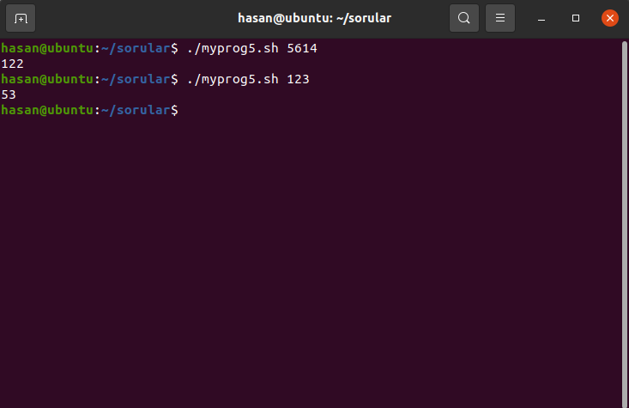

Figure 10. Outputs of the program