MessManager — Bachelor Mess Expense & Meal System for CODETREE
Hasan Imam
ID# 22203032

A Practicum in the Partial Fulfillment of the Requirements
for the Award of Bachelor of Computer Science and Engineering (BCSE)

Department of Computer Science and Engineering
College of Engineering and Technology
IUBAT—International University of Business Agriculture and Technology
Spring 2026

MessManager — Bachelor Mess Expense & Meal System
Hasan Imam

A Practicum in the Partial Fulfillment of the Requirements for the Award of Bachelor of Computer Science and Engineering (BCSE)
The practicum has been examined and approved,

_____________________________
Prof. Dr. Utpal Kanti Das
Chairman

_____________________________
Shahinur Alam
Co-supervisor, Coordinator and Assistant Professor

_____________________________
Jannatul Ferdous
Supervisor and Lecturer

Department of Computer Science and Engineering
College of Engineering and Technology
IUBAT—International University of Business Agriculture and Technology
Spring 2026

Letter of Transmittal
11 May 2026
The Chair
Practicum Defense Committee
Department of Computer Science and Engineering
IUBAT—International University of Business Agriculture and Technology
4 Embankment Drive Road, Sector 10, Uttara Model Town
Dhaka 1230, Bangladesh.

Subject: Letter of Transmittal.

Dear Sir,
With due respect, I am pleased to submit my practicum report titled “MessManager — Bachelor Mess Expense & Meal System,” developed as a partial requirement for the Bachelor of Computer Science and Engineering (BCSE) degree at IUBAT. During my three-month practicum at CODETREE, I was involved in the design, development, and implementation of a centralized mess management system aimed at automating meal tracking, bazaar expense logging, and complex monthly bill calculations.
I would like to express my sincere gratitude to the CODETREE team for their professional cooperation and technical support throughout the practicum period.

Yours sincerely,
_____________
Hasan Imam
22203032

Organization’s Certificate

Place your organization’s certificate scanned copy here.

Student’s Declaration
I hereby declare that the practicum report titled “MessManager — Bachelor Mess Expense & Meal System” is my own original work. This report is submitted in partial fulfillment of the requirements for the degree of Bachelor of Computer Science and Engineering (BCSE) at IUBAT—International University of Business Agriculture and Technology. I further declare that this report has not been submitted to any other university or institution for any degree or diploma. All sources of information and data used in this report have been duly acknowledged and cited according to academic standards.

_____________
Hasan Imam
22203032

Supervisor’s Certification
This is to certify that the practicum report titled “MessManager — Bachelor Mess Expense & Meal System” has been prepared by Hasan Imam, ID#22203032, under my direct supervision and guidance. To the best of my knowledge, the work presented in this report is original and fulfills the requirements for the award of the degree of Bachelor of Computer Science and Engineering (BCSE). The report is now ready for examination and defense.

_______________________________
Jannatul Ferdous
Supervisor and Lecturer
Department of Computer Science and Engineering
IUBAT—International University of Business Agriculture and Technology

Abstract
Managing shared living expenses and meal systems (messes) in Bangladesh is traditionally a manual, error-prone process. This report describes the development of MessManager, a Bachelor Mess Expense & Meal System designed to automate meal tracking, expense management, and billing calculations. Built using Laravel 10 for the backend and React 19 for the frontend, the system provides role-based dashboards for administrators, managers, and members. Key features include a dynamic meal rate calculator based on bazaar expenses, an approval-based deposit workflow, and automated splitting of monthly fixed costs like rent and utilities. The system ensures financial transparency and operational efficiency, replacing paper logs with a secure digital environment. Future work involves integrating character-level OCR to automate bazaar receipt data entry.

Acknowledgments
First, I would like to express my deepest gratitude to Almighty Allah for giving me the strength and patience to complete this practicum successfully.

I am profoundly grateful to my supervisor, Jannatul Ferdous, for providing invaluable guidance, constant encouragement, and technical insights throughout the development of MessManager. I also wish to thank Prof. Dr. Utpal Kanti Das, Chairman of the Department of CSE, and Shahinur Alam, Co-supervisor and Coordinator, for their administrative support and academic mentorship.

Special thanks go to the team at CODETREE for providing me with a professional environment and the resources necessary to implement this project as a Trainee IT Executive. Finally, I am thankful to my family and friends for their continuous support and motivation during my undergraduate studies.

Table of Contents
Letter of Transmittal iii
Organization’s Certificate iv
Student’s Declaration v
Supervisor’s Certification vi
Abstract vii
Acknowledgments viii
List of Figures xiv
List of Tables xvi
Chapter 1. 1
Introduction 1
1.1 Background of the Study 2
1.2 Methodology 2
1.2.1 Primary Sources 2
1.2.2 Secondary Sources 2
1.3 Objectives 3
1.3.1 Broad Objective 3
1.3.2 Specific Objectives 3
1.4 Process Model 3
1.5 Feasibility Study 4
1.5.1 Technical Feasibility 4
1.5.2 Economic Feasibility 5
1.5.3 Operational Feasibility 5
1.6 Structure of the Report 5
Chapter 2. 6
Organizational Overview 6
2.1 Organization Profile 7
2.2 Organization Vision 8
2.3 Organization Mission 8
2.4 Organization Services 8
2.5 Organizational Structure 9
2.6 My Position in this Organization 9
2.7 Address of the Organization 10
Chapter 3. 11
Requirement Engineering 11
3.1 Requirement Elicitation & Analysis 12
3.2 Functional Requirements (FR) 12
3.3 Non-Functional Requirements 13
3.4 Use Case Diagram 14
Chapter 4. 16
System Analysis 16
4.1 Activity Diagrams 17
4.1.1: Admin Activity Diagram 17
4.1.2: Manager Activity Diagram 19
4.1.3: User Activity Diagram 20
4.2 Swimlane Diagram 21
4.2.1 Deposit Approval Flow 21
4.3 Class Diagram 22
4.4 Sequence Diagram 23
4.4.1 Monthly Billing Calculation 23
4.5 CRC Cards 25
Chapter 5. 31
Risk Management 31
5.1 Risk Identification 32
5.2 Risk Analysis 32
5.3 Risk Prioritization 33
5.4 RMMM Plan 33
5.4.1 RMMM for Technical Risks (System Stability) 33
5.4.2 RMMM for Security Risks (Data Protection) 33
5.5 Monitoring & Review Plan 34
Chapter 6. 35
Project Planning & Scheduling 35
6.1 Function Point Estimation 36
6.1.1 Functionality, Input, Output 36
6.1.2 Identify Complexity 37
6.1.3 Unadjusted Function Point Contribution 38
6.1.4 Calculation of Total Degree of Influence (TDI) 40
6.1.5 Final Calculation 40
6.2 Project Scheduling 41
6.2.1 Gantt Chart Breakdown 41
6.3 Resource & Cost Estimate 42
Chapter 7. 43
System Design & Implementation 43
7.1 System Architecture 44
7.2 Data Flow Diagrams (DFD) 44
7.3 Entity Relationship Diagram (ERD) 48
7.3.1 Database Field Design 50
7.4 Interface Design 54
7.4.1 Home Page 54
7.4.2 Login Page 55
7.4.3 Admin Interface 56
7.4.4 Manager Interface 58
7.4.5 User Interface 61
7.5 API Design Summary 63
7.6 Implementation Notes 64
Chapter 8. 65
Testing 65
8.1 Test Strategy 66
8.2 Test Environment & Data 66
8.3 Test Case Tables 66
8.4 Test Results & Bug Log 67
8.5 Performance & Security Checks 68
Chapter 9. 69
Ethical Considerations & Sustainability 69
9.1 Ethical Considerations 70
9.1.1 Data Privacy and Security 70
9.1.2 Responsibility to Stakeholders 70
9.2 Sustainability Through Software Engineering 71
9.2.1 Paperless Impact (Social & Environmental Sustainability) 71
9.2.2 Economical Sustainability 71
9.3 Professional Responsibility 71
Chapter 10. 72
Conclusion 72
10.1 Conclusion 73
10.2 Limitations 73
10.3 Future Work & Roadmap 74
10.3.1 Character-Level OCR Integration 74
10.3.2 Functional Roadmap 74

List of Figures
Figure 1.1 Agile Process Model 4
Figure 2.1: Organization’s Logo 7
Figure 2.2: ‘CODETREE’ Company Structure 9
Figure 2.3: Organizational Location Map 10
Figure 3.1: Use Case Diagram for MessManager 15
Figure 4.1.1: Activity Diagram for Admin 18
Figure 4.1.1: Activity Diagram for Admin 19
Figure 4.1.1: Activity Diagram for User 20
Figure 4.2: Deposit Approval Swimlane Diagram 21
Figure 4.3: MessManager Class Diagram 22
Figure 4.4: Billing Calculation Sequence Diagram 24
Figure 6.1: MessManager 12-Week Gantt Chart 41
Figure 7.1 DFD Level 0 45
Figure 7.2 DFD Level 1 46
Figure 7.3 DFD Level 2 (1) 47
Figure 7.4 DFD Level 2 (2) 48
Figure 7.5 Entity Relationship Diagram 49
Figure 7.6 Database field design 50
Figure 7.7 User Table 50
Figure 7.8 Expense Table 51
Figure 7.9 Fixed Costs Table 51
Figure 7.10 Meals Table 52
Figure 7.11 Messes Table 52
Figure 7.12 Mess Request Table 52
Figure 7.13 User Deposite Requests 53
Figure 7.14 User Transaction Table 53
Figure 7.15 Home Page 54
Figure 7.16 Login Page 55
Figure 7.17 Admin Dashboard 56
Figure 7.18 Mess Group Request 56
Figure 7.19 Manager Details 57
Figure 7.20 Create Mess Request 58
Figure 7.21 Manager Dashboard 59
Figure 7.22 Add New Member 59
Figure 7.23 Add Expense 60
Figure 7.24 Meals Chart 60
Figure 7.25 Monthly Report 61
Figure 7.26 User Dashboard 61
Figure 7.27 Meal Entry 62
Figure 7.28 My Bill 62
Figure 7.29 Balance 63
Figure 10.1 Plagiarism Report 76

List of Tables
Table 3.1 Functional Requirements 12
Table 4.1 CRC of User 25
Table 4.2 CRC of Mess 25
Table 4.3 CRC of MessRequest 26
Table 4.4 CRC of Meal 26
Table 4.5 CRC of Expense 27
Table 4.6 CRC of FixedCost 27
Table 4.7 CRC of UserTransaction 28
Table 4.8 CRC of UserDepositRequest 28
Table 4.9 CRC of AuthService 29
Table 4.10 CRC of MemberManagementService 29
Table 4.11 CRC of BillingCalculator 30
Table 4.12 CRC of BillingCalculator 30
Table 5.1 Risk Identification 32
Table 5.1 Risk Analysis 32
Table 6.1 Functionality, Input, Output 36
Table 6.2: Identify Complexity of Data Function 37
Table 6.3: Identify Complexity of Transaction Function 38
Table 6.4: UFP of Transaction Function 38
Table 6.5: UFP of Data Function 39
Table 6.6: UFP of Data Function 40
Table 7.5: API Design Summary 63
Table 8.1 Authentication and Role Access 67
Table 8.2 Core Functional Flows 67

Chapter 1.

Introduction

Manual management of a shared mess (meal system) often leads to significant challenges, including errors in bazaar cost tracking, inconsistent meal rate calculations, and complex manual splits. To address these issues, MessManager was developed as a unified digital platform to automate and centralize all mess operations. This chapter provides the background, objectives, and foundational methodology utilized in the development of the system.

1.1 Background of the Study
In the context of student housing and shared living in Bangladesh, people frequently struggle to answer questions regarding individual meal consumption, bazaar vs. fixed cost expenditures, and precise balances after deposits. Traditional manual tracking is prone to human error and lack of transparency. The "Background of the Study" provides the justification for automating these processes to ensure a fair and efficient environment for all members.

1.2 Methodology
The development of MessManager was grounded in a thorough research process aimed at understanding the specific operational challenges of shared living. To ensure a robust system, data was gathered from two distinct categories of information sources:

1.2.1 Primary Sources
- Interviews: Conducted conversations with mess managers and members to identify daily problems like hard-to-track paper records.
- Observation: Watched existing manual processes to see where delays occur, such as manual meal calculations and deposit tracking.
- User Workshops: Direct insights were used to define core requirements like role-based access and automated billing logic.

1.2.2 Secondary Sources
- Technical Documentation: Reviewing Laravel 10 and React 19 documentation to ensure industry-standard security and coding practices.
- Literature Review: Analyzing existing software solutions and management systems to benchmark features and UI design.
- Web Resources: Utilizing online repositories and research papers regarding automated billing and system design.

1.3 Objectives
The goals of the proposed system are divided into broad and specific categories.

1.3.1 Broad Objective
The main goal of this project is to create an online MessManager system to automate daily tasks, moving away from paper-based documentation to a paperless, digital environment that ensures transparency.

1.3.2 Specific Objectives
- To create a secure, role-based platform for superAdmin, manager, and user (member) roles.
- To build a robust booking engine for daily meal tracking (Lunch, Dinner, or Off).
- To implement a dynamic billing system that calculates the meal rate based on bazaar expenses and splits fixed costs equally.
- To integrate an approval-based deposit flow that updates user balances in real-time.
- To design user-friendly dashboards for monitoring transactions and monthly bill summaries.

1.4 Process Model
The Agile Process Model was utilized for the development of MessManager. This iterative approach allowed for flexibility, breaking the system into manageable modules such as Appointment, Report, and Admin Dashboards.
Reasons for choosing the Agile Model:
- Adaptability: Allowed for quick changes based on feedback during sprints.
- Early Bug Detection: Module-wise testing helped identify and fix issues early in the lifecycle.
- User-Centric Design: Continuous feedback from the target user group improved overall usability.

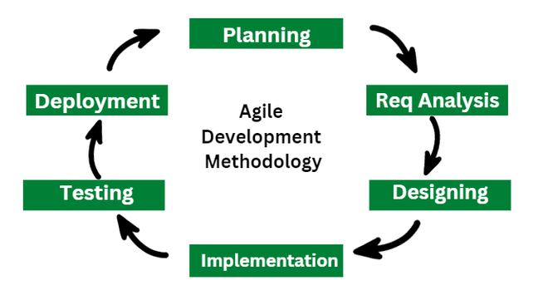
Figure 1.1 Agile Process Model

1.5 Feasibility Study
This study evaluates whether the system can be developed efficiently within the available resources and organizational environment.

1.5.1 Technical Feasibility
The project is technically feasible as it utilizes the modern and mature Laravel/React stack. (Otwell, 2023) Laravel provides strong security features like CSRF protection and Bcrypt hashing, while MySQL ensures reliable relational data management.

1.5.2 Economic Feasibility
MessManager is economically feasible because it utilizes open-source technologies (PHP, Laravel, React, MySQL), significantly reducing software licensing costs. By automating billing and expenses, it reduces human error and administrative overhead.

1.5.3 Operational Feasibility
The system is designed with a user-centric approach, providing distinct and intuitive dashboards for different roles. It aligns with real-world mess operations, making it easy for members and managers to adopt without extensive training.

1.6 Structure of the Report
The report is structured into ten chapters, beginning with this introduction, followed by chapters that delve into the Organizational Overview, Requirement Engineering, System Analysis, Risk Management, Project Scheduling, System Design, Testing, Ethical Considerations, and a final Conclusion.

Chapter 2.

Organizational Overview

2.1 Organization Profile
CODETREE is a software and IT solutions company based in Bangladesh that has been in business since 2017. It has offices in Dhaka and Ontario, Canada. The company focuses on providing a variety of digital services, such as creating custom software, designing websites and web apps, developing mobile apps, graphic design, image post-production, digital marketing, and bulk SMS services. CODETREE also makes specialized systems like school and college management solutions, inventory and POS systems, and platforms for managing donations. The company is known for making solutions that are easy to use, efficient, and customizable. It stresses clean coding, responsive designs, and quick delivery, and it also makes sure that customers can get help 24/7. Over the years, CODETREE has earned the trust of its clients by providing innovative, dependable, and affordable digital solutions, working with industry leaders like SSLCOMMERZ, and serving as an official IT partner for a number of local and international events.



Figure 2.1: Organization’s Logo

2.2 Organization Vision
Vision: “We code better life.” This concise, aspirational statement reflects CODETREE’s commitment to enhancing everyday experiences through smart, efficient, and life-enriching digital solutions.

2.3 Organization Mission
CODETREE is driven by a bold mission: to unite the diverse expertise of designers, developers, and entrepreneurs under one roof—one “tree”—to deliver the best-quality digital outcomes tailored to client needs.

2.4 Organization Services
CODETREE offers a comprehensive suite of services, catering to a wide range of digital and technological needs. Key services include:
- Web Development & Design: Creating dynamic, responsive websites.
- App Development: Building custom mobile applications.
- Graphic Design: Crafting visual identities and marketing materials.
- Digital Marketing: Implementing online advertising and promotion strategies.
- Bulk SMS Services: Mass messaging for customer outreach.
- Cloud Hosting: Reliable infrastructure for hosting client solutions.
Additionally, they provide specialized software solutions such as:
- Point-of-Sale (POS) & Inventory Management.
- School & College Management Systems.
- Donation Management Platforms.

2.5 Organizational Structure
The company follows a hierarchical model that facilitates collaboration between design, development, and management teams.

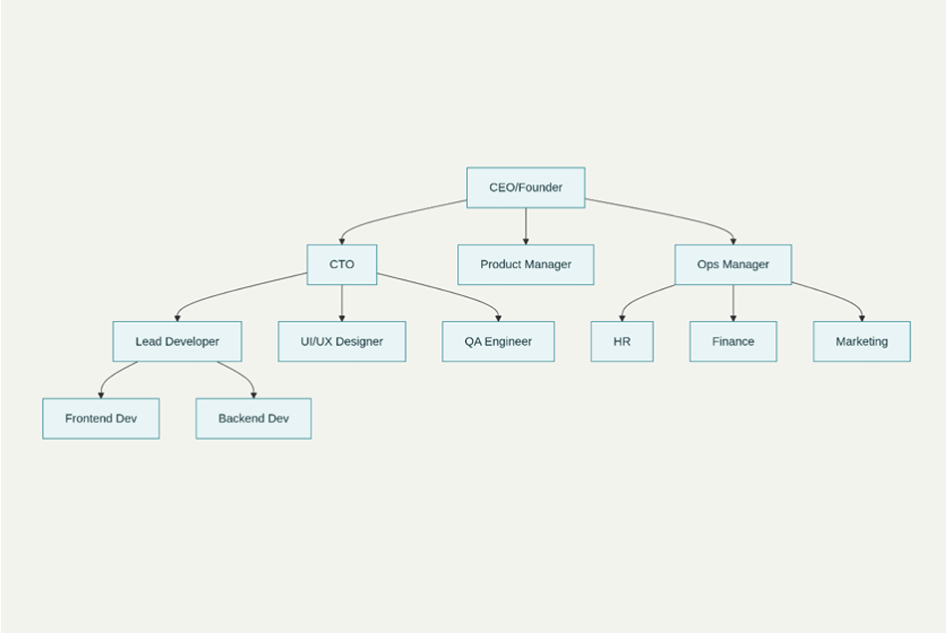

Figure 2.2: ‘CODETREE’ Company Structure

2.6 My Position in this Organization
During my practicum at CODETREE, I served in the “TRAINEE IT EXECUTIVE PROGRAM”. My primary responsibilities included assisting in the design and development of the MessManager system for CODETREE, implementing both frontend and backend features, testing system functionalities, and collaborating with the design and development teams to ensure quality and timely delivery.

2.7 Address of the Organization
CODETREE: House 73/F, Road 12/B, Sector 10, Uttara, Dhaka 1230, Bangladesh.
Contact Information:
- Phone: 01710070606.
- Email: codetreebd@gmail.com.
- Working Hours: 09:00 AM – 06:00 PM.
- https://www.google.com/maps/place/CODETREE/

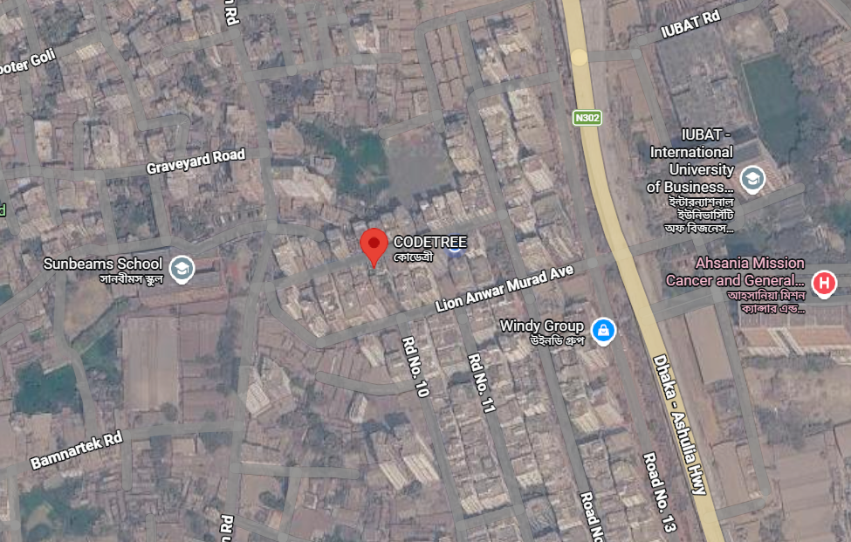

Figure 2.3: Organizational Location Map

Chapter 3.

Requirement Engineering

Requirement Engineering is the disciplined application of proven principles, methods, and tools (Society, 2014) to describe the behavior of the MessManager system and its associated constraints. This phase focused on understanding the actual needs of the stakeholders—specifically the Super Admin, Mess Manager, and members—to ensure the final product effectively solves their operational challenges regarding meal tracking and billing.

3.1 Requirement Elicitation & Analysis
This step involved gathering raw requirements from various sources to understand the functional depth of the system. The methods utilized included:
- Stakeholder Analysis: Identifying the key users—Super Admin, Manager, and Members—and understanding their specific privileges and workflows within the mess ecosystem.
- Observation: Observing manual processes currently used in messes, such as paper-based "Bazaar" lists and manual meal registers, to identify bottlenecks and calculation errors.
- Conflict Resolution: Potential conflicts, such as the need for detailed financial data vs. member privacy, were resolved by designing a robust role-based access control (RBAC) system.

3.2 Functional Requirements (FR)
These requirements define the specific functions and interactions within the system for different user roles.
Table 3.1 Functional Requirements
FR ID | Role | Description | Acceptance Criteria
FR-01 | Public | Mess Creation Request | Manager can submit a request with mess name and email.
FR-02 | Super Admin | Request Approval | Super Admin can approve or reject pending mess requests.
FR-03 | Manager | Member Management | Manager can add, update, or delete mess members.
FR-04 | User | Meal Entry | Members can log Lunch, Dinner, or "Off" status for specific dates.
FR-05 | Manager | Expense Tracking | Manager logs bazaar and other costs; titles labeled "Bazaar" impact meal rate.
FR-06 | Manager | Fixed Cost Setup | Manager enters monthly rent, utilities, and WiFi costs to be split equally.
FR-07 | User | Deposit Request | Members submit deposit requests which remain pending until approved.
FR-08 | System | Billing Summary | System generates a monthly summary showing total bill, paid, and due.

3.3 Non-Functional Requirements
These requirements define the quality attributes and performance constraints of the system.
- Security: Passwords must be hashed using Bcrypt before storage, and critical routes must be protected by Laravel Sanctum middleware. (Otwell, 2023)
- Data Integrity: The database must ensure referential integrity; for example, an expense cannot exist without a valid Mess ID.
- Performance: The system should load dashboards within 2-3 seconds under normal network conditions.
- Responsiveness: The interface must be responsive, adapting its layout for desktops and mobile devices used by members on the go.
- Availability: The application must be available 24/7 to allow members to update meal statuses at their convenience.

3.4 Use Case Diagram
The Use Case Diagram illustrates the interactions between the primary actors and the core functionalities of the MessManager system.
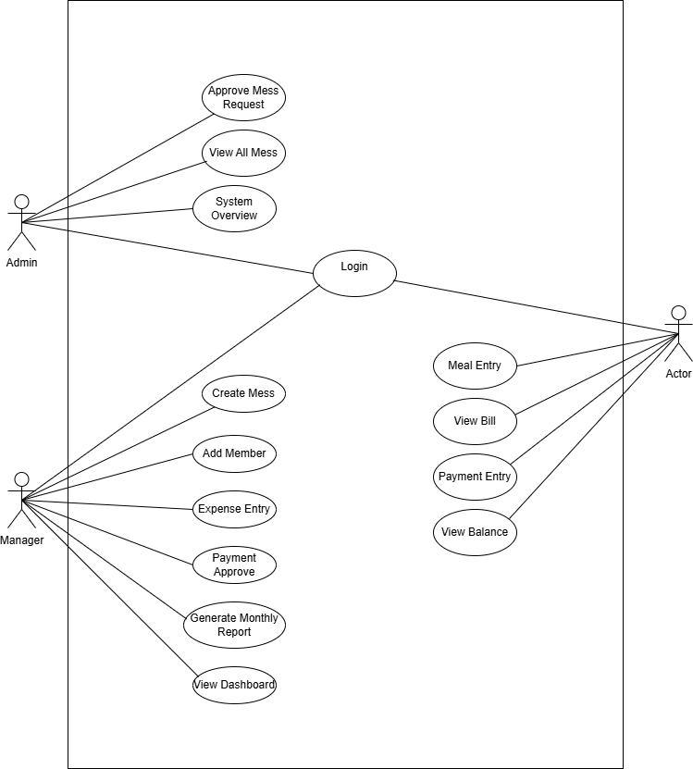
Figure 3.1: Use Case Diagram for MessManager

Chapter 4.

System Analysis

System analysis involves the creation of behavioural and structural models to represent the logic and data flow within the MessManager application. This chapter utilizes UML (Unified Modeling Language) diagrams and CRC cards to define how the system processes meal data, manages financial transactions, and organizes its internal object structure.

4.1 Activity Diagrams
Activity diagrams represent the operational workflows of the system, illustrating the transfer of control from the user to the system through sequential phases.

4.1.1: Admin Activity Diagram
This flow describes how a member updates their daily meal status:
- Member selects a date from the calendar.
- Member chooses status: Lunch, Dinner, or Off.
- System validates if the date is within the current month.
- System updates the meal quantity (Quantity is 0 if the status is Off).
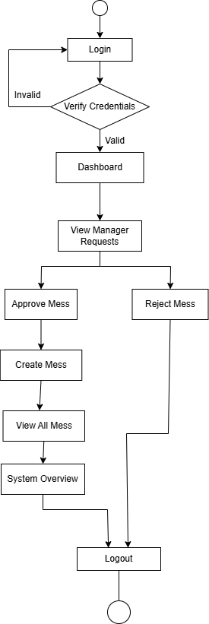

Figure 4.1.1: Activity Diagram for Admin

4.1.2: Manager Activity Diagram
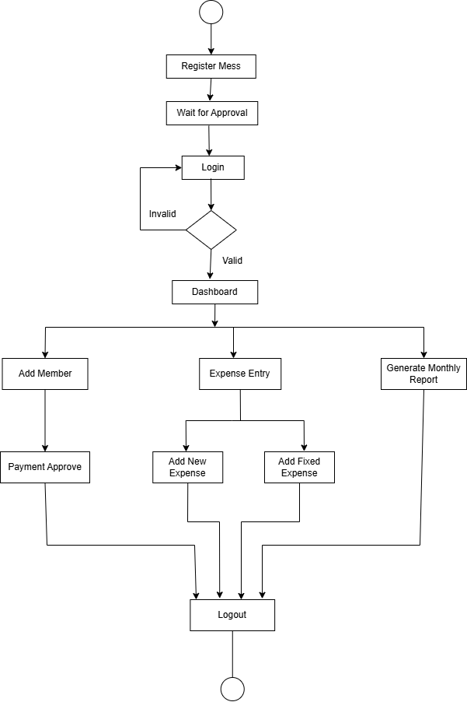
Figure 4.1.1: Activity Diagram for Admin

4.1.3: User Activity Diagram
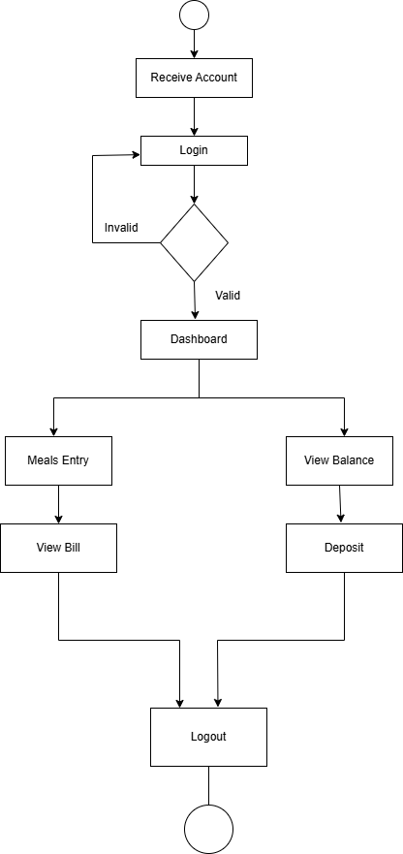
Figure 4.1.1: Activity Diagram for User

4.2 Swimlane Diagram
Swimlane diagrams visualize role-based tasks, showing the coordinated responsibilities of different actors and the system.

4.2.1 Deposit Approval Flow
This diagram shows the interaction between the User (Member), the Manager, and the System for financial deposits:
- User Lane: Submits a deposit request with the amount.
- System Lane: Stores the request as Pending and notifies the Manager.
- Manager Lane: Reviews the request and clicks "Approve".
- System Lane: Creates a transaction record and updates the user’s running balance.

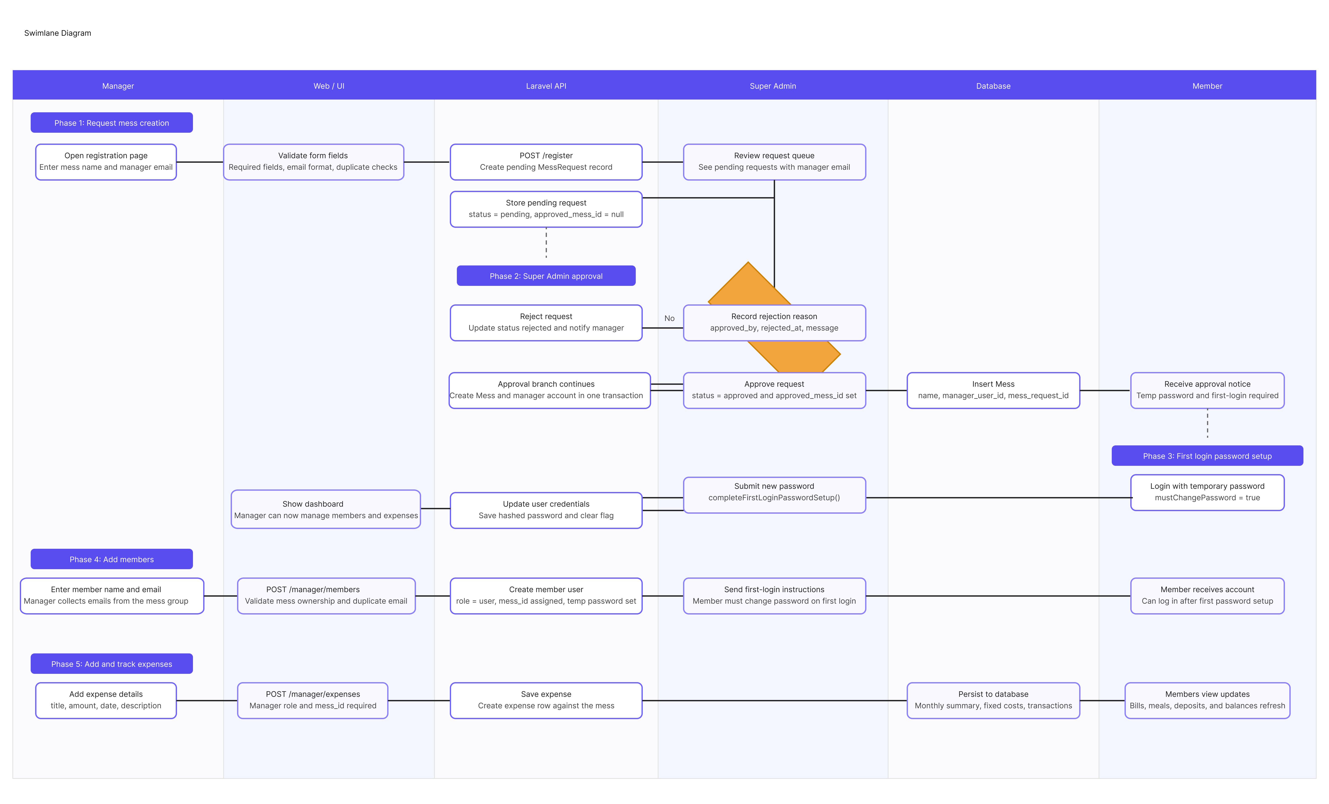
Figure 4.2: Deposit Approval Swimlane Diagram

4.3 Class Diagram
The Class Diagram provides a structural view of the system, detailing the attributes and associations between core entities. (Corporation, 2023)

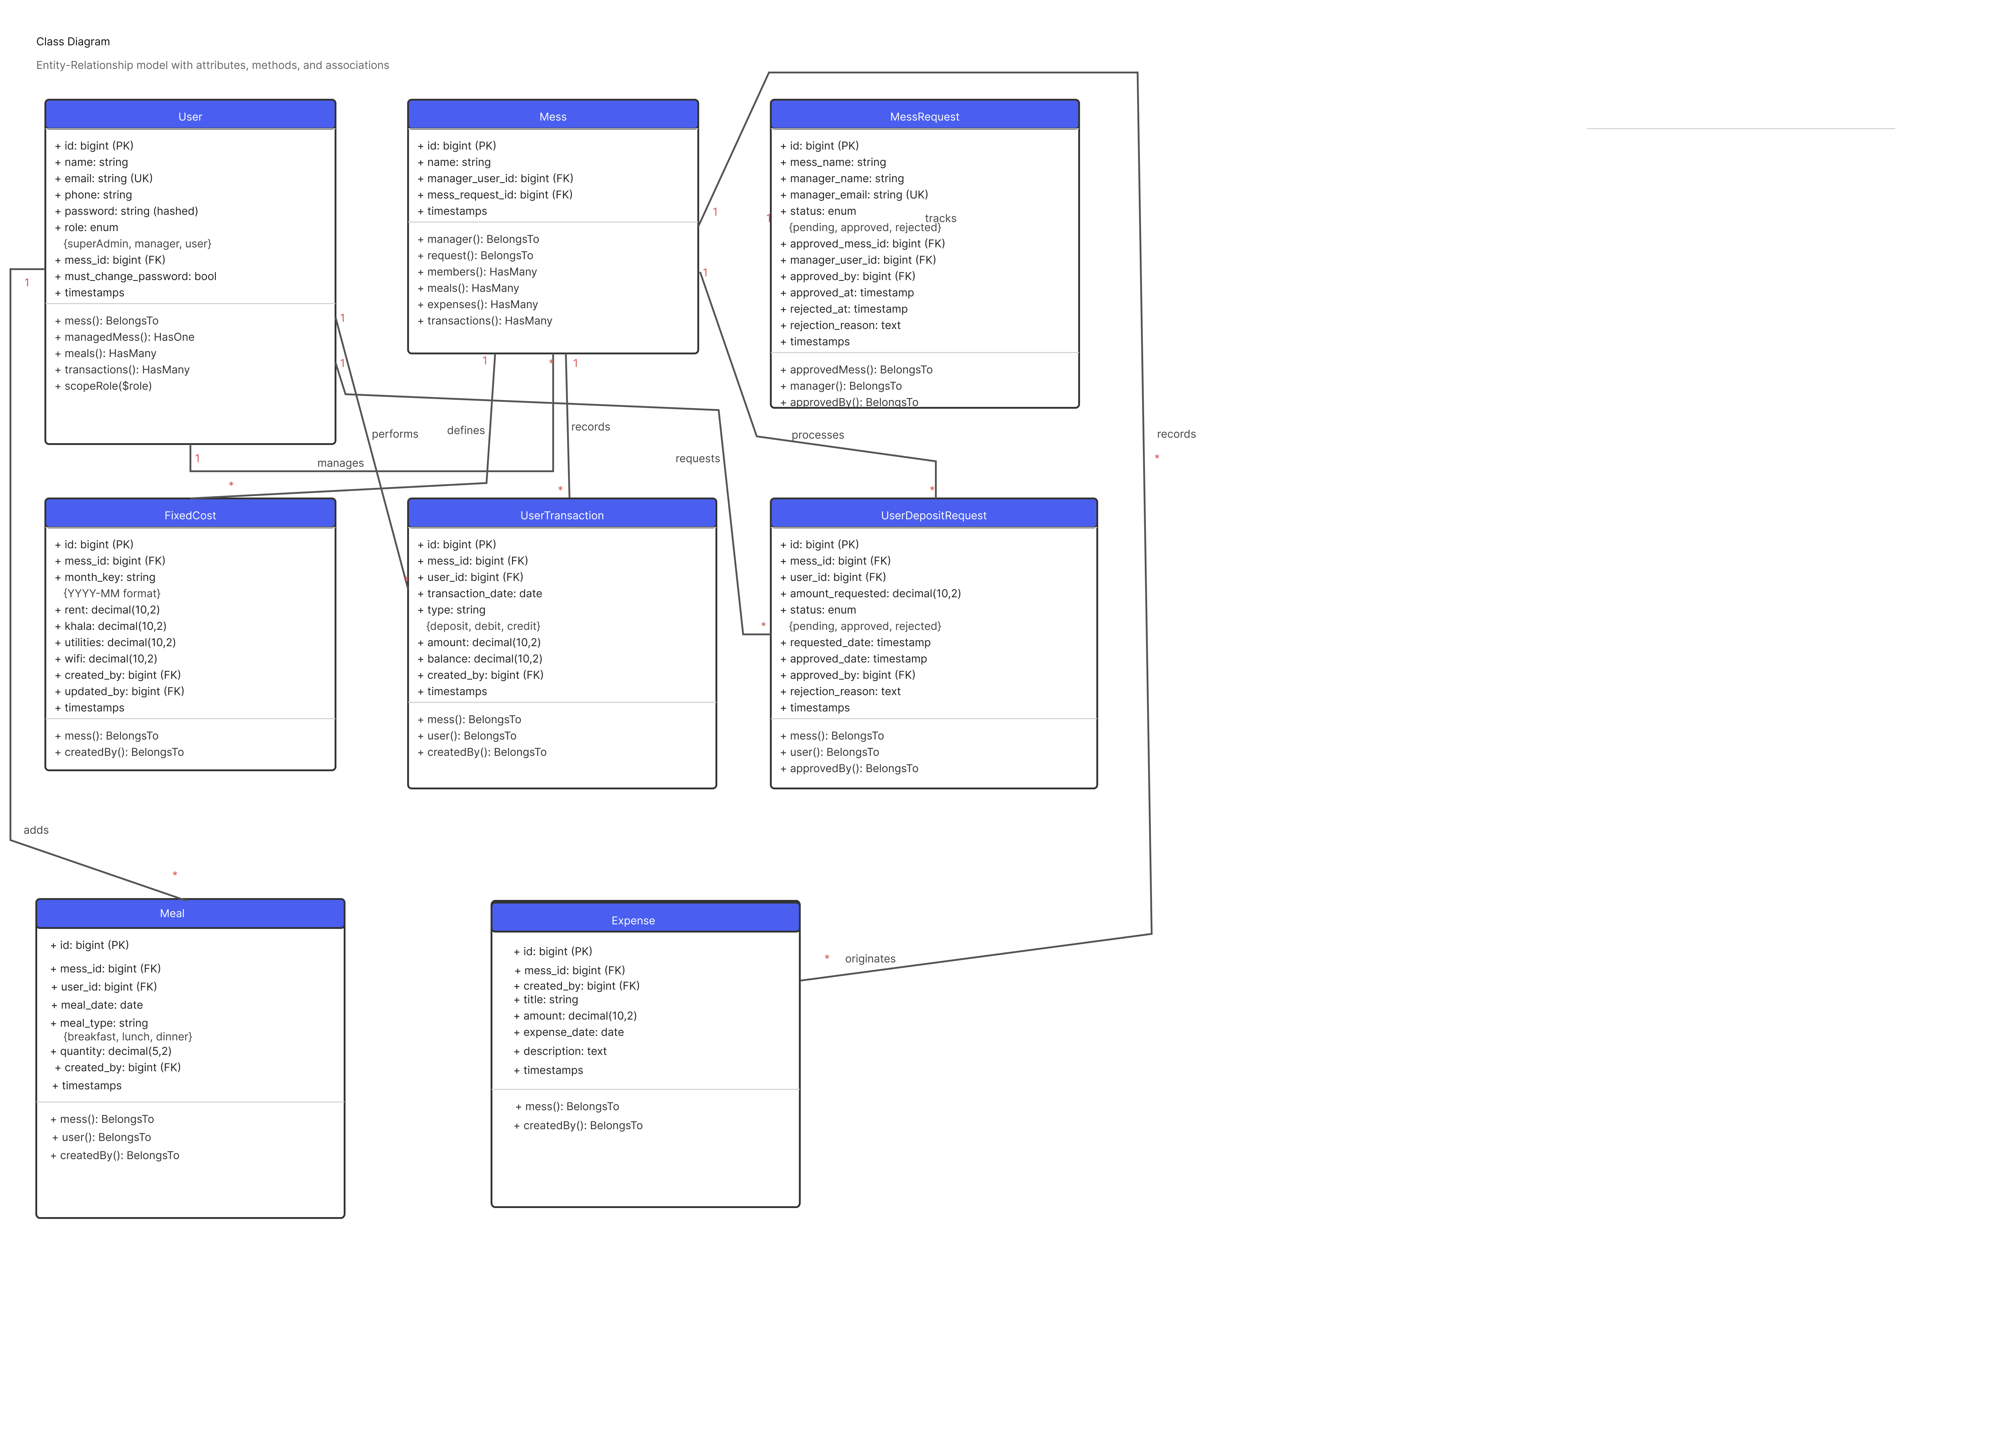
Figure 4.3: MessManager Class Diagram

4.4 Sequence Diagram
Sequence diagrams detail the logic behind complex system processes over a timeline.

4.4.1 Monthly Billing Calculation
This sequence tracks how the system computes a member's final bill:
- Manager adds bazaar expenses for the month.
- Manager adds fixed costs (Rent, WiFi, etc.).
- System sums all bazaar costs and divides by total meals to get the Meal Rate.
- System calculates the Fixed Share by dividing total fixed costs by member count.
- System generates the Total Bill for each user: (\text{User Meals} \times \text{Rate}) + \text{Fixed Share}.
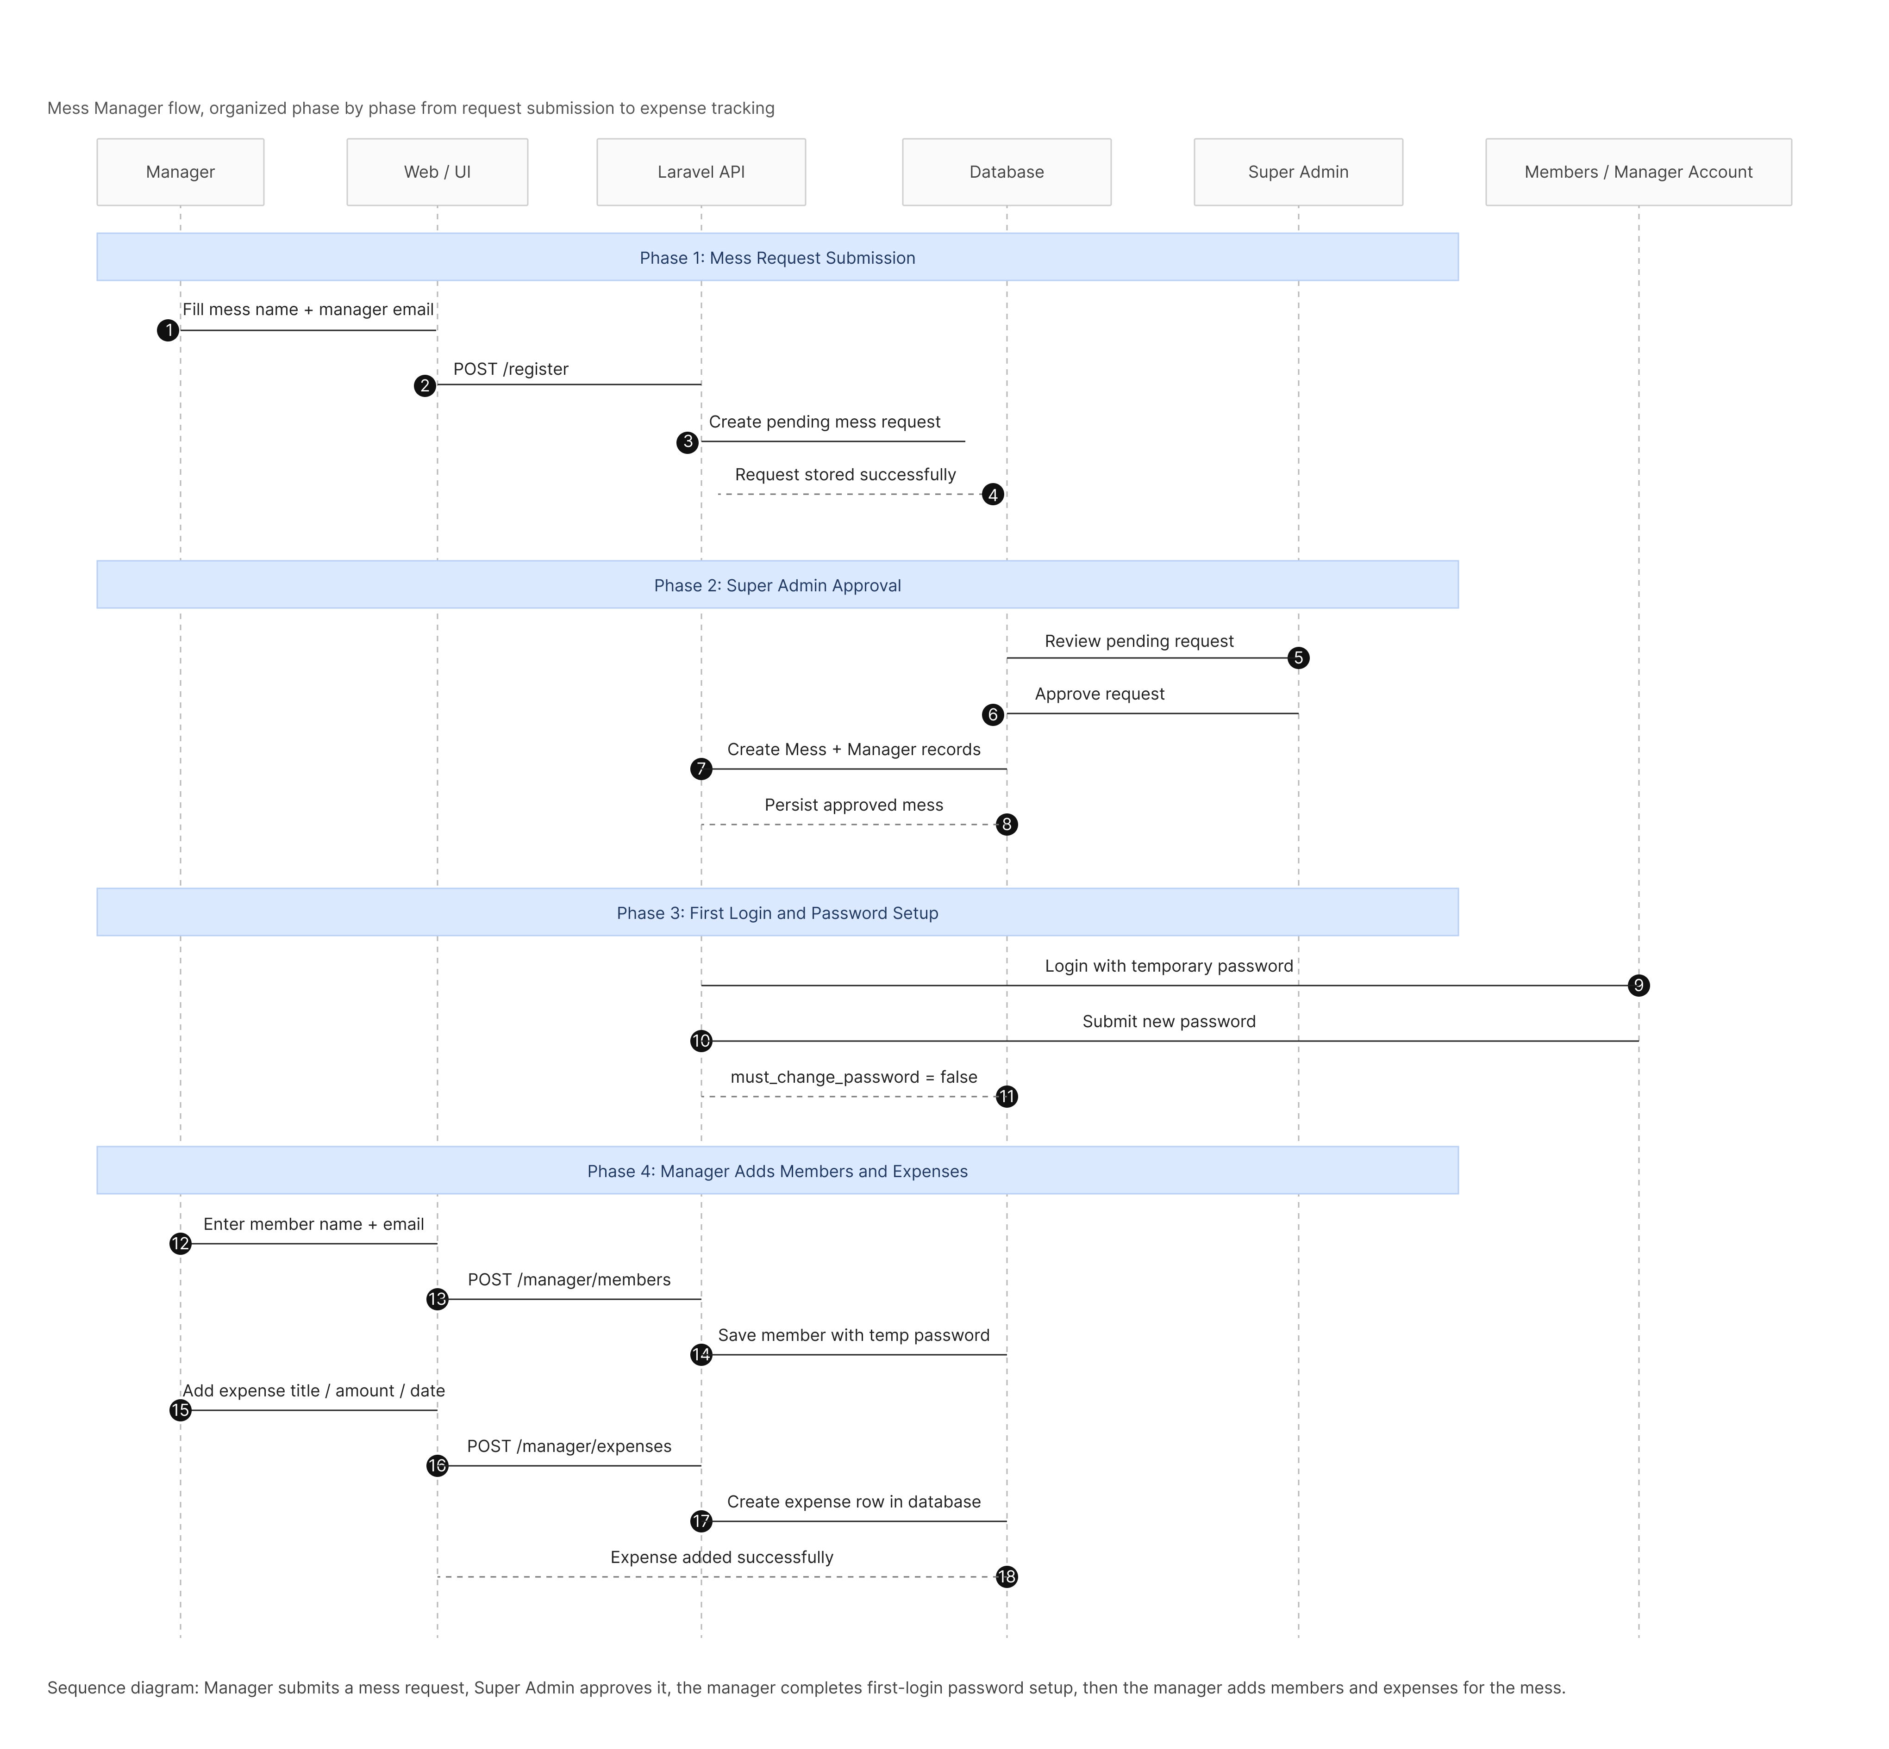

Figure 4.4: Billing Calculation Sequence Diagram

4.5 CRC Cards
CRC (Class-Responsibility-Collaborator) cards identify the specific duties of core classes and how they interact.
Table 4.1 CRC of User
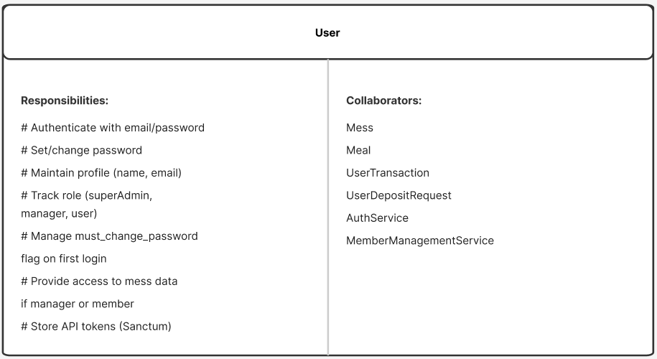
Table 4.2 CRC of Mess
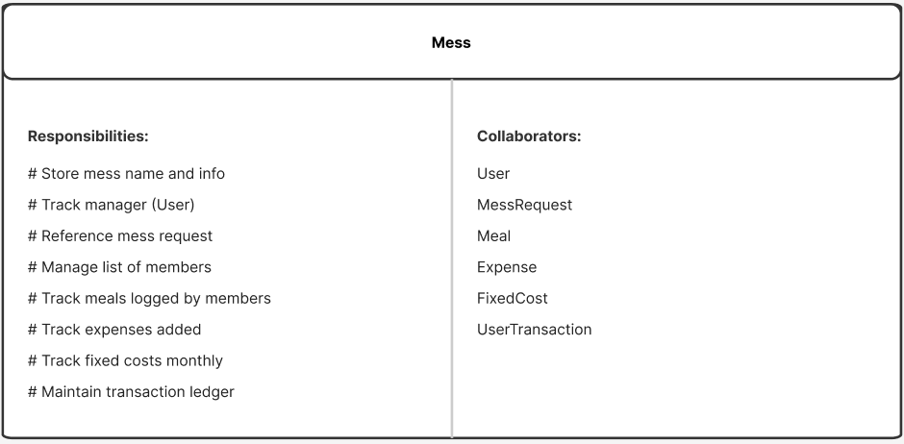

Table 4.3 CRC of MessRequest
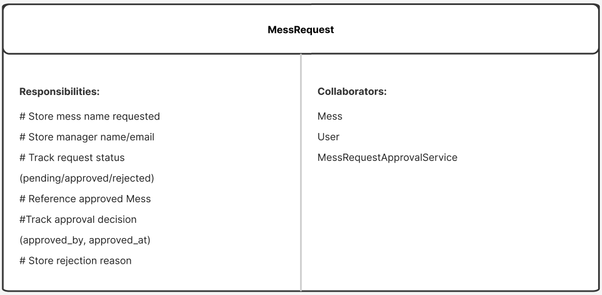

Table 4.4 CRC of Meal
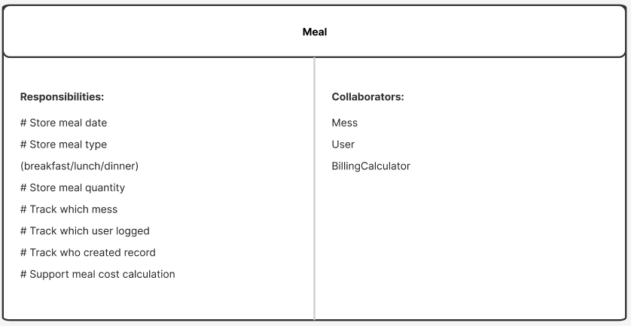

Table 4.5 CRC of Expense
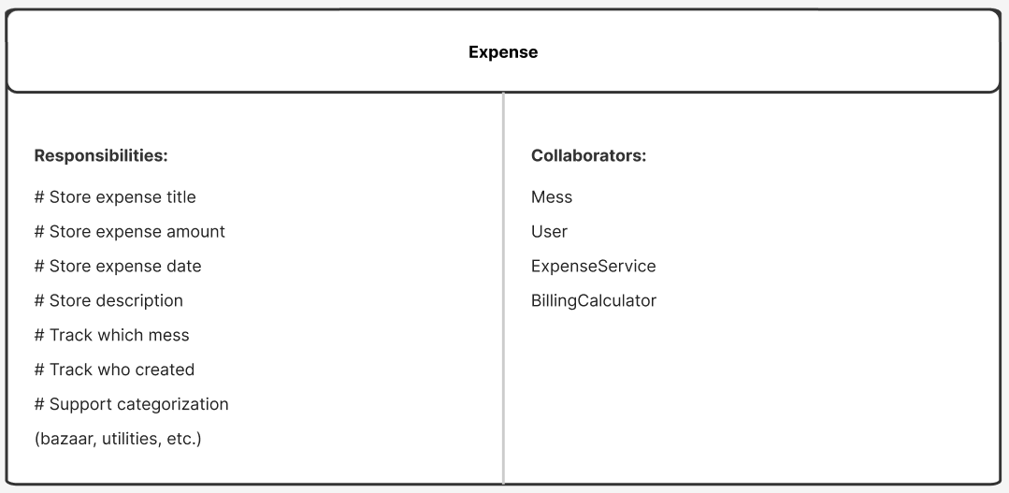

Table 4.6 CRC of FixedCost
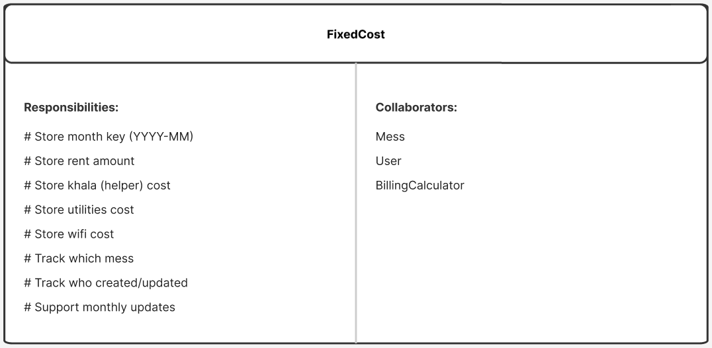

Table 4.7 CRC of UserTransaction
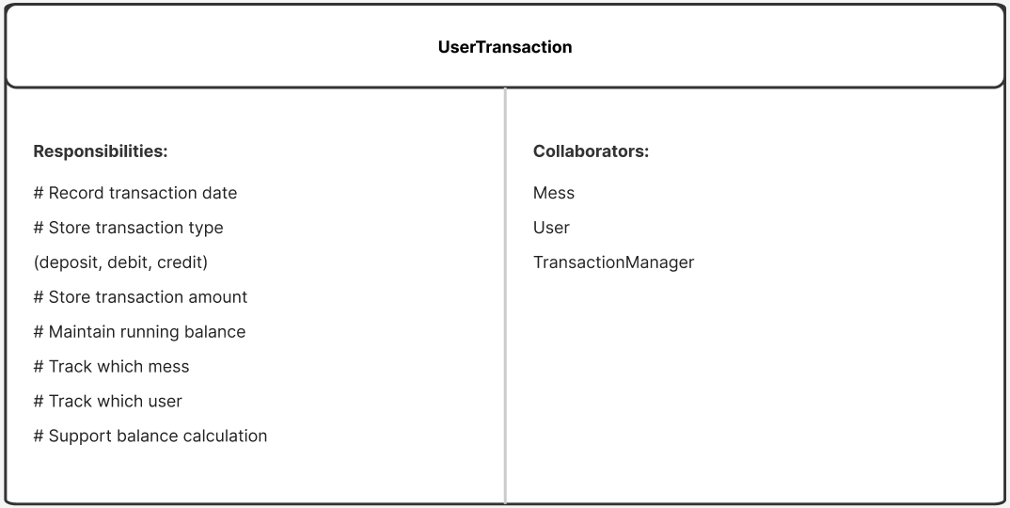

Table 4.8 CRC of UserDepositRequest
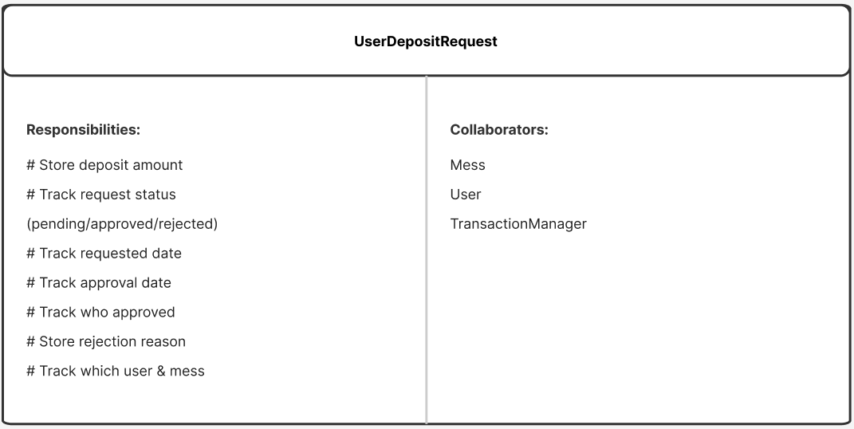

Table 4.9 CRC of AuthService
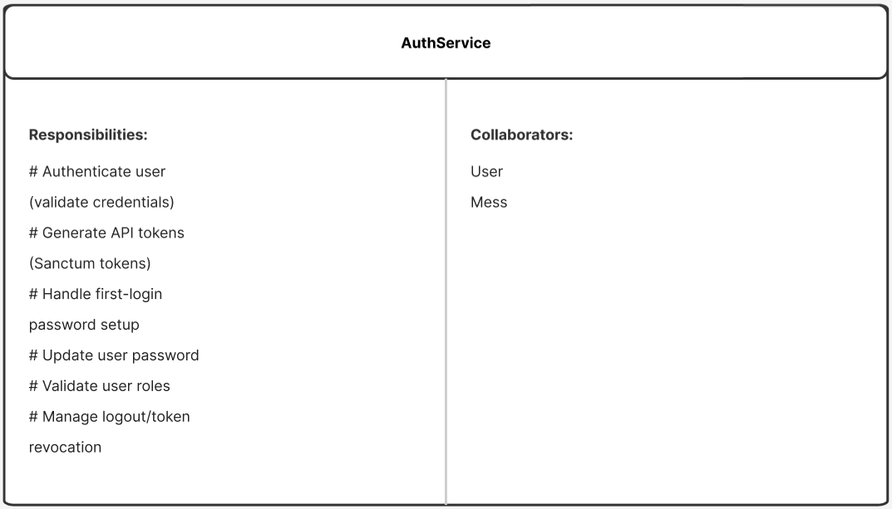

Table 4.10 CRC of MemberManagementService
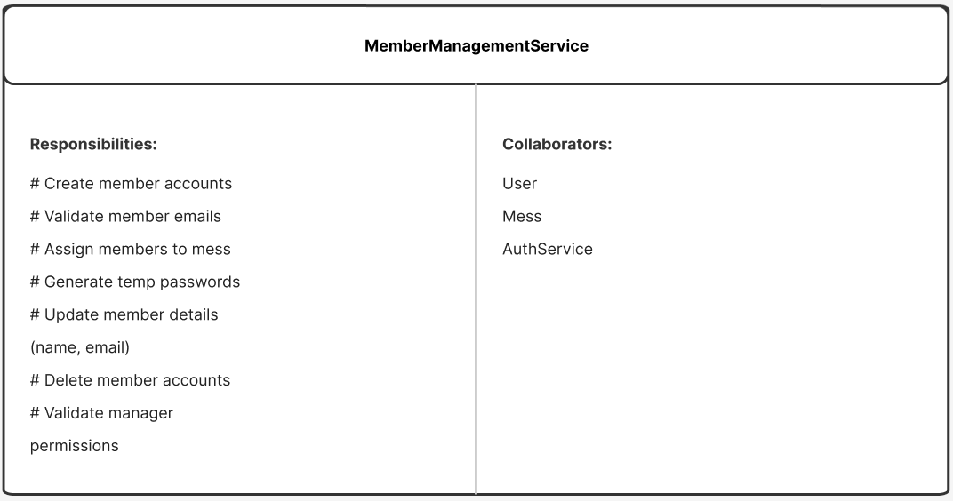

Table 4.11 CRC of BillingCalculator
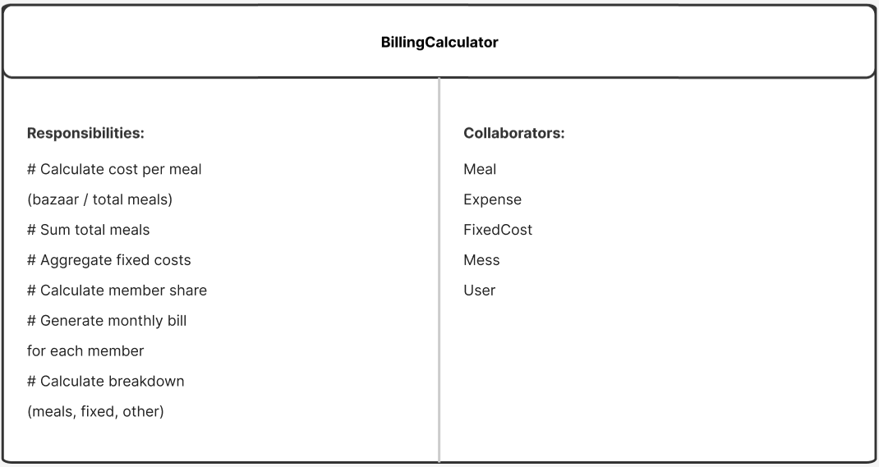

Table 4.12 CRC of BillingCalculator
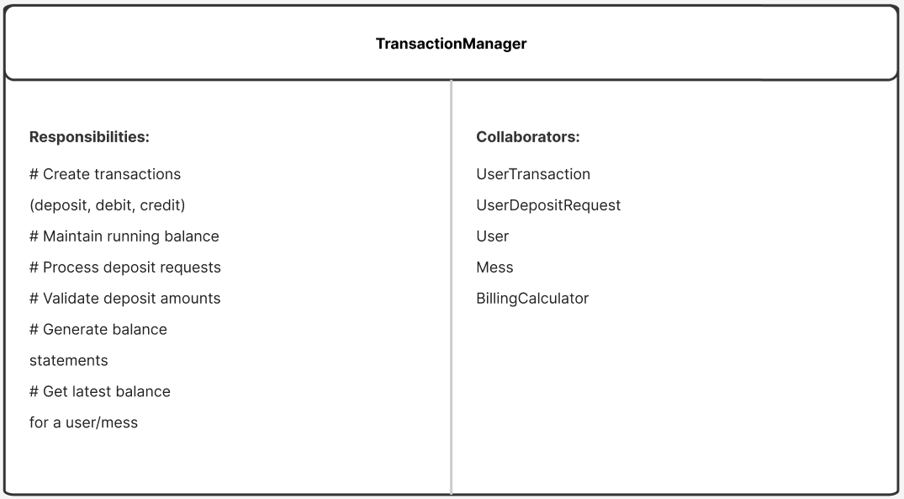

Chapter 5.

Risk Management

Risk management is a critical process for identifying, analyzing, and addressing potential issues that could negatively impact the success of the MessManager project. By planning for risks early, the development team can minimize disruptions and ensure the system remains efficient and reliable.

5.1 Risk Identification
The following table outlines the potential risks categorized by their nature within the MessManager ecosystem.
Table 5.1 Risk Identification
Risk Type | Possible Risk
Technical | System crashes, Laravel/PHP framework issues, or MySQL database downtime.
Security | Data breaches, unauthorized access to member financial records, or token leakage.
Operational | Low user adoption, data entry errors by managers, or calculation discrepancies.
Financial | Failures in deposit tracking or future payment gateway integrations.
Performance | Slow response times during peak hours when all members log meals simultaneously.

5.2 Risk Analysis
Each identified risk is evaluated based on its probability of occurrence and its potential impact on the project.
Table 5.1 Risk Analysis
Possible Risk | Probability | Impact
System Downtime | 30-40% (Moderate) | Serious
Data Breaches | 20-30% (Moderate) | Catastrophic
Unauthorized Edits | 20-30% (Moderate) | Serious
Low User Adoption | 30-40% (Moderate) | Tolerable

5.3 Risk Prioritization
Prioritization focuses on risks with high impact and moderate-to-high probability. For MessManager, Data Security and System Availability are the top priorities to ensure that sensitive meal and financial data remain protected and accessible 24/7.

5.4 RMMM Plan
The Risk Mitigation, Management, and Monitoring (RMMM) plan outlines the specific actions taken to handle the primary technical and security risks.

5.4.1 RMMM for Technical Risks (System Stability)
- Risk Name: System crashes or server downtime.
- Mitigation: Use of reliable cloud hosting and automated database backups to prevent data loss.
- Monitoring: Implement real-time monitoring tools to alert the developer of any service interruptions.
- Management: The developer will respond to alerts immediately and restore services using the latest backup if a crash occurs.

5.4.2 RMMM for Security Risks (Data Protection)
- Risk Name: Unauthorized access or data breaches.
- Mitigation: Use of Bcrypt for password hashing and Laravel Sanctum for secure, token-based authentication. (Group, 2021)
- Monitoring: Reviewing activity logs and login logs to detect suspicious patterns or unauthorized attempts to access manager routes.
- Management: If a breach is detected, the affected tokens will be revoked, and security patches will be applied to the middleware.

5.5 Monitoring & Review Plan
Risk management is an iterative process. The RMMM plan will be reviewed at the end of each development sprint to identify new risks—such as those arising from the future integration of OCR receipt scanning—and to ensure that current mitigation strategies remain effective.

Chapter 6.

Project Planning & Scheduling

Project planning and scheduling are essential to the management of software development operations. For MessManager, this phase involved establishing the project's objectives, resources, and timeline to ensure a functional product is delivered within the allotted three-month practicum period.

6.1 Function Point Estimation
Function Point Analysis (FPA) is a standardized method for measuring the functional size of software applications. For the MessManager system, we calculate the function points to estimate the project size and effort.

6.1.1 Functionality, Input, Output
The table below shows the core functionality, inputs, and outputs of the MessManager system.
Table 6.1 Functionality, Input, Output
Functionality | Input | Output
Mess Registration | messName, managerEmail, managerName | Pending mess request created
User Authentication | email, password | Login successful, dashboard redirect
Member Management | name, email, temporaryPassword | User account created
Meal Entry | date, mealType (Lunch/Dinner/Off) | Daily meal logged
Expense Entry | title, amount, date | Expense added (Bazaar/Other)
Fixed Cost Entry | rent, utilities, wifi, monthKey | Monthly fixed costs stored
Deposit Request | amount, paymentMethod | Pending deposit submitted
Bill Summary | monthKey | Total bill, paid, and due summary

6.1.2 Identify Complexity
Complexity is determined by identifying Data Element Types (DET) and Record Element Types (RET) for Data Functions, and File Types Referenced (FTR) for Transaction Functions.
Table 6.2: Identify Complexity of Data Function
Function Name | Types | DET | RET | Complexity
Users | ILF | 12 | 1 | Low
Meals | ILF | 12 | 1 | Low
Expenses | ILF | 10 | 1 | Low
Fixed Costs | ILF | 9 | 1 | Low
Transactions | ILF | 10 | 1 | Low
Mess Requests | ILF | 8 | 1 | Low

Table 6.3: Identify Complexity of Transaction Function
Function Name | Type | DET | FTR | Complexity
Mess Registration | EI | 5 | 1 | Low
User Authentication | EI | 2 | 2 | Low
Meal Entry | EI | 8 | 3 | Average
Expense Entry | EI | 6 | 2 | Average
Fixed Cost Entry | EI | 5 | 2 | Average
Deposit Request | EI | 5 | 2 | Average
Bill Summary | EQ | 4 | 2 | Low

6.1.3 Unadjusted Function Point Contribution
The Unadjusted Function Points (UFP) are calculated by applying standard weights to the identified functions.
Table 6.4: UFP of Transaction Function
Function Name | Type | DET | FTR | Complexity | UFP
Mess Registration | EI | 5 | 1 | Low | 3
User Authentication | EI | 2 | 2 | Low | 3
Meal Entry | EI | 8 | 3 | Average | 4
Expense Entry | EI | 6 | 2 | Average | 4
Fixed Cost Entry | EI | 5 | 2 | Average | 4
Deposit Request | EI | 5 | 2 | Average | 4
Bill Summary | EQ | 4 | 2 | Low | 3
Total UFP (Transaction) |  |  |  |  | 25

Table 6.5: UFP of Data Function
Function Name | Type | DET | RET | Complexity | UFP
Users | ILF | 12 | 1 | Low | 7
Meals | ILF | 12 | 1 | Low | 7
Expenses | ILF | 10 | 1 | Low | 7
Fixed Costs | ILF | 9 | 1 | Low | 7
Transactions | ILF | 10 | 1 | Low | 7
Total UFP (Data) |  |  |  |  | 35

6.1.4 Calculation of Total Degree of Influence (TDI)
The degree of influence is calculated based on 14 general system characteristics.
Table 6.6: UFP of Data Function
SI | Characteristic | DI | SI | Characteristic | DI
01 | Data Communication | 5 | 08 | Online Update | 5
02 | Distributed Data Processing | 3 | 09 | Complex Processing | 4
03 | Performance | 4 | 10 | Reusability | 3
04 | Heavily Used Configuration | 4 | 11 | Installation Ease | 3
05 | Transaction Rate | 4 | 12 | Operational Ease | 4
06 | Online Data Entry | 5 | 13 | Multiple Sites | 2
07 | End-User Efficiency | 5 | 14 | Facilitate Change | 4
Total TDI |  |  |  |  | 55

6.1.5 Final Calculation
The Value Adjustment Factor (VAF) and Adjusted Function Point (AFP) are calculated as follows:
- VAF = 0.65 + (0.01 \times TDI)
- VAF = 0.65 + (0.01 \times 55) = 1.10
- Total UFP = UFP(Transaction) + UFP(Data) = 25 + 35 = 60
- AFP = UFP \times VAF = 60 \times 1.10 = 66
The final functional size of the MessManager system is 66 Adjusted Function Points.

6.2 Project Scheduling
The MessManager development was planned over a 12-week timeline (3 months) following the Agile methodology. The project is divided into six distinct phases to ensure iterative testing and quality assurance.

6.2.1 Gantt Chart Breakdown
The following 12-week schedule outlines the progression from requirements gathering to final deployment.

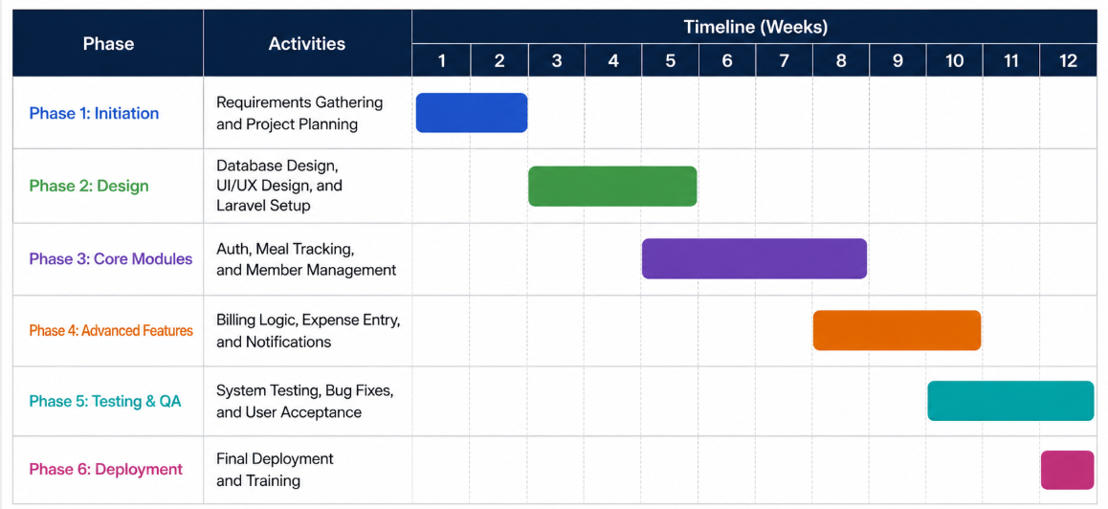
Figure 6.1: MessManager 12-Week Gantt Chart

6.3 Resource & Cost Estimate
The project utilized open-source technologies (Laravel, React, MySQL) which significantly reduced the financial burden. The primary resources included the development environment (VS Code, PHP 8.1+, Node.js) and the staging server for initial testing. This approach ensured that the project remained economically sustainable while meeting all functional objectives

Chapter 7.

System Design & Implementation

System design and implementation translate the logical requirements into a physical, functioning application. This chapter details the technical architecture, data structures, and interface components of the MessManager system, highlighting how the Laravel backend and React frontend interact to provide a seamless user experience.

7.1 System Architecture
The application follows a decoupled, layered architecture to ensure scalability and maintainability. It is built as a Single Page Application (SPA) that communicates with a RESTful API.
- Frontend Layer (React 19 + Vite): Handles the user interface, routing, and client-side state management using Redux Toolkit.
- API Layer (Laravel 10): Provides secure endpoints, business logic processing, and authentication via Laravel Sanctum.
- Database Layer (MySQL): Stores persistent data such as user profiles, meal records, and financial transactions.

7.2 Data Flow Diagrams (DFD)
Data Flow Diagrams illustrate how information moves through the system, from external inputs to database storage.

- Level 0 (Context Level): Shows the high-level interaction between actors (Manager, Member, Super Admin) and the MessManager system.

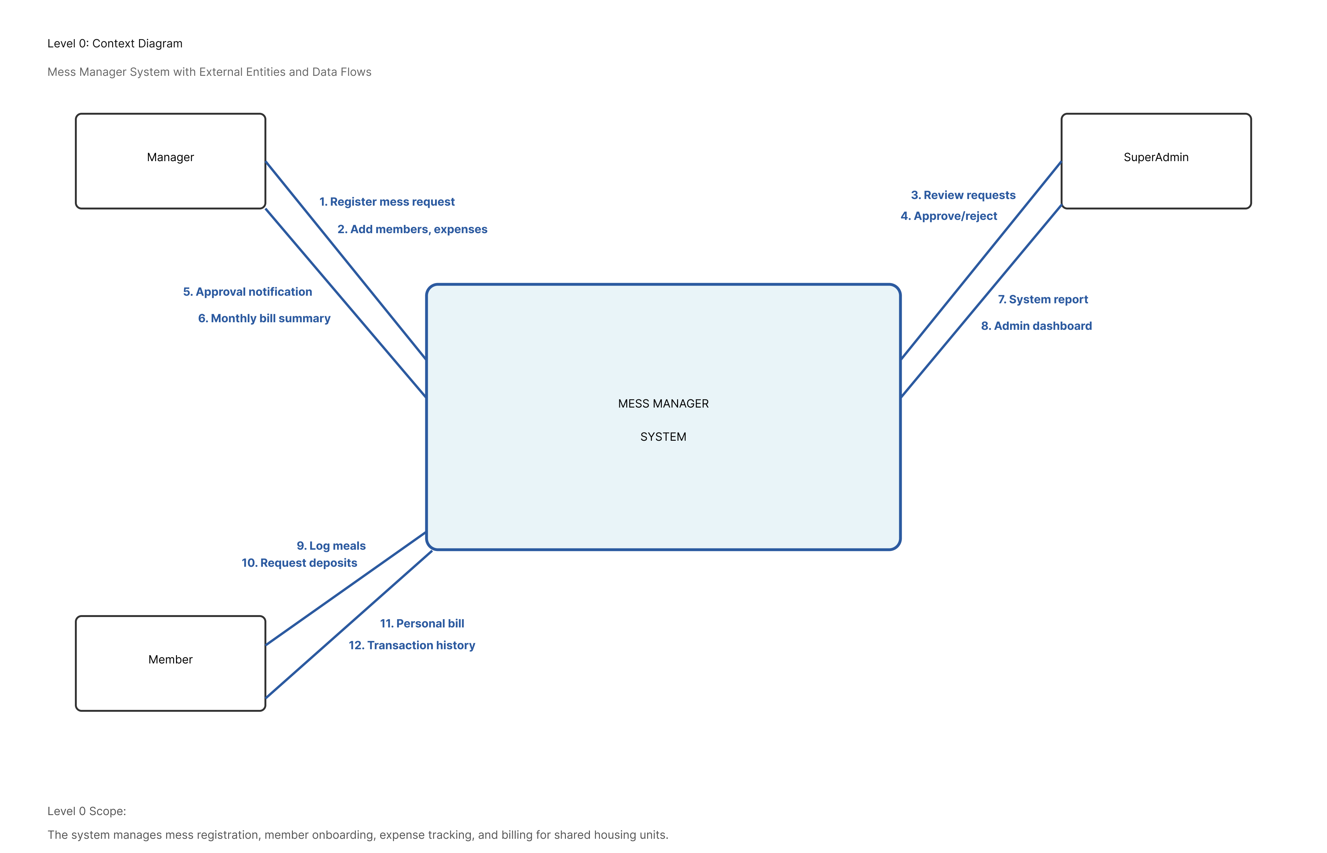
Figure 7.1 DFD Level 0

- Level 1 (Process Overview): Breaks down the system into core modules like Auth, Meal Management, and Billing.

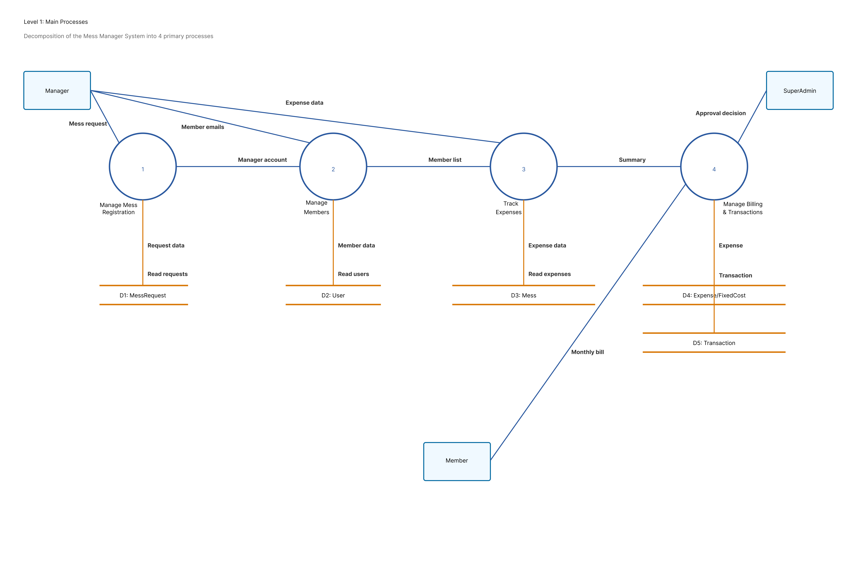
Figure 7.2 DFD Level 1

- Level 2 (Billing Sub-flow): Specifically details the transition from bazaar expense entry to the final per-user bill calculation.
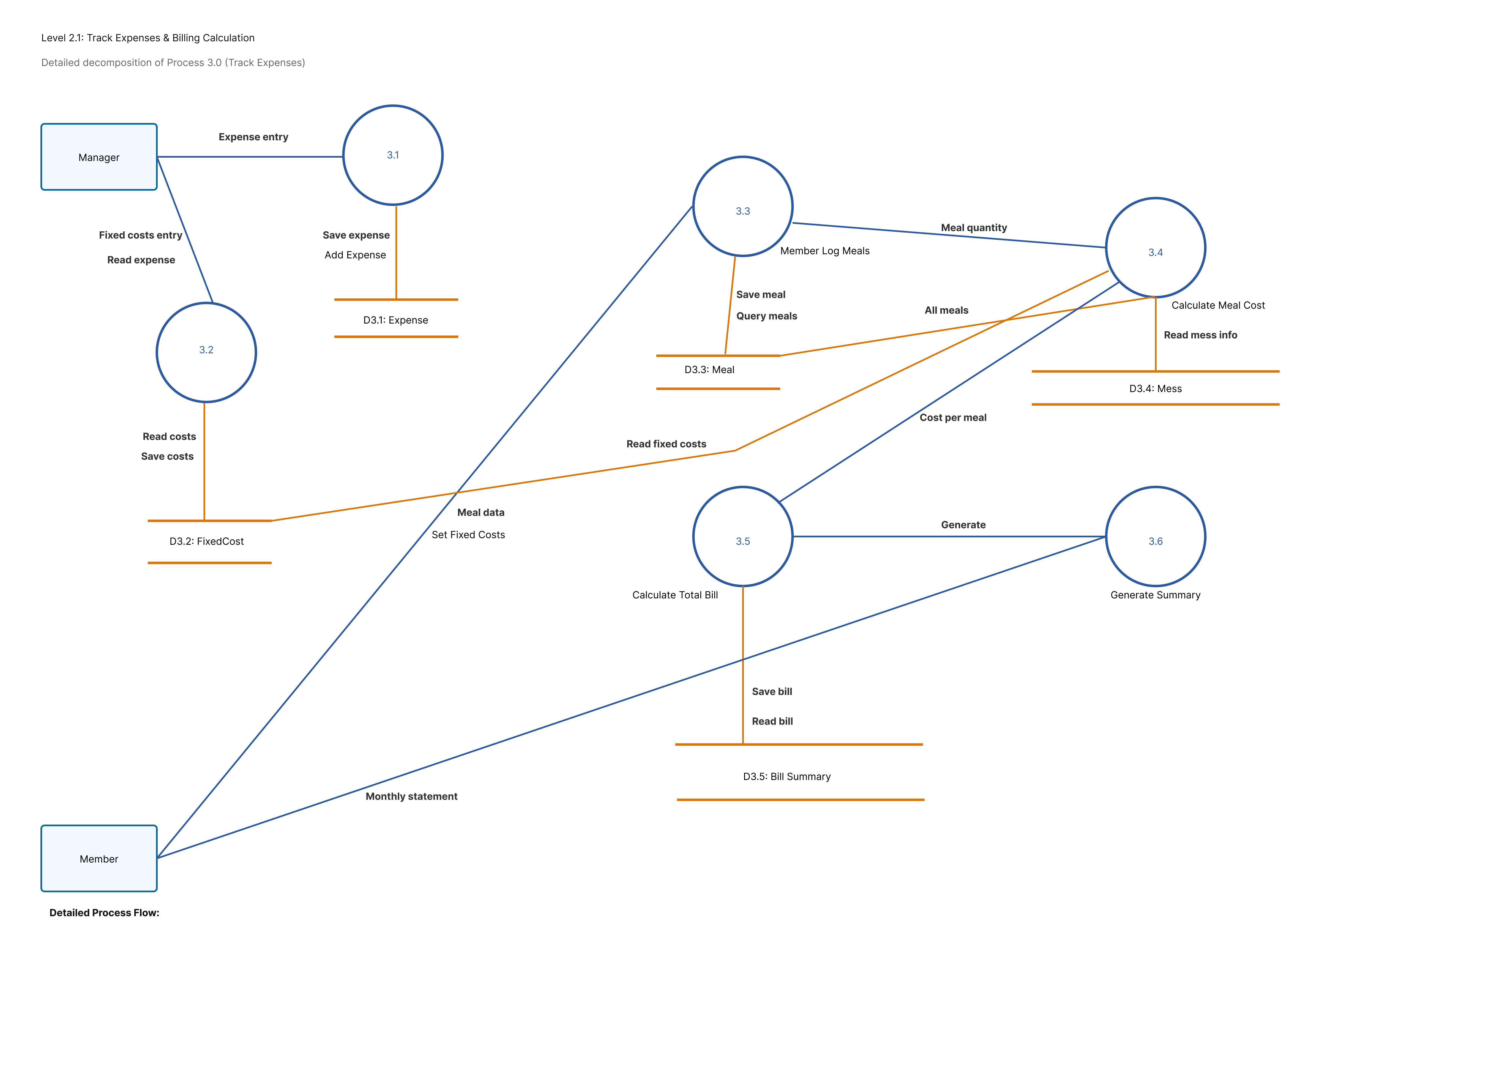
Figure 7.3 DFD Level 2 (1)

- Level 2 ( Transaction & Settilement ):
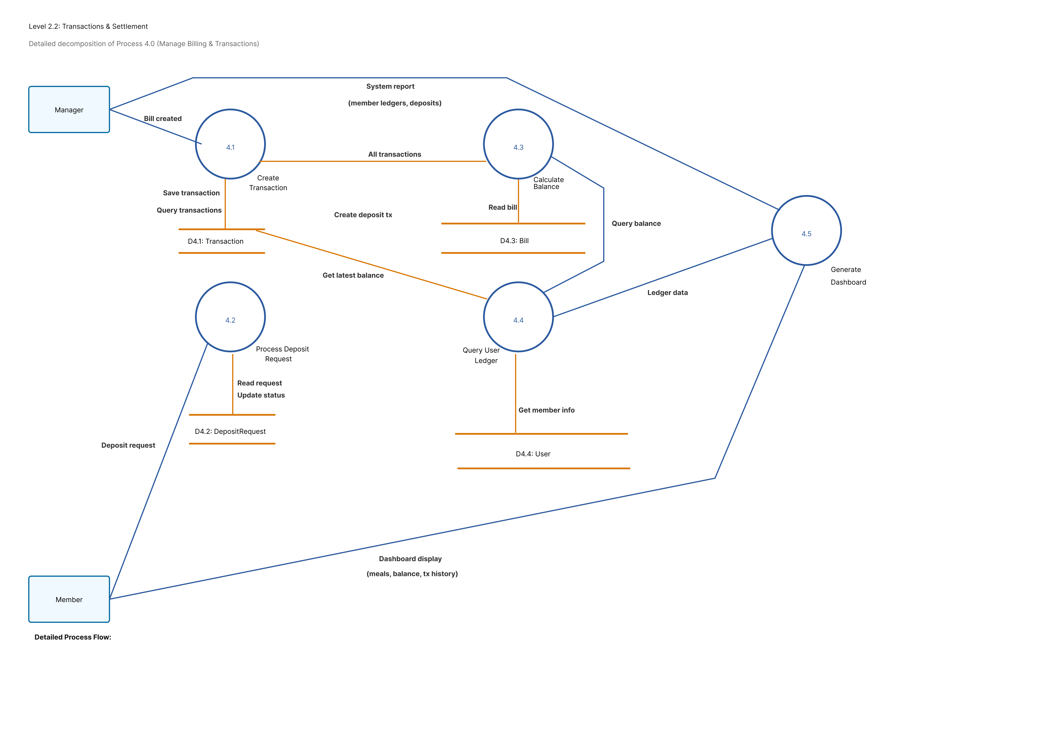
Figure 7.4 DFD Level 2 (2)

7.3 Entity Relationship Diagram (ERD)
The ERD defines the database schema and the relationships between tables. Key relationships include: (Corporation, 2023)
- One-to-Many: A Mess has many Users, Meals, and Expenses.
- One-to-One: Each User is associated with one primary Mess group and one specific Role.
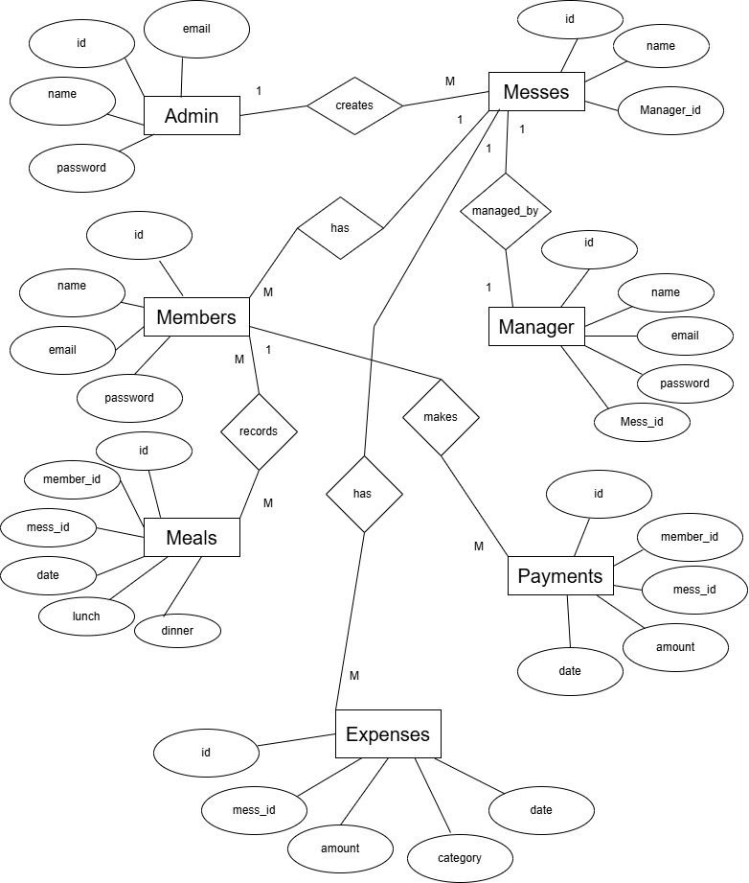

Figure 7.5 Entity Relationship Diagram

7.3.1 Database Field Design
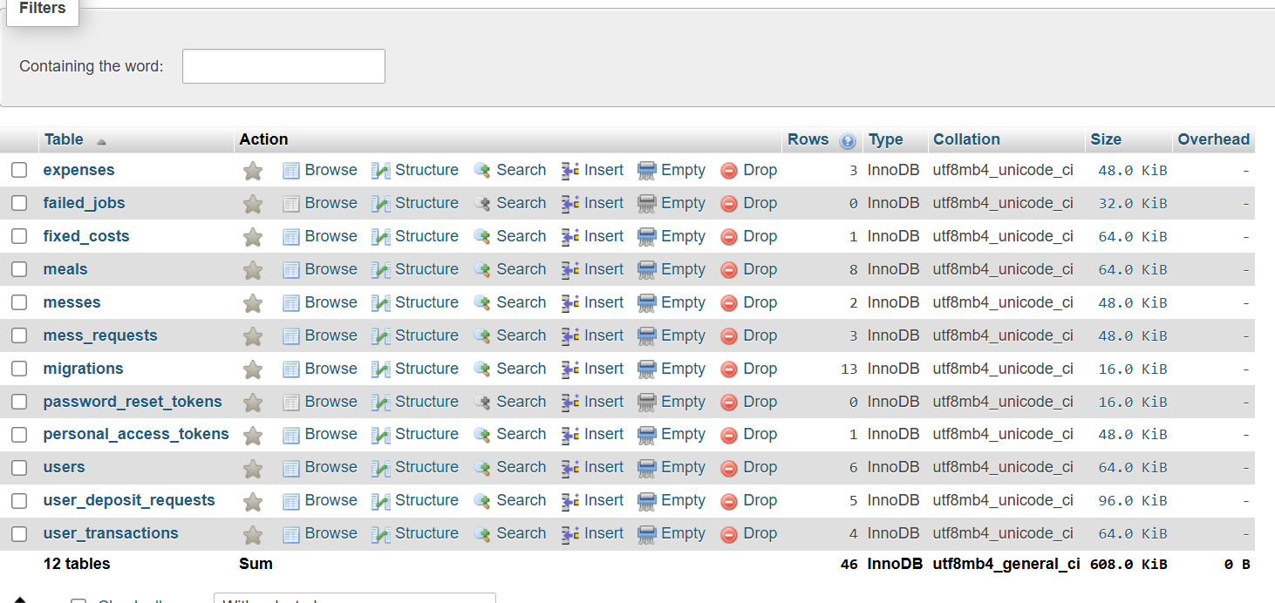
Figure 7.6 Database field design

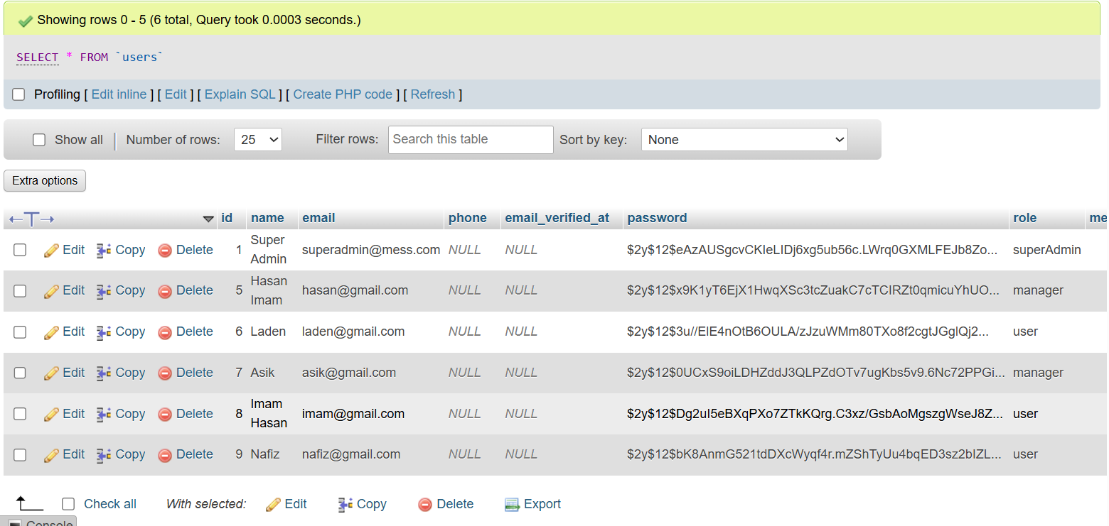
Figure 7.7 User Table
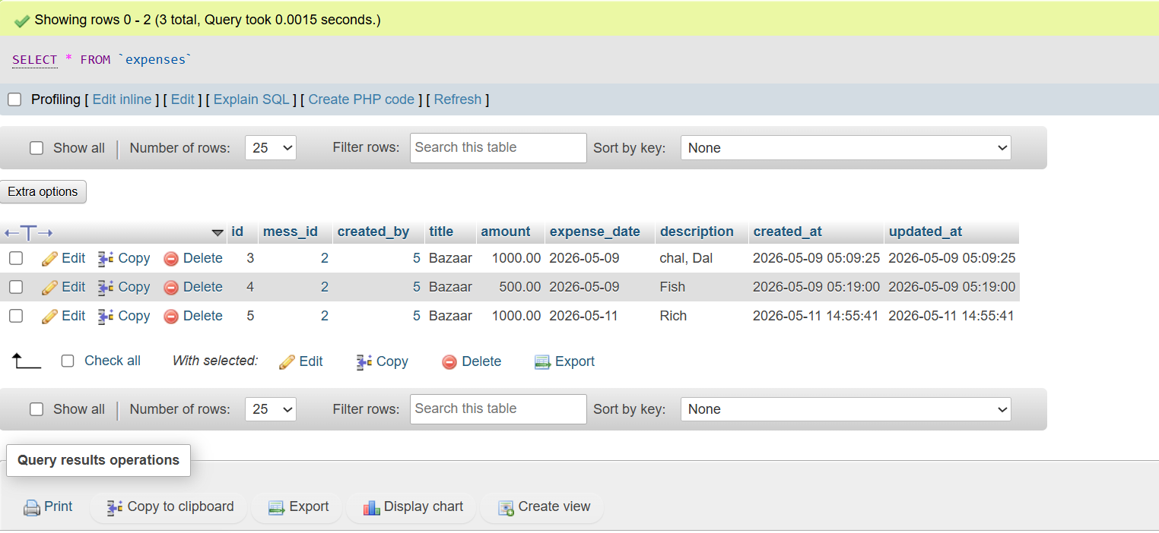
Figure 7.8 Expense Table
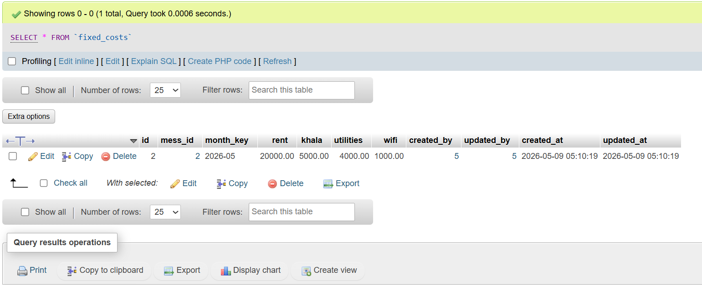
Figure 7.9 Fixed Costs Table
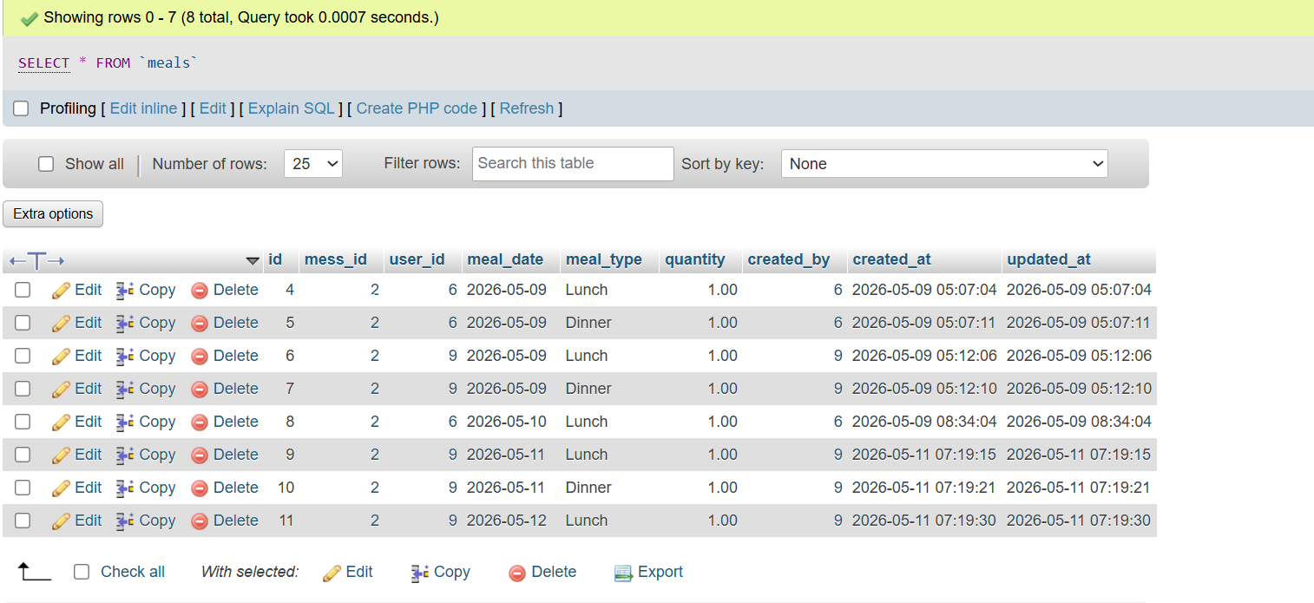
Figure 7.10 Meals Table
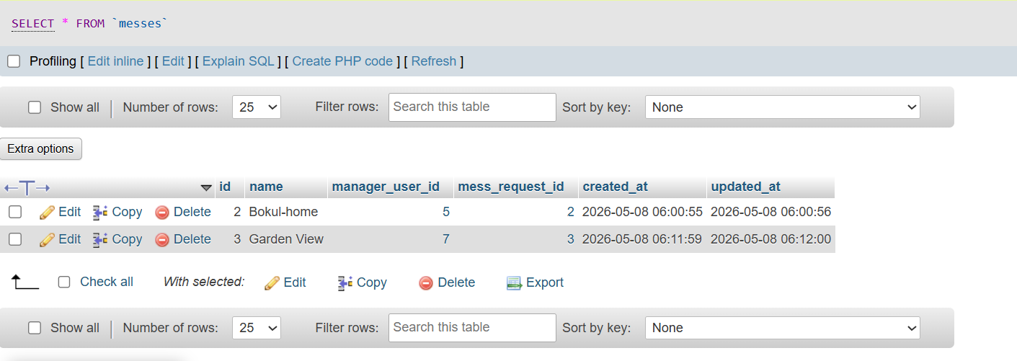
Figure 7.11 Messes Table
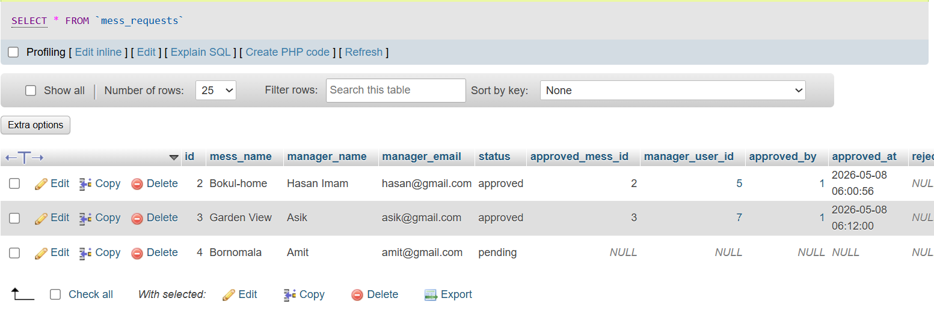
Figure 7.12 Mess Request Table
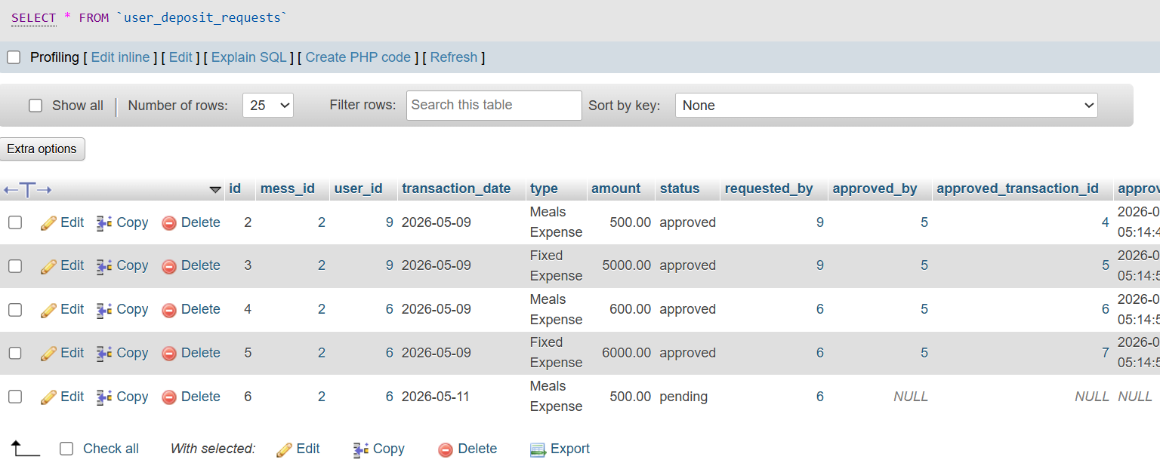
Figure 7.13 User Deposite Requests
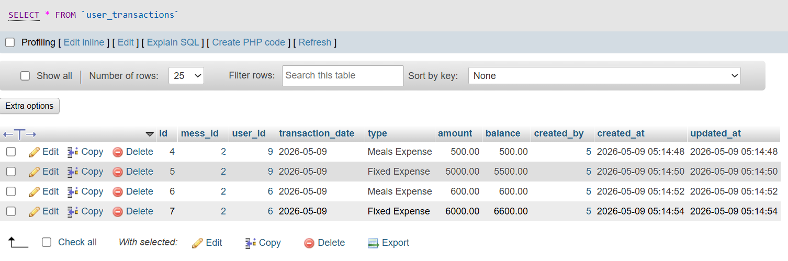
Figure 7.14 User Transaction Table

7.4 Interface Design
The user interface is designed to be intuitive and role-specific, ensuring that members only see features relevant to them.
- Manager Dashboard: Provides a bird's-eye view of mess statistics, member lists, and pending deposit approvals.
- Member Panel: Focuses on meal logging, viewing current personal balances, and requesting deposits.
- Billing Summary: A tabular view showing the monthly breakdown of bazaar costs, fixed costs, and the calculated meal rate.

7.4.1 Home Page
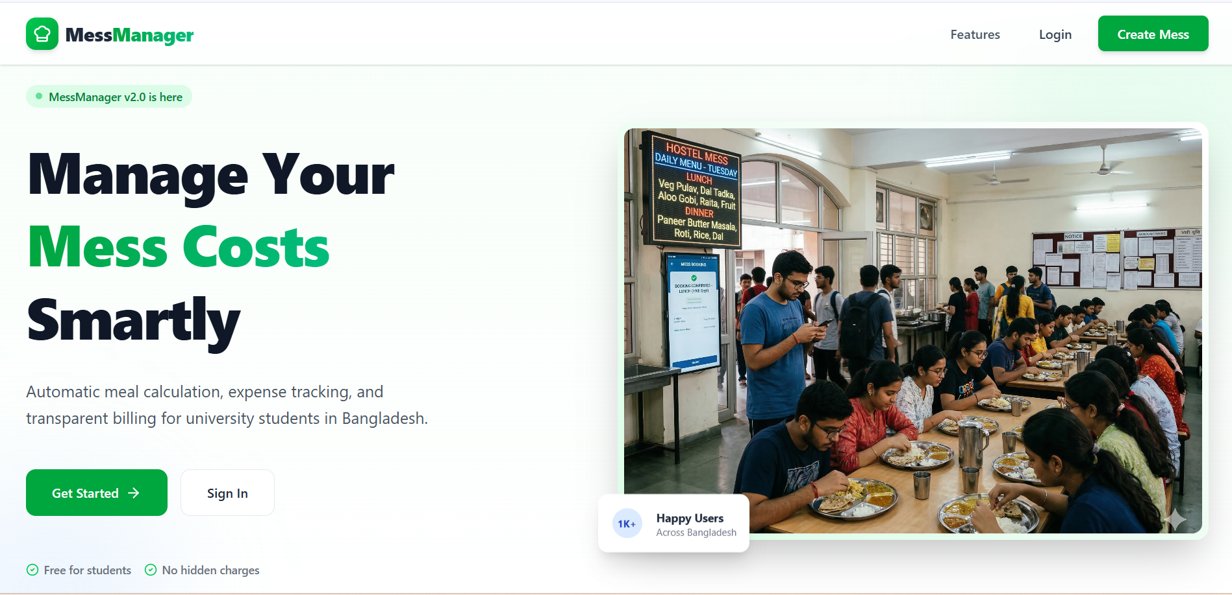
Figure 7.15 Home Page

7.4.2 Login Page
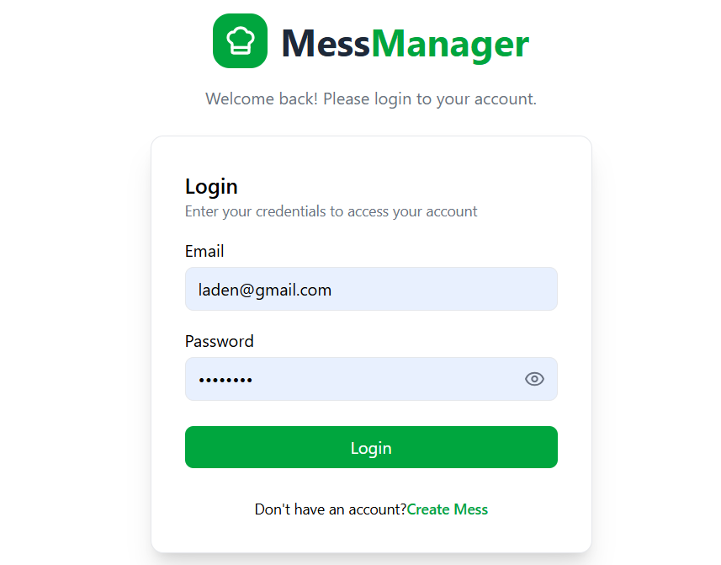
Figure 7.16 Login Page

7.4.3 Admin Interface
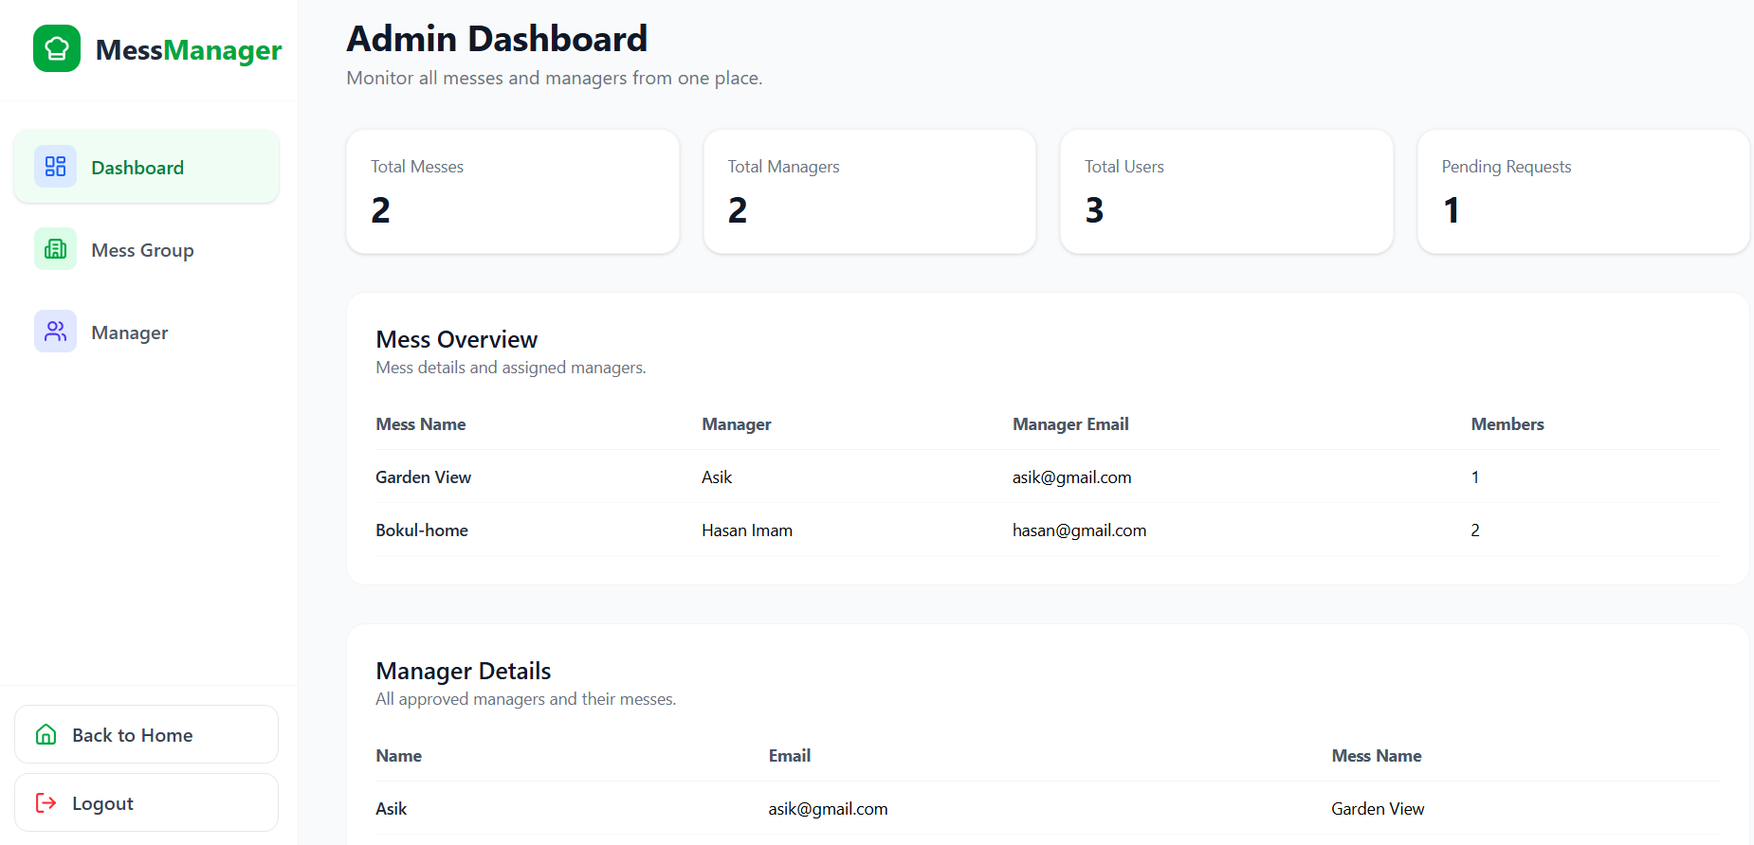
Figure 7.17 Admin Dashboard

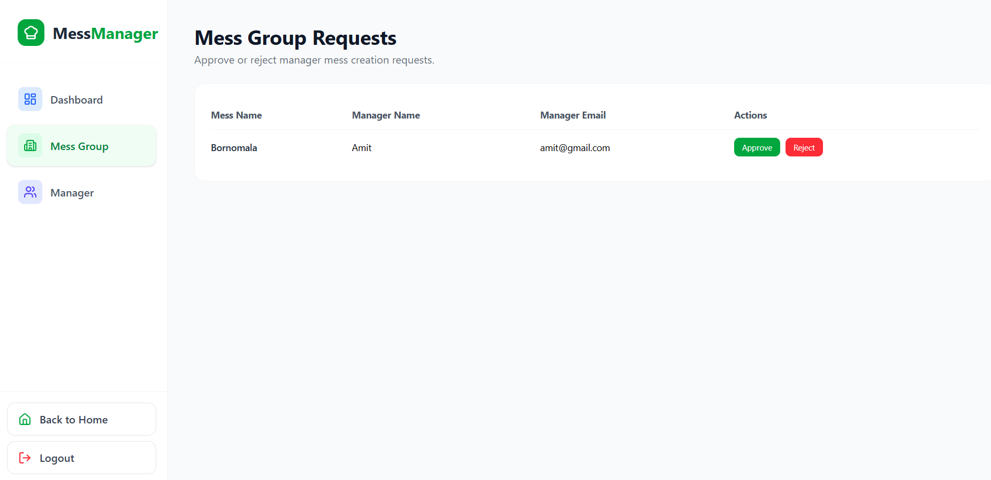
Figure 7.18 Mess Group Request

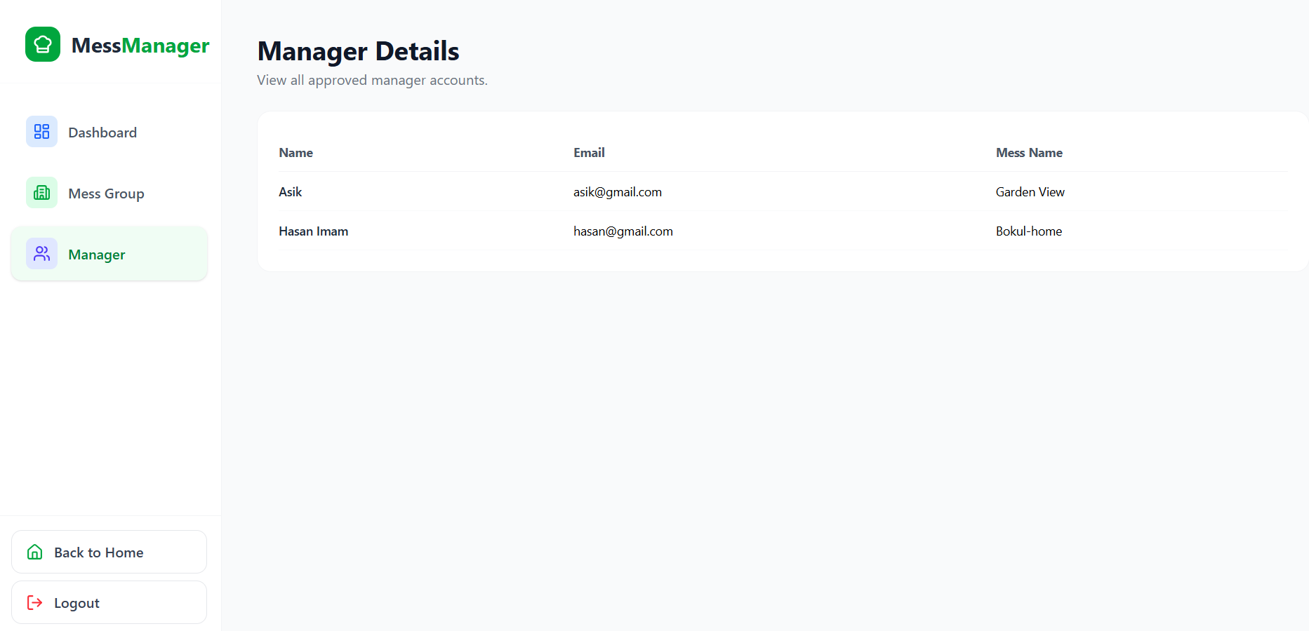
Figure 7.19 Manager Details

7.4.4 Manager Interface
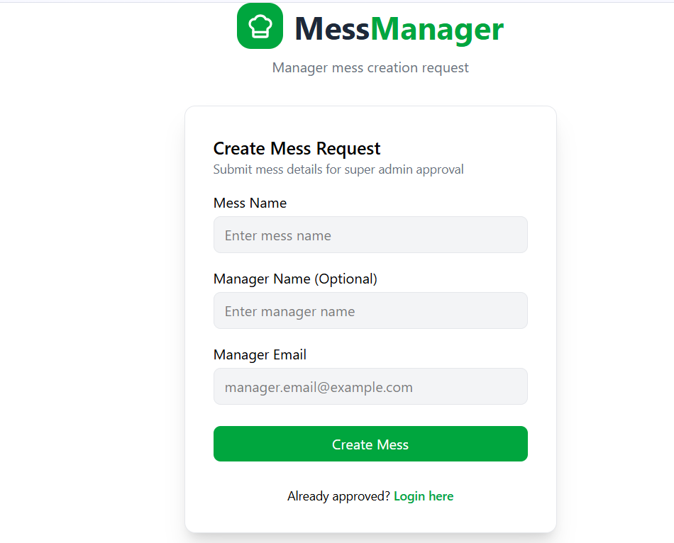
Figure 7.20 Create Mess Request

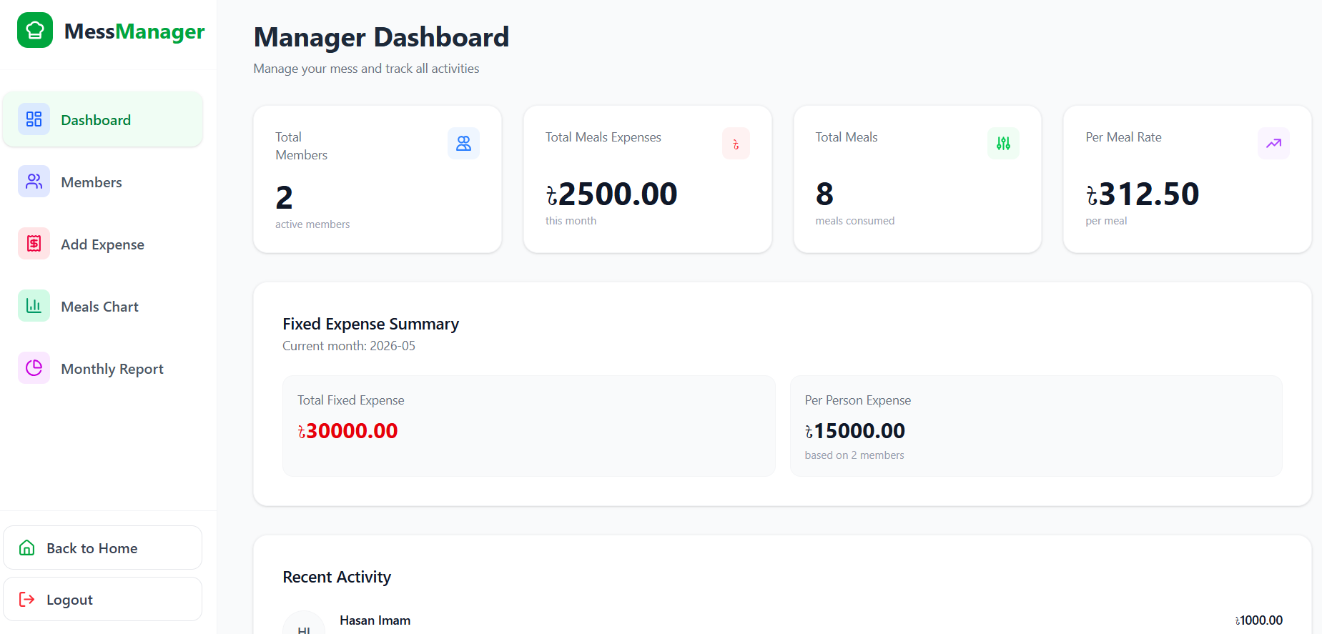
Figure 7.21 Manager Dashboard

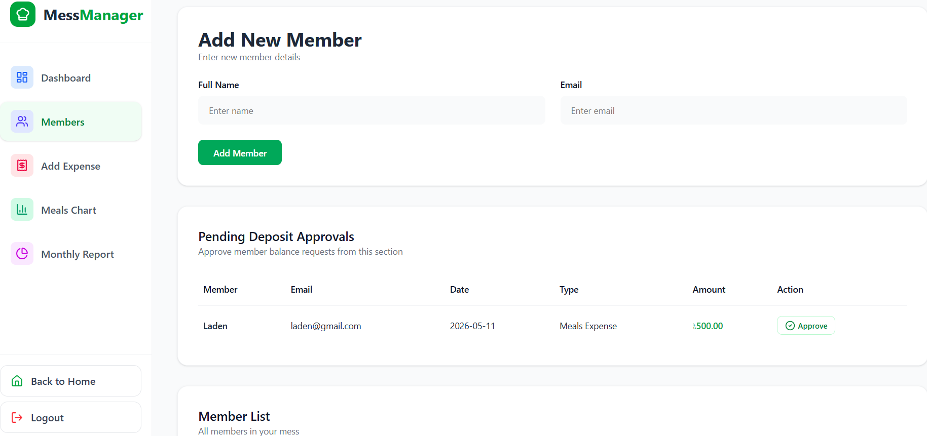
Figure 7.22 Add New Member

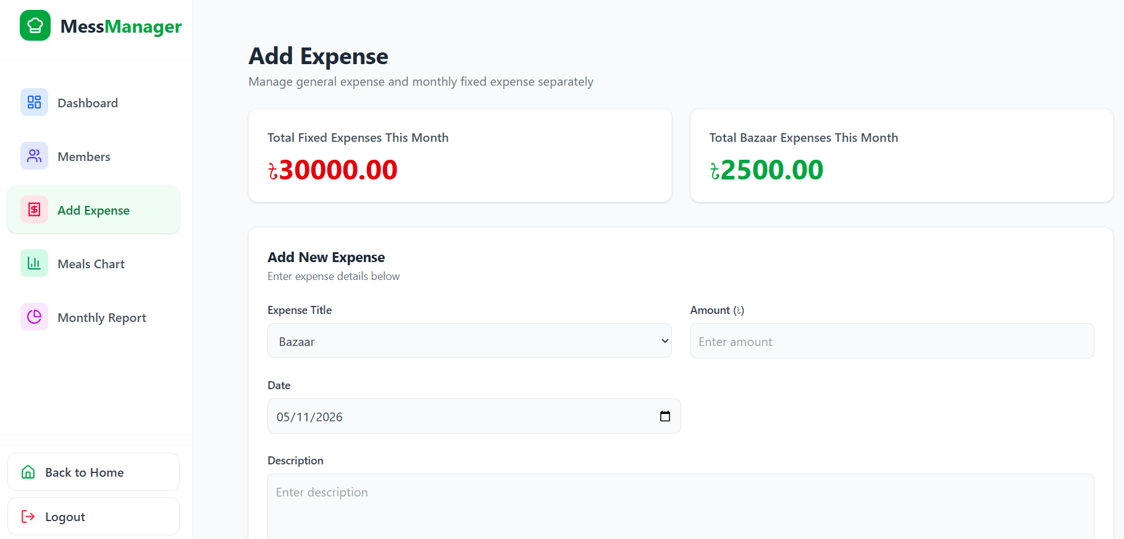
Figure 7.23 Add Expense

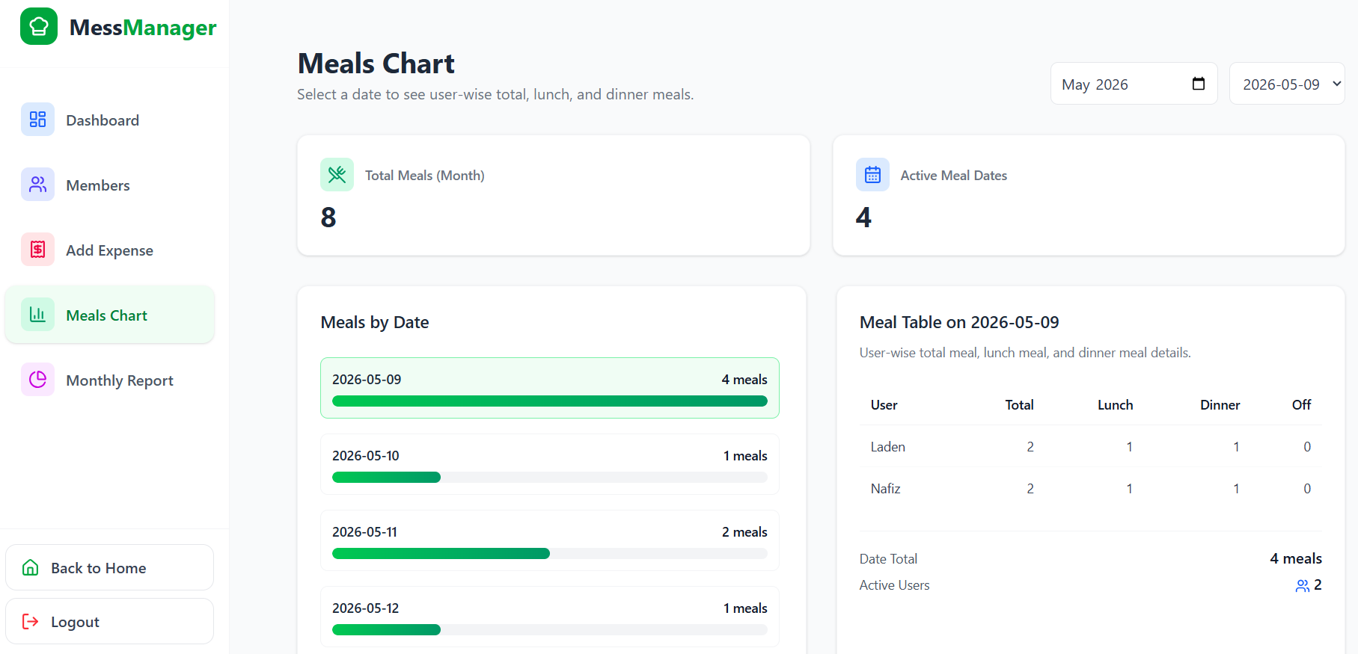
Figure 7.24 Meals Chart

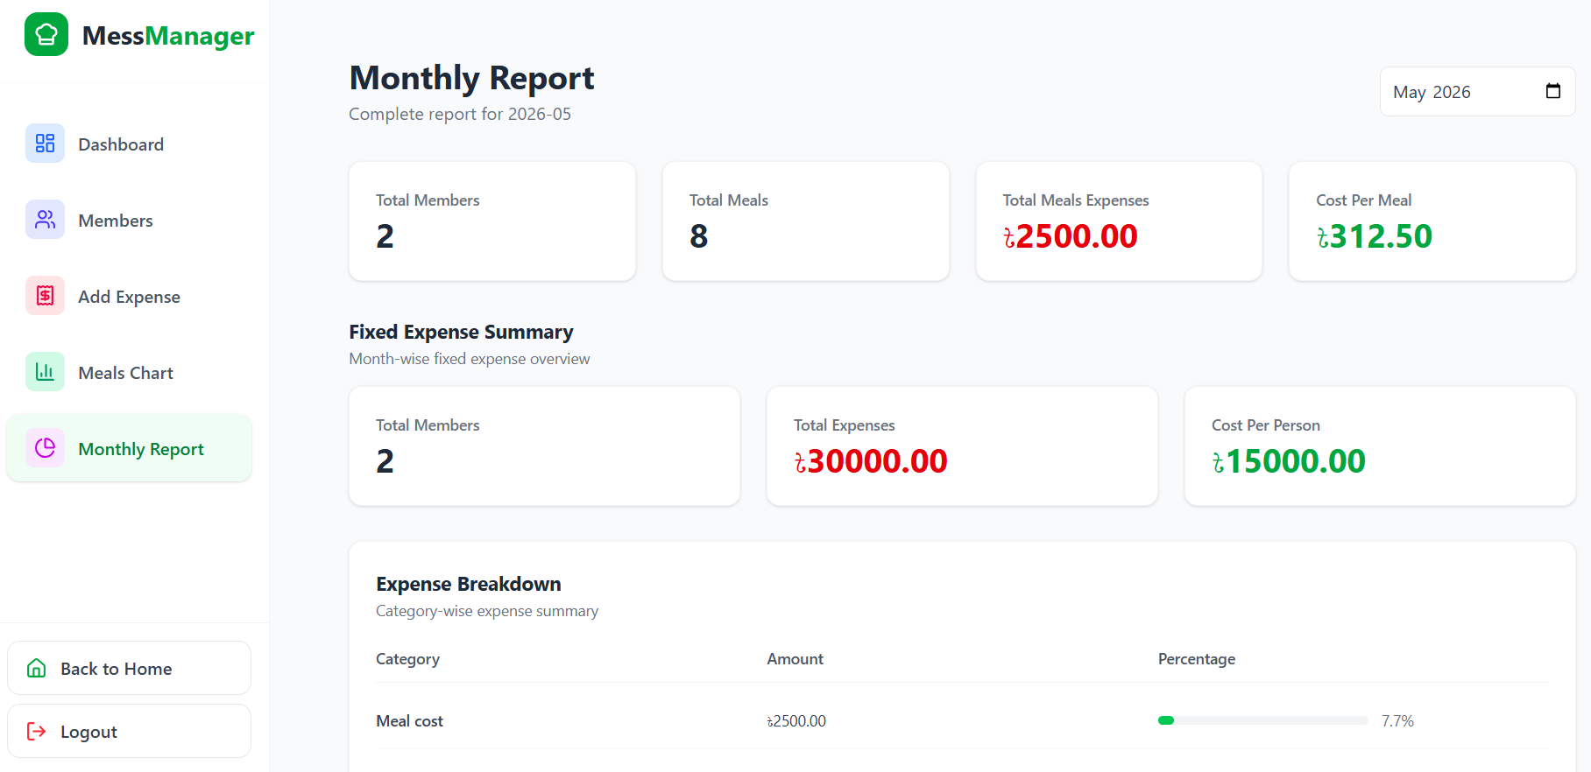
Figure 7.25 Monthly Report

7.4.5 User Interface
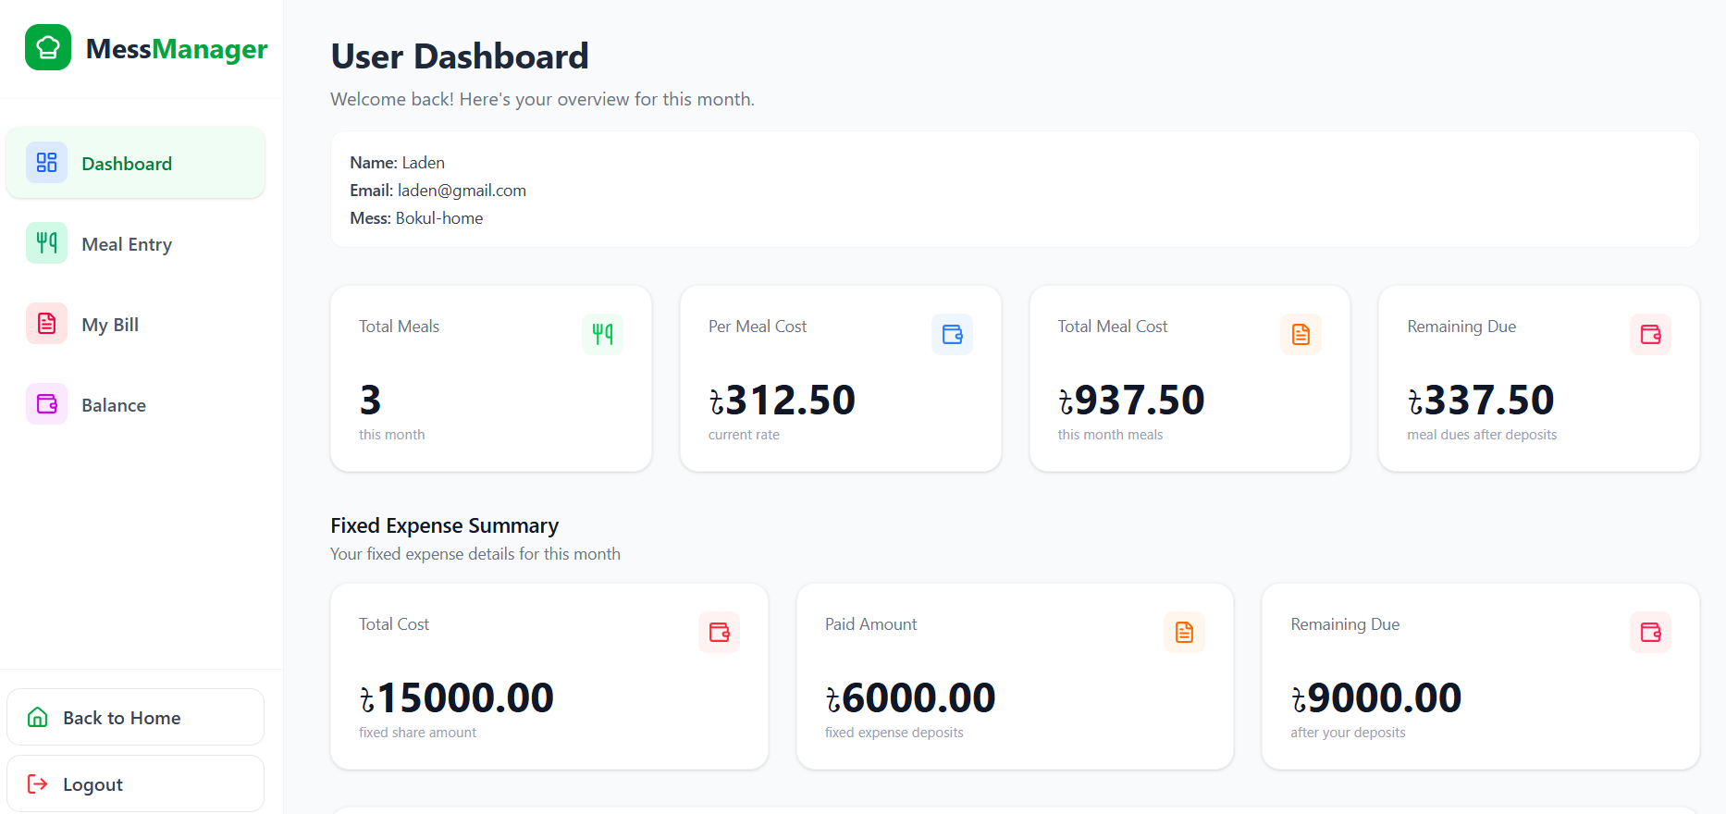
Figure 7.26 User Dashboard

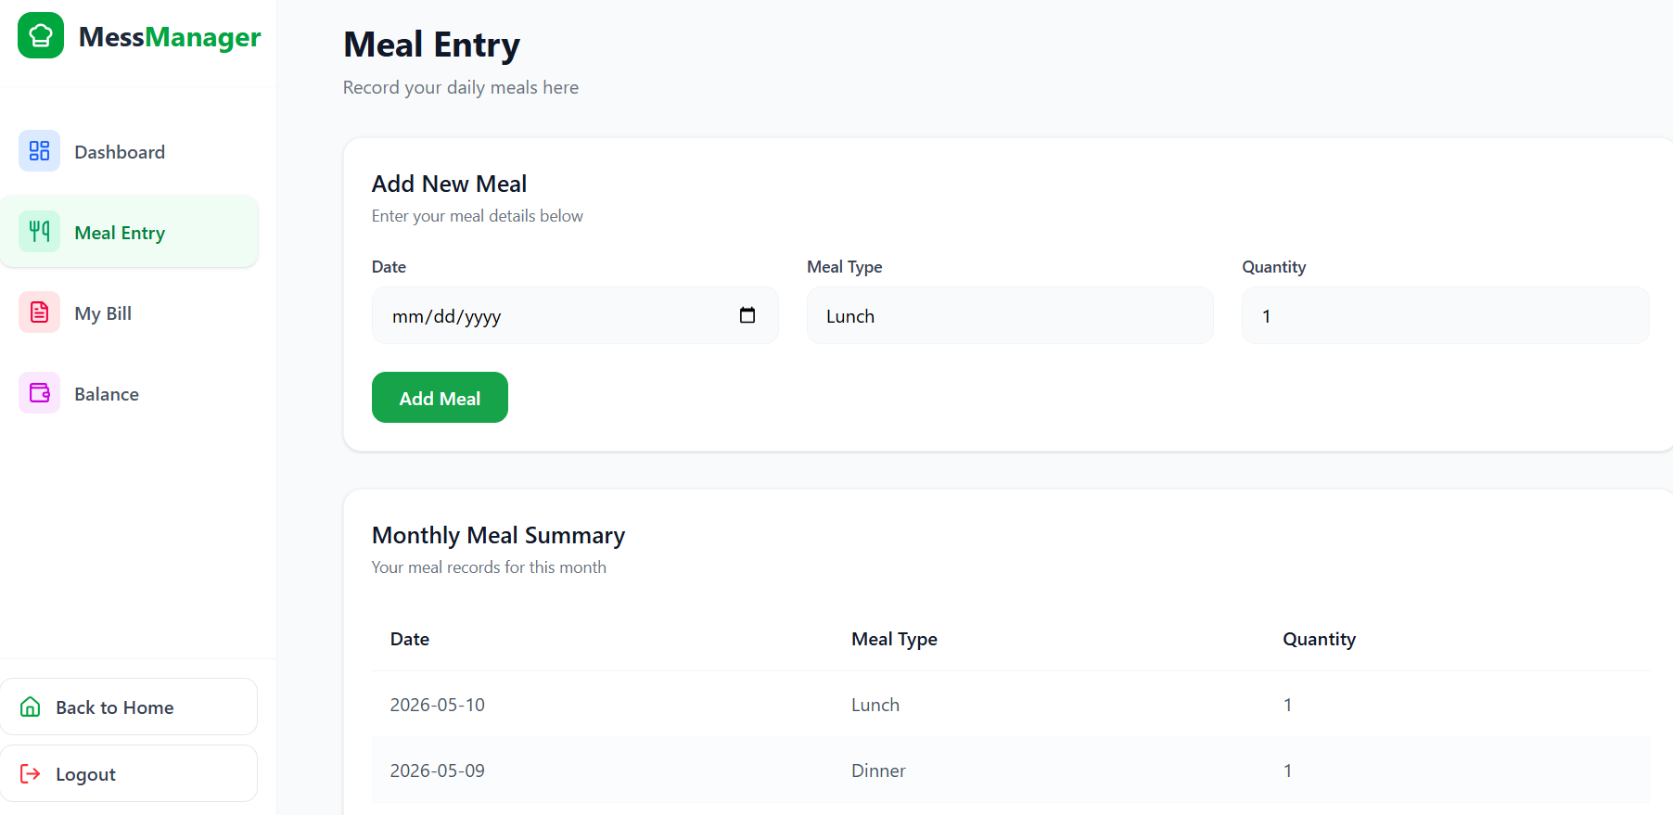
Figure 7.27 Meal Entry
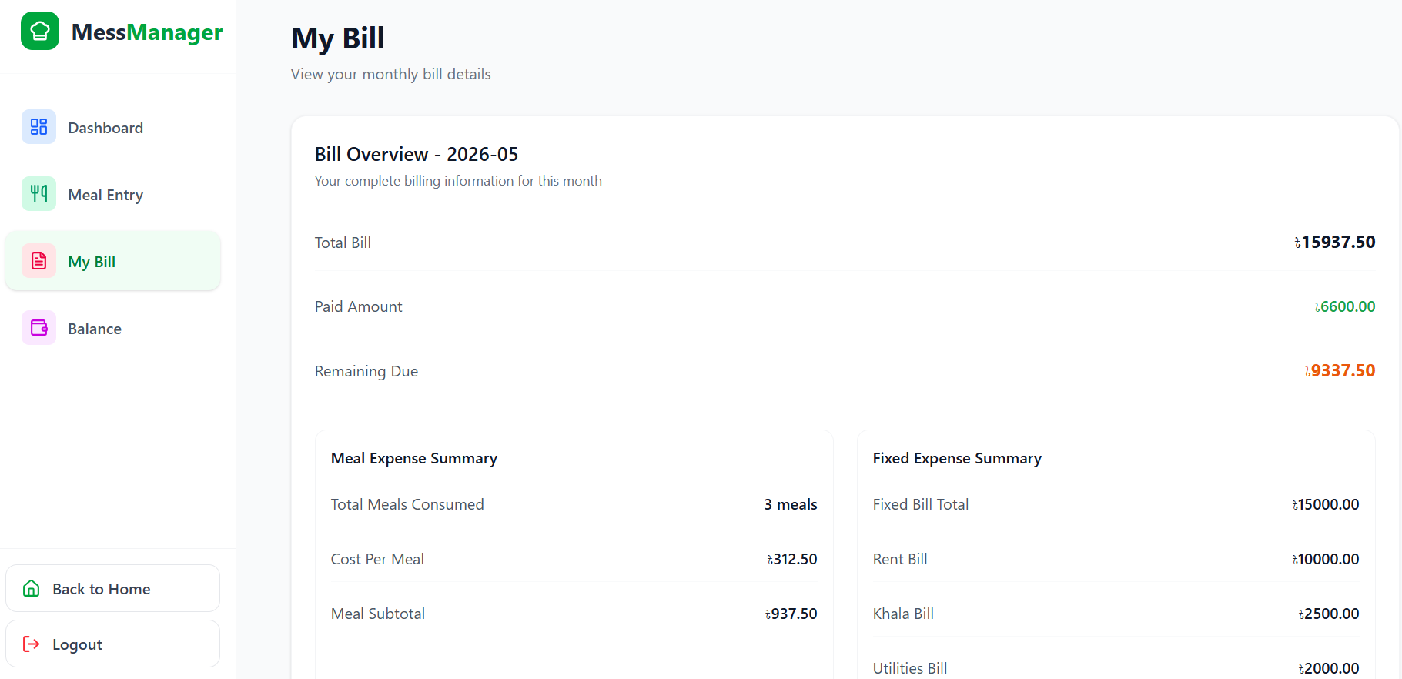
Figure 7.28 My Bill

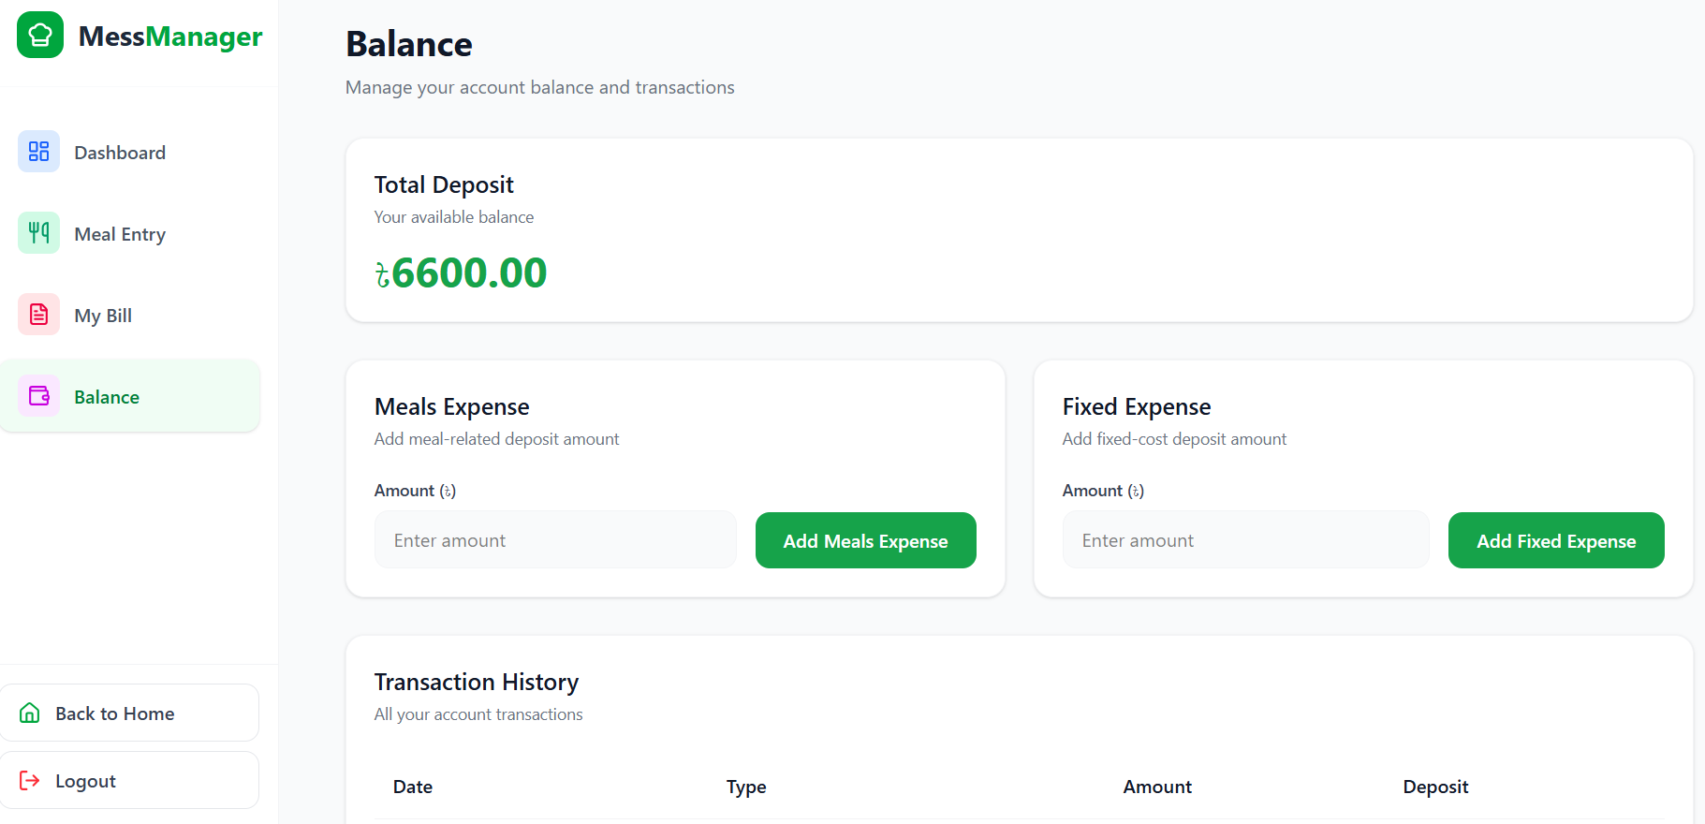
Figure 7.29 Balance

7.5 API Design Summary
The backend exposes several key RESTful endpoints to support frontend functionality.
Table 7.5: API Design Summary
Endpoint | Method | Role | Description
/api/register | POST | Public | Submit mess creation request.
/api/user/meals | POST | Member | Add or update a daily meal record.
/api/manager/fixed-costs | POST | Manager | Set rent and utilities for a specific month.
/api/user/bill/summary | GET | All | Fetch the current month's bill and meal rate.

7.6 Implementation Notes
The core business logic of the system resides in the Laravel Controllers. For example, the billing logic is encapsulated within the ExpenseController, which filters bazaar costs by their title to compute the dynamic meal rate. On the frontend, RTK Query is utilized for efficient data fetching and caching, (Meta Platforms, 2024) ensuring that the UI remains fast and responsive even with frequent data updates.

Chapter 8.

Testing

Testing is a critical phase in the development of MessManager to ensure that the software feature or function works correctly and reliably. This chapter outlines the strategies, environmental setup, and specific test cases used to verify that the system meets its functional requirements and provides an error-free experience for mess members and managers.

8.1 Test Strategy
The testing process followed a multi-layered approach to ensure both technical stability and a smooth user experience. (Society, 2014)
- Unit Testing: Focused on testing individual components, such as the billing logic in the ExpenseController and model relationships.
- Integration Testing: Verified that the React 19 frontend successfully communicates with the Laravel 10 REST API and that data is accurately stored in the MySQL database.
- Manual Acceptance Testing: Simulated real-world mess scenarios, such as multiple members logging meals and a manager approving deposits, to ensure the workflow aligns with user expectations.

8.2 Test Environment & Data
To maintain consistency, a controlled environment was established for all testing phases.
- Software Stack: Laravel 10 (PHP 8.1+), React 19, and MySQL.
- Tools: VS Code for debugging and Postman for API endpoint validation.
- Test Data: Automated database seeders were used to create test accounts for superAdmin, manager, and user roles to simulate a populated mess environment.

8.3 Test Case Tables
The following test cases document the execution steps, expected outcomes, and actual results for the core features of MessManager.

Table 8.1 Authentication and Role Access
Test Case ID | Module | Test Title | Expected Result | Actual Result | Status
TC-01 | Auth | User Login Test | User is redirected to their specific dashboard based on role. | Logged in and redirected to Manager Dashboard. | Pass
TC-02 | Auth | First Login Password Setup | User is forced to change their temporary password on first login. | "Change Password" prompt appeared and updated successfully. | Pass

Table 8.2 Core Functional Flows
Test Case ID | Module | Test Title | Expected Result | Actual Result | Status
TC-03 | Meals | Add Meal Entry | System stores meal status and updates quantity to 0 for "Off". | Meal stored correctly with accurate quantities. | Pass
TC-04 | Billing | Meal Rate Calculation | System correctly divides total bazaar costs by total meals. | Calculation matched manual verification exactly. | Pass
TC-05 | Deposits | Deposit Approval | Manager approval creates a transaction and updates user balance. | Balance updated and transaction record created. | Pass

8.4 Test Results & Bug Log
The testing phase confirmed that the core modules—Authentication, Meal Tracking, and Billing Logic—function according to the defined specifications. Minor UI bugs were identified during manual acceptance testing, such as date formatting issues in the meal calendar, which were promptly resolved before the final deployment.

8.5 Performance & Security Checks
The system was verified to load dashboards within the target of 2-3 seconds. Security was confirmed through middleware checks, ensuring that a standard user cannot access manager routes or edit system-wide fixed costs.
.

Chapter 9.

Ethical Considerations & Sustainability

Fundamental ethical values served as the foundation for the creation of the MessManager system. Because the application handles both personal activity and sensitive financial data, it is built to benefit members and managers alike without compromising integrity or privacy. Transparency in how costs are allocated and the security of financial records are the pillars of this system's ethical framework.

9.1 Ethical Considerations
The development of MessManager prioritizes professional responsibility and fairness across all user roles.

9.1.1 Data Privacy and Security
Strong security measures are implemented to manage protected financial and personal information:
- Authentication: Bcrypt password hashing is used in conjunction with Laravel Sanctum to ensure secure user access.
- Authorization: Role-Based Access Control (RBAC) ensures that standard members cannot access manager settings or modify the bazaar expenses of others.
- Confidentiality: Individual deposit histories and bill summaries are restricted to the specific user and the mess manager to maintain financial privacy.
- CSRF Protection: All web forms include security tokens to prevent Cross-Site Request Forgery attacks.

9.1.2 Responsibility to Stakeholders
The system maintains a sense of accountability to its primary stakeholders:
- To Mess Managers: Providing accurate financial summaries and automated meal rate calculations for better decision-making.
- To Members: Ensuring that their digital records are accurate, transparent, and always accessible for verification.

9.2 Sustainability Through Software Engineering
The project contributes to environmental and economic sustainability by optimizing resource usage and eliminating physical waste.

9.2.1 Paperless Impact (Social & Environmental Sustainability)
MessManager aims to address real-world problems by contributing positively to the community without negative environmental impacts:
- Reduction of Waste: By digitizing meal registers and bazaar logs, the system eliminates the need for physical notebooks and paper-based accounting.
- Long-term Accuracy: Digital records prevent the loss of information that often occurs with physical documents, ensuring social sustainability through trust and transparency.

9.2.2 Economical Sustainability
Economic sustainability refers to developing a system that is cost-effective for both the developer and the end-users:
- Open-Source Efficiency: The use of Laravel, React, and MySQL reduces software licensing costs, making the platform affordable (Group, 2021) for student-managed messes.
- Minimized Errors: Automated calculations reduce financial discrepancies, leading to long-term economic stability within the mess group.

9.3 Professional Responsibility
Throughout the development of MessManager, professional standards were maintained by working honestly and with a mindset of continuous improvement. All third-party libraries and frameworks used, such as Redux Toolkit and Tailwind CSS, have been properly utilized according to their open-source licenses.
.

Chapter 10.

Conclusion

10.1 Conclusion
The primary goal of the MessManager project was to replace inefficient, manual paper-based mess tracking with a transparent and automated digital solution. By utilizing a modern Laravel 10 and React 19 tech stack, the system successfully addresses the core pain points of student shared living in Bangladesh:
- Automation of Calculations: The system now automatically computes the dynamic meal rate and splits monthly fixed costs equally among members, eliminating human calculation errors.
- Transparency: Role-based dashboards allow every member to view their real-time balance, deposit status, and total bill, fostering trust within the mess.
- Operational Efficiency: Managers can now oversee dozens of members, approve financial requests, and log expenses through a single unified interface, significantly reducing administrative overhead.
The successful implementation of this practicum project demonstrates that complex community-based financial operations can be streamlined through disciplined software engineering and user-centric design.

10.2 Limitations
While MessManager provides a robust foundation for mess operations, certain limitations were identified during the testing and evaluation phases that fall outside the current project scope:
- Manual Expense Entry: Managers must still manually type in bazaar expense titles and amounts, which can be time-consuming after large shopping trips.
- Offline Access: The application requires a stable internet connection to sync meal data and financial transactions with the MySQL database.
- Currency Restrictions: The current billing logic is hardcoded for Bangladeshi Taka (BDT) and does not yet support multi-currency or localized formatting for international users.
- Mobile App Absence: While the web interface is responsive, the lack of a dedicated native mobile application limits features like push notifications for meal reminders.

10.3 Future Work & Roadmap
The next phase of MessManager development focuses on increasing automation and improving the mobile user experience.

10.3.1 Character-Level OCR Integration
The most significant planned update is the integration of an OCR (Optical Character Recognition) module for bazaar receipts.
- Transition Strategy: Moving from page-level to character-level OCR for Bangla handwriting and printed text to ensure high accuracy for localized receipts.
- Workflow: Managers will be able to take a photo of a physical bazaar memo, and the system will automatically extract the date, title, and total amount to populate the expense log.
- Technology: Plans include utilizing a Convolutional Neural Network (CNN) classifier trained on datasets like Ekush or BanglaLekha-Isolated to better recognize handwritten Bangla digits and characters.

10.3.2 Functional Roadmap
- Automated Notifications: Implementing SMS or email alerts to remind members to log their "Off" meals before the daily deadline.
- Digital Payment Integration: Adding support for mobile financial services (MFS) like bKash or Nagad to allow members to pay their bills directly through the app.
- Predictive Analytics: Using historical data to forecast future bazaar costs, helping mess groups plan their budgets more effectively.
By executing this roadmap, MessManager will evolve from a record-keeping tool into a fully automated financial ecosystem, further enhancing the quality of life for students and residents in shared living environments.

References
Corporation, O., 2023. MySQL 8.0 Reference Manual, Austin, TX: s.n.
Group, T. P., 2021. PHP 8.1 Manual. [Online]
Available at: https://www.php.net/docs.php
Meta Platforms, I., 2024. React 19 Documentation. [Online]
Available at: https://react.dev/
Otwell, T., 2023. Laravel 10.x Documentation. [Online]
Available at: https://laravel.com/docs/10.x
Society, I. C., 2014. SWEBOK Guide: Guide to the Software Engineering Body of Knowledge. [Online]
Available at: https://www.computer.org/education/bodies-of-knowledge/software-engineering

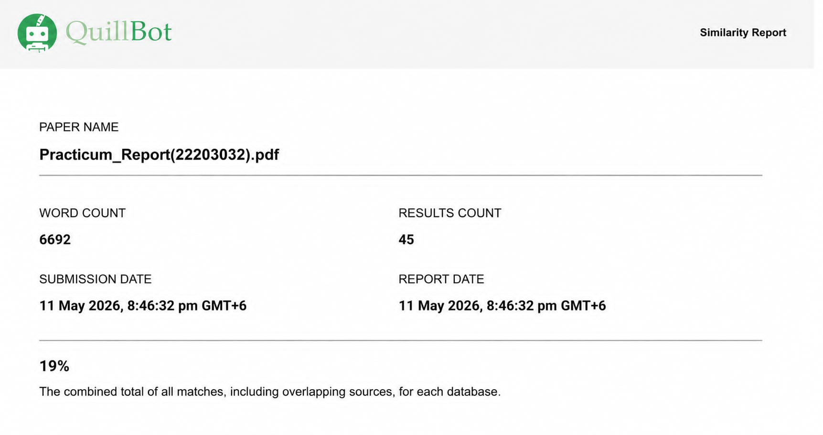
Figure 10.1 Plagiarism Report

