1. Process Details table

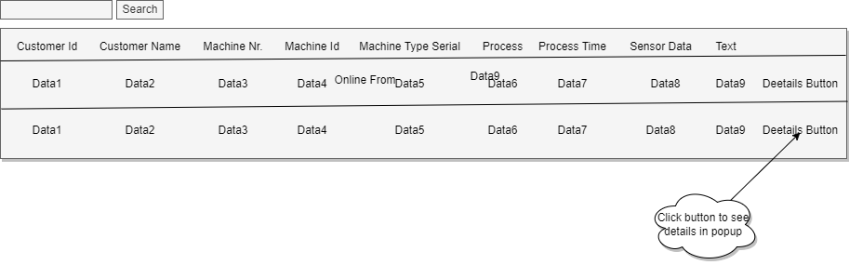

1. Display each details in popup

