1. **What is the mean and variance for the loaded dice?**

Mean = 4.5 and Variance = 3.25

1. **Make a function in R that ‘rolls’ this dice …**

## function 'rollLoadedDie'

rollLoadedDie <- function(numRolls) {

data_sample <- sample(data_x, numRolls, replace=TRUE, prob=data_prob)

return (data_sample)

}

1. **Make a histogram of some large number of rolls. Do the rolls of the loaded die approximate a uniform distribution?**

The following histogram is for ‘rollLoadedDie(1000000)’. No, it does not seem to be a uniform distribution.

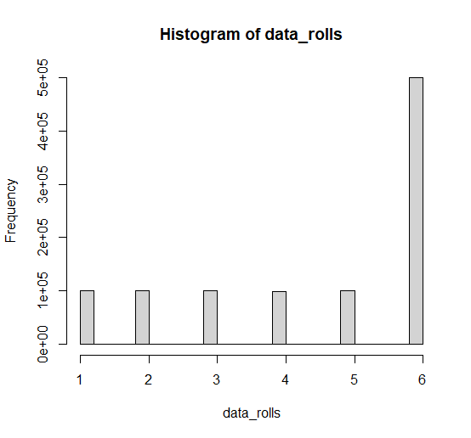

1. **Modify the code on Slide #58 of lecture #2 so that …**

The following plots are for (left) means vs trial sizes and (right) variances vs trial sizes. It seems like in both cases we get the convergence for around 10^4 rolls.

