**1) Problem #1 - part (1)**

R script: ‘lab_2/problem_1_part_1.R’ and

graph plot: ‘lab_2/problem_1_part_1_plot.PNG’

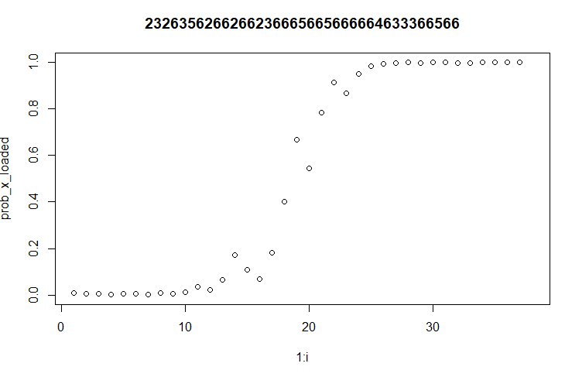

**2) Problem #1 - part (2)**

R script: ‘lab_2/problem_1_part_2.R’.

Number of trials considered: 100,000.

Avg. (to be 99.999% sure): **56.38795 rolls.**

**3) Problem #2 - part (1): with disease**

R script: ‘lab_2/problem_2_part_1.R’.

Number of trials considered: 100,000.

Avg. (to reach 0.99999): **13.84896 tests.**

**4) Problem #2 - part (2): without disease**

R script: ‘lab_2/problem_2_part_2.R’.

Number of trials considered: 100,000.

Avg. (to reach 0.99999): **3.79683 tests.**

**5) Problem #2 - part (3): with & without disease**

R script: ‘lab_2/problem_2_part_3.R’.

Number of trials considered: 10 (10 trials each having 1 million patients)

Avg. test/cost for 1 million patients (to reach 0.99999): 3810868.2 test or $3810868.2

**COMMENTS:**

In problem #2 part 1, we simulated based on patients with disease, since the initial/prior belief is of 0.1% it takes several (**13.84896**) tests to reach the posterior to 0.99999.

On the other hand, in problem #2 part 2, we simulated based on patients without disease, and since the initial/prior belief is of 99.900% (without disease) it takes only a few (**3.79683**) tests to reach the posterior to 0.99999.

As the majority of the patients are without disease, we see the avg. in problem #2 part 3 (3810868.2 tests for 1 million patients) towards the value of what we found in problem #2 part 2.