**1) Problem (1A)**

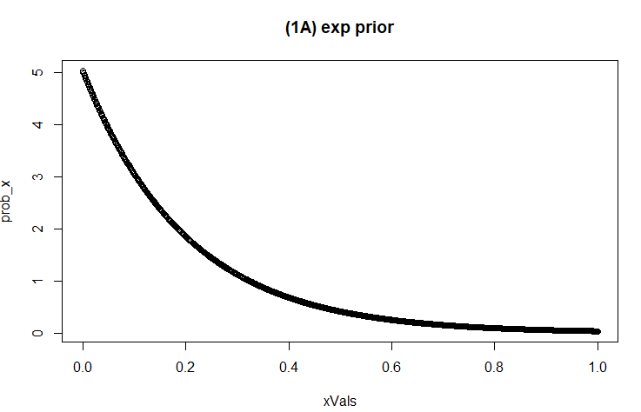

**2) Problem (1B): 14 heads, 10 tails**

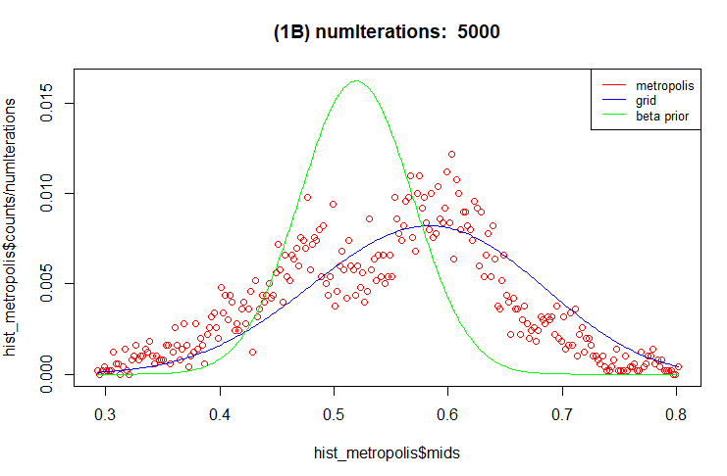

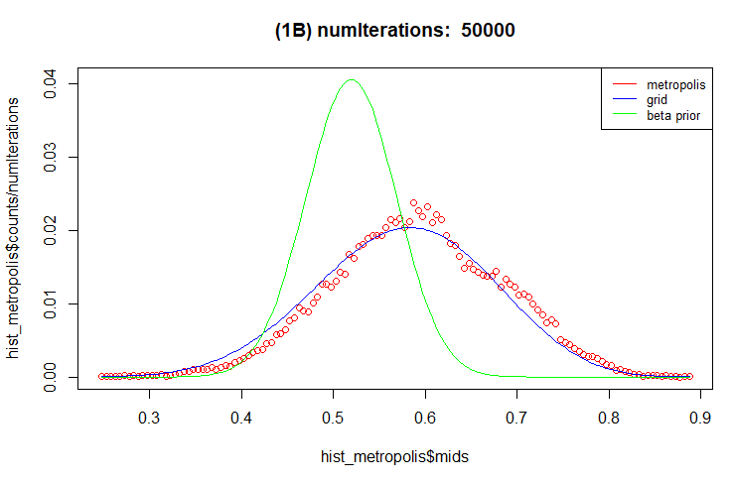

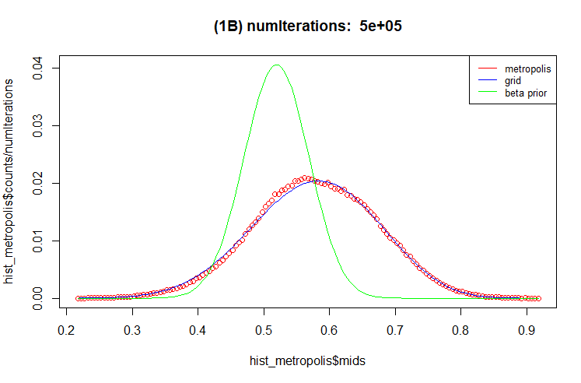

For Problem (1B), I have plotted 3 different cases with number of iterations: 5k, 50k, and 500k. In each case, metropolis, grid, and beta prior distributions are represented by red, blue, and green color lines respectively.

It seems like with large number of iterations both metropolis and grid approximation almost agree.

**3) Problem (1C): 583 heads, 417 tails**

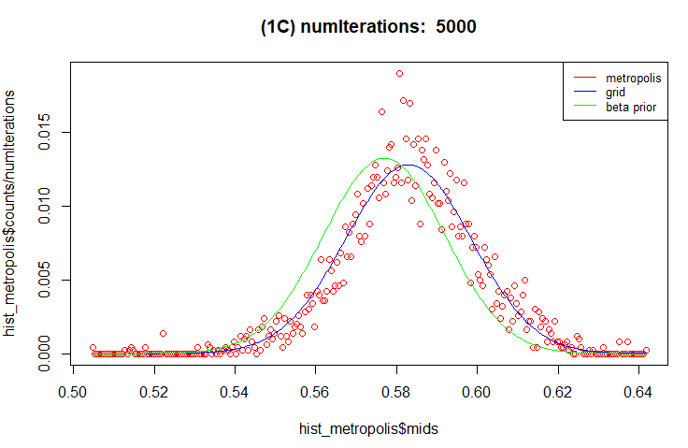

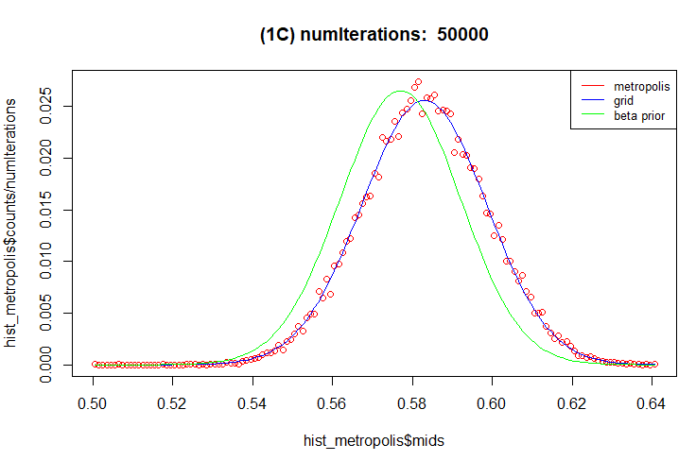

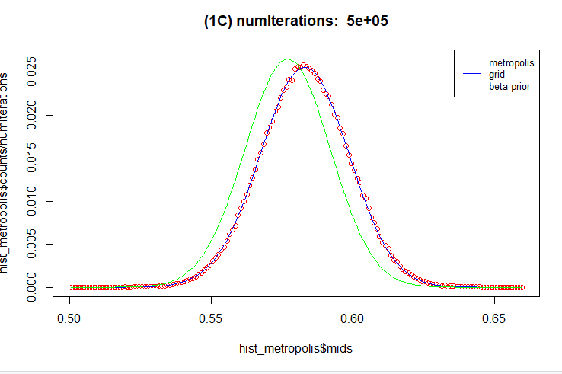

Similarly, For Problem (1C), I have plotted 3 different cases with number of iterations: 5k, 50k, and 500k. In each case, metropolis, grid, and beta prior distributions are represented by red, blue, and green color lines respectively.

Again, it seems like with large number of iterations both metropolis and grid approximation almost agree. Interestingly, I did not change the step size. In both problems (1B and 1C), I have used step size = 0.01.

**COMMENTS on the shape difference:**

In problem (1B), the exact analytical solution with beta prior had higher peak. On the other hand, the distribution of both metropolis and grid approximation had lower peaks and a bit wider shape than the analytical one.

In problem (1C), it seems like the peak value for exact analytical, metropolis, and grid approximation are almost in the same range. Moreover, both distributions from metropolis and grid approximation became narrower. The reason I guess is because, even though the likelihood probability is almost same in problem (1B) and (1C), we have seen more events or we have more data in problem (1C). As a result, the uncertainty is reduced. Therefore, we have seen a narrower distribution than problem (1B).