To customize anything from the WINDOWS SETTINGS, Do these two things at first :
- Most Important Pre-work before customizing (If you know you know)
- Then Create a Local Account If you don’t have it yet.

# MOST IMPORTANT WORK (Before Beginning)
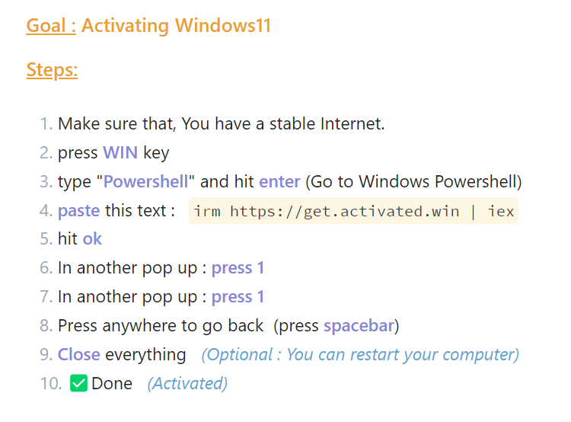

Now you can Customize your Environment.

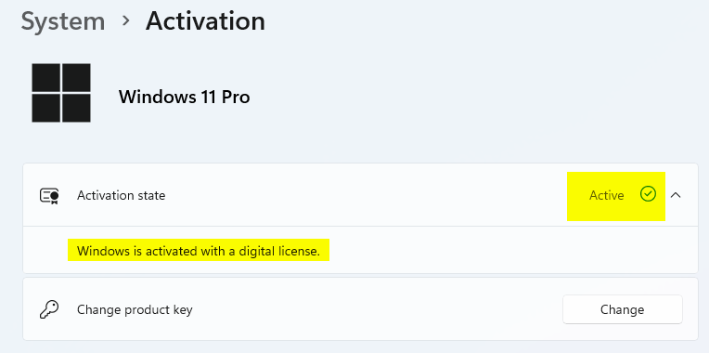

# Creating a Local Account (If you don’t have it yet)

N:B: Mandatory to do this thing, Remove your MS_account from the Computer and after all these you have done the Important job and also you have a Fully Local account (What you can Customize)

Press WIN + I --> to go to Settings (in windows OS)

I have only marked the things that I change here, the rest of the things are always come in default settings.

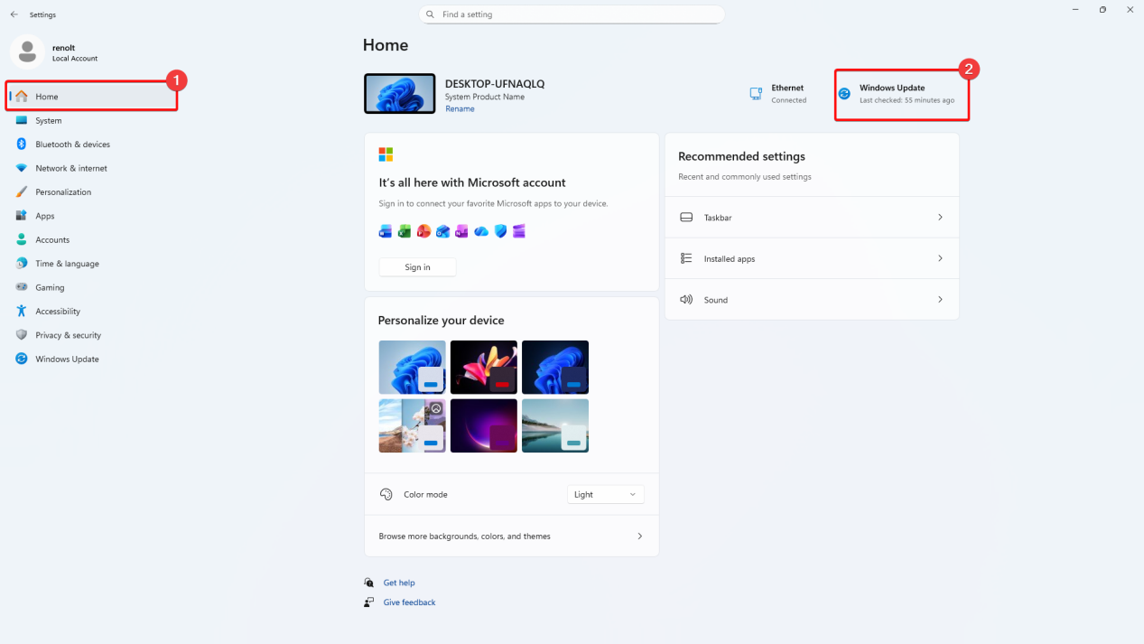

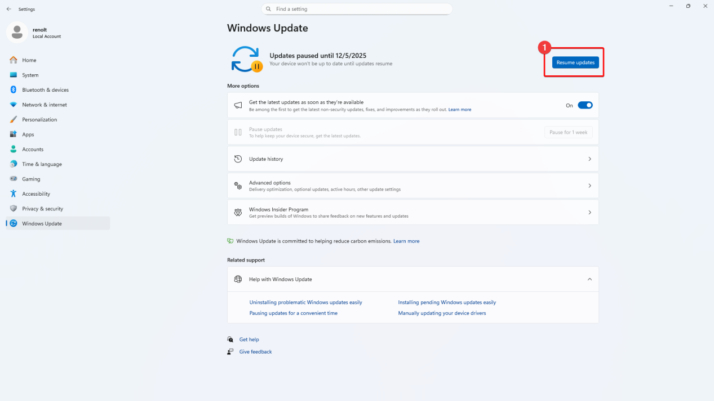

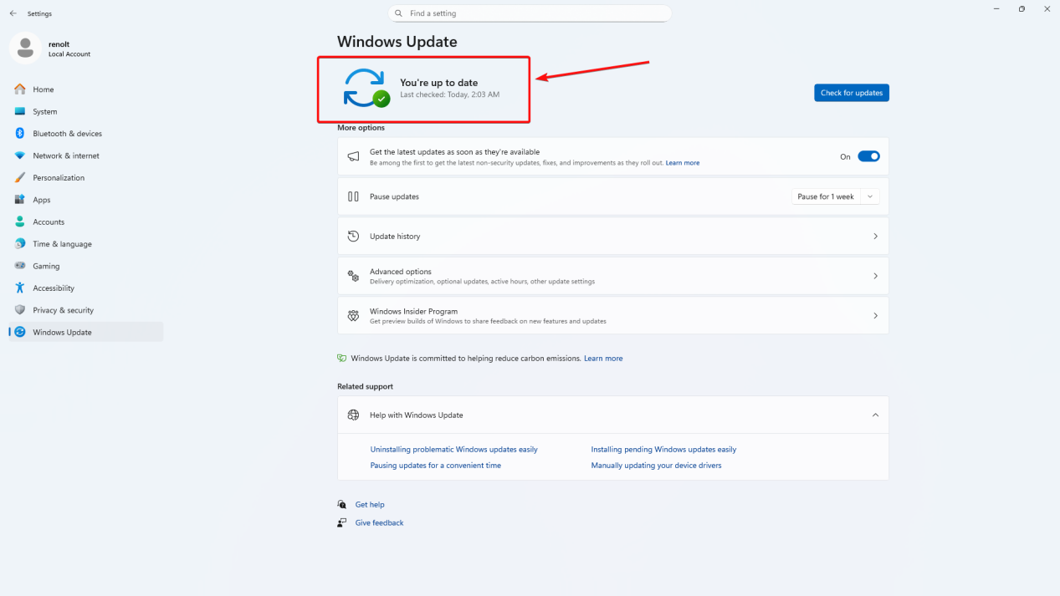

After the latest Version
Now If you want you can Pasue the Updates

# SYSTEM

## DISPLAY

(Go to each section in this Order; As per the Arrow Indicates)

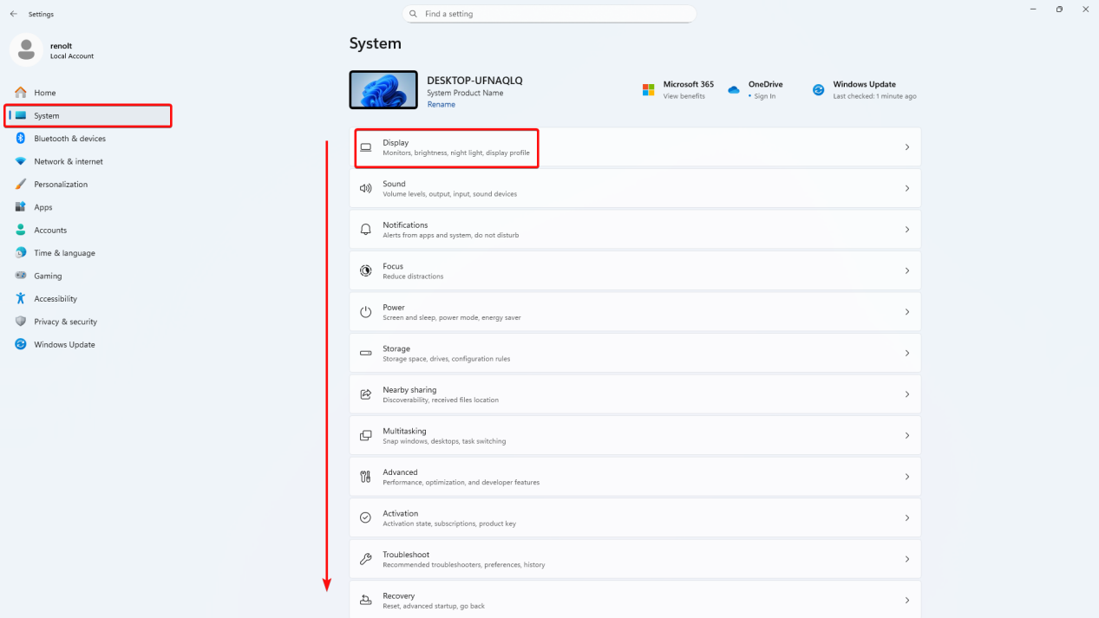

I only change these Parts :

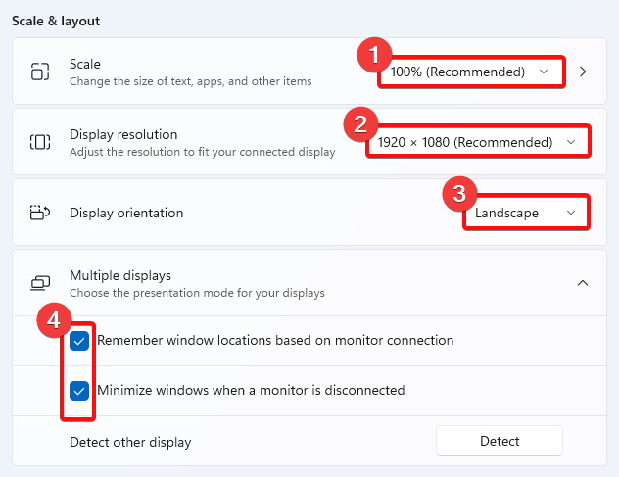

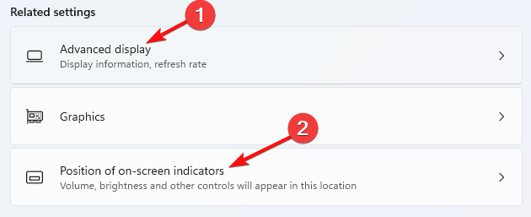

Change here
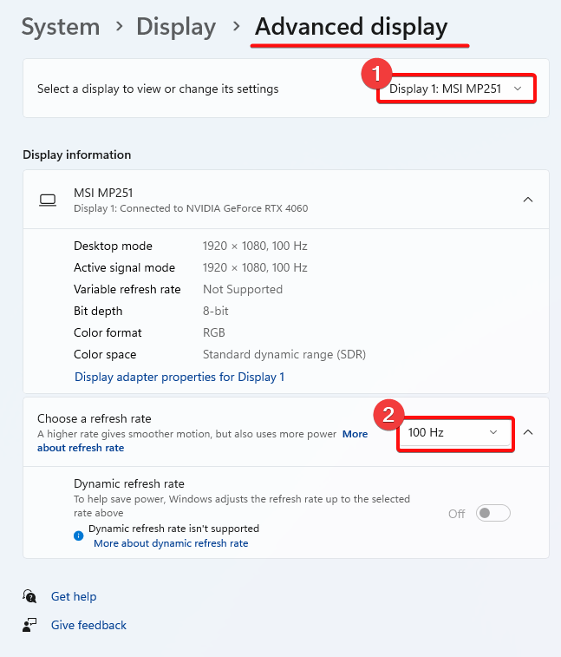

## SOUND

Change here
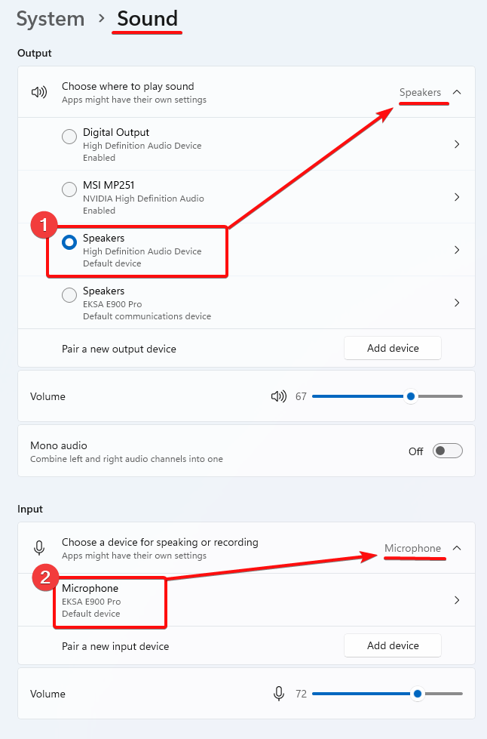

## NOTIFICATIONS
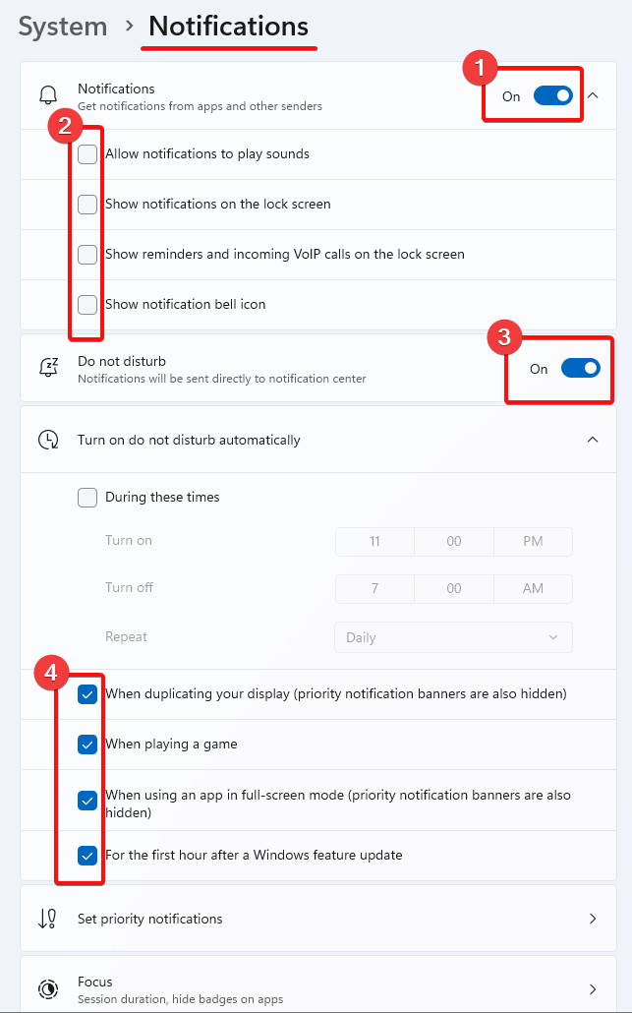

For all these I will go through one by one and do the same thing for image-00.
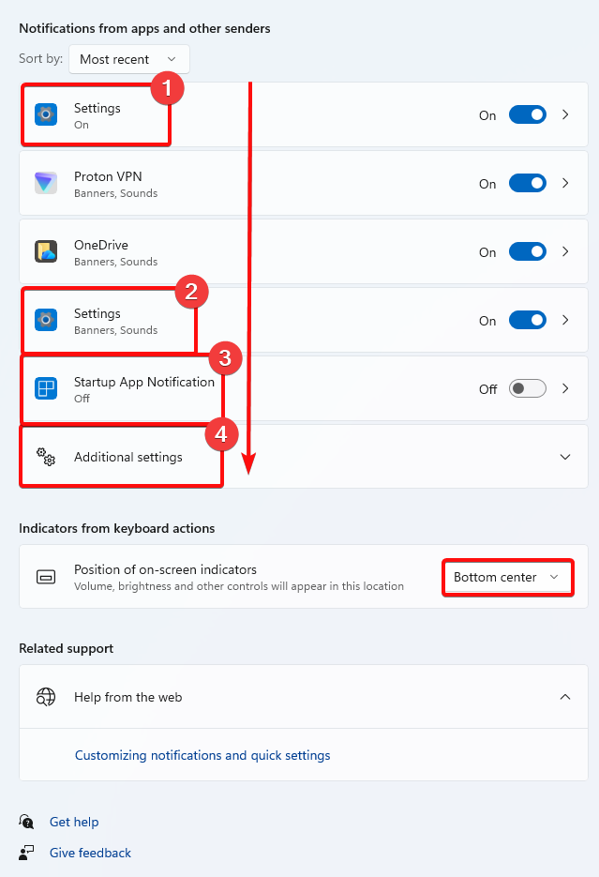

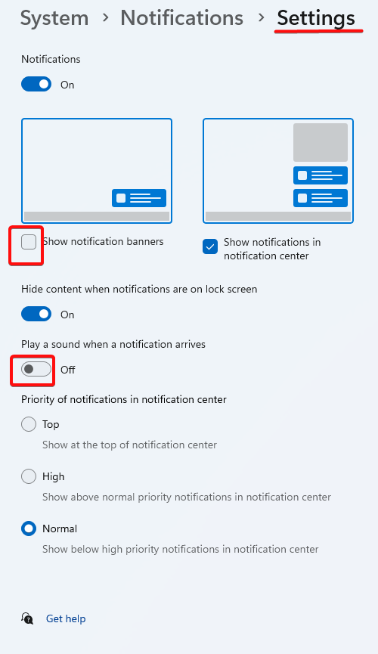

## POWER

If you have Laptop then there is work for you right here, other than that, you don’t need too do too much here.

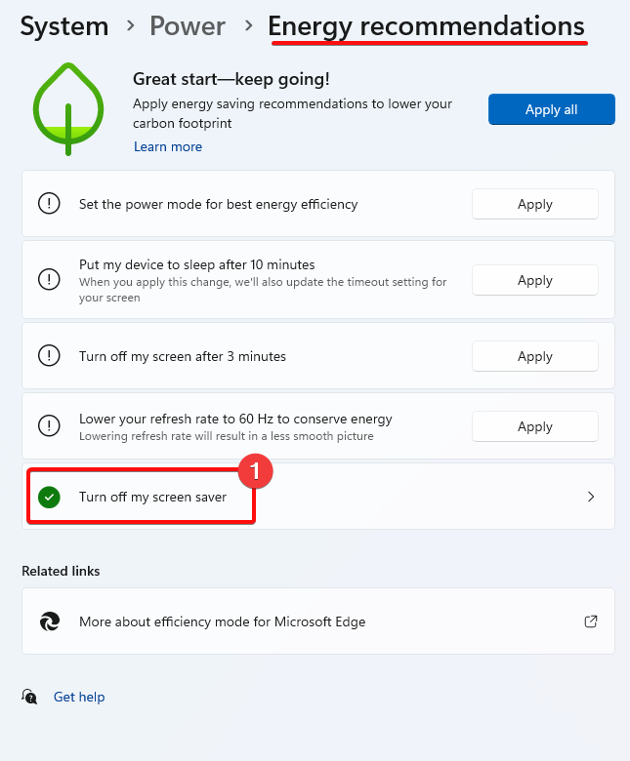

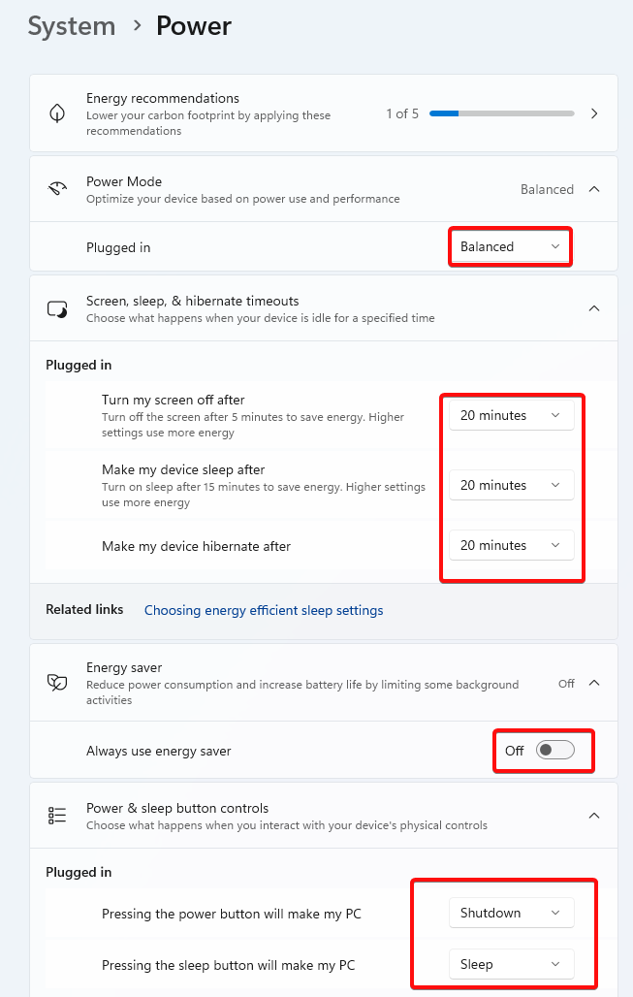

## MULTITASKING

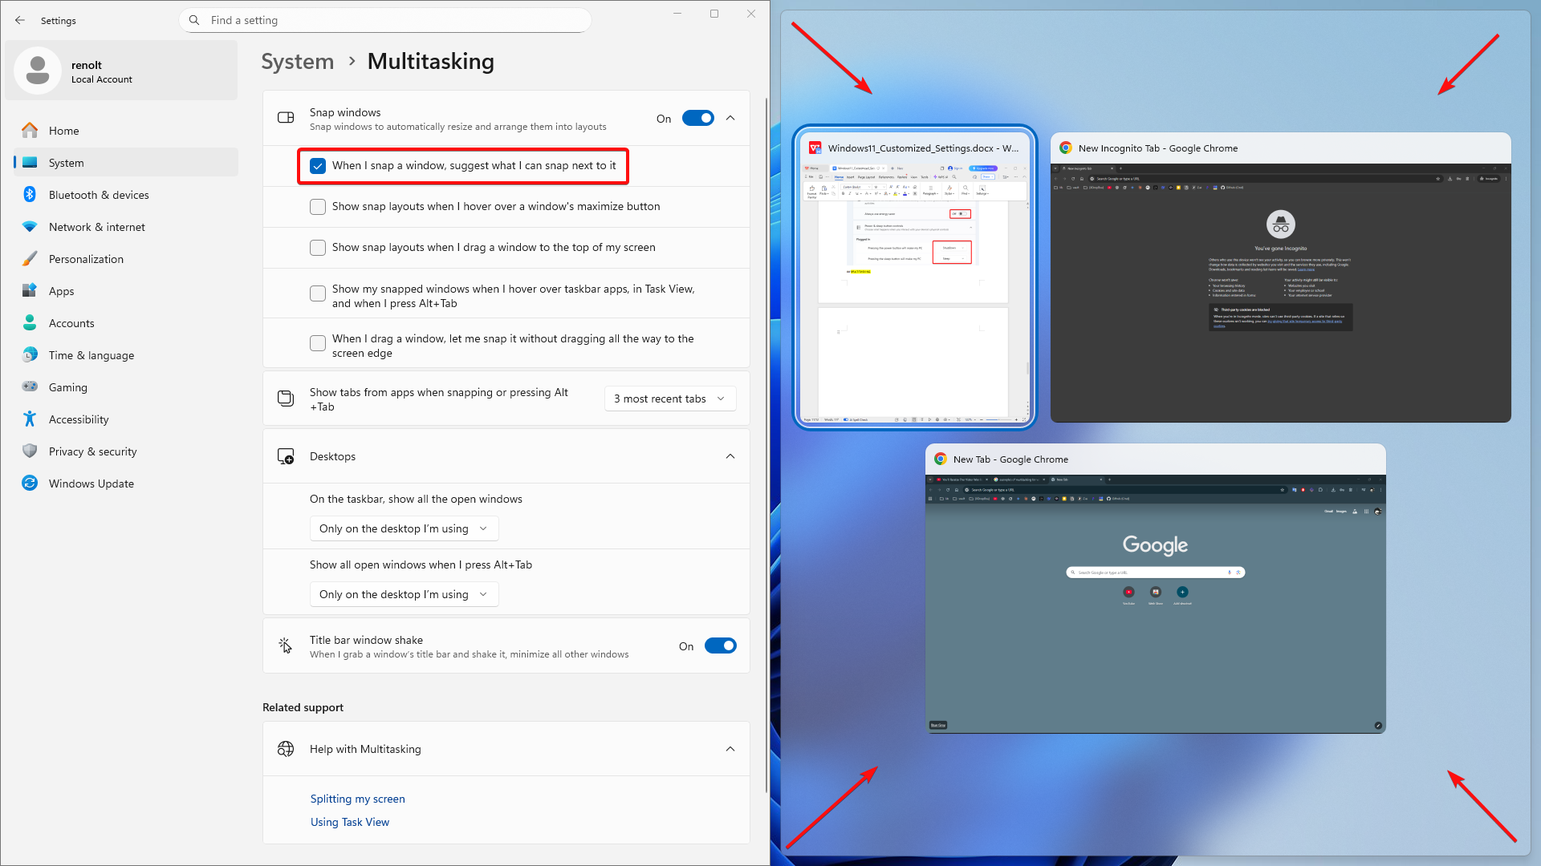

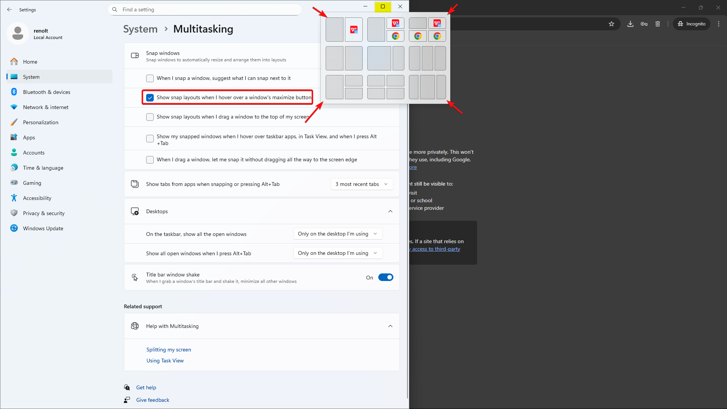

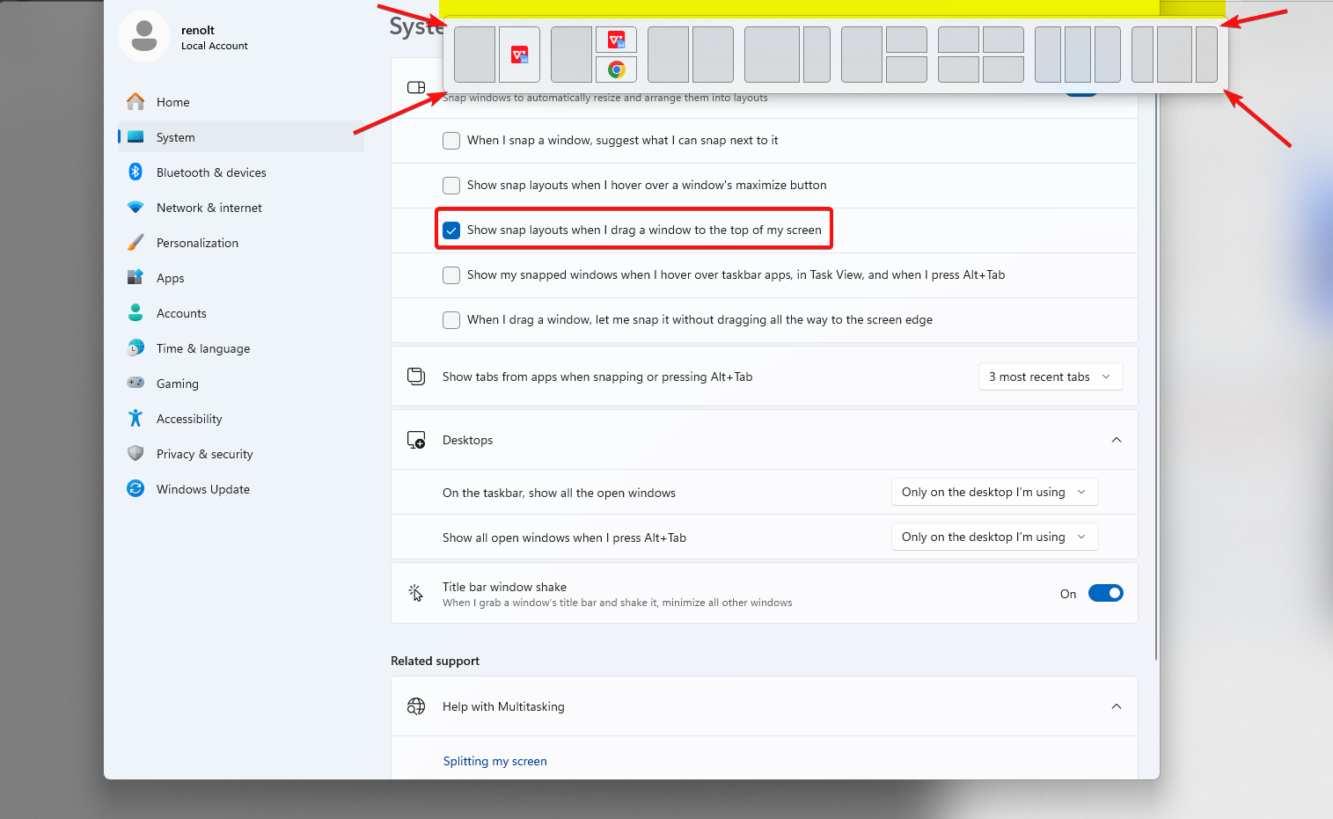

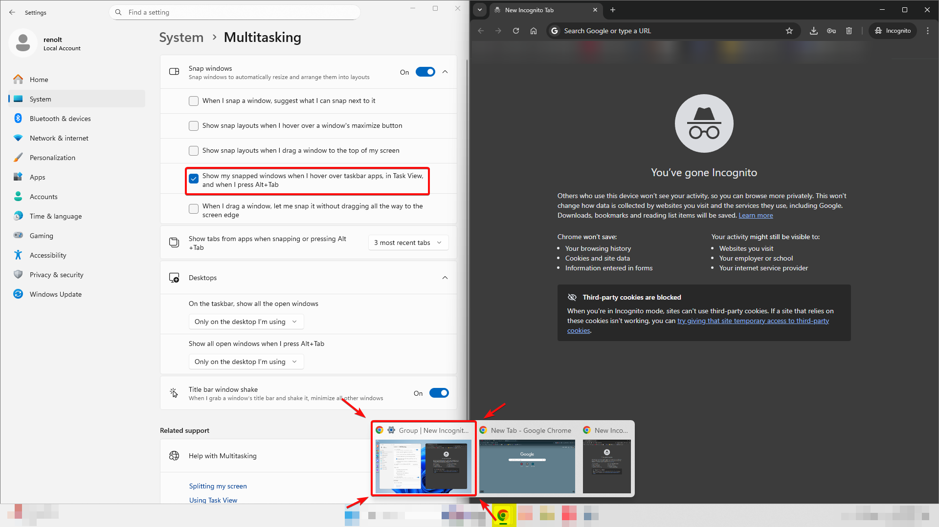

So after all of these My favourite Settings for these are :

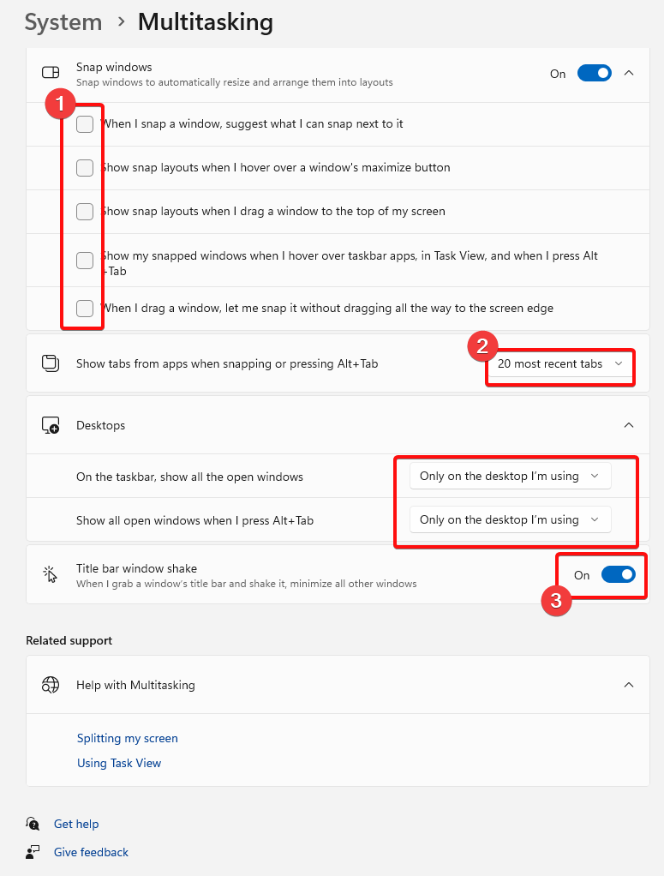

## ADVANCED

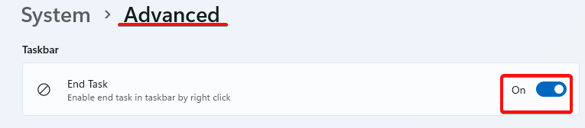
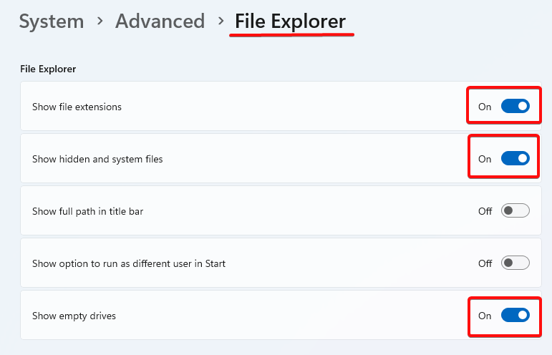

## CLIPBOARD

## ABOUT
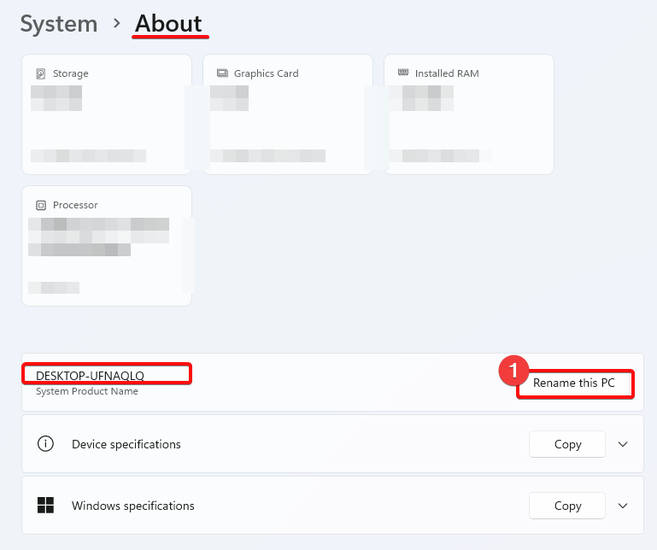

# NETWORK & INTERNET

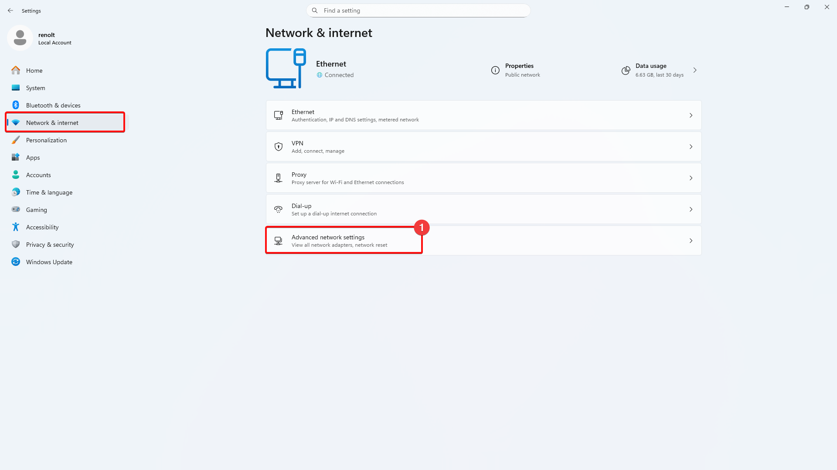

If the Ethernet is Disable, Enable it & also if you want you can change its name (I leave it by default)

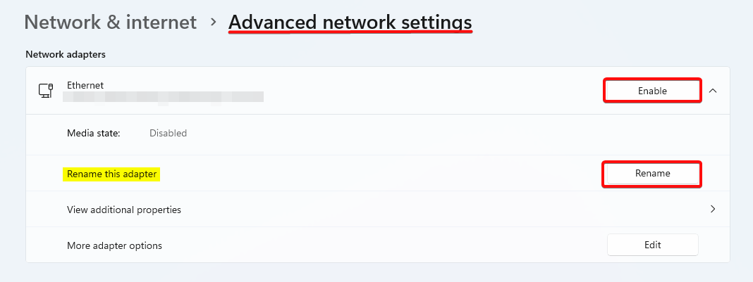

# PERSONAL

## Background

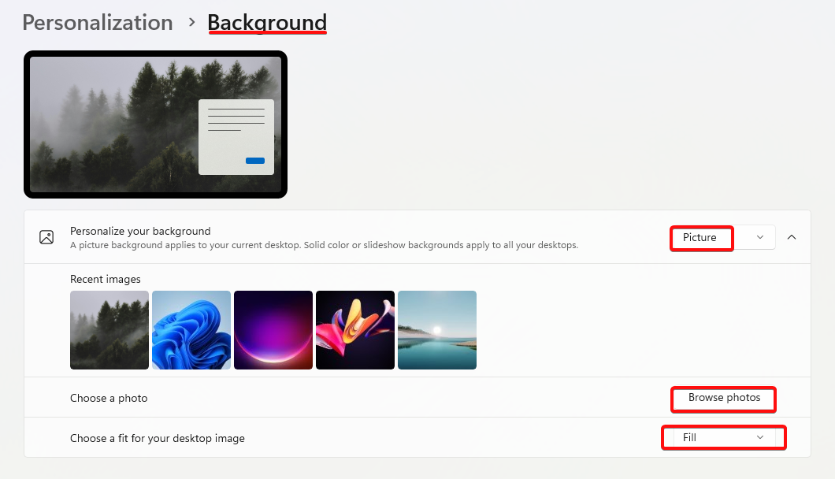

## COLORS
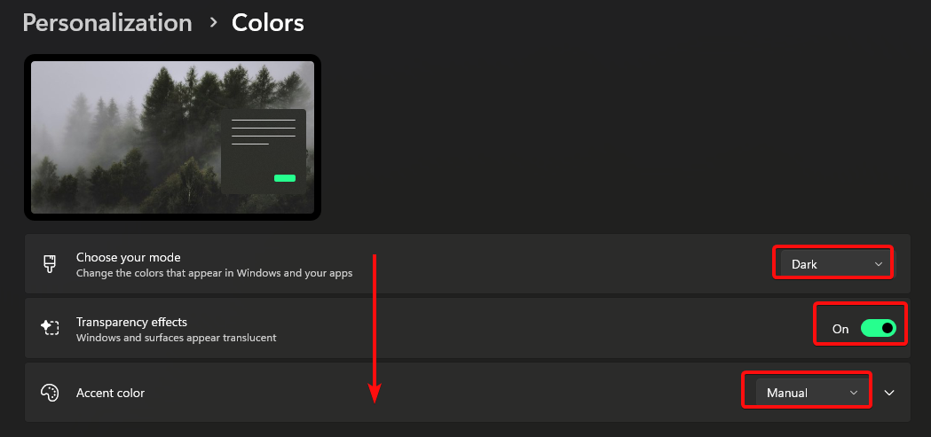

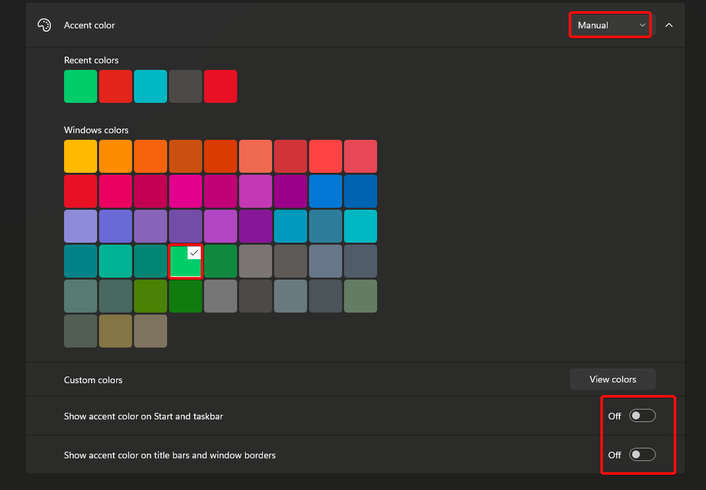

## DYNAMIC LIGHTING

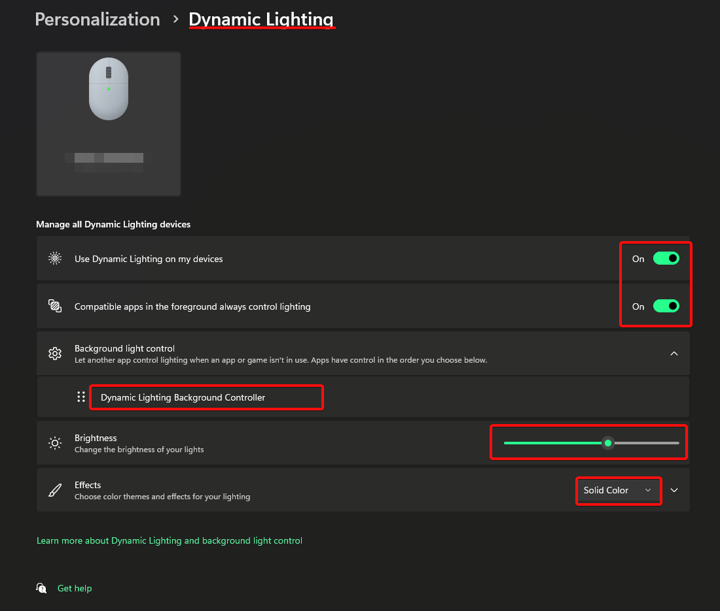

## LOCK SCREEN

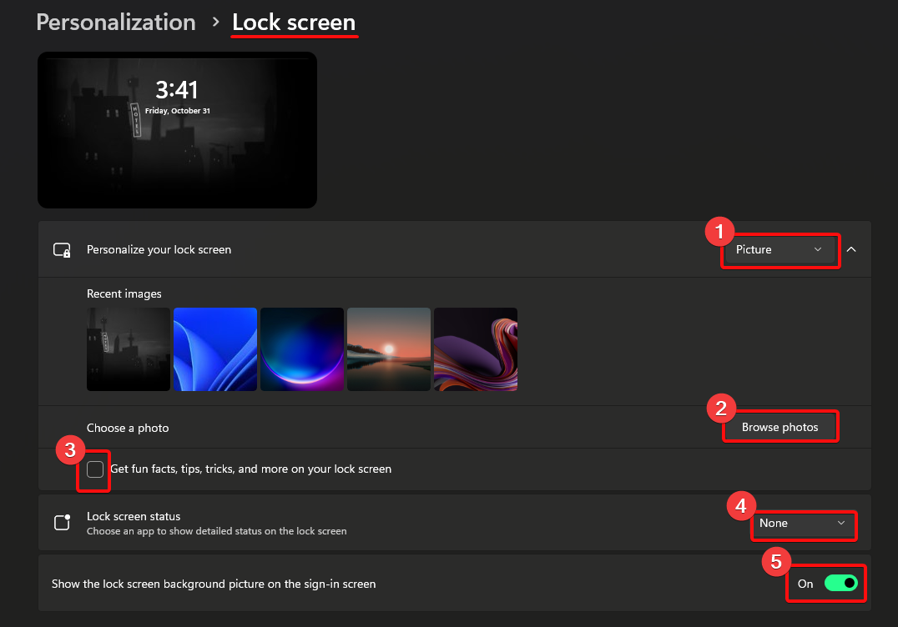
## START

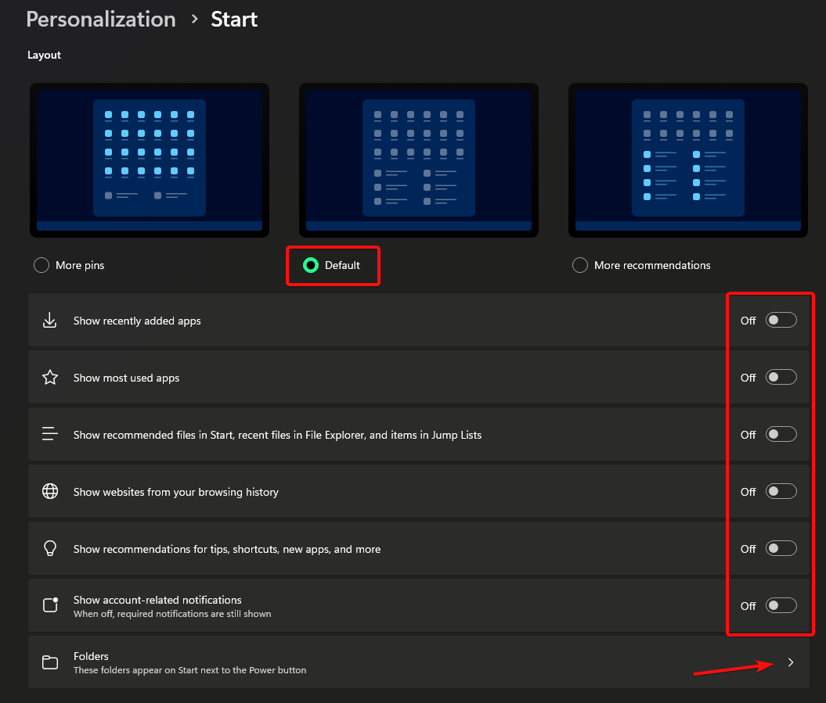

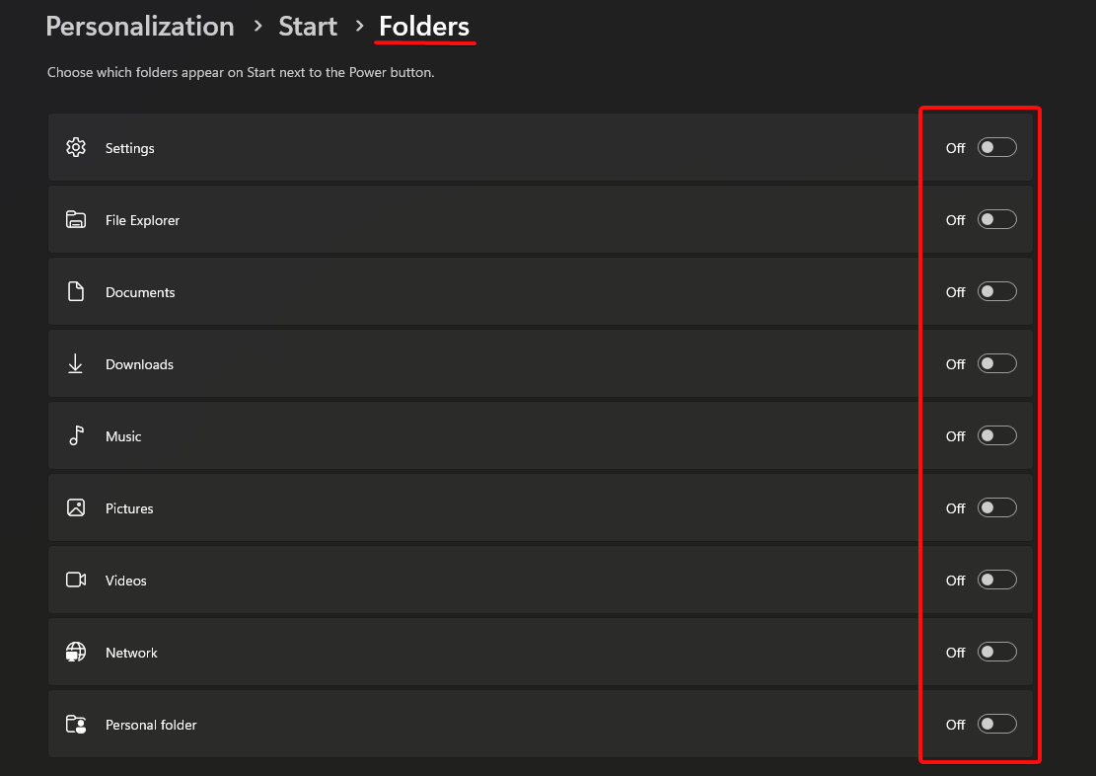

## TASKBAR

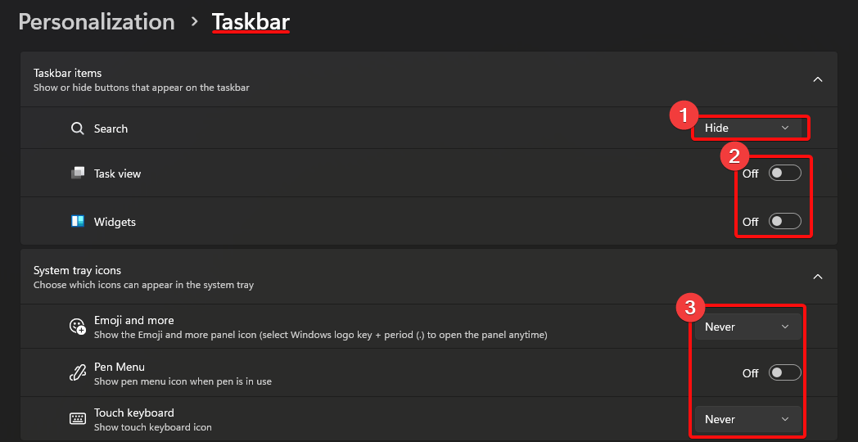

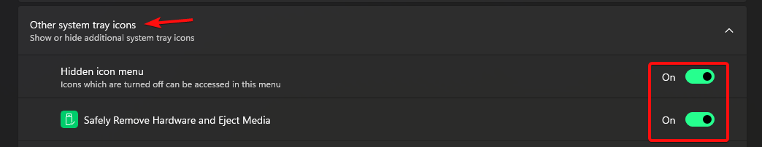

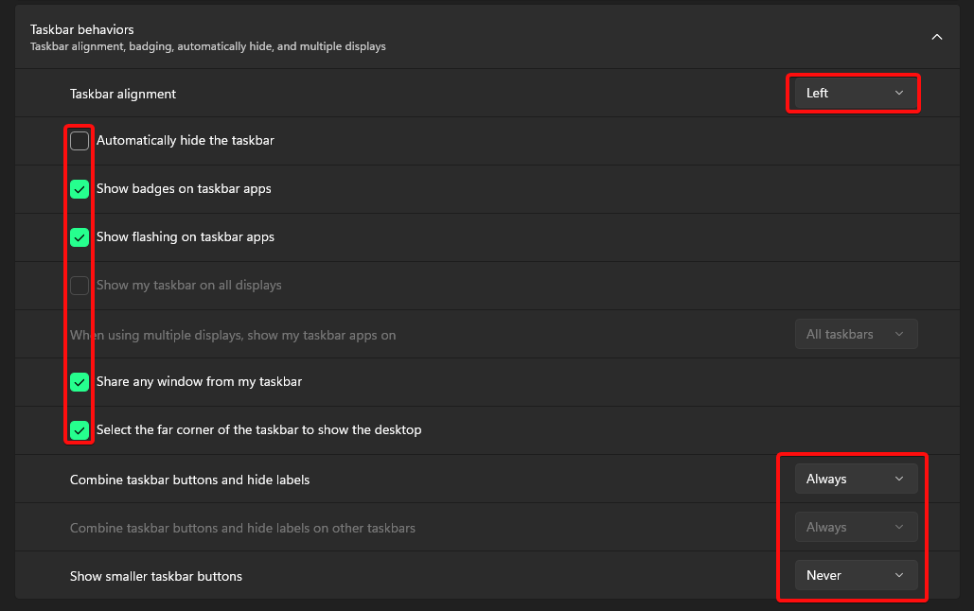

# APPS

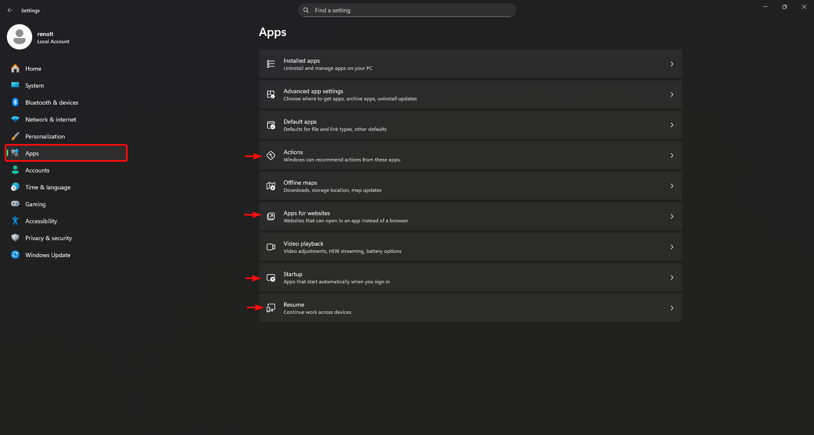

## ACTIONS

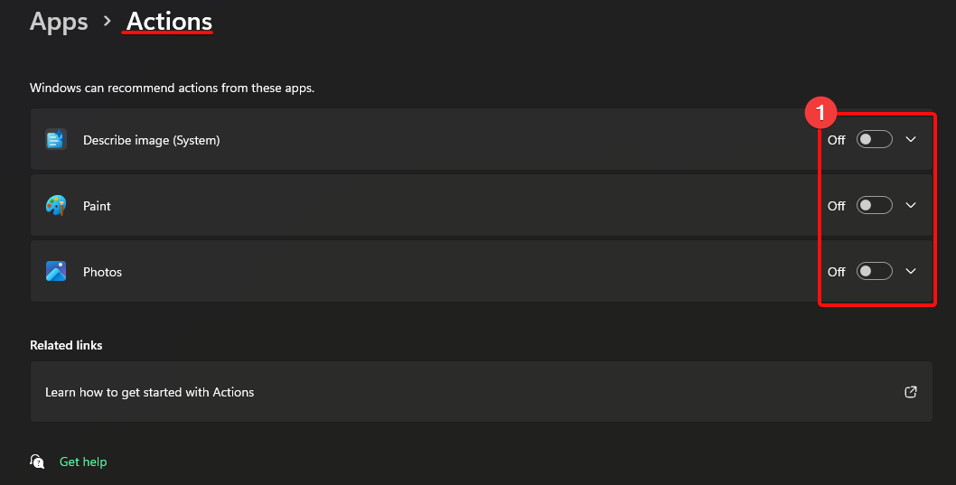

## APPS FOR WEBSITES

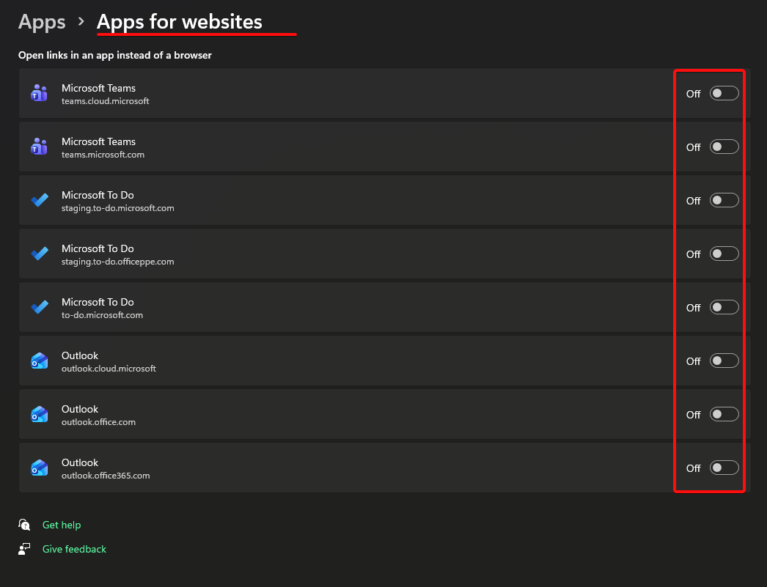

## STARTUPS

As you install new software’s you should come to place and edit at your own (This will be quite frequently)

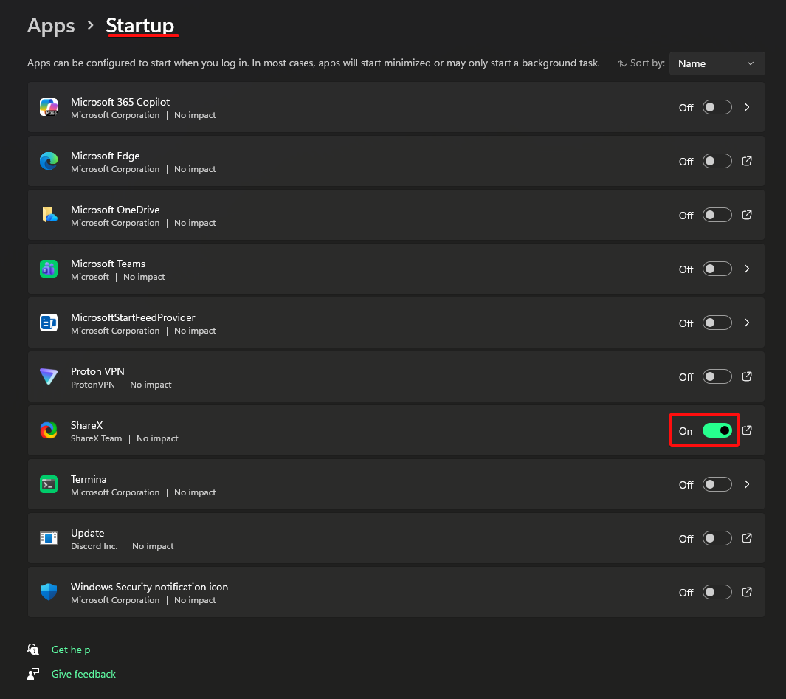

## RESUME

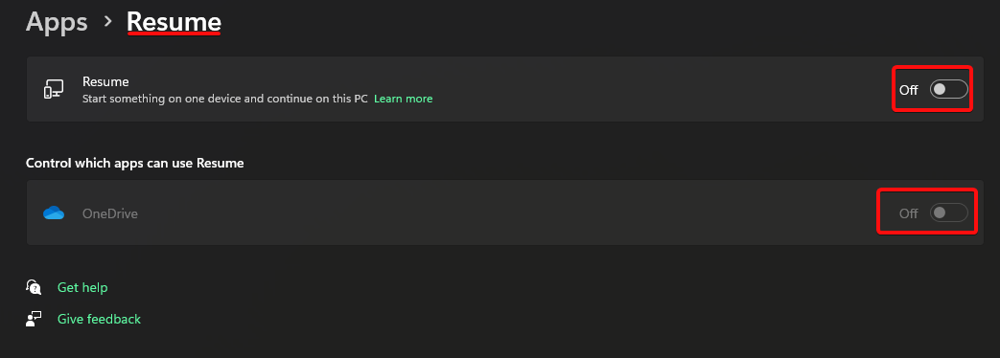

# ACCOUNTS

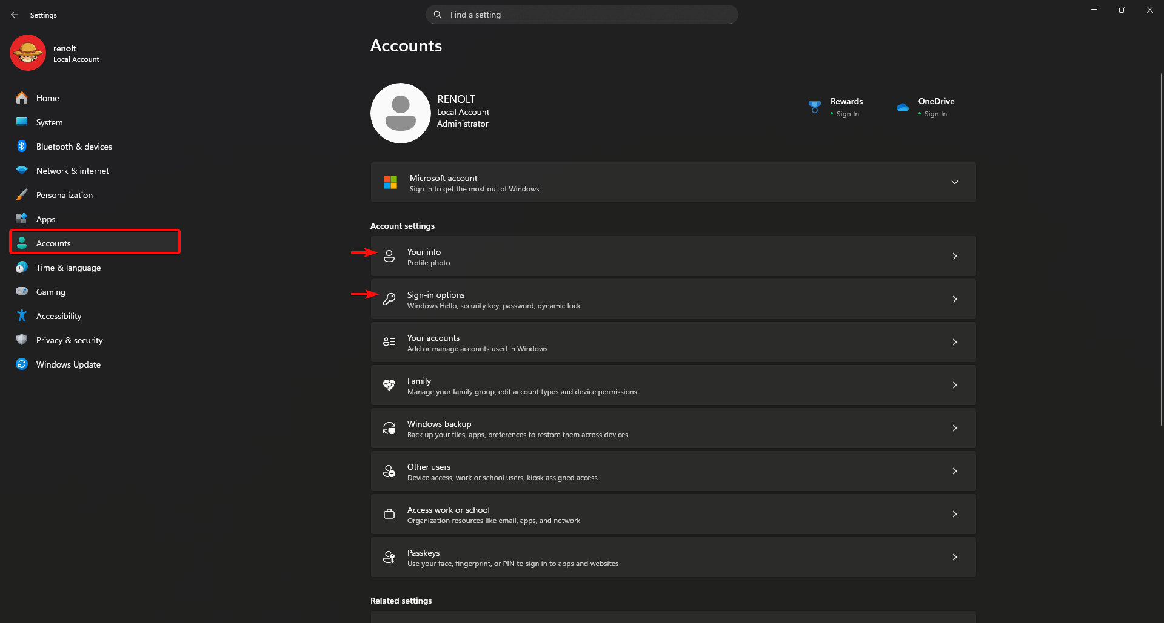

## YOUR INFO

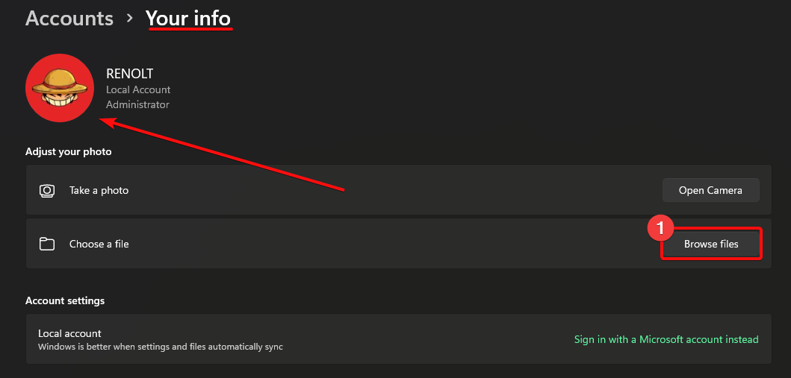

## SIGN IN OPTIONS

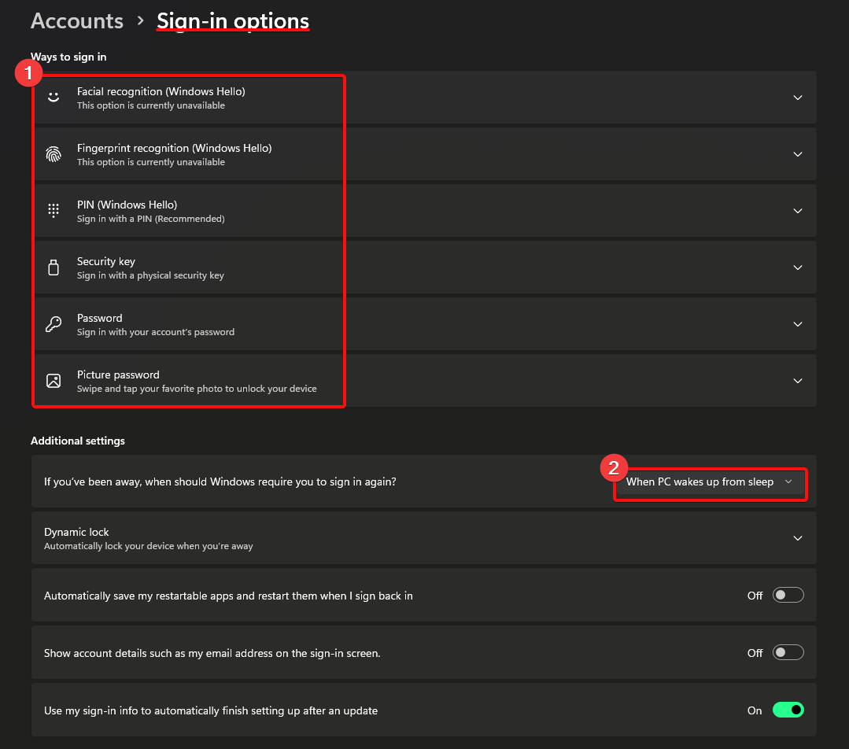

# TIME & LANGUAGE

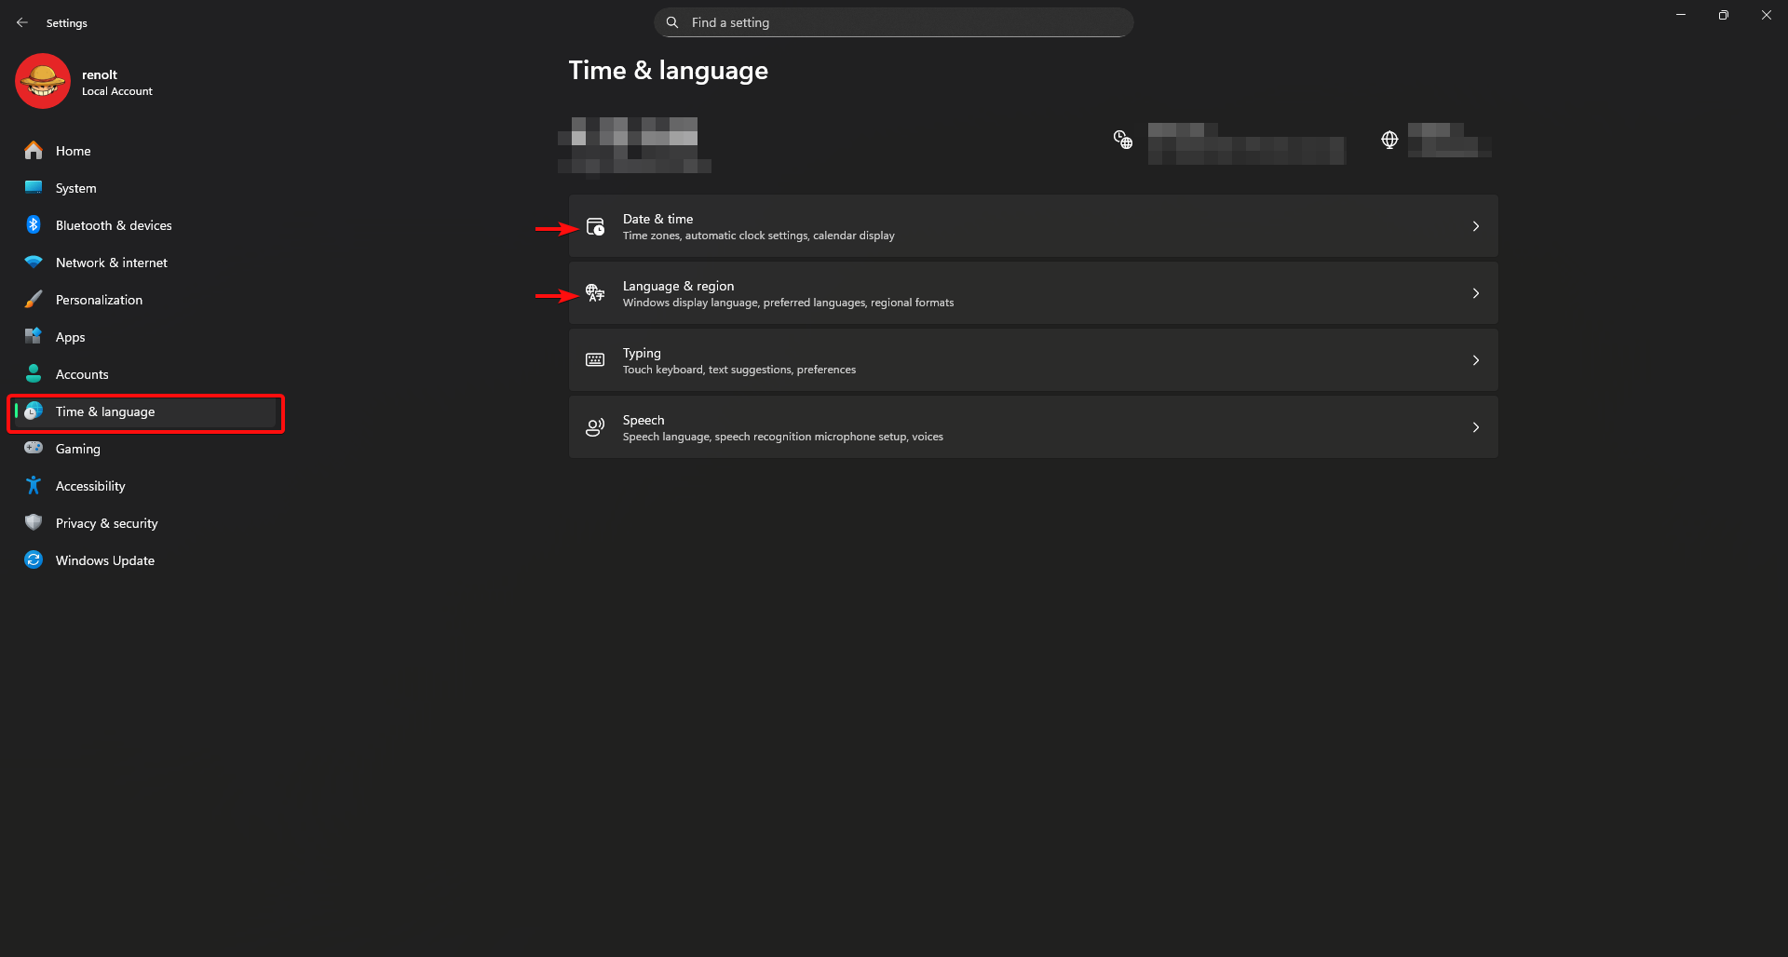

## DATE & TIME
Choose your UTC based Time Zone so that you can automatically set the time

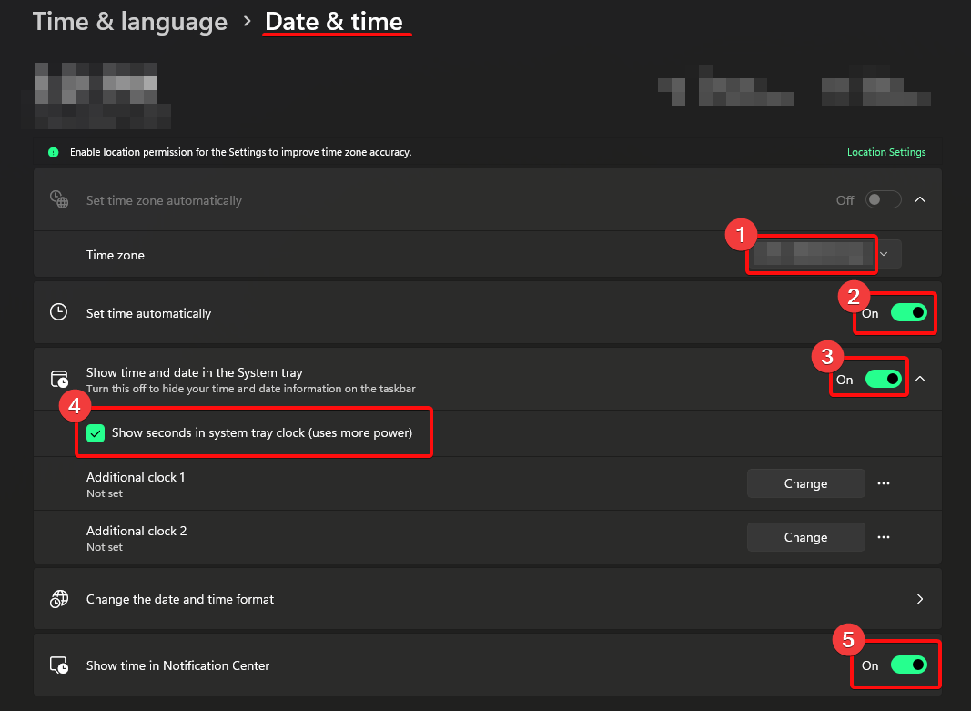

## LANGUAGE & REGION

These are all Default values (It has been edited when windows setup was being install.)

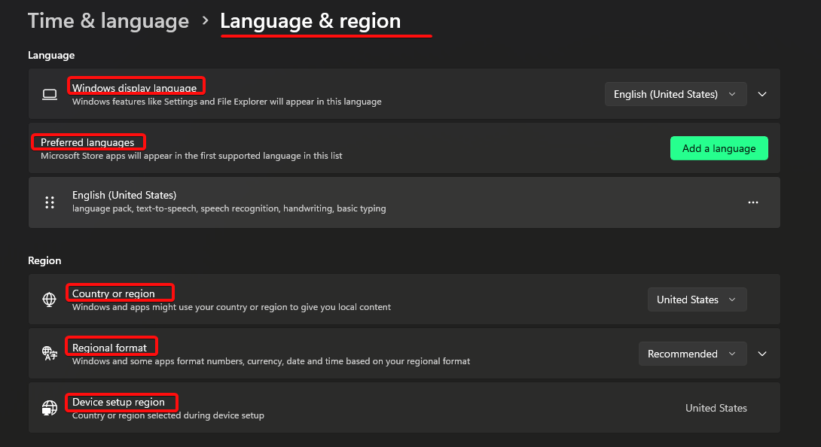

# ACCESSIBILITY

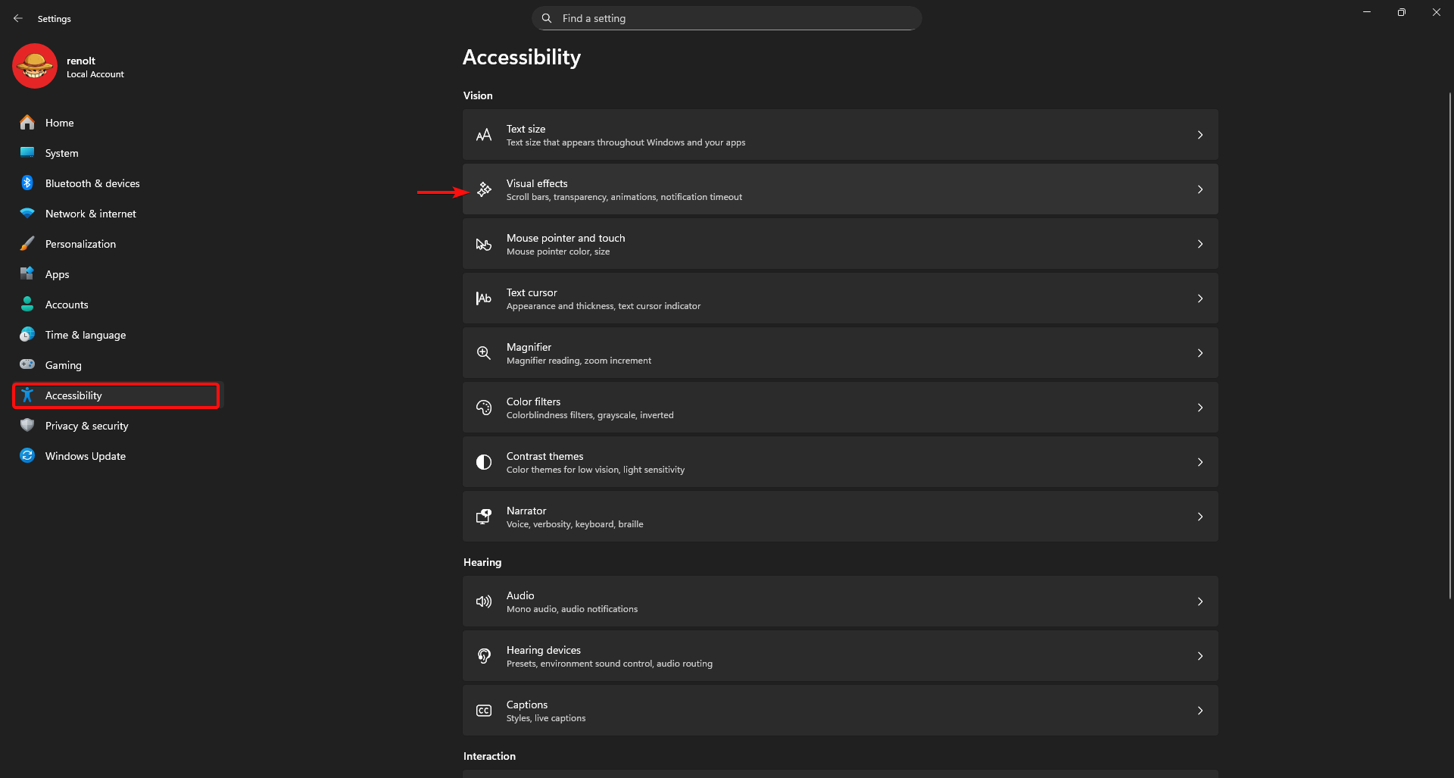

## VISUAL EFFECTS

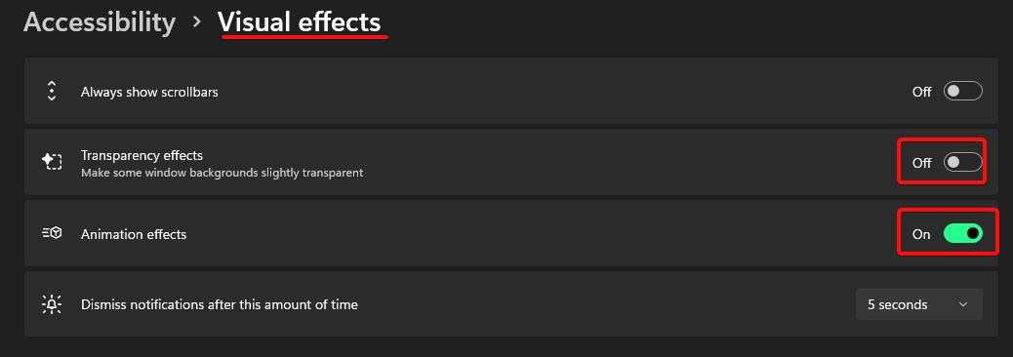

# PRIVACY & SECURITY

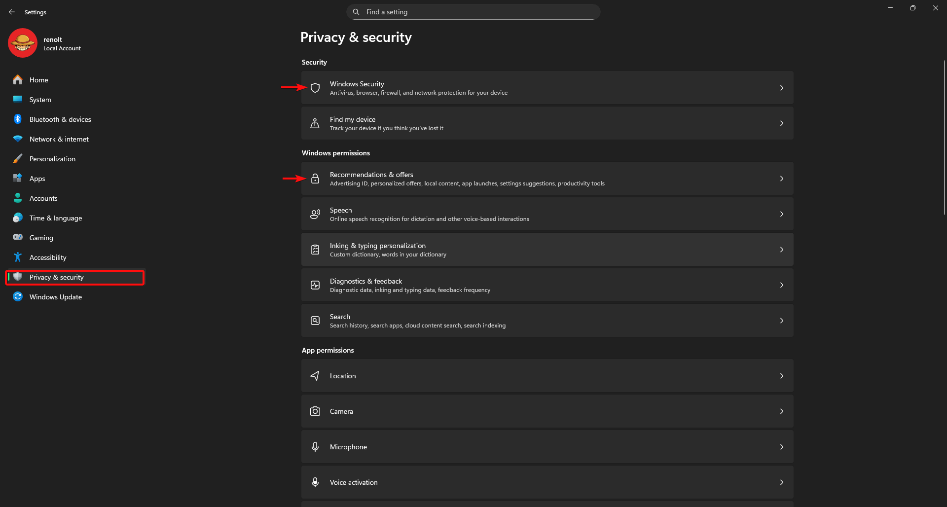

## WINDOWS SECURITY

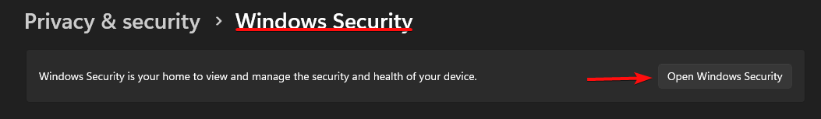

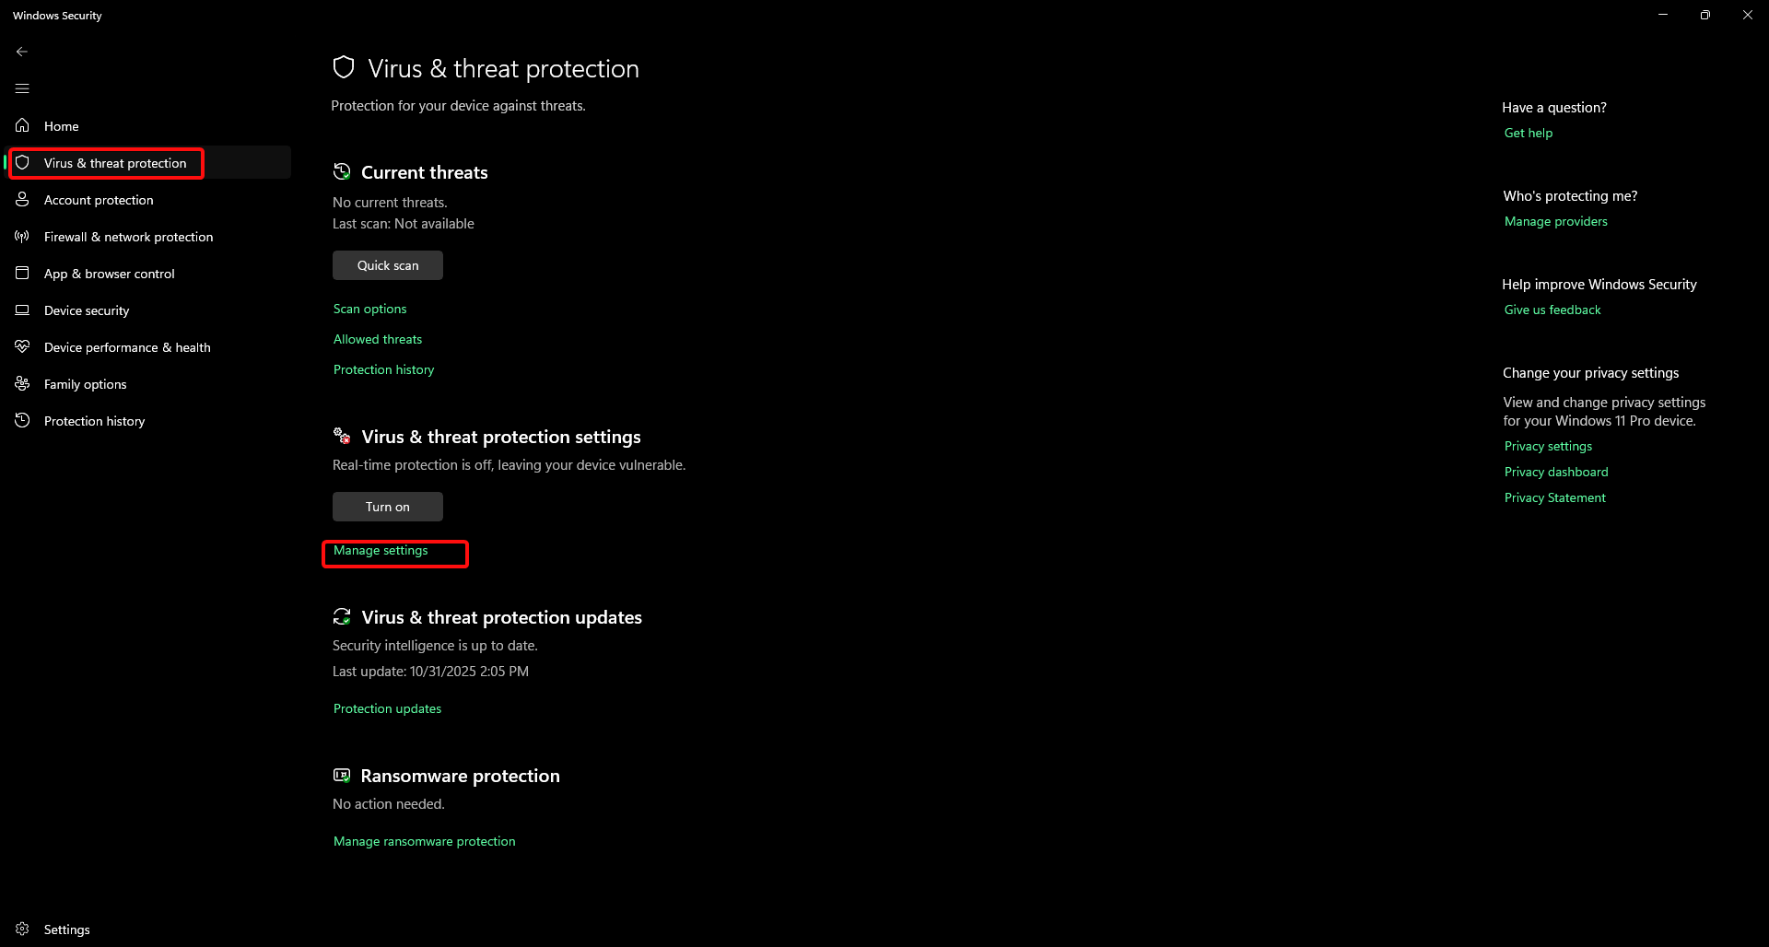

This is my personal Preferences you should not do this unless you know what you are doing.

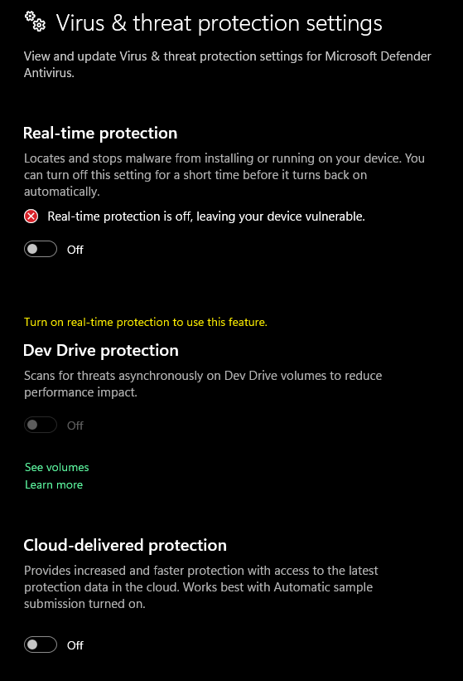

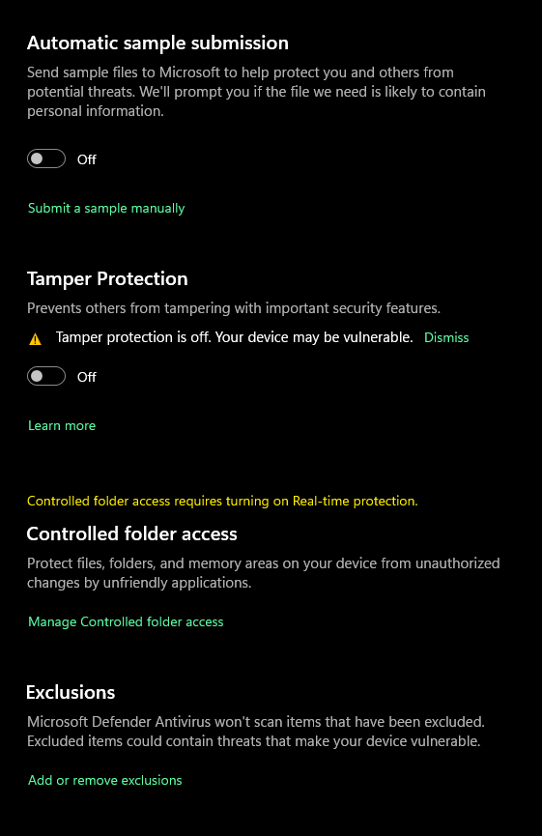

## RECOMMENFATIONS & OFFERS

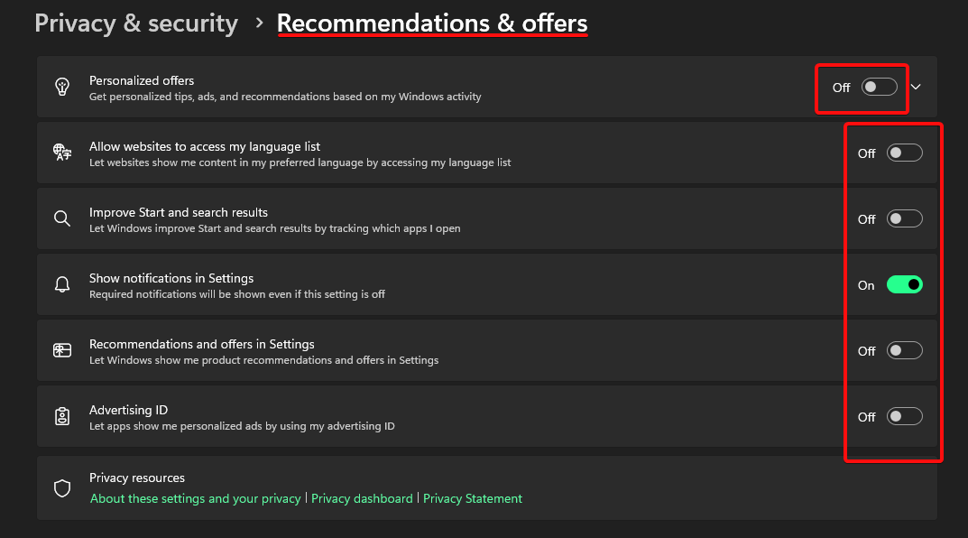

End

