**TENT GAMİNG**

**Üyeler** : Esat Ertuğrul FİLİZ

Bartu DUMAN

Erdem KURU

Hasan KAPLAN

**Mail** : [181805066@stu.adu.edu.tr](mailto::181805066@stu.adu.edu.tr)

[181805056@stu.adu.edu.tr](mailto:181805056@stu.adu.edu.tr)

[161805058@stu.adu.edu.tr](mailto:161805058@stu.adu.edu.tr)

161805052@stu.adu.edu.tr

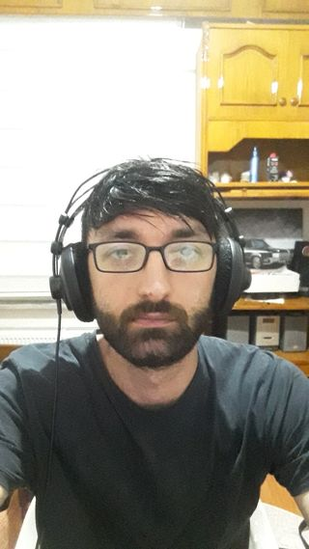

My name is Esat Ertuğrul Filiz. I was born in Istanbul in 1993. I went to Sağmalcılar Anatolian High School.

I have played professional basketball for many years and have been playing guitar for 9 years. Sports, music and exploring new places without breaking away from nature are my biggest hobbies. I have a curious and adventurous personality who is sensitive to the events around me,loves research,thinks that a person grows a little more not with time but with every knowledge he/she learns.

I am a university student who aims to be a software developer who has a practical intelligence, who tries to solve the problem he faces himself, is responsible and does not advocate that he knows a subject he does not know.

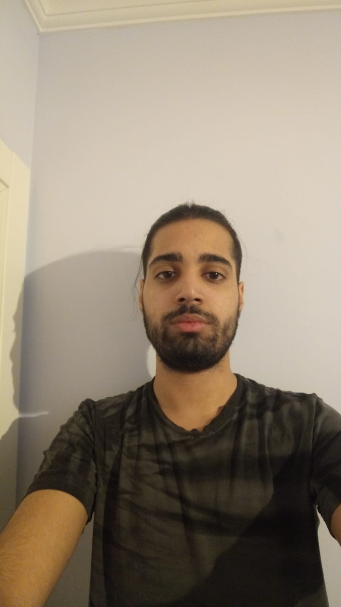

My name is Bartu Duman. I was born in İstanbul in 1999. I studied at Seahorse College until high school Then I went to Hayrullah Kefoğlu Anatolian High School I played basketball professionally . I also tried football and swimming for a while . Currently, frequently follow basketball and football matches . As a junior in college who who majors in computer science engineering, I try to improve myself in coding . I am interested in cybersecurity . My goal is to go abroad , learn several different languages and improve myself in my proffesion.

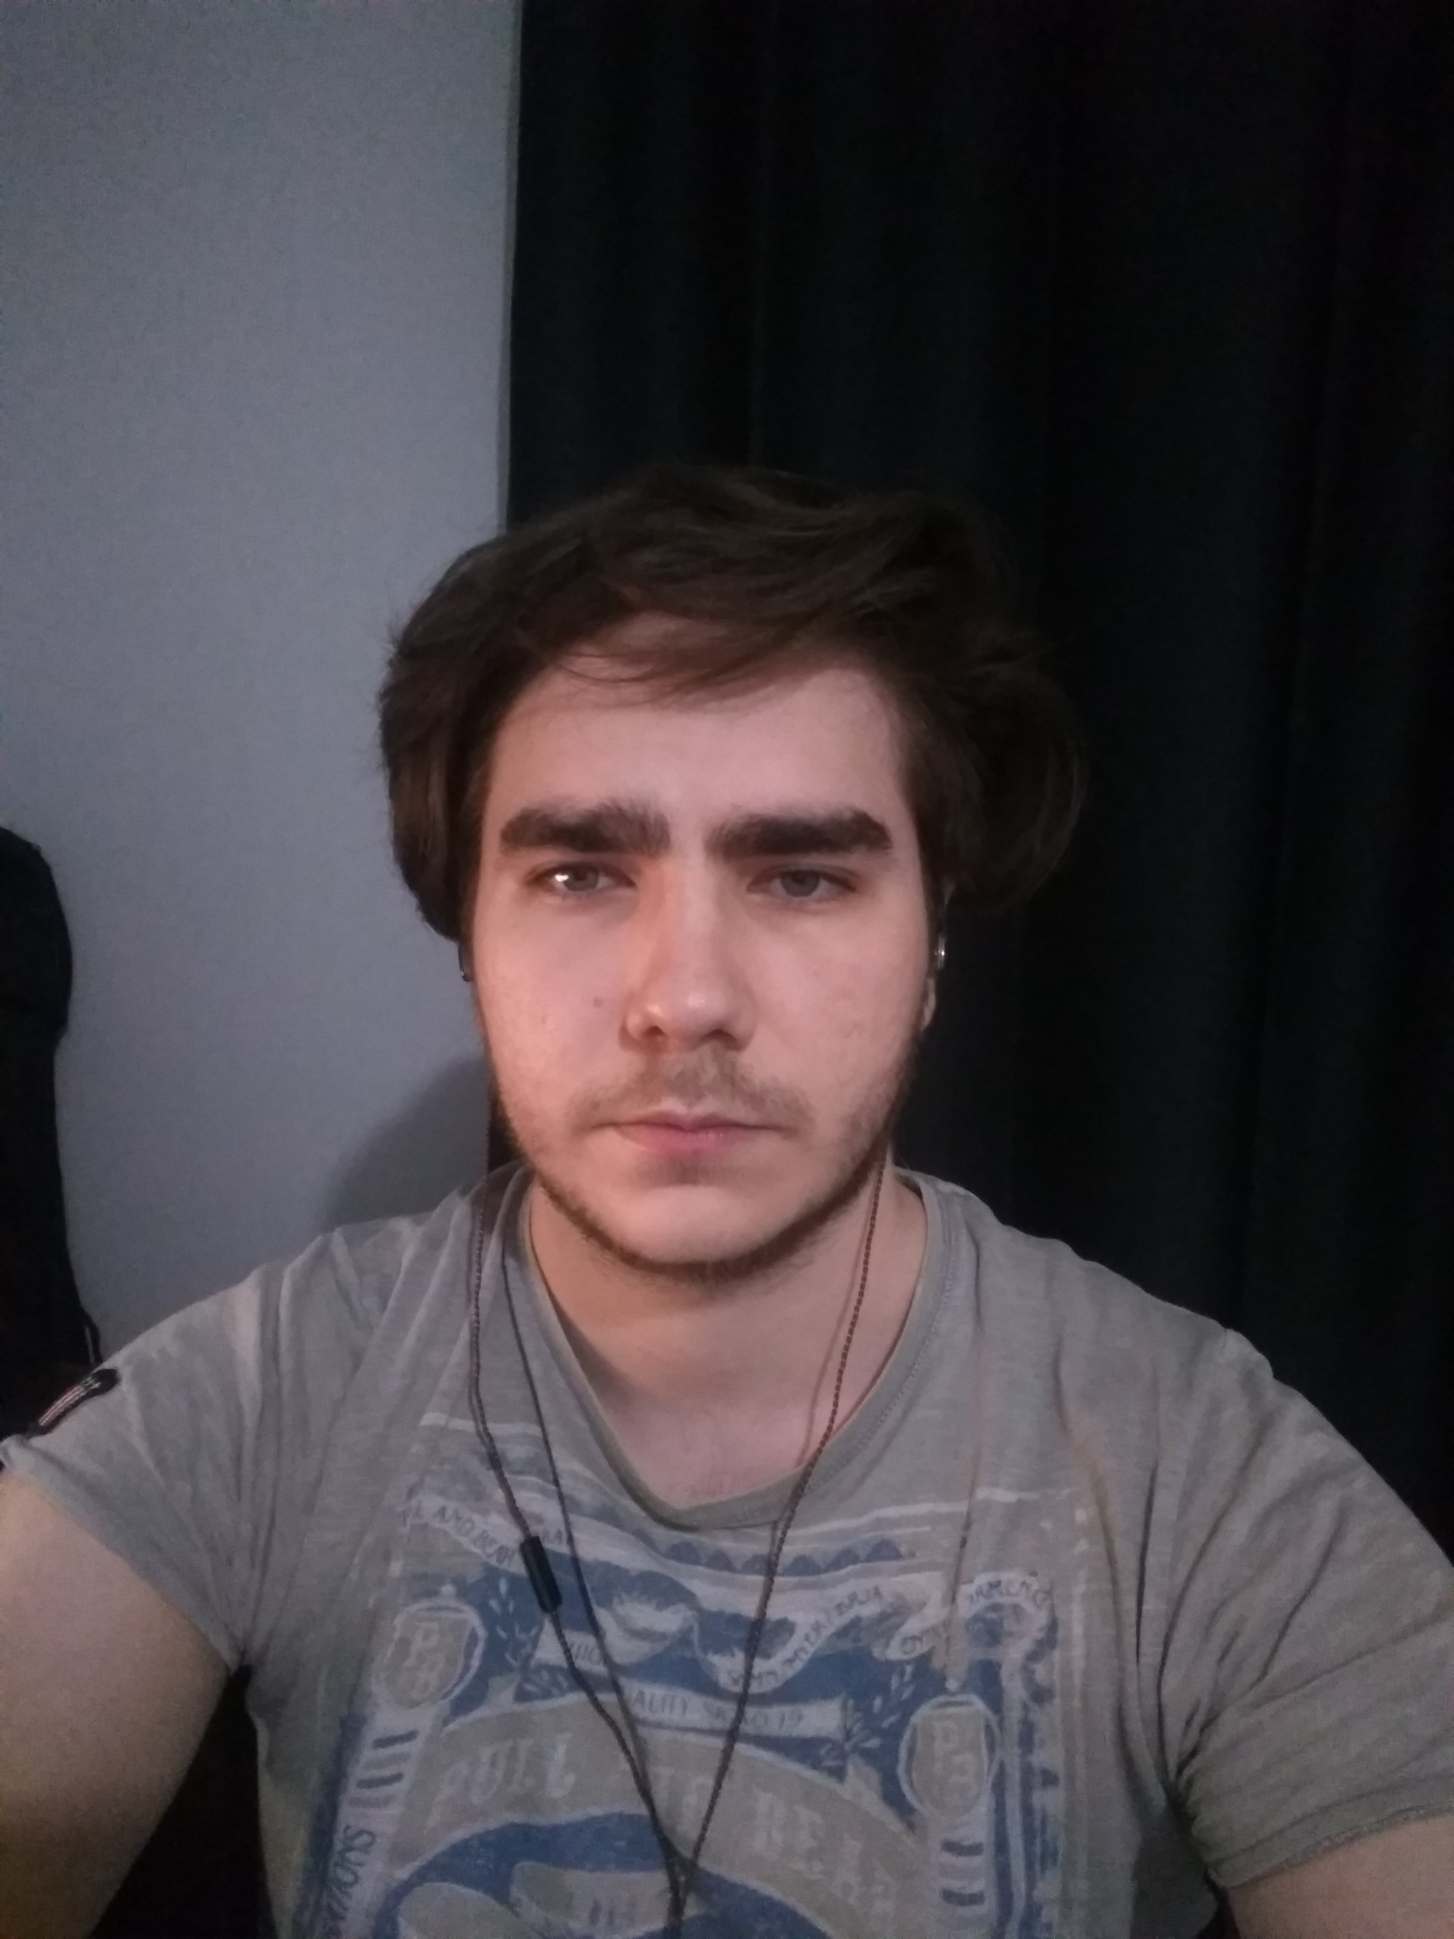

My name is Erdem KURU . I was born in İstanbul in 2000. I studied in Hızırreis primary school then i passed Cahit elginkan Anatolian High School.

I started to programming when i was 16 years old . My first program was a calculator. Then after high school i go to Adnan menderes universty for study. My department is Computer engineering. My hobbies are bodybuilding and computer games. I devoloped games for my carier and i aim for the big game company.

As a summary i am a student who have plans for his life and carier. Also i am a game developer and i love this job.

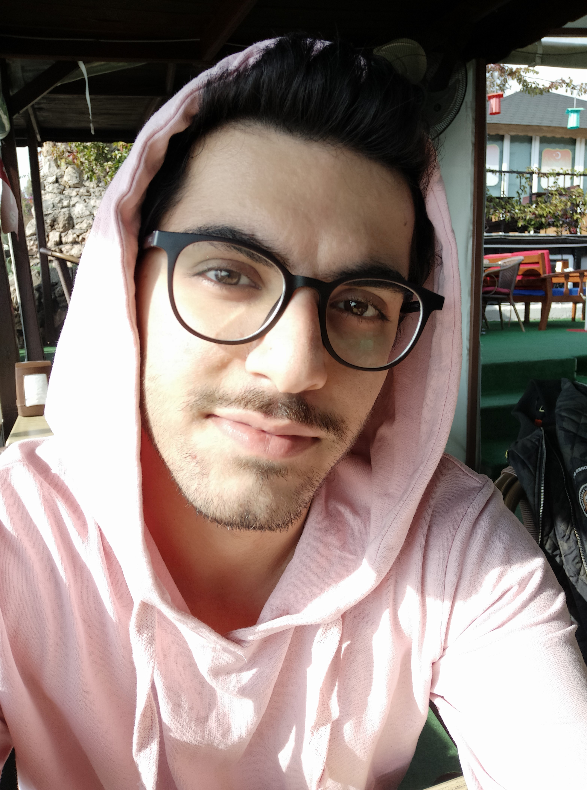

My name is Hasan. I was born in Ankara in 1997. I went to Paşa Karaca Anatolian Teacher High School.

I played basketball in school team. Computer games and reading books my hobbies.Firstly i want coding game but its so hard for one person after ı create youtube channel. I create game videos for my youtube channel. Im enjoying while video editing and ı earn my money.

I am a student at Adnan Menderes University. I want to be game developer or i want to improve my channel. I hope ı will reach one of my goals

The screenshoot of first meeting

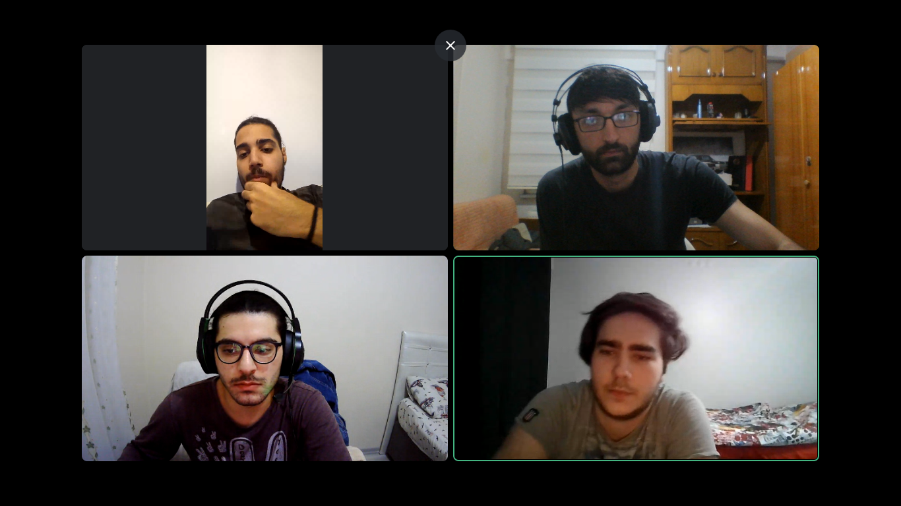

Team agreements

* We will use phone,whatsapp,discord for communication
* We will check our messages in every 2 day
* We will plan meeting one in every week
* Everyone will complate their tast for meeting , Bartu will takes notes
* Ertuğrul will desing the game concept,Hasan will work on game effects,Bartu and Erdem will coding.
* Erdem will submit assignments.
* There will be a 2 group Hasan and Ertuğrul will be a first Erdem and Bartu will be the second . When one of group members will dropout other one takes his job.

[JasamGudzevic](https://github.com/JasamGudzevic) -Ertuğrul

ErdemKuru – Erdem

Hasankaplan01 –Hasan

Bartu-duman - Bartu