

**CC5067 Coursework Report**

**NHS waiting times, 16 January to 15 February 2024**

Name: Hasan Khan

ID Number: 21002595

Contents

Abstract/Summary: 2

Part A: 3

Topic: 3

Relevant Data: 3

Background and Related: 4

What is the Data: 5

PART B: 6

Importing Data into Power BI: 6

Design an Efficient and Interactive Dashboard Using Different Visualisation Charts: 6

Analysing the Data: 7

PART C: 9

Conclusion: 9

# Abstract/Summary:

NHS waiting times, 16 January to 15 February 2024

Source: GP Access Survey from the Office for National Statistics

Date published: 3 April 2024

Contact details

Statistical contact

The Policy Evidence and Analysis team:

+44 (0)300 0671543

Policy.Evidence.Analysis@ons.gov.uk

Media contact:

+44 (0)845 604 1858 or +44 (0)203 973 4761

Media.Relations@ons.gov.uk

# Part A:

## Topic:

NHS Waiting Times, 16th January to 15th February 2024

## Relevant Data:

Sampling Information:

Sex – Male/Female.

Age [Category5] - Aged 16 to 24, Aged 25 to 34, Aged 35 to 49, Aged 50 to 69, Aged 70 and over

Age [Category 8]- Aged 16 to 24, Aged 25 to 34, Aged 35 to 44, Aged 45 to 54, Aged 55 to 64, Aged 65 to 74, Aged 75 to 84, Aged 85 and over.

Age+Sex Group - Female: Aged 16 to 24, Female: Aged 25 to 34, Female: Aged 35 to 44, Female: Aged 45 to 54, Female: Aged 55 to 64, Female: Aged 65 to 74, Female: Aged 75 to 84, Female: Aged 85 and over, Male: Aged 16 to 24, Male: Aged 25 to 34, Male: Aged 35 to 44, Male: Aged 45 to 54, Male: Aged 55 to 64, Male: Aged 65 to 74, Male: Aged 75 to 84, Male: Aged 85 and over

Ethnic Group - Asian or Asian British, Black, African, Caribbean, or Black British, Mixed or Multiple ethnic groups, White, Other Ethnic Group.

Disability Status - Disabled, Non-disabled, Disability status not disclosed.

Disability Severity - Disabled - limited a little, Disabled - limited a lot, Non-disabled - No Health Condition, Non-disabled - non-limiting health condition, Disability status not disclosed.

Region - North East, North West, Yorkshire and The Humber, East Midlands, West Midlands, East of England, London, South East, South West.

Employment Status - In Employment, In Education, Unemployed, Economically Inactive, Employee, Self-Employed, In Education - College or Apprenticeship, In Education - University, Unemployed, Economically Inactive - Long-Term Sick, Economically Inactive - Looking After Family or Home or doesn't want work, Economically Inactive – Retired.

Career Status - Provides unpaid care, Does not provide unpaid care, Provides unpaid care for 9 hours a week or less, Provides unpaid care for 10 to 19 hours a week, Provides unpaid care for 20 to 34 hours a week, Provides unpaid care for 35 to 49 hours a week, Provides unpaid care for 50 or more hours a week, Does not provide unpaid care.

long Covid Status - Reports having Long Covid, Does not report having Long Covid

Integrated Care Board - NHS Bath and North East Somerset, Swindon and Wiltshire Integrated Care Board, NHS Bedfordshire, Luton and Milton Keynes Integrated Care Board, NHS Birmingham and Solihull Integrated Care Board, NHS Black Country Integrated Care Board, NHS Bristol, North Somerset and South Gloucestershire Integrated Care Board, NHS Buckinghamshire, Oxfordshire and Berkshire West Integrated Care Board, NHS Cambridgeshire and Peterborough Integrated Care Board, NHS Cheshire and Merseyside Integrated Care Board, NHS Cornwall and the Isles of Scilly Integrated Care Board, NHS Coventry and Warwickshire Integrated Care Board, NHS Derby and Derbyshire Integrated Care Board, NHS Devon Integrated Care Board, NHS Dorset Integrated Care Board, NHS Frimley Integrated Care Board, NHS Gloucestershire Integrated Care Board, NHS Greater Manchester Integrated Care Board, NHS Hampshire and Isle of Wight Integrated Care Board, NHS Herefordshire and Worcestershire Integrated Care Board, NHS Hertfordshire and West Essex Integrated Care Board, NHS Humber and North Yorkshire Integrated Care Board, NHS Kent and Medway Integrated Care Board, NHS Lancashire and South Cumbria Integrated Care Board, NHS Leicester, Leicestershire and Rutland Integrated Care Board, NHS Lincolnshire Integrated Care Board, NHS Mid and South Essex Integrated Care Board, NHS Norfolk and Waveney Integrated Care Board, NHS North Central London Integrated Care Board, NHS North East London Integrated Care Board, NHS North East and North Cumbria Integrated Care Board, NHS North West London Integrated Care Board, NHS Northamptonshire Integrated Care Board, NHS Nottingham and Nottinghamshire Integrated Care Board, NHS Shropshire, Telford and Wrekin Integrated Care Board, NHS Somerset Integrated Care Board, NHS South East London Integrated Care Board, NHS South West London Integrated Care Board, NHS South Yorkshire Integrated Care Board, NHS Staffordshire and Stoke-on-Trent Integrated Care Board, NHS Suffolk and North East Essex Integrated Care Board, NHS Surrey Heartlands Integrated Care Board, NHS Sussex Integrated Care Board, NHS West Yorkshire Integrated Care Board.

Indices of Multiple Deprivation - 1st decile most deprived, 2nd decile, 3rd decile, 4th decile, 5th decile, 6th decile, 7th decile, 8th decile, 9th decile, 10th decile least deprived.

## Background and Related:

This dataset includes information on GP practice access experiences and NHS waiting times and is published alongside data from the Opinions and Lifestyle Survey (OPN). While the OPN and this dataset share similar questions, there may be discrepancies due to differences in scope, question definition, and data collection methods. It's important to acknowledge that the estimates in this dataset are based on self-reported data, potentially leading to variations when compared to other data sources, including official measures, and for administrative data on NHS waiting lists, an alternative source is recommended.

Smilarly there are datasets for:

Experiences of GP practice access and NHS waiting times, England, 17 to 28 January 2024 ¬ Release Date: 3rd April 2024 ¬ Author: The Policy Evidence and Analysis Team (Policy.Evidence.Analysis@ons.gov.uk) ¬ Available at: <https://www.ons.gov.uk/peoplepopulationandcommunity/healthandsocialcare/healthcaresystem/datasets/experiencesofgppracticeaccessandnhswaitingtimesengland17to28january2024> ¬ Date Accessed: 08/04/2024

Experiences of GP practice access, 16 January to 15 February 2024 ¬ Release Date: 3rd April 2024 ¬ Author: The Policy Evidence and Analysis team Policy.Evidence.Analysis@ons.gov.uk) ¬ Available at: <https://www.ons.gov.uk/peoplepopulationandcommunity/healthandsocialcare/healthcaresystem/datasets/experiencesofgppracticeaccess16januaryto15february2024> ¬ Date Accessed: 08/04/2024

Mental Health Services Monthly Statistics - Access and Waiting Times ¬ Release Date: 12th April 2018 ¬ Author: NHS Digital ¬ Available at: <https://www.data.gov.uk/dataset/299e55ef-2bce-4976-8732-75f225c7a5f3/mental-health-services-monthly-statistics-access-and-waiting-times> ¬ Date Accessed: 08/04/2024

## What is the Data:

Worksheet 1: Are you currently waiting for a hospital appointment, test, or to start receiving medical treatment through the NHS?

11 Columns, 512 rows.

Worksheet 2: How long have you been waiting for a hospital appointment, test, or to start receiving medical treatment through the NHS? If you are waiting to start treatment for multiple conditions, please tell us about the longest wait.

11 Columns, 1280 rows.

Variables:

Response – Yes, No, Do not know, Prefer not to say.

Upper Confidence Limit (UCL) - represents the upper boundary of a confidence interval (a range of values that contains the true population parameter with a certain level of confidence), indicating the highest plausible value for a parameter estimated from a sample.

The Lower Confidence Limit (LCL) - the lower boundary of a confidence interval, indicating the lowest plausible value for a parameter estimated from a sample.

Weighted Count - adjusts survey responses to accurately reflect the demographic distribution of the population, considering survey design and non-response factors.

Sample size - refers to the number of respondents or observations included in a survey/study for each question with a response option.

Rounding - Rounding is the process of adjusting values to a specified degree of precision, to either a certain number of decimal places or significant figures.

Suppression and Shorthand - the withholding of specific data points such as estimates based on a small number of respondents (for quality and confidentiality reasons), shown by "[c]" or "[w]". Shorthand, on the other hand, involves using symbols like "[u]" for unreliable estimates based on a sample size of 10 or fewer respondents when rounded to the nearest 10, or "[x]" for when data is not available, ensuring clarity and consistency in reporting.

Age Standardised - Age Standardised Estimate %, Age Standardised LCL %, Age Standardised UCL %.

Response Option Sample - Unweighted Sample for Response Option, Weighted Sample for Response Option.

Breakdown Name and Breakdown Type – Sampling Information categories/variables (Worksheet 2).

# PART B:

## Importing Data into Power BI:

Applying data transformation: checking for errors and inconsistencies:

Checking for errors:

There were no errors in any of the tables.

Checking for Inconsistencies:

There were no inconsistencies or repeated data. Removing repeated data did remove columns and rows that were necessary to the dataset. Power BI should be able to acknowledge repeated data based on the rows and values for the data. If possible, A.I. should be implemented to understand what data is repeated.

## Design an Efficient and Interactive Dashboard Using Different Visualisation Charts:

Dashboard objectives:

* Create a Q n A for the user to get what answers they want straight away without having to manually look for data
* 2 visualisation charts for both datasets – drill down
* Banners to show what data is included

Interactive Dashboard:

As you can see, there are 3 ‘banners’ to indicate the title of the entire data and the titles of both the datasets. The QnA interactive feature was implemented to allow users to quickly ask a question related to the data and the A.I. within this interactive feature will answer it. On the visualization pane, I have used the ‘key influencers’ to design 2 tables which correspond to both the datasets. I did have to rename the columns to make it clearer to see as initially each column was written as ‘Column N’ (where n is a number for the number of columns).

## Analysing the Data:

Standard deviation:

After numerous attempts, none of my columns can produce standard deviation. I have this error when creating a card to showcase the standard deviation. Here is the code:

Standard Deviation = CALCULATE(STDEVX.P('1','1'[LCL %]),ALLSELECTED())

Distribution:

Here is the code:

Distribution = COUNTROWS('1')

Mean:

I have the same error as standard deviation. I think the reason for these errors is due to the way the dataset is written. Code:

Mean = AVERAGE('1'[UCL %])

Max:

This is the max for the UCL. Code:

Max = MAX('1'[LCL %])

# PART C:

Linear Regression:

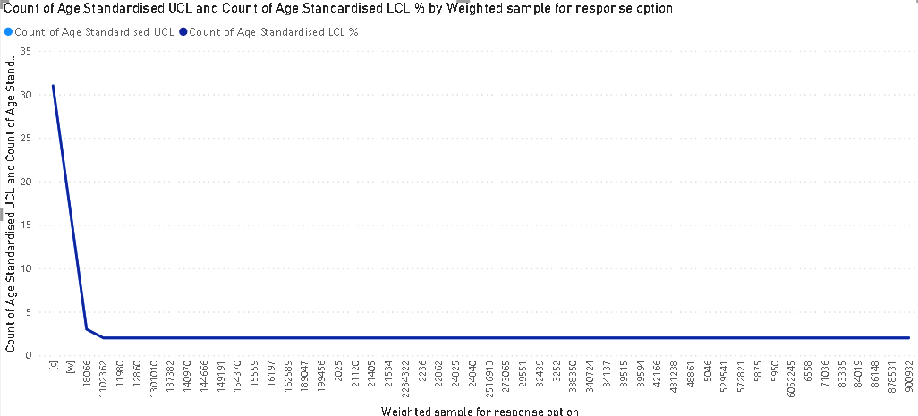

I have compared the Age Standardised UCL % and LCL % and this is what was produced using a line chart. As you can see, the x-axis is the weighted sample, and the y-axis is both the LCL % and UCL%.

# Conclusion:

In wrapping up this project, I've realized the importance of considering both ethical and social factors. Ethically, it's crucial to think about issues like privacy and fairness as we develop graphs that can understand how any business functions. Another ethical consideration is how and where the data comes from - since data can be altered/lies/stolen it can cause ethical breaches on a lot of peoples’ and businesses’ social lives. Socially, we need to ensure that everyone can benefit from this, not just the select few that have access. This project has made me think more deeply about the impacts on society. It's clear that while this has great potential, we need to be mindful of how it's used and who benefits. Personally, I'm committed to approaching this with integrity and a focus on making a positive difference in the world.