CC5051 – Databases
21002595 – Hasan Khan

Contents
QUESTION1) Normalisation 2
QUESTION2) ERD Diagram 6
QUESTION3) Data Dictionary 7
QUESTION4) Database Tables: 9
QUESTION4)A) 9
QUESTION4)B) 17
QUESTION5) 22
QUESTION5)A) 22
QUESTION5)B) 23
QUESTION5)C) 23
QUESTION5)D) 23
QUESTION5)E) 24
QUESTION6) 24
QUESTION7) 26

QUESTION1) Normalisation

UNF | UNF LEVEL | 1NF – Remove Repeating Groups
CustomerID (PK) | 1 | Customer  CustomerID (PK)  CustomerName  Phone  CustomerNotes
CustomerName | 1
Phone | 1
CustomerNotes | 2
AddressID (PK) | 1 | Address  AddressID (PK)  DoorNo  FlatApartmentName  StreetAddress  Postcode  City  County  Country  AddressType  AddressNotes  Address*  AddressID (PK)  DoorNo  FlatApartmentName  StreetAddress  Postcode  City  County  Country  AddressType  AddressNotes
DoorNo | 1
FlatApartmentName | 1
StreetAddress | 1
Postcode | 1
City | 1
County | 1
Country | 1
AddressType | 1
AddressNotes | 2
SaleID (PK) | 1 | Sale  SaleID (PK)  SaleDate  ArrivalDate  SalePrice  SaleNotes  Sale*  SaleID (PK)  SaleDate  ArrivalDate  SalePrice  SaleNotes
SaleDate | 1
ArrivalDate | 2
SalePrice | 1
SaleNotes | 2
ItemID (PK) | 1 | Item  ItemID (PK)  ItemInfo  ItemQuantity  CurrentOwner  Categories  Value  ItemNotes  Item*  ItemID (PK)  ItemInfo  ItemQuantity  CurrentOwner  Categories  Value  ItemNotes
ItemInfo | 1
ItemQuantity | 1
CurrentOwner | 2
Categories | 1
Value | 1
ItemNotes | 2
SaleItemID (PK) | 1 | SaleItem  SaleItemID (PK)  SalePrice  SaleItemNotes  SaleItem*  SaleItemID (PK)  SaleItemNotes
SalePrice | 1
SaleItemNotes | 2
CategoryID (PK) | 1 | Category  CategoryID (PK)  CategoryNames
CategoryNames | 1 | Category  CategoryID (PK)  CategoryNames
ItemCategoryID (PK) | 1 | ItemCategory  ItemCategoryID (PK)  ItemCategory*  ItemCategoryID (PK)
ProvenanceID (PK) | 1 | Provenance  ProvenanceID (PK)  ProvenanceInfo  ProvenanceNotes
ProvenanceInfo | 1
ProvenanceNotes | 2

1NF – Remove Repeating Groups | 2NF – Attributes wholly dependent on part identifier to be seperated | 3NF-Attributes wholly dependent on another attribute be seperated
Customer  CustomerID (PK)  CustomerName  Phone  CustomerNotes | Customer_Details**  CustomerName  Phone  Customer_Notes**  CustomerNotes | N/A
Address  AddressID (PK)  DoorNo  FlatApartmentName  StreetAddress  Postcode  City  County  Country  AddressType (e.g. Home, Billing, Shipping)  AddressNotes  Address*  AddressID (PK)  DoorNo  FlatApartmentName  StreetAddress  Postcode  City  County  Country  AddressType  AddressNotes | Address_Details**  AddressID (PK)  DoorNo  FlatApartmentName  StreetAddress  Postcode  City  County  Country  AddressType  Address_Notes**  AddressNotes | N/A
Sale  SaleID (PK)  SaleDate  ArrivalDate  SalePrice  SaleNotes  Sale*  SaleID (PK)  SaleDate  ArrivalDate  SalePrice  SaleNotes | Sale_Details**  SaleID (PK)  SalePrice  Sale_Dates**  SaleDate  ArrivalDate  Sale_Notes**  SaleNotes | N/A
Item  ItemID (PK)  ItemInfo  ItemQuantity  CurrentOwner  Categories  Value  ItemNotes  Item*  ItemID (PK)  ItemInfo  ItemQuantity  CurrentOwner  Categories  Value  ItemNotes | Item_Details**  ItemID (PK)  ItemInfo  ItemQuantity  CurrentOwner  Categories  Value  Item_Notes**  ItemNotes | Item_Info***  ItemID (PK)  ItemInfo  ItemQuantity  Item_OwnedBy***  CurrentOwner  Item_Type***  Categories  Item_Cost***  Value
SaleItem  SaleItemID (PK)  SalePrice  SaleItemNotes  SaleItem*  SaleItemID (PK)  SaleItemNotes | SaleItem_Details**  SaleItemID (PK)  SaleItem_Notes**  SaleItemNotes | N/A
Category  CategoryID (PK)  CategoryNames | Category_Details**  CategoryID (PK)  CategoryNames | N/A
ItemCategory  ItemCategoryID (PK)  ItemCategory*  ItemCategoryID (PK) | ItemCategory_Details**  ItemCategoryID (PK) | N/A
Provenance  ProvenanceID (PK)  ProvenanceInfo  ProvenanceNotes | Provenance_Details**  ProvenanceID (PK)  ProvenanceInfo  Provenance_Notes**  ProvenanceNotes | N/A

QUESTION2) ERD Diagram

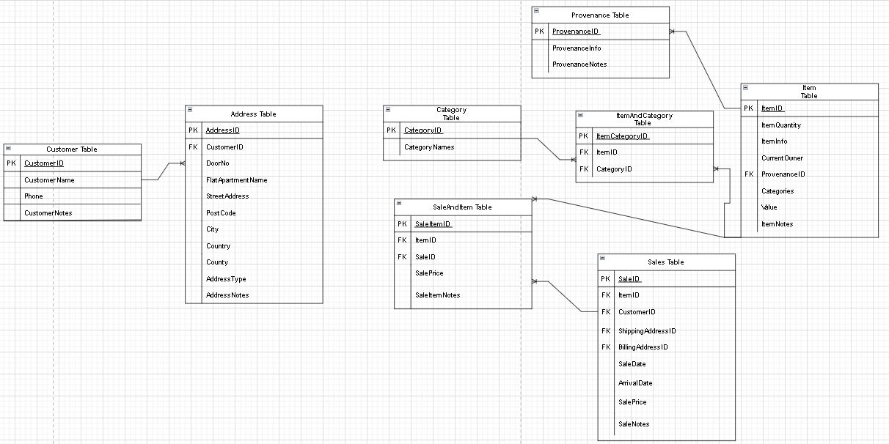

QUESTION3) Data Dictionary

FIELD - DONE | DATA TYPE (Int = Number (referencing sql)) | DATA TYPE FIELD SIZE | CONSTRAINT | DESCRIPTION
CustomerID (PK) | Number | 22 | Primary Key | ID, auto-generated
CustomerName | Varchar | 100 | N/A | Name
Phone | Varchar | 15 | N/A | Phone number
CustomerNotes | Varchar | 4000 | N/A | Notes on customer
AddressID (PK) | Number | 22 | Primary Key | ID, auto-generated
DoorNo | Varchar | 10 | N/A | Door number
FlatApartmentName | Varchar | 50 | N/A | Flat or apartment name
StreetAddress | Varchar | 100 | N/A | Street address
Postcode | Varchar | 10 | N/A | postcode
City | Varchar | 50 | N/A | City
County | Varchar | 50 | N/A | County
Country | Varchar | 50 | N/A | Country
AddressType | ENUM/Varchar | 22 | N/A | Type of address (home, billing or shipping
AddressNotes | Varchar | 4000 | N/A | Notes on Address
SaleID (PK) | Number | 22 | Primary Key | ID, auto-generated
SaleDate | Date | 7 | N/A | The date the sale was made
ArrivalDate | Date | 7 | N/A | Arrival date of items
SalePrice | Varchar | 22 | N/A | Price of the sale
SaleNotes | Varchar | 4000 | N/A | Notes on sale
ItemID (PK) | Number | 22 | Primary Key | ID, auto-generated
ItemInfo | Varchar | 4000 | N/A | Info on items
ItemQuantity | Number | 22 | N/A | Quantity of items (duplicates/copies)
CurrentOwner | Varchar | 100 | N/A | Current owner of the item(s)
Categories | Varchar | 20 | N/A | Item categories
Value | Number | 22 | N/A | Value of the item(s)
ItemNotes | Varchar | 4000 | N/A | Notes on item
SaleItemID (PK) | Number | 22 | Primary Key | ID, auto-generated
SalePrice | Number | 22 | N/A | Price of the sale
SaleItemNotes | Varchar | 4000 | N/A | Notes on SaleItem
CategoryID (PK) | Number | 22 | Primary Key | ID, auto-generated
CategoryNames | Varchar | 100 | N/A | Names of the Category
ItemCategoryID (PK) | Number | 22 | Primary Key | ID, auto-generated
ProvenanceID (PK) | Number | 22 | Primary Key | ID, auto-generated
ProvenanceInfo | Varchar | 4000 | N/A | Provenance Information (the details)
ProvenanceNotes | Varchar | 4000 | N/A | Notes on Provenance

QUESTION4) Database Tables:

NOTE: I had to create another table called AddressTypes for the ENUM ‘AddressType’ that’s in the Addresses Table. Without this, it would not work, and I can’t reference a type later.

QUESTION4)A)

-- Customers Table
CREATE TABLE Customers (
CustomerID NUMBER PRIMARY KEY,
CustomerName VARCHAR2(100),
Phone VARCHAR2(15),
CustomerNotes VARCHAR2(4000)
);

-- AddressTypes Table - for ENUM
CREATE TABLE AddressTypes (
AddressTypeID NUMBER PRIMARY KEY,
AddressTypeName VARCHAR2(20)
);

-- AddressType names for the AddressType
INSERT INTO AddressTypes (AddressTypeID, AddressTypeName) VALUES (1, 'Billing');
INSERT INTO AddressTypes (AddressTypeID, AddressTypeName) VALUES (2, 'Home');
INSERT INTO AddressTypes (AddressTypeID, AddressTypeName) VALUES (3, 'Shipping');

-- Addresses Table
CREATE TABLE Addresses (
AddressID NUMBER PRIMARY KEY,
CustomerID NUMBER,
DoorNo VARCHAR2(10),
FlatApartmentName VARCHAR2(50),
StreetAddress VARCHAR2(100),
Postcode VARCHAR2(10),
City VARCHAR2(50),
County VARCHAR2(50),
Country VARCHAR2(50),
AddressTypeID NUMBER,
AddressNotes VARCHAR2(4000),
FOREIGN KEY (CustomerID) REFERENCES Customers(CustomerID),
FOREIGN KEY (AddressTypeID) REFERENCES AddressTypes(AddressTypeID)
);

-- Provenance Table
CREATE TABLE Provenance (
ProvenanceID NUMBER PRIMARY KEY,
ProvenanceInfo VARCHAR2(4000),
ProvenanceNotes VARCHAR2(4000)
);

-- Categories Table
CREATE TABLE Categories (
CategoryID NUMBER PRIMARY KEY,
CategoryNames VARCHAR2(100)
);

-- Items Table
CREATE TABLE Items (
ItemID NUMBER PRIMARY KEY,
ItemInfo VARCHAR2(4000),
ItemQuantity NUMBER,
CurrentOwner VARCHAR2(100),
Categories VARCHAR2(20),
ProvenanceID NUMBER,
Value NUMBER,
ItemNotes VARCHAR2(4000),
FOREIGN KEY (ProvenanceID) REFERENCES Provenance(ProvenanceID)
);

-- ItemCategory Table - handles many-to-many relationships
CREATE TABLE ItemCategory (
ItemCategoryID NUMBER PRIMARY KEY,
ItemID NUMBER,
CategoryID NUMBER,
FOREIGN KEY (ItemID) REFERENCES Items(ItemID),
FOREIGN KEY (CategoryID) REFERENCES Categories(CategoryID)
);

-- Sales Table
CREATE TABLE Sales (
SaleID NUMBER PRIMARY KEY,
CustomerID NUMBER,
ShippingAddressID NUMBER,
BillingAddressID NUMBER,
SaleDate DATE,
ArrivalDate DATE,
SalePrice NUMBER,
SaleNotes VARCHAR2(4000),
FOREIGN KEY (CustomerID) REFERENCES Customers(CustomerID),
FOREIGN KEY (ShippingAddressID) REFERENCES Addresses(AddressID),
FOREIGN KEY (BillingAddressID) REFERENCES Addresses(AddressID)
);

-- SaleItems Table - handles many-to-many relationships
CREATE TABLE SaleItems (
SaleItemID NUMBER PRIMARY KEY,
SaleID NUMBER,
ItemID NUMBER,
SalePrice NUMBER,
SaleItemNotes VARCHAR2(4000),
FOREIGN KEY (SaleID) REFERENCES Sales(SaleID),
FOREIGN KEY (ItemID) REFERENCES Items(ItemID)
);

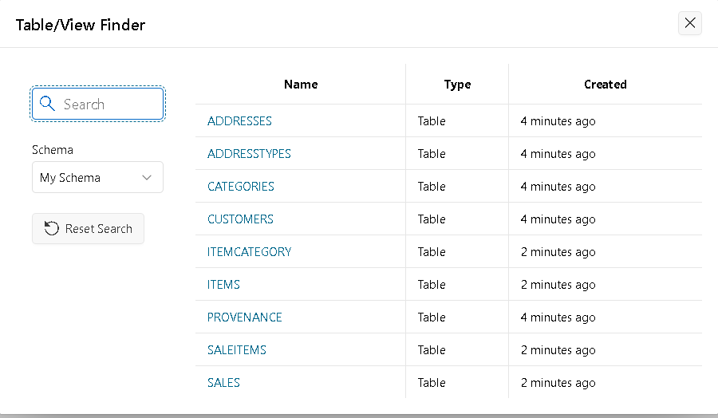
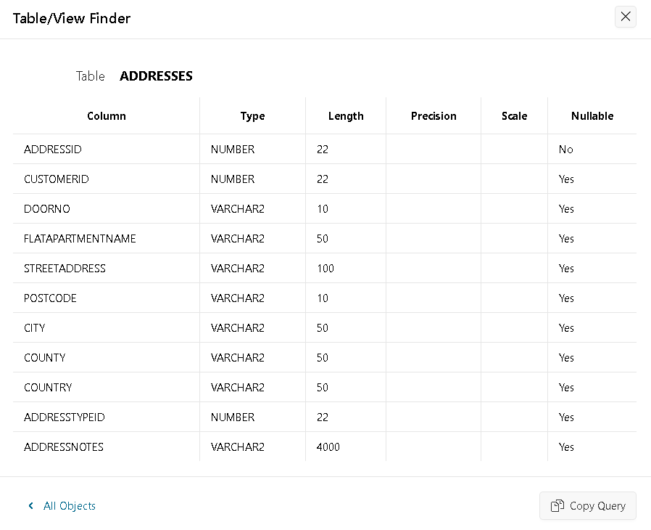
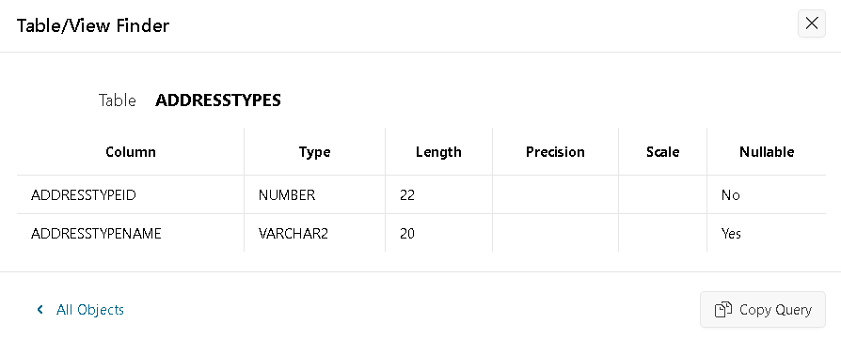
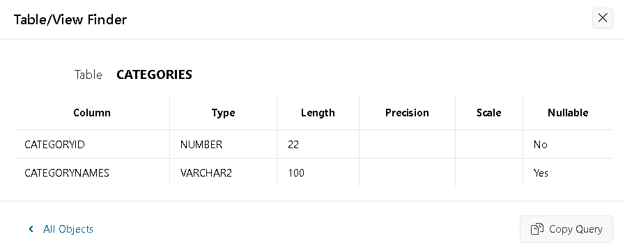
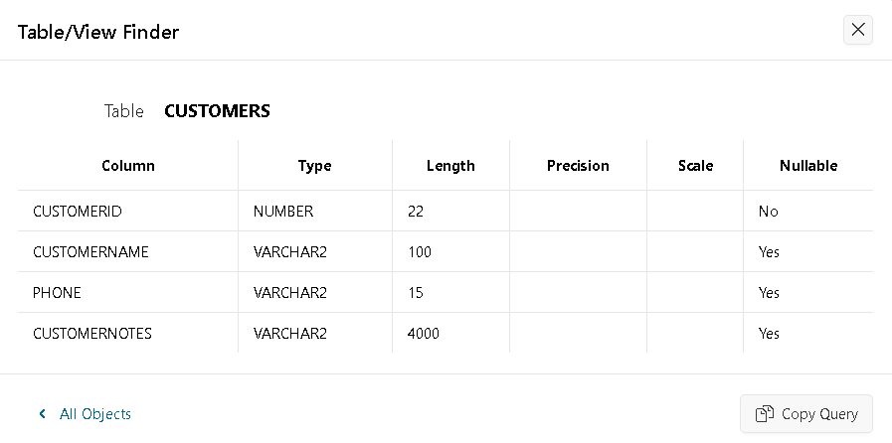
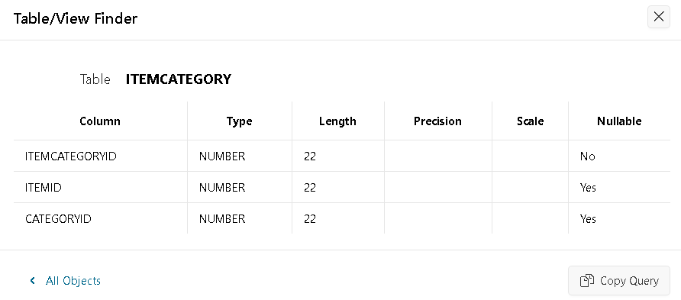
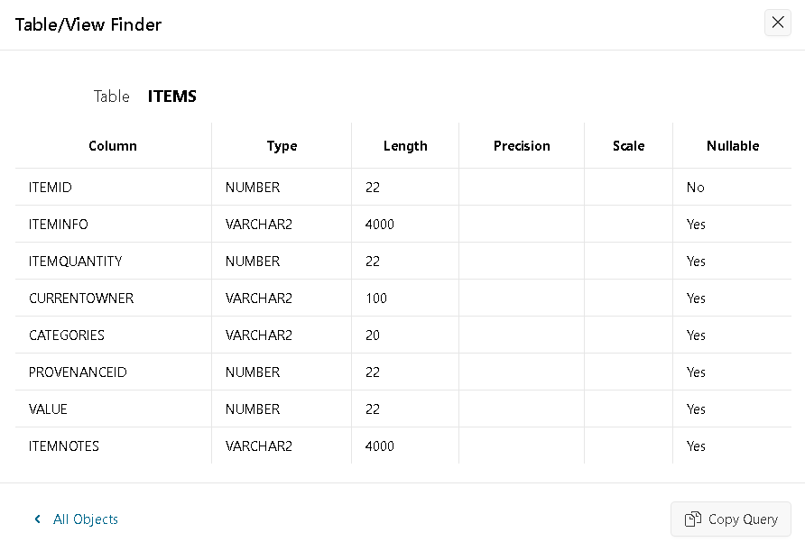
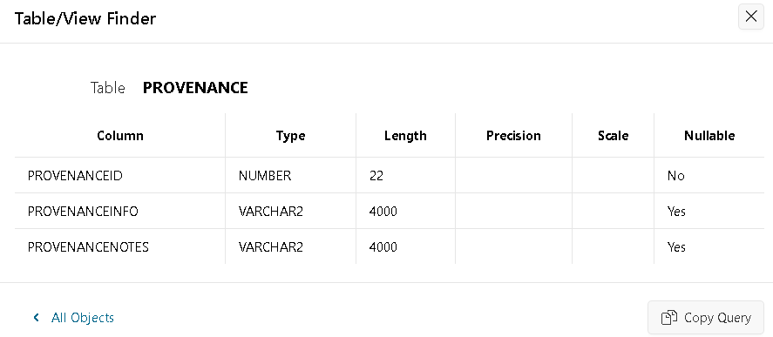
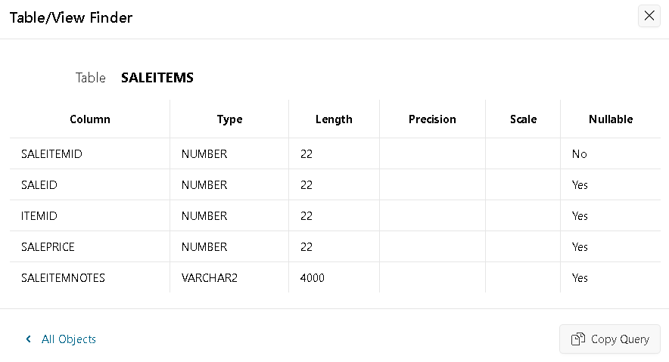
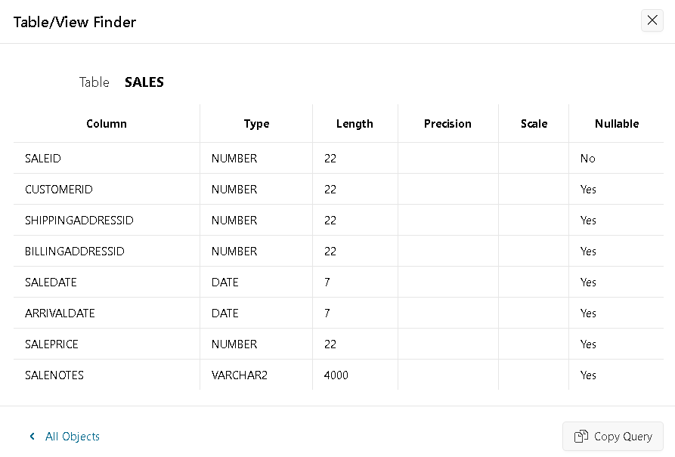

QUESTION4)B)

-- Customers

INSERT INTO Customers (CustomerID, CustomerName, Phone, CustomerNotes) VALUES (1, 'Hasan Khan', '07999999999', 'Hes gonna get a 1st');
INSERT INTO Customers (CustomerID, CustomerName, Phone, CustomerNotes) VALUES (2, 'Sam Noodle', '07123456789', 'He likes shiny stuff');
INSERT INTO Customers (CustomerID, CustomerName, Phone, CustomerNotes) VALUES (3, 'John Jhon', '07234567890', 'Likes coins');
INSERT INTO Customers (CustomerID, CustomerName, Phone, CustomerNotes) VALUES (4, 'F. W. King', '07345678901', 'Loves islands');
INSERT INTO Customers (CustomerID, CustomerName, Phone, CustomerNotes) VALUES (5, 'King Smith', '07456789012', 'has money');

-- Address Types - need to declare this
INSERT INTO AddressTypes (AddressTypeID, AddressTypeName) VALUES (1, 'Billing');
INSERT INTO AddressTypes (AddressTypeID, AddressTypeName) VALUES (2, 'Home');
INSERT INTO AddressTypes (AddressTypeID, AddressTypeName) VALUES (3, 'Shipping');

-- Addresses
INSERT INTO Addresses (AddressID, CustomerID, DoorNo, FlatApartmentName, StreetAddress, Postcode, City, County, Country, AddressTypeID, AddressNotes) VALUES (1, 1, '90', 'Apt 99', 'The Street', 'W1 1AA', 'London', 'Greater London', 'UK', 1, 'Billing Address');
INSERT INTO Addresses (AddressID, CustomerID, DoorNo, FlatApartmentName, StreetAddress, Postcode, City, County, Country, AddressTypeID, AddressNotes) VALUES (2, 1, '100', 'Apt 100', 'The Street', 'W1 1AA', 'London', 'Greater London', 'UK', 2, 'Home Address');
INSERT INTO Addresses (AddressID, CustomerID, DoorNo, FlatApartmentName, StreetAddress, Postcode, City, County, Country, AddressTypeID, AddressNotes) VALUES (3, 1, '101', 'Apt 101', 'The Street', 'W1 1AA', 'London', 'Greater London', 'UK', 3, 'Shipping Address');
INSERT INTO Addresses (AddressID, CustomerID, DoorNo, FlatApartmentName, StreetAddress, Postcode, City, County, Country, AddressTypeID, AddressNotes) VALUES (4, 2, '25', '', 'This Street', 'W10 1AG', 'London', 'Greater London', 'UK', 3, 'Shipping Address');
INSERT INTO Addresses (AddressID, CustomerID, DoorNo, FlatApartmentName, StreetAddress, Postcode, City, County, Country, AddressTypeID, AddressNotes) VALUES (5, 3, '38', '', 'That Street', 'N5 3EG', 'London', 'Greater London', 'UK', 1, 'Billing Address');
INSERT INTO Addresses (AddressID, CustomerID, DoorNo, FlatApartmentName, StreetAddress, Postcode, City, County, Country, AddressTypeID, AddressNotes) VALUES (6, 4, '34', '', 'Other Street', 'N2 3EG', 'London', 'Greater London', 'UK', 1, 'Billing Address');
INSERT INTO Addresses (AddressID, CustomerID, DoorNo, FlatApartmentName, StreetAddress, Postcode, City, County, Country, AddressTypeID, AddressNotes) VALUES (7, 5, '1', '', 'No Street', 'N9 3EG', 'London', 'Greater London', 'UK', 1, 'Billing Address');

-- Provenance
INSERT INTO Provenance (ProvenanceID, ProvenanceInfo, ProvenanceNotes) VALUES (1, 'This is the provenance Info', 'document');
INSERT INTO Provenance (ProvenanceID, ProvenanceInfo, ProvenanceNotes) VALUES (2, 'This is the provenance Info', 'Certification');
INSERT INTO Provenance (ProvenanceID, ProvenanceInfo, ProvenanceNotes) VALUES (3, 'This is the provenance Info', 'Record');
INSERT INTO Provenance (ProvenanceID, ProvenanceInfo, ProvenanceNotes) VALUES (4, 'This is the provenance Info', 'Verification');
INSERT INTO Provenance (ProvenanceID, ProvenanceInfo, ProvenanceNotes) VALUES (5, 'This is the provenance Info', 'Verification');

-- Categories
INSERT INTO Categories (CategoryID, CategoryNames) VALUES (1, 'Militaria');
INSERT INTO Categories (CategoryID, CategoryNames) VALUES (2, 'Vintage');
INSERT INTO Categories (CategoryID, CategoryNames) VALUES (3, 'Coins');
INSERT INTO Categories (CategoryID, CategoryNames) VALUES (4, 'Guns');
INSERT INTO Categories (CategoryID, CategoryNames) VALUES (5, 'Statues');

-- Items
INSERT INTO Items (ItemID, ItemInfo, ItemQuantity, CurrentOwner, Categories, ProvenanceID, Value, ItemNotes) VALUES (1, 'Rare Gun', 1, 'Hasan Khan', 'Guns', 1, 9999, 'Desert Eagle 50 Caliber');
INSERT INTO Items (ItemID, ItemInfo, ItemQuantity, CurrentOwner, Categories, ProvenanceID, Value, ItemNotes) VALUES (2, 'Vintage desk', 2, 'Sam Noodle', 'Vintage', 2, 2000, 'An 18th Century Desk');
INSERT INTO Items (ItemID, ItemInfo, ItemQuantity, CurrentOwner, Categories, ProvenanceID, Value, ItemNotes) VALUES (3, 'Ancient coin', 5, 'John Jhon', 'Coins', 3, 5000, 'Just an old coin');
INSERT INTO Items (ItemID, ItemInfo, ItemQuantity, CurrentOwner, Categories, ProvenanceID, Value, ItemNotes) VALUES (4, 'Sword', 1, 'F. W. King', 'Militaria', 4, 100000, 'A masterpiece from 17th Century Japan');
INSERT INTO Items (ItemID, ItemInfo, ItemQuantity, CurrentOwner, Categories, ProvenanceID, Value, ItemNotes) VALUES (5, 'WW1 medal', 3, 'King Smith', 'Militaria', 5, 1000000, 'A medal for losing all his possessions, family and his legs');

-- ItemCategory - makes links
INSERT INTO ItemCategory (ItemCategoryID, ItemID, CategoryID) VALUES (1, 1, 1);
INSERT INTO ItemCategory (ItemCategoryID, ItemID, CategoryID) VALUES (2, 2, 2);
INSERT INTO ItemCategory (ItemCategoryID, ItemID, CategoryID) VALUES (3, 3, 3);
INSERT INTO ItemCategory (ItemCategoryID, ItemID, CategoryID) VALUES (4, 4, 4);
INSERT INTO ItemCategory (ItemCategoryID, ItemID, CategoryID) VALUES (5, 5, 5);

-- Sales
INSERT INTO Sales (SaleID, CustomerID, ShippingAddressID, BillingAddressID, SaleDate, ArrivalDate, SalePrice, SaleNotes) VALUES (1, 1, 1, 2, TO_DATE('2023-10-21', 'YYYY-MM-DD'), TO_DATE('2023-10-22', 'YYYY-MM-DD'), 10, 'Purchased a gun');
INSERT INTO Sales (SaleID, CustomerID, ShippingAddressID, BillingAddressID, SaleDate, ArrivalDate, SalePrice, SaleNotes) VALUES (2, 2, 3, 4, TO_DATE('2023-02-01', 'YYYY-MM-DD'), TO_DATE('2023-05-01', 'YYYY-MM-DD'), 9999999, 'Purchased vintage - huge profit');
INSERT INTO Sales (SaleID, CustomerID, ShippingAddressID, BillingAddressID, SaleDate, ArrivalDate, SalePrice, SaleNotes) VALUES (3, 3, 5, 5, TO_DATE('2023-03-01', 'YYYY-MM-DD'), TO_DATE('2023-03-15', 'YYYY-MM-DD'), 9999999, 'Purchased coin - huge profit');
INSERT INTO Sales (SaleID, CustomerID, ShippingAddressID, BillingAddressID, SaleDate, ArrivalDate, SalePrice, SaleNotes) VALUES (4, 4, 6, 6, TO_DATE('2023-04-01', 'YYYY-MM-DD'), TO_DATE('2023-04-25', 'YYYY-MM-DD'), 9999999, 'Purchased sword - huge profit');
INSERT INTO Sales (SaleID, CustomerID, ShippingAddressID, BillingAddressID, SaleDate, ArrivalDate, SalePrice, SaleNotes) VALUES (5, 5, 7, 7, TO_DATE('2023-05-01', 'YYYY-MM-DD'), TO_DATE('2023-05-17', 'YYYY-MM-DD'), 9999999, 'Purchased medal - huge profit');

-- SaleItems - makes links
INSERT INTO SaleItems (SaleItemID, SaleID, ItemID, SalePrice, SaleItemNotes) VALUES (1, 1, 1, 10, 'deserved it');
INSERT INTO SaleItems (SaleItemID, SaleID, ItemID, SalePrice, SaleItemNotes) VALUES (2, 2, 2, 9999999, 'upselled and made profit');
INSERT INTO SaleItems (SaleItemID, SaleID, ItemID, SalePrice, SaleItemNotes) VALUES (3, 3, 3, 9999999, 'upselled and made profit');
INSERT INTO SaleItems (SaleItemID, SaleID, ItemID, SalePrice, SaleItemNotes) VALUES (4, 4, 4, 9999999, 'upselled and made profit');
INSERT INTO SaleItems (SaleItemID, SaleID, ItemID, SalePrice, SaleItemNotes) VALUES (5, 5, 5, 9999999, 'upselled and made profit');

-- Verifying:

-- Select Customers
SELECT * FROM Customers;

-- Select AddressTypes
SELECT * FROM AddressTypes;

-- Select Addresses
SELECT * FROM Addresses;

-- Select Provenance
SELECT * FROM Provenance;

-- Select Categories
SELECT * FROM Categories;

-- Select Items
SELECT * FROM Items;

-- Select ItemCategory
SELECT * FROM ItemCategory;

-- Select Sales
SELECT * FROM Sales;

-- Select SaleItems
SELECT * FROM SaleItems;

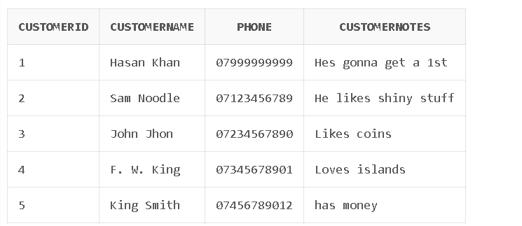
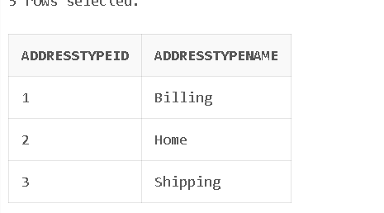
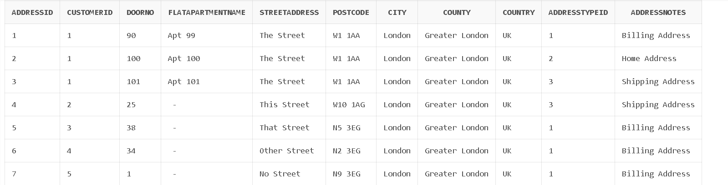

QUESTION5)

QUESTION5)A)

SELECT * FROM Customers
WHERE CustomerName LIKE 'S%' OR CustomerName LIKE 'D%';

QUESTION5)B)

SELECT * FROM Items
WHERE CurrentOwner = 'F. W. King';

QUESTION5)C)

SELECT * FROM Items
WHERE Categories = 'Militaria';

QUESTION5)D)

SELECT c.CustomerName, s.SaleID, s.SaleDate, i.ItemInfo, si.SalePrice
FROM Customers c
--combining it
JOIN Sales s ON c.CustomerID = s.CustomerID
JOIN SaleItems si ON s.SaleID = si.SaleID
JOIN Items i ON si.ItemID = i.ItemID

WHERE c.CustomerName = 'King Smith';

QUESTION5)E)

SELECT c.CustomerName, s.SaleID, s.SaleDate, s.SalePrice AS OrderTotal, s.SaleNotes
FROM Customers c
JOIN Sales s ON c.CustomerID = s.CustomerID

WHERE s.SaleDate = TO_DATE('2023-10-21', 'YYYY-MM-DD');

QUESTION6)

-- Query 7:
--Salespersons Table
CREATE TABLE Salespersons (
SalespersonID NUMBER PRIMARY KEY,
SalespersonName VARCHAR2(100),
ContactNumber VARCHAR2(15)
);

-- Altering Sales Table and adding SalespersonID
ALTER TABLE Sales ADD (SalespersonID NUMBER);
-- Adding foreign key
ALTER TABLE Sales ADD CONSTRAINT fk_sales_salesperson FOREIGN KEY (SalespersonID) REFERENCES Salespersons(SalespersonID);

-- Insert Salespersons
INSERT INTO Salespersons (SalespersonID, SalespersonName, ContactNumber) VALUES (1, 'SOMEONES NAMES', '07888888888');
INSERT INTO Salespersons (SalespersonID, SalespersonName, ContactNumber) VALUES (2, 'ANOTHER NAME', '07111111111');

-- Update Sales and adding SalespersonID
UPDATE Sales SET SalespersonID = 1 WHERE SaleID = 1;
UPDATE Sales SET SalespersonID = 2 WHERE SaleID = 2;

-- Query 8:
-- Summary – monthly sales
SELECT TO_CHAR(SaleDate, 'YYYY-MM') AS Month,
COUNT(SaleID) AS NumberOfSales,
SUM(SalePrice) AS TotalRevenue,
AVG(SalePrice) AS AverageSaleAmount
FROM Sales
GROUP BY TO_CHAR(SaleDate, 'YYYY-MM')
ORDER BY Month;

QUESTION7)

Data Model: SQL databases use a structured model with predefined schemas, while NoSQL databases use various non-relational models with dynamic (flexible) schemas.
Schema Flexibility: SQL databases require a fixed schema which is complex and NoSQL databases allow dynamically changing data structures, offering more flexibility.
Query Language: SQL databases use structured query language (SQL) for manipulating data, while NoSQL databases use various query languages or APIs specific to their data models, which can be more flexible but less standardized.

