Hasan Khan – Student No: 21002595
CS5053 Cloud Computing and the Internet of Things

Contents
1. Introduction 1
2. Simulation Tasks and Scenario’s 3
2.1 Scenario 1: 3
2.2 Scenario 2: 3
2.3 Scenario 3: 4
2.4 Scenario 4: 5
2.5 Scenario 5: 6
2.6 Scenario 6: 6
2.7 Scenario 7: 6
3. Conclusion 7

1. Introduction

First and foremost, my general aim was to create a good design for an Internet of Things home-system. Through connections between a Home Gateway, devices such as fans, lights and many more can be controlled/monitored remotely using gadgets such as a smartphone. In this modern era, a system like this would be very beneficial as it’s as simple as forgetting to turn off a light when travelling but being able to remotely turn it off - thus saving electricity (and the damage it would cause to your monthly bill).
I had begun by placing key components: Home Gateway, Wireless Home-Router, Switch, Smartphone, PC, Laptop, Tablet, Server and an MCU Board. These key components are crucial to the Internet of Things (IOT) home system because this was the basis for the connections between appliances and devices. Between a few of these components I added wires to generally link them together as you can see in the image below:

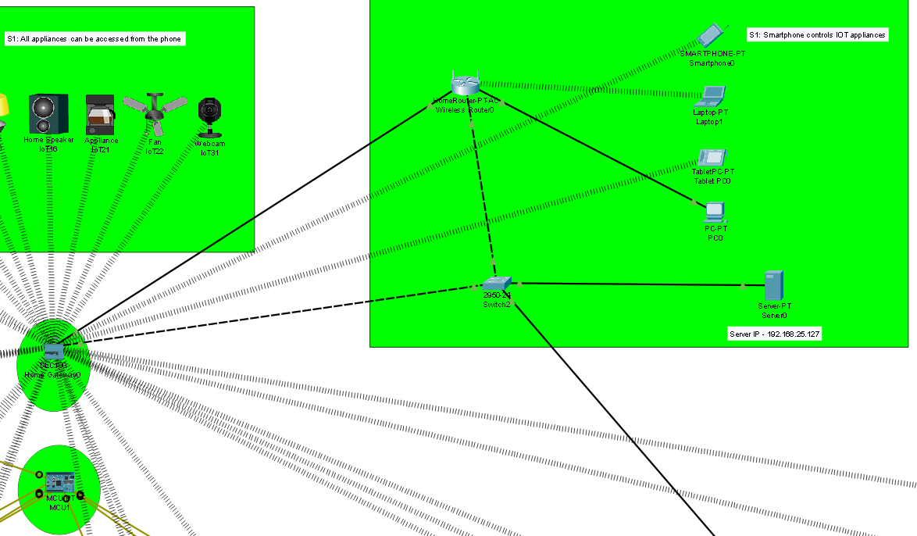
Within the green box and circles are the key components. There is empty space between these components strictly for the program purpose as to not confuse the viewer.

In a real-world scenario, the Home Gateway, Server, Switch and MCU Board would be kept in certain places, most often a basement. However, this can all vary based on factors such as the type of building, network architecture, and individual preferences.

2. Simulation Tasks and Scenario’s

2.1 Scenario 1:

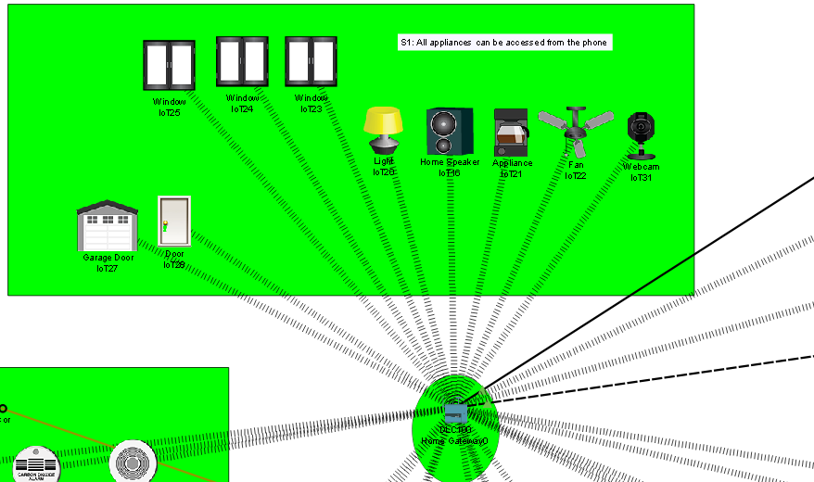

You are available to view the wireless connections between the Scenario 1 appliances and Home Gateway

The devices in Scenario 1 are connected to the Home Gateway which can be accessed via the smartphone. Browse from the Smartphone to the IoT Monitor (located in the Desktop section) and after logging in, you are able to view and turn on/off these appliances.

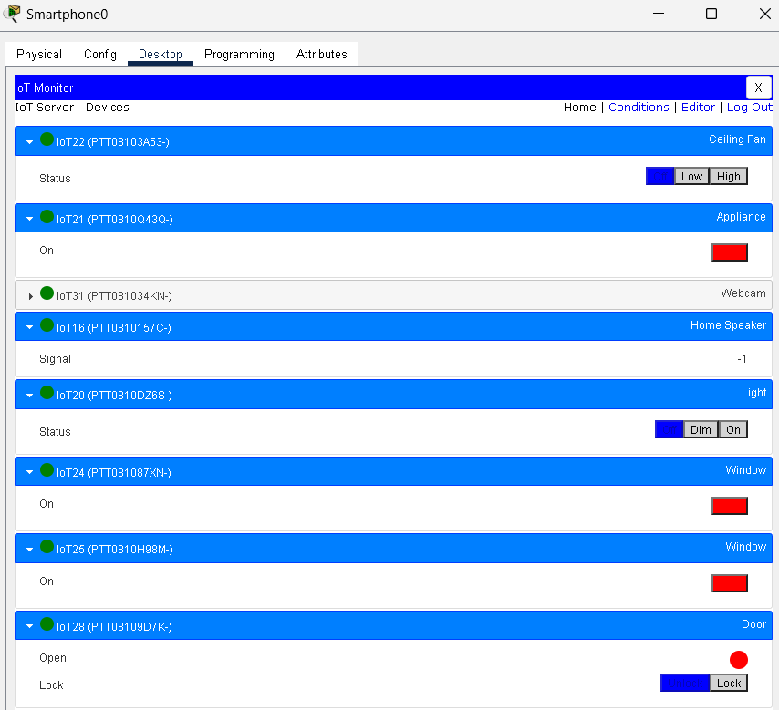
As you can see, there are various settings based on the device. The ceiling fan has different settings than the window.
I had made these connections by changing the SSID of the devices to HomeGateway and modifying the configuration page to make connections to the IoT Server.

2.2 Scenario 2:

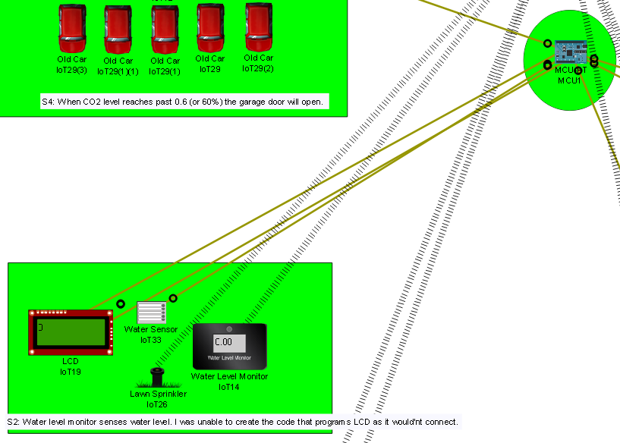
You can view the IoT custom cables which are connected to the MCU Board

In this Scenario the Lawn Sprinkler releases water and the Water Level Monitor measures the amount of water released. I was able to make this part of the scenario work perfectly, especially with connecting the readings from the Water Level Monitor to the Registration Server. I had problems programming the LCD to produce outputs when the water level exceeds 5cm. I had tried many times in many ways including trying to program in a separate IDE, but I always somehow produced errors. Additionally, I placed the water sensor but was unsure about how to create a connection as it can theoretically be placed anywhere in a certain radius to sense water.

2.3 Scenario 3:

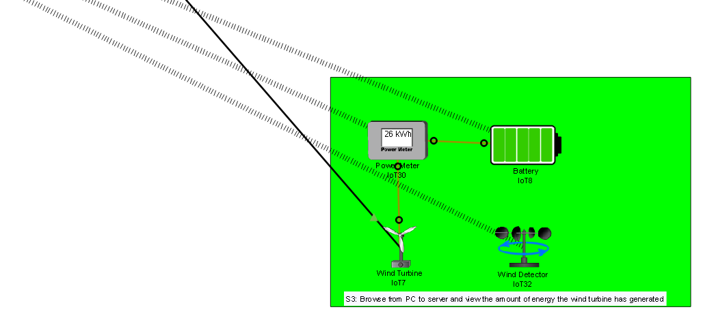
The Copper Straight-Through wire connects from the Wind Turbine to the Switch. The original switch I had placed did not allow the connection to be made so I had to change the switch to the 2950-24 Switch. I connected the Battery and Power Meter by IoT Custom Cables and did the same between the Power Meter and Wind Turbine. I included a Wind Detector to make sure I was attracting wind for the Wind Turbine to generate power. Upon initial placement the Battery was not charged, however after connections had been made, I witnessed the singular bars filling the battery indicating it was being charged. I was able to view the energy generated from the Wind Turbine by browsing from PC to Server (of course after creating the connection between the Wind Turbine and the IOT Server).

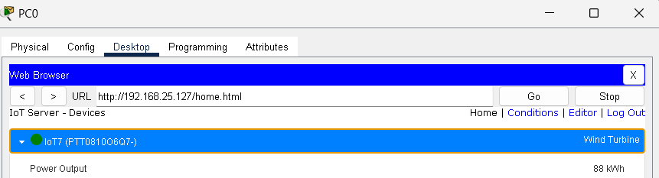
Adding more Wind Turbines and batteries would increase the amount of energy produced.

2.4 Scenario 4:

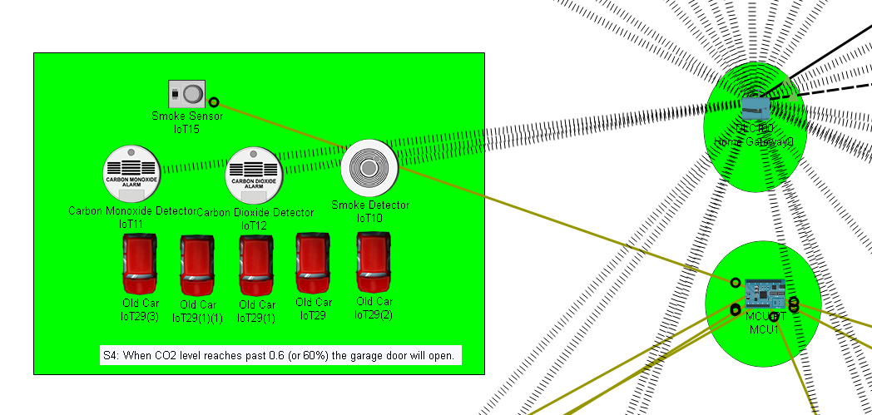

Scenario 4 only required connections between the CO2 detector and the Registration. When the CO2 level reached and exceeded 0.6 (or 60%) the registration server opened the garage door. I was able to do this by creating a condition as shown below.

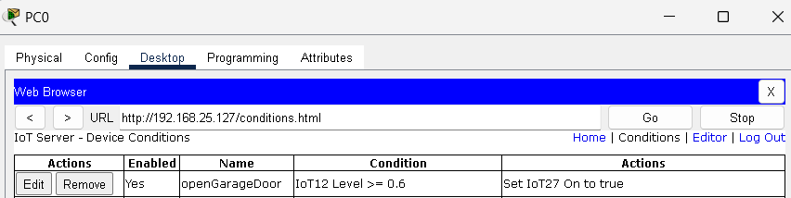

As you can see when the IOT device 12 (CO2 Detector) is greater than or equal to 0.6, the garage door will open. I also added another condition so when the CO2 level was less than 0.6 the garage door would stay closed.

I included 5 cars as to speed up the process and reach 60% CO2 level faster. It was only after finishing the simulation that I realised I could modify the amount of CO2 exerted by the car by programming the car.

2.5 Scenario 5:

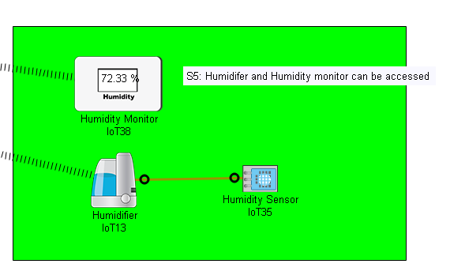
This scenario was very straight-forward as I only had to create the connections between the Humidifier, Humidity Monitor and link them to the Registration Server. I also added a Humidity Sensor but was unsure how it would play a significant role if the Humidity Monitor both sensed and produced a figure to show the environments humidity level.

2.6 Scenario 6:

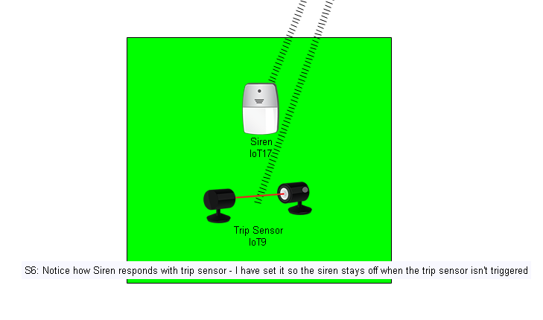
I created wireless connections between the Siren and Trip Sensor to the Registration Server. When the Trip Sensor is triggered, the Siren produces a red light. I was able to do this by creating a condition which you can view in the condition page of the Registration Server. Furthermore, I added another condition to turn off the Siren when the Trip Sensor isn’t triggered as in a real-world scenario you would not want a siren constantly on after the problem has been sorted.

2.7 Scenario 7:

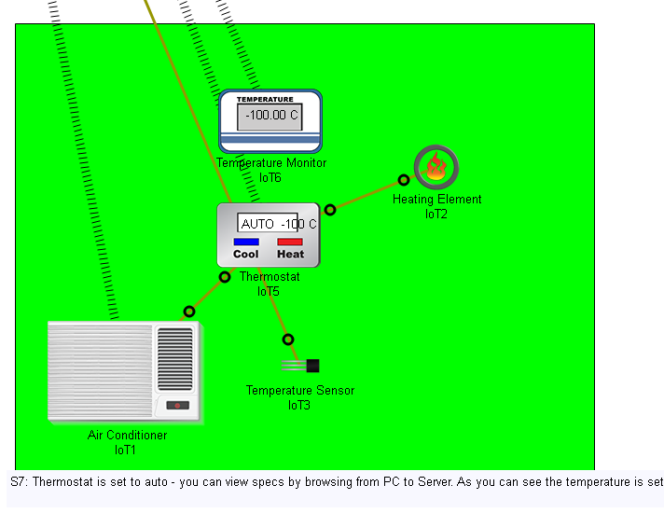
I had many problems with this scenario as I struggled to allow the sensor to automatically send signals and control the thermostat when temperature was not in-between 19Degrees and 20Degrees. I set it to auto and looked at the programming but there seems to not be a problem that I could find. I created a link to the Registration server so you can view the Thermostat there.

3. Conclusion

Packet Tracer is a fundamental tool to help Network Engineers troubleshoot and create real-world scenarios when constructing/renovating all types of buildings. As mentioned in my introduction, IOT smart-home systems are the future of housing and commercial development with many benefits especially for the elderly who generally struggle to maintain appliances. Scenario 4 was a great learning experience as most people would struggle to realise the amount of CO2/Carbon Monoxide in their household and automatically having a garage door (or even windows) open to let in fresh O2 positively impacts personal health. However, having an IOT smart-home system may lead to devices/appliances being susceptible to glitches and remote-hacking. Another disadvantage can be shown in this example: a front door that can be unlocked using a smartphone and having that smartphone stolen would make the home vulnerable to theft.
Personally, I was overall impressed with this module and being able to use packet tracer to further my understanding on networking and network structures between Switches, Routers and IOT devices. With more time and practise I hope to become an expert in this field and overcome the problems I encountered with Scenario 7. The lecturers and workshop tutors did brilliantly when it came to teaching and helping me out with the simulation.

