Task 1: outputs

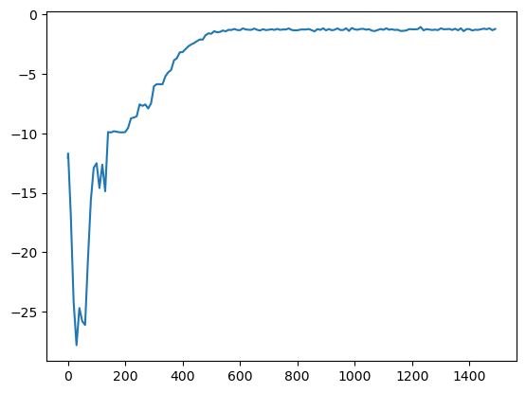

Task 2 outputs:

Loss:

(accuracy)

