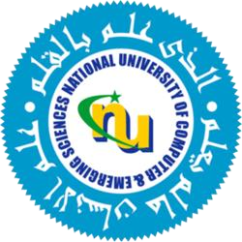

PROJECT REPORT – V4

Course: High Performance Computing
Instructor: Dr. Imran Ashraf

Muhammad Musa (23I-0526)
Ruhab Ahmad (23I-0559)
Hasan Naveed (23I-0797)
Degree: Computer Science
Section: E
FAST - NUCES

