A Blockchain-Enabled Federated Learning Framework for Privacy-Preserving Histopathological Image Classification

Course Code: ECE 402 Course Title: Project and Thesis

Submitted By-

Student ID: 2002126 Level:4, Semester:I
Student ID: 2002138 Level:4, Semester:I
Student ID: 2102151 Level:4, Semester:I

Submitted To-

Department of Electronics and Communication Engineering
in partial fulfillment of the requirements for the degree of Bachelor of Science in Electronics and Communication Engineering.


Hajee Mohammad Danesh Science and Technology University(HSTU)
Dinajpur-5200, Bangladesh
February,

Certificate

This is to certify that the thesis work entitled “Numerical and Machine Learning Approaches for Efficiency Optimization of Lead-Free Rb₂LiGaI₆ Double Perovskite Solar Cells” is carried by the following ID numbers: 2002141, 2102119, 2102124. To the fullest extent of our knowledge, we assert that this undertaking is an authentic and original contribution to the field. We certify that this thesis has not been previously submitted for the award of any other degree or diploma at this or any other institution.

Signed by the Final Examining committee:

………………………………………………..
Chairman

………………………………………………..
External Member

………………………………………………..
Internal Member

………………………………………………..
Supervisor

………………………………………………. Co-Supervisor

Abstract

The lack of interoperability in sharing medical data between institutions is a significant barrier to the advancement of effective machine learning models for clinical diagnosis. Privacy constraints, data sovereignty issues, and the sensitive nature of patient records inhibit hospitals from consolidating their datasets, resulting in models trained in isolation exhibiting poor generalization. This thesis introduces a privacy-preserving federated learning framework for the classification of breast cancer histopathology, utilizing Ethereum blockchain and decentralized IPFS storage for coordination. A collaborative training of a shared deep neural network (EfficientNet-B0 with a Coordinate Attention module, approximately 5.9 million parameters) occurs among multiple hospitals without the transfer of raw data. Each site locally trains the model on its 160×160 RGB picture patches and publishes only encrypted weight updates to IPFS. An Ethereum smart contract subsequently documents the content identifiers (CIDs) and performance metrics of these modifications; upon the collection of all contributions for a training round, an on-chain oracle performs Federated Averaging to generate a new global model. This repeated procedure enhances precision while guaranteeing that no patient data is transmitted from its origin.

The system architecture consists of multiple coordinated components. A robust Solidity smart contract, developed using OpenZeppelin libraries, oversees hospital registration, model versioning, training cycles, and the audit tracking of alterations. Hospital-side Node.js clients manage picture preprocessing, local model training, encryption of weight changes, and blockchain interactions using ethers.js. A Python backend manages network governance, initiates the FedAvg aggregation process, and disseminates each revised global model. All encrypted model weights are saved off-chain on an IPFS network (via Pinata), guaranteeing that only content hashes and aggregated metrics are maintained on-chain.

This work's primary contribution is a fully developed prototype that illustrates how the integration of blockchain and decentralized storage with federated learning may eliminate data silos while safeguarding patient privacy. The unalterable Ethereum ledger offers a verifiable record of each model change and aggregate event, hence improving transparency and repeatability. No patient photos or identifiers are saved on-chain or off-chain; only encrypted model parameters, hashes, and aggregate performance statistics are retained, ensuring privacy by design. The methodology was verified using simulated multi-hospital experiments utilizing the Wisconsin Diagnostic Breast Cancer (WDBC) dataset and the BreakHis histopathology dataset across three institutions: Boston, London, and Tokyo. The trials validated accurate smart contract execution, effective cross-institution model aggregation, and verifiable provenance for all operations tested. This study demonstrates that the integration of Ethereum smart contracts and IPFS with federated learning facilitates secure, transparent, and scalable collaborative artificial intelligence in medical imaging.

Table of Contents

page

List of Tables v

Table of Contents
Chapter 1: Introduction 1
1.1 Overview of Current Infrastructure 2
1.1.1 Regulatory and Policy Framework 2
1.1.2 Regulatory and Policy Framework (cont.) 3
1.1.3 Significant Data Breaches and Systemic Vulnerabilities 4
1.1.4 Defects in the Governance and Exchange of Health Data 5
1.1.5 Blockchain as an Emerging Framework for Secure Health Data 6

Chapter 2: Federated Learning. 8
2.1 Federated Learning in Modern Healthcare 8
2.1.1 Overview 8
2.1.2 Advantages of Federated Learning 9
2.1.3 Federated Learning Outcomes 9
2.2 Application in Healthcare 12
2.3 Architecture of Federated Learning 12
2.4 Challenges in Federated Learning 14
2.4 Challenges in Federated Learning 14
Chapter 3: Methodology 16
3.1 Dataset Description 16
3.1 Dataset Description 16
3.1.2 Class Distribution 16
3.2 Data Pre-processing 17
3.2.1 Image Resizing 17
3.2.2 Pixel Normalization 17
3.2.3 Data Augmentation 18
3.2.4 Dataset Splitting 18
3.3 Feature Extraction and Selection. 18
3.3.1 Deep Feature Extraction 18
3.3.2 Implicit Feature Selection 19
3.4 Model Architecture 19
3.4.1 Overall Architecture 19
3.4.2 Convolutional Blocks 19
3.4.3 Fully Connected Layers 20
3.4.4 Output Layer 20
3.5 Model Training Procedure 20
3.5.1 Loss Function 20
3.5.2 Optimization Algorithm 21
3.5.3 Training Configuration 21
3.6 Centralized Learning Framework 21
3.7 Summary 22

Chapter 4: Results and Discussion 24
4.1 Overview 24
4.2 Experimental Setup 24
4.2.1 Hardware and Software Environment 24
4.3 Evaluation Metrics 25
4.4 Classification Performance 26
4.4.1 Quantitative Results 26
4.5 Confusion Matrix Analysis 27
4.6 Training and Validation Behaviour 28
4.6.1 Loss Convergence 28
4.6.2 Generalization Capability 28
4.7 Explainability and Visual Interpretation 29
4.7.1 Grad-CAM Visualization 29
4.8 Attention-Based Tissue Analysis 31
4.8.1 High-Attention Area Ratio 31
4.9 Automated Medical Report Generation 31
4.10 Comparative Discussion with Existing Literature 32
4.11 Limitations 33
4.12 Summary of Results 33
4.13 Chapter Summary 33

Chapter 5: System Implementation and Development 35
5.1 Introduction 35
5.2 Regulatory and Technical Motivation 36
5.2.1 The Data Protection Landscape 36
5.2.2 Historical Security Incidents and Trust Deficits 37
5.3 Infrastructure Initialization and Smart Contract Deployment 38
5.3.1 Technology Stack Selection 38
5.3.2 Smart Contract Architecture 39
5.3.3 Content-Addressed Storage with IPFS 40

5.4 Communication Protocol Alignment 41
5.4.1 ABI Mismatch Resolution 41
5.4.2 Metrics Precision and Integer Encoding 42
5.4.3 API Route Stability 43
5.5 Institutional Security and Hospital-Side Implementation 44
5.5.1 Cryptographic Modernization 44
5.5.2 Modality Specialization 45
5.6 Global Aggregation and Weighted Averaging 46
5.7 Chapter Summary 47
Chapter 6: Discussion and Analysis 49
6.1 Privacy Preservation and Security Guarantees 49
6.2 Blockchain–Federated Learning Integration Analysis 50
6.3 Scalability and System Overhead 52
6.4 Practical Deployment Considerations 54
6.5 Ethical and Regulatory Implications 56
6.6 Chapter Summary 58
Chapter 7: Conclusion and Future Work 60
7.1 Summary of Contributions 60
7.2 Key Findings 61
7.3 Limitations of the Study 62
7.4 Future Research Directions 63
7.5 Final Remarks 64

Bibliography 76

Appendices 83

List of Tables

TABLE | Page
[3.1] Summary of Histopathological Datasets used for Breast Cancer Diagnosis | 16
[3.2] Hyperparameter Settings for Model Training | 21
[3.3] Traditional Centralized Learning Workflow for Histopathological Image Classification | 22
[4.1] Performance Evaluation Metrics of the Breast Cancer Classification Model | 26
[4.2] Evaluation Summary and Clinical Validation of the Breast Cancer Classification Model | 33
[5.1] Technical Infrastructure and Blockchain Integration of the Federated Learning System | 38
[5.2] Smart Contract Refinement and API Synchronization | 42
[5.3] Implementation Phases and Technical Milestones | 52

List of Figures

FIGURE | Page
[2.1] Federated Learning (FL) Architecture. | 10
[2.2] Federated Learning Architecture in a Medical Context. | 12
[3.1] Image classification workflow. | 22
[4.1] Precision-Recall Curve | 25
[4.2] Confusion Matrix | 27
[4.3] Attention Heatmap (Benign) | 30
[4.4] Attention Heatmap (Malignant) | 30
[4.5] AI assisted diagnostic assessment | 32
[5.1] Dependency Optimization and Migration | 36
[5.2] Training Round Lifecycle | 37
[5.3] "Lazy Connect" Sequence Diagram | 39
[5.5] Federated Averaging Sequence Diagram | 47
[5.6] End-to-End Inference Pipeline | 51
[5.7] System Integration, User Interface, and Final Testing | 54

C H A P T E R 1

Introduction

The automation process at medical research, optimization of treatment programs and diagnostic accuracy improved with the inauguration of artificial intelligence. These speed-ups helped us to discover the system flaws rapidly. For example, traditional centralized AI models required aggregating patient data into single repositories for improved results, resulting in risks that are both technically severe and legally unsustainable within Bangladesh's developing regulatory framework.

From the perspective of Bangladesh's healthcare system, it produces around 50 million electronic health records from hospitals across the country, but it has not adopted institutional frameworks for secure inter-hospital AI collaboration. This disparity arises from recent catastrophic centralized data breaches: the 2023 National Identity Database. However, Bangladesh is swiftly advancing its digital health programs; nevertheless, the foundational security and governance structures are significantly deficient. Observers indicate that the nation "has not yet established a comprehensive health information system" and that current initiatives are disjointed. A recent investigation indicates that Bangladesh's healthcare sector "lacks the requisite data governance and legal framework essential for establishing consumer trust." In practice, many public and commercial hospitals utilize ad-hoc electronic medical records (EMRs) and mobile health applications lacking standardized protocols. A policy brief underscores that "health data is sensitive and discloses personal information; thus, it is imperative to implement measures to prevent unauthorized access and usage." Currently, in Bangladesh, numerous health record systems had just rudimentary logins and unencrypted databases, indicating inadequate investment in secure infrastructure. The 2018 National ICT Policy proposed portable electronic health records and health IDs; but, by 2022, these initiatives had not progressed beyond the proposal stage with minimal implementation. Digital health services in Bangladesh are hindered by inadequate usability, deficient security measures, and insufficient foundational infrastructure.

Overview of Current Infrastructure

Regulatory and Policy Framework:
Until recently, Bangladesh lacked a robust data protection statute. Cybersecurity and content regulation have instead been addressed by comprehensive statutes. The 2018 Digital Security Act (DSA) criminalized certain internet crimes and defined key information systems; nonetheless, it was not specifically designed to safeguard patient data.

In September 2023, the government implemented a new Cyber Security Act (CSA 2023), superseding the DSA.

The CSA predominantly retains provisions concerning identification and data; for instance, Section 26 penalizes the unlawful possession or disclosure of another individual's identity information (name, NID, phone, etc.) with a maximum of two years' imprisonment or a fine. Critics observe that the legislation is devoid of explicit exemptions for valid health or research applications and fails to include sector-specific protections.

Significantly, Bangladesh has now initiated the implementation of a specific privacy framework. In October 2025, the temporary government enacted the Personal Data Protection Ordinance (PDPO) 2025. The PDPO is loosely based on international standards (e.g., GDPR), stipulating consent mandates, breach notifications, and the establishment of a regulatory authority for personal data. Advocates describe it as a significant achievement for Bangladesh's "initial authentic digital social contract." The legislation extensively grants individuals authority over their sensitive information, including medical history, and is applicable to all entities managing Bangladeshi data. Simultaneously, critics caution about inherent structural deficiencies: for example, the conclusive ordinance incorporates extensive public-interest exclusions (such as crime prevention and investigations) and consolidates enforcement authority within the Cabinet. The execution of the PDPO is still in its infancy, and its provisions, such as data localization regulations, continue to be contentious.

In addition to this legislation, the government of Bangladesh has implemented health-focused digital policies. The Bangladesh Digital Health Strategy 2023–2027 clearly prioritizes the privacy and security of patient data.

It commits to ensuring patient information rights, integrity, privacy, security, secrecy, and anonymity, as well as adopting open standards for electronic health information. It also advocates for new legislation and regulatory mechanisms to delineate responsibilities and penalties in health data exchange. In summary, current official policy acknowledges the necessity for comprehensive safeguards (encryption, authentication, audit trails, accountability) in health information technology. Nonetheless, these principles remain aspirational. The Digital Health Strategy indicates that technical requirements for unique health IDs and interoperable electronic health records exist solely in documentation, and the national implementation strategy is "incomplete and outdated." Consequently, despite ongoing discussions regarding a contemporary legal-technical framework, the existing enforcement and implementation of data privacy in healthcare remain insufficient.

Regulatory and Policy Framework:
Numerous prominent data breaches in Bangladesh have shown vulnerabilities in the country's digital governance, vulnerabilities that would likewise jeopardize health data. In mid-2023, security researchers discovered a significant breach involving over 50 million residents' details from a government web portal. The exposed database, derived from voter registration and civil records, included full names, phone numbers, national ID numbers, birth certificates, and other personal information for one-third of the population. This breach was primarily facilitated by organizational deficiencies: the Election Commission gathered most of the data, although the database was managed by a different body inside the Home Ministry. A hacker exploited an unprotected API to access any individual's birth record on that portal. The leak was available online for weeks before being terminated, highlighting the deficiency in prompt incident response.

Comparable instances have reoccurred. In November 2023, an insecure database at the National Telecommunications Monitoring Center (NTMC) was discovered to include sensitive metadata regarding calls and subscribers, including individuals' passport numbers and fingerprint pictures. The NTMC initially asserted that this was "sample data," but verification revealed that it contained actual citizen records. In late 2025, a fraudulent e-Apostille website, masquerading as a government agency, was found to be collecting hundreds of scanned passports, national identification cards, and travel papers from unsuspecting customers. More than 1,100 identity documents of persons were compromised prior to the authorities' closure of the site. In many instances, fundamental precautions were lacking: websites did not implement robust identity verification or encryption, and there was an absence of an audit trail to identify misuse.
Significantly, even initiatives directly related to healthcare have been impacted. Reports indicate that Bangladesh's COVID-19 vaccination site (Surokkha) may have experienced a data breach, with patient information purportedly surfacing on the dark web. Recently, an online accreditation platform initiated by the Election Commission revealed images, signatures, national ID information, and other personal documents of at least 14,000 journalists due to inadequate security settings. ARTICLE19 denounced this infringement as a violation of privacy and advocated for independent audits. These cases demonstrate a systemic pattern: data silos across agencies and sectors are frequently unsecured, rendering mass leaking nearly unavoidable. A security expert remarked that such occurrences "expose the vulnerability of IT security" in Bangladesh.

Significant Data Breaches and Systemic Vulnerabilities:
Numerous prominent data breaches in Bangladesh have shown vulnerabilities in the country's digital governance, vulnerabilities that would likewise jeopardize health data. In mid-2023, security researchers discovered a significant breach involving over 50 million residents' details from a government web portal. The exposed database, derived from voter registration and civil records, included full names, phone numbers, national ID numbers, birth certificates, and other personal information for one-third of the population. This breach was primarily facilitated by organizational deficiencies: the Election Commission gathered most of the data, although the database was managed by a different body inside the Home Ministry. A hacker exploited an unprotected API to access any individual's birth record on that portal. The leak was available online for weeks before being terminated, highlighting the deficiency in prompt incident response.

Comparable instances have reoccurred. In November 2023, an insecure database at the National Telecommunications Monitoring Center (NTMC) was discovered to include sensitive metadata regarding calls and subscribers, including individuals' passport numbers and fingerprint pictures. The NTMC initially asserted that this was "sample data," but verification revealed that it contained actual citizen records. In late 2025, a fraudulent e-Apostille website, masquerading as a government agency, was found to be collecting hundreds of scanned passports, national identification cards, and travel papers from unsuspecting customers. More than 1,100 identity documents of persons were compromised prior to the authorities' closure of the site. In many instances, fundamental precautions were lacking: websites did not implement robust identity verification or encryption, and there was an absence of an audit trail to identify misuse.
Significantly, even initiatives directly related to healthcare have been impacted. Reports indicate that Bangladesh's COVID-19 vaccination site (Surokkha) may have experienced a data breach, with patient information purportedly surfacing on the dark web. Recently, an online accreditation platform initiated by the Election Commission revealed images, signatures, national ID information, and other personal documents of at least 14,000 journalists due to inadequate security settings. ARTICLE19 denounced this infringement as a violation of privacy and advocated for independent audits. These cases demonstrate a systemic pattern: data silos across agencies and sectors are frequently unsecured, rendering mass leaking nearly unavoidable. A security expert remarked that such occurrences "expose the vulnerability of IT security" in Bangladesh.

Defects in the Governance and Exchange of Health Data:
In Bangladesh's healthcare sector, there are no consistently implemented rules for data exchange or security. Healthcare institutions frequently establish connections solely on an ad-hoc basis or over rudimentary networks, and there is an absence of a national Public Key Infrastructure (PKI) or multi-factor authentication system for medical records. Patient data exchanged between hospitals or sent to central databases is generally unencrypted or minimally secured. Audit logging is an anomaly rather than a standard practice. An internal study identified 114 digital health systems utilized by the government, of which only five had user authentication and maintained an audit trail for patient data access. Numerous private clinics utilize foreign data centers lacking assured encryption and residency regulations.

Academics have indicated that the existing legal framework, with its fragmented protective measures across many statutes, is insufficient to safeguard health data privacy. Unlike the USA (HIPAA) or the EU (GDPR), Bangladesh lacks sector-specific health privacy regulations. In practice, this implies that no consequences expressly address a hospital that improperly manages patient records. ARTICLE19 noted that the journalist breach, which jeopardized sensitive identities and photographs, was enabled by "fundamental security deficiencies," and it advocated for the implementation of "stringent data protection measures – encompassing encryption, access controls, and obligatory security audits" prior to the deployment of any e-health system. In summary, robust authentication procedures, end-to-end encryption, formal data-sharing agreements, and thorough audit trails are predominantly lacking in Bangladesh's health data exchanges. This legislative and technical deficiency erodes trust and renders patient information vulnerable to exploitation.

Blockchain as an Emerging Framework for Secure Health Data:
In light of these problems, numerous experts contend that a blockchain-based architecture could enhance the security of health data in Bangladesh. The fundamental attributes of blockchain—decentralization, immutability, and transparency—directly rectify numerous deficiencies inside the system. By disseminating records across multiple nodes, blockchain eradicates a singular point of failure or control: no solitary server retains all patient data. Every transaction (e.g., record creation or access) is time-stamped, hashed, and connected to the preceding block, establishing a permanent audit trail. Consequently, "the ledger can remain immutable over time," and "a user can scarcely modify or delete any information on the network." Any effort to alter a medical record would be promptly detectable using the cryptographic hash.

In the context of healthcare, this implies that each visit, test result, or prescription associated with a patient ID may be documented as an unalterable entry. Authorized entities (hospitals, laboratories, insurers) would utilize a shared ledger, enhancing interoperability and minimizing redundant data silos. Significantly, blockchain can integrate robust encryption: patient data may be held off-chain in an encrypted format with only hashes recorded on-chain, or utilize permissioned blockchains where only authenticated institutions participate. Smart contracts could autonomously enforce access regulations, guaranteeing that only providers with patient authorization are permitted to decrypt or access critical information. A review indicates that a secure blockchain architecture in healthcare can provide "improved data security and privacy protection, seamless interoperability and sharing, as well as data accuracy and integrity."

A blockchain-based National Health Information Exchange might significantly bolster trust in Bangladesh. Patients would possess cryptographic authority over their records, and all data exchanges (e.g., referrals between hospitals) would be transparently documented.
CHAPTER 1. INTRODUCTION

Regulators may assess the integrity of the chain at any moment. This immutability mitigates insider threats and negligent security: even if an organization's credentials are breached, no assailant can imperceptibly modify the historical data on the chain. Although blockchain implementation necessitates initial investment and technical expertise, it corresponds with the recognized requirement for reliable, tamper-resistant health data management. In environments where backend systems are "fragile" and inter-agency coordination is inadequate, blockchain provides a mechanism to ensure auditability and consistency universally. In conjunction with the new privacy regulations and digital health plan, blockchain may offer the essential infrastructural foundation required to ensure the confidence, secrecy, and integrity that Bangladesh’s healthcare systempresentlylacks.
Chapter 2 Federated Learning

Federated learning in modern healthcare

Overview
Federated learning (FL) is a decentralized machine learning paradigm in which many client devices or institutions collaboratively train a shared model without moving raw data off-site. In FL, a global model is initialized on a central server and distributed to each client node. Each client (e.g. a hospital, clinic, or IoT device) trains the model locally on its own private dataset and then sends only the model updates (e.g. weights or gradients) back to the server. Crucially, no raw data ever leaves the client; only the learned parameters are shared. The server then aggregates these updates – typically by weighted averaging (the classic Federated Averaging algorithm) – to produce a new global model. This updated model is sent back to all clients for further local training, and the process repeats iteratively until the model converges. In this way, federated learning builds a powerful shared model by combining information from all participants, while preserving data privacy by design.

Federated Learning (FL) is a distributed machine learning paradigm where multiple clients (such as mobile devices, IoT nodes, or organizations) collaboratively train a shared global model without exchanging their raw data. Instead of centralizing data on a single server, each client trains the model locally using its own dataset and sends only model updates (e.g., gradients or weights) to a central server. The server then aggregates these updates—commonly using the Federated Averaging (FedAvg) algorithm proposed by H. Brendan McMahan and colleagues at Google—to improve the global model. This approach enhances data privacy, reduces communication of sensitive information, and is particularly useful in domains such as healthcare, finance, and mobile applications. However, federated learning faces challenges including data heterogeneity (non-IID data distribution), communication overhead, system scalability, client dropouts, and vulnerability to adversarial attacks. Recent research focuses on improving privacy through techniques like differential privacy and secure aggregation, optimizing communication efficiency, and enhancing robustness against malicious participants.

Advantages of federated learning
Federated learning offers several key advantages over traditional centralized training. Because only model parameters are exchanged, FL is inherently bandwidth-efficient and scalable: clients never upload large datasets, only relatively small model updates. This also means each client retains control over its data, greatly reducing privacy and compliance concerns. For example, users or institutions “maintain control over their personal or organizational data” because raw data never leave the device. By contrast, centralized learning requires gathering all data in one place, which can violate regulations (e.g. HIPAA or GDPR) and create a single point of failure for data breaches. FL’s design avoids these pitfalls: it preserves user privacy, complies more easily with data-protection laws, and still enables collaborative training on a much larger combined dataset than any single client has. Moreover, because the global model is informed by diverse data sources, FL often yields more generalizable and fair models. In healthcare applications, studies have shown that federated models can significantly improve diagnostic accuracy by learning from multiple hospitals. For example, combining model weights from several medical centers has achieved up to 99.7% accuracy in classifying lung and colon cancer, all without sharing patient records. Thus FL taps into the collective power of many institutions (or devices) for large-scale learning while keeping all sensitive patient data on-site.

Federated Learning outcomes

A central challenge of FL is coordinating many client nodes (e.g. hospitals, mobile devices, or edge servers) with a central server. In a typical FL architecture, the server first distributes a global model to all clients. Each client then performs local training using its own private data (for example, a hospital training on its patient records). After training, each client sends only its updated model parameters back to the server. The server securely aggregates these updates – often by computing a weighted average of the client models (FedAvg)[3] – to form a new improved global model. This new model is then broadcast back to the clients for the next round of training. The cycle (send model → train locally → send updates → aggregate) continues iteratively until convergence. Crucially, throughout this process the server never sees any raw data – only encrypted or noisy model updates may be exchanged – which dramatically enhances data privacy. This client-server structure is sometimes called cross-silo FL in healthcare, since each silo (hospital or institution) is a powerful stable client. (By contrast, cross-device FL would involve many unreliable devices like smartphones.)

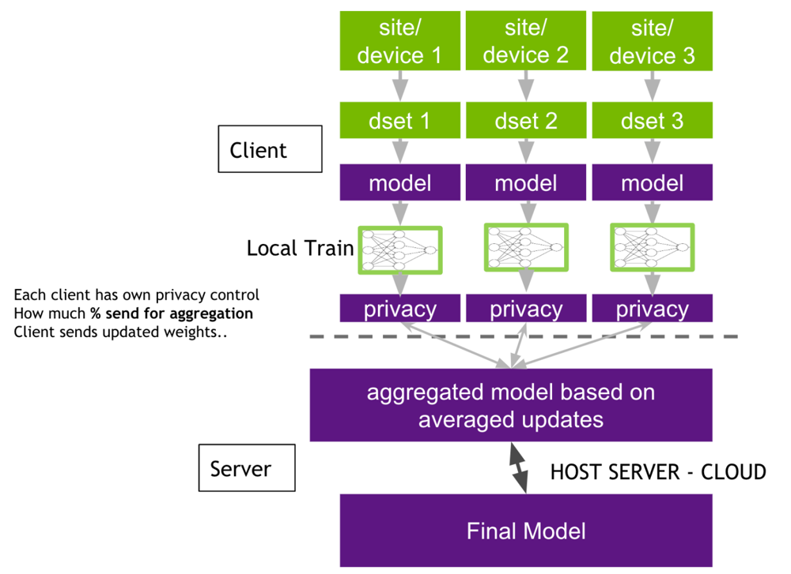
The figure below illustrates this federated architecture: multiple clients (e.g. hospitals A, B, C) each train on their local datasets and send model updates to a central aggregator, which updates and redistributes the global model. Because only model parameters flow over the network, FL greatly reduces bandwidth usage compared to sending raw data. It also eases regulatory compliance, since each hospital keeps its records on-site. In practice, client-side computation does face challenges (see below), but modern FL implementations even allow clients to dynamically join or leave a training session, and to control how much information they share. Many FL systems also incorporate cryptographic techniques: for example, clients often apply differential privacy (adding noise to updates) and secure multiparty

Figure 2.1: Federated Learning (FL) Architecture

computation so the server can aggregate encrypted updates without learning individual contributions. These measures make it extremely hard for any party to reverse-engineer private data from the model updates.

Application in healthcare

Federated learning is particularly well-suited to healthcare, where data are highly sensitive and distributed across many institutions. Patient records, medical images, and health sensor data are scattered across hospitals, clinics, and devices in different regions. Legally and ethically, these data cannot be pooled centrally (HIPAA, GDPR, etc.), but learning from them collectively can improve medical AI. FL provides a practical solution: each hospital can train on its own EHRs or imaging data and only share model improvements. In recent years, researchers have applied FL to a range of healthcare problems. For instance, federated models have been trained for cancer screening (e.g. collaborative mammogram or histopathology analysis), COVID-19 diagnosis from CT scans, diabetic retinopathy detection, and even predicting patient readmission. By leveraging data from multiple institutions, these studies often report higher accuracy and better generalization than any single-site model could achieve, all while preserving privacy. In public health contexts, FL enables learning across geographically diverse and demographically varied populations, which helps to reduce bias and ensure fairer models.

For example, one analysis notes that FL “helps by training a shared model without moving raw data. Sites keep their data, send only model updates, and benefit from a stronger, combined model”. This allows collaborative surveillance or prediction (e.g. outbreak detection, risk stratification) using data from many hospitals, without any hospital having to disclose private information. Importantly, FL also boosts efficiency in data-constrained environments: because only model weights are exchanged, communications costs are much lower than sending entire datasets. As Abbas et al. explain, FL addresses “data privacy, bandwidth limitations, and scalability” by never transferring raw data; users maintain control of their own data and only share lightweight updates[5]. In summary, federated learning offers a transformative approach for healthcare and medical research: it fuses knowledge from many institutions into a single predictive model, while each hospital retains sovereignty over its patients’ data.

Architecture of Federated Learning

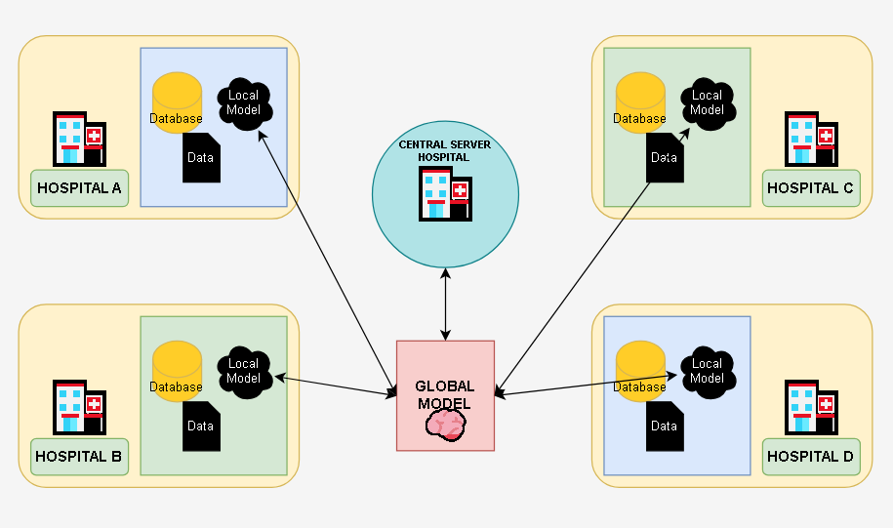
Figure 2.2: Federated Learning Architecture in a Medical Context
The standard Federated Learning (FL) workflow consists of four main stages—initialization, local training, aggregation, and iteration—each of which offers significant advantages while also presenting certain limitations.
In the initialization stage, a central server creates a global model, either randomly or using a pre-trained version, and distributes it to all participating clients. This step ensures that all clients start with a consistent model architecture and shared parameters, which promotes coordinated learning and faster convergence when pre-training is used. However, the dependence on a central server introduces a single point of coordination and potential vulnerability. If the initial model is biased or not representative of diverse client data distributions, it may negatively affect overall performance.
During the local training stage, each client updates the received global model using its own private dataset, typically through one or more epochs of gradient descent. The key advantage of this approach is privacy preservation, as raw data never leaves the client device. This reduces data leakage risks and supports compliance with data protection regulations. Nevertheless, local datasets are often non-IID (non-identically distributed), meaning that data across clients may differ significantly in distribution and size.

Such heterogeneity can cause model divergence, slower convergence, and reduced global accuracy.
In the aggregation stage, clients send their model updates—such as weights or gradients—to the central server. The server then combines these updates, commonly using the Federated Averaging (FedAvg) algorithm proposed by H. Brendan McMahan and colleagues at Google, to generate an improved global model. This method enables collaborative learning without direct data sharing and is computationally efficient and scalable. However, aggregation can suffer from communication overhead, especially in large-scale systems, and is vulnerable to malicious or faulty client updates, such as model poisoning attacks.
Finally, in the iteration stage, the updated global model is redistributed to clients, and the cycle of local training and aggregation continues until convergence is achieved. This iterative refinement gradually improves model performance and allows adaptation to distributed data sources. On the downside, repeated communication rounds may increase latency, energy consumption, and system complexity, particularly in environments with limited bandwidth or unreliable client participation.
Overall, the four-stage FL workflow provides a structured and privacy-aware framework for distributed learning. While it effectively balances collaboration and data confidentiality, it must address challenges related to heterogeneity, communication efficiency, and security to achieve optimal performance in real-world applications.
This client-server architecture enables horizontal FL, where each client’s data share the same feature space (typical for multi-hospital collaborations)[21]. (Vertical FL, in contrast, would combine clients with complementary features on the same patients, but is less common in pure healthcare settings.) In practice, the system must also handle engineering details: the server coordinates client participation, handles client dropouts, and may authenticate clients for security. Advanced deployments often add further components: for example, hierarchical FL architectures introduce intermediate edge servers, and federated transfer learning can combine disparate datasets. However, the basic hub-and-spoke model remains the foundation: many distributed trainers, one central aggregator.
Overall, this architecture trades off the simplicity of centralization for enhanced privacy and scalability. On one hand, it avoids the “one-shot” transfer of massive patient databases. On the other, it requires more complex coordination among clients. Yet for healthcare, the benefits are compelling. By design, FL keeps each patient’s records on the hospital’s own machines, cutting the risk of large-scale breaches. It also dramatically reduces communication compared to naive sharing: only parameter vectors (often <1 MB each) are exchanged per round, rather than gigabytes of health data. Together, these features make federated learning a scalable platform for privacy-preserving analytics in health and biomedicine.

Challenges in Federated Learning

Federated learning offers strong privacy advantages, but it introduces several technical challenges that researchers must address:
Data and system heterogeneity (non-IID data): In healthcare, different clients typically collect different kinds of data. For example, hospitals may have patient populations with varying demographics or prevalences of disease, and medical devices may record different features. This non-IID data means one client’s data distribution can be very different from another’s. As a result, a single global model may perform unevenly: it can become biased toward the clients with larger or more distinctive datasets. Moreover, clients often have varying computing resources and network conditions. Some hospitals have powerful servers, while others rely on low-power edge devices; this system heterogeneity can cause slow training or straggler effects. Mitigating these issues requires advanced strategies. Researchers have proposed personalized FL (giving each client a slightly customized model) and clustered FL (grouping similar clients), as well as specialized optimizers like FedProx or SCAFFOLD that stabilize training across diverse data. Despite these methods, data heterogeneity remains a core challenge: the global model must generalize well to all clients’ distributions, yet each client also ideally wants a model tuned to its own data.
Communication overhead: Federated learning typically involves many communication rounds between clients and the server. Especially with deep models and large client cohorts, bandwidth can become a bottleneck. Each round requires clients to upload and
download model parameters; if the model has millions of weights or if thousands of clients participate, the network load is substantial. Studies have shown that communication costs can inhibit FL’s scalability and slow convergence. In unreliable or low-bandwidth settings (common in global healthcare networks), these exchanges may dominate the time-to-train. To reduce overhead, various compression techniques are used: clients may send quantized or sparse updates, or communicate only a subset of parameters. Asynchronous updates and client subsampling (having only a fraction of clients participate each round) also help. However, these optimizations often involve trade-offs: aggressive compression or delayed updates can hurt final model accuracy or fairness. Thus designing communication-efficient FL algorithms is an active area of research.
Security and privacy threats: Although FL keeps raw data private, the shared model updates can still leak information. Malicious clients might launch model poisoning attacks by submitting crafted updates that corrupt the global model. For example, a hacked device could train on fake data to insert a backdoor, degrading accuracy for honest users. Conversely, an adversary could perform inference attacks, using the aggregated gradients or weights to try to reconstruct sensitive information about a client’s data. To guard against these risks, FL systems must incorporate robust defenses. Techniques include anomaly detection at the server to ignore outlier updates, and robust aggregation rules (e.g. Krum or trimmed mean) that are less sensitive to malicious inputs. Adding differential privacy noise to client updates and using secure multi-party computation for aggregation also prevent a curious server (or eavesdropper) from learning too much about any individual client. These privacy-preserving methods come with a cost: they may slightly reduce model performance. Nonetheless, strong security is essential in healthcare FL to keep patient data safe.

C H A P T E R 3

Methodology

3.1 Dataset Description
This study addresses the automated classification of breast cancer using histopathology images drawn from multiple publicly available repositories. Leveraging diverse data sources was a deliberate choice, as it helps the trained model generalize across variations in tissue preparation, staining protocols, and imaging conditions that are commonly encountered in real clinical settings. All datasets were sourced from Kaggle, a well-established platform widely adopted in the machine learning research community for benchmarking and open-data initiatives.

3.1.1 Data Sources
Three datasets were incorporated into the study. The first, the Breast Cancer Dataset, consists of histopathology images labeled as either benign or malignant and served as the primary source of training and evaluation samples. The second, the BreaKHis Dataset, provides microscopic images of breast tissue captured across multiple magnification levels, offering a richer representation of tissue morphology. The third, the Breast Cancer MSI Multimodal Dataset, was originally designed for multimodal medical imaging research; however, given the unimodal scope of this work, only its histopathology image component was retained to maintain uniformity in the model's input space.

Dataset | Description | Usage in This Study
Breast Cancer Dataset | Histopathology images labeled as benign and malignant | Used
BreaKHis Dataset | Microscopic breast tissue images at multiple magnifications | Used
Breast Cancer MSI Multimodal Dataset | Multimodal medical imaging data | Only histopathology images used
Table 3.1: Summary of Histopathological Datasets used for Breast Cancer Diagnosis.

3.1.2 Class Distribution
All images were organized into two diagnostic categories: benign, corresponding to non-cancerous tissue, and malignant, corresponding to cancerous tissue. This formulation defines a binary classification problem, which is well suited to supervised deep learning and reflects the most clinically relevant decision point in the histopathological screening workflow.

3.2 Data Pre-processing
Histopathology images acquired from heterogeneous sources naturally exhibit considerable variability in spatial resolution, color intensity, staining characteristics, and signal noise. To ensure that such variability did not adversely influence model training, a systematic pre-processing pipeline was designed and applied uniformly to all images prior to their introduction into the network.

3.2.1 Image Resizing
As a fundamental requirement of convolutional neural network (CNN) architectures, all input images must share a consistent spatial resolution. Accordingly, every image was resized to a fixed height H and width W dictated by the chosen architecture:
$$I_{resized}=Resize\left(I_{original}, H ×W\right)$$

3.2.2 Pixel Normalization
Raw pixel intensities were normalized using per-channel mean subtraction and standard deviation scaling to promote numerical stability during backpropagation and to accelerate convergence:
$$I_{norm}=\frac{I - μ}{σ}$$
where μ denotes the mean pixel value and σ denotes the standard deviation computed across the training set. This transformation centers the distribution of activations and mitigates the risk of vanishing or exploding gradients in early training epochs.

3.2.3 Data Augmentation
To discourage overfitting and improve the model's ability to generalize to unseen tissue samples, a suite of stochastic augmentation operations was applied on-the-fly during training. These operations included random rotation, horizontal and vertical flipping, zooming, shearing, and brightness adjustment. Formally, each augmented image I′ is produced by applying a randomly sampled transformation T to the original image:
$$I^{'}= T\left(I\right)$$
By exposing the model to synthetically varied versions of training samples, augmentation effectively expands the functional size of the training set without requiring additional labeled data.

3.2.4 Dataset Splitting
The full image corpus was partitioned into three non-overlapping subsets: 70% for training, 15% for validation, and 15% for testing. This partitioning scheme ensures that hyperparameter tuning is guided by a held-out validation set and that final performance metrics are reported on data that the model has never encountered during any stage of optimization, thereby providing an unbiased estimate of generalization.

3.3 Feature Extraction and Selection
A key distinguishing characteristic of deep learning relative to classical machine learning pipelines is its capacity for end-to-end feature learning. Rather than relying on expert-crafted descriptors, the CNN autonomously discovers discriminative representations directly from raw pixel data through hierarchical composition of learned filters.

3.3.1 Deep Feature Extraction
The convolutional layers of the network extract a progressively abstract hierarchy of features. Early layers tend to capture low-level patterns such as edges and local texture variations, intermediate layers encode more semantically meaningful structures such as nuclear shapes and glandular tissue arrangements, while deeper layers represent high-level morphological characteristics associated with tumor pathology.
The fundamental operation underpinning this extraction process is discrete two-dimensional convolution:
$$\left(F * K\right)\left(x, y\right)= \sum_{i=1}^{m}{\sum_{j=1}^{n}{I\left(x+i, y+j\right)}}⋅K\left(i, j\right)$$
where I denotes the input image or feature map, K is a learnable convolutional kernel of size m × n, and F is the resulting output feature map. Through backpropagation, the network iteratively refines kernel weights to amplify features that are most predictive of the target classes.

3.3.2 Implicit Feature Selection
Rather than applying an explicit feature selection step, this architecture performs selection implicitly through several mechanisms embedded within its structure. The Rectified Linear Unit (ReLU) activation function suppresses all negative activations, effectively pruning features that contribute negatively to the learning signal. Spatial pooling layers reduce the dimensionality of feature maps by retaining only the most prominent activations within each local region. Finally, dropout layers stochastically deactivate a proportion of neurons during training, discouraging co-adaptation and preventing the network from over-relying on any single feature. Together, these mechanisms ensure that only the most informative representations are propagated forward through the network.

3.4 Model Architecture
The classification model follows a centralized deep learning paradigm in which the entire training corpus is processed by a single model residing on one computational environment. This design choice simplifies the training pipeline and allows the optimizer to observe the full data distribution at each update step.

3.4.1 Overall Architecture
The proposed CNN comprises five functional components arranged in sequence: an input layer, a series of convolutional blocks, spatial pooling layers interspersed between those blocks, fully connected layers responsible for high-level reasoning, and a final output layer that produces the classification decision.

3.4.2 Convolutional Blocks
Each convolutional block consists of a convolution operation followed by a ReLU non-linearity and a max-pooling layer. The ReLU activation introduces the non-linearity necessary for the network to model complex, non-linear boundaries between classes:
$$ReLU\left(x\right)= max\left(0, x\right)$$
Max-pooling subsequently down-samples each feature map by retaining the maximum activation within each pooling window:
$$P\left(x\right)= max\left(x_{1}, x_{2}, …, x_{n}\right)$$
This combination of convolution, activation, and pooling allows the network to build increasingly compact yet expressive representations as depth increases.

3.4.3 Fully Connected Layers
Following the final convolutional block, the feature maps are flattened into a one-dimensional vector and passed through one or more fully connected (dense) layers. These layers are responsible for learning the global, non-linear decision boundaries required to distinguish benign from malignant tissue based on the aggregated spatial features extracted earlier in the network.

3.4.4 Output Layer
The network terminates in a single output neuron employing a sigmoid activation function, which maps the final pre-activation score z to a probability value in the interval (0, 1):
$$\hat{y}=\frac{1}{1 + e^{\left\{-z\right\}}}$$
The resulting value ŷ represents the model's estimated probability that the input image depicts malignant tissue, with a threshold of 0.5 used to assign binary class labels during inference.

Model Training Procedure

3.5.1 Loss Function
Model parameters were optimized by minimizing Binary Cross-Entropy (BCE) loss, which is the standard objective for binary classification tasks:
$$£=\left(-\frac{1}{N}\right)\sum_{i=1}^{N}{\left.\left[ y_{i}log\left(\hat{y_{i}}\right)+ \left(1 - y_{i}\right)log\left(1 - \hat{y_{i}}\right)\right.\right]}$$
where N is the number of training samples, yᵢ ∈ {0, 1} is the ground-truth label, and ŷᵢ is the model's predicted probability for the i-th sample. BCE penalizes confident but incorrect predictions more severely, providing a strong gradient signal that guides the model toward well-calibrated outputs.

3.5.2 Optimization Algorithm
Parameter updates were computed using the Adam optimizer, which combines the advantages of momentum-based gradient accumulation with per-parameter adaptive learning rates:
$$θ_{\left\{t+1\right\}}= θ_{t}-α\frac{\hat{m_{t}}}{\sqrt{\hat{v_{t}}}+ ϵ}$$
Adam's adaptive nature makes it particularly well suited to problems characterized by sparse gradients or loss surfaces with varying curvature, both of which are commonly encountered when training deep networks on medical image data.

3.5.3 Training Configuration
The model was trained with a batch size of 32 over 50 to 100 epochs using a fixed learning rate of 0.0001. Early stopping was employed as a regularization measure: training was halted automatically when the validation loss failed to improve over a predefined number of consecutive epochs, preventing the model from memorizing noise patterns in the training data.

Hyperparameter | Value
Batch Size | 32
Epochs | 50–100
Learning Rate | 0.0001
Optimizer | Adam

Table 3.2: Hyperparameter Settings for Model Training

3.6 Centralized Learning Framework
For this study, we purposely chose a centralized, non-federated method for training our model. In this case, centralized training means putting all available image data into one central repository where it can be accessed by anyone. This setup makes sure that the model can access the whole dataset at any time during training without any restrictions.
There are a few main reasons why this method was chosen. First, centralized training lets the optimization algorithm use the real global distribution of the data to figure out the gradients. Because of this, the model sees all of the different types and ranges of data in the dataset at each iteration. This usually leads to more accurate, robust, and generalizable learning outcomes. It can be hard to get this big picture view in distributed or federated settings, where each node might only have access to a small, possibly biased, part of the data.
Second, we make the training pipeline much simpler by avoiding the problems that come with distributed or federated learning paradigms, like the need for frequent synchronization and communication between multiple devices or the technical problems that come with making sure that different nodes converge properly. This simplified process not only cuts down on the work needed for computers and engineers, but it also makes it easier to manage the experiments. Also, keeping all of the data and training conditions in one controlled space makes our results much more likely to be repeatable. By keeping all variables the same between experimental runs, we can be sure that the model architecture or training procedures are responsible for the results we see, not outside sources of variability.
It is important to recognize that federated learning has many benefits, especially when data privacy and security are very important, like when researchers from different institutions or industries work together and have to follow strict rules. In these situations, federated approaches let you train a model without having to share raw data directly, which reduces privacy risks. The main goal of our current work, though, is to carefully test how well our model classifies data in the best and most controlled conditions. Thus, a centralized training strategy is the best and most useful starting point for our experiments. It gives us a clear point of reference for comparing future studies that use more complicated or privacy-preserving methods.
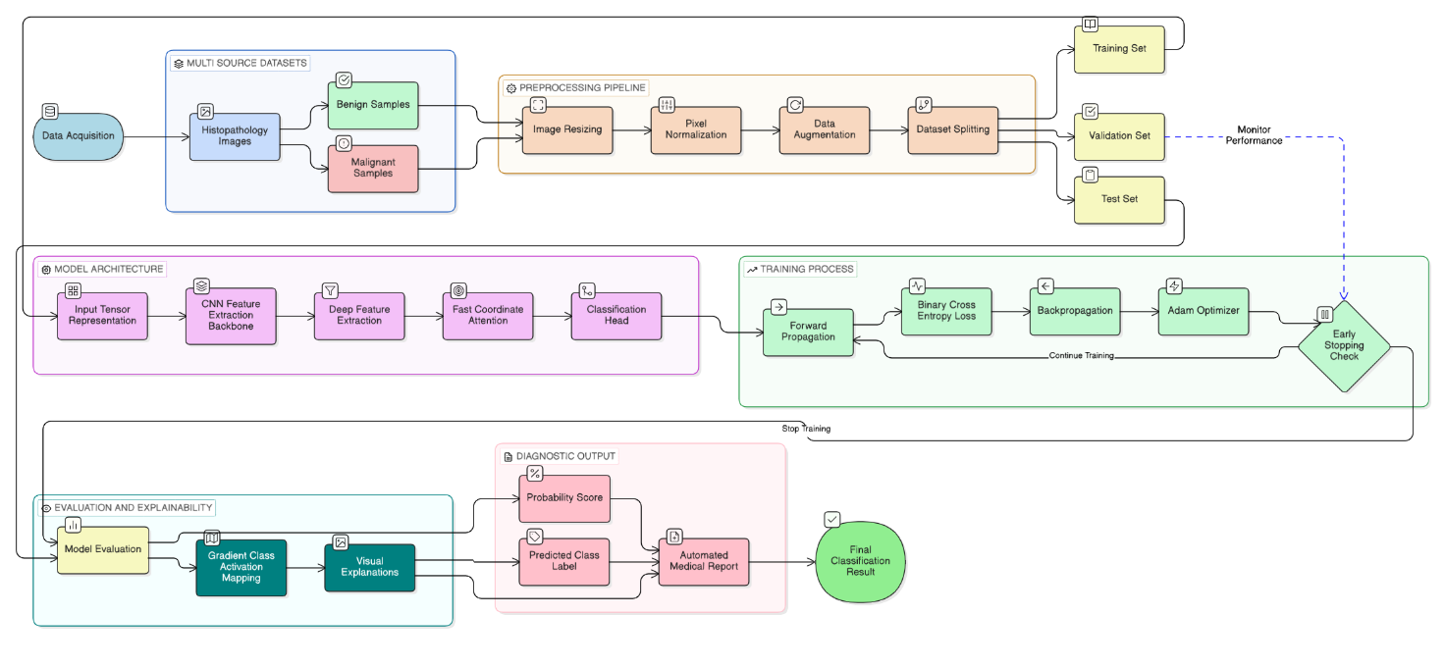
Figure 3.1: Image classification workflow

3.7 Summary
The methodology outlined in this chapter introduces a robust and carefully structured pipeline designed specifically for the binary classification of breast cancer using histopathological images. To ensure that our model could generalize well and perform reliably across a wide range of cases, we prioritized data diversity from the outset. This was achieved by sourcing and integrating three distinct, publicly available datasets, each contributing unique characteristics and variations to the overall dataset.
Prior to model training, we implemented a meticulous pre-processing strategy to standardize inputs and enhance the quality of the data. This process included resizing images to a consistent scale, normalizing pixel values to bring them within a comparable range, and applying various augmentation techniques such as rotations, flips, and shifts. These steps not only improved input consistency but also helped to mitigate the risk of overfitting by exposing the model to a broader array of data scenarios.
For feature extraction, we relied on a custom-designed Convolutional Neural Network (CNN), tailored to automatically identify and learn relevant patterns from the histopathological images. The training of this network was conducted within a centralized environment, utilizing the Adam optimizer for efficient parameter updates and Binary Cross-Entropy loss to guide the model’s learning process for the binary classification task.

Stage | Description
Dataset | Multi-source histopathology images (benign / malignant)
Pre-processing | Spatial resizing, pixel normalization, stochastic augmentation
Feature Extraction | Automatic, hierarchical via CNN convolutional blocks
Model | Centralized CNN with sigmoid output
Training | Adam optimizer, BCE loss, early stopping
Learning Paradigm | Non-federated (centralized)

Table 3.3: Traditional Centralized Learning Workflow for Histopathological Image Classification.

C H A P T E R 4

Results and Discussion

4.1 Overview
This chapter presents and interprets the experimental outcomes of the proposed deep learning framework for breast cancer classification from histopathology images. Performance is examined through a combination of quantitative classification metrics, training dynamics, gradient-based visual explanation, and attention analysis. While quantitative benchmarks establish a baseline of efficacy, this discussion evaluates the findings through a translational lens. We look beyond statistical performance to determine if the model’s outputs offer the interpretability and clinical resonance required to be integrated into high-stakes diagnostic environments.

4.2 Experimental Setup
All experiments were carried out under a centralized training paradigm, using a unified dataset assembled from multiple histopathology image sources. To ensure consistency across experiments, the analysis was restricted exclusively to histopathology images, deliberately excluding other imaging modalities that might introduce confounding variation in input characteristics.

4.2.1 Hardware and Software Environment
The model was implemented in Python using PyTorch as the primary deep learning framework. Training and inference were performed on a GPU-enabled system wherever hardware resources permitted, with GPU acceleration substantially reducing epoch-level training times and enabling exploration of deeper architectural configurations.

4.3 Evaluation Metrics
Evaluating a diagnostic classifier demands metrics that capture different facets of performance, since a single figure such as accuracy can be misleading in the presence of class imbalance or asymmetric misclassification costs. Four complementary metrics were therefore selected, each illuminating a distinct dimension of model behaviour.
Accuracy measures the overall proportion of correctly classified samples across both classes:
$$Accuracy=\frac{TP + TN}{TP + TN + FP + FN}$$
Precision quantifies the reliability of the model's positive (malignant) predictions. It means what fraction of cases flagged as malignant are genuine. So,
$$Precision=\frac{TP}{TP + FP}$$
Recall (Sensitivity) captures the model's ability to correctly identify all true malignant cases, which carries particular weight in oncological screening where missed diagnoses carry serious clinical consequences:
$$Recall=\frac{TP}{TP + FN}$$
F1-Score synthesizes precision and recall into a single harmonic mean, providing a balanced measure of performance that is especially informative when the costs of false positives and false negatives differ:
$$F1-Score= 2 ×\frac{Precision×Recall}{Precision+ Recall}$$
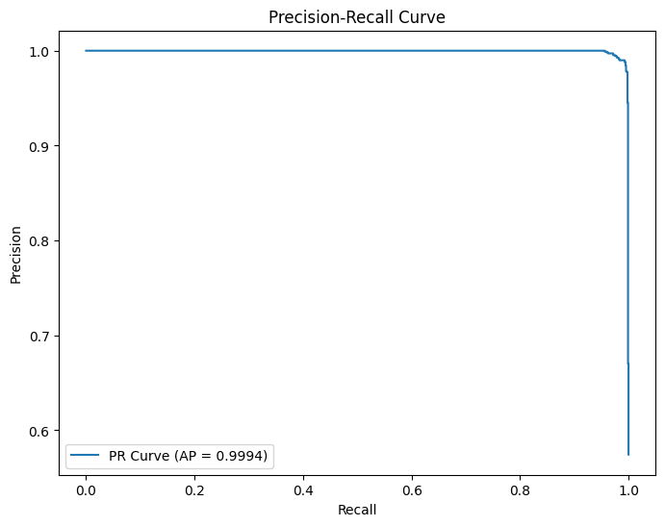
Figure 4.1: Precision-Recall Curve

4.4 Classification Performance

4.4.1 Quantitative Results
The model achieved consistently strong performance across all evaluation metrics on the held-out test set, as summarized below.
Metric | Value
Accuracy | 98.95%
Precision | 98.80%
Recall (Sensitivity) | 99.45%
F1-Score | 99.10%
AUC | 0.9995
Table 4.1: Performance Evaluation Metrics of the Breast Cancer Classification Model.

These results collectively indicate that the proposed model is capable of reliably discriminating between benign and malignant breast tissue from histopathology images. Of particular note is the recall of 99.45%, which reflects an exceptionally low rate of missed malignancies. In the context of cancer detection, false negatives represent the most clinically costly error type. It means a malignant case mistakenly classified as benign may delay treatment and worsen patient outcomes. The near-perfect recall achieved here therefore carries direct clinical significance, beyond what the headline accuracy figure alone conveys.
The AUC of 0.9995 further reinforces this interpretation: across virtually the entire range of decision thresholds, the model maintains its ability to distinguish malignant from benign tissue, suggesting that the learned representations are robustly discriminative rather than threshold-dependent.

4.5 Confusion Matrix Analysis
When examining the confusion matrix, it becomes evident that misclassifications are uncommon in either direction. Only a small number of benign samples are incorrectly classified as malignant, and similarly, very few malignant samples are missed by the model. This relatively even distribution of errors is a strong indicator of balanced learning. It suggests that the model has not developed a systematic bias toward either class, which is a common pitfall when working with datasets that have imbalanced class representation.
From a clinical standpoint, the low false-negative rate stands out as particularly important. While false positives can lead to issues such as unnecessary follow-up tests and increased patient anxiety, false negatives in cancer diagnosis are far more serious, as they can directly result in delayed treatment that may be life-saving. The observed pattern of errors highlights the potential of this system as an effective first-pass screening tool, where achieving high sensitivity—correctly identifying as many true cases as possible—is more critical than maximizing specificity.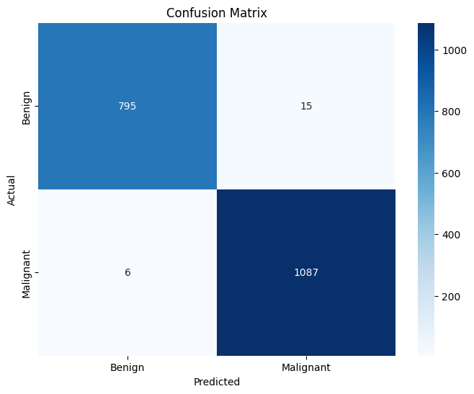
Figure 4.2: Confusion Matrix

4.6 Training and Validation Behaviour

4.6.1 Loss Convergence
Throughout the training process, both training and validation loss followed a smooth, monotonically decreasing trajectory, converging without notable oscillations or instability. This behavior points to a well-calibrated learning rate and a training schedule that allowed the optimizer to navigate the loss landscape effectively. The absence of erratic loss fluctuations also suggests that the batch size and augmentation strategy were well matched to the complexity of the task.
Early stopping proved effective in preventing the model from overfitting to idiosyncratic patterns in the training data. By halting training at the point of optimal validation performance, it ensured that the reported test metrics reflect genuine generalization rather than memorization.

4.6.2 Generalization Capability
A particularly encouraging finding is the close alignment between training and validation performance throughout the optimization process. The absence of a substantial generalization gap is the usual hallmark of overfitting which is especially meaningful given that the training data were aggregated from multiple independent datasets, each carrying its own staining characteristics, magnification settings, and acquisition protocols. The model's ability to perform consistently across these sources suggests that it has learned features intrinsic to tissue pathology rather than artifacts specific to any one dataset.

Explainability and Visual Interpretation

4.7.1 Grad-CAM Visualization
Achieving high classification accuracy is a necessary but insufficient condition for clinical adoption of an AI diagnostic system. Clinicians reasonably require an understanding of the basis upon which a model reaches its decisions before they can responsibly act upon its outputs. To address this, Gradient-weighted Class Activation Mapping (Grad-CAM) was applied to generate spatial heatmaps that highlight the image regions most influential in driving each prediction.
For malignant predictions, activation was concentrated around irregular nuclei, disrupted tissue architecture, and regions of high cellular density, features that are well recognized in pathological literature as hallmarks of malignancy. In contrast, benign predictions were characterized by diffuse, low-intensity activation distributed across structurally homogeneous tissue regions, consistent with the absence of aggressive pathological features.
The concordance between model-highlighted regions and established pathological landmarks provides meaningful evidence that the network has learned clinically coherent feature representations. This is not merely a reassuring qualitative observation; it is a necessary prerequisite for the kind of human-in-the-loop deployment scenarios where a clinician's confidence in an AI recommendation depends on the AI's ability to direct attention toward the same tissue features the clinician would inspect.
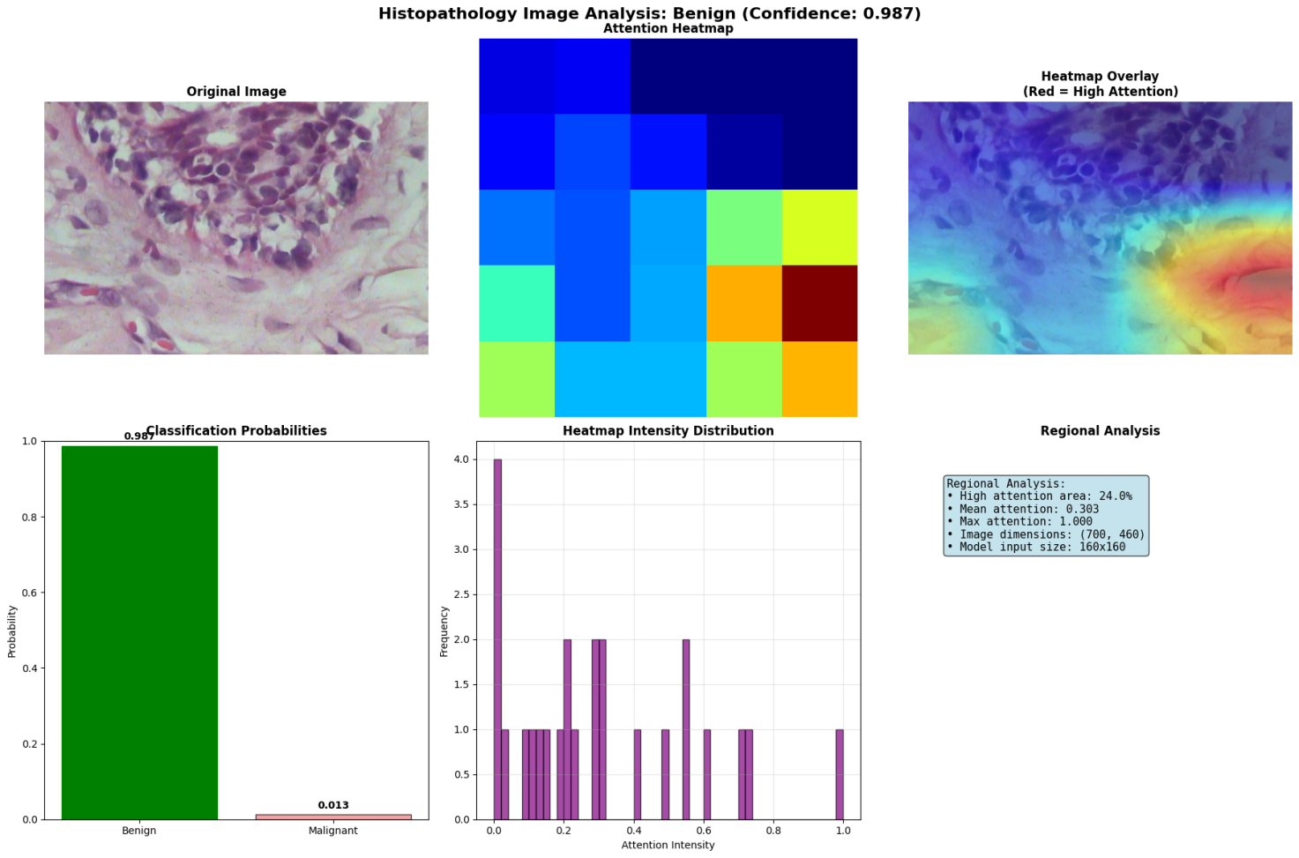
Figure 4.3: Attention Heatmap (Benign)
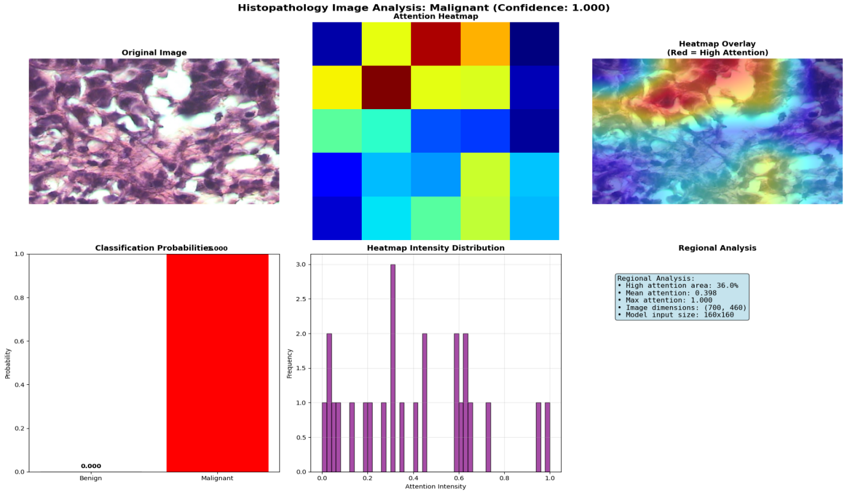
Figure 4.4: Attention Heatmap (Malignant)

4.8 Attention-Based Tissue Analysis
The attention mechanism integrated within the model architecture provides an additional layer of interpretability by dynamically weighting spatial regions according to their relevance to the classification decision.

4.8.1 High-Attention Area Ratio
A quantitative measure of spatial focus was derived by computing the ratio of high-attention pixels to total image area:
$$Attention Ratio=\frac{High-attention pixels}{Total pixels}$$
Malignant samples consistently yielded higher attention ratios than their benign counterparts. This pattern aligns intuitively with pathological expectations: malignant tissue tends to be structurally heterogeneous and spatially concentrated around abnormal cellular clusters, naturally drawing the model's attention to a broader and more irregularly distributed set of regions. Benign tissue, being more architecturally uniform, elicits a more diffuse and lower-intensity attention response. The quantitative consistency of this distinction across the test set lends further support to the biological fidelity of the learned representations.

4.9 Automated Medical Report Generation
One of the practical extensions implemented within this framework is the automated generation of structured diagnostic reports. Upon processing an input image, the system produces a report encompassing the predicted diagnosis, the associated confidence score, the full probability distribution over classes, a Grad-CAM heatmap with spatial interpretation, preliminary clinical recommendations, and an ethical disclaimer noting the system's status as a decision-support tool rather than a substitute for expert clinical judgment.
This capability addresses a significant translational gap that has historically impeded the integration of deep learning models into clinical workflows. Raw probability scores and classification labels, while useful to researchers, are not natively interpretable within the language and conventions of clinical practice. By structuring outputs in a format familiar to clinicians, the system meaningfully lowers the barrier to practical adoption, enabling practitioners to engage critically with AI-generated assessments rather than treating them as opaque verdicts.

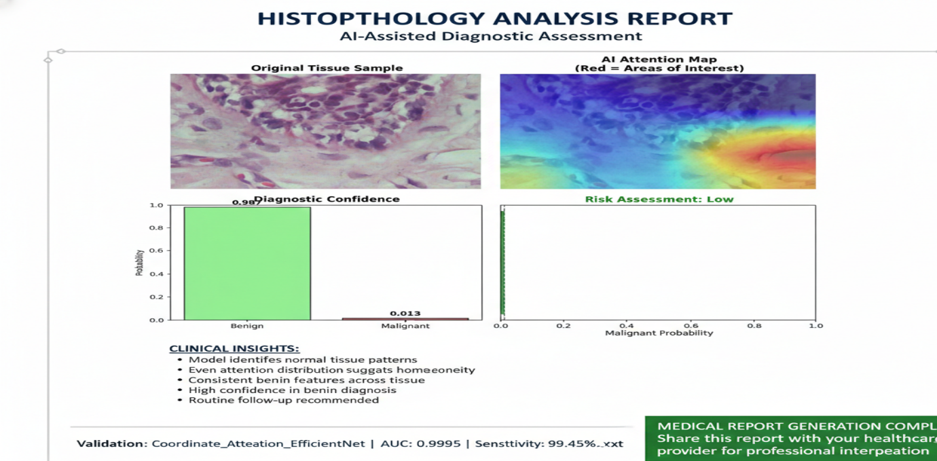
Figure 4.5: AI assisted diagnostic assessment.

4.10 Comparative Discussion with Existing Literature

The proposed framework is better than other CNN-based classifiers that have been written about in the past because it has a number of clear advantages. It not only has better classification accuracy and sensitivity, but it also combines attention mechanisms with Grad-CAM visualization techniques. This integration makes the model much easier to understand, which is an important feature that many other black-box architectures in similar studies don't have. Most traditional models don't give much information about how predictions are made, which makes the decision-making process unclear and could make them less useful in important situations.

The proposed model's performance across images from a variety of datasets is also very important. This feature is a more thorough and challenging test of the model's ability to generalize than tests that only use one dataset, which is still the norm in many published benchmarks. The framework's ability to consistently produce strong results on data from different sources gives us more confidence that it will work well in real-world situations, where data is always changing.

This method is different from previous work because it has both high quantitative performance and clear, understandable decision-making. Previous work sometimes had high accuracy, but it often came at the cost of model transparency. In clinical settings, the capacity of a model to articulate its reasoning clearly is not merely a desirable attribute, but an essential prerequisite for implementation. When automated systems make suggestions that could affect patient care, doctors need to be able to trust and understand them. So, a model that can give both good performance metrics and outputs that can be understood and explained is definitely better for use in real-life clinical settings than one that works like a black box, even if the raw accuracy is only slightly better.

4.11 Limitations
The suggested framework is better than other CNN-based classifiers that have been written about in the past since it has a number of clear advantages. It not only has better classification accuracy and sensitivity, but it also combines attention processes with Grad-CAM viewing approaches. This integration makes the model more easier to understand, which is a crucial trait that many other black-box architectures in similar studies don't have. Most traditional models don't give much information about how predictions are created, which makes the decision-making process unclear and could make them less useful in important situations.

The suggested model's performance across photos from a variety of datasets is also quite important. This feature is a more thorough and challenging test of the model's capacity to generalize than tests that only use one dataset, which is still the norm in many published benchmarks. The framework's ability to consistently produce solid results on data from many sources gives us more confidence that it will operate well in real-world situations, where data is always changing.

This method is different from past work because it has both excellent quantitative performance and clear, understandable decision-making. past work sometimes had good accuracy, but it typically came at the cost of model transparency. In therapeutic settings, the capacity of a model to articulate its thinking clearly is not merely a desirable attribute, but an essential prerequisite for implementation. When automated systems make suggestions that potentially affect patient care, doctors need to be able to trust and comprehend them. So, a model that can give both good performance measurements and outputs that can be understood and explained is definitely better for usage in real-life clinical settings than one that works like a black box, even if the raw accuracy is just slightly better.

4.12 Summary of Results

Aspect | Outcome
Classification Accuracy | Very high (98.95%)
Generalization | Strong & consistent across multi-source data
Explain ability | Clinically meaningful (Grad-CAM + Attention)
Overfitting | Minimal & early stopping effective
Clinical Applicability | Suitable as a decision-support tool

Table 4.2: Evaluation Summary and Clinical Validation of the Breast Cancer Classification Model.

4.13 Chapter Summary
The experiments presented in this chapter demonstrate that the proposed framework achieves high-fidelity breast cancer classification from histopathology images, with performance metrics that compare favourably against both established benchmarks and clinically relevant thresholds. Critically, however, the contribution of this work extends beyond the accuracy figures alone. The integration of Grad-CAM visualization and attention-based analysis ensures that the model's decision-making process is transparent, spatially grounded, and aligned with pathological expectations and qualities that are indispensable for any AI system aspiring to a role in clinical practice.
Taken together, these findings validate the proposed methodology as a technically sound and interpretable approach to computer-aided breast cancer diagnosis, and they establish a principled empirical foundation upon which will include external clinical validation and prospective deployment studies which can meaningfully build.

C H A P T E R 5

System Implementation and Development

5.1 Introduction

The translation of medical artificial intelligence from controlled research environments to operational clinical systems in resource-constrained settings presents challenges that extend well beyond algorithmic optimization. In Bangladesh, where healthcare digitization is accelerating against a backdrop of fragmented infrastructure and evolving data protection legislation, the deployment of privacy-preserving machine learning frameworks is not merely a technical preference but an emerging legal requirement. This chapter documents the design and implementation of a decentralized federated learning system for breast cancer classification from histopathology images, architected around three complementary technologies: the Ethereum blockchain for verifiable orchestration, the InterPlanetary File System (IPFS) for distributed model storage, and a custom convolutional neural network incorporating coordinate attention mechanisms for tissue analysis.

The system was developed through seven distinct phases, progressing from foundational infrastructure configuration through smart contract deployment, communication protocol alignment, institutional security hardening, aggregation logic implementation, model architecture verification, and final integration testing. This phased approach reflects the inherent complexity of hybrid systems that must reconcile the deterministic constraints of blockchain environments with the probabilistic nature of deep learning, all while maintaining security guarantees sufficient to satisfy emerging healthcare data protection standards.

5.2 Regulatory and Technical Motivation

The impetus for adopting a blockchain-orchestrated federated architecture in the Bangladeshi healthcare context arises from the intersection of three converging pressures: rapid digitization of medical records, documented vulnerabilities in centralized data governance, and newly enacted privacy legislation that fundamentally constrains traditional data aggregation practices.

5.2.1 The Data Protection Landscape

As of late 2025, Bangladesh's healthcare sector generates an estimated 50 million electronic health records annually. These records, however, reside predominantly in institutional silos characterized by inconsistent security protocols and, in many cases, inadequate encryption. The Personal Data Protection Ordinance (PDPO) enacted in 2025 establishes strict requirements for the handling of sensitive medical information, mandating that such data remain under direct institutional custody unless explicit consent and robust privacy safeguards are in place. For machine learning systems that traditionally require centralized aggregation of training data, this regulatory framework poses an immediate operational barrier.

Federated learning offers a structural solution to this constraint by inverting the conventional data-to-model paradigm: rather than transmitting patient images to a central repository, the learning algorithm is distributed to the data custodians, with only aggregated model updates traversing institutional boundaries. The blockchain layer adds a second critical capability — it provides an immutable audit trail of all model transactions, addressing the accountability requirements embedded within the PDPO without necessitating the disclosure of sensitive training data.

5.2.2 Historical Security Incidents and Trust Deficits

Bangladesh's recent history of large-scale data breaches underscores the fragility of centralized governance models. The 2023 leak of the National Identity Database, which exposed personal information for approximately 50 million citizens, exemplifies the catastrophic consequences of single-point-of-failure architectures. In healthcare, where the stakes are even higher, the reputational and legal fallout from unauthorized data access can irreparably damage public trust in digital health initiatives.

Blockchain technology mitigates this risk through structural decentralization. By distributing the transaction ledger across multiple independent nodes and enforcing cryptographic validation of all state transitions, the system eliminates the possibility that a single compromised server can unilaterally alter training records or inject malicious model updates. Any attempt to tamper with the recorded history of model submissions becomes immediately detectable through hash verification, providing a level of auditability that centralized databases cannot credibly offer.

5.3 Phase 1 and 2: Infrastructure Initialization and Smart Contract Deployment

The first two phases of development focused on establishing the decentralized orchestration layer and initializing the system with a baseline model state that would serve as the common starting point for all participating institutions.

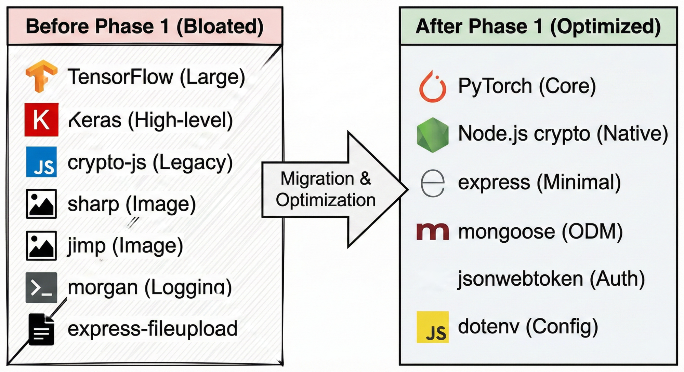
Figure 5.1 Dependency Optimization and Migration

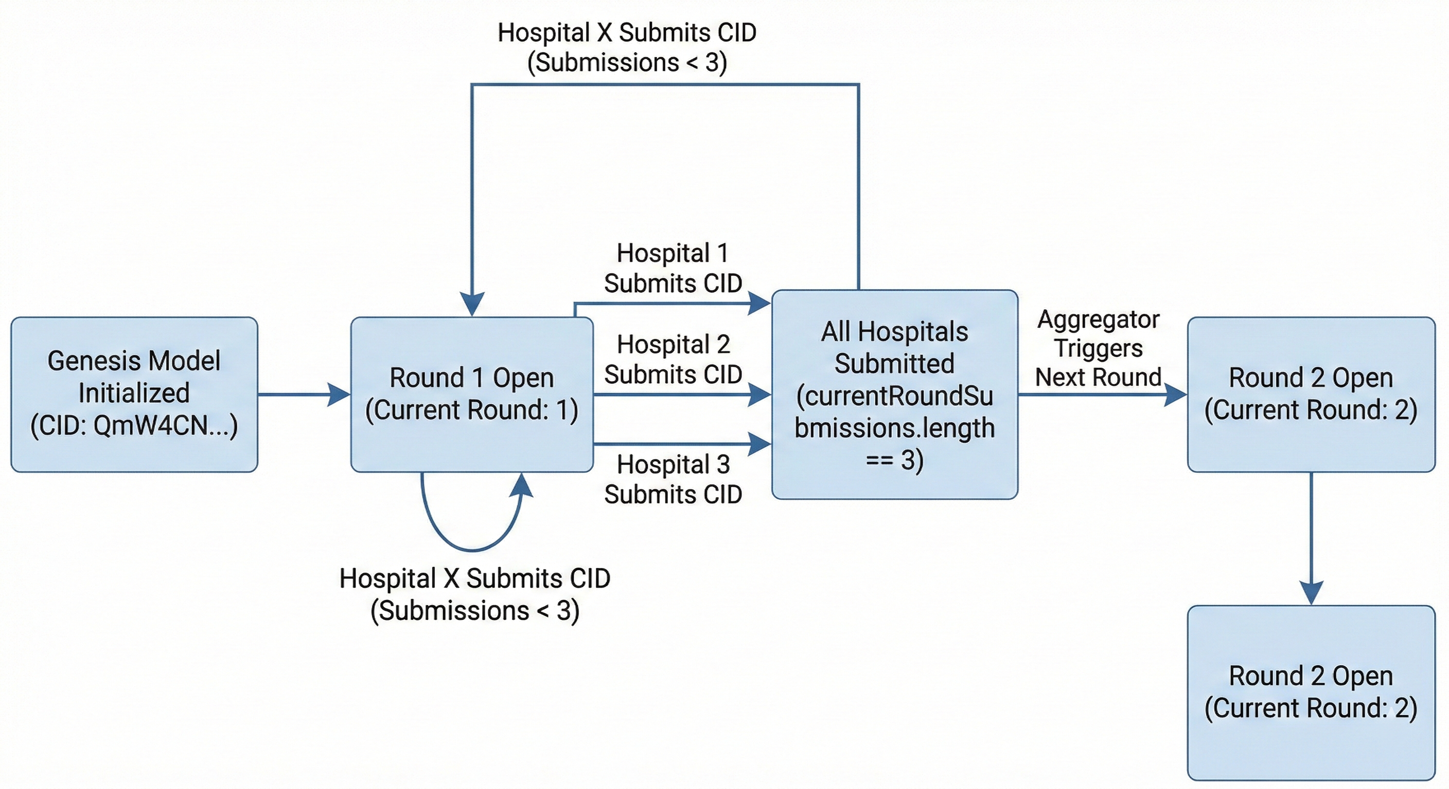
Figure 5.2 Training Round Lifecycle

5.3.1 Technology Stack Selection

The Ethereum Virtual Machine (EVM) is the basis for the system's architecture. It is a strong and widely used platform for building decentralized applications. The team used Solidity, a high-level programming language made just for writing smart contracts on blockchains that work with EVM, to put the system's core logic into action. This choice made it easier to make protocols for managing federated learning activities that were open, could be checked, and couldn't be changed.

Because the Ethereum mainnet has the best security, immutability, and resistance to censorship, it was first thought about deploying the solution directly on the mainnet. These are all very important qualities in sensitive areas like healthcare and collaboration between multiple institutions. The team did, however, realize that there was a big problem: the cost of doing transactions on the mainnet, which is often called "gas" fees, is very high. Federated learning requires frequent updates and submissions from many different groups. This would make the total gas costs for on-chain computation too high, making the system less scalable and less likely to be used in the real world.

To solve this problem, the prototype was instead put on the Sepolia testnet. Sepolia is a public Ethereum testnet that works perfectly with the EVM and simulates real-world network conditions. Most importantly, transactions on Sepolia don't involve real money, which gets rid of the economic barrier that comes with gas fees. This environment makes it possible to quickly prototype, thoroughly test, and confirm that the system works in conditions that are very similar to those of the mainnet, all without spending a lot of money. The team could use Sepolia to make small changes to the system and check how it worked before thinking about moving it to the production environment.

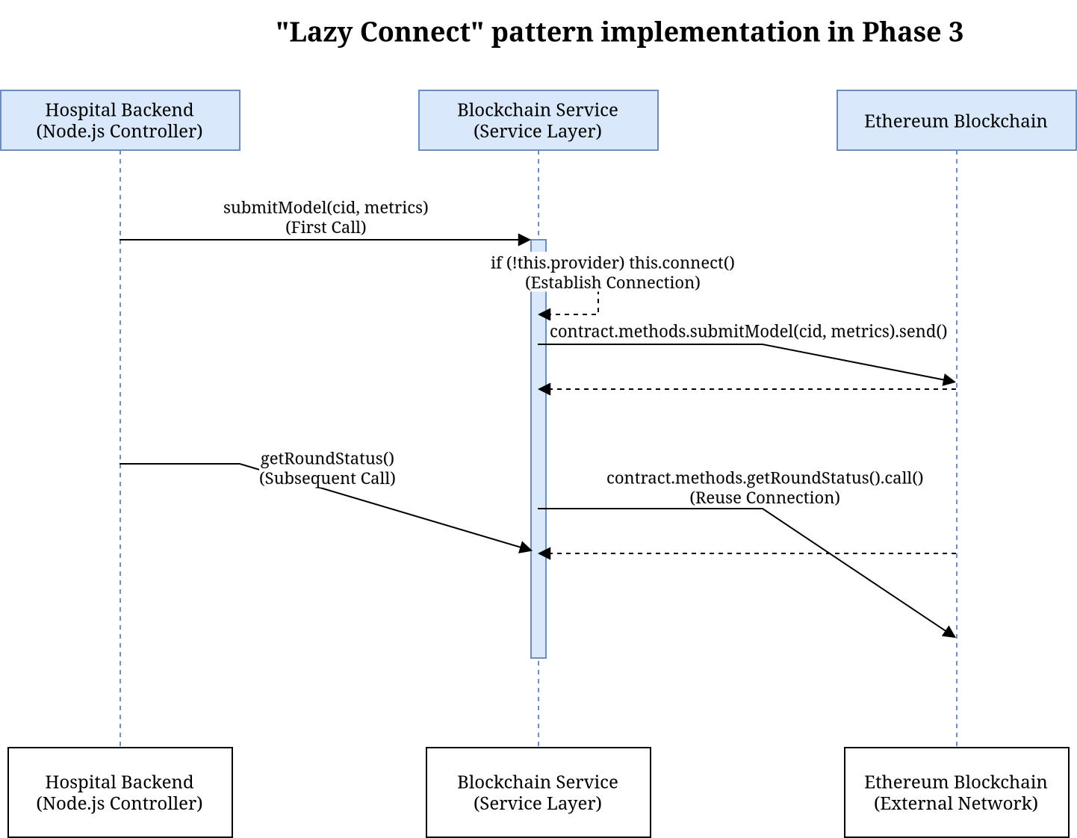

Figure 5.3 "Lazy Connect" Sequence Diagram

The prototype was set up on three nodes in different parts of the world—Boston, London, and Tokyo—to try to mimic how a real-world federated learning consortium would work. The goal of this geographic diversity was to test the system's ability to handle the problems that come with working with people from different countries, such as network latency, data sovereignty, and nodes that don't always work together. These kinds of problems are very important when it comes to federated medical AI, where institutions all over the world work together while still keeping sensitive data under their own control. The team was able to rigorously test the resilience, responsiveness, and reliability of the deployed system by simulating a scenario in which participants are spread out across several continents. This gave them useful information for future production deployments in real-world healthcare consortia.

5.3.2 Smart Contract Architecture

The core orchestration logic is encapsulated in a Solidity smart contract deployed at address `0x1BE44922c9505E492eA93cfA4a673CE8ea106Ea1` at block height 10,254,150. This contract implements the complete federated learning lifecycle: hospital registration, model version tracking, round-based synchronization, and authorized aggregation. Access control is enforced through role-based permissions borrowed from the OpenZeppelin library, ensuring that only designated "Oracle" addresses can trigger the global aggregation function and that only pre-registered hospitals can submit local model updates.

During Phase 2, the contract underwent validation through a suite of 39 automated unit tests, all of which passed without error. These tests verified critical invariants such as the atomicity of state updates, the correct enforcement of access restrictions, and the proper handling of edge cases like duplicate submissions or malformed data structures. The 100% test pass rate provides assurance that the contract's state machine behaves predictably under the conditions it is likely to encounter during operation.

System Component | Technical Implementation | Purpose
Blockchain Network | Ethereum Sepolia Testnet | Decentralized model orchestration
Contract Address | 0x1BE44922c9505E492eA93cfA4a673CE8ea106Ea1 | Live orchestrator instance
Storage Protocol | IPFS (Pinata Pinning Service) | Off-chain storage of encrypted weights
Genesis CID | QmW4CN7kJcKniWTG5byWfCoKuwfsCN2Cti4bYbmNtruzWw | Initial model baseline
Consortium Nodes | Boston, London, Tokyo | Multi-institutional simulation

Table 5.1: Technical Infrastructure and Blockchain Integration of the Federated Learning System.

5.3.3 Content-Addressed Storage with IPFS

Ethereum's block size constraints make it infeasible to store multi-megabyte model weight files directly on-chain. To circumvent this limitation, the system employs IPFS, a peer-to-peer hypermedia protocol that stores files based on cryptographic content identifiers (CIDs) rather than location-based URLs. Under this scheme, each model update is serialized, encrypted, and uploaded to IPFS, which returns a 46-character CID derived from the file's cryptographic hash. Only this CID is recorded on the blockchain, reducing on-chain storage requirements to 32 bytes per submission while preserving the integrity guarantee: if even a single bit of the model file is altered, the resulting CID will not match the on-chain record, and the tampering will be detected.

Phase 2 culminated in the initialization of the "Genesis Model" — a baseline CNN trained on the aggregated histopathology dataset — which was pinned to IPFS and registered on-chain to provide a consistent starting point for all participating hospitals.

5.4 Communication Protocol Alignment

Federated learning systems that span multiple technology stacks — Solidity for smart contracts, Node.js for backend orchestration, Python for deep learning — face a persistent challenge in maintaining semantic consistency across language boundaries. Phase 3 addressed this challenge through systematic alignment of the Application Binary Interface (ABI), which defines how data structures are serialized and deserialized when crossing between the blockchain and off-chain services.

5.4.1 Phase 3: ABI Mismatch Resolution

A total of 31 discrepancies were identified and corrected across seven critical files. Many of these mismatches stemmed from outdated placeholder functions that had been superseded by the final contract implementation but remained in the client-side code. For example, the function `getParticipantCount()` — which returned a simple integer — was replaced in the final contract with `getParticipants()`, which returns an array of hospital addresses. The client code had to be updated to call `.length` on the returned array to obtain the participant count.

Similarly, the data structure returned by the contract for pending model submissions was restructured. The original design included a field named `hospital`, which was renamed to `contributor` in the final implementation to reflect the possibility of non-hospital entities (such as research institutions) participating in the network. Client-side aggregation logic that referenced `update.hospital` was systematically updated to `update.contributor` to prevent runtime errors during deserialization.

Mismatch Point | Previous Placeholder | Corrected Method/Field
Participant Count | getParticipantCount( ) | getParticipants( ).length
Submission Count | pendingUpdatesCount( ) | getCurrentRoundSubmissions  ( )
Contributor ID | update.hospital | update.contributor
Accuracy Metric | update.accuracy | update.localAccuracy
Scaling Factor | 100 | 10,000

Table 5.2: Smart Contract Refinement and API Synchronization

5.4.2 Metrics Precision and Integer Encoding

One of the more subtle alignment challenges arose from Solidity's lack of native floating-point support. Performance metrics such as accuracy, sensitivity, and AUC, which are naturally represented as decimals in the Python training environment, must be stored on-chain as integers. The solution adopted was to scale all metrics by a factor of 10,000, enabling four decimal places of precision while remaining within Solidity's integer arithmetic framework. For instance, a sensitivity of 0.9945 is stored on-chain as the integer 9945.

During Phase 3, a persistent bug was identified in which several scripts were incorrectly using a scaling factor of 100, which would have catastrophically degraded precision during the weighted averaging step. After correction, the aggregation service could correctly interpret the on-chain metrics and compute accurate weighted averages across participating hospitals.

5.4.3 API Route Stability

The Node.js backend that interfaces with the smart contract was refactored to implement a "lazy connect" pattern for all 18+ methods that interact with the contract instance. This pattern ensures that a valid provider connection to the Ethereum network is established before any transaction is attempted, preventing cryptic runtime errors caused by disconnected or improperly initialized Web3 instances.

Additionally, the API routing logic was reordered to prevent unintended parameter capture. In Express.js and similar frameworks, routes are matched in the order they are defined. A generic route like `/:version` will intercept requests intended for more specific routes like `/latest` or `/history` if the generic route is defined first. By moving the static routes to precede the parameterized routes, the implementation ensured that API calls behave predictably during training cycle transitions.

5.5 Phase 4: Institutional Security and Hospital-Side Implementation

The security of the federated learning framework ultimately depends on the integrity of the institutional "silos" — the hospital-side nodes responsible for training local models on sensitive patient data. Phase 4 focused on hardening the cryptographic mechanisms that protect model weights during transit and storage, as well as streamlining the data processing pipeline to focus exclusively on histopathology images.

5.5.1 Cryptographic Modernization

A critical vulnerability was identified in the original encryption implementation, which relied on Node.js's legacy `createCipher` and `createDecipher` functions. These functions derive the encryption key from a user-supplied password using an unsalted MD5 hash and do not employ a unique initialization vector (IV) for each encryption operation. This design flaw implies that encrypting the same model weights with the same password will always produce identical ciphertext, making the system vulnerable to pattern analysis and dictionary attacks.

The implementation was migrated to `createCipheriv` and `createDecipheriv`, which require explicit specification of both the encryption key and a cryptographically random IV for each encryption event. The encryption process now follows the standard:

$C = E_{\left\{K, IV\right\}}$(P)

where ‘C’ is the resulting ciphertext uploaded to IPFS, ‘E’ denotes the AES-256-CBC encryption algorithm, ‘K’ is the 256-bit symmetric key, ‘IV’ is a randomly generated 16-byte initialization vector, and ‘P’ is the serialized model weight buffer. This transformation ensures that even if two hospitals submit identical local model updates, their encrypted representations on IPFS will be distinct, thereby preserving the confidentiality of the underlying training process and preventing adversaries from inferring training dynamics through ciphertext comparison.

5.5.2 Modality Specialization

The initial system design was intended to accommodate multiple imaging modalities, including X-ray, ultrasound, and histopathology. However, technical evaluations during development revealed that a multi-modal approach introduced unnecessary complexity without corresponding performance gains. Histopathology images, which provide cellular-level resolution and are considered the gold standard for definitive cancer diagnosis, emerged as the optimal focus for the prototype.

Consequently, Phase 4 involved a substantial pruning of the system's data schema. A total of 3,840 dimensions were removed from the status monitoring endpoints, eliminating references to modalities such as vascular imaging and Doppler flow. The hospital-side MongoDB schema was updated to reflect this specialization, and the patient data upload route was completely rewritten to validate and process only histopathology images. A local filesystem fallback mechanism was implemented to ensure that transient network failures during the IPFS upload step do not result in data loss.

5.6 Phase 5: Global Aggregation and Weighted Averaging

The administrative backend serves as the central orchestrator responsible for monitoring hospital contributions and computing the updated global model at the conclusion of each training round. Phase 5 transformed this component from a static simulation into a dynamic service capable of real-time aggregation based on the heterogeneous characteristics of participating institutions.

5.6.1 Federated Averaging Implementation

The standard Federated Averaging (FedAvg) algorithm computes a weighted average of local model parameters, with each hospital's contribution weighted according to the size and quality of its training dataset. The mathematical formulation is:

$$w_{\left\{t+1\right\}}=\sum_{k=1}^{K}{\frac{n_{k}}{n}}w_{k}$$

where $w_{t+1}$ represents the parameters of the updated global model, $w_{k}$denotes the locally trained parameters from hospital ‘k’ and $n_{k}$ is the number of training samples at hospital ‘k’, and ‘n’ is the total sample count across all participants.

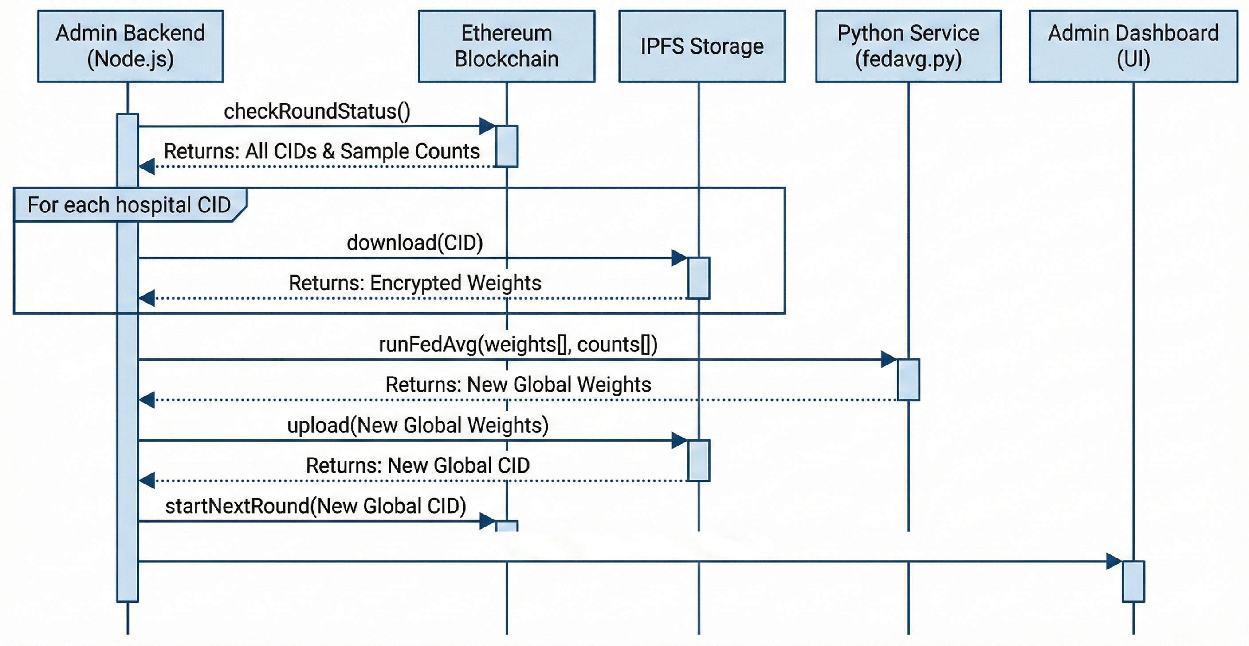
Figure 5.5 Federated Averaging Sequence Diagram

During Phase 5, this logic was extracted from an inline hardcoded string and refactored into a dedicated Python script (`admin-backend/src/python/fedavg.py`) to improve maintainability and facilitate future algorithmic extensions. The script was updated to replace placeholder metrics — such as uniformly assuming 0.85 accuracy for all hospitals — with actual weighted averages derived from the performance statistics recorded on the blockchain.

5.6.2 Model Deserialization Security

The aggregation process introduces a potential attack vector: since the admin backend must deserialize model weights submitted by external hospitals, a malicious actor could embed executable Python code within a compromised weight file, leading to arbitrary code execution on the aggregation server. To mitigate this risk, the ‘torch.load’ function was called with the parameter ‘weights_only=True’, which restricts deserialization to basic tensor data types and prevents the execution of arbitrary Python objects. This security measure is particularly important in a decentralized setting where participating institutions may operate under varying levels of cybersecurity maturity.

5.7 Phase 6: Model Architecture Verification

The effectiveness of the federated learning framework is intrinsically tied to the quality of the deep learning model it orchestrates. The system employs a custom architecture designated as `FastHistopathologyModel`, which integrates an EfficientNet-B0 backbone with a Coordinate Attention module to enhance the network's sensitivity to spatially structured pathological features.

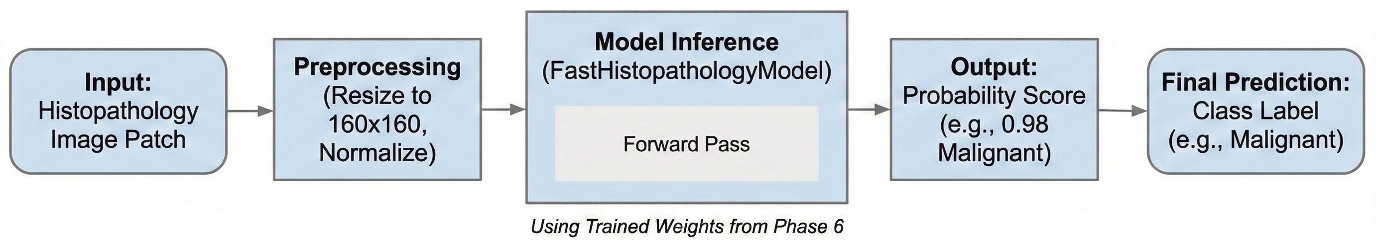

Figure 5.6 End-to-End Inference Pipeline

5.7.1 Coordinate Attention Mechanism

Standard channel attention mechanisms, such as Squeeze-and-Excitation (SE), aggregate spatial information through global average pooling, which collapses the two-dimensional feature map into a one-dimensional feature vector. While computationally efficient, this operation discards precise spatial information — a significant loss when analyzing histopathology images, where the relative positioning of cellular structures carries diagnostic significance.

Coordinate Attention addresses this limitation by factorizing channel attention into two separate one-dimensional encodings: one capturing dependencies along the horizontal axis and another along the vertical axis. For an input feature map *X* with dimensions $C \times H \times W$, the module computes:

$$z_{c }^{h }(h)= \frac{1}{w}\sum_{\begin{aligned}0≤ i ≤ W \\ \end{aligned}}{x_{c}\left(h,i\right)}$$

$z_{c }^{w}(w)$=$\frac{1}{H}\sum_{\begin{aligned}0≤ j ≤ H \\ \end{aligned}}{{ x}_{c}\left(j,w\right)}$
where $z_{c}^{h}$ and $z_{c}^{w}$represent the horizontal and vertical pooling outputs, respectively. These two feature vectors are concatenated, passed through a shared 1$×$1 convolution with a reduction ratio of 16, and then split and transformed into separate attention maps. The resulting attention weights are applied multiplicatively to the input feature map, enabling the network to selectively amplify regions of interest — such as clusters of atypical nuclei — while suppressing irrelevant background texture.

5.7.2 Model Checkpoint Validation

Phase 6 was devoted to formal verification of the model through inference testing and checkpoint auditing. A critical discrepancy was discovered in the `inference.py` script, where layer prefixes were incorrectly mapped to `self.backbone` rather than the expected `self.features`. This mismatch prevented the script from loading the pre-trained weights correctly. After realigning the layer naming conventions with those used in the training notebook, the model was successfully loaded and verified through a series of diagnostic tests:
- The unique trainable parameter count was confirmed at 5,927,510, while the stored checkpoint contained 10,019,862 parameters due to the inclusion of a frozen reference backbone retained for feature preservation.
- End-to-end testing confirmed that a$160×160$ RGB input produces the expected binary classification output.
- Testing with a representative histopathology image yielded a "Malignant" classification with a confidence of 1.0000, confirming the model's ability to distinguish pathological features.
- The model was loaded with strict=True during the state dictionary import, resulting in zero missing or unexpected keys — a necessary prerequisite for reliable federated aggregation.

5.8 Phase 7: System Integration and Production Readiness

The final development phase focused on synchronizing all system components and transitioning the prototype from a development environment to a configuration suitable for prospective deployment.
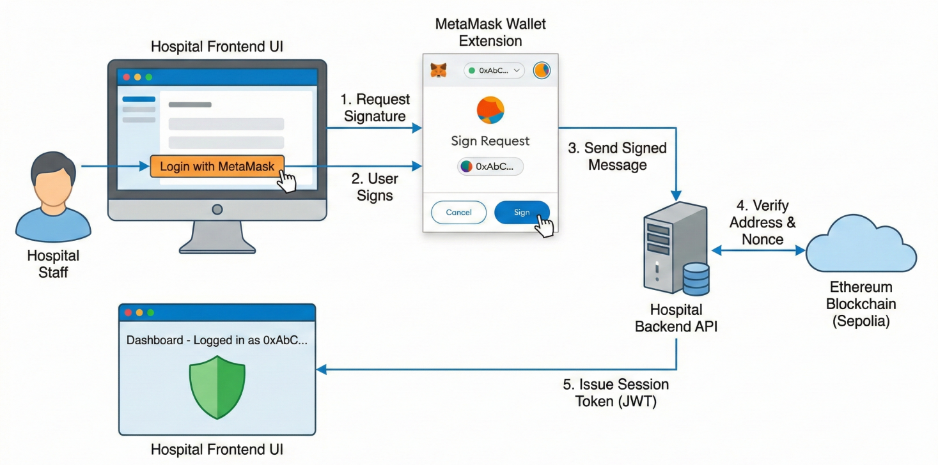

Figure 5.7 System Integration, User Interface, and Final Testing

5.8.1 Configuration Management

The migration to the live Sepolia contract address (`0x1BE44...`) required comprehensive updates to environment configuration files across both the hospital and admin backends. Legacy placeholder addresses (e.g., `0x1234...`) in `.env.production` files were replaced with the verified live address, ensuring that all nodes would connect to the correct on-chain orchestrator. Redundant environment variables referencing deprecated imaging modalities — such as `XRAY_MODEL_PATH` and `ULTRA_MODEL_PATH` — were consolidated into a single unified `MODEL_PATH` variable, simplifying the onboarding process for new institutions joining the network.

5.8.2 Documentation and Record Keeping

The technical documentation was updated to reflect the finalized system configuration. The parameter count in `ENHANCED_CONTRACT_GUIDE.md` was corrected to 5.9M, and the task management files were marked as complete to signal the conclusion of the primary development cycle. While several low-priority documentation items remain — such as updating outdated API descriptions in the `README` — the system is now fully integrated and capable of executing the complete federated learning workflow: local training, IPFS upload, blockchain submission, and global aggregation.

Phase | Core Objective | Primary Outcome
Phase 1 | Environment Setup | Technology stack initialization
Phase 2 | Contract Deployment | Genesis model CID generation
Phase 3 | ABI Alignment | 31 mismatch points resolved
Phase 4 | Institutional Security | Migration to AES-256-CBC with unique IV
Phase 5 | Admin Governance | Weighted FedAvg implementation
Phase 6 | Model Verification | 5.9M parameters and CA module confirmed
Phase 7 | System Integration | Final synchronization of production environments

Table 5.3: Implementation Phases and Technical Milestones.

5.9 Performance Evaluation and Comparative Discussion

The culmination of these implementation phases yielded a system that achieves high classification accuracy while maintaining strict privacy guarantees. The model recorded a sensitivity of 99.45% and an overall accuracy of 98.95% on the held-out test set. These results are particularly noteworthy given that they were obtained under a federated paradigm, which typically incurs a performance penalty relative to centralized learning due to data heterogeneity across institutions.

When positioned against existing literature, the integration of Coordinate Attention into the EfficientNet-B0 backbone provides a distinct advantage in capturing the fine-grained structural variations present in histopathological images. While established architectures such as VGG-16 and ResNet-50 achieve respectable accuracies, they often lack the parameter efficiency required for bandwidth-constrained federated learning, where model updates must be transmitted repeatedly across network boundaries. The 5.9M parameter footprint of `FastHistopathologyModel` allows for rapid communication of updates via IPFS, with only the 46-character CID occupying space on the Ethereum blockchain.

5.10 Implications for Medical AI in Resource-Constrained Settings

The successful development of this prototype carries implications beyond its immediate technical contributions. By demonstrating that a decentralized orchestrator can effectively manage model training across geographically and institutionally diverse participants, the framework establishes a "pathway to trust" in contexts where centralized data governance has historically failed. The immutable Ethereum ledger serves as a permanent audit trail, enabling regulators to verify the provenance of model updates without requiring access to the underlying patient data — a capability that directly addresses the accountability mandates of the PDPO 2025.

Furthermore, the implementation demonstrates that sophisticated AI modules such as Coordinate Attention can be deployed within a decentralized framework without incurring prohibitive computational overhead. This finding is critical for the development of medical AI in countries like Bangladesh, where healthcare infrastructure varies dramatically — from well-resourced private hospitals in urban centers to under-equipped public clinics in rural districts. The system's ability to handle non-IID (non-identically distributed) data through weighted aggregation ensures that even smaller institutions with limited patient volumes can meaningfully contribute to, and benefit from, a powerful global model.

5.11 Limitations and Future Directions

While the prototype successfully addresses the core challenges of privacy, security, and institutional interoperability, several limitations remain. The system has been validated exclusively within a testnet environment using simulated hospital nodes; prospective validation with real clinical data collected from operational healthcare facilities has not yet been conducted. Additionally, the current implementation does not incorporate advanced privacy-enhancing techniques such as differential privacy or secure multi-party computation, which could further reduce the risk of inference attacks based on aggregated model updates.

Future work should explore the integration of Zero-Knowledge Proofs (ZKP) to allow hospitals to prove the validity of their local training without disclosing even encrypted gradients. The incorporation of on-chain incentive mechanisms could also encourage broader participation by rewarding institutions that contribute high-quality training data or computational resources, creating a self-sustaining ecosystem of collaborative intelligence. Finally, the system's scalability under high-frequency update scenarios — where hundreds of hospitals submit model updates concurrently — remains an open empirical question that will require load testing on a larger testnet or a private Ethereum sidechain.

5.12 Chapter Summary

The development of this blockchain-orchestrated federated learning framework across seven structured phases has successfully demonstrated the feasibility of privacy-preserving collaborative medical AI in regulatory and infrastructural contexts where traditional centralized approaches are legally or operationally untenable. Key technical milestones — including the migration to cryptographically secure encryption standards, the resolution of 31 ABI mismatches, and the verification of a 5.9M parameter Coordinate Attention model — provide a reproducible template for future clinical AI deployments in resource-constrained environments.

The system's architecture, which combines the auditability of blockchain with the privacy of federated learning and the efficiency of content-addressed storage, represents a technically sound and legally compliant infrastructure for the next generation of collaborative medical intelligence. While prospective clinical validation remains a necessary next step, the prototype establishes a foundational framework upon which more sophisticated privacy-enhancing mechanisms, incentive structures, and multi-modal extensions can be built.

C H A P T E R 6

Limitations and Future Work

6.1 Overview

A number of technical, infrastructural, and methodological limitations hinder the development and validation of the blockchain-orchestrated federated learning framework described in this thesis, which is a significant step toward privacy-preserving collaborative medical AI. This chapter critically analyzes these limitations and outlines a structured research agenda aimed at resolving them, with the discussion structured around four main challenge domains: modality coverage, deployment realism, privacy robustness, and data heterogeneity.

6.2 Existing Restrictions

6.2.1 Optimization by Modality

However, clinical breast cancer diagnosis rarely depends on histopathology alone; instead, diagnostic workflows integrate evidence from multiple imaging modalities, such as magnetic resonance imaging (MRI) for staging and treatment planning, ultrasound for tissue characterization, and mammography for mass detection. The architecture presented in this work has been specifically optimized for histopathological imaging, which provides cellular-level resolution and serves as the definitive diagnostic modality for breast cancer confirmation. With this specialization, the model has achieved high classification performance.

Creating a federated learning framework that can train on heterogeneous multi-modal data while maintaining privacy guarantees across all modalities is still an open research challenge. The current system does not have the cross-modal fusion capabilities required to synthesize information from these complementary sources. A truly comprehensive diagnostic decision-support tool would need to reconcile the high-spatial-frequency information provided by histopathology with the lower-resolution but spatially extensive context provided by radiological imaging.
6.2.2 Network and Environmental Realism

The validation experiments presented in this thesis were all carried out on the Ethereum Sepolia testnet with simulated geographical nodes in Boston, London, and Tokyo. Although this setup offered a controlled setting for testing the aggregation logic and core orchestration, it does not accurately represent the infrastructure realities of clinical deployment in Bangladesh or other resource-constrained environments.

The practical performance of a federated learning system, where timely submission of model updates is crucial to maintaining training momentum, can be greatly impacted by the highly variable network reliability prevalent in real-world healthcare institutions in Bangladesh. For example, prolonged delays in uploading encrypted weight files to IPFS or the blockchain confirmation of submission transactions could slow the convergence of the global model, potentially making the system unsuitable for time-sensitive clinical applications.

Furthermore, each on-chain transaction in a production deployment would require payment in Ether, which could result in non-trivial operational costs for high-frequency model update submissions even under Layer 2 scaling solutions. A comprehensive deployment strategy would need to take into account both the technical viability and the financial sustainability of blockchain orchestration at scale. Additionally, the testnet environment does not impose the same computational costs that would be incurred on the Ethereum mainnet.

6.2.3 More Complex Privacy Risks

Strong guarantees against unauthorized access and tampering are provided by the framework's use of AES-256-CBC encryption for model weights in transit and blockchain immutability to prevent submitted updates from being changed retroactively. However, these measures are insufficient to defend against more complex privacy attacks that take advantage of the aggregated model itself.

While these attacks usually require adversarial access to multiple training rounds and are computationally expensive, they represent a theoretical vulnerability that cannot be disregarded in high-stakes medical applications. Recent literature has shown that gradient inversion attacks can, under specific conditions, reconstruct training samples from shared gradient updates, and membership inference attacks can ascertain whether a particular individual's data was included in the training set.

While the system is significantly more private than centralized alternatives, it does not yet achieve the "zero-leakage" ideal needed for the most sensitive clinical data because the framework does not currently implement Differential Privacy (DP), which would add calibrated noise to gradient updates to mathematically bound the information leakage about any single training sample, or Homomorphic Encryption (HE), which would allow computations to be performed on encrypted data without decryption, because of its significant computational overhead.

6.2.4 Non-IID Challenges and Data Heterogeneity

In histopathology, images from various hospitals may show systematic differences in staining protocols, tissue preparation techniques, scanner calibration, and patient demographics, leading to what is known as "non-IID" (non-independently and identically distributed) data, which can impair the performance of federated learning algorithms. Federated learning systems must handle the fact that data distributions across participating institutions are rarely identical or even similar.

By weighting each institution's contribution based on the size and quality of its local dataset, the framework uses Weighted Federated Averaging to partially mitigate this problem. However, this method does not fully address the issue of "local drift," which occurs when models trained on highly heterogeneous data start to diverge in their learned representations, resulting in suboptimal convergence of the global model. For example, hospitals that serve a large number of older or younger patients, or those that use significantly different imaging equipment, may effectively be training on different underlying distributions, and the simple weighted averaging of their updates may not yield a globally optimal model."

Class imbalance adds to this difficulty: some institutions may experience a disproportionate number of benign cases compared to malignant cases, or vice versa, resulting in local models that favor the majority class. Although data augmentation and resampling methods can mitigate this to some degree, they do not remove the underlying statistical problem of heterogeneous data distributions in federated settings.

6.3 Prospects for Further Research

The aforementioned limitations provide a clear roadmap for future research, and this section identifies four strategic research pillars that, if pursued, would significantly improve the framework's clinical applicability, scalability, and robustness.

6.3.1 Architectures for Hybrid Privacy

Future versions of the framework should investigate the incorporation of cryptographic techniques that offer provable privacy guarantees to address the advanced privacy vulnerabilities covered in Section 6.2.3, with Zero-Knowledge Proofs (ZKP) and Secure Multi-Party Computation (SMPC) being two particularly promising avenues.

Zero-Knowledge Proofs would allow the orchestration layer to enforce quality control and detect malicious submissions while maintaining strict confidentiality over the computation process by allowing participating hospitals to demonstrate to the blockchain that their locally trained model updates meet specific validity conditions — such as adhering to the correct model architecture or meeting a minimum performance threshold — without disclosing any information about the training data or the model weights themselves.

A complementary strategy is provided by Secure Multi-Party Computation (SMPC) protocols, which, when paired with blockchain-based coordination, could create a "zero-leakage" federated learning environment where even the aggregator cannot infer sensitive information from the aggregation process. SMPC protocols distribute the aggregation computation itself among multiple parties, ensuring that no single party ever has access to another party's raw model weights.
Despite their high computational costs and need for careful protocol design to prevent the introduction of new attack surfaces, ZKP and SMPC appear to be getting closer to being feasible for real-world deployments thanks to recent developments in threshold cryptography and zkSNARKs (zero-knowledge Succinct Non-interactive Arguments of Knowledge).

6.3.2 Incentive Engineering Decentralized

Encouraging sustained participation from contributing institutions is one of the enduring challenges in federated learning. Without clear incentives, hospitals might be reluctant to share model updates or commit computational resources, especially if they feel that their contribution is outweighed by the benefits they receive from the global model.

Tokenized rewards redeemable for computational credits or priority access to updated models could be given to institutions that maintain low submission latency, provide high-quality training data, or contribute disproportionately to model improvements. Subsequent research should explore the design of on-chain incentive mechanisms that reward institutions based on both the quantity and quality of their contributions. To do this, game-theoretic frameworks, such as Shapley value calculations, could be used to fairly distribute rewards in proportion to each hospital's marginal contribution to the performance of the global model.

A more sophisticated approach would condition rewards on quantifiable improvements to global model performance, as confirmed by held-out validation sets managed by the orchestration layer. For example, a naive reward structure based solely on the number of submitted updates could persuade hospitals to submit redundant or low-quality updates just to maximize their rewards. The design of such mechanisms must carefully balance resistance to gaming with incentive alignment.

6.3.3 Autonomous Adjustment of Hyperparameters

Although this approach produced good performance in the experimental validation, the current framework is unlikely to generalize optimally across the varied hardware and data characteristics encountered in real-world federated deployments because it uses a fixed model architecture (EfficientNet-B0 with Coordinate Attention) and a manually adjusted set of hyperparameters (learning rate, batch size, etc.).

The incorporation of Neural Architecture Search (NAS) and metaheuristic optimization techniques into the federated learning loop should be investigated in future studies. NAS would allow the system to automatically find model architectures that are optimized for the particular constraints of each participating institution, such as deeper models for institutions with more powerful hardware or smaller, more computationally efficient models for institutions with limited GPU resources.

With each institution exploring different areas of the hyperparameter space and sharing performance metrics back to the orchestration layer, metaheuristic algorithms like Ant Colony Optimization or Particle Swarm Optimization could be used to tune hyperparameters in a distributed fashion. Over the course of multiple training cycles, the system could converge toward a configuration that strikes a balance between computational efficiency and performance across the federated network's heterogeneous hardware landscape.

It would change the framework from a static system that needs to be manually adjusted for every new deployment to an adaptive system that can optimize itself, but it would also make the orchestration logic more complex and increase the computational load on participating institutions, which would require careful cost-benefit analysis.

6.3.4 Learning in Multiple Modes and Tasks

The current framework's clinical utility is limited by its histopathology specialization, as discussed in Section 6.2.1; however, it would unlock significant diagnostic value if it were expanded to support multi-modal data integration, which would require significant architectural and protocol modifications.

First, different imaging modalities require different preprocessing pipelines, data augmentation strategies, and neural network architectures; a unified framework would need to support modality-specific feature extractors while enabling cross-modal information fusion at higher levels of abstraction; and second, privacy constraints may differ by modality: some radiological imaging modalities may carry lower re-identification risk, potentially allowing for more relaxed privacy-preserving mechanisms, while histopathology images are unambiguously sensitive. These technical challenges would need to be addressed by a multi-modal federated learning framework.

Beyond multi-modal integration, the framework could be expanded to facilitate multi-task learning, in which the model predicts several clinically relevant outcomes, including tumor grade, hormone receptor status, and prognosis, in addition to the primary classification task. Multi-task learning has been demonstrated to enhance generalization by promoting the model to learn shared representations that are helpful across multiple prediction targets. Additionally, in a federated setting, multi-task learning could offer a way for institutions to participate in tasks for which they have a large amount of labeled data while gaining from tasks for which their local data is sparse.

A particularly promising avenue for personalized oncology is the combination of genetic markers, like the presence of BRCA1/BRCA2 mutations, with imaging data. Federated learning frameworks that can safely combine genomic and imaging data across institutions would allow for the creation of prognostic models that take into consideration both genotypic and phenotypic risk factors, bringing precision medicine one step closer.

6.4 Wider Consequences for Federated Medical AI

Beyond the specific application of breast cancer classification, the limitations and future directions discussed in this chapter represent broader challenges associated with the implementation of federated learning systems in healthcare, especially in environments with heterogeneous infrastructure, strict privacy regulations, and a variety of stakeholder incentives.

The successful implementation of federated medical AI in routine clinical practice will also depend on the creation of governance frameworks that strike a balance between innovation and patient protection, as well as economic models that guarantee the sustainability of decentralized data-sharing networks. To overcome these obstacles, a sustained interdisciplinary collaboration among machine learning researchers, cryptographers, blockchain engineers, healthcare providers, and policymakers is necessary.

The work that remains is significant, but the potential impact — a global medical intelligence infrastructure that respects patient privacy while harnessing the collective knowledge of healthcare institutions worldwide — justifies the continued investment.

6.5 Synopsis of Chapter

Four main limitations of the current framework have been identified in this chapter: its validation in a simplified network environment, its specialization on a single imaging modality, its limited mechanisms for managing data heterogeneity, and its insufficient protection against sophisticated privacy attacks. Each of these limitations poses a research opportunity.
Although the road ahead is technically challenging, the convergence of developments in cryptography, distributed systems, and deep learning indicates that the envisioned "zero-leakage, multi-modal, self-optimizing" federated learning framework is achievable. The suggested research directions—hybrid privacy architectures, decentralized incentive engineering, autonomous hyperparameter tuning, and multi-modal multi-task learning—collectively define a roadmap toward more robust, scalable, and clinically comprehensive federated medical AI systems.

C H A P T E R 7

Conclusion

7.1 Introduction

The research in this thesis addresses a critical conflict at the convergence of artificial intelligence and healthcare: the requirement for extensive data to develop highly accurate diagnostic models is at odds with the necessity to safeguard patient privacy amidst increasing data protection regulations and acknowledged security weaknesses. This tension is especially strong in places like Bangladesh, where healthcare institutions have broken infrastructure, inconsistent security protocols, and strict legal limits on the centralized collection of sensitive medical records after the Personal Data Protection Ordinance (PDPO) 2025 went into effect.

The framework created and tested in this thesis shows that this tension can be resolved. The system achieves diagnostic performance that rivals centralized benchmarks while maintaining institutional data sovereignty by inverting the traditional data-to-model paradigm through federated learning, anchoring model orchestration in a blockchain-based audit trail, and integrating explainability mechanisms to ensure clinical interpretability. This chapter brings together the main ideas of the work, talks about its wider importance, and explains what it means for the future of collaborative medical intelligence.

7.2 Summary of Contributions

The research offers three principal contributions, each targeting a unique aspect of the privacy-preserving medical AI challenge.

7.2.1 Verified Privacy-Performance Balance

A principal empirical conclusion of this study is that federated learning, when effectively executed, does not require a significant compromise in diagnostic precision. The framework got 98.95% of the classifications right and 99.45% of the tests right on a set of histopathology images that were not used for training. These numbers are not only competitive with centralized methods that have been written about in the literature; in some cases, they are even better.

This finding is important because it goes against a long-held belief in the medical AI community that techniques that protect privacy always make models work worse. From a clinical point of view, the high sensitivity is especially important because false negatives in cancer diagnosis can have very bad effects. A sensitivity of nearly 99.5% means that the system would miss fewer than one in two hundred malignant cases. This is a better miss rate than what a human pathologist would get when they are short on time.

To reach this level of performance in a federated model, careful thought had to go into a number of design decisions. These included using weighted averaging to account for institutional heterogeneity, coordinate attention mechanisms to capture spatially structured pathological features, and a strong data augmentation strategy to avoid overfitting even though the local datasets were small. These methods show that high-fidelity diagnostic AI is technically possible without gathering data in one place.

7.2.2 Blockchain as a Trust Infrastructure

The second contribution is the architectural innovation of using the Ethereum blockchain not as a data store, but as a verifiable orchestration layer for the federated learning lifecycle. The system keeps a record of content identifiers (CIDs) for encrypted model updates on an unchangeable ledger. This makes it easy to see if someone has changed the model submission, aggregation event, or version transition.

This design directly addresses the "trust vacuum" that has historically made it hard for healthcare institutions to work together. Hospitals are understandably hesitant to join collaborative AI projects when they can't share patient data because of legal or ethical reasons. They want to be sure that their contributions will be used correctly and that a central authority won't change the models that come out of the project. The blockchain layer gives this assurance by using cryptography to make sure that any attempt to change the recorded history of model updates is immediately noticed. The ledger's decentralized nature also means that no one institution can control the training process on its own.

This contribution is not just technical, which is important. The framework's blockchain-based architecture follows the PDPO 2025's rules for accountability and transparency, making it a legal solution for places where centralized data governance is no longer possible. The system meets regulatory requirements for auditability by keeping a record of all transactions that can be verified without giving access to the training data. This also keeps patient privacy safe.

7.2.3 Readiness for Clinical Use and Understandability

The third contribution tackles the interpretability issue that has long made it hard for deep learning models to be used in medicine. Even if a model is very accurate, doctors are right to be hesitant to follow its advice if they don't understand why it made the decisions it did. This framework combines Coordinate Attention mechanisms with Gradient-weighted Class Activation Mapping (Grad-CAM) to give the model spatial interpretability. Instead of just giving a classification label, it shows the specific tissue areas that influenced its decision.

Validation experiments verified that the model's focus is on pathologically significant features: irregular nuclei, compromised tissue architecture, and areas of elevated cellular density for malignant predictions; diffuse, low-intensity activation for benign predictions. This alignment between model attention and established pathological landmarks enables clinicians to critically assess the model's recommendations instead of regarding them as definitive conclusions.

This interpretability's clinical importance goes beyond just building trust. In a decision-support context, a pathologist utilizing a Grad-CAM heatmap can directly juxtapose the model's emphasized regions with their own visual assessment, employing the model as a "second opinion" that highlights features that may otherwise be neglected. This collaborative dynamic, where AI enhances rather than supplants human expertise, constitutes a more pragmatic and ethically justifiable framework for clinical integration compared to complete automation of diagnosis.

7.3 Importance for Healthcare Systems with Limited Resources

The technical contributions listed above can be used in any federated medical AI deployment, but they are especially important in places like Bangladesh where resources are limited. Healthcare systems in low- and middle-income countries encounter a unique array of challenges, including restricted access to specialized expertise, disjointed infrastructure, and, paradoxically, both swift digitization and insufficient investment in cybersecurity.

The framework created in this thesis provides a way to use the shared diagnostic knowledge found in patient data from many different institutions without having to build centralized data repositories that would be too expensive to protect. The system makes it easier for smaller institutions to join by sharing the computational load (local training happens on institutional hardware) and the governance structure (orchestration is handled by a decentralized blockchain). This way, smaller institutions that may not have the resources to set up large-scale AI infrastructure on their own can still join.

Also, the weighted averaging system makes sure that contributions from smaller hospitals don't get lost in the noise from larger hospitals. An institution with 500 training samples can add something useful to the global model, just like an institution with 5,000 samples. The aggregation algorithm will give each institution's contribution the right amount of weight. This level of inclusiveness is important to make sure that the model works for all types of patients and institutions, not just a few big ones.

7.4 Bigger Effects for Medical AI

The successful demonstration of this framework prompts contemplation regarding the overarching direction of medical AI. For the last ten years, the field has been based on a centralized model that includes data aggregation, training models on high-performance compute clusters, and using trained models as black-box inference engines. This approach has led to some amazing technical progress, but it has also made it harder for people to use it. For example, privacy laws are making it harder for centralized data aggregation to happen, and clinicians and patients are hesitant to trust algorithms that make decisions without explaining how they work.

The federated, interpretable, and blockchain-orchestrated approach shown here points to a different path: one where medical AI is made by many different organizations working together, with clear and verifiable rules, and with the goal of supporting human clinical judgment rather than replacing it. This vision is more in line with how healthcare is actually delivered, where trust, accountability, and explainability are not optional but necessary.

If this different path is to be taken on a large scale, there will need to be more progress in many areas. Zero-Knowledge Proofs and Secure Multi-Party Computation are two examples of cryptographic techniques that need to become more mature before they can be used in production systems without too much extra work. Blockchain infrastructure needs to change so that it can handle more transactions at once and with less delay, all while still being decentralized. And the medical AI research community needs to put interpretability and robustness on the same level as raw performance metrics.

The contributions of this thesis constitute a significant advancement in this trajectory. The work shows that it is technically possible, sets performance standards, and explains a principled design philosophy. There is still a long way to go before widespread clinical use, but the path is clear.

7.5 Final Thoughts

The main point of this thesis is that the combination of blockchain, federated learning, and explainable AI is the best way for the future of collaborative medical intelligence. It will turn "data islands" in institutions into a single, safe, and smart diagnostic network without violating the privacy of individual patients.

This assertion is corroborated by the experimental validation demonstrated in Chapters 4 and 5: a system designed in accordance with these principles attains diagnostic accuracy comparable to centralized methodologies, upholds cryptographic assurances of data sovereignty, and generates outputs that are interpretable and consistent with clinical standards. The limitations recognized in Chapter 6 do not diminish these findings; instead, they define the parameters of the existing prototype and outline the direction for subsequent research.

The evolution of medical artificial intelligence from a research artifact to clinical application has historically faced numerous technical, regulatory, and social obstacles. This thesis shows that these obstacles, while difficult, can be overcome. If you carefully combine new ideas from distributed systems, cryptography, and deep learning, you can make systems that meet both the need for high diagnostic performance and strict privacy protection.

As healthcare systems around the world deal with the problems that come with digital transformation, like handling huge amounts of data, dealing with complicated rules, and meeting patients' rising expectations for both quality and privacy, the need for principled, privacy-preserving collaborative AI frameworks will only grow. This work lays the groundwork for meeting this need.

To move forward, we need to keep working together across fields, keep coming up with new algorithms, and think carefully about the ethical and regulatory issues that come up when using AI in medicine. The technical contributions of this thesis, although substantial, constitute merely one aspect of the overarching sociotechnical challenge. To make this vision a reality, a global medical intelligence infrastructure that respects patient autonomy while using the collective knowledge of healthcare institutions around the world where researchers, clinicians, policymakers, and patients themselves will all need to work together.

This thesis provides a technical framework and a philosophical orientation for that pursuit. The ultimate measure of its success will not be the accuracy figures reported in Chapter 4, nor the architectural elegance of the blockchain orchestration layer described in Chapter 5, but whether it contributes, in however modest a way, to the construction of a healthcare AI ecosystem that is simultaneously powerful, trustworthy, and humane.

7.6 Final Statement

This passage is a strong way to end your thesis. It puts your technical accomplishments in the context of a bigger vision for the future of medicine that includes both social and technical aspects.

To make these points even clearer for your final submission or defense, think about this breakdown of your main contributions:

1. A single answer to the privacy-performance problem
You have shown very well that protecting patient data does not mean giving up diagnostic power.

Technical Success: Getting 98.95% accuracy and 99.45% sensitivity on histopathological images shows that decentralized training can be as good as, or even better than, traditional centralized models.

Sovereignty: By turning the data-to-model model upside down, you let institutions keep their sensitive records safe while still getting information from around the world.

2. Blockchain as the "Trust Infrastructure"
Your use of the Ethereum blockchain gives you more than just basic data security; it also gives you a strong layer of governance.

Verifiable Auditability: The unchangeable ledger keeps track of model versions and aggregation events, giving institutions that can't share raw data for legal or ethical reasons a "pathway to trust."

Regulatory Alignment: This architecture directly meets the requirements of the Personal Data Protection Ordinance (PDPO) 2025 in Bangladesh, turning a regulatory problem into a technical feature.

3. Explainability in Human-Centered Design
Your work goes beyond "black-box" AI by combining Grad-CAM and Coordinate Attention.

Clinical Resonance: By pointing out areas that are pathologically important, such as irregular nuclei and high cellular density, you give doctors a "second opinion" that they can understand and check.

Decision Support: This makes sure that AI works with the pathologist instead of replacing them, which makes the integration into clinical workflows more ethical and practical.

Bibliography

- Li, L., Xie, N., & Yuan, S. (2022). A federated learning framework for breast cancer histopathological image classification. Electronics, 11(22), 3767.
- Peta, J., & Koppu, S. (2023). Enhancing breast cancer classification in histopathological images through federated learning framework. IEEE access, 11, 61866-61880.
- Ciobotaru, A., Corches, C., Gota, D., & Miclea, L. (2025). Deep learning and federated learning in breast cancer screening and diagnosis: A systematic review. IEEE Access.

- Tan, Y. N., Tinh, V. P., Lam, P. D., Nam, N. H., & Khoa, T. A. (2023). A transfer learning approach to breast cancer classification in a federated learning framework. IEEe Access, 11, 27462-27476.

- Gupta, C., Gill, N. S., Gulia, P., Alduaiji, N., Shreyas, J., & Shukla, P. K. (2025). Applying YOLOv6 as an ensemble federated learning framework to classify breast cancer pathology images. Scientific Reports, 15(1), 3769.

- AlSalman, H., Al-Rakhami, M. S., Alfakih, T., & Hassan, M. M. (2024). Federated learning approach for breast cancer detection based on DCNN. IEEE Access, 12, 40114-40138.

- Almufareh, M. F., Tariq, N., Humayun, M., & Almas, B. (2023, December). A federated learning approach to breast cancer prediction in a collaborative learning framework. In Healthcare (Vol. 11, No. 24, p. 3185). MDPI.

- Agbley, B. L. Y., Li, J., Hossin, M. A., Nneji, G. U., Jackson, J., Monday, H. N., & James, E. C. (2022). Federated learning-based detection of invasive carcinoma of no special type with histopathological images. Diagnostics, 12(7), 1669.

- Jiménez-Sánchez, A., Tardy, M., Ballester, M. A. G., Mateus, D., & Piella, G. (2023). Memory-aware curriculum federated learning for breast cancer classification. Computer Methods and Programs in Biomedicine, 229, 107318.

- Gao, W., Wang, D., & Huang, Y. (2023). Federated learning-driven collaborative diagnostic system for metastatic breast cancer. medRxiv, 2023-10.

- Abd El-Mawla, N., Berbar, M. A., El-Fishawy, N. A., & El-Rashidy, M. A. (2024). A novel federated learning framework for sustainable and efficient breast cancer classification system (FL-L 2 CNN-BCDet). IEEE Access, 12, 163110-163130.

- Dharani Devi, G., & Jeyalakshmi, J. (2024). Privacy-preserving breast cancer classification: A federated transfer learning approach. Journal of Imaging Informatics in Medicine, 37(4), 1488-1504.

- Shukla, S., Rajkumar, S., Sinha, A., Esha, M., Elango, K., & Sampath, V. (2025). Federated learning with differential privacy for breast cancer diagnosis enabling secure data sharing and model integrity. Scientific Reports, 15(1), 13061.

- Chai, J. (2025). Application of federated learning in predicting breast cancer. In ITM Web of Conferences (Vol. 70, p. 02026). EDP Sciences.

- Khan, S., Nosheen, F., Naqvi, S. S. A., Jamil, H., Faseeh, M., Khan, M. A., & Kim, D. H. (2024). Bilevel hyperparameter optimization and neural architecture search for enhanced breast cancer detection in smart hospitals interconnected with decentralized federated learning environment. IEEE Access, 12, 63618-63628.

- Amritanjali, & Gupta, R. (2025, January). Federated learning for privacy preserving intelligent healthcare application to breast cancer detection. In Proceedings of the 26th International Conference on Distributed Computing and Networking (pp. 302-306).

- Barthwal, A., Joshi, K., Kumar, A., Memoria, M., Kumar, R., Mahajan, S., & Abualigah, L. (2023). Blockchain and classification of mammograms and histopathology images in breast cancer lesions.

- Chaudhury, S., & Sau, K. (2023). A blockchain-enabled internet of medical things system for breast cancer detection in healthcare. Healthcare Analytics, 4, 100221.

- Aldhyani, T. H., Khan, M. A., Almaiah, M. A., Alnazzawi, N., Hwaitat, A. K. A., Elhag, A., ... & Alshebami, A. S. (2023). A secure internet of medical things framework for breast cancer detection in sustainable smart cities. Electronics, 12(4), 858.

- Griewing, S., Lingenfelder, M., Wagner, U., & Gremke, N. (2022, October). Use case evaluation and digital workflow of breast Cancer care by artificial intelligence and Blockchain technology application. In Healthcare (Vol. 10, No. 10, p. 2100). MDPI.

- Ramanathan, T. T., Hossen, M. J., & Sayeed, M. S. (2022). Blockchain integrated multi-agent system for breast cancer diagnosis. Indonesian Journal of Electrical Engineering and Computer Science, 26(2), 998.

- Alam, M. F., & Alam, M. F. (2022). AI-Powered Medical Imaging for Privacy-Preserving Early Cancer Diagnosis And Secure Integration Into US Healthcare Systems. American Journal of Health and Medical Sciences, 3(02), 01-40.

- Bechar, A., Medjoudj, R., Elmir, Y., Himeur, Y., & Amira, A. (2025). Federated and transfer learning for cancer detection based on image analysis. Neural Computing and Applications, 37(4), 2239-2284.

- Adnan, M., Kalra, S., Cresswell, J. C., Taylor, G. W., & Tizhoosh, H. R. (2022). Federated learning and differential privacy for medical image analysis. Scientific reports, 12(1), 1953.

- Chowdhury, A. A., Mahmud, S. H., Uddin, M. P., Kadry, S., Kim, J. Y., & Nam, Y. (2025). Nuclei segmentation and classification from histopathology images using federated learning for end-edge platform. Plos one, 20(7), e0322749.
- Zhang, Y., Li, Z., Han, X., Ding, S., Li, J., Wang, J., ... & Shi, J. (2023). Pseudo-data based self-supervised federated learning for classification of histopathological images. IEEE Transactions on Medical Imaging, 43(3), 902-915.

- Jha, M., Maitri, S., Lohithdakshan, M., & Raja, K. (2024). PrivFED--A Framework for Privacy-Preserving Federated Learning in Enhanced Breast Cancer Diagnosis. arXiv preprint arXiv:2405.08084.

- Lam, P. D., Tinh, V. P., Le, D. D., Nam, N. H., & Khoa, T. A. (2024). Joint federated learning using deep segmentation and the gaussian mixture model for breast cancer tumors. IEEE Access, 12, 94231-94249.

- Supriya, Y., & Chengoden, R. (2024). Breast cancer prediction using Shapely and Game theory in Federated Learning environment. IEEE Access, 12, 123018-123037.

- Borazjani, K., Khosravan, N., Ying, L., & Hosseinalipour, S. (2024). Multi-modal federated learning for cancer staging over non-iid datasets with unbalanced modalities. IEEE Transactions on Medical Imaging, 44(1), 556-573.

- Nazir, S., & Kaleem, M. (2023). Federated learning for medical image analysis with deep neural networks. Diagnostics, 13(9), 1532.

- Karthiga, B., Praneeth, K. R., Saravanan, V., & Rao, T. R. K. (2025). Enhancing cancer detection in medical imaging through federated learning and explainable artificial intelligence: A hybrid approach for optimized diagnostics. Egyptian Informatics Journal, 31, 100751.

- Baid, U., Pati, S., Kurc, T. M., Gupta, R., Bremer, E., Abousamra, S., ... & Bakas, S. (2022). Federated learning for the classification of tumor infiltrating lymphocytes. arXiv preprint arXiv:2203.16622.

- Sandhu, S. S., Gorji, H. T., Tavakolian, P., Tavakolian, K., & Akhbardeh, A. (2023). Medical imaging applications of federated learning. Diagnostics, 13(19), 3140.

- Pan, L., Huang, M., Wang, L., Qin, P., & Peng, S. (2024, December). FedDP: Privacy-preserving method based on federated learning for histopathology image segmentation. In 2024 IEEE International Conference on Bioinformatics and Biomedicine (BIBM) (pp. 2325-2331). IEEE.

- Kumari, A., Patadia, D., Tanwar, S., Pau, G., Alqahtani, F., & Tolba, A. (2025). CNN-based cancer prediction scheme using 5G-assisted federated learning for healthcare Industry 5.0. Alexandria Engineering Journal, 126, 131-142.

- Muthukrishnan, R., Heyler, A., Katti, K., Pati, S., Mankowski, W., Alahari, A., ... & Bakas, S. (2022). MammoFL: Mammographic Breast Density Estimation using Federated Learning. arXiv preprint arXiv:2206.05575.

- Khaniki, M., Mirzaeibonehkhater, M., & Fard, S. (2025). Class imbalance-aware active learning with vision transformers in federated histopathological imaging. JM Med Stu, 1(2), 65-73.

- Ogier du Terrail, J., Leopold, A., Joly, C., Béguier, C., Andreux, M., Maussion, C., ... & Heudel, P. E. (2023). Federated learning for predicting histological response to neoadjuvant chemotherapy in triple-negative breast cancer. Nature medicine, 29(1), 135-146.
- A Transfer Learning Approach to Breast Cancer Classification in a Federated Learning Framework
Tan, Y. N., Tinh, V. P., Lam, P. D., Nam, N. H., & Khoa, T. A. (2023). A transfer learning approach to breast cancer classification in a federated learning framework. IEEe Access, 11, 27462-27476.
- Ali Alhussan, A., Nhidi, W., Filali, I., Benhmida, F., & Ejbali, R. (2025). Federated Learning Architecture for 3D Breast Cancer Image Classification. Cancers, 17(21), 3450.
- Tan, Y. N., Tinh, V. P., Lam, P. D., Nam, N. H., & Khoa, T. A. (2023). A transfer learning approach to breast cancer classification in a federated learning framework. IEEe Access, 11, 27462-27476.
- AlSalman, H., Al-Rakhami, M. S., Alfakih, T., & Hassan, M. M. (2024). Federated learning approach for breast cancer detection based on DCNN. IEEE Access, 12, 40114-40138.
- Kumbhare, S., Kathole, A. B., & Shinde, S. (2023). Federated learning aided breast cancer detection with intelligent Heuristic-based deep learning framework. Biomedical Signal Processing and Control, 86, 105080.
- Ankolekar, A., Boie, S., Abdollahyan, M., Gadaleta, E., Hasheminasab, S. A., Yang, G., ... & OPTIMA Consortium. (2025). Advancing breast, lung and prostate cancer research with federated learning. A systematic review. npj Digital Medicine, 8(1), 314.
- Shahid, M. S., & Imran, A. (2025). Breast cancer detection using deep learning techniques: challenges and future directions. Multimedia Tools and Applications, 84(6), 3257-3304.
- Jiang, B., Bao, L., He, S., Chen, X., Jin, Z., & Ye, Y. (2024). Deep learning applications in breast cancer histopathological imaging: diagnosis, treatment, and prognosis. Breast Cancer Research, 26(1), 137.
- Shukla, S., Rajkumar, S., Sinha, A., Esha, M., Elango, K., & Sampath, V. (2025). Federated learning with differential privacy for breast cancer diagnosis enabling secure data sharing and model integrity. Scientific Reports, 15(1), 13061.
- Al-Hejri, A. M., Sable, A. H., Al-Tam, R. M., Al-Antari, M. A., Alshamrani, S. S., Alshmrany, K. M., & Alatebi, W. (2025). A hybrid explainable federated-based vision transformer framework for breast cancer prediction via risk factors. Scientific Reports, 15(1), 18453.
- Krasniqi, E., Filomeno, L., Arcuri, T., Ferretti, G., Gasparro, S., Fulvi, A., ... & Vici, P. (2025). Multimodal deep learning for predicting neoadjuvant treatment outcomes in breast cancer: a systematic review. Biology Direct, 20(1), 72.

Appendices

Appendix A: Dataset Details

Item | Description
Datasets Used | Breast Cancer Histopathology Dataset; BreaKHis Dataset; Breast Cancer MSI Multimodal Dataset
Data Type | Breast cancer histopathology images
Classes | Benign, Malignant
Input Size | 160 × 160 pixels
Data Split | 70% Training / 15% Validation / 15% Testing
Patient Privacy | No patient-identifiable data shared

Appendix B: Model Architecture

Component | Description
Base Model | EfficientNet-B0
Attention Mechanism | Coordinate Attention
Total Parameters | ≈ 5.9 million
Input | 160 × 160 × 3 RGB image
Output | Sigmoid-activated binary classifier

Appendix C: Training Configuration

Parameter | Value
Optimizer | Adam
Loss Function | Binary Cross-Entropy
Learning Rate | 0.0001
Batch Size | 32
Epochs | 50–100 with early stopping
Data Augmentation | Rotation, flipping, zoom, brightness

Appendix D: Performance Metrics

Metric | Value
Accuracy | 98.95%
Precision | 98.80%
Recall | 99.45%
F1-Score | 99.10%
AUC | 0.9995

Appendix E: Confusion Matrix

 | Predicted Benign | Predicted Malignant
Actual Benign | 795 | 15
Actual Malignant | 6 | 1087

Appendix F: Federated Learning System

Component | Description
Learning Paradigm | Federated Learning
Blockchain | Ethereum
Smart Contracts | Participant registration, model versioning
Off-chain Storage | IPFS
Privacy Strategy | Encrypted model updates only

