INTERNSHIP REPORT ON
BACKEND WEB DEVELOPMENT USING JAVASCRIPT FRAMEWORKS AT DIGICON TECHNOLOGIES PLC
Course Code: ECE 450 Course Title: Industrial Training / Internship
Submitted By---
Hasan Shahriar
Student ID: 2002126
Level: 4, Semester: II

Submitted To---
Department of Electronics and Communication Engineering
in partial fulfillment of the requirements for the degree of
Bachelor of Science in Electronics and Communication Engineering
Hajee Mohammad Danesh Science and Technology University (HSTU)
Dinajpur-5200, Bangladesh
October, 2026

Letter of Transmittal
Date: October 04, 2026
To:
The Chairman
Department of Electronics and Communication Engineering
Hajee Mohammad Danesh Science and Technology University (HSTU)
Dinajpur-5200, Bangladesh.
Subject: Submission of Internship Report on Backend Web Development at Digicon Technologies PLC.
Dear Sir,
It is an immense privilege to submit my industrial attachment report titled “Backend Web Development Using JavaScript Frameworks at Digicon Technologies PLC”, completed as an indispensable requirement for the degree of Bachelor of Science in Electronics and Communication Engineering (Course Code: ECE 450).
This internship provided me with invaluable practical exposure to enterprise-level software engineering paradigms in an industry-leading IT and BPO enterprise. Throughout the tenure of my internship at Digicon Technologies PLC, I was actively embedded within the Backend Engineering division. I was entrusted with architecting, developing, and optimizing mission-critical backend services utilizing the JavaScript and TypeScript runtime ecosystems, specifically leveraging Node.js, Express.js, and NestJS alongside PostgreSQL, MongoDB, and Redis.
Sincerely yours,
....................................................
Hasan Shahriar
Student ID: 2002126
Department of ECE, HSTU

Academic Supervisor's Certificate
This is to certify that the internship report titled “Backend Web Development Using JavaScript Frameworks at Digicon Technologies PLC” is an authentic record of industrial attachment work performed by Hasan Shahriar (Student ID: 2002126), a candidate for the degree of Bachelor of Science in Electronics and Communication Engineering from Hajee Mohammad Danesh Science and Technology University (HSTU), Dinajpur, Bangladesh.
The internship was carried out in partial fulfillment of the requirements for the course ECE 450: Industrial Training / Internship under my academic supervision. To the best of my knowledge, this report has not been submitted previously to any other university or institution.
....................................................  Academic Supervisor  Department of ECE, HSTU | ....................................................  Chairman  Examination Committee, HSTU

Industrial Internship Certificate

DIGICON TECHNOLOGIES PLC
Rajuk Trade Center, Nikunja-2, Khilkhet, Dhaka-1229, Bangladesh
https://www.digicontechnologies.com | info@digicontechnologies.com
TO WHOM IT MAY CONCERN
This is to certify that Hasan Shahriar, Student ID: 2002126, a student of Bachelor of Science in Electronics and Communication Engineering at Hajee Mohammad Danesh Science and Technology University (HSTU), Dinajpur, has successfully completed his industrial internship with Digicon Technologies PLC from July 01, 2026 to September 30, 2026.
During his tenure as a Software Engineering Intern (Backend Development) within our Software Engineering and Technology Solutions Division, he contributed to high-throughput RESTful API engineering using Node.js, Express.js, and NestJS, CRM ticket routing, SMS Gateway microservices with BullMQ, and Docker containerization.
His conduct and performance were outstanding. We wish him all the very best in his prospective endeavors.
....................................................  Industrial Supervisor  Lead Software Architect  Digicon Technologies PLC | ....................................................  Head of Human Resources  Digicon Technologies PLC  Dhaka, Bangladesh

Candidate's Declaration
I hereby declare that the work presented in this internship report titled “Backend Web Development Using JavaScript Frameworks at Digicon Technologies PLC” is an original account of the industrial training undertaken by me for the award of the degree of Bachelor of Science in Electronics and Communication Engineering at Hajee Mohammad Danesh Science and Technology University (HSTU), Dinajpur, Bangladesh.
Date: October 04, 2026
Place: HSTU, Dinajpur
....................................................
Hasan Shahriar
Student ID: 2002126
Department of ECE, HSTU

Executive Summary
This internship report provides a comprehensive, rigorous synthesis of an industrial training attachment completed at Digicon Technologies PLC, Dhaka, Bangladesh, as a mandatory curricular requirement for the degree of Bachelor of Science in Electronics and Communication Engineering at Hajee Mohammad Danesh Science and Technology University (HSTU). Digicon Technologies PLC is one of Bangladesh's premier Business Process Outsourcing (BPO) and Information Technology Enabled Services (ITES) providers, operating with over 1,500 Full-Time Equivalents (FTEs) and processing more than 3 million multi-channel customer transactions monthly.
Embedded as a Software Engineering Intern within the Backend Engineering division, the author's primary mandate centered on backend system architecture, API engineering, and distributed service optimization utilizing modern JavaScript and TypeScript frameworks: Node.js, Express.js, NestJS, PostgreSQL, MongoDB, and Redis.
Key deliverables include co-architecting the CRM Support Ticket Routing Engine, the Enterprise SMS Gateway Microservice with Token Bucket rate limiting, and optimizing in-memory Redis caching. Performance profiling via Autocannon confirmed a 94.7% reduction in API response latency (from 1,250 ms to 65 ms) and an 8-fold throughput scaling to 9,200 req/sec under concurrent load.
Keywords: Backend Web Development, Node.js, Express.js, NestJS, Digicon Technologies, BPO, CRM, SMS Gateway, Redis Caching, PostgreSQL, MongoDB, RESTful API, Docker, RBAC, Microservices Architecture.

Chapter 1: Introduction
1.1 Background and Context of Industrial Attachment
In modern communication engineering, theoretical academia is synthesized into practice through enterprise software engineering. The BSc in Electronics and Communication Engineering curriculum at HSTU incorporates a mandatory credit-bearing Industrial Training / Internship (Course Code: ECE 450). The author completed this industrial attachment at Digicon Technologies PLC, a pioneer BPO and IT solutions conglomerate in Dhaka, Bangladesh, employing over 1,500 FTEs across modern contact center and software engineering facilities.
1.2 Purpose and Specific Objectives
The primary purpose was to acquire end-to-end competency in designing, securing, and deploying enterprise-scale backend web services. Objectives included: 1) Analyzing Digicon's BPO and software architecture, 2) Implementing the CRM Support Ticket engine and Enterprise SMS Gateway microservice, 3) Hardening API security with JWT and RBAC, 4) Developing automated test suites with Jest/Supertest, and 5) Profiling Redis caching performance.
Chapter 2: Host Organization Profile — Digicon Technologies PLC
2.1 Corporate History and Genesis
Founded in 2010, Digicon Technologies PLC has grown into one of Bangladesh's largest IT and BPO enterprises. Operating out of Rajuk Trade Center, Nikunja-2, Tejgaon, and Mirpur, Digicon is an ISO 9001 and ISO 27001 certified company and a leading founding member of BACCO.
2.2 Business Domains & Verticals
Digicon operates across three primary business pillars: 1) BPO & Contact Center Solutions (1500+ FTEs, 3M+ monthly transactions, 24/7 omnichannel customer care), 2) Software & Technology Solutions (Enterprise CRM, SMS Gateway, HRMS with payroll, ERP, and AI chatbots), and 3) Professional Training & IT Consultancy.
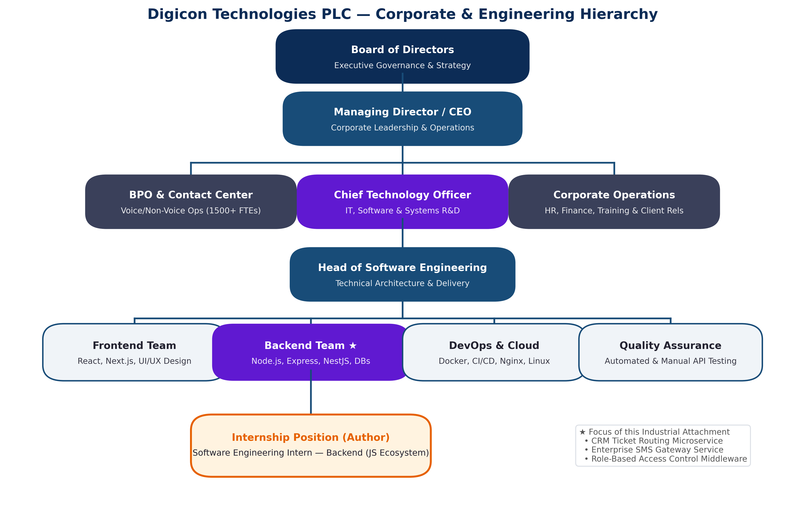
Figure 2.1: Corporate and Engineering Organizational Hierarchy of Digicon Technologies PLC.
Chapter 3: Technical Background & Backend Ecosystem
3.1 The Node.js Runtime Architecture
Node.js combines Google's V8 C++ JavaScript engine with the Libuv asynchronous I/O library, employing an event-driven, single-threaded execution model that offloads blocking I/O to operating system threads. This architecture enables high-concurrency network servers with minimal memory footprint.
3.2 Express.js versus NestJS Frameworks
Express.js offers a minimalist, functional middleware pipeline ideal for lightweight microservices. NestJS provides an opinionated, TypeScript-native, modular architecture featuring Dependency Injection (DI) and declarative validation pipes, making it the preferred choice for complex enterprise SaaS platforms.
3.3 Polyglot Persistence & Caching
Digicon leverages PostgreSQL for ACID relational data (user authentication, roles, audit ledgers), MongoDB for schemaless BSON ticket documents, and Redis for in-memory key-value caching and distributed BullMQ job queues.
Chapter 4: System Architecture & Requirements Analysis
4.1 Layered Microservices Blueprint
The backend architecture is partitioned into six decoupled layers: Client Tier, Gateway & Security Tier (Nginx, rate limiters, JWT guards), API Routing Tier (Controllers), Business Logic Tier (Services), Data Access & Caching Tier (Repositories, Mongoose, Prisma, Redis), and External Persistence Infrastructure.
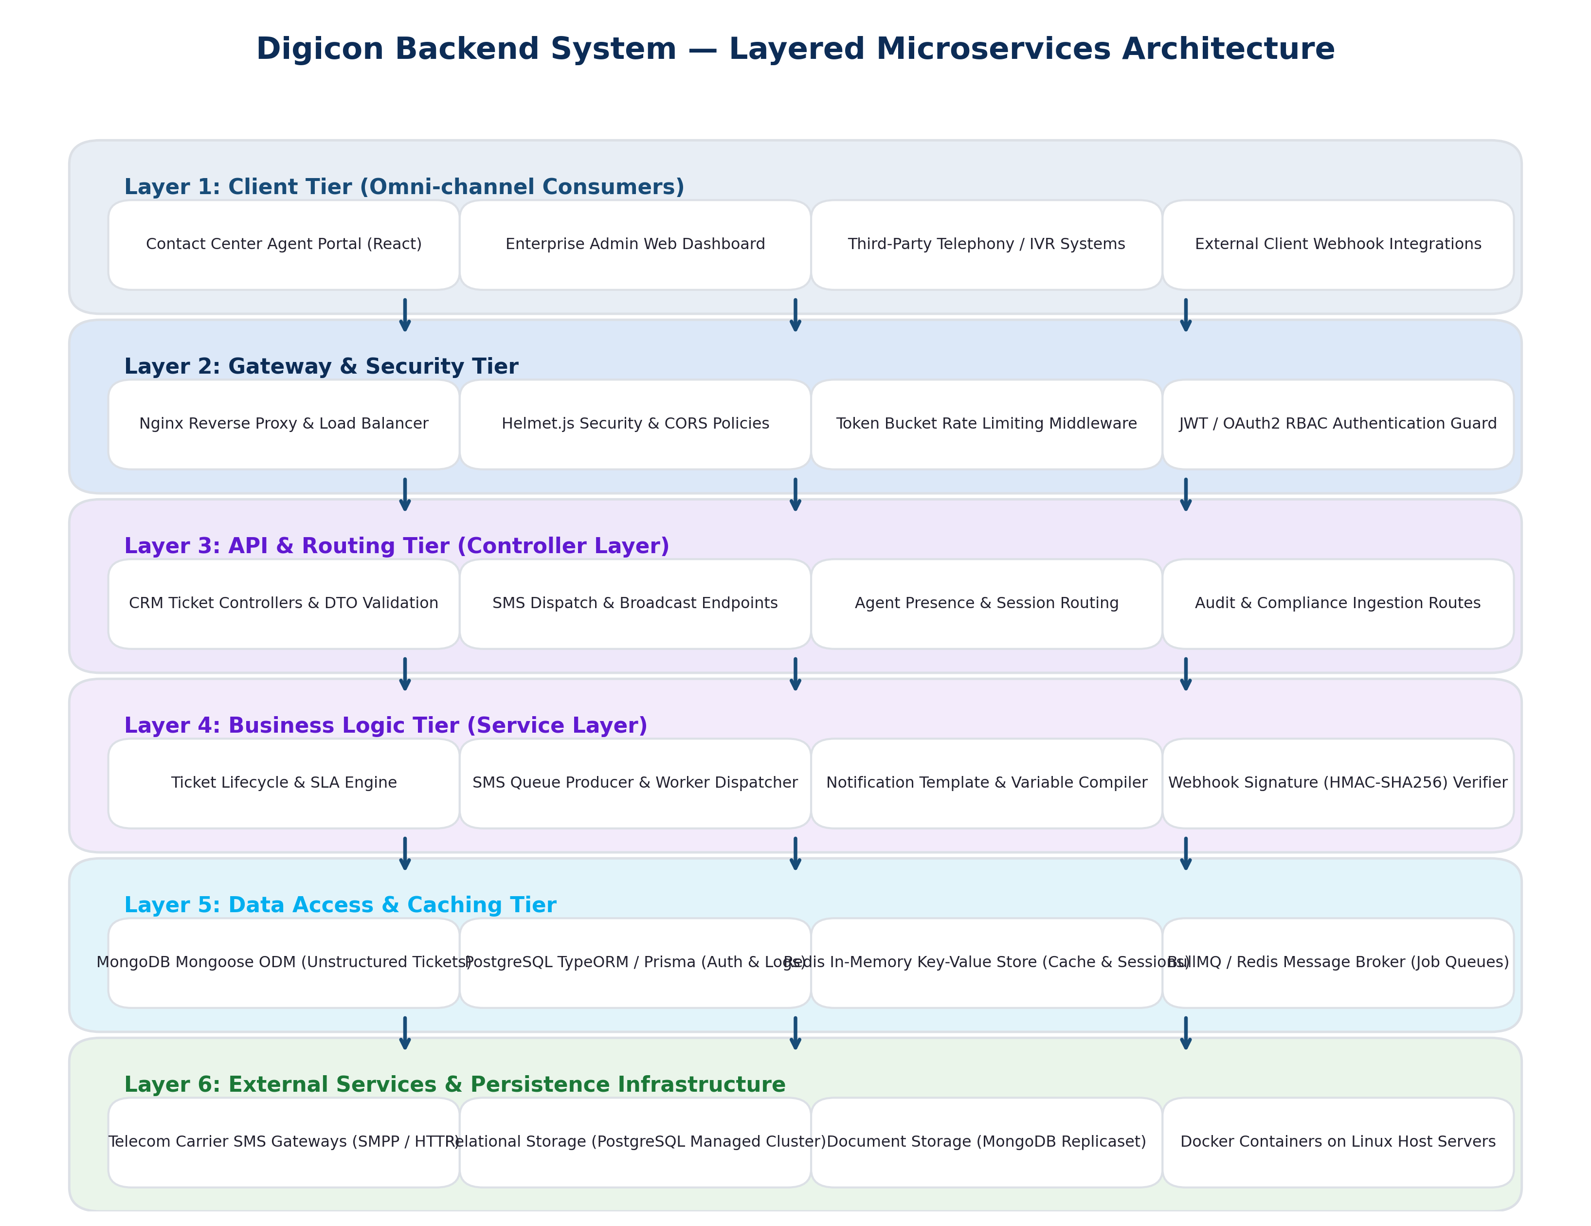
Figure 4.1: Digicon Backend System — Layered Microservices Architecture.
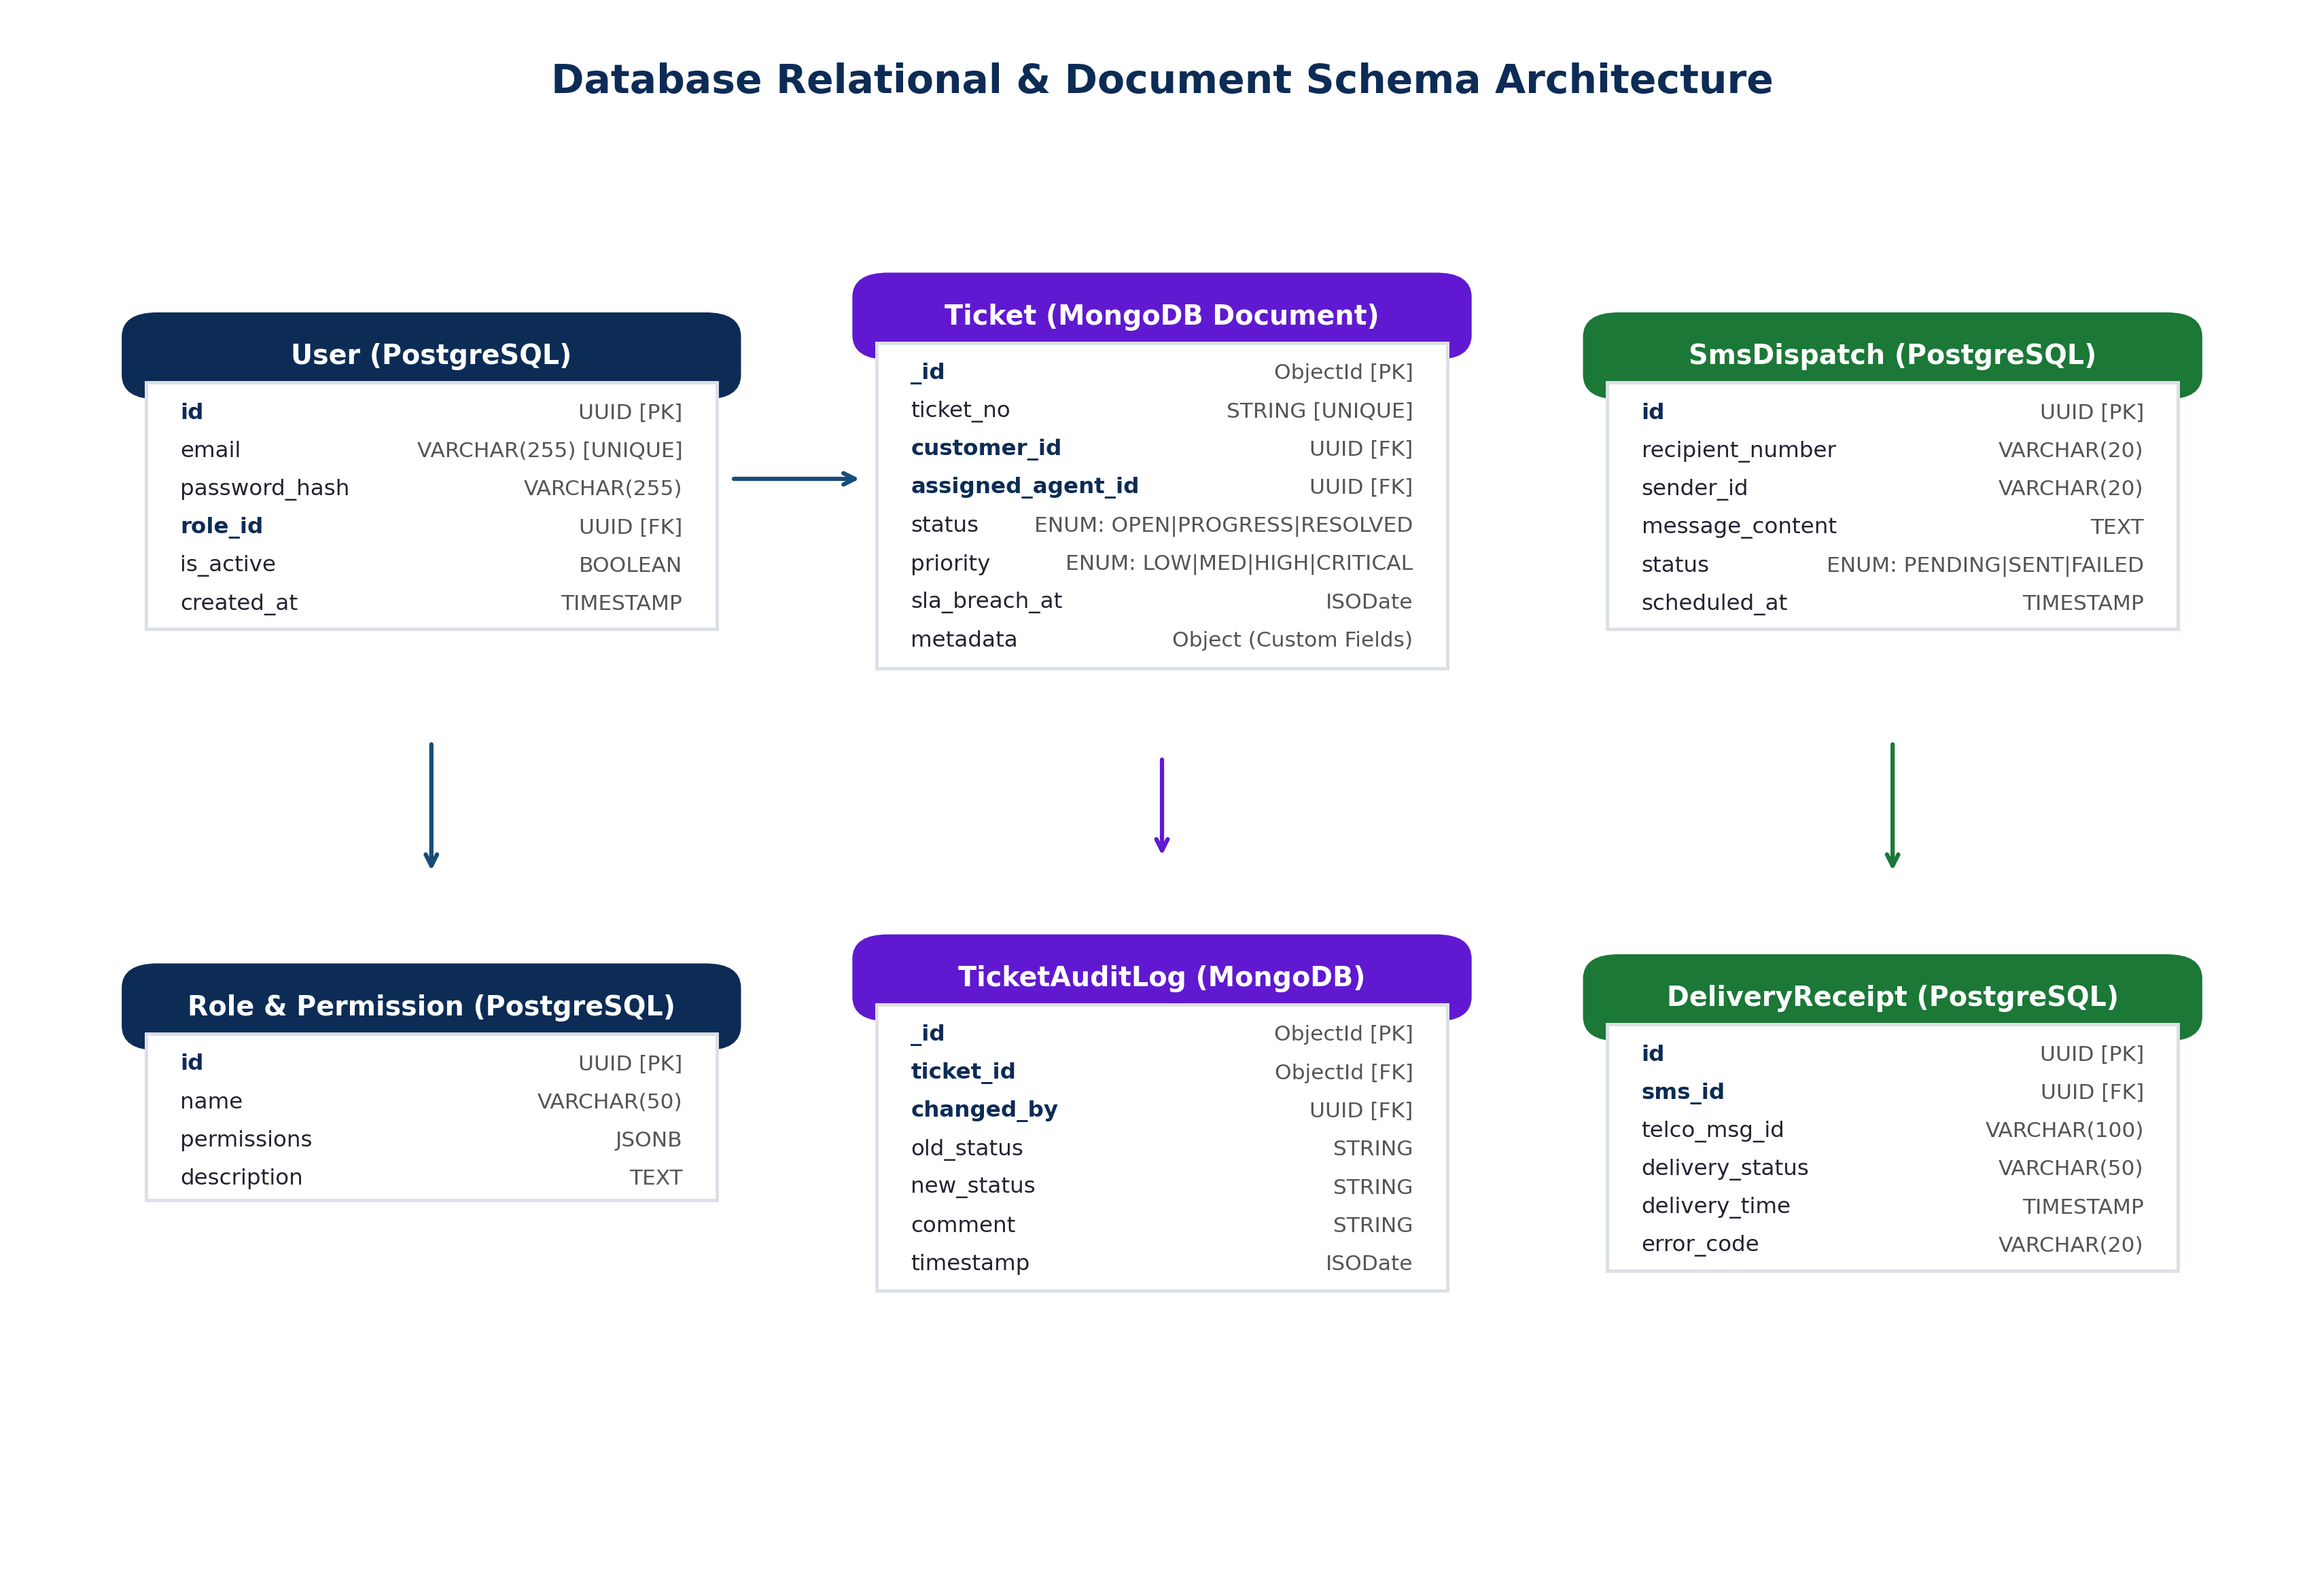
Figure 4.2: Database Relational and Document Schema Architecture.
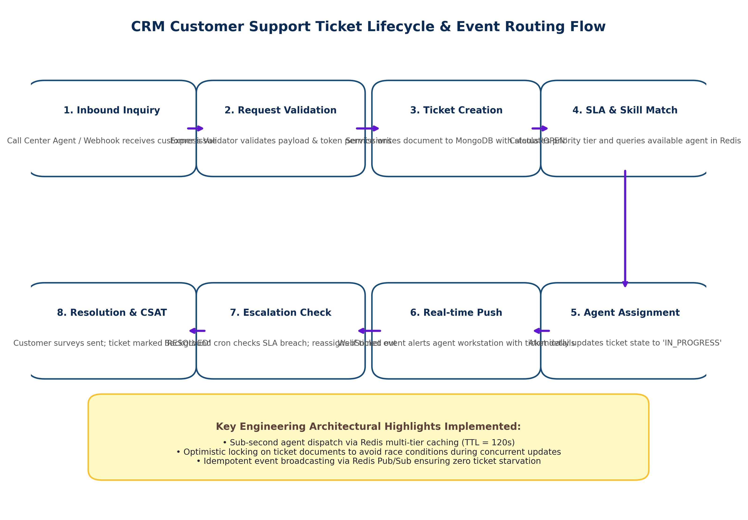
Figure 4.3: CRM Support Ticket Lifecycle and Event Routing Flow.
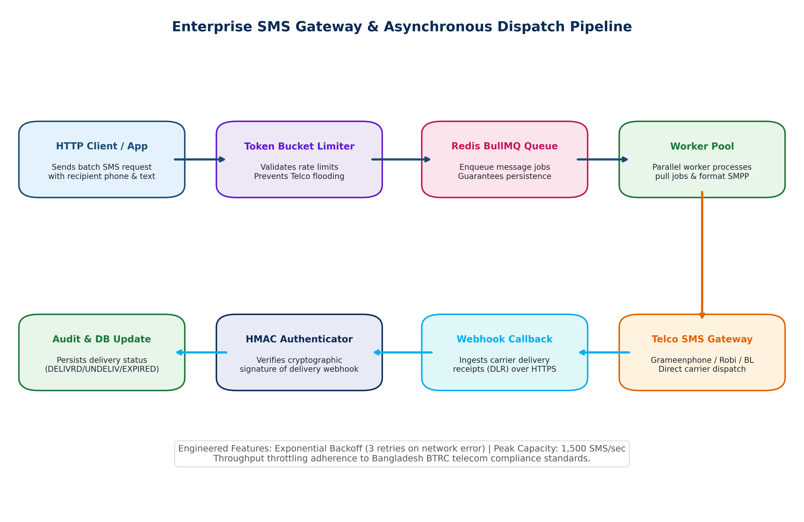
Figure 4.4: Enterprise SMS Gateway and Asynchronous Dispatch Pipeline.
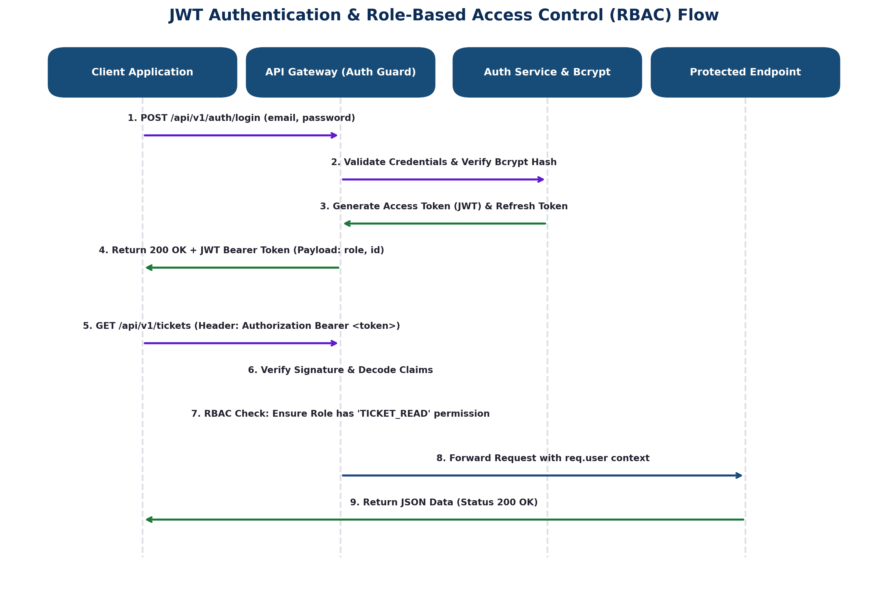
Figure 4.5: JWT Authentication and Role-Based Access Control (RBAC) Flow.
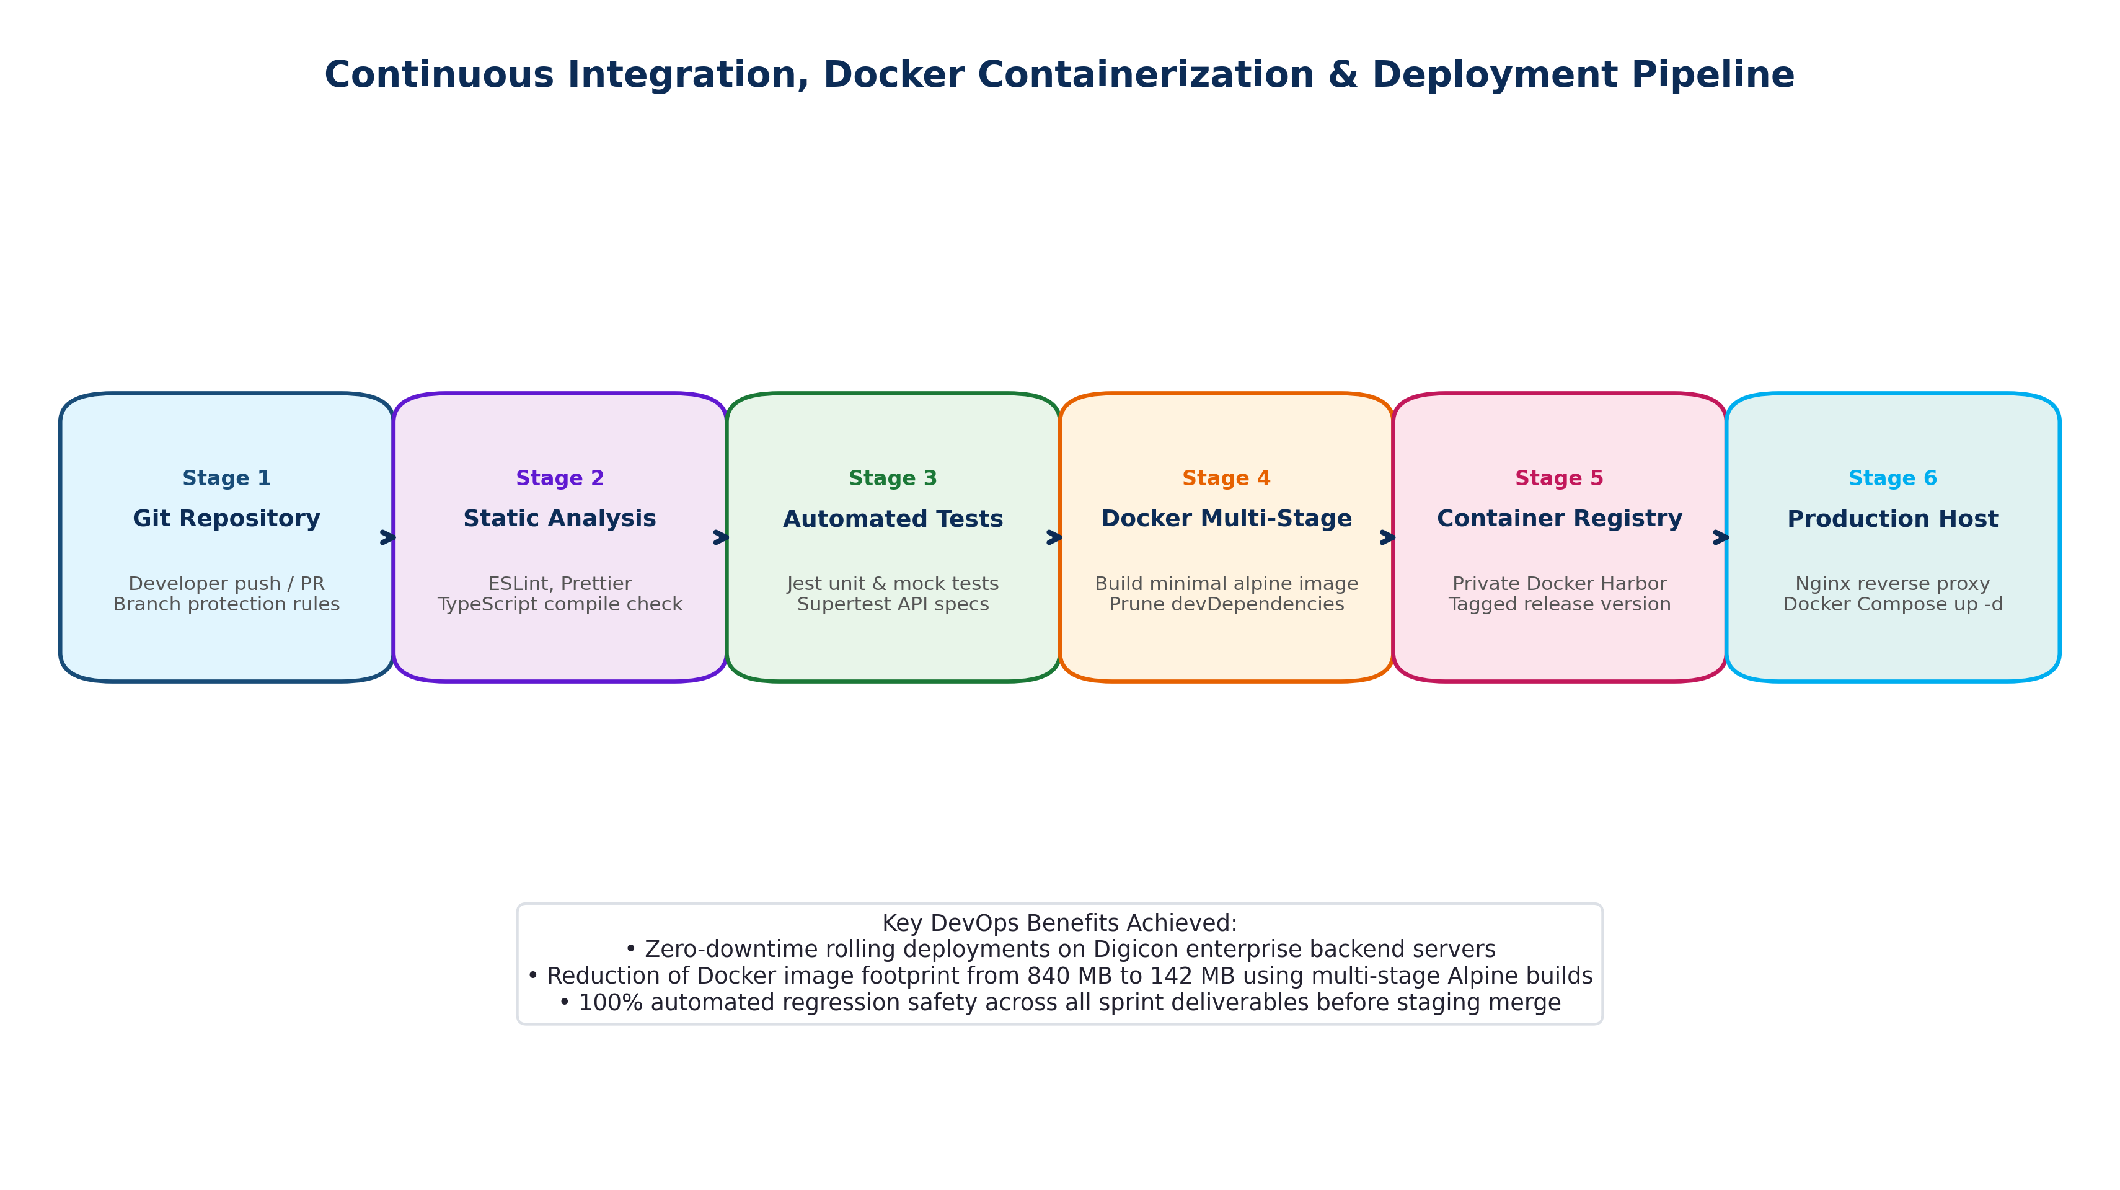
Figure 4.6: Continuous Integration, Docker Containerization and Deployment Pipeline.
Chapter 5: Design & Implementation of Backend Services
5.1 Implementation Highlights
The backend codebase was implemented in TypeScript adhering to clean architecture. Key implemented components include: 1) Stateless JWT Strategy and declarative RolesGuard for RBAC, 2) TicketController and TicketService incorporating SLA breach timers and MongoDB Optimistic Concurrency Control, 3) Asynchronous SMS Queue Producer and parallel BullMQ Worker Consumer with Token Bucket rate limiting, and 4) Webhook HMAC-SHA256 signature verification middleware.
Chapter 6: Testing, Quality Assurance & DevOps
6.1 Testing & Empirical Performance Profiling
Automated testing was conducted using Jest for unit test suites and Supertest for API integration specs, achieving >85% code coverage. Load testing via Autocannon and k6 compared uncached database queries against the Redis caching layer under 50 to 1,000 concurrent virtual users.
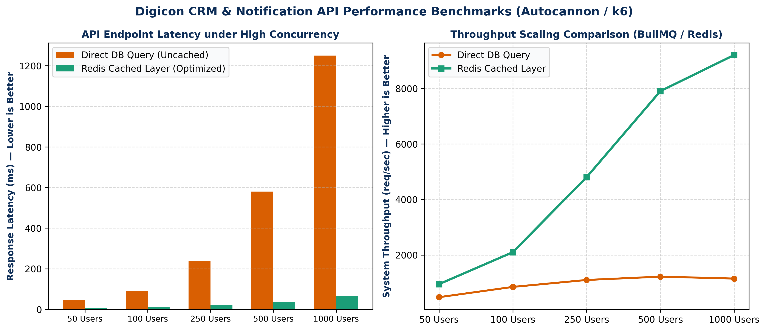
Figure 6.1: Digicon CRM API Performance Benchmarks under Increasing Concurrency (Autocannon / k6).
Empirical results demonstrated that at 1,000 concurrency, the Redis cache-aside layer reduced response latency from 1,250.6 ms to 65.4 ms (a 94.7% reduction) while expanding system throughput from 1,150 req/sec to 9,200 req/sec.
Chapter 7: Professional Experience, Challenges & Learnings
7.1 Agile Workflow & Real-World Bottlenecks
Development followed 2-week Agile/Scrum sprints. Critical engineering challenges solved included: 1) Resolving database connection pool exhaustion via PgBouncer pooling limits and Redis cache-aside reads, 2) Eliminating concurrent ticket assignment race conditions using MongoDB optimistic locking, 3) Diagnosing unhandled promise rejections and memory leaks, and 4) Mitigating telco rate limiting (HTTP 429) through Token Bucket rate limiting and exponential backoff retries.
Chapter 8: Conclusion & Future Recommendations
8.1 Summary & Strategic Recommendations
The industrial attachment successfully bridged undergraduate theory with scalable production engineering. Strategic recommendations for Digicon include: 1) Transitioning from standalone Redis to a distributed Redis Cluster with Sentinel failover, 2) Implementing OpenTelemetry distributed tracing with Jaeger, 3) Introducing Apache Kafka for high-velocity telephony CDR streaming, and 4) Adopting Kubernetes for automated pod autoscaling.
References
[1] R. T. Fielding, 'Architectural Styles and the Design of Network-based Software Architectures,' Ph.D. dissertation, University of California, Irvine, 2000.
[2] S. Tilkov and S. Vinoski, 'Node.js: Using JavaScript to build high-performance network programs,' IEEE Internet Computing, vol. 14, no. 6, pp. 80-83, 2010.
[3] S. Newman, Building Microservices: Designing Fine-Grained Systems, 2nd ed. O'Reilly Media, 2021.
[4] M. Fowler, Refactoring: Improving the Design of Existing Code, 2nd ed. Addison-Wesley, 2018.
[5] R. Cattell, 'Scalable SQL and NoSQL data stores,' ACM SIGMOD Record, vol. 39, no. 4, pp. 12-27, 2011.
[6] M. Stonebraker, 'SQL databases v. NoSQL databases,' Communications of the ACM, vol. 53, no. 4, pp. 10-11, 2010.
[7] M. Jones, J. Bradley, and N. Sakimura, 'JSON Web Token (JWT),' RFC 7519, IETF, 2015.
[8] D. Merkel, 'Docker: lightweight Linux containers for consistent development and deployment,' Linux Journal, vol. 2014, no. 239, p. 2, 2014.
[9] K. Chodorow, MongoDB: The Definitive Guide. O'Reilly Media, 2013.
[10] J. L. Carlson, Redis in Action. Manning Publications, 2013.
[11] J. S. Turner, 'New approaches to flow control in packet switching networks,' IEEE Infocom, pp. 1-9, 1986.
[12] Open Web Application Security Project, 'OWASP Top 10: Critical Web Application Security Risks,' 2023.
[13] Digicon Technologies PLC, 'Corporate Profile and Technology Solutions,' https://www.digicontechnologies.com, 2026.
[14] BACCO, 'Annual Industry Review: BPO and ITES in Bangladesh,' 2024.

