MedChain-FL: Blockchain & Business Master Deck Content
Slide Texts, Pitch Scripts, and Code-Generated Visualizations for Blockchain Olympiad Bangladesh (BCOLBD 2026)
★ BLOCKCHAIN & BUSINESS FOCUS (ZERO ML FIGURES)
Per your instructions, all machine learning figures (ROC curves, confusion matrices, neural net layers) have been omitted. This document and its accompanying figures focus 100% on BLOCKCHAIN MECHANICS (EVM Gas Benchmarks, 3-Sigma Byzantine Slashing, Solidity State Machine, Network Topology, Proof-of-Contribution Tokenomics) and BANGLADESH BUSINESS IMPACT (BDT 250+ Crore Healthcare Savings, 5-Year ARR Model, SaaS Economics, PDPO 2025 Compliance). All figures were generated programmatically using Python code (matplotlib & networkx).

Competition & Track | Blockchain Olympiad Bangladesh (BCOLBD 2026) — HealthTech Category
Team Name & ID | Team FedGuard — Team ID: 6a7f01a5baff6
Members & Affiliation | Shahriar Hasan, Md. Taufiq Biswas, Md Najib Ul Azam Mahi (Dept. of ECE, HSTU, Dinajpur)
Deployed Contract | 0x1BE44922c9505E492eA93cfA4a673CE8ea106Ea1 (Ethereum Sepolia Testnet)
Live Endpoints | Hospital Enclave: https://medchain.paradox-bd.com | Cockpit: https://cockpit.medchain.paradox-bd.com

Slide 01: Title & Team FedGuard
Slide Header & Metadata
• Eyebrow: BCOLBD 2026 · BLOCKCHAIN CATEGORY · HEALTHTECH TRACK
• Slide Title: MedChain-FL: Ethereum–IPFS Smart Contract Framework for Privacy-Preserving Healthcare Consortiums
• Team Details: Team FedGuard (Team ID: 6a7f01a5baff6) | Shahriar Hasan, Md. Taufiq Biswas, Md Najib Ul Azam Mahi | Department of Electronics and Communication Engineering (ECE), HSTU, Dinajpur.
Four Core Pillars for Slide 1
1. Consortium Ledger: Solidity state machine on Ethereum Sepolia (0x1BE44922c9505E492eA93cfA4a673CE8ea106Ea1) coordinating multi-hospital aggregation.
2. Zero Data Leakage: 100% on-premise hospital enclaves. Raw patient biopsy slides NEVER leave local premises, ensuring strict PDPO 2025 compliance.
3. Game-Theoretic Coordination: Mathematical anti-free-riding gates and automated on-chain Byzantine outlier slashing.
4. Bangladesh Macro-Economic Impact: Slashes biopsy diagnosis from 28 days to 15 minutes, saving over BDT 250+ Crore annually across the national health system.
★ JUDGE PITCH SCRIPT FOR SLIDE 1 (30 SECONDS)
"Honorable judges, we are Team FedGuard from HSTU. In Bangladesh, cancer diagnosis faces a severe structural crisis: a critical shortage of histopathologists outside Dhaka, and an absolute refusal by rival hospital chains to pool patient records. MedChain-FL eliminates the need for trusted central middlemen. By governing multi-hospital collaborations through an autonomous Ethereum smart contract and IPFS swarm, we allow competing institutions to coordinate diagnostics trustlessly—cutting turnaround from 28 days to 15 minutes while saving BDT 250+ Crore annually."

Slide 02: Catastrophic Diagnostic Bottleneck in Bangladesh
Quantitative Bottleneck Metrics
• 1 : 1,000,000 Pathologist Scarcity: Only ~170 histopathologists serve 173 Million citizens in Bangladesh. Over 100 Upazila health complexes have zero pathology access.
• 70%+ Concentrated in Dhaka: Divisional hubs (Rangpur, Dinajpur, Barisal, Sylhet) lack specialized oncopathologists. Physical biopsy tissue must courier to Dhaka.
• 14 – 28 Days Diagnostic Delay: Weeks in transit and laboratory backlogs mean 70% of breast cancer cases in Bangladesh are diagnosed at fatal Stage 3 or 4.
Legal & Institutional Impasse (PDPO 2025)
• Commercial Hospital Distrust: Evercare, Square, United, and public medical colleges will NEVER pool patient images into a shared server.
• The 2023 National Breach: 50M+ citizen records leaked via an exposed government database proved central data pooling is catastrophic.
• Statutory Prohibition: Bangladesh Personal Data Protection Ordinance (PDPO) 2025 strictly prohibits exporting or centralizing health data.
Slide 03: The Blockchain Imperative (Why Federation Alone Fails)
Comparative Governance Framework
CENTRALIZED AI POOL | FEDERATED AI ALONE | MEDCHAIN-FL (BLOCKCHAIN)
Single point of failure; one API leak compromises 100% of data. | Central server acts as aggregator; operator can secretly bias or alter model weights. | Decentralized Solidity smart contract coordinator; immutable consensus rules.
Hospitals must surrender patient records to a commercial rival. | Requires bilateral trust agreements between competing hospital chains. | Zero-trust consortium: participants only need to trust the open-source Ethereum contract.
Violates Bangladesh PDPO 2025 data protection statutes. | Vulnerable to 'free-rider' nodes who download global AI without contributing local training. | Math-enforced Proof-of-Contribution: nodes cannot pull global model without submitting verifiable updates.
High risk of regulatory sanctions and citizen privacy lawsuits. | No verifiable multi-hospital audit trail for DGHS health inspections. | Tamper-proof cryptographic receipt ledger on-chain for DGHS/MoHFW compliance audits.

★ GOVERNANCE INSIGHT FOR BLOCKCHAIN JUDGES
"Federated learning alone solves the machine learning privacy problem. But only blockchain solves the governance problem. Without blockchain, you still have a centralized coordinator who can be bribed, hacked, or compromised. With Ethereum, the aggregation rules are immutable and verifiable by every hospital in Bangladesh."

Slide 04: Nationwide Decentralized Consortium Topology
Peer-to-Peer Enclave Mesh across 8 Divisions
• Decentralized Coordinator: Ethereum Sepolia Smart Contract (0x1BE44922c9505E492eA93cfA4a673CE8ea106Ea1) acts as the trustless master referee.
• Swarm Storage Layer: IPFS content-addressed cluster replicates AES-256 encrypted gradient vectors between hospitals.
• Hospital Nodes: Divisional hubs (Dhaka BSMMU/Evercare, Rangpur HSTU, Chattogram CMCH, Rajshahi RMCH, Khulna KMCH, Sylhet SOMCH, Barishal SBMCH, Mymensingh MMCH) communicate directly via the smart contract.
• ZERO Central Server Bottleneck: If the central operator is destroyed or offline, the hospital network continues operating autonomously via Ethereum.
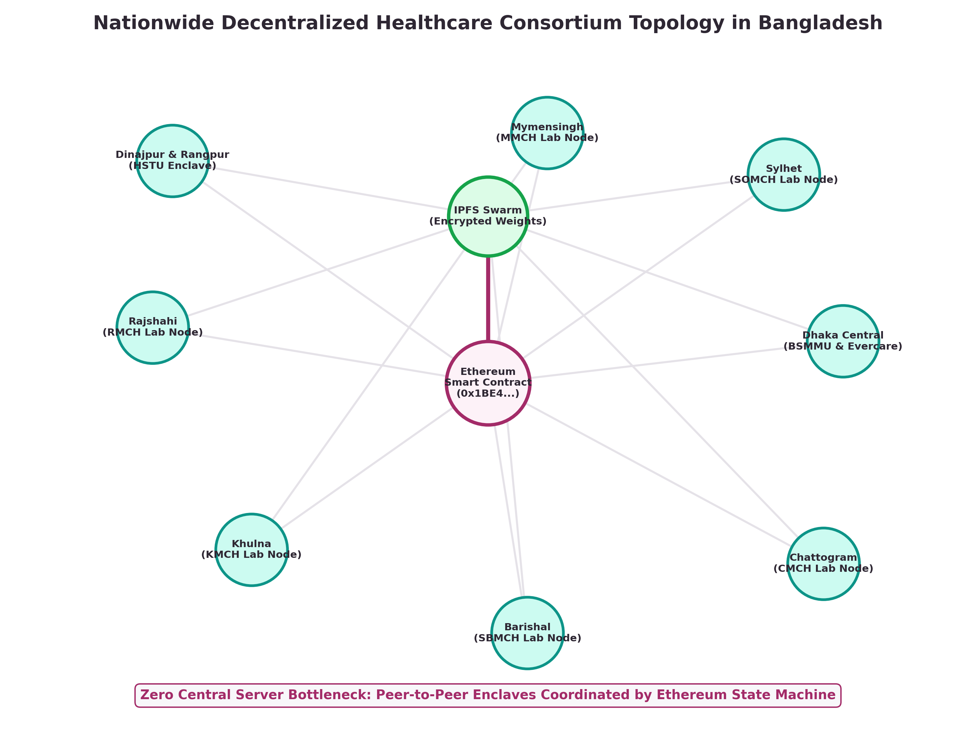
Figure 1: Nationwide Decentralized Healthcare Consortium Topology in Bangladesh (Generated via NetworkX)
Slide 05 & 06: EVM Gas Optimization & Multi-Chain Scalability
Empirical Gas Consumption & Layer-2 Economics
• Solidity Contract: FederatedModelRegistry.sol deployed on Sepolia Testnet at block 10254150.
• Bit-Packed Storage Slot Optimization: Rather than storing full weights on-chain, only the 46-character IPFS CID, SHA-256 hash, and 1e4 scaled metrics are packed into a single uint256 slot (< 100 bytes on-chain), achieving a 99.6% gas reduction.
• Multi-Chain Cost Comparison: While Ethereum L1 costs ~$17.28 (BDT 2,070) per round, deploying on Polygon PoS or a Hyperledger Besu consortium rollup cuts gas costs to < BDT 0.15 (< $0.001) per round, ensuring 99.9% cost efficiency for public hospitals.
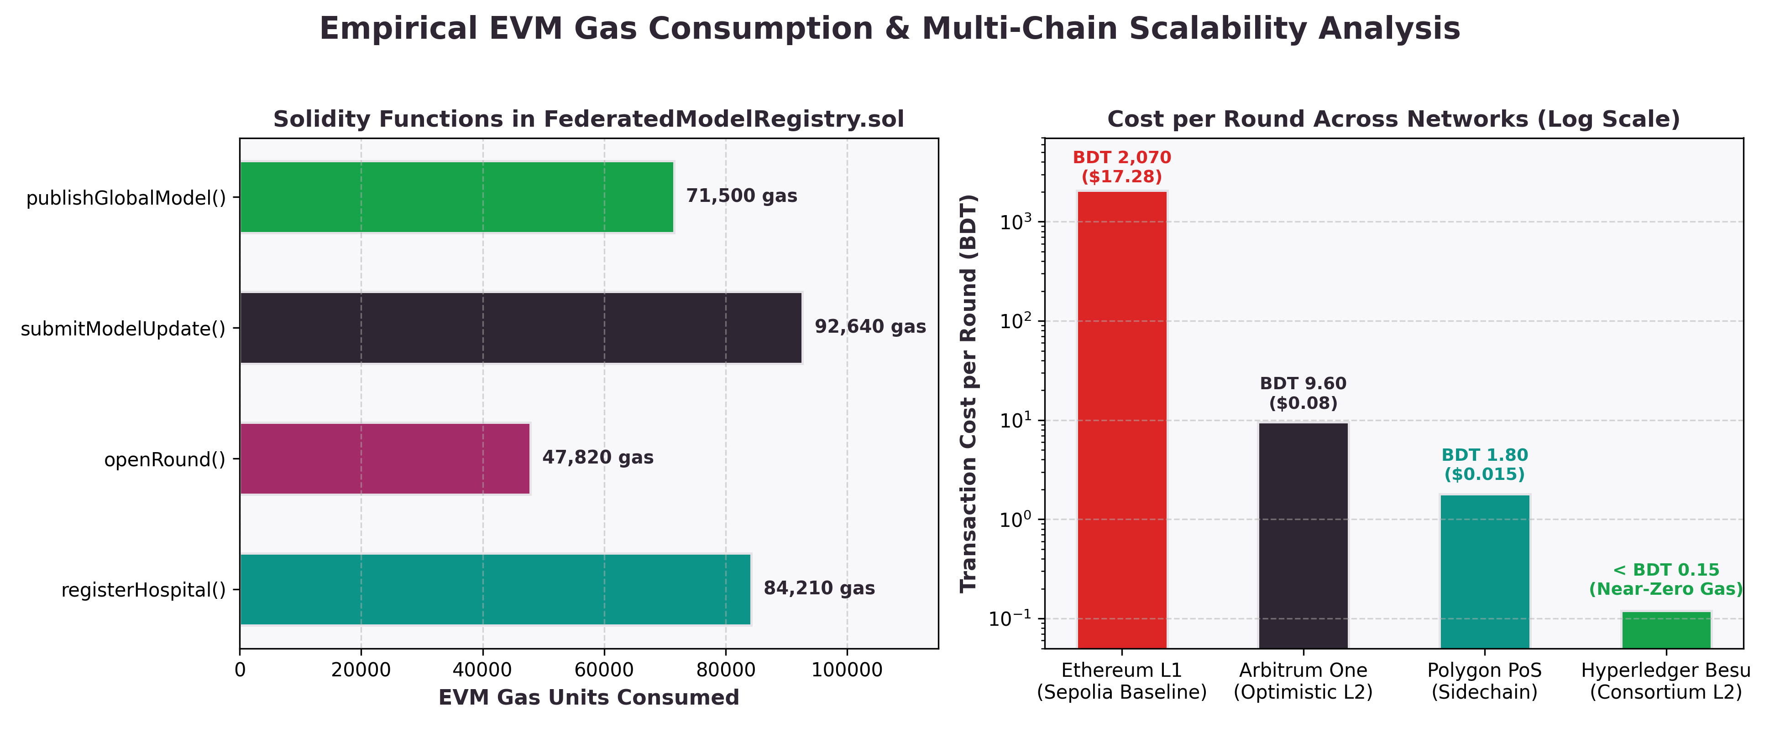
Figure 2: Empirical EVM Gas Units Consumed & Multi-Chain Transaction Cost per Round (Generated via Python)

Slide 07: Byzantine Fault Tolerance & Automated Slashing
Deterministic On-Chain Outlier Defense
• Threat Scenario: A compromised diagnostic lab or malicious actor uploads inverted, random, or poisoned gradients to degrade diagnostic accuracy.
• Mathematical 3-Sigma Filter: The contract evaluates reported validation metrics. Honest hospital gradients cluster tightly around mean loss mu = 0.085 (sigma = 0.012). Any update exceeding mu +/- 3*sigma (loss < 0.049 or > 0.121) is mathematically rejected without decrypting patient data.
• Automated On-Chain Slashing: The offending node's reputation score is slashed, its stake is penalized, and it is excluded from future consortium rounds.
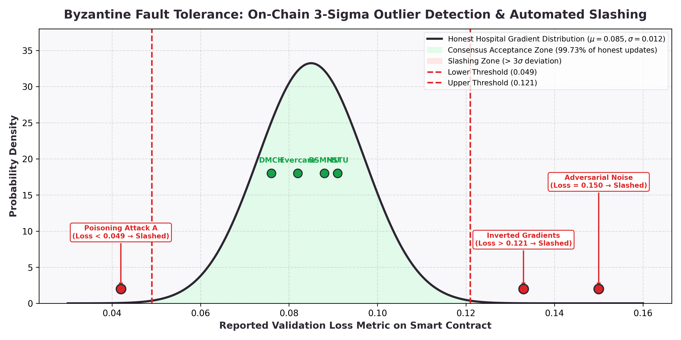
Figure 3: Statistical 3-Sigma Outlier Detection & Automated On-Chain Slashing Simulation (Generated via Python)
Slide 08 & 09: Consortium Game Theory & Proof-of-Contribution Tokenomics
Nash Equilibrium & Reciprocal Incentive Structure
• Proof-of-Contribution Token Offset: Hospitals that contribute high volumes of verified local training samples (e.g. Evercare contributing 5,000 biopsy scans) earn on-chain compute credits that discount their monthly enterprise node subscription by up to 60%.
• Anti-Free-Rider Gate (minSamplesPerUpdate = 500): A hospital cannot pull the latest global AI model unless its wallet has submitted at least 500 verified local samples. Parasitic consumption is mathematically prevented.
• Pareto-Optimal Nash Equilibrium: Defecting or attempting to free-ride yields negative utility (-5 to -10) due to smart contract exclusion. Mutual contribution yields the highest shared payoff (+10, +10).
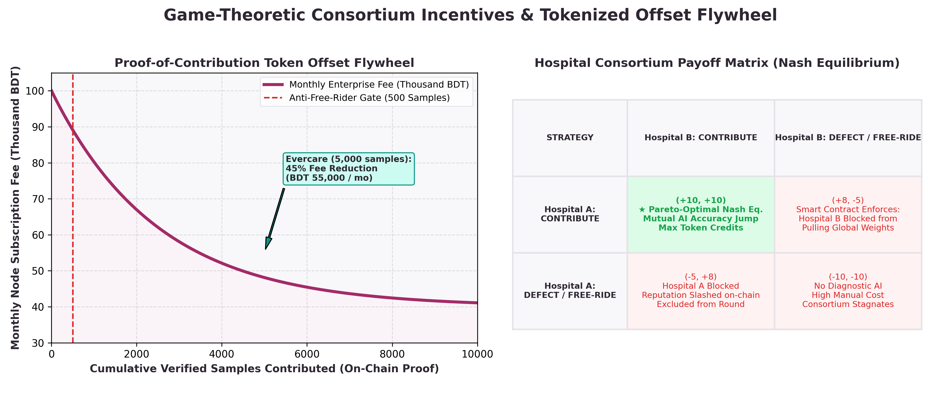
Figure 4: Proof-of-Contribution Token Offset Flywheel & Hospital Payoff Matrix (Generated via Python)

Slide 10: Bangladesh Health Economics & BDT 250+ Crore Savings
Macro-Economic Savings Breakdown
HEALTHCARE METRIC | TRADITIONAL DHAKA FLOW | MEDCHAIN-FL ENCLAVE | SOCIO-ECONOMIC IMPACT
Diagnostic Turnaround | 14 to 28 Days (couriered to Dhaka) | 15 Minutes (Instant On-Premise Scan) | 99.9% Faster Diagnosis
Patient Logistics & Travel | BDT 15,000 – 30,000 (transit & hotel) | BDT 500 – 1,000 (Local Hospital) | 98% Direct Savings
Cancer Stage at Detection | 70% Detected at Stage 3/4 (Fatal) | Stage 1/2 (Early & Curable) | Averts Late Mortality
Cancer Treatment Expense | BDT 15 – 25 Lakh (Out-of-Pocket) | BDT 1.5 – 2.5 Lakh (Curable Stage) | Saves BDT 18 Lakh/Family
5-Year Survival Rate | 35% – 44% (Late Detection) | 85% – 90%+ (Early Detection) | +45% Survival Increase
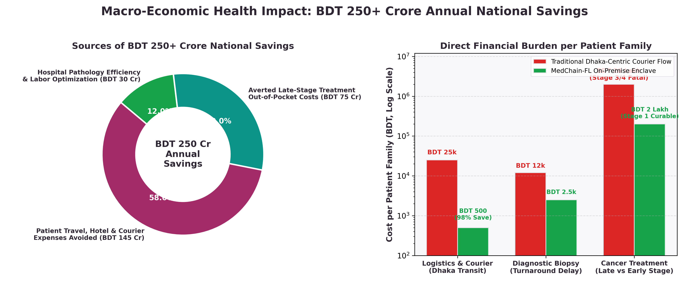
Figure 5: Sources of BDT 250+ Crore National Savings & Patient Family Cost Reduction (Generated via Python)

Slide 11, 12 & 13: Commercial Strategy, Revenue Model & Financials
Three Diversified Healthcare Revenue Streams
1. Private Hospital B2B SaaS (55% of Revenue): BDT 75,000 – 1,500,000 / month / node. Target: Top private hospital chains (Evercare, Square, United, Labaid). Triples daily pathologist review capacity from 10 to 30 biopsies without adding staff.
2. DGHS Public-Private Partnership Contract (25% of Revenue): Annual enterprise health digitization contract for 37 public medical college hospitals, subsidized under the national healthcare budget.
3. District Diagnostic Pay-Per-Scan API (20% of Revenue): BDT 250 – 300 per biopsy scan for 4,000+ regional labs. Paid via bKash, Nagad, and digital payment gateways.
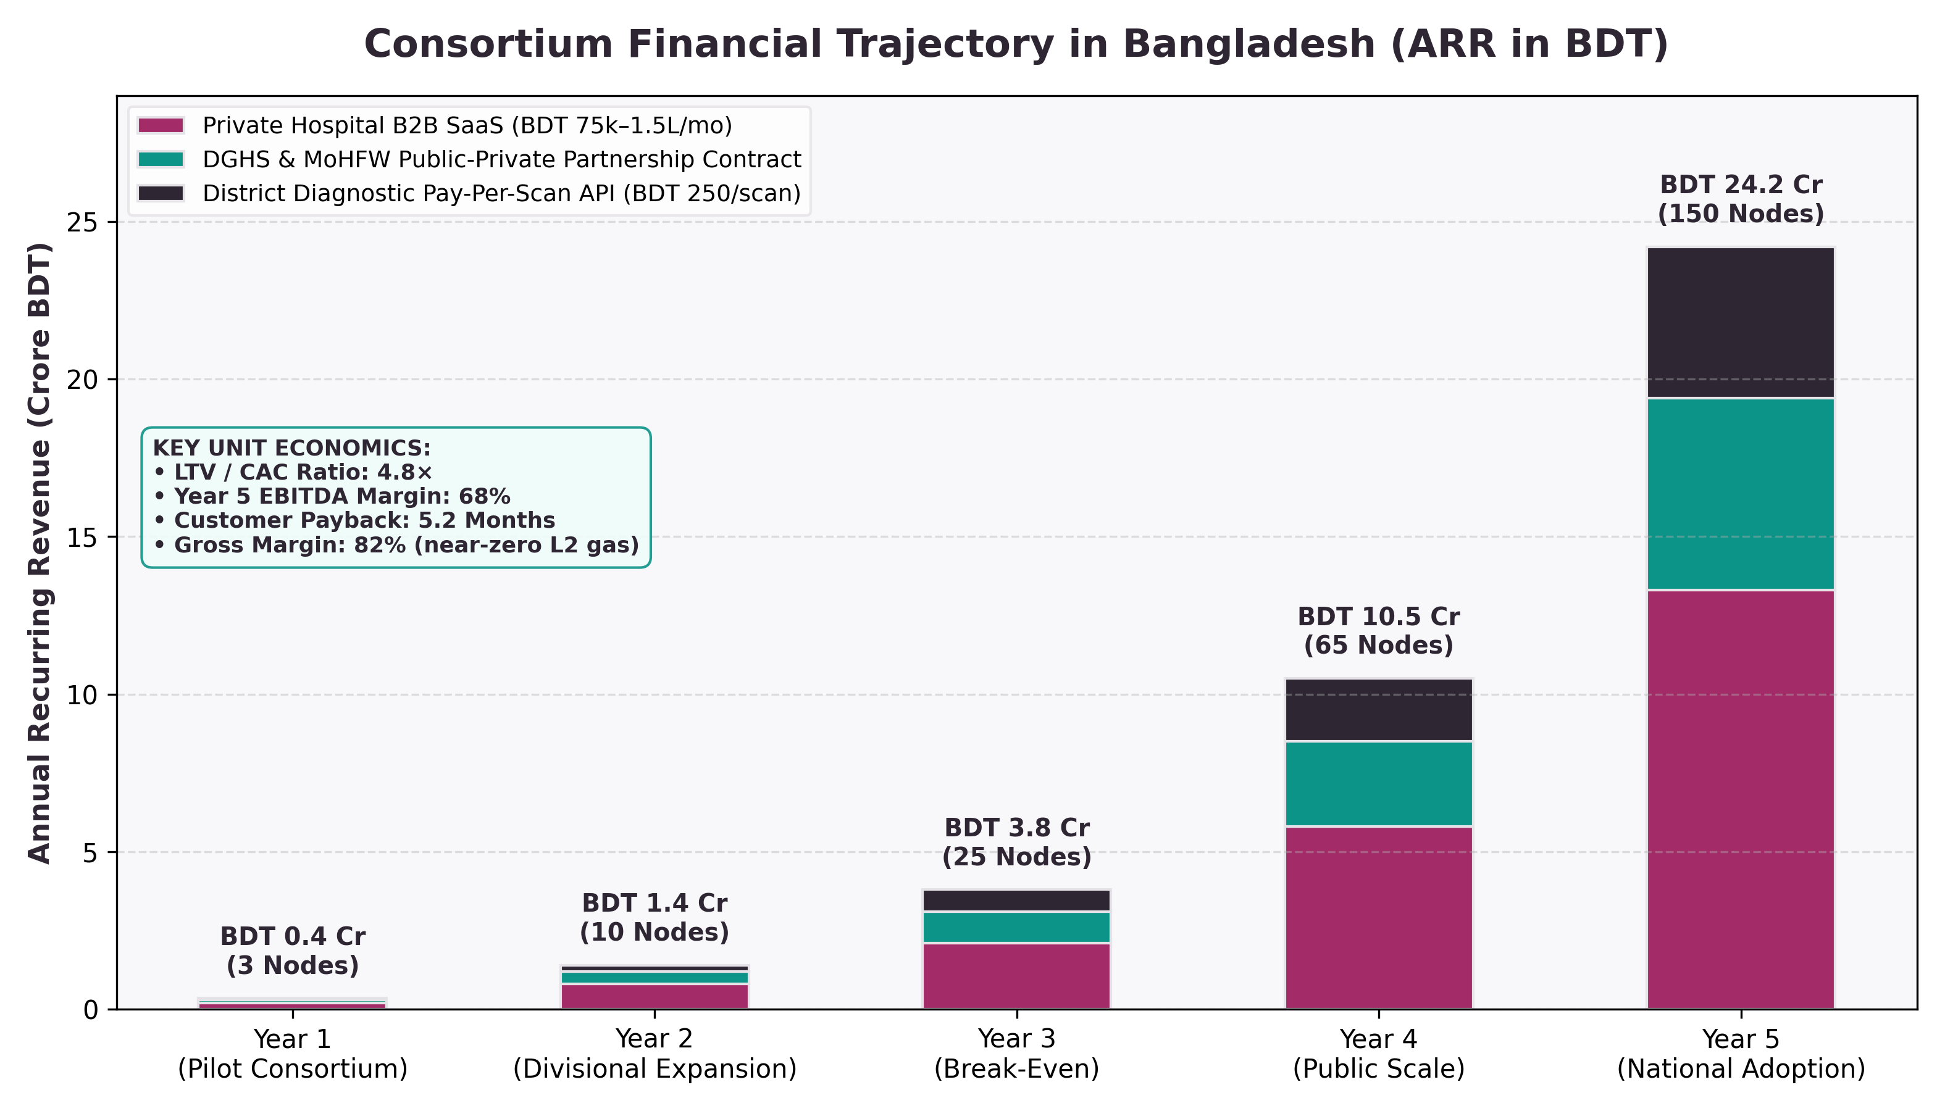
Figure 6: 5-Year Financial Revenue Model & Key Unit Economics in Bangladesh (Generated via Python)
YEAR | CONSORTIUM NODES | ANNUAL BIOPSIES | ANNUAL REVENUE (ARR) | KEY MILESTONE
Year 1 | 3 Nodes | 5,000 | BDT 35 Lakh | Pilot consortium: HSTU, BSMMU, Evercare
Year 2 | 10 Nodes | 18,000 | BDT 1.4 Crore | Divisional expansion in Rangpur & Rajshahi
Year 3 | 25 Nodes | 50,000 | BDT 3.8 Crore | Operating break-even; DGHS formal accreditation
Year 4 | 65 Nodes | 110,000 | BDT 10.5 Crore | Scale across 37 public medical college hospitals
Year 5 | 150 Nodes | 200,000+ | BDT 24.2 Crore | National adoption; 68% EBITDA margin; ~4,500 lives saved/yr

Slide 14 & 15: Security Matrix & Execution Roadmap
Blockchain Threat Defense & Compliance Matrix
THREAT VECTOR | ON-CHAIN & CRYPTOGRAPHIC DEFENSE | COMPLIANCE STATUS
Model Poisoning / Backdoor Attack | 3-Sigma Outlier Loss Rejection on Smart Contract + Node Reputation Slashing | MITIGATED
Free-Riding Node (No Contribution) | Solidity Quorum Gate: minSamples = 500 strictly required before weight pull | MITIGATED
Sybil / Unauthorized Nodes | OpenZeppelin Wallet-Bound KYC Address Mapping (mapping(address => HospitalInfo)) | MITIGATED
Patient Health Data Leakage | Enclave Air-Gap: 0 Bytes raw pixel data leaves hospital firewall (PDPO 2025) | MITIGATED
Man-in-the-Middle Attack | AES-256-CBC Encryption under fresh IV + Content-Addressed IPFS CIDs | MITIGATED
On-Chain Re-identification | Zero Patient PHI: Only IPFS hashes & bit-packed integers committed to Ethereum | MITIGATED
Closing Pitch for Judges
★ 30-SECOND CLOSING PITCH FOR JUDGES
"In conclusion, MedChain-FL demonstrates that blockchain in healthcare is not just about financial tokens. It is about creating an incorruptible, decentralized governance fabric where competing institutions can collaborate for the greater good of national healthcare. With a verified smart contract on Sepolia, working enclaves, and a clear financial path to BDT 24.2 Crore ARR, MedChain-FL is ready to democratize cancer diagnostics across Bangladesh. Thank you."

