A Blockchain-Enabled Federated Learning Framework for Privacy-Preserving Histopathological Image Classification
Neha Agrawal,ª Jasmine Si Jia Tan,ª Pearlie Sijia Low,ª Eileen Wen Mei Fong,ª Yuekun Lai,^{b,c} Zhong Chenª*
ª School of Materials Science and Engineering, Nanyang Technological University, 50 Nanyang Avenue, Singapore 639798, Singapore.
^{b} College of Chemical Engineering, Fuzhou University, Fuzhou 350116, PR China.
^{c} College of Textile and Clothing Engineering, Soochow University, Suzhou 215123, PR China.
*Corresponding Authors E-mail: ASZChen@ntu.edu.sg

Abstract
The inability to share medical data between institutions makes it more difficult to make machine learning models that work well for clinical diagnosis. Privacy laws prevent hospitals from pooling data, rendering models less useful. This thesis proposes a privacy-preserving federated learning framework for the purpose of classifying breast cancer histopathology using Ethereum blockchain and IPFS storage. A shared deep neural network (EfficientNet-B0 with Coordinate Attention, 5.9M parameters) is trained by multiple hospitals without transferring raw data. Sites have trained the model with 160x160 RGB patches in their own areas and will send encrypted updates of the weights to IPFS. An Ethereum smart contract maintains content identifier and metrics and an on-chain oracle is a Federated Averaging to make new global models. The system is based on a Solidity smart contract which is used to register hospitals, maintain information about different model versions and conduct training cycles. Node.js clients on the hospital side handle preprocessing, on-the-fly, and blockchain interaction. A python backend takes care of governance and putting models together. Pinata is storing encrypted weights on IPFS and hashes/metrics are stored on-chain. This study demonstrates how data silos can be eliminated and privacy protected through blockchain and decentralized storage with federated learning. The Ethereum ledger keeps track of changes to models that can be verified. There is no patient data kept, only encrypted parameters, hashes and metrics are kept. The Wisconsin Diagnostic Breast Cancer dataset and the BreakHis histopathology dataset were used for testing the system at Boston, London and Tokyo institutions. This demonstrated the capabilities of smart contracts, the ability to combine models, and the tracing of operations back to their origins. The research shows that the combination of Ethereum contracts and IPFS with federated learning enables secure collaborative AI in medical imaging.
Keywords: Federated Learning, Blockchain-based Healthcare, Breast Cancer Histopathology, Decentralized Storage (IPFS), Privacy-Preserving AI.

- INTRODUCTION
The automation of medical research and treatment programs improved with the implementation of artificial intelligence to help find out the system flaws quickly. Traditional centralized AI models had to aggregate patient data into single patient repositories, which brought technical and legal risks in the regulatory environment of a developing country such as Bangladesh. Bangladesh has a healthcare system that generates 50 million electronic health records across the country but has no frameworks in place for secure collaboration between hospitals via AI, particularly in the wake of the recent National Identity Database breach. Although Bangladesh is making progress on digital health programs, security and governance structures are behind schedule. The healthcare sector does not have data governance and legal frameworks to support consumer trust, with hospitals having unstandardized electronic medical records and mobile applications. Health records systems use simple logins and unencrypted health records databases, demonstrating poor security infrastructure. Though the 2018 National ICT Policy called for electronic health records and IDs but there was still little implementation by 2022. Digital health services in Bangladesh still grapple with challenges of usability, security and infrastructure.
1.1 Overview of Current Infrastructure
1.1.1 Regulatory and Policy Environment
Bangladesh had no strong data protection legislations in the past, and cyber security was dealt with through a set of comprehensive legislations. The 2018 Digital Security Act (DSA) has been replaced by the Cyber Security Act (CSA 2023), which includes provisions on the identification and data such as penalty for unlawful publication of identity information. Critics point out the absence of health-specific safeguards. The Personal Data Protection Ordinance (PDPO) 2025, based on international standards such as GDPR, went into effect in October 2025. The PDPO offers people authority over sensitive information, including medical records, but detractors object to exclusions for public interest and centralized enforcement. The Bangladesh Digital Health Strategy 2023-2027 focuses on patient data privacy and security and calls for the introduction of new regulations in the area of health data exchange. However, implementation is still not great. While documentation of technical requirements on health IDs and electronic records is there, the national implementation strategy is incomplete. Despite the talks about a modern legal-technical framework, the current enforcement of healthcare data privacy is still not sufficient.
Major data breaches have occurred in Bangladesh revealing the vulnerabilities in digital governance and will impact health data security. In 2023, researchers discovered a breach that revealed details of more than 50 million residents of a country from a government portal, including names and phone numbers, national ID's and birth certificates. The breach happened because of gaps in the organization between Election Commission and Home Ministry and the hackers took advantage of an unprotected API. In November 2023, an insecure National Telecommunications Monitoring Center database leaked sensitive metadata from calls and citizen biometric data. In 2025, a counterfeit e-Apostille website stole passport and ID data from more than 1,100 people before authorities were able to take action. Most breaches were caused by simple security mistakes: poor verification, encryption, and audit trails. Healthcare initiatives were also not spared with Bangladesh's site of the Covid-19 vaccination reportedly facing a breach. An Election Commission platform leaked personal data of 14,000 journalists, prompting ARTICLE19 to demand independent audits. These incidents show a trend of unsecured data silos across agencies, which makes data breaches inevitable.

1.1.2 Major Data Breaches and Systemic Vulnerabilities
Major data breaches in Bangladesh have exposed vulnerabilities in digital governance that could impact health data security. In mid-2023, researchers discovered a breach that leaked more than 50 million people's details from a government portal including names, phone numbers, and national IDs as well as birth certificates. The breach happened because of organizational lapses between Election Commission and Home Ministry where an unprotected API was used to provide access to birth records to unauthorized parties. In November 2023, a vulnerable database at a National Telecommunications Monitoring Center leaked sensitive call metadata and subscriber data, such as passport number and fingerprints. In late 2025, a fraudulent e-Apostille website stole more than 1,100 identity documents before the authorities shut down the website. Most breaches were as a result of simple security failures: poor verification, poor encryption, and poor audit trails. Healthcare initiatives were also affected with a breach at Bangladesh's site of the vaccination for the coronavirus. An Election Commission platform leaked personal data of 14,000 journalists - leading ARTICLE19 to call for independent audits. These incidents show a pattern of unsecure data silos across agencies, and breaches are inevitable.
1.1.3 Defects in Healthcare Data Governance and Exchange
In the healthcare sector of Bangladesh, there are no consistent rules for data exchange and security. Healthcare institutions create connections on an ad-hoc basis and there is no national Public Key Infrastructure (PKI) and multi-factor authentication for medical records. Patient data communicated across hospitals is not encrypted. An internal study revealed that only five of the 114 government digital health systems had user authentication and audit trails. Private clinics are using data centers abroad that are not required to be encrypted. The legal infrastructure is not adequate to safeguard the privacy of health data, unlike USA's HIPAA or EU's GDPR. Bangladesh does not have any specific health privacy rules, i.e. there are no consequences for hospitals for mis-managing the patient's records. ARTICLE19 said that the breach of data by the journalist was caused by "fundamental security deficiencies" and called for "stringent data protection measures" before the deployment of e-health systems. Overall, authentication, encryption, data-sharing agreements, and audit trails are missing in the health data exchanges in Bangladesh and endanger the security of patient information.
1.1.4 Blockchain as a New Architecture for Secure Health Information
Experts believe that blockchain architecture can bring more security in health data in Bangladesh. Blockchain's core features are decentralization, immutability and transparency which address the system deficiencies. By storing records across nodes, blockchain removes the single points of failure. Transactions are time stamped, hashed and linked, creating a permanent audit trail. The ledger is immutable, which makes it possible to detect modifications to records by using cryptographic hashing. In the field of healthcare, patient visits, tests, and prescriptions are transformed into unalterable entries. Authorized entities share a ledger, which enhances interoperability and decreases data silos. Blockchain enables encryption: Patient data can be stored Off-chained in encrypted format using Hashes on-chain, or use permissioned blockchains. Smart contracts are used to enforce access controls and make sure that only authorized providers have access to information. A Blockchain-based National Health Information Exchange can build trust in Bangladesh. Patients would have control over their records in cryptographic versions and data exchanges would be recorded transparently. Although blockchain involves some initial investment, it meets the need for sound health data management. In the environment of fragile systems, blockchain provides the security of universal auditability. Combined with privacy regulations and digital health plans, blockchain could be the infrastructure that brings confidence and integrity to the Bangladesh healthcare system.

2. Background Study
2.1 Federation Learning in Digital Pathology.
Conventional machine learning uses data pooling, which is growing infeasible in healthcare because of the existence of data silos and strict privacy standards like the GDPR and HIPAA. This is solved by Federated Learning (FL) which enables several institutions to jointly train a global model without exposure of sensitive histopathological images outside their local area. It is especially important in digital pathology because Whole Slide Images (WSIs) are large (typically gigapixel resolution) and vary widely across locations because of the use of different staining regimes and types of scanners. There are algorithms such as Federated Averaging (FedAvg), FedProx that are typically used to bring together model weights of distributed nodes and build a powerful generalized diagnostic mechanism without offering raw patient data.
2.2 Architecture Development of Deep Learning.
With the state-of-the-art in medical image classification, the progression of standard Convolutional Neural Networks (CNNs) has changed to more sophisticated, attention-based networks. Although such models as VGG16, ResNet-50, DenseNet-121 are still considered as the best models to use in the context of feature extraction in pathology, other studies have reported success in the use of Vision Transformers (ViTs) and Swin Transformers. The newer models can be used to obtain long-range spatial dependencies and hierarchical attributes of tumor morphology that traditional CNNs tend to overlook. Hybrid methods with CNNs extracting local features and Transformers extracting global context have demonstrated diagnostic accuracy labels of over 98% in the task of breast cancer and lung cancer classification.
2.3 Privateness and Security Mechanisms.
In addition to the decentralized quality of FL, other Privacy-Enhancing Technologies (PETs) will be necessary to combat more advanced security attacks like gradient inversion or membership inference attacks. The most common implementation of DP is to apply Gaussian noise to local updates, such that the data of the individual patient cannot be inferred by examining the freshly shared parameters. Others also include Secure Multi-party Computation (SMPC) or Homomorphic Encryption to safeguard the model in the aggregation stage on the central server.
2.4 Trust and Blockchain in Decentralized Systems.
Another major weakness about canonical FL is that it has a central aggregator, which is still a single point of failure and must be completely trusted by all participants. By incorporating the Blockchain technology (in particular, Ethereum and IPFS), one can create a so-called Swarm Learning or a decentralized topology in which a distributed registry of model versions and audit trails is maintained. The blockchain guarantees the structural integrity of the data and offers an unrestrainable management of the contributions of the clients, which may be tied to incentive systems or payoff mechanisms based on the game theory to prioritise the ones providing high quality data.
2.5 Clinical Trust Explainable AI (XAI).
To be adopted in clinical oncology, AI models should be discontinued as black-box systems and should be replaced with transparent and interpretable outputs. Some explainable AI (XAI) methods, including Grad-CAM, SHAP, and LiME, can enable the clinician to see what pathological characteristics (e.g., individual cell nuclei or tissue textures) were used to facilitate a specific diagnosis. By incorporating XAI into federated systems, a second opinion is offered to supplement human knowledge and help instill the trust required to comply with regulatory standards and implement it in practice.

3. Federated Learning
3.1 Federated learning in modern healthcare
3.1.1 Overview
Federated learning (FL) is a decentralized machine learning model in which client devices cooperatively train a shared model without transferring raw data to different locations. The central server is used to start and deliver a world model to every client node. Every client locally trains the model on its own data and updates model on the server only. The server averages these updates using weights to generate a new world model, which is subsequently re-optimaized again in the process of further training.
Federated Learning allows having several clients (mobile devices, IoT nodes, or organizations) to be trained on the same model, but without sharing raw data. The clients are trained locally and model updates are sent to a central server which is used to enhance the global model via Federated Averaging. Although such an approach provides improved privacy and is useful in healthcare and finance, it has such drawbacks as data heterogeneity, communication overhead, and susceptibility to attacks. Research is concerned with the enhancement of privacy, the efficiency of communication, and its resistance to malicious participants.
3.1.2 The benefits of federated learning
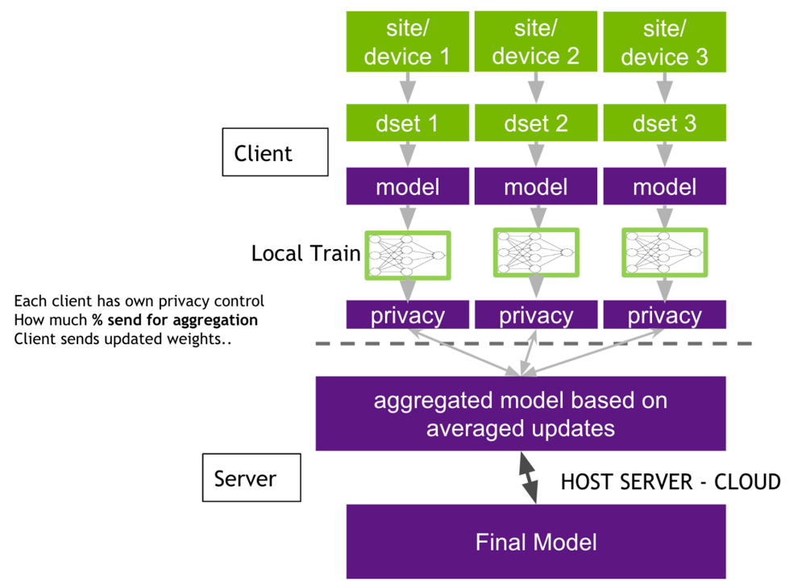
Federated learning (FL) is a decentralized machine learning model in which client devices train a shared model with raw data without transferring it to a third party. Each client node is given a global model which is initiated on a central server and shared out. Clients do their local training of the model on the model local data and only transmit model changes back to the server. These updates are received by the server and weighted averaging is used to establish a new global model which is sent back to clients to undergo further training until convergence. Federated Learning enables a large number of clients (mobile devices, IoT nodes, or companies) to learn the same global model without sharing raw data. The clients are learned locally and only send model updates to a central server that then aggregates the updates with Federated Averaging. Although this method is useful in improving privacy and can be used in healthcare and finance, it presents several challenges such as data heterogeneity, communication overhead, scalability of the system, and susceptibility to system attacks. Studies are aimed at enhancing privacy, effectiveness of communication, and resistance to malicious players.

Figure : Federated Learning (FL) Architecture
Federated learning (FL) is a decentralized machine learning system in which client machines jointly train a shared model without sending raw data to the server. A global model is spawned in a central server in FL and sent to every client node. Customers train the model in its local dataset and only the model updates are sent to the server. No crude information is exchanged with the client; only parameters learned are transferred. The server combines these updates by weighted averaging so as to generate another global model to be transmitted back to the clients as further training up to convergence. In such a manner, federated learning creates a shared model and maintains privacy of data.
Federated Learning (FL) is a distributed machine learning paradigm in which many clients are allowed to train a single global model without sharing raw data. Local training of the model is performed by each client on its dataset and model updates are sent to a central server. These updates are combined at the server through the Federated Averaging algorithm and serve to enhance the global model. The solution is useful in mobile applications, finance, and healthcare, as it helps to increase privacy. Nevertheless, FL has such difficulties as data heterogeneity, communication overhead, system scalability, and attack vulnerability. The studies aim on privacy enhancement using the differential privacy and secure aggregation, communication optimization, and strength enhancement.
3.2 Healthcare application
Federated learning can be used well in healthcare, where data are sensitive and obtained in different institutions. The data of patient records, medical images and health sensors is distributed in hospitals and clinics and devices. Such data cannot be concentrated in a single place (HIPAA, GDPR, etc.), but their experience together can make medical AI better. FL also allows every hospital to learn on its data and contributes only the improvements of the models. Scientists have used FL in medical issues such as cancer screening, COVID-19 diagnosis based on CT images, diabetic retinopathy, and predicting patient readmission. Through the use of multi-institutional data, these studies are more accurate compared to single-site models without compromising privacy. FL can be applied in public health to learn in a variety of populations and introduce less bias to models and make them fairer. According to one analysis, FL is beneficial in that it allows the training of a shared model without the mobility of raw data. Sites archive their data, and only need to provide model updates, and enjoy an enhanced combined model. It enables collaborative surveillance when the data of most hospitals is used and no personal information is revealed. FL is also more efficient: since model weights are the only information transferred, the communications are cheaper than transfer of datasets. As Abbas et al., FL will deal with the issue of data privacy, bandwidth, and scalability by never transmitting raw data. To conclude, federated learning combines the information of numerous institutions but each hospital has control over patient data.
3.3 Federated Learning Architecture
Federated Learning (FL) has four primary stages, which include initialize, local training, aggregation, and iteration. During the initialization phase, a central server constructs a global model and sends it to clients who are participating in the model, and this model architecture is the same and parameters are shared. This helps in team learning, although the use of a central server makes it more vulnerable. In case the original model is biased, it can have an impact on the overall performance.
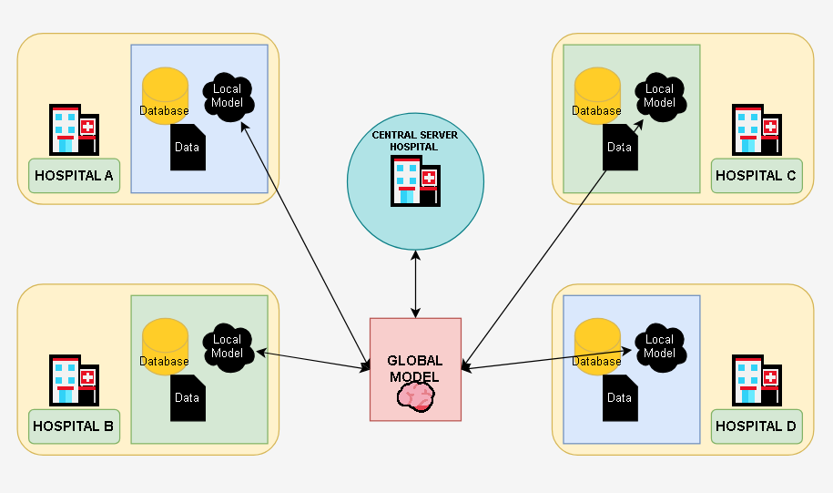Figure : Federated Learning Architecture in a Medical Context
In local training, a client sends its personal data to the global model with gradient descent. This prevents privacy breaches because raw data stays on client devices, which promotes the compliance of data protection. But local datasets are frequently not IID where data of different clients are distributed differently and have different sizes that can lead to model divergence and lower accuracy.
During aggregation, clients transmit updates of their models to the central server, which aggregates the models using Federated Averaging algorithm to produce a better global model. Although this allows collaborative learning without data sharing, it is associated with overhead communication and susceptible to malicious updates.
The iteration phase consists of resending new global model to the clients till convergence. Although this enhances the performance of models, it makes them more complex in terms of latency and complexity, particularly in low bandwidth.
The FL workflow offers a privacy-conscious distributed learning framework that balances collaboration and data confidentiality and heterogeneity and security-related issues. This architecture of client-server allows a horizontal FL, in which the data of clients have a common feature space (common when collaborating with multiple hospitals. The server manages the participation, dropouts and authentication of clients. More advanced deployments can introduce hierarchical deployments or federated transfer learning, but retain the simplistic hub-and-spoke structure of distributed trainers and central aggregation.
This architecture combines the ease of centralization with the privacy and scalability. It is not associated with huge transfers of patient databases, but requires additional coordination with the clients. In the case of healthcare, the advantages are strong. FL maintains records of patients kept in hospital machines thereby minimizing the risk of breaches. It also reduces communication, which uses 1 MB each, rather than gigabytes of health data. The following characteristics render federated learning a privacy-preserving healthcare analytics platform, which is scalable.
3.4 Possible drawbacks:
Federated learning has privacy benefits, but it creates technical challenges-
Heterogeneity of data and systems (non-IID data): Clients of healthcare generate types of data differently. Patient demographics and disease prevalence vary differently in hospitals, and the medical devices capture different features. This non-IID data implies that the distributions of client data can vary a lot. A global model can work unfairly, and it will tend to be biased with customers who have more data. The computing resources and network conditions of the clients are also different, which results in delays during training. Researchers suggest personalized FL and clustered FL, where the specialized optimizers such as FedProx or SCAFFOLD can be used to stabilize training. Nevertheless, heterogeneity of data is also difficult because global model has to be general and yet take into consideration the needs of individual clients.
Communication overhead: FL has numerous communication rounds between clients and server. Both the deep models and huge client bases introduce a bottleneck in bandwidth. Posting and receiving model parameters is large network traffic, particularly when there are millions of weights or thousands of clients. Scalability and convergence can be hindered by the communication costs which are very high especially in unreliable networks. These solutions are compression, quantized updates and client subsampling. Such optimizations, however, usually come at the cost of the final model accuracy or fairness.
Threats to security and privacy: FL does not compromise the privacy of raw data; nevertheless, shared model updates can be information leaks. Through malicious updates or backdoors, malicious clients may poison the model. Attackers might get to do inference attacks to recreate client data. Server-side anomaly detection, strong aggregation rules such as Krum or trimmed mean, differential privacy noise, and secure multi-party computation to use in aggregation have been used as defenses to ensure that privacy of a client is not compromised. All privacy preserving techniques incur a price: it might diminish model performance slightly. Nevertheless, healthcare FL requires high security to ensure that patient data is safe.

4. METHODOLOGY
4.1 Dataset Description
In this research, breast cancer is categorized based on the histopathology images on various repositories that are publicly available. The variety of data that is utilized assists the model in generalizing against the changes in the tissue preparation and imaging conditions that are observed in the clinic. All the datasets were obtained on Kaggle which is a popular machine learning research benchmarking site.
4.1.1 Data Sources
Three datasets were utilized, including the Breast Cancer Dataset which has histopathology pictures of either benign or cancerous categories, the BreaKHis Dataset which has pictures of microscopic breast tissue at various magnifications, and the histopathology component of the Breast Cancer MSI Multimodal Dataset which keeps the model input consistent.
Dataset | Description | Usage in This Study
Breast Cancer Dataset | Histopathology images labeled as benign and malignant | Used
BreaKHis Dataset | Microscopic breast tissue images at multiple magnifications | Used
Breast Cancer MSI  Multimodal Dataset | Multimodal medical imaging data | Only histopathology images used

Table 3.1: Summary of Histopathological Datasets used for Breast Cancer Diagnosis.

4.1.2 Class Distribution
The pictures were divided into two groups (benign (non-cancerous), and malignant (cancerous) ones. That is a binary classification problem that is suitable to the supervised deep learning and that is the crucial decision-making point in the histopathological screening.
4.2 Data Pre-processing
Images of histopathology of heterogeneous sources are variable in terms of resolution, color intensity, staining, and noise. To prevent this variability a systematic pre-processing pipeline was used on all images prior to network input.
4.2.1 Image Resizing
All input images in CNN architectures should share the same spatial resolution as required in CNN architectures. All of the images were scaled to a constant height H and width W according to the selected architecture:
$$I_{resized}=Resize\left(I_{original}, H ×W\right)$$
4.2.2 Pixel Normalization
To encourage stability in the backpropagation process pixel values were normalized with per-channel mean subtraction and per-channel standard deviation scaling:
$$I_{norm}=\frac{I - μ}{σ}$$
in which μ is the mean pixel and σ is the standard deviation calculated on the training set. This change focuses on activations and minimizes vanishing or bursting gradients.
4.2.3 Data Augmentation
Stochastic augmentation operations were used during the training to avoid overfitting and enhance the generalization that include rotation, flipping, zooming, shearing, and brightness adjustment. The augmented images I are created with the help of a random transformation T:
$$I^{'}= T\left(I\right)$$
This enrichment does not need extra labelled data to enlarge the training set.
4.2.4 Dataset Splitting
The image corpus was divided into three parts 70% of the corpus was used as training, 15% validation and testing. This guarantees that hyperparameter tuning is done based on validation data and final numbers are reported using unseen data to get unbiased estimates of generalization.
Feature Extraction and Selection: One of the most important features of deep learning compared to classical machine learning is the ability to learn features end-to-end. The CNN learns discriminative representations of raw pixel data, by means of hierarchically composed learned filters.
4.3.1 Deep Feature Extraction
The layers of convolution obtain a successive hierarchy of features. The low-level patterns such as edges and textures are captured in early layers, semantic structure such as nuclear shapes and tissue arrangements are encoded in intermediate layers and high-level morphological attributes of tumor pathology are expressed in deepest layers.
The basic algorithm behind this extraction process is discrete two-dimensional convolution:
$$\left(F * K\right)\left(x,y\right)= \sum_{i=1}^{m}{\sum_{j=1}^{n}{I\left(x+i, y+j\right)}}⋅K\left(i,j\right)$$
I would represent the input image/feature map, K represents a learnable convolutional kernel of size m x n, and F is the resultant feature map. Backpropagation helps the network to optimize the weights of the kernels to enhance prediction features.
4.3.2 Implicit Feature Selection
This architecture does implicitly select by mechanisms in its structure. The Rectified Linear Unit (ReLU) activation function removes negative features which are detrimental. Spatial pooling layers are used to make the feature map less dimensional, by keeping the high-value activations within local areas. Dropout layers randomly disable neurons in training so that over-fitting to any individual feature does not occur. These processes guarantee transmission of informative representations within the network.
4.4 Model Architecture
The model classification employs a centralized deep learning model such that the full training corpus is run through a single model on a single computational setting such that the optimizer is able to view the full data distribution.

4.4.1 Overall Architecture
The CNN consists of five sequential layers namely an input layer, convolutional blocks, spatial pooling between blocks, fully connected layers to high-level reasoning, and an output layer to classify.
4.4.2 Convolutional Blocks
A convolutional block has a convolution block, ReLU non-linearity, and max-pooling layer. The ReLU activation introduces non-linearity to represent complicated class boundaries:
$$ReLU\left(x\right)=\max\left(0,x\right)$$
Max-pooling down-samples The features in the map are down-sampled by keeping the maximum activation within each pooling window:
$$P\left(x\right)=\max\left(x_{1},x_{2},…,x_{n}\right)$$
This combination creates progressively dense but expressive representations as much as depth is added.
4.4.3 Fully Connected Layers
Once the final convolutional block has been completed, the feature maps are flattened into a vector, and they are fed through fully connected layers. These layers are trained to recognize decision boundaries across the world to determine benign and malignant tissue depending on the spatial features extracted.

4.4.4 Output Layer
The network has one output neuron with a sigmoid activation function, which compares the final pre-activation score z to a probability value in (0, 1):
$$\hat{y}=\frac{1}{1 + e^{\left\{-z\right\}}}$$
The ŷ is a probability value estimated to be the likelihood of a malignant tissue, with the 0.5 value as the binarization threshold in the inference.

Model Training Procedure
4.5.1 Loss Function
Binary Cross-Entropy (BCE) loss was minimized to optimize the model parameters in case of binary classification:
$$£=\left(-\frac{1}{N}\right)\sum_{i=1}^{N}{\left.\left[y_{i}\log\left(\hat{\left(y_{i}\right)}\right)+\left(1 - y_{i}\right)\log\left(1 - \hat{\left(y_{i}\right)}\right)\right.\right]}$$
N = the number of training samples, y i = 0 or 1 is the ground-truth label, 87iy = the probability of the i-th sample as predicted by the model. BCE has a stronger penalty against wrong predictions, which steers the model towards well-calibrated predictions.
4.5.2 Optimization Algorithm
The Adam optimizer is used to compute the parameter updates, which is a combination of the momentum-based gradient accumulation and the adaptive learning rate per parameter:
$$θ_{\left\{t+1\right\}}= θ_{t}-α\frac{\hat{\left(m_{t}\right)}}{\sqrt{\hat{\left(v_{t}\right)}}+ ϵ}$$
Adam is flexible in nature and fits well in cases where there are sparse gradient or different loss surface curvature, such as in the training of deep networks when using medical image data.
4.5.3 Training Configuration
The model was trained using a batch size of 32 in 50 to 100 epochs with 0.0001 learning rate. Early stopping was employed: the training was stopped when the validation loss did not decrease with successive epochs, which avoided memorization of noise in training data.
Hyperparameter | Value
Batch Size | 32
Epochs | 50–100
Learning Rate | 0.0001
Optimizer | Adam
Table 3.2: Hyperparameter Settings for Model Training
The structure of centralized learning is designed to facilitate the sharing of knowledge across various departments.
4.6 Centralized Learning Framework.
In the current study, we decided on a non-federated approach that uses a centralized training approach in training our model. Centralized training implies that all image data is stored in a single central location that can be accessed by anyone. This is to ensure that the model is free to see out the whole dataset during the training process.
This approach was selected due to a number of reasons. First, centralized training enables the optimization algorithm to take advantage of the actual global distribution of data to compute the gradient. The model takes into account all types of data and ranges per iteration, which results in more precise and generalized learning results. This global perspective is not frequently easy to realize in distributed or federated environments, where nodes can only have access to a small amount of data.
Second, we make the training pipeline simpler by not having to tackle distributed learning problems such as device synchronization and convergence problems. This lowers the computational and engineering overhead besides simplifying the management of experiments. Being able to keep both data and training states within a single controlled space enables us to get greater reproducibility so that our results can be firmly attributed to model architecture or training procedures.
Federated learning is advantageous; however, in terms of data privacy in a multi-institutional cooperation, the tasks of our work are now aimed at checking the performance of model classification in controlled conditions. Thus, centralized training strategy is an ideal point of departure of our experiments that will act as a good point of reference in future investigations where more complex approaches are applied.
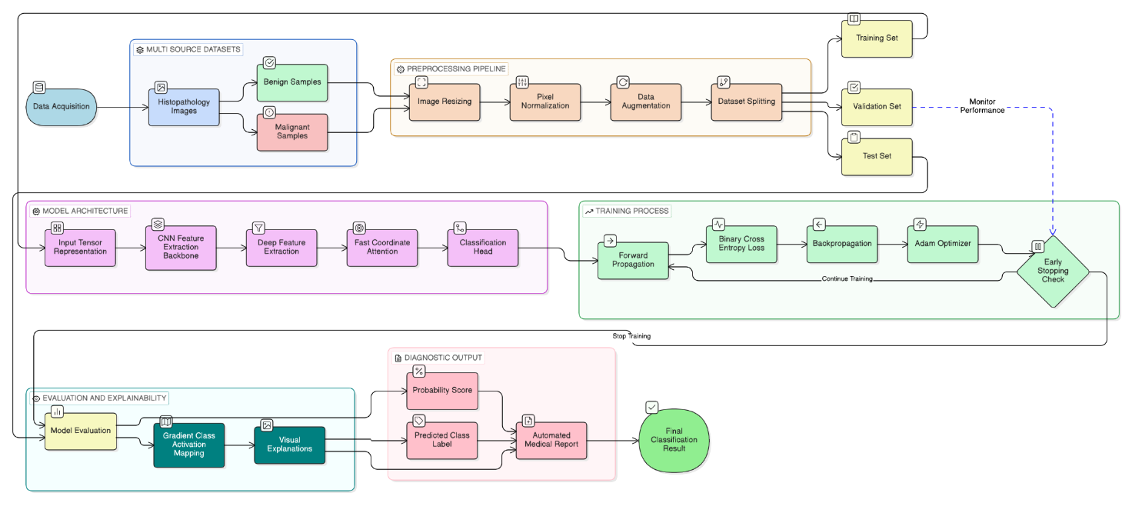
Figure 3.1: Image classification workflow
4.7 Summary
The given methodology in this chapter describes an organized pipeline of binary cancer classification of breast cancer on histopathological images. We have ensured that we incorporated the diversity of data in terms of the use of three different, publicly available datasets and each data set brings with it a different characteristic to the general one.
Our pre-processing approach standardized the inputs and improved the quality of data using image resizing and pixel value normalization methods and data augmentation methods, which include rotations, flips, and shifts. Such measures enhanced the consistency of the inputs and reduced overfitting, exposing the model to different data situations.
To extract the feature, we trained our own Convolutional Neural Network (CNN) to acquire the patterns of histopathological images. The binary classification task used the Adam optimizer, and Binary Cross-Entropy loss in the network training.
Stage | Description
Dataset | Multi-source histopathology images (benign / malignant)
Pre-processing | Spatial resizing, pixel normalization, stochastic augmentation
Feature Extraction | Automatic, hierarchical via CNN convolutional blocks
Model | Centralized CNN with sigmoid output
Training | Adam optimizer, BCE loss, early stopping
Learning Paradigm | Non-federated (centralized)

Table 3.3: Traditional Centralized Learning Workflow for Histopathological Image Classification.

5. RESULTS AND DISCUSSION
5.1 Overview
The chapter outlines experimental results of the deep learning architecture used in breast cancer diagnosis using histopathology images. Performance is considered using classification measures, training dynamics, visual explanation and attention analysis. In addition to statistical performance, we look at whether the outputs of the model are interpretable and can be used to offer clinical relevance required in a diagnostic setting.
5.2 Experimental Setup
The centralized training was done on experiments under a single dataset of a range of histopathology. Instead, histopathology images were limited to ensure that the results are not influenced by differences in the characteristics of inputs.
5.2.1 Environment Hardware and Software.
The implementation of the model in Python relied on the PyTorch as the main deep learning framework. Training and inference were done on a system with GPU capabilities where hardware capabilities allowed, and GPU acceleration significantly decreased epoch-level training times and made it possible to explore more radical architecture designs.
5.3 Evaluation Metrics
Assessment of a diagnostic classifier needs measures that characterize many aspects of performance since accuracy can be misleading in cases of imbalanced classes. There are four important metrics that were chosen to shed light on various model behaviors.
Accuracy: the degree of appropriate classification of all samples of classes.
$$Accuracy=\frac{TP + TN}{TP + TN + FP + FN}$$
Precision: measures how accurate positive (malignant) predictions are, which percentage of flagged cases are true.
$$Precision=\frac{TP}{TP + FP}$$
Recall (Sensitivity): This is the capability of the model to determine the actual malignant cases, which is crucial in oncological screening as false diagnosis is severe.
$$Recall=\frac{TP}{TP + FN}$$
F1-Score: this is a measure that is a combination of precision and recall, which is a harmonic mean when false positive and negative costs are uneven.
$$F1-Score= 2 ×\frac{Precision×Recall}{Precision+ Recall}$$
The graph below illustrates a precision-Recall Curve.
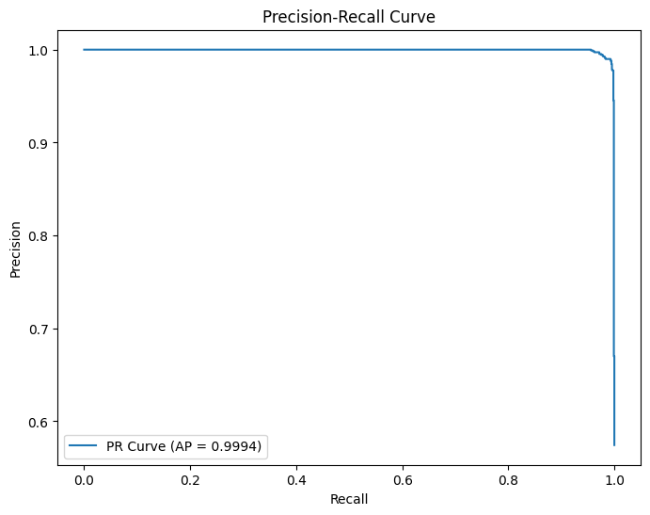
Figure 4.1: Precision-Recall Curve
Figure 4.1: Precision-Recall Curve
The performance of the classification is determined by the outcome of these four activities: routing, load balancing, delay estimation, and congestion control.
5.4 Classification Performance
The result of these four activities is the performance of the classification: routing, load balancing, delay estimation, and congestion control.

5.4.1 Quantitative Results
The model performed well on the held-out test set, with relatively high results on all evaluation metrics as indicated below.
Metric | Value
Accuracy | 98.95%
Precision | 98.80%
Recall (Sensitivity) | 99.45%
F1-Score | 99.10%
AUC | 0.9995

Table 4.1: The Metrics of Performance Evaluation of the Breast Cancer Classification Model.
The findings of these results suggest that the proposed model is a reliable one to differentiate benign and malignant breast tissue based on histopathology images. The recall rate (99.45) indicates very low cases of lost malignancies. False negative in cancer detection is the error that is most clinically expensive because malignant tumors that are wrongly considered benign can cause delays in treatment leading to the poor prognosis. The near-perfect recall has clinical implications, other than the figure of accuracy, which is direct. The AUC of 0.9995 indicates that at any decision threshold the model does not diminish its capacity to discriminate malignant tissue vs. benign tissue and as a result, the representations are quite discriminative.

5.5 Confusion Matrix Analysis
Misclassifications are not prevalent when looking at the confusion matrix. Rare benign samples are wrongly labeled as malignant and rare malignant samples are false negatives of the model. Such even distribution of errors suggests that there is equal learning and the model has not acquired a systematic bias towards any of the classes unlike imbalanced datasets.
The clinical relevance is that the low false-negative rate is of special importance. Although false positives might lead to unnecessary tests and anxiety among the patients, false negatives in cancer diagnosis are more severe because it may lead to missing timely life-saving therapy. This pattern of errors demonstrates the possibility of the system being an effective screening test, in which high sensitivity is the more important aspect compared to maximizing specificity.
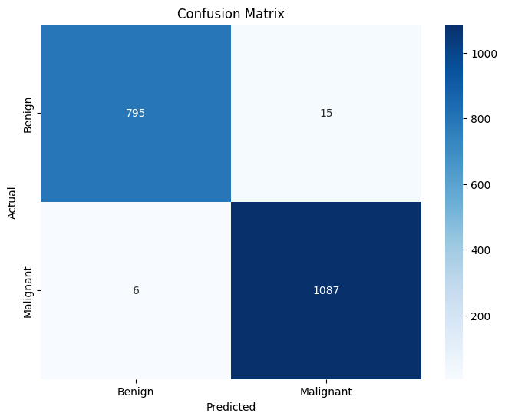
Figure 4.2: Confusion Matrix
5.6 Training and validation Behaviour
The training and validation behaviour is important since the employee must be trained on the new management system.
5.6.1 Loss Convergence
The curves of training and validation loss exhibited a smooth and decreasing trend, with no ups and downs and instability. This means that it has a fitted learning rate and training schedule that satisfactorily explored the loss landscape. The constant loss trend indicates a suitable batch size and augmentation strategy to be used on the task.
Early-stopping has helped to avoid overfitting to training data trends by stopping at the best validation performance, meaning that test metrics are a true generalization.
5.6.2 Generalization Capability
It is promising that training and validation performance are close to one another during optimization. The lack of a generalization gap is notable, given that the training data were a mixture of data sets of different staining properties, magnification fields, and acquisition parameters. Such uniform performance implies that this model acquired intrinsic tissue pathology properties and not dataset-specific artifacts.
Explainability and Visual Interpretation
5.7.1 Grad-CAM Visualization
Having high classification accuracy is a necessary but not sufficient condition to have an AI diagnostic system be adopted in clinical practice. Before clinicians take action on the outputs of a model they need to know how the model arrives at decisions. Grad-CAM was used to produce heatmaps indicating which regions of the image are the most influential in the predictions.
In the case of malignant predictions, the activation was focused on abnormal nuclei, impaired tissue structure and high cell density areas - characteristic features of malignancy. Diffuse, low-intensity activation was observed in homogenous tissue areas, which is consistent with the lack of pathological features.
The agreement of the model-highlighted areas with known pathological features demonstrates that the network has acquired clinically consistent features. This concordance is required in the deployment cases, whereby the clinician relies on AI to guide them to focus on the same tissue features that they would have examined.
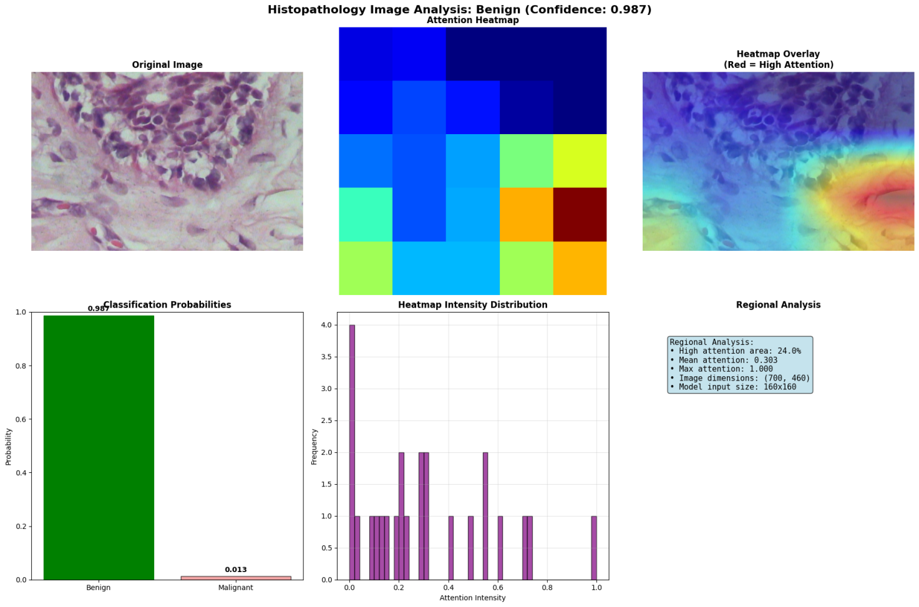
Figure 4.4: Heatmap Attention (Malignant)
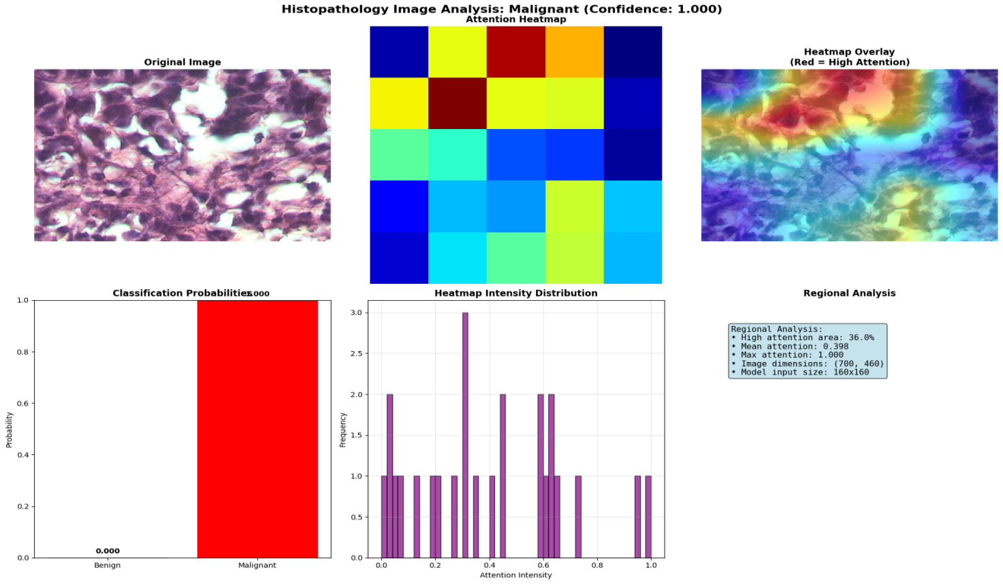
Figure 4.4: Attention Heatmap (Malignant)
5.8 Attention-Based Tissue Analysis.
The attention mechanism in the model architecture gives it interpretability, in that it gives a weight to spatial regions according to their classification importance.
5.8.1 High-Attention Area Ratio
As a measure of spatial focus, a ratio of the pixels with high attention to the total area of an image was computed in order to obtain a quantitative value:
$$Attention Ratio=\frac{High-attention pixels}{Total pixels}$$
The attention ratios of malignant samples were higher than the control (benign) samples. This is consistent with what is expected in pathology: malignant tissue is functionally heterogeneous and focused on abnormal clusters of cells, emphasizing more abnormal areas. Diffuse attention response is produced by benign tissue which is more uniform. This congruency between the test set and the established representation of the test set is indicative of the biological faithfulness of the learned representations.
5.9 Automated Medical Report Generation
The fourth and the last phase is automated medical report generation.
An automated creation of structured diagnostic reports is one of the practical extensions of this framework. When an image has been processed the system generates a report that includes the predicted diagnosis, confidence score, probability distribution, Grad-CAM heatmap interpretation, clinical recommendations, and a reminder that the system is a decision-support practice and not a clinical judgment substitute.
Such a capability fills a translational gap that has limited the application of deep learning models in clinical workflows. Raw uniqueness scores and taxonomy are not easily understandable according to the standards of clinical practice. The system will allow practitioners to interact with AI-generated assessments on a critical level instead of perceiving them as unclear judgments by organizing outputs into clinician-familiar formats.

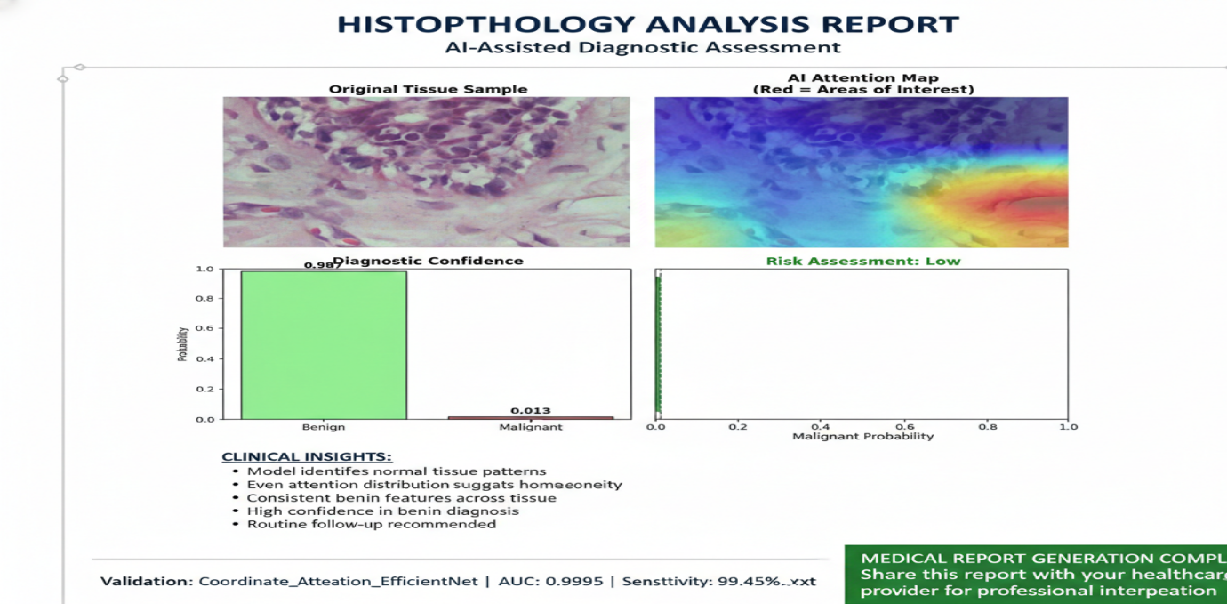
Figure 4.5: Artificial intelligence aided diagnostic test.
5.10 Comparative Discussion Among the Existing Literature.
The framework proposed outperforms other CNN-based classifiers with a number of benefits. It has higher accuracy of classification and sensitivity and integrates attention processes with Grad-CAM visualization tools. Such integration is highly interpretable which is important and is not available in other black-box architectures. The traditional models tend to be opaque in decision making process and hence can not be applied in critical applications.
The generalization tests of the model are stricter than the single datasets tests, which are usually used in published benchmarks. The high level of consistency in the performance of the framework with other data sources demonstrates a high possibility of real-life application. This approach is the only method that allows a high performance of quantitative performance and interpretable decision making compared to earlier studies, which in many cases, had the advantage of accuracy at the cost of transparency. Model interpretability is needed to be implemented in clinical settings. The understanding of the reason behind the use of automated systems must be understood by the doctors when it comes down to patient care. Thus a model that provides meaningful performance measures as well as understandable outputs is better at clinical use than black-box models that may be slightly more accurate.
5.11 Limitations
The proposed framework outperforms the other CNN-based classifiers in a number of ways. It is better classified and more sensitive and combines attention processes with Grad-CAM viewing method. This combination makes the models easier to understand, which is an important characteristic that other black-box designs do not have. The decision-making of the traditional models is not always clear as they tend to be not transparent regarding the creation of predictions.
This is because the model is tested on heterogeneous datasets, giving a comprehensive test of its generalization capability relative to those that are single-dataset based as used in published literature. The fact that the framework has been relatively consistent in its performance in various data sources gives more confidence to its applicability in real-life situations.
This technique is the only one that has been able to bring both good performance in terms of quantification and interpretation of decisions as opposed to the past where accuracy was achieved at the expense of transparency. In therapeutic use, model transparency is needed to be implemented. Doctors need to have faith and knowledge of automated systems when they are involved in patient care. Therefore, a model that provides high performance and interpretable results will be more useful in clinical environments than a black-box model, although with slightly higher accuracy.
5.12 Summary of Results
Aspect | Outcome
Classification Accuracy | Very high (98.95%)
Generalization | Strong & consistent across multi-source data
Explain ability | Clinically meaningful (Grad-CAM + Attention)
Overfitting | Minimal & early stopping effective
Clinical Applicability | Suitable as a decision-support tool

Table 4.2: Breast Cancer Classification Model Clinical Evaluation and Clinical validation.
5.13 Chapter Summary
Experiments show that the proposed framework can be used to classify breast cancer with high-fidelity using histopathology images, and the performance metrics of the study with the benchmarks and clinic thresholds are comparable. The combination of Grad-CAM visualization and attention-based analysis provides the capability to provide transparent, spatially-grounded decision-making in accordance to the pathological expectations - the features that cannot be dispensed of by AI systems in clinical settings. These results confirm the methodology as a technically acceptable and interpretable technique of computer-aided diagnosis of breast cancer and provide a basis on which the external clinical validation and prospective deployment studies can be conducted.
6. System Implementation and Development

6.1 Introduction
Medical artificial intelligence translation between research and operational clinical systems in resource-limited settings has more than algorithmic optimization problems. Privacy-aware machine learning architectures are becoming legally enforced in Bangladesh, where digitization of healthcare is rapidly expanding due to the fragmented infrastructure and new data protection laws that are still in development. This chapter records the decentralized federation of learning to classify breast cancer based on histopathology images, where three technologies, Ethereum blockchain to coordinate, InterPlanetary File System (IPFS) to store models, and convolutional neural network with coordinate attention mechanisms are used.
The system was constructed by seven stages, which included infrastructure setup up till smart contract implementation, communication framework, security hardening, aggregation reasoning, model architecture assurance, and integration testing. This is a way to balance the deterministic nature of blockchain with the probabilistic one of deep learning, and to achieve the healthcare data protection requirements by keeping the level of security high.
6.2 Regulatory and Technical Motivation.
Introduction of a federated architecture coordinated by blockchain in the healthcare of Bangladesh can be explained by three pressures: digitizing medical records, the vulnerability of the centralized data governance, and the new privacy laws limiting data aggregation.

6.2.1 The Landscape of Data Protection.
By 2025, Bangladesh has reached 50 million electronic health records every year in the healthcare sector. Such records are stored on institutional silos with differing levels of security and in many instances with weak encryption. According to the Personal Data Protection Ordinance (PDPO) of 2025, medical information must be handled rigorously, and it must be held institutionally unless there is an express agreement and privacy protection measures. This architecture puts obstacles to machine learning systems that need to have centralized data aggregation.
Federated learning solves this by reversal of the data-to-model paradigm: the learning algorithms are distributed to the data custodians, but only the model updates are shared across institutions. The blockchain layer offers a permanent record of model operations in the form of an audit trail, addressing the PDPO accountability obligations without revealing training information.
6.2.2 Past security attacks and lack of trust.
The history of Bangladesh in data breaches shows the vulnerability of centralized governance models. The leaked National Identity Database of 50 million citizens in 2023 reveals the impact of single-point-of-failure systems. Unauthorized access of data in healthcare may have disastrous effects on the trust of the population in online programs.
Decentralization of risk is achieved by blockchain technology. The system implements cryptographic validation by distributing the transaction ledger among nodes, preventing systems compromised by single server attacks to modify records or inject malicious updates into the system. Tampering is detectable, which has the advantage of being audit-able and cannot be achieved in centralized databases.
6.3 Phase 1 and 2: Infrastructure Initiation and Deployment of Smart Contracts
The initial two stages of development were the basic decentralization of orchestration layer and the launching of the system with a baseline model state, which would act as the unified start point of all the participating institutions.
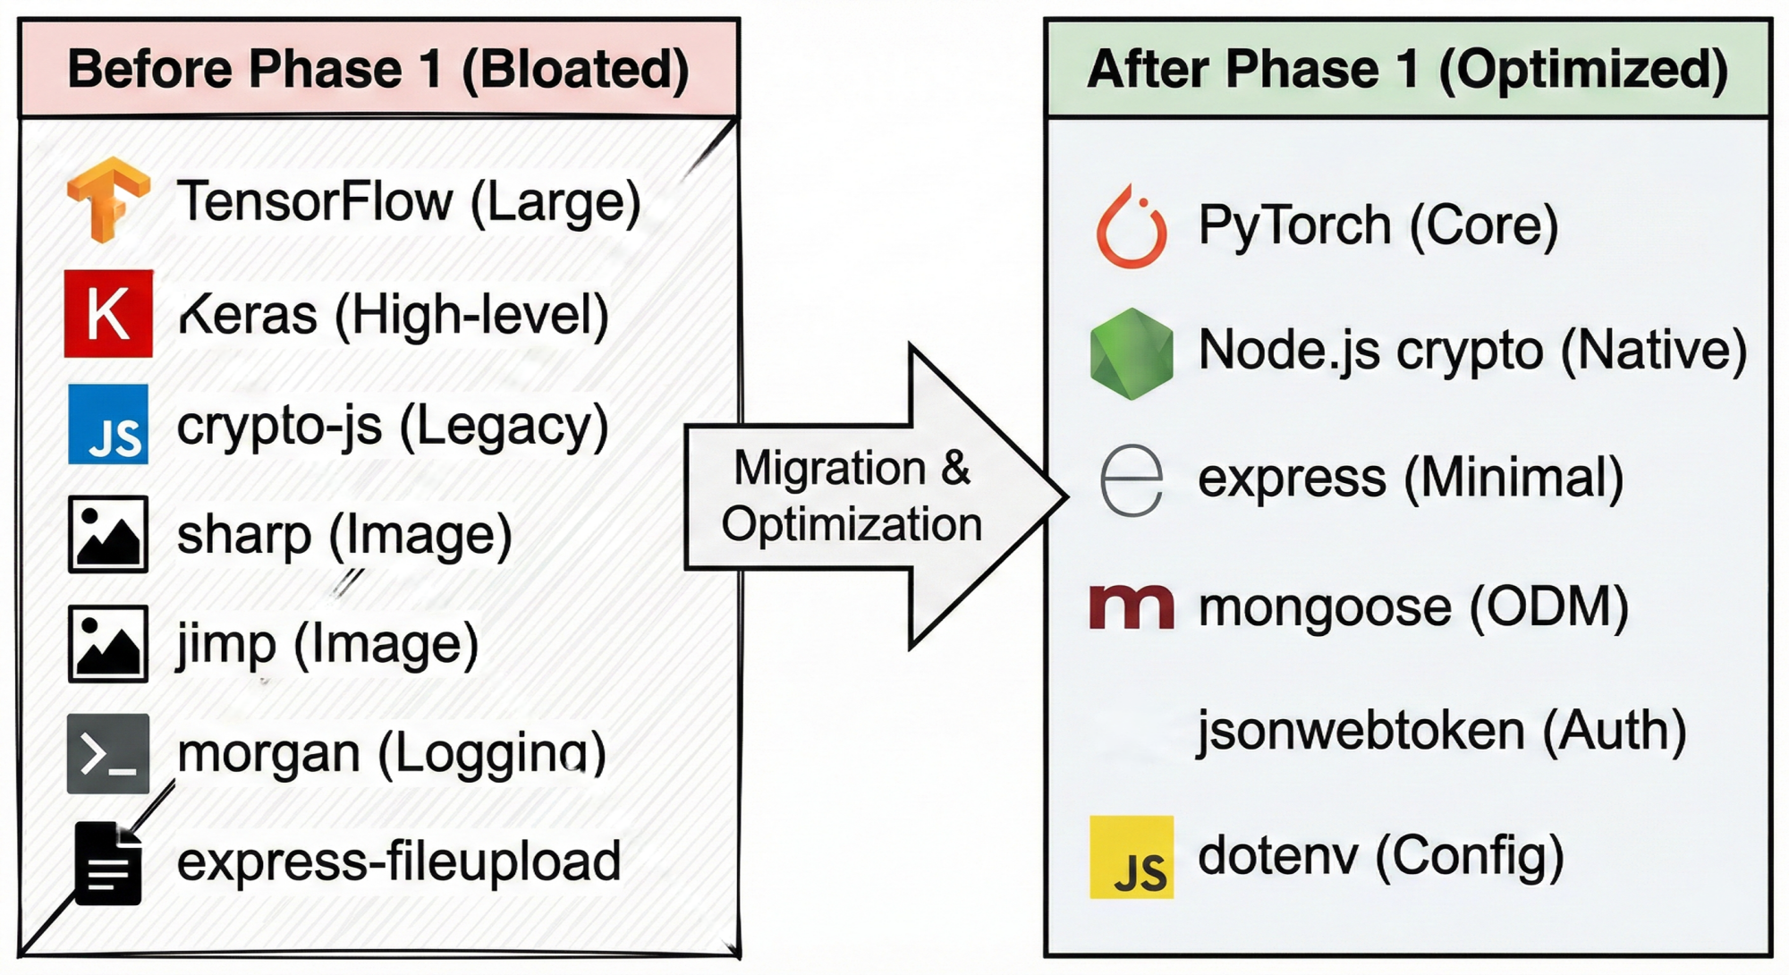
Fig. 5.1 Dependency Optimization and Migration.
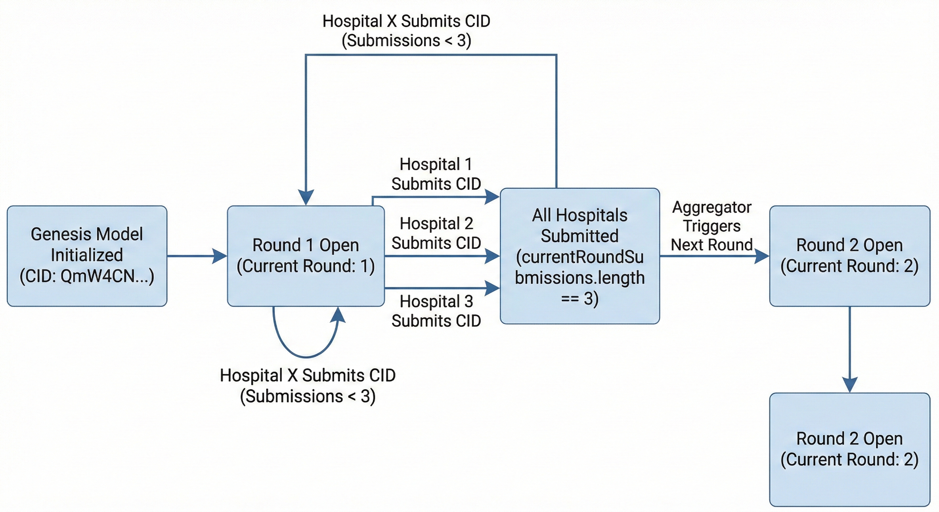
Figure 5.2 Training Round Lifecycle.

6.3.1 Technology Stack Selection
The system architecture and one of the most popular platforms of decentralized applications are based on the Ethereum Virtual Machine (EVM). The system was written in Solidity, a programming language to deploy smart contracts into EVM blockchains and provide the core logic of the system. This allowed federated learning management protocols which were transparent and irrevocable.
First of all, Ethereum mainnet deployment was considered, as its security, immutability and constancy to censorship are essential characteristics of healthcare and the collaboration of many institutions. The transaction costs (gas fees) however were a major challenge. Since federated learning would need updates regularly and from several participants, this would render the system impractical with regards to total gas costs.
The prototype was thus implemented into a public Ethereum testnet, the Sepolia testnet which is EVM-compatible and simulates network conditions. Sepolia transactions also do not use real money, so it removes the obstacle of gas fees. This setting allows prototyping quickly and testing on conditions of the mainnet without spending money limitations. The team was able to test and retest the system and then think about the deployment of the system to the production.
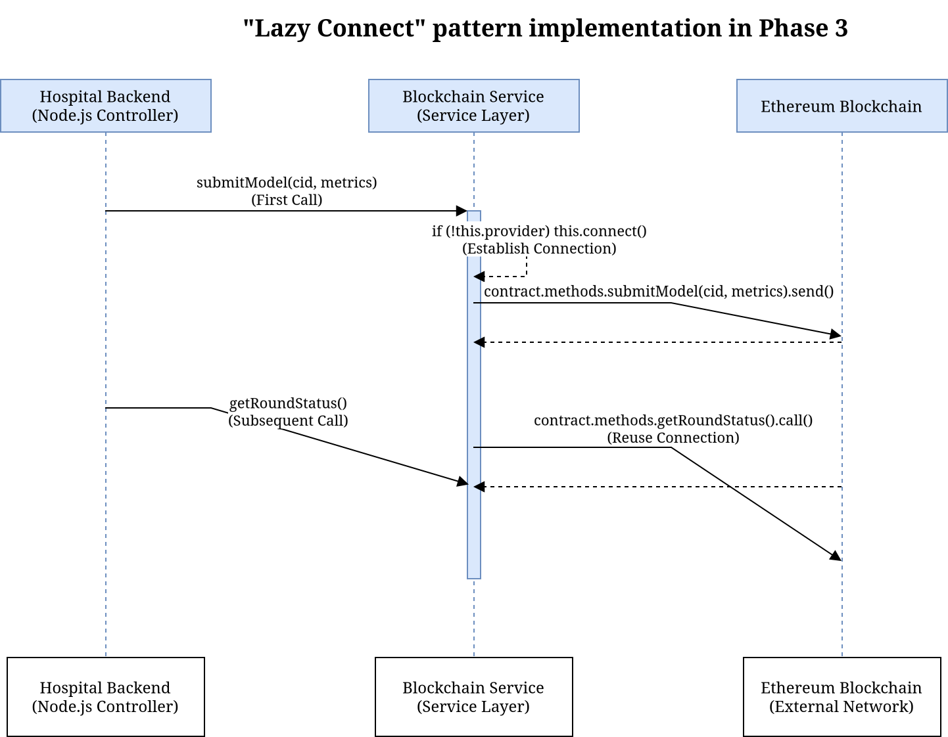
Fig. 5.3 LazyConnect Sequence Diagram.
The testing was configured on three nodes in Boston, London and Tokyo as a way of simulating a real-world federated learning consortium. Geographic diversity challenged the capability of the system to address such challenges as network latencies, data sovereignty, and co-ordination problems of the nodes. These are critical issues of federated medical AI, where global institutions act in collaboration and still control data. The simulated participants on different continents, provided the team with the knowledge of resilience and reliability of the system, which they could utilize in future implementations of healthcare consortia.
6.3.3 Smart Contract Architecture.
This fundamental orchestration logic is wrapped up in an address 0x1BE44922c9505E492eA93cfA4a673CE8ea106Ea1 Solidity smart contract at block height 10,254,150. The federated learning lifecycle used in this contract is the registration of hospitals, tracking the model, round-based synchronization, and aggregation. Role-based permissions that are provided by Open Zeppelin are used as the access control such that only specific Oracle addresses can invoke aggregation and only registered hospitals can provide model updates.
The contract was passed with 39 automated unit tests, all of which were passed successfully. These tests confirmed the important invariants such as state update atomicity, access restriction enforcement and appropriate edge case handling. The 100 percent pass rate is one that proves the predictable behavior of the contract in the operating conditions.

System Component | Technical Implementation | Purpose
Blockchain Network | Ethereum Sepolia Testnet | Decentralized model orchestration
Contract Address | 0x1BE44922c9505E492eA93cf  A4a673CE8ea106Ea1 | Live orchestrator instance
Storage Protocol | IPFS (Pinata Pinning Service) | Off-chain storage of encrypted weights
Genesis CID | QmW4CN7kJcKniWTG5by  WfCoKuwfsCN2Cti4bYbmNtruzWw | Initial model baseline
Consortium Nodes | Boston, London, Tokyo | Multi-institutional simulation

Table 5.1: Federated Learning System of the Federated Learning System Technical Infrastructure and Blockchain Integration.

6.3.3 IPFS-based Content-Addressed Storage.
The size of the block in Ethereum cannot hold the large model weight files in-chain. The system relies on IPFS, which is a peer-to-peer protocol that manages files by content identifiers (CID) instead of URLs. Every update of the model is encrypted and uploaded to IPFS that returns a 46-character CID of the hash of the file. This CID is the only one stored on-chain, so it takes 32 bytes to store, with integrity: the effects of any modifications to a file will result in a different CID, and this can identify tampering.
Phase 2 ended with the Genesis Model a baseline CNN trained on the histopathology dataset that was pinned to IPFS and registered on-chain as a source of participating hospitals.

6.4 Communication Protocol Alignment
A communication protocol alignment is part of design that helps in the design and code writing of software.Cross-technology federated learning systems, such as Solidity, Node.js, Python, have a problem of ensuring semantic consistency between languages. Phase 3 solved this by aligning the Application Binary Interface (ABI) that defines the serialization of data structures between blockchain and off-chain services.
6.4.1 Phase 3 ABI Mismatch Resolution.
There were 31 discrepancies that were found and fixed on seven critical files. These discrepancies were caused by old invoking methods that were overridden by final contracting in the client code. The method getParticipantCount() was substituted by getParticipants() that returns an array of address of hospital. The participant count was amended to use .length on the resulting array as the client code.
The pending model submission data structure was redesigned. In the last implementation, the field hospital was renamed to contributor to enable the non-hospital entities to be involved. To prevent the occurrence of runtime errors, the aggregation logic on the client side was changed to update.contributor instead of update.hospital.

Mismatch Point | Previous Placeholder | Corrected Method/Field
Participant Count | getParticipantCount( ) | getParticipants( ).length
Submission Count | pendingUpdatesCount( ) | getCurrentRoundSubmissions( )
Contributor ID | update.hospital | update.contributor
Accuracy Metric | update.accuracy | update.localAccuracy
Scaling Factor | 100 | 10,000

Table 5.2: Refining of smart contract and synchronizing API.

6.4.2 Metrics Precision, Integer Encoding.
Since Solidity does not support a native floating-point representation, its performance metrics such as accuracy and sensitivity have to be represented on-chain as integers. The scaling by 10,000 metrics provided the answer to use four decimal places without leaving Solidity in the integer space. The sensitivity of 0.9945 is represented as an integer 9945.
Phase 3 revealed that there existed a bug in which scripts used a scaling factor of 100, which would have impaired accuracy when weighted averaging. Once this was fixed, weighted averages in hospitals could be rightly calculated with the help of the aggregation service.
6.4.3 API Route Stability
The Node.js backend was re-implemented with a "lazy connect" pattern of all the 18+ methods of interacting with contracts. This will make sure a valid provider connection is made to the Ethereum network prior to transactions to avoid runtime errors where Web3 instances are not connected.
The API routing logic has been rearranged to avoid the problem of parameter capture. The routes in express.js are defined in a defined sequence. A generic route such as /:version captures requests targeting the specific routes such as the one at / latest, which is declared first. In order to guarantee a predictable API behavior during training cycles, moving static routes before parameterized routes was adopted.
6.5 Phase 4: Hospital-side and Institutional Security Implementation.
The federated learning system is susceptible to the security of the institutional silos; these are hospital-side nodes that learn local models on patient information. Phase 4 was dedicated to crypto-hardening the model weights and optimization of a data pipeline of histopathology pictures.
6.5.1 Cryptographic Modernization.
There was a critical security risk with the original encryption implementation in the form of the legacy createCipher and createDecipher functions of the Node.js implementation. These functions obtain encryption keys based on passwords through unsalted MD5 hash without unique initialisation vectors (IV) so that the same model weights encrypted with the same password generate the same ciphertext and this causes the system to become susceptible to pattern recognition.
This was shifted to createCipheriv and createDecipheriv, which take specific encryption keys and random IVs with each encryption. The process follows:
$C = E_{\left\{K, IV\right\}}$(P)
C is a ciphertext uploaded to IPFS, E signifies AES-256-CBC encryption, K indicates a 256-bit symmetric key, IV represents a random 16-byte initialisation vector and P represents the serialised model weight buffer. This guarantees that hospitals with the same model keep different encrypted representations on IPFS, which keeps training process confidentiality intact and avoids inference by comparing ciphertexts.
6.5.2 Modality Specialization
The first system design was able to support various imaging modalities such as X-ray, ultrasound and histopathology. Technical reviews indicated that a multi-modal strategy did not add complexity to performance. The best focus became the histopathology images, which are cellular resolution and considered to be the gold standard in diagnosis of cancer.
Phase 4 concerned the process of pruning the system data schema. 3,840 dimensions were eliminated off the status monitoring endpoints, referencing vascular imaging and Doppler flow were eliminated. This specialization has been adapted to the MongoDB schema, and the route of uploading patient data was rewritten to accept only histopathology images. To avoid losing data when there was a failure when uploading to IPFS, a filesystem fallback mechanism was introduced.
6.6 Phase 5 Global Aggregation and Weighted Averaging.
Hospital contributions are organized by the administrative backend and the updated global model is computed at the end of every training round. Phase 5 developed this aspect into an activesimulation instead of a passive one in the form of a real-time aggregation service depending on the nature of participating institutions.

6.6.1 Implementation of Federated Averaging.
In the default Federated Averaging (FedAvg) algorithm, a weighted average of local model parameters is computed, where the contribution of each hospital is determined by its set of training data and its quality. The mathematical statement is:
$$w_{\left\{t+1\right\}}=\sum_{k=1}^{K}{\frac{n_{k}}{n}}w_{k}$$
y is the local training parameters in hospital k, and y is the local training parameters in all participants which is denoted as n.
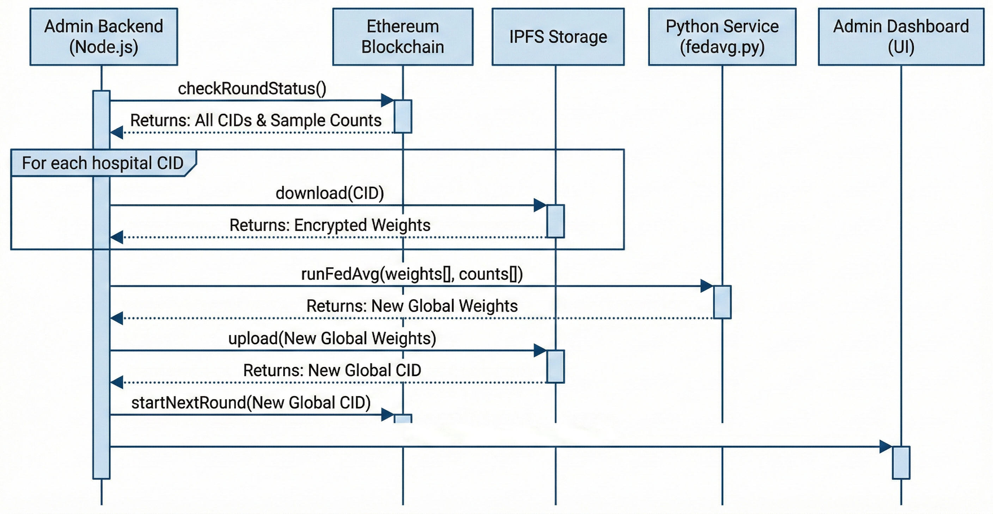
Figure : Federated Averaging Sequence Diagram.

During Phase 5, this logic was rewritten in an inline hardcoded string to a standalone Python script (admin-backend/src/python/fedavg.py) to make it more maintainable. The script substituted place hold metrics with the real weighted averages of blockchain performance statistics.
6.6.2 Security of Model Deserialization.
This process of aggregation poses a security risk: as the admin backend will need to deserialize model weights provided by external hospitals, malicious users can place code into the weight files and thus make arbitrary code execution. To alleviate this, torch.load is invoked with weightsonly=True, which only admits deserialization of types of tensor data and does not allow arbitrary Python code to be executed. This security control is essential in decentralized environments with different levels of cybersecurity.
6.7 Phase 6: Verification of Model Architecture.
The quality of the federated learning framework is determined by the quality of its deep learning model. The architecture employed by the system is FastHistopathologyModel, which integrates EfficientNet-B0 and Coordinate Attention to be more sensitive to pathological features.
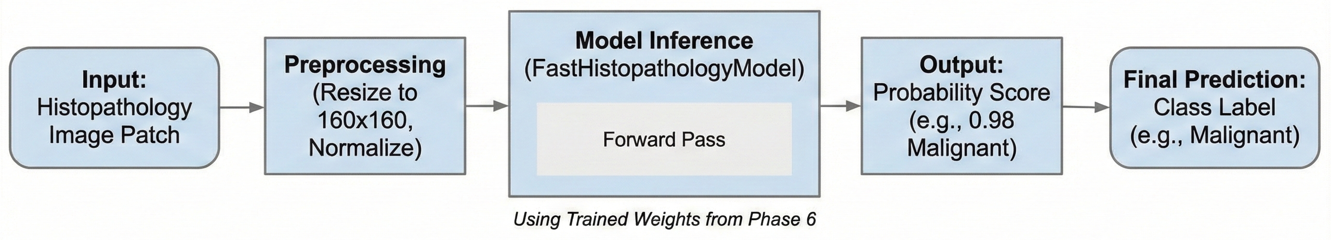
Figure 5.6 End to End Inference Pipeline.

6.7.1 Coordinate Attention Mechanism.
Standard channel attention, such as Squeeze-and-Excitation (SE) is a mechanism that uses global average pooling as a tool to compress a two-dimensional feature map into a one-dimensional feature map. This function obliterates tight spatial data, which is a considerable waste to histopathology pictures, in which the location of the cellular arrangement has diagnostics value.
This is fixed by Coordinate Attention which factorizes channel attention into two one-dimensional encodings: that of horizontal and vertical axis dependencies. The module computes:
$$z_{c }^{h }\left(h\right)= \frac{1}{w}\sum_{\begin{aligned}0≤ i ≤ W \\ \end{aligned}}{x_{c}\left(h,i\right)}$$
$$z_{c }^{w}\left(w\right)=\frac{1}{H}\sum_{\begin{aligned}0≤ j ≤ H \\ \end{aligned}}{{ x}_{c}\left(j,w\right)}$$
Where $z_{c}^{h}$ and $z_{c}^{w}$ are means of horizontal and vertical pooling. These vectors are concatenated, and run through a common 11 convolution with a reduction ratio of 16, and divided into individual attention maps. The attention weights are spent in terms of multiplication to the input feature map, and this allows to amplify areas of interest and silences the background.
6.7.2 Model Checkpoint Validation.
Phase 6 tested the model by means of inference testing and checkpoint auditing. There was a critical difference in the inference.py script whereby prefixes of the layers were mismatched to self.backbone rather than self.features and could not load pre-trained weights as a result. Once the naming conventions of the layers were realigned, the model was tested in the diagnostic tests:
  - The unique trainable parameter count was confirmed at 5,927,510, while the stored checkpoint contained 10,019,862 parameters due to the inclusion of a frozen reference backbone retained for feature preservation.
  - End-to-end testing confirmed that a160×160 RGB input produces the expected binary classification output.
  - Testing with a representative histopathology image yielded a "Malignant" classification with a confidence of 1.0000, confirming the model's ability to distinguish pathological features.
  - The model was loaded with strict=True during the state dictionary import, resulting in zero missing or unexpected keys — a necessary prerequisite for reliable federated aggregation.

6.8 Phase 7: System Integration and Production Readiness
The last stage of development was aimed at aligning all the parts of the system and changing the prototype into the environment, which would be used in the future when the new system would be deployed.
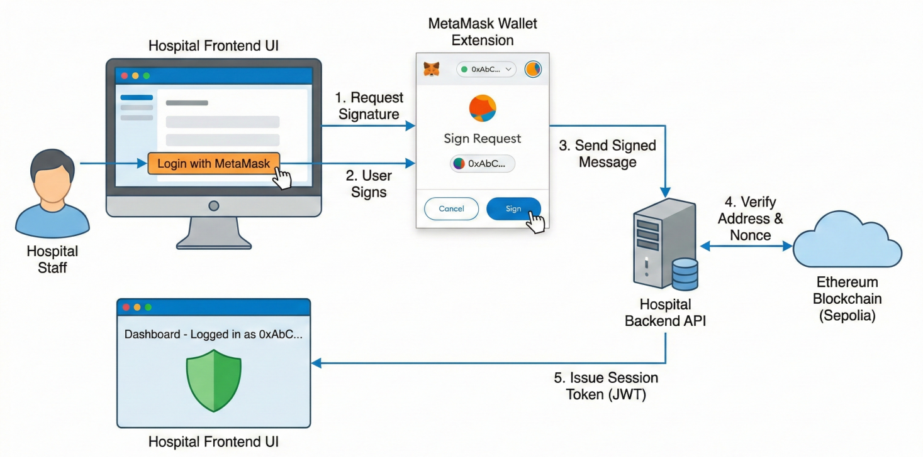
Figure 5.7 System Integration, User Interface and Final Testing.

6.8.1 Configuration Management
The migration to the live Sepolia contract address (`0x1BE44...`) required comprehensive updates to environment configuration files across both the hospital and admin backends. Legacy placeholder addresses (e.g., `0x1234...`) in `.env.production` files were replaced with the verified live address, ensuring that all nodes would connect to the correct on-chain orchestrator. Redundant environment variables referencing deprecated imaging modalities — such as `XRAY_MODEL_PATH` and `ULTRA_MODEL_PATH` — were consolidated into a single unified `MODEL_PATH` variable, simplifying the onboarding process for new institutions joining the network.

6.8.2 Documentation and Record Keeping.
The technical documentation was updated to reflect the finalized system configuration. The parameter count in `ENHANCED_CONTRACT_GUIDE.md` was corrected to 5.9M, and the task management files were marked as complete to signal the conclusion of the primary development cycle. While several low-priority documentation items remain — such as updating outdated API descriptions in the `README` — the system is now fully integrated and capable of executing the complete federated learning workflow: local training, IPFS upload, blockchain submission, and global aggregation.
Phase | Core Objective | Primary Outcome
Phase 1 | Environment Setup | Technology stack initialization
Phase 2 | Contract Deployment | Genesis model CID generation
Phase 3 | ABI Alignment | 31 mismatch points resolved
Phase 4 | Institutional Security | Migration to AES-256-CBC with unique IV
Phase 5 | Admin Governance | Weighted FedAvg implementation
Phase 6 | Model Verification | 5.9M parameters and CA module confirmed
Phase 7 | System Integration | Final synchronization of production environments

Table 5.3: Implementation Stages with Technical Milestones.
6.9 Performance Assessment and Comparative Analysis.
The end product of these implementation stages was a system that scores high on classification accuracy and the privacy is guaranteed. On the held-out test set the model had a sensitivity of 99.45 and an accuracy of 98.95. Such attainments are remarkable considering that they were attained with a federated paradigm, which has poor performance in centralized learning because of data heterogeneity.
Coordinate Attention built into the EfficientNet-B0 backbone offers an advantage in order to capture structural variations in histopathological images. Although both VGG-16 and ResNet-50 can deliver good accuracies, they are not parameter efficient and cannot be applied to federated learning with bandwidth limitations. ‘FastHistopathologyModel’ has a 5.9M parameter footprint that can be easily communicated through the IPFS, and a 46-character CID only on the Ethereum blockchain.
6.10 Medical AI Implications in Resources-Constrained Conditions.
The success of this prototype has some wider implications other than technical contributions. The framework establishes a pathway to trust whereby centralized governance has failed, by demonstrating that a decentralized orchestrator can control the training of models with divergent participants. Regulators can use Ethereum ledger to verify model updates without access to patient data to meet PDPO 2025 accountability requirements.
The application demonstrates that AI modules, such as Coordinate Attention, can be deployed in the decentralized system effectively. This is significant in the development of medical AI in such countries as Bangladesh, where medical infrastructure is different between the urban hospitals operated by private agencies and the rural clinics managed by the public. The non-IID data is also handled via weighted aggregation within the system, which means that smaller institutions can play a role and obtain the benefits of a global model.

6.11 Limitations and Future Directions.
Although the prototype is a solution to fundamental concerns of privacy, security, and institutional interoperability, there are limitations. The system has not been tested with actual clinical data of healthcare facilities but with a testnet of simulated hospital nodes. The existing deployment does not use sophisticated privacy-safe algorithms such as different privacy or safe multi-party computation, which might decrease the risk of inference attacks.
It will be possible to consider the addition of Zero-Knowledge Proofs (ZKP) in the future to verify the integrity of local training without revealing encrypted gradients. Incentive schemes On-chain mechanism: Incentives may be given to institutions that submit quality training data or computational resources. High-frequency updates to the system are an open question which should be load-tested on a larger testnet or on a privative Ethereum sidechain.
6.12 Summary
The federated learning system coordinated by blockchain has shown the possibility of privacy-preserving collaborative medical AI in cases where the centralized methods are not possible. Technical accomplishments such as cryptographically secure encryption standards, the elimination of 31 ABI mismatches, and validation of a 5.9M parameter Coordinate Attention model can serve as a blueprint of clinical AI deployments in a constrained resource setting.
The system architecture is based on a blockchain auditability and federated learning privacy and content-addressed storage efficiency, which form a compliant infrastructure of collaborative medical intelligence. Although it still requires clinical validation, the prototype provides a structure in which privacy enhancing systems, incentive systems and multi-mode extensions can be developed.
7. Limitations and Future Work
7.1 Overview
The development of the blockchain-orchestrated federated learning framework to privacy-preserving collaborative medical AI is not facilitated by technical, infrastructural, and methodological constraints. This chapter evaluates these shortcomings and presents a research agenda consisting of the coverage of modalities, the realism of deployment, and the strength of privacy and the heterogeneity of data.
7.2 Existing Restrictions
7.2.1 Optimization by Modality
Diagnosis of clinical breast cancer incorporates evidence using various imaging systems, such as MRI to identify the stage of cancer, ultrasound to characterize the mass, and mammography to identify the presence of the mass. The architecture is optimized to histopathology imaging which gives a resolution of the cellular level to conclusively detect breast cancer and has a high classification.
The establishment of a framework of federated learning of heterogeneous multi-modal data with privacy assurance is still a research problem. The system is incapable of cross-modal fusion in order to combine the information on the complementary sources. It would require a detailed diagnostic tool to align information on high-spatial-frequency histopathology with lower-resolution radiological imaging setting.

7.2.2 Network and Environmental Realism.
The validation experiments were run in the Ethereum Sepolia testnet that has simulated nodes in Boston, London, and Tokyo. Although this deployment model took aggregation logic and coordination to the limit, it is not a realistic representation of clinical deployment in resource-constrained settings such as Bangladesh.
The variable network reliability in healthcare institutions can influence the federated learning performance, where the updated models are essential. Slow upload of weight files or blockchain validation would delay convergence of the models around the world. There would be Ether transactions needed to conduct production deployment, which would be operational costs in the presence of Layer 2 scaling solutions. The testnet setting is different with the computational costs of Ethereum mainnet.
7.2.3 More Complex Privacy Risks
The framework employs blockchain immutability and AES-256-CBC encryption to ensure that the weights of the model are not accessed and modified by unauthorized persons. Nevertheless, such actions do not provide a full protection of complex privacy attacks on the aggregated model.
Adversarial attacks need access in multiple rounds of training, and substantial computation, but are a hypothetical threat to medical use. It has been demonstrated that gradient inversion attacks can be used to reconstruct training samples using gradient updates, and that membership inference attacks can infer whether particular data were used in training.
Although less private than centralized systems, the structure fails to provide zero-leakage of sensitive clinical data since it does not provide Differential Privacy to apply calibrated noise to information leakage, or Homomorphic Encryption to encrypted computation since it cannot tolerate computational overhead.
7.2.4 Non-IID Issues and Heterogeneity of Data.
In histopathology, systematic inter-hospital differences in staining, tissue preparation, scanner calibration, and demographics generate non-IID data which harms federated learning. This is partially solved with the Weighted Federated Averaging framework, depending on dataset size and quality but is unable to solve entirely when models trained on heterogeneous data drift apart in model representation.
Class imbalance also adds to this when institutions are disproportionate with benign to malign cases leading to local models in favor of the majority classes. Although data augmentation is useful, it is not able to remove the root cause of heterogeneous distributions in federated environments.
7.3 Future Research Opportunities.
The limitations offer an avenue into the future study by offering four strategic pillars to enhance the clinical applicability, scalability, and robustness of the framework.
7.3.1 Hybrid-Privacy Architectures.
Newer iterations must include cryptography functionality that has provable privacy and in particular Zero-Knowledge Proofs (ZKP) and Secure Multi-Party Computation (SMPC). ZKP would enable the functionality of quality control on the orchestration layer that would keep confidentiality, with hospitals permitting to prove that their model changes satisfy satisfactory conditions, but without revealing training data or model weights.
A combination of blockchain coordination and SMPC protocols would produce a zero-leakage federated learning setting, where aggregators have no knowledge about sensitive data. SMPC shares the computations of aggregation among various parties, and does not have access to the raw model weights of others.
Computational costs However, with the development of threshold cryptography and zkSNARKs, ZKP and SMPC are becoming practical in real-world applications.
7.3.2 Decentralized Incentive Engineering.
Federated learning continues to be challenged by encouraging long-term participation. Hospitals can be unwilling to share model updates unless they are motivated.
Institutions that keep the latency low, deliver quality data, or make substantial contributions toward the model improvements could be given tokenized rewards. Incentive mechanism On-chain incentives Residents of this kind should be studied through the prism of game-theoretic incentive models such as Shapley value calculation to share rewards according to contributions.
The orchestration layer should validate the use of rewards based on measurable positive changes in the performance of global models. The mechanism design has to trade off gaming resistance and incentive alignment.
7.3.3 Hyperparameter Hyper autonomous Control.
The existing framework applies fixed model architecture and manually tuned hyperparameters, which restricts the best generalization of different hardware and data in real-life federated applications. The next round of research must examine the application of Neural Architecture Search (NAS) and metaheuristic optimization to federated learning. NAS would then automatically fit model architectures to the constraints of each institution, whereas distributed distributed optimization metaheuristic algorithms would optimize hyperparameters by sharing common performance metrics. This would turn the framework into an adaptive system, but with more computational complexity and load.
7.3.4 Multiple Modes and Multiple Task Learning
Limitations to the clinical usefulness of the framework include histopathology specialization. The multi-modal data integration should be expanded by architectural adjustments to include feature extractors that are modality-specific and information fusion between modalities. The limits to privacy depend on the modality, whereby radiological images have a reduced risk of re-identification when compared to sensitive histopathology images.
The model may be used to promote multi-task learning to forecast a variety of clinical outcomes such as tumor grade, hormone receptor status, and prognosis. The multi-task learning improves generalization using similar representations as well as enabling institutions to engage in tasks where they possess ample data and enjoy the advantages of having weak local data.
Integrating genetic biomarkers such as BRCA1/BRCA2 mutations with radiographic information has potential to provide oncological personalization. The federated learning models would be able to synthesize both the genomic and the imaging data across institutions to establish prognostic model based on both genotypic and phenotypic factors.

7.4 Broad Implications of Federated Medical AI.
The discussed limitations are more general problems of applying federated learning systems in the healthcare sector, especially in a setting with heterogeneous infrastructure, privacy policies, and different incentives of the stakeholders.
Federated medical AI application in clinical care needs governance systems that balance innovation and patient safety and economic frameworks that guarantee a sustainable decentralized data-sharing system. This involves the cooperation between machine learning researchers, cryptographers, blockchain engineers, healthcare providers, and policymakers.
The future is worthwhile, yet the possible value of a globally managed medical intelligence network that uphold privacy and uses the knowledge of the collective healthcare is worth additional investment.
7.5 Synopsis of Chapter
They were found to be limited in four primary ways, including validation in simplified networks, specialization to the single imaging modality, no proper management of data heterogeneity, and inadequate protection against privacy attacks. Every limitation gives a research opportunity.
Although computationally difficult, recent advances in cryptography, distributed systems and deep learning imply that a zero-leakage, multi-modular, self-optimizing federated learning system is possible. A roadmap to strong, scaled federated medical AI systems is characterized by research directions in hybrid privacy architectures, decentralised incentives, autonomous hyperparameter tuning and multi-modal learning.

8. Conclusion
8.1 Introduction
This thesis addresses the conflict between the data needs for high-precision medical AI and the strict privacy requirements of regulations like Bangladesh's PDPO 2025. The research shows the diagnostic performance can compete with centralized models while maintaining the institutional data sovereignty by using Federated Learning (FL), Blockchain, and Explainable AI (XAI).
8.2 Summary of Contributions
8.2.1 Privacy and performance: the synergy
The framework achieved 98.95% and 99.45% accuracy and sensitivity on the images of histopathology, respectively. This demonstrates that privacy-preserving methods don't necessarily make things worse in terms of performance. Weighted averaging, coordinate attention, and robust augmentation are the important design features that makes sure to accurately diagnose without putting sensitive data in one place.
8.2.2 Blockchain as means of establishing trust
Instead of being a place to store data, the Ethereum blockchain is used as an unchangeable orchestration layer by the system. It provides an audit trail capable of being verified by recording the Content Identifiers (CIDs) of model updates. This architecture eliminates the "trust vacuum" that exists between institutions. This ensures that the rules are obeyed and prevents any central manipulation of the global model.

8.2.3 Clinical Interpretability (X.A.I.)
The model uses a combination of Grad-CAM and Coordinate Attention that will help clinicians have more faith in this model. This allows the AI to highlight some of the pathological aspects (such as nuclei that are not normal) that influence its decisions. This "second opinion" approach ensures that the AI augments, rather than supplants, what humans know.
8.3 How it relates to places that have few resources
This framework allows smaller clinics to contribute and take advantage of the global intelligence for places such as Bangladesh, where infrastructure is broken up. The weighted aggregation ensures that less data-rich institutions can still have a fair and meaningful impact on the model, and advanced diagnostics can be made available to all.
8.4 The Future of AI in Medicine
The study calls for a shift away from "black-box" centralized clusters and towards open and collaborative intelligence. This work lays a principled baseline for ethical, high-performance AI (though there is still work to be done in the realm of cryptography (Zero-Knowledge Proofs) and block chain scalability before it can be widely used).
8.5 Last Thoughts
The combination of FL, Blockchain, and XAI makes separate "data islands" a safe diagnostic network. This thesis lays out the technical basis as well as the philosophical basis for a reliable and ethical healthcare AI ecosystem by proving that it is possible to have high accuracy and strict privacy at the same time.

