Contents

1.0 System Overview 1

2.0 SYSTEM SUMMARY 2

2.1 System Configuration 2

2.2 User Access Levels 2

3.0 GETTING STARTED 3

3.1 Installation 3

4.0 Administrative User Module 4

4.1 Login 4

4.2 Contest Management 4

4.2.1 Set Contest 4

4.2.2 Set Problem 4

4.2.3 Remove Problem 5

4.2.4 Modify Contest 5

4.2.5 Delete Contest 6

4.3 User Profile 7

5.0 Normal User Module 8

5.1 Registration 8

5.2 Login 8

5.3 Account Recovery 9

5.4 User Profile 10

5.5 Contest 11

Figures

Figure 1: Set Contest 4

Figure 2: Set Problem 5

Figure 3: Edit Contest 6

Figure 4: Delete Contest 6

Figure 5: Sign Up 8

Figure 6: Login 9

Figure 7: Account Recovery 9

Figure 8: Password Change 10

Figure 9: Modify Profile 11

Figure 10: User Image Change 11

Figure 11: Contest 12

Figure 12: Particular Contest Access 12

Figure 13: Problem Description 13

Figure 14: Submission Standings 14

Figure 15: Rank 14

Figure 16: Upcoming Contest 15

Figure 17: All Submissions 15

Figure 18: Personal Submissions 16

SUPERVISED BY

MOHAMMAD SHOYAIB

PROFESSOR

INSTITUTE OF INFORMATION TECHNOLOGY

UNIVERSITY OF DHAKA

----------------------------------------------------

SIGNATURE

PROJECT MEMBERS

MD. SHAYAKH SHIHAB UDDIN

BSSE 813

---------------------------------------------------

MD. HASAN TAREK

BSSE 818

----------------------------------------------------

# 1.0 System Overview

A Programming platform is a platform where a user can see some programming problems and solve them by writing code, and submit that code in that system for judgment. In this project, only authenticated user can enter to the system. Only administrator can set, remove or modify contest and problems. Normal user (problem solver) can participate in contest and solve those problems. The programming language of the submitted code must be in C and C++. Then the system will compile and execute the submitted code and give a verdict to the user. Here the verdict will be one of these (compilation error, right answer, wrong answer, time limit exceed). A user can also modify his/her profile.

# 2.0 SYSTEM SUMMARY

System Summary section provides a general overview of the system. The summary outlines the uses of the system’s hardware and software requirements, system’s configuration, user access levels and system’s behavior in case of any contingencies.

## 2.1 System Configuration

Programming Platform is a web based application which can be accessed through any web browser. The web application has been hosted on a linux based server using the XAMPP server. In this project, the project has been hosted on a Linux distribution called Ubuntu.

## 2.2 User Access Levels

Registered Users can use the web application.

# 3.0 GETTING STARTED

Getting Started section explains how to get Programming Platform and install it on the device. The section presents briefly system menu.

## 3.1 Installation

The newest installation version currently available can be downloaded from https://github.com/hasantarek2002/SPL2. This project should be installed on a Linux based web server. XAMPP (version 7.2.1) web server for Linux needs to be installed. Then the project should be placed in the htdocs folder inside the xampp folder.

* The/opt/lampp/htdocs/programmingPlaform/imageUpload
* /opt/lampp/htdocs/programmingPlaform/setContest/uploads
* /opt/lampp/htdocs/programmingPlaform/submitAndRunCode/CCode and
* /opt/lampp/htdocs/programmingPlaform/submitAndRunCode/CPPCode

Directory path access should be changed to all user accesses by writing the following command:

#chmod 777 directoryPath

The URL (Uniform Resource Locator) for accessing this project will be: “ipAddress/programmingPlatform”.

The system will have two types of user. They are: Administrative User and Normal User. They will be provided with two different interfaces with different functionalities. For Example, the administrative user will be able to set, modify and remove contest. But the normal user won’t have the facility of this. They will only be permitted to participate in contests and solve problems.

# 4.0 Administrative User Module

## 4.1 Login

For Administrative user to login to the system, the default username is” admin” and the default password is”1234”. By using this username and password the administrative user will be logged in to the system.

## 4.2 Contest Management

### 4.2.1 Set Contest

For setting contest, the admin user needs to go to the set contest. Then the admin will have to set the contest name, starting time and the duration of the contest.

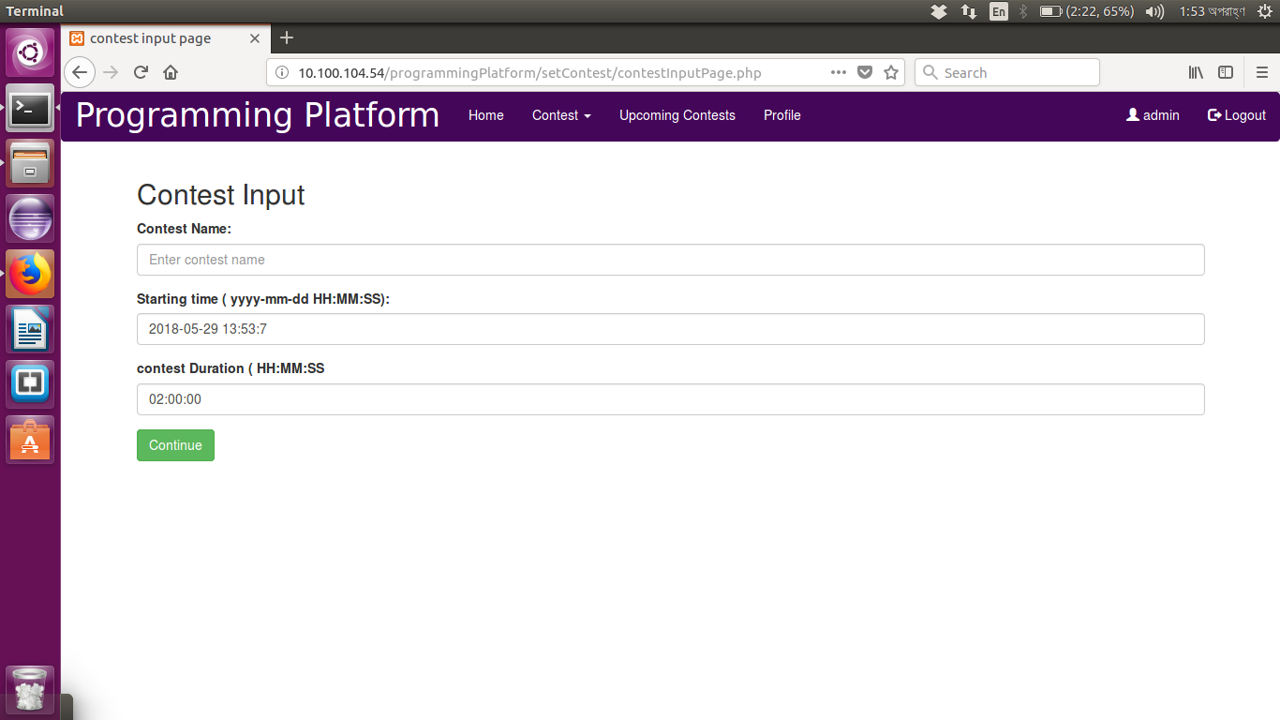

Figure : Set Contest

### 4.2.2 Set Problem

Then the admin will have to add problems to the contest. For adding problems to the contest the admin needs to set the problem name, time limit and also needs to upload the question file, input file and output file.

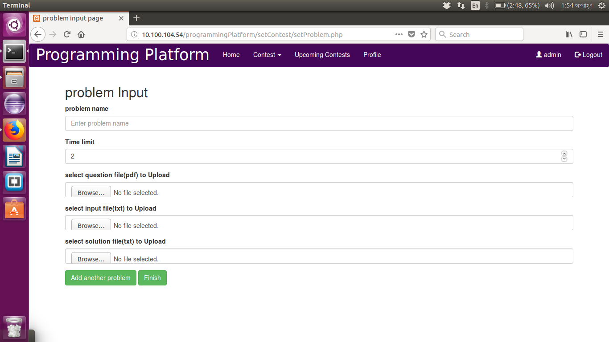

Figure : Set Problem

Then if the admin wants to add another problem then the admin needs to click the “Add another problem” button. If all the problems that need to be uploaded has been set then the admin needs to click the “Finish” button.

### 4.2.3 Remove Problem

For removing problems, the admin just needs to click the “Remove” button associated with the problem.

### 4.2.4 Modify Contest

For contest Modification, the admin needs to click the button “Edit”. Then the admin can modify the contest data.

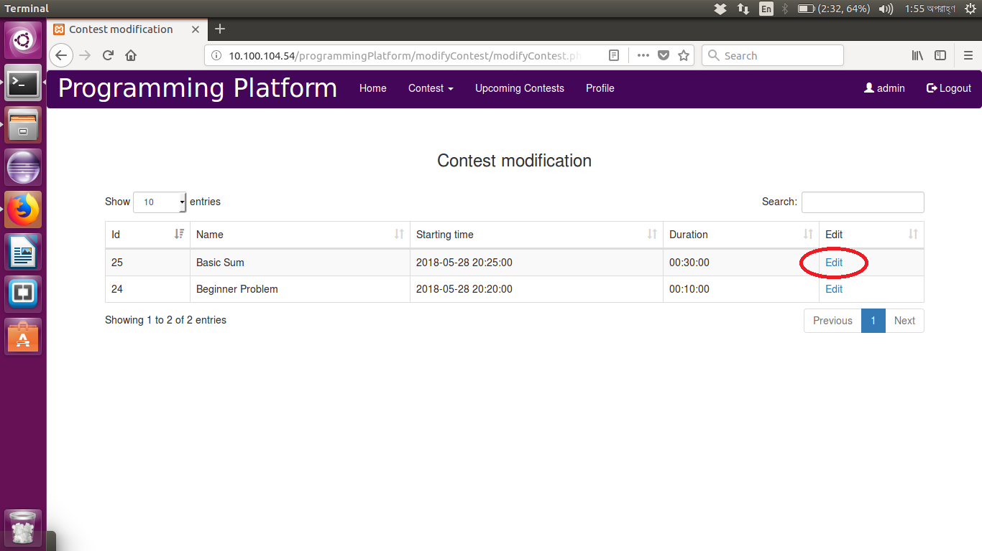

Figure : Edit Contest

### 4.2.5 Delete Contest

For deleting the contest, the admin needs to press the “Delete” button associated with the particular contest.

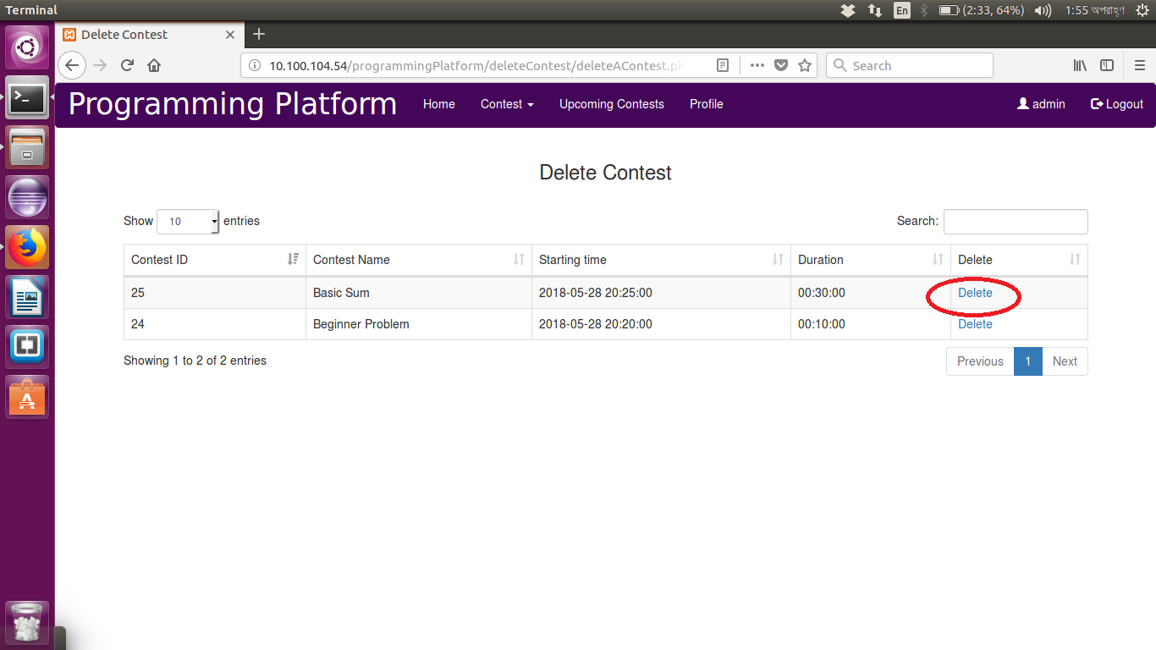

Figure : Delete Contest

## 4.3 User Profile

Admin user profile is same as the normal user profile which will be described in the following part of the document.

# 5.0 Normal User Module

## 5.1 Registration

A user needs to register to the system before s/he can start using the system. For registration the user needs to fill the form represented below:

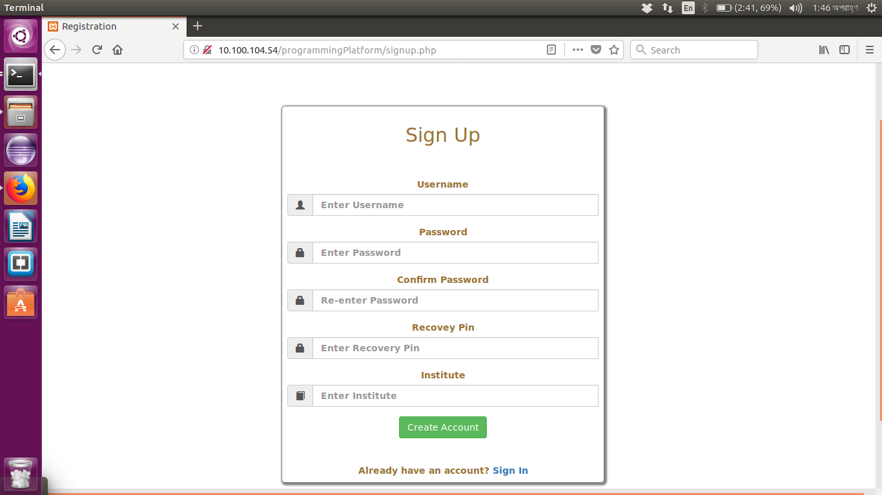

Figure : Sign Up

## 5.2 Login

The system can be accessed only if the user is logged in. For login the user needs to provide her/his username and password. Then s/he needs to click the sign in button. If the data match with the provided the data then the user will be logged into the system.

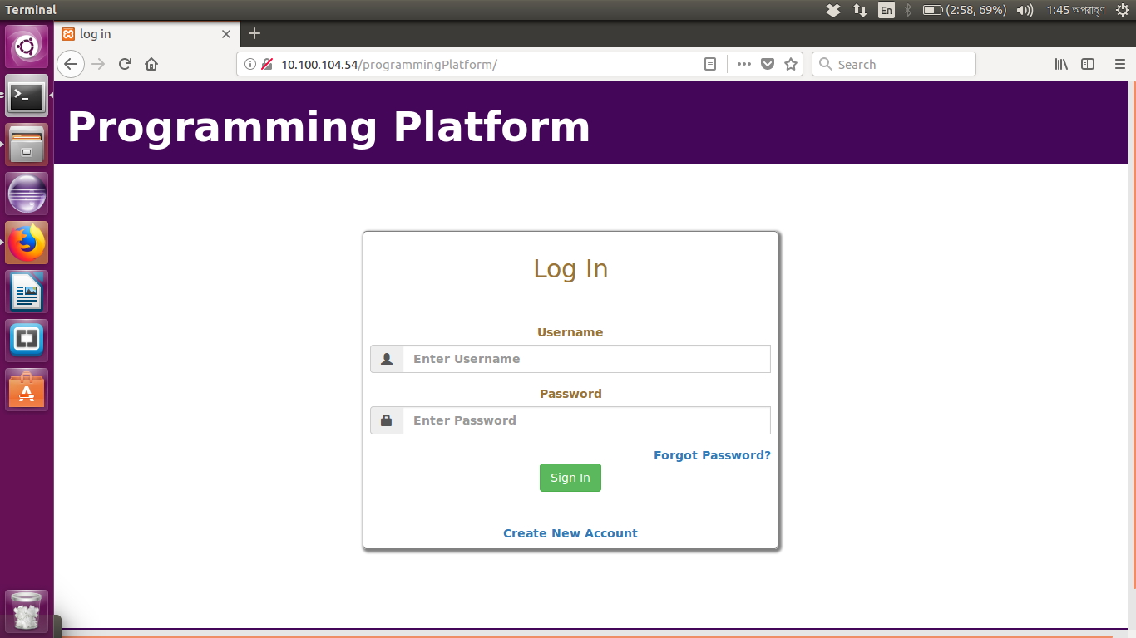

Figure : Login

## 5.3 Account Recovery

If the user forgets her/his password s/he can recover the account by the recovery pin. Then the user can change her/his password. Thus the user account can be recovered.

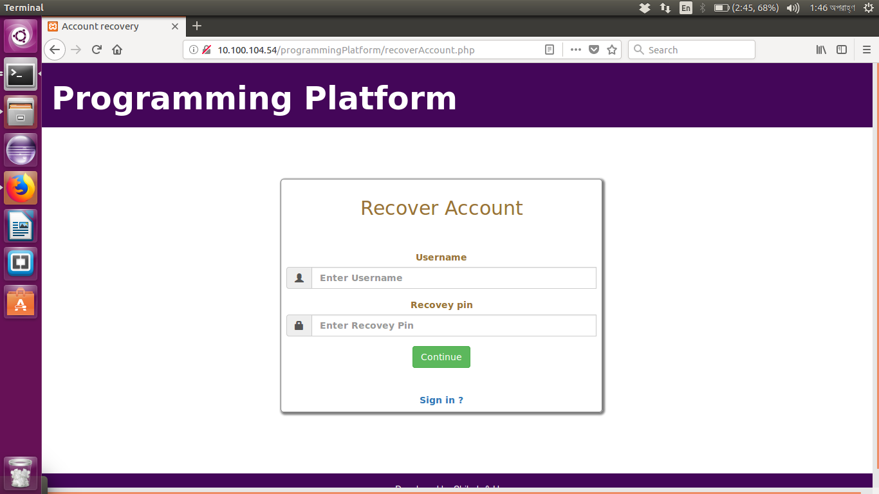

Figure : Account Recovery

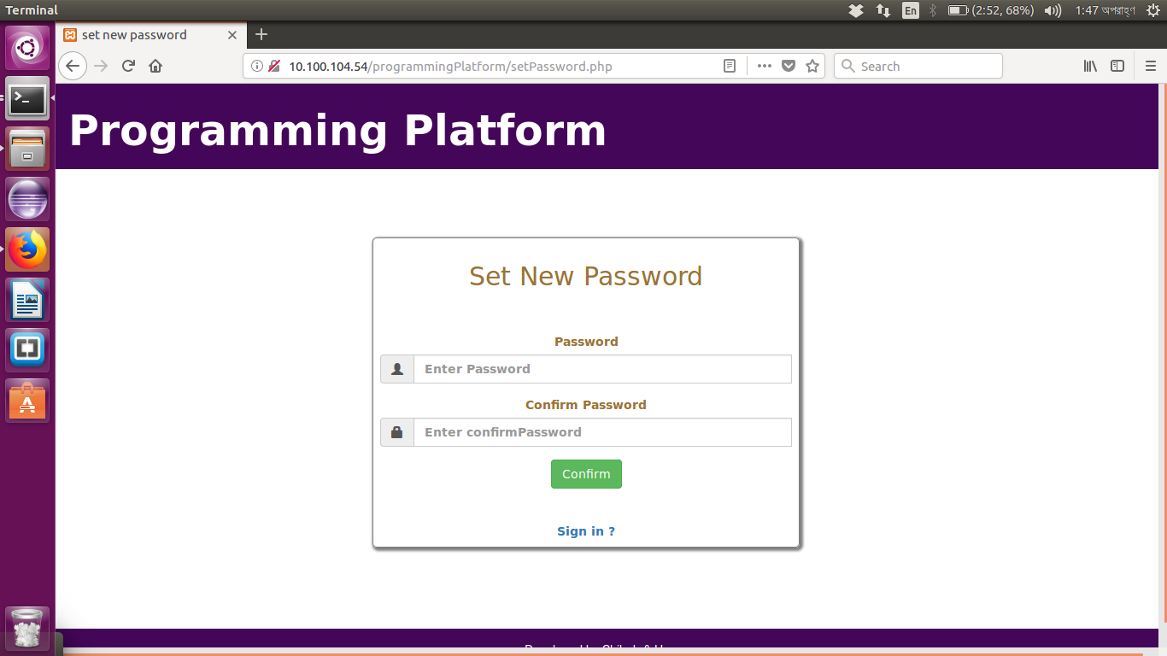

Figure : Password Change

## 5.4 User Profile

The user can see her/his user information by just clicking the username of the user located in the navigation bar.

The user can modify her/his profile by clicking the “Modify Profile” button.

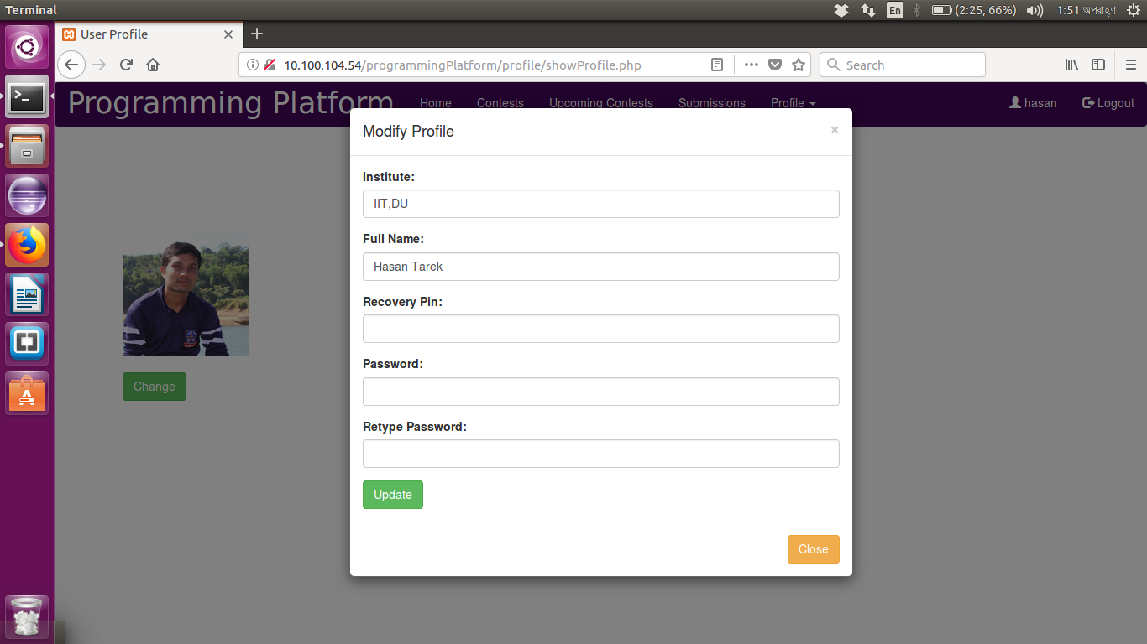

Figure : Modify Profile

The user can change her/his user profile picture by clicking the “Change” button.

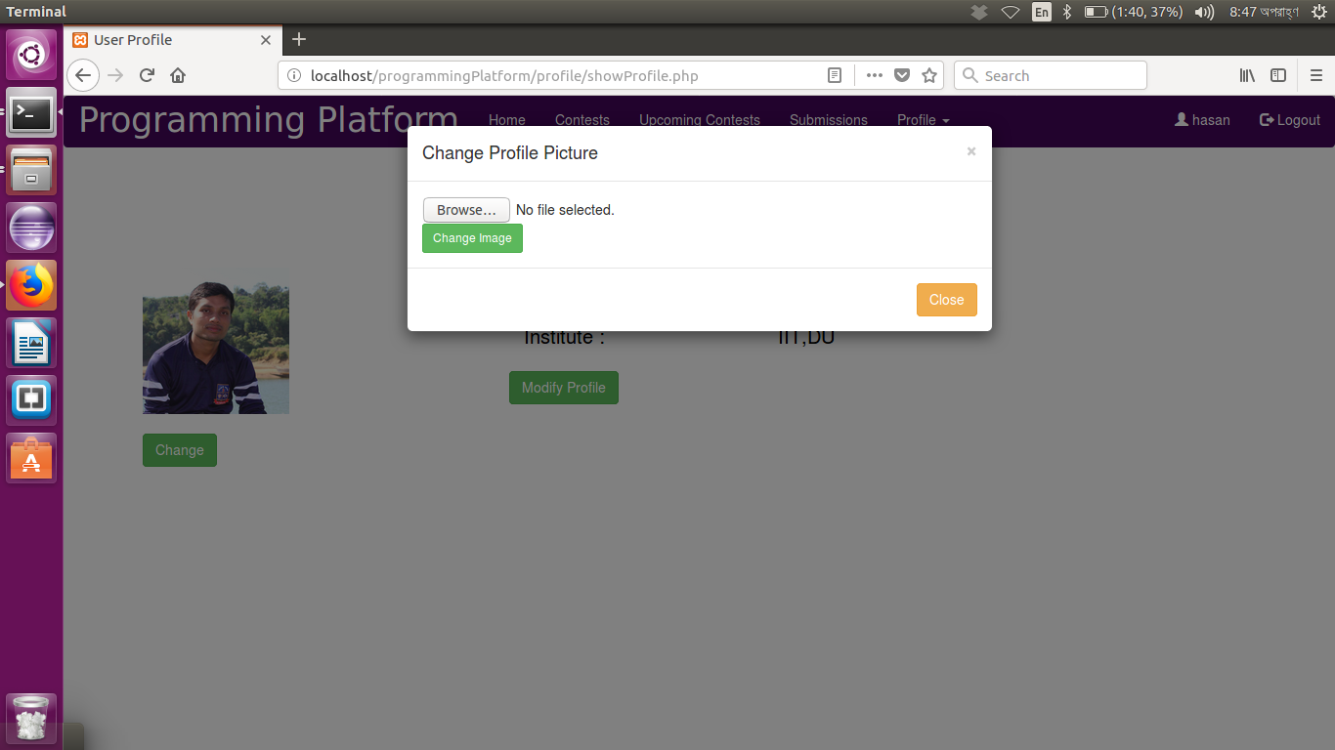

Figure : User Image Change

## 5.5 Contest

The user can see the contest list by just clicking the “Contest” button.

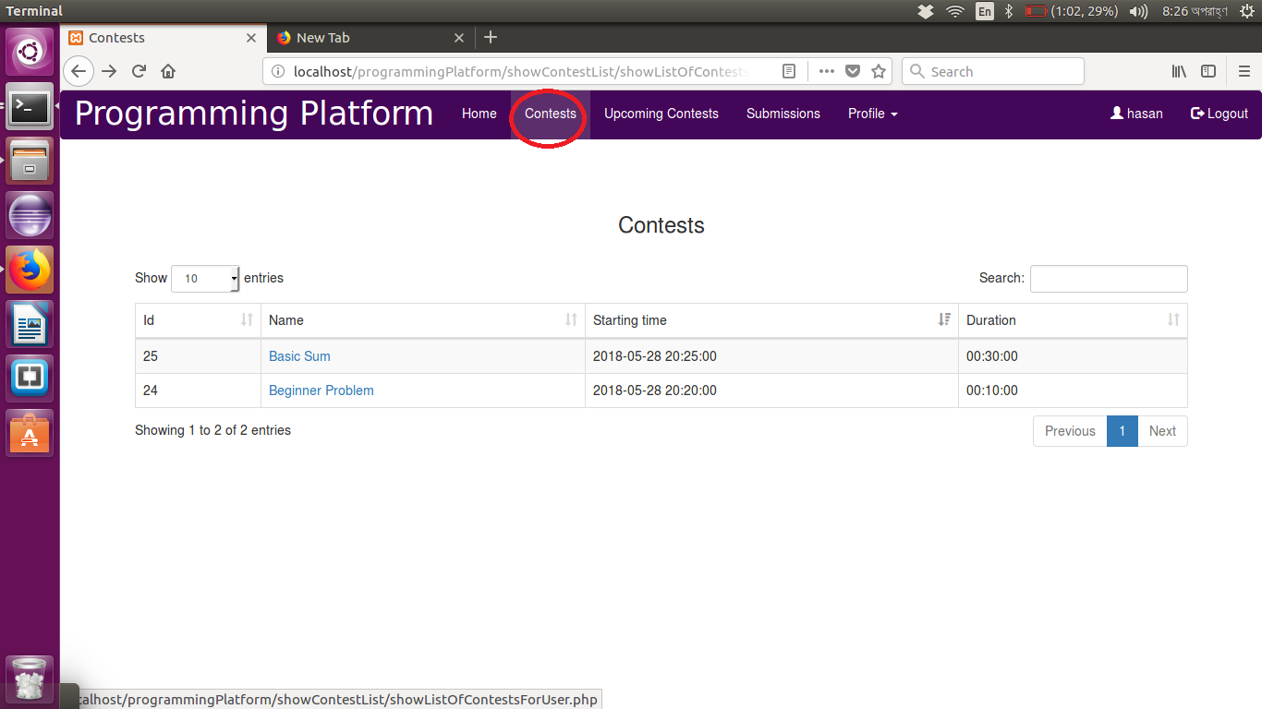

Figure : Contest

Then by selecting the contest, the user can see the problems of the contest. That is the problem list of the contest will be shown.

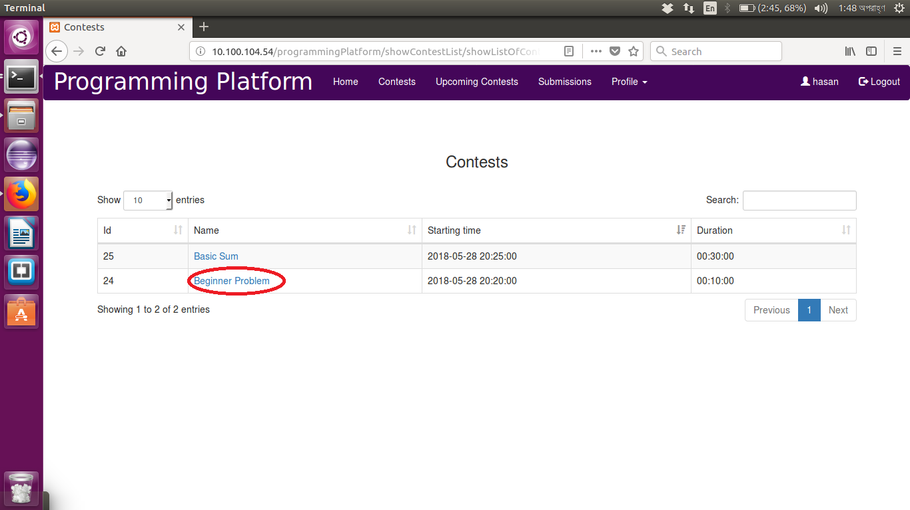

Figure : Particular Contest Access

Then the user will select the problem s/he wants to solve. S/he will be able to see the pdf version of the problem description. Then in that page s/he can submit the solution code of the problem. For submitting the code the user needs to press the “Submit” button.

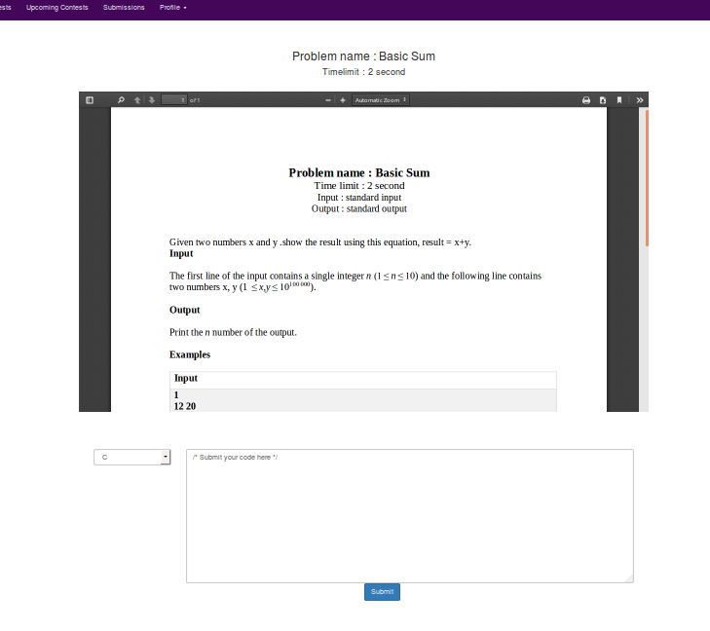

Figure : Problem Description

Then the standing page of the problems submission will be showed.

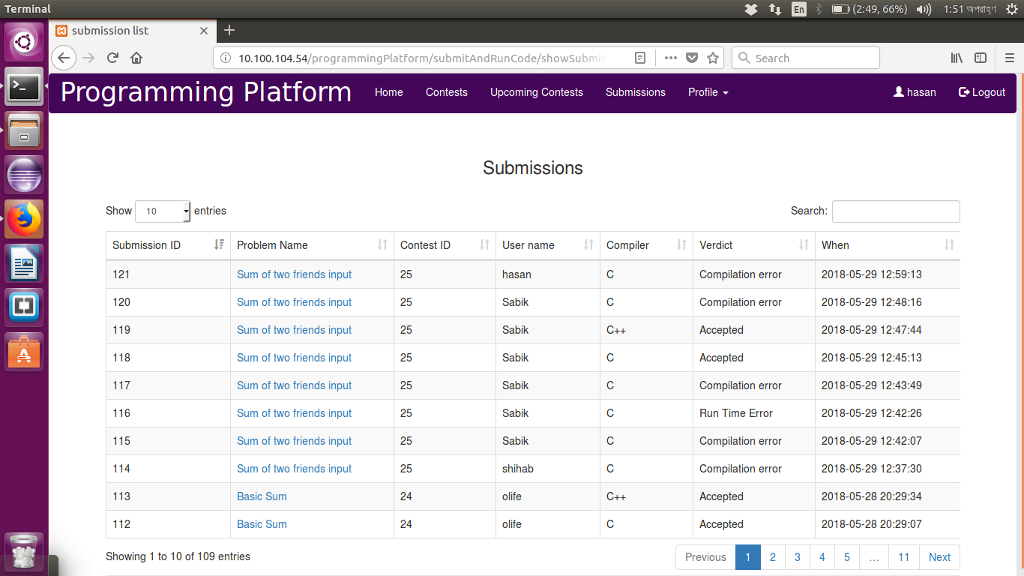

Figure : Submission Standings

Every contest has a rank list. For every contest there will be a “Rank” button in the navigation bar. By clicking that button rank of a contest will be shown.

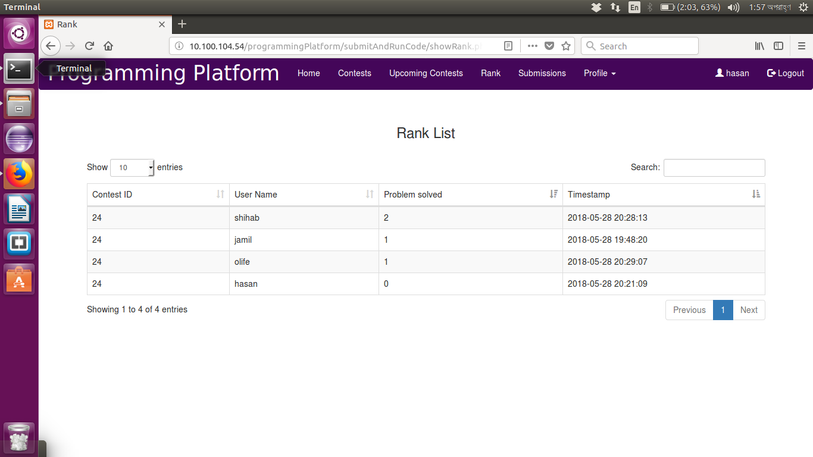

Figure : Rank

The user can see the upcoming contests by clicking the “Upcoming Contest” button in the navigation bar.

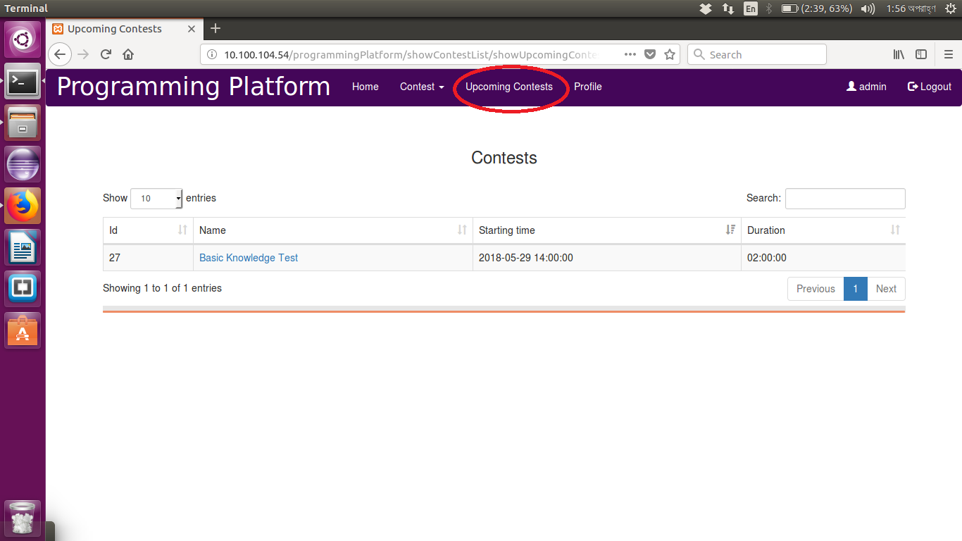

Figure : Upcoming Contest

By clicking the “Submission” button the user can see the submissions of all users.



Figure : All Submissions

The user can see her/his submission by clicking the “My Submission” button under the Profile dropdown.

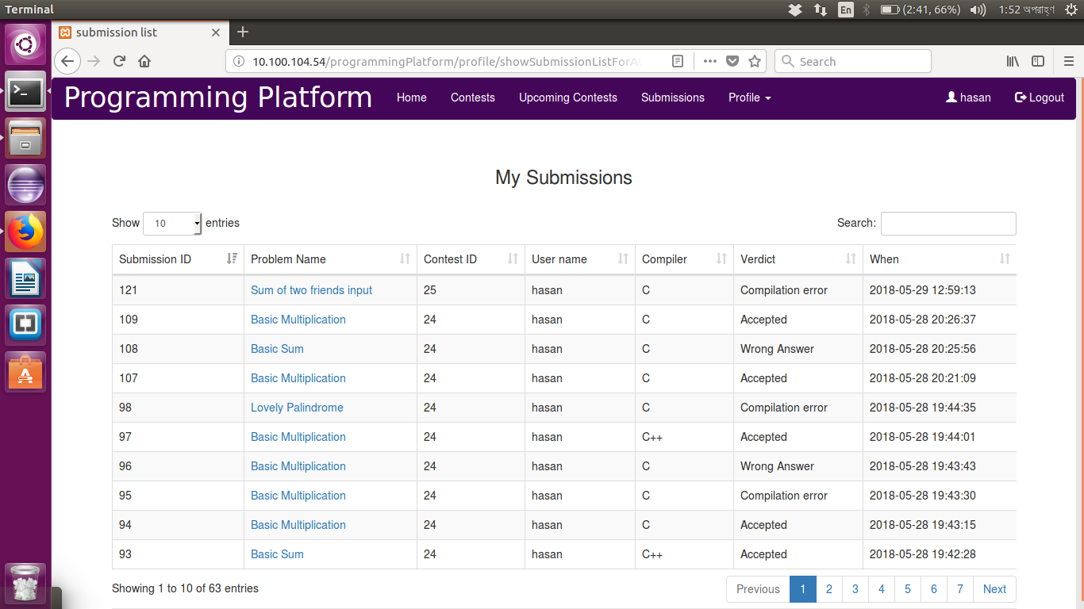

Figure : Personal Submissions