

EC6020
EC6020
Embedded Systems Design Project Proposal

Rescue Boat Protection and Emergency Coordination System Using Embedded Mesh Networking

Faculty of Engineering
University of Jaffna

GROUP MEMBERS :
KARUNANAYAKA H.K.V.S - 2022/E/043 JAYARATHNA H.M.M.N - 2022/E/051 HERATH H.M.N.P - 2022/E/052 GUNAWARDHANA K.H.M.I - 2022/E/072 THENNAKOON T.M.H.R - 2022/E/156

Problem and Solution

Problem:

Sri Lanka has recently faced severe natural disasters such as cyclones, floods, and heavy storms. During such disasters, rescue boats play a critical role in saving stranded civilians and transporting emergency supplies. However, rescue operations are often conducted under dangerous and unpredictable conditions, including rough sea states, poor visibility, and loss of communication.

One of the major challenges faced during rescue missions is the lack of real-time safety monitoring and coordination among rescue boats. Rescue boats may become damaged, overloaded, or even sink due to harsh environmental conditions. Additionally, communication failures can prevent timely assistance when a rescue boat itself encounters danger.

These issues can lead to delays in rescue operations, increased risk to rescue personnel, and potential loss of life.

Solution:
To address these challenges, this project proposes a Rescue Boat Protection and Emergency Coordination System based on embedded systems and mesh networking. Each rescue boat is equipped with a standalone embedded safety node capable of detecting emergency conditions and transmitting alerts to nearby rescue boats.

The system uses long-range wireless communication to form a decentralized mesh network among rescue boats. If a rescue boat experiences danger—such as capsizing, collision, or manual SOS activation—an emergency alert containing the boat’s location and status is automatically broadcast to nearby boats. This ensures rapid response, improved coordination, and enhanced safety for rescue teams, even when conventional communication infrastructure is unavailable.

Introduction about project :

The proposed system is an embedded safety and coordination platform designed specifically for rescue boats operating in disaster-affected regions. Each rescue boat is equipped with a standalone microcontroller-based unit integrated with sensors, a wireless communication module, and a power management system.
The system continuously monitors the status of rescue boats and allows rescue personnel to manually trigger emergency alerts using an SOS button. In critical situations such as boat capsizing or system failure, alerts are automatically generated and transmitted. Emergency messages are propagated through a mesh network, ensuring that nearby rescue boats receive timely information even if the affected boat is far from shore or out of mobile network coverage.
Uniqueness of the Project
- Focuses specifically on rescue boat safety, not civilian monitoring
- Automatic capsize detection combined with manual SOS triggering
- Infrastructure-independent mesh networking
- Real-time location-based alerts to nearby rescue units

High-Level Architecture

The system consists of multiple rescue boat nodes forming a distributed mesh network.
System Components
Input System:
- SOS push button
- Capsize / motion sensors
Processing Unit:
- Standalone microcontroller handling sensing, decision-making, and routing
Communication System:
- Long-range wireless module enabling boat-to-boat communication
Output System:
- Buzzer and LED indicators
- Mobile application alerts
Power System:
- Battery-powered operation with charging and voltage regulation

Technological Choices:

Hardware Components

Standalone microcontroller (e.g., ATmega328P)

Long-range wireless module (LoRa)

GPS module for location tracking

Motion / tilt sensor for capsize detection

Battery, charging, and regulation circuitry

LEDs and buzzer for alerts

Software Technologies

Embedded C/C++ for firmware development

Mobile application for alert visualization

SPI, UART, and I2C communication protocols

Communication Protocols

SPI: Communication between microcontroller and LoRa module

UART: GPS data reception and mobile interface communication

I2C: Sensor interfacing (motion / tilt detection)

Why This Technology?

The chosen microcontroller-based architecture offers low power consumption, reliability, and flexibility, which are essential for marine rescue applications. Long-range wireless communication enables real-time coordination between rescue boats without relying on GSM or internet connectivity. Mesh networking improves system robustness by allowing alerts to be forwarded dynamically, ensuring uninterrupted communication during rescue missions.



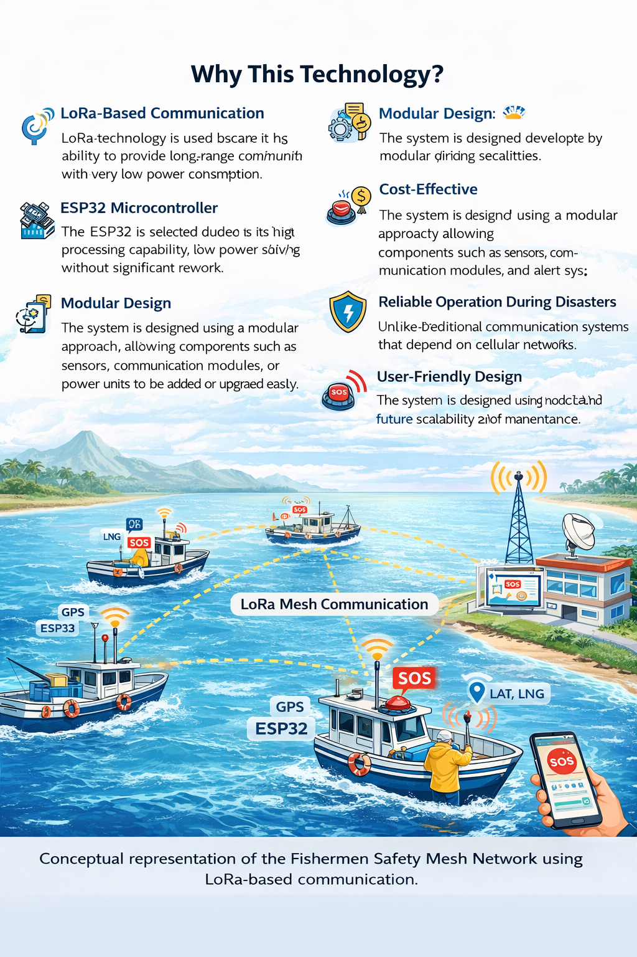

- GitHub Repository
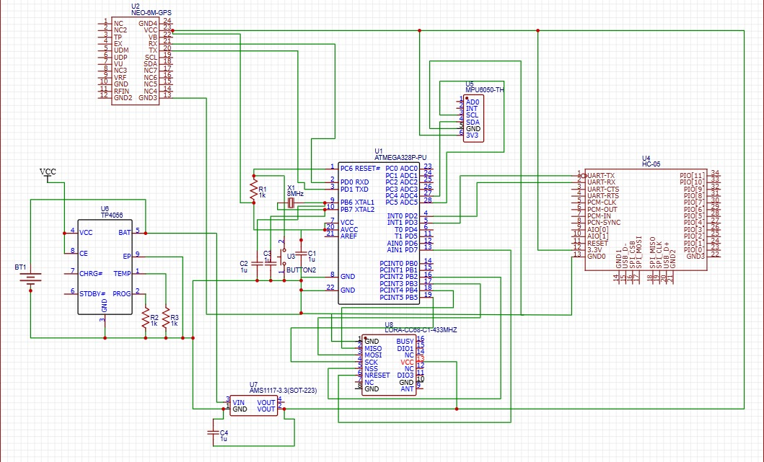
Circuit Design

This circuit represents a Rescue Boat Protection System powered by a 3.7 V Li-ion battery with safe charging through a TP4056 IC and regulated to 3.3 V using an AMS1117. A standalone ATmega328P microcontroller controls the system, receiving location data from a GPS module and motion data from an MPU6050 sensor for capsize detection, while an SOS button allows manual emergency triggering. When a danger is detected, the system transmits an alert containing the boat’s status and location via a LoRa module to nearby rescue boats using mesh networking, and simultaneously sends the alert to a mobile application through a Bluetooth module, enabling fast coordination and improved safety during rescue operations.

System Architecture
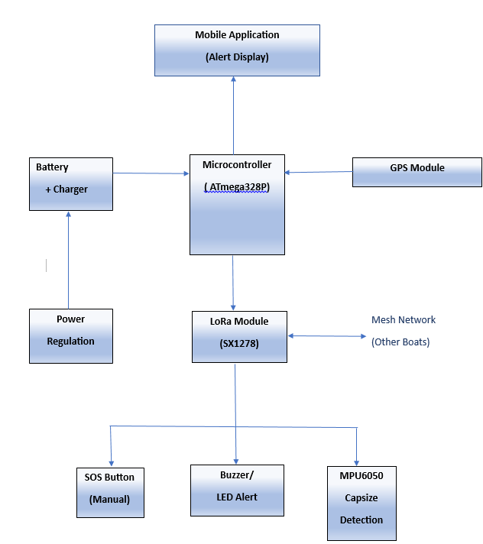

TIMELINE

BUDGET

No. | Component | Specification | Unit Price (LKR) | Total (LKR)
1 | Microcontroller | ATmega328P-PU (Standalone) | 750 | 750
2 | LoRa Module | SX1278 (433 MHz) | 1,500 | 1,500
3 | GPS Module | NEO-6M | 1,000 | 1,000
4 | Bluetooth Module | HC-05 | 700 | 700
5 | Accelerometer | MPU6050 | 680 | 680
6 | Li-ion Battery | 18650 (3.7 V) | 520 | 520
7 | Charging module(Type C) | TP4056 | 50 | 50
8 | Voltage Regulator | AMS1117-3.3 | 10 | 10
9 | SOS Push Button | Waterproof type | 300 | 300
10 | Buzzer | Active Buzzer | 170 | 170
11 | LED + Resistor | Status indicator | 80 | 80
12 | Antenna | 433 MHz external | 120 | 120
13 | Capacitors & Resistors | Assorted | 400 | 400
14 | PCB / Breadboard | Prototype board | 300 | 300
15 | Wiring & Connectors | Jumper wires | 250 | 250
16 | Enclosure | Waterproof (IP-rated) | 400 | 400
Total |  |  |  | 7,230

