CURRICULUM VITAE OF
MD. AMINUL ISLAM

MD. AMINUL ISLAM

Mailing Address:
Chotobongram Uttarpara, Post: Sopura  P.S: Chandrima , District: Rajshahi  Cell No: +880 01765718472  E-mail : aminul513788@gmail.com | 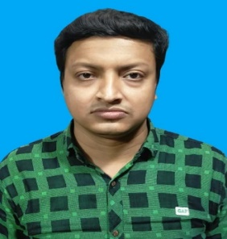

CAREER OBJECTIVES

Looking for challenging career, where there is scope for demonstration, always on a look out
for a positive & bigger outlook, Currency are ideas, Rigorous thinking and boundless curiosity,
Sets levels & standards that exceed expectations, Have fun attitude is everything, Bottom line
rises with the Organization, A Learner for Life.

ACADEMIC QUALIFICATION

Name of Exam | Group / Major | Name of the Institution | Year of Passing | GPA/CGPA/ Class | Board/ University
M.S.S | Political Science | National University | 2017 | 3.28 (Out of 4) | National University
B.S.S  (Honor’s) | Political Science | National University | 2016 | 3.40 (Out of 4) | National University
H.S.C. | Commerce | Govt. City College, Rajshahi | 2012 | 4.30 (Out of 5.00) | Rajshahi
S.S.C. | Commerce | Masjid Mission Academy ( School & College), Rajshahi | 2010 | GPA 4.56 (Out of 5.00) | Rajshahi

COMPUTER SKILLS

MS Office Application & Power point, Database work, Internet browsing, etc.
LANGUAGE PROFICIENCY

- Bengali: Native
- English: Competent

PERSONAL INFORMATION

Full Name | MD. AMINUL ISLAM |  | Date Of Birth | 14 February, 1999

Father’s Name | MD. SHAHADAT HOSSAIN |  | Sex | Male

Mother’s Name | ROMELA BEGUM |  | Home District | Naogaon

Present  Address | ChotobongramUttarpara,  Post : Sopura  P.S: Chandrima,  District: Rajshahi |  | Permanent Address | Village: Kandolma  Post: Jonardanbati (6403)  P.S: Atrai  District: Naogaon

Nationality | Bangladeshi (By Birth)

Religion | Islam | Blood Group | AB (+)

Height | 5’ 8”

PERSONAL SKILLS

- Efficient in effective communication and good public relations.
- I have strong analytical, problem solving and decision making ability
- Always I am interested to take a challenging work.
- I have positive attitude to my responsibility.
- Hard working in any environment
REFERENCE

SM AZAM ULLAH  INSTRUCTER (ELE), RAJSHAHI POLYTECNIC INSTITUTE, RAJSHAHI  Mob:01550004286 | MD. LUTFOR RAHMAN  ASST.PROFESSOR, RAJSHAHI COLLEGE RAJSHAHI Mob: 01720547890.

DECLARATION

Hereby I declare that all information furnished in the curriculum vitae are correct and complete.
Signature
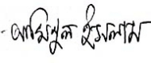
..................................................
(MD. AMINUL ISLAM)
Date :

