Resume
Of
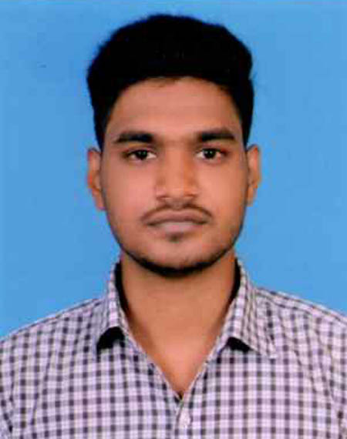
Photo
AHMED AL ZUBAYAR
Vill-Sagorpara Bollovgonj, Post-Ghoramara,
Post Code – 6100, P.S-Boalia, Dist-Rajshahi.
Mobile:01774634779
E-mail : monon360@gmail.com

CAREER OBJECTIVES:
I would like to work in an institution or organization where discipline & high tech environment will ensure development & will more skillful than other sector. I want to pursue a long term career, taking challenges & commitment to achieve result by working in a competent sector.

KEY QUALITIES:
Motivating people, leadership capacity, presentation ability, good in team work, energetic, strong analytical and responsibility taking attitude.

ACADEMIC ACHIEVEMENTS:

Title : Higher Secondary Certificate (HSC)
Institution : Adarsho Karigori & Banijjik College.
Board : Rajshahi
Group : Business Studies
Result : GPA-4.58(out of 5.00)
Year : 2021

Title : Secondary School Certificate (SSC)
Institution : Adarsho Karigori & Banijjik College.
Board : Rajshahi
Group : Computer & Information Technology
Result : GPA-4.86(out of 5.00)
Year : 2018
LANGUAGE PROFICIENCY:
Smooth in written and oral communication ability in both English and Bengali with good command and interpersonal skill.

COMPUTER SKILLS:
- Have a good access on Computer Software Management.
- E-mail and Internet Browsing.
- Computer Basic problems and their solution
PERSONAL DETAIL:
Father’s Name : MD. RASHED ALI MILON
Mother’s Name : MST. RUBAIYA BEGUM
Date of Birth : 11 Dec, 1999
Nationality : Bangladeshi by birth
Permanent Address : Vill-Sagorpara Bollovgonj, Post-Ghoramara,
Post Code – 6100, P.S-Boalia, Dist-Rajshahi.
Height : 5’6”
Weight : 68 Kg
Blood Group : A⁺ ve
Marital Status : Married
Religion : Islam
National Id No. : 4209553678

Hobbies :
 Journey, Reading, Internet Browsing, Meet New Person Etc.

Self-Assessment :

 So far I believe, I am an honest person and want to work in the company honestly due to the love and faith towards my religion.

Responsibility is the term to which I am devoted.

