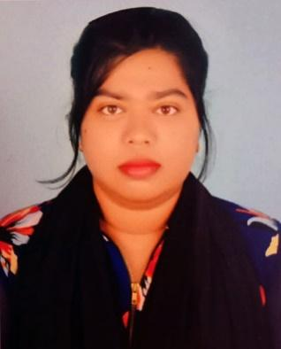
CURRICULUM VITAE
of
ROKEYA SIDDIKA TONU
Mailing Address : 69, Vill- Namo Rajarampur, Post –Rajrampur-6301, upazila – Chapainawabganj Sador, District – Chapainawabganj.
E-mail: tonujcms@gmail.com
Mobile: 01767-766611
NID NO: 3701132817.
Career

Objective
To reach career excellence through dedication, sincerity, creativity, hard work and also seek continuous self-improvement with the changing institutional, internal and external needs. Looking for a job related to my academic qualifications to enhance my skills and to make myself forward with serving the organization.
Academic Qualifications
- Masters of Social Science(EMSS)
Institute: University of Rajshahi
Session: 2019
Passing:2019
Subject: Mass Communication and journalism
Result: CGPA 3.26 out of 4.00
- Bachelor of Social Science (BSS)
Institute: Varendra University, Rajshahi
Session: Fall -2015
Passing Year: 2018
Subject: journalism Communication and media Studies
Result: CGPA 3.21 out of 4.00
- Higher Secondary School Certificate (HSC) Examination:
Institute:Shah Neamatullah College Nawabganj.
Board: Rajshahi.
Group: Humanities.
Passing Year: 2014
Result: GPA 4.30 out of 5.00
- Secondary School Certificate (SSC) Examination:
Institute: Namo Rajarampur High School.
Board: Rajshahi
Group: Humanities.
Passing Year: 2012
Result: GPA 3.56 out of 5.00
Computer Skills
- Operating Systems: Windows XP, Windows 7, Windows 8.
- Applications: Good knowledge in Microsoft Word, Microsoft Excel, Microsoft PowerPoint, Adobe Photoshop. Also excellent capabilities in Internet Browsing.
Language Skills
- Bengali: Excellent as mother language.
- English: Good Oral & written.
- Hindi: Good at talking.

My Strength
- Ability to meet any challenge with confidence, determination & sincerity.
- Enjoy working under different challenging and creative situations, management and ability to take leadership.
- Positive service mindset with helping attitude.
- Ability to learn quickly and implement efficiently.
- Honest, Confident, well disciplined and organized.
My Interests & Hobbies
- Photography
- Designing dress
- Cooking

Personal Information

Name:Rokeya Siddika Tonu
Fathers Name:Md. Abu Bakkar Siddik
Mothers Name:Mahamuda Siddika
Date of Birth:28th December,1996
Sex:Female
Marital Status:Unmarried
Nationality: Bangladeshi
Religion:Islam
Blood Group: A (+ve)
Permanent Address: Post –Rajrampur-6301 , upazila – Chapainawabganj Sadar
District – Chapainawabganj.

Present Address: Flat No:7B, building no: 61, Green Villa, Green Road, Dhanmondi, Dhaka – 1205.

Signature

……………………………………
Rokeya Siddika Tonu
Date:04/01/2020

