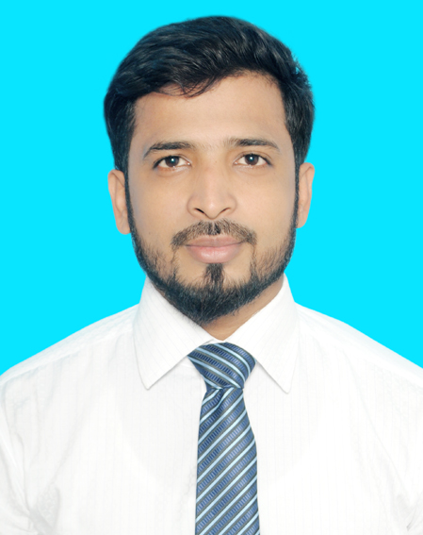

CURRICULUM VITAE OF
MUHAMMAD MUSAEB IBNE TAHER

Contact No: +8801308804401

Career Objectives:
Willing to build up career in a challenging position and to prove myself as a quick learner and highly energetic person to face any challenge in the Information sector where the contribution will be acknowledged, if would be given an opportunity.

Educational Qualification:
 Bachelor of Science (B.Sc)
Name of the institution : Varendra University, Rajshahi
􀀀 Subject : Computer science and engineering (CSE)
􀀀 Result : 2.76 (out of 4.00)
􀀀 Passing Year : 2019

 Higher Secondary School Certificate, H.S.C
Name of the institution : Rajshahi Govt. City College, Rajshahi
􀀀 Group : Science
􀀀 Passing Year : 2014
􀀀 Obtained G.P. A : 3.50 (out of 5.00)
􀀀 Board : Rajshahi

 Secondary School Certificate, S.S.C
Name of the institution : Madinatul Ulum Kamil Madrasha
􀀀 Group : Science
􀀀 Passing year : 2012
􀀀 Obtained G.P. A : 5.00 (out of 5.00)
􀀀 Board : Madrasha Board

Achievements :
􀀀 Strong communication and interpersonal skills.
􀀀 Good analytical and problem solving skills.

Computer Liability:
Microsoft Office, Microsoft Excel, Power Point, Internet Browsing etc.

Language Skills:
Bangla (Excellent).
􀀀 2. English (Good).

Relevant Skills:
􀀀 Capable of working in a team as well as independently.
􀀀 Comfortable with working long hours in the site as well as an organization.
􀀀 Fluent in speaking, writing & listening in both English and Bengali.

Personal Information:
􀀀 Name : Muhammad Musaeb Ibne Taher
􀀀 Father’s Name : Md. Abu Taher
􀀀 Mother’s Name : Julekha
􀀀 Nationality : Bangladeshi (by birth).
􀀀 Religion : Islam
􀀀 Sex : Male
􀀀 Marital Status : Married.
􀀀 Date of Birth : 19-08-1997
􀀀 Height : 5 Fit 6 Inc.
􀀀 NID no : 4652528458
􀀀 Weight : 70 Kg.
􀀀 Blood Group : O+ (positive).

Permanent Address :
􀀀 Village : 52, New Colony
􀀀 Post Office : Sopura
􀀀 Post Code : 6203
􀀀 Police Station : Boalia
􀀀 District : Rajshahi 

Present Address :
􀀀 Village : 52, New Colony
􀀀 Post Office : Sopura
􀀀 Post Code : 6203
􀀀 Police Station : Boalia
􀀀 District : Rajshahi 

Experience :

One year working experience as a teacher at Jago Foundation. Feb 5,2020 to Dec 31,2020.

Reference :

Faisal Imran  Lecturer  Department of CSE  National Institute of Textile Engineering and research  Cell: 01917-326076  E-mail: faisal.cse@niter.edu.bd | MD Abdul Halim  Office assistant cum computer Operator  Upazila nirbahi office, Godagari, Rajshahi  Cell: 01716-311444  E-mail: mdadib1981@gmail.com

Date:

Signature:
Muhammad Musaeb Ibne Taher

