## Lab 4

**Implementation of Queue**

A Queue Data Structure is a fundamental concept in computer science used for storing and managing data in a specific order. It follows the principle of “First in, First out” (FIFO), where the first element added to the queue is the first one to be removed. Queues are commonly used in various algorithms and applications for their simplicity and efficiency in managing data flow

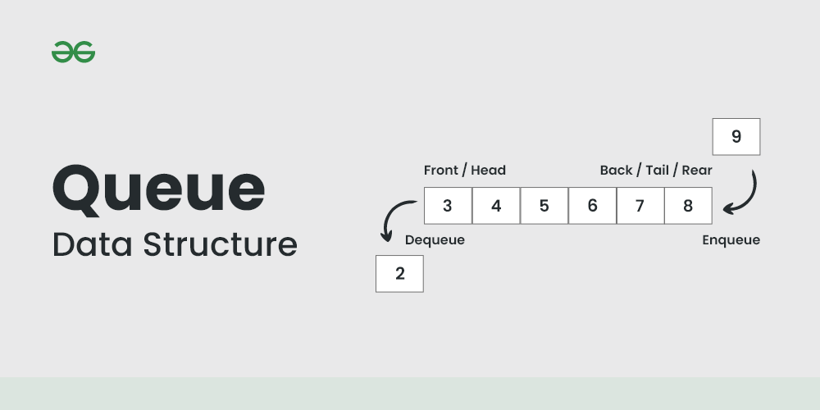

### Queue ADT Operations

* Initialize -- Sets queue to an empty state.
* IsEmpty -- Determines whether the queue is currently empty.
* IsFull -- Determines whether the queue is currently full.
* Insert (ItemType newItem) -- Adds newItem to the rear of the queue.
* Remove (ItemType& item) -- Removes the item at the front of the queue and returns it in item.

### Implementation of Queue Using Circular Arrays

Given

* an array **Items**[0:N-1] consisting of N items
* two indices **Front** and **Rear**, that designate positions in the Items array

We can use the following assignments to increment the indices so that they always wrap around after falling off the high end of the array.

##### front = (front + 1) % N rear = (rear + 1) % N

//

// CLASS DEFINITION FOR QUEUE

// #include <iostream>

#define maxQue 100

typedef int ItemType;

class Queue {

private:

ItemType items[maxQue]; // Array to store queue items

int front, rear, count; // Front and rear pointers, and count of items

public:

Queue(); // Constructor

int IsEmpty(); // Check if the queue is empty

int IsFull(); // Check if the queue is full

void Insert(ItemType newItem); // Insert a new item into the queue

void Remove(ItemType &item); // Remove an item from the queue

};

// Constructor: Initializes an empty queue

Queue::Queue() {

count = 0;

front = 0;

rear = 0;

}

// Check if the queue is empty

int Queue::IsEmpty() {

return (count == 0);

}

// Check if the queue is full

int Queue::IsFull() {

return (count == maxQue);

}

// Insert a new item into the queue

void Queue::Insert(ItemType newItem) {

if (IsFull()) {

std::cout << "Overflow: Cannot insert, queue is full.\n";

}

else {

items[rear] = newItem;

rear = (rear + 1) % maxQue; // Circular queue logic

++count;

}

}

// Remove an item from the queue

void Queue::Remove(ItemType &item) {

if (IsEmpty()) {

std::cout << "Underflow: Cannot remove, queue is empty.\n";

} else {

item = items[front];

front = (front + 1) % maxQue; // Circular queue logic

--count;

}

}

int main() {

Queue q;

ItemType item;

// Test inserting items into the queue

for (int i = 1; i <= 5; ++i) {

q.Insert(i);

std::cout << "Inserted: " << i << std::endl;

}

// Test removing items from the queue

while (!q.IsEmpty()) {

q.Remove(item);

std::cout << "Removed: " << item << std::endl;

}

return 0;

}

**Output:**

Inserted: 1

Inserted: 2

Inserted: 3

Inserted: 4

Inserted: 5

Removed: 1

Removed: 2

Removed: 3

Removed: 4

Removed: 5

# Dynamic Implementation of Queue

### Queue Using Template and Dynamic Array

//

// CLASS TEMPLATE DEFINITION FOR QUEUE

//

#include <iostream>

using namespace std;

template<class ItemType>

class Que {

public:

Que(); // Default constructor

Que(int max); // Parameterized constructor

~Que(); // Destructor

int IsFull() const; // Check if the queue is full

int IsEmpty() const; // Check if the queue is empty

void Insert(ItemType newItem); // Insert a new item into the queue

void Remove(ItemType& item); // Remove an item from the queue

private:

int front; // Front index

int rear; // Rear index

int maxQue; // Maximum size of the queue (array size)

int count; // Current number of elements in the queue

ItemType* items; // Dynamic array for storing items

};

// Default constructor

template<class ItemType>

Que<ItemType>::Que() {

maxQue = 501; // Default size of the queue

front = 0;

rear = 0;

count = 0;

items = new ItemType[maxQue]; // Dynamically allocate array

}

// Parameterized constructor

template<class ItemType>

Que<ItemType>::Que(int max) {

maxQue = max + 1; // Set maxQue to max + 1 for circular logic

front = 0;

rear = 0;

count = 0;

items = new ItemType[maxQue]; // Dynamically allocate array

}

// Destructor

template<class ItemType>

Que<ItemType>::~Que() {

delete[] items; // Deallocate the dynamic array

}

// Check if the queue is empty

template<class ItemType>

int Que<ItemType>::IsEmpty() const {

return (count == 0);

}

// Check if the queue is full

template<class ItemType>

int Que<ItemType>::IsFull() const {

return (count == maxQue - 1); // Queue is full if count == maxQue - 1

}

// Insert a new item into the queue

template<class ItemType>

void Que<ItemType>::Insert(ItemType newItem) {

if (IsFull()) {

cout << "Overflow: Cannot insert, queue is full.\n";

} else {

items[rear] = newItem; // Add item to the rear

rear = (rear + 1) % maxQue; // Circular increment

++count;

}

}

// Remove an item from the queue

template<class ItemType>

void Que<ItemType>::Remove(ItemType& item) {

if (IsEmpty()) {

cout << "Underflow: Cannot remove, queue is empty.\n";

} else {

item = items[front]; // Remove item from the front

front = (front + 1) % maxQue; // Circular increment

--count;

}

}

// Example driver program

int main() {

Que<int> q(5); // Create a queue with a capacity of 5 elements

int item;

// Insert elements into the queue

q.Insert(10);

q.Insert(20);

q.Insert(30);

q.Insert(40);

q.Insert(50);

// Try inserting when the queue is full

q.Insert(60);

// Remove elements from the queue

while (!q.IsEmpty()) {

q.Remove(item);

cout << "Removed: " << item << endl;

}

// Try removing when the queue is empty

q.Remove(item);

return 0;

}

Output:

Overflow: Cannot insert, queue is full.

Removed: 10

Removed: 20

Removed: 30

Removed: 40

Removed: 50

Underflow: Cannot remove, queue is empty.

**Task 1:**

Write a driver program to insert 10 numbers in a queue and then remove and print the numbers

**Hint:**

• **Inserting numbers:** Numbers from 1 to 10 are inserted into the queue using push(). During each insertion, both front() and back() operations are used to display the current front and back elements of the queue.

• **Removing and printing:** The program removes each number using pop(). Before each removal, the front () and back() operations are used to display the first and last elements in the queue at that moment.

## Task 2:

Reverse First K elements of Queue Given an integer K and a queue of integers, we need to reverse the order of the first K elements of the queue, leaving the other elements in the same relative order. Only following standard operations are allowed on queue.

* + 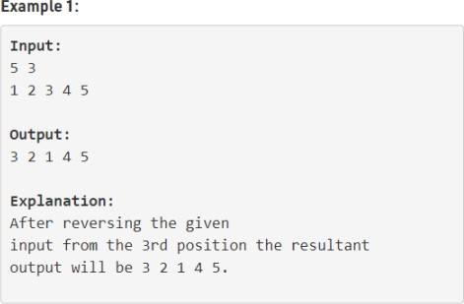**enqueue(x)** : Add an item x to rear of queue
  + **dequeue()** : Remove an item from front of queue
  + **size()** : Returns number of elements in queue.
  + **front()** : Finds front item.

**int:**

1. **Initialize the queue** and insert 8 numbers into it.
2. **Check if K is valid** before proceeding with the reversal.
3. **Remove the first K elements** and store them in an array.
4. **Insert the elements in reverse order** back into the queue.
5. **Rearrange the remaining elements** by dequeuing and re-enqueuing them to maintain their order.
6. **Print the final queue** after the reversal