LAB 13: Open-Ended Lab

Graphical User Interface (Ticket Machine)
Introduction:
Until now most of the applications we developed did not had a proper UI experience but rather followed a command line interface (CLI). In real word applications require a proper and easy to use UI in most cases a graphical user interface to be considered as an appropriately designed app. Even if your program has implemented some amazing piece of logic but if your user interface is not properly organized it will be considered as a poorly designed application. In todays lab we will cover GUI in Java.

GUI in Java:
In Java, GUI-based programs are implemented by using the classes from the standard packages that are:​
​
- Swing Classes​: java.swing
- AWT Classes (Abstract Windows Toolkit ) : java.awt
- GUI elements:​
  - Container​
    - Panel, Frame, Dialog, etc.​
  - Components​
    - Button, Label, Checkbox, Scrollbar, etc.​
- Layout managers:​
  - Flow Layout, Border Layout, Grid Layout etc.​
- Supporting classes ​

Component Hierarchy:
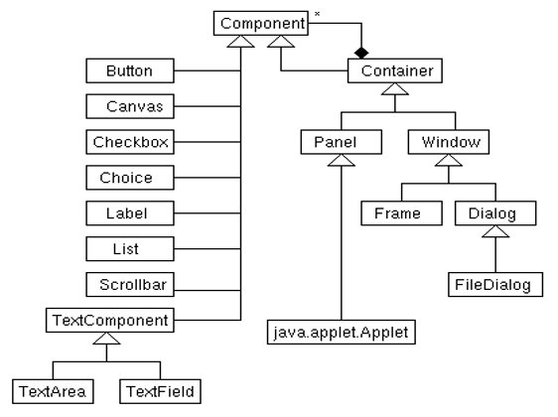

GUI Environment:

In GUI environment, there are basically two types of window:​
- General purpose frame​
- Special purpose dialog​
​In java we use “JFrame” object for a frame window and “JDialog” object for a dialog.​

Steps to build a GUI:
- import package
- Setup top level container (e.g. JFrame)
- Apply layout (e,g, BorderLayout)
- Add components (e.g. Label, Button)
- Register listeners
- Use the application

Java Swing Components:
- Top Level Containers

- General Purpose Containers
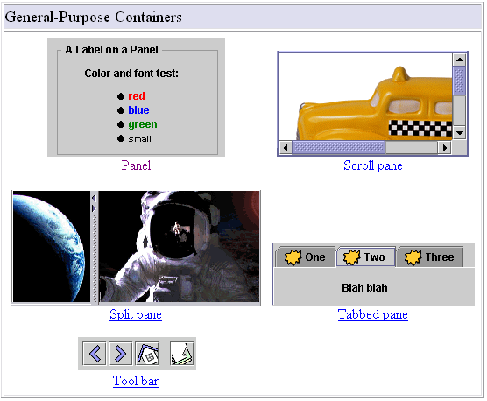

- Special Purpose Containers

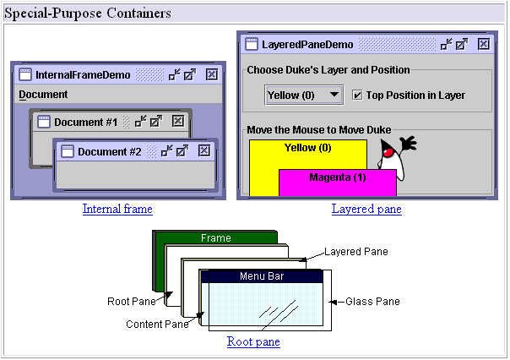

- Basic Controls

- Un-editable Information Displays

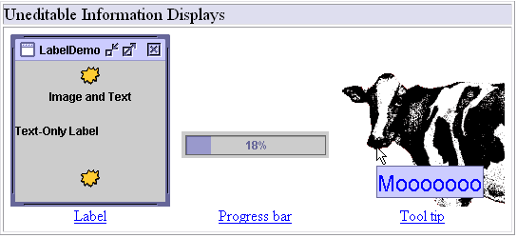

- Interactive Displays of Highly Formatted Information

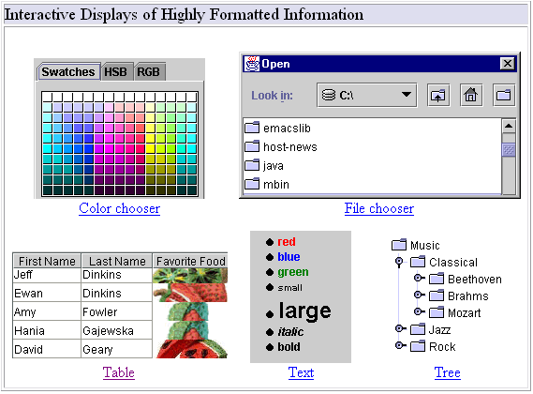

GUI Programming Basics:
There are two key aspects involved in GUI programming:
- Placement of GUI objects on the content pane of a frame.
- Handling of events generated by GUI objects.

Placement of GUI Objects:
There are two general approaches for placing GUI objects:
- Layout Manager
- Absolute Positioning
Layout Managers:

The layout manager for a container is an object that controls the placement of the GUI objects.

- The layout of the elements in a container is handled by the layout manager associated with the container.
- Relative positions of the elements are specified, not their absolute coordinates.
- The positions and sizes of the element will be automatically adjusted when the window is resized
Java supplies five commonly used layout managers:
- Border Layout
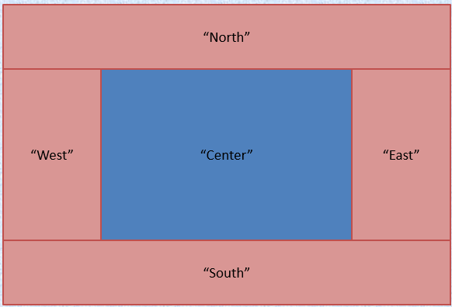

- Box Layout
  - The Box Layout class puts components in a single row or column.
  - It respects the components requested maximum sizes.


- Flow Layout
  - Flow Layout is the default layout manager for every JPanel.
  - It simply lays out components from left to right, starting new rows if necessary.
  - Specify in constructor:
FlowLayout.LEFT, FlowLayout.CENTER, FlowLayout.RIGHT

- GridBag Layout
GridBag Layout is the most sophisticated, flexible layout manager the Java platform provides.

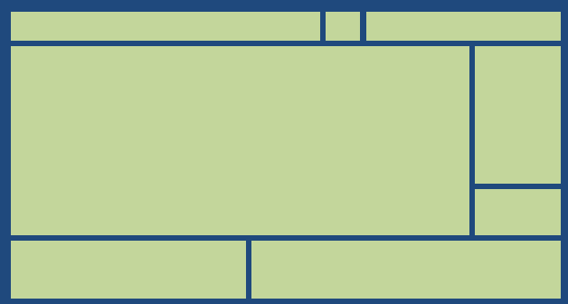

- Grid Layout
  - Grid Layout( rows, columns )
  - Forces a size on a component equal to the size of the cell.
  - Add( component ) - Adds from left to right.

Hierarchy Sample:

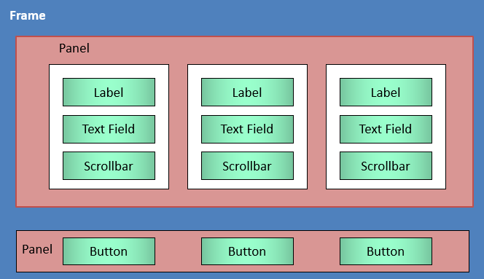

Using JButton:
Constructors:

JButton() | Creates a button with no text or icon
JButton(Icon icon) | Creates a button with an icon
JButton(String text) | Creates a button with text
Jbutton (String text, Icon icon) | Creates a button with initial text and an icon

Methods:

addActionListener(ActionListener a) | Registers ActionListener to JButton Inherited from AbstractButton
setFont(Font font) | Specifies Font (Type, Style, Size) Inherited from JComponent
setBackground(  Color color) | Sets background color Inherited from JComponent
setActionCommand(String text) | Used to specify button if listener is registered to multiple buttons

Constructing a Panel:

- Construct the panel (new Panel()).
- Give the panel a layout manager (setLayout())
- Populate the panel (add())
- Add the panel to its own container (add()).

Text- Related Components:

There are three Swing GUI classes:
- Jlabel
- JTextField
- JTextArea
The first two deal with a single line of text and the last with multiple lines of text.

Example::
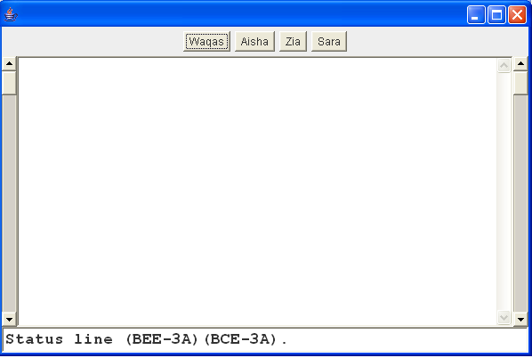
import java.awt.*;
import javax.swing.*;
public class Example_1 extends JFrame
{
public static void main(String[ ] args)
{
Example_1 ob = new Example_1 ( );
Container c = ob.getContentPane();
c.setLayout(new BorderLayout());
//Add Scroll bars to the container
Scrollbar sbRight = new Scrollbar(Scrollbar.VERTICAL);
c.add(sbRight,BorderLayout.EAST);
Scrollbar sbLeft = new Scrollbar(Scrollbar.VERTICAL);
c.add(sbLeft,BorderLayout.WEST);

//Add Panel , buttons, Text Area
Panel toolBar = new Panel();
toolBar.add(new Button("Rafia"));
toolBar.add(new Button("Aisha"));
toolBar.add(new Button("Zia"));
c.add(toolBar,BorderLayout.NORTH);

//Add TextField in the code
TextFieldstatus = new TextField("Status line (BEE2A)(BCE2A).");
status.setFont(new Font("Cambria",Font.BOLD,18));
c.add(status,BorderLayout.SOUTH);

//Add TextArea in the code
TextArea ta = new TextArea(10,10);
c.add(ta,BorderLayout.CENTER);
ob.setSize(800,600);
ob.setVisible(true);
ob.setTitle("NewWindow");
ob.setDefaultCloseOperation(EXIT_ON_CLOSE);
}
}
//Add TextArea in the code
TextArea ta = new TextArea(10,10);
c.add(ta,BorderLayout.CENTER);
ob.setSize(800,600);
ob.setVisible(true);
ob.setTitle("NewWindow");
ob.setDefaultCloseOperation(EXIT_ON_CLOSE);
}
}

Example Hello World:
import java.awt.*;
import javax.swing.*;
// Extend Frame in order to override paint()
class NewFrame extends Frame {
// Override paint():
public void paint (Graphics g)
{
// drawString() is a Graphics method.
// Draw the string "Hello World" at location 100,100
g.drawString ("Hello World!", 100, 100);
}
}
public class Application {
public static void main (String[] argv)
{
// Create an instance of NewFrame
NewFrame nf = new NewFrame ();
// Set the title and other parameters.
nf.setTitle ("Hello World Application");
nf.setResizable (true);
nf.setBackground (Color.cyan);
nf.setSize (500, 300);
// Show the frame.
nf.setVisible (true);
}
}
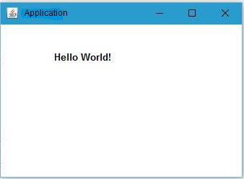
Conclusion:
In this lab we covered the basics of Java GUI and how it can be used to improve the design of the application and also making the application more interactive.

Open-Ended Lab Tasks:
Task 1:
Create the GUI for a ticket machine that is used to buy train or bus tickets.
Task 2:
Extend your code from Task 1 to convert your ticketing machine to fully functioning ticket machine.
Note: Try to use java documentation extensively.

