Bahria University, Islamabad

Department of Software Engineering

Computer Communication & Networking Lab (Fall-2025)

Instructor: Engr. Muhammad Faisal Zia

Student:

Enrollment:

Lab Journal: 03

Date:

|  |  |  |  |  |  |  |
| --- | --- | --- | --- | --- | --- | --- |
| **Task No:** | **Task Wise Marks** | | **Documentation Marks** | | | **Total Marks**  **(20)** |
| **Assigned** | **Obtained** | **Assigned** | **Obtained** | |
| 1 |  |  |  |  |  | |
| 2 |  |  |
| 3 |  |  |
| 4 |  |  |
| 5 |  |  |

**Comments:**

**Signature**

# LAB # 3

# Building and testing a Peer-to-Peer network

**Objectives:**

* Design and build a simple peer-to-peer network using a crossover cable supplied by the instructor.
* Verify connectivity between the peers using the ping command.

**Introduction:**

**Step 1: Diagram the network**

1. A network diagram is a map of the logical topology of the network. In the space below, sketch a simple peer-to-peer network connecting two PCs. Label one PC with IP address 192.168.1.1 and the other PC with IP address 192.168.1.2. Use labels to indicate connecting media and any necessary network devices.
2. A simple network like the one you designed can use a hub or switch as a central connecting device, or the PCs may be directly connected. Which kind of cable is required for a direct Ethernet connection between the two PCs?

|  |
| --- |
|  |
|  |
|  |

**Step 2: Document the PCs**

1. Check the computer name settings for each PC and make adjustments as necessary. For each PC, select **Start** and **Control Panel. Click System and Security -> System** **-> Remote Settings,**  a new window opens, then click the **Computer Name** tab. Write down the computer name that is displayed following **Full computer name**:

|  |  |
| --- | --- |
| **PC1 Name:** |  |
| **PC2 Name:** |  |

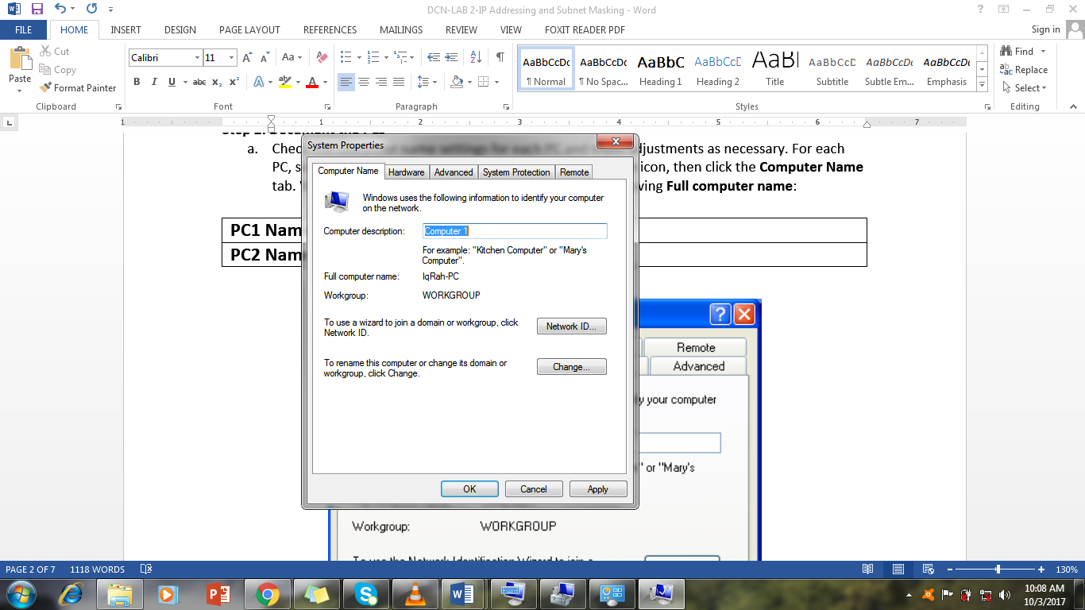

1. Check to see if the two PCs have the same name. If they do, change the name of one PC by clicking the **Change** button, typing a new name in the **Computer name** field, then clicking **OK**.
2. Click **OK** to close the **System Properties** window.
3. Why is it important that each PC on a network have a unique name?

_______________________________________________________________

**Step 3: Connect the Ethernet cable**

1. Use the Ethernet crossover cable provided by the instructor. Plug one end of the cable into the Ethernet NIC of PC1.
2. Plug the other end of the cable into the Ethernet NIC of PC2. As you insert the cable, you should hear a click which indicates that the cable connector is properly inserted into the port.

**Step 4: Verify physical connectivity**

1. After the Ethernet **crossover cable** is connected to both PCs, take a close look at each Ethernet port. A light (usually green or amber) indicates that physical connectivity has been established between the two NICs. Try unplugging the cable from one PC then reconnecting it to verify that the light goes off then back on.
2. Go to the **Control Panel**, click **Network and Internet** **-> Network Connections -> Change Adapter Settings [from the menu on the left side]**, and confirm that the local area connection is established. The following figure shows an active local area connection

If physical connectivity problems exist, you will see a red **X** over the Local Area Connection icon with the words **Network cable unplugged**.

If the Local Area Connection does not indicate that it is connected, troubleshoot by repeating Steps 3 and 4. You may also want to ask your instructor to confirm that you are using an Ethernet crossover cable.

**Step 5: Configure IP settings**

1. Configure the logical addresses for the two PCs so that they are able to communicate using TCP/IP. On one of the PCs, go to the Control Panel, **double click the Network Connections icon**, and then **right click the connected Local Area Connection icon**. Choose Properties from the pull-down menu.
2. Using the scroll bar in the **Local Area Connection Properties** window, scroll down to highlight **Internet Protocol (TCP/IP)**. Click the **Properties** button.

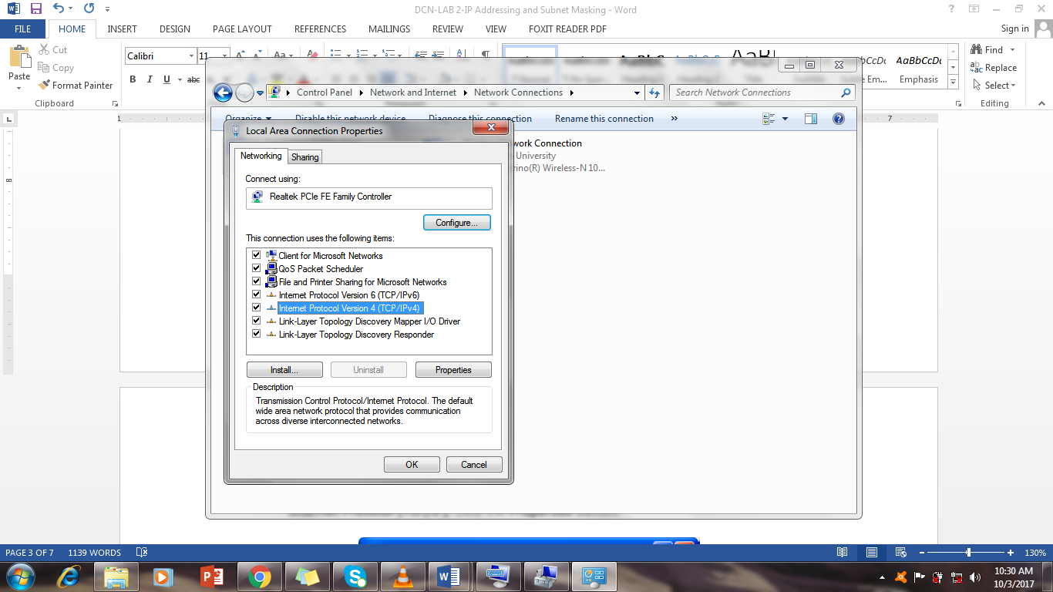

1. Select the **Use the following IP address** radio button and enter the following information:

|  |  |
| --- | --- |
| **IP Address** | **192.168.1.1** |
| **Subnet Mask** | **255.255.255.0** |



1. Click **OK**, which will close the **Internet Protocol (TCP/IP) Properties** window. Click the **Close** button to exit the **Local Area Connection Properties** window.
2. Repeat steps 5a – 5d for the second PC using the following information:

**IP Address 192.168.1.2**

**Subnet Mask 255.255.255.0**

**Step 6: Verify IP connectivity between the two PCs**

**NOTE:** To test TCP/IP connectivity between the PCs, Windows Firewall must be disabled temporarily on both PCs. Windows Firewall should be re-enabled after the tests have been completed.

1. On PC1, on the Windows desktop, click **Start**. From the Start menu, select **Control Panel**, and double-click **Network Connections**.
2. Right-click the Local Area Connection icon and select **Properties**. Click the **Advanced** tab. Locate and click the **Settings** button.
3. Make a note of whether the firewall settings are ENABLED (ON) for the Ethernet port or DISABLED (OFF) for the Ethernet port. ____________________________________________________
4. If the firewall settings are enabled, click the **Off (not recommended)** radio button to disable the firewall. The setting will be re-enabled in a later step. Click **OK** in this dialog box and the following to apply this setting.
5. Now that the two PCs are physically connected and configured correctly with IP addresses, we need to make sure they communicate with each other. The **ping** command is a simple way to accomplish this task. The **ping** command is included with the Windows XP operating system.
6. On PC1, go to **Start**, then **Run** or use **Windows Button + R**. Type **cmd**, and then click **OK**. A Windows command prompt window will appear as shown in the figure below.
7. At the **>** prompt, type **ping 192.168.1.2** and press **Enter**. A successful **ping** will verify the IP connectivity. It should produce results similar to those shown in here.



1. Repeat Steps 6a-6c on the second PC. The second PC will **ping** 192.168.1.1.
2. Close the Windows command prompt window on both PCs.

**Step 7: Verify connectivity using Networks**

1. A PC can share its resources with other PCs on the network. PCs with shared resources should be visible through **Networks**. On PC1, go to **Start**, type **Networks** in the search bar, and click on **Network**. OR Go to **Control Panel**, click **Network and Internet** under **Network and Sharing Center** click in **View network computers and devices.**

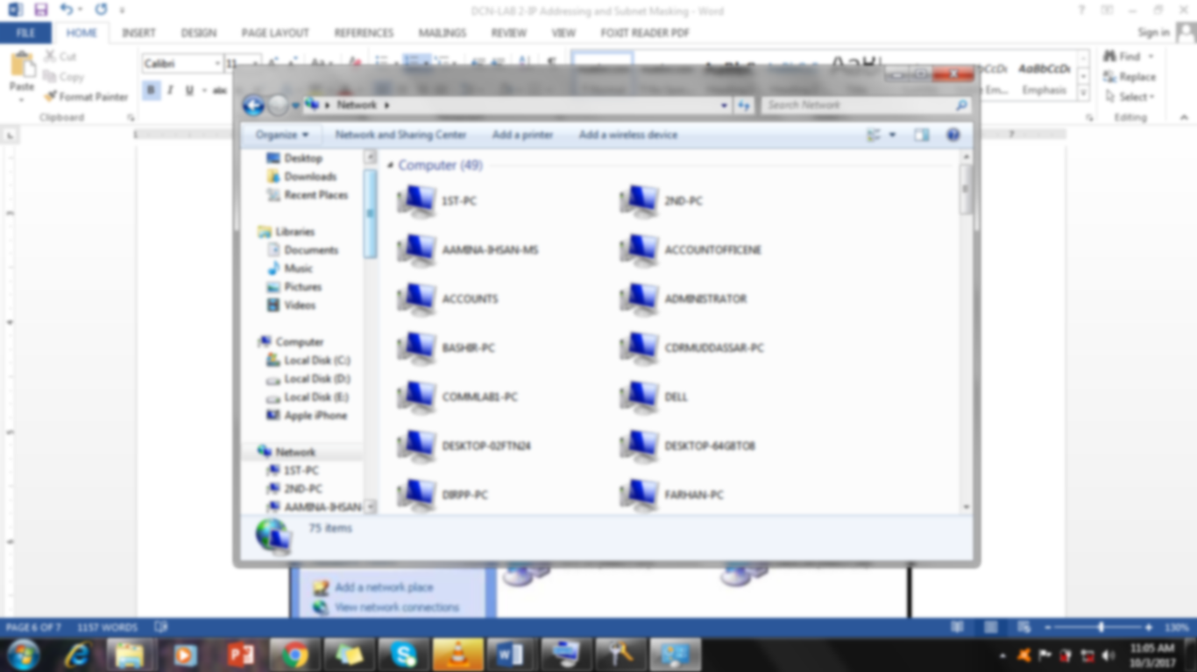

1. Do you see an icon for the other PC in your peer-to-peer network? _______________________
2. What is the name of the other PC? ________________________________________________
3. Is it the same name you recorded in Step 2? _________________________________________
4. Perform Step 7a on the second PC.
5. Close any open windows.

**Step 8: (Optional – Use only if the Firewall was originally ENABLED) Re-enable the firewall**

1. If you disabled the Windows Firewall in Step 6, click **Start**, select **Control Panel**, and open the **Network Connections** control panel.
2. Right-click the Ethernet network connection icon and select **Properties**. Click the **Advanced** tab. Locate and click **Settings**.
3. If the firewall settings are disabled (and they were enabled before this lab began), click the **On** radio button to enable the firewall. Click **OK** in this dialog box and the following one to apply this setting.

**Tasks**

**Task 1:**

1. Perform all the steps explained above and answer the questions that are being asked. Provide screen shots of results or observations where applicable.
2. Create a simulation of a simple peer-to-peer network using Packet Tracer. Provide screen shots of results or observations where applicable.