Here is the explanation of UI Design:

1. Main Page

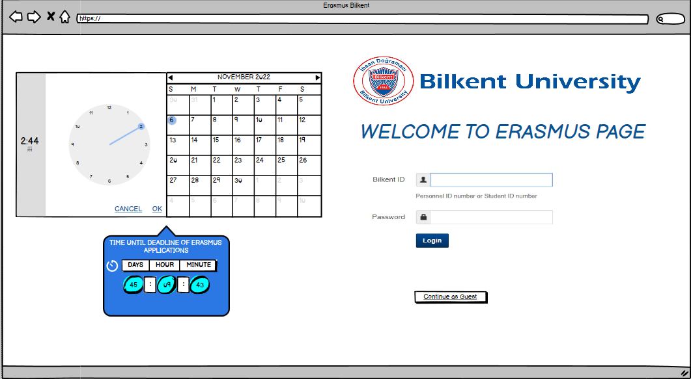

The main page will be shown first when the user enters the website. The time until the deadline for ERASMUS applications will be shown on the left part of the main page. On the right side, since users can log in through SRS, the SRS login will be there. Also, users can use the website without logging in by pressing Continue as Guest button.

1. University Information

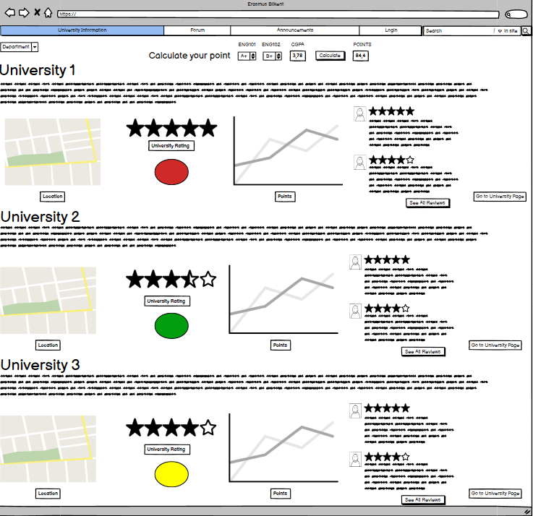

When the user continues as a guest, the university information page will be opened. On this page, users can see all the possible ERASMUS universities of the particular departments. Users can see reviews, the points of former students, location, university ratings and users can go to university’s webpage by button. Moreover, at the top of the website, there will be an ERASMUS point calculation area. When the calculation is done, the circles that are shown in each university information will be:

* 1. Red: It means that the user is not likely to be selected for that university.
  2. Yellow: The user may enter that university.
  3. Green: The user might be easily selected for that university.

1. Forum

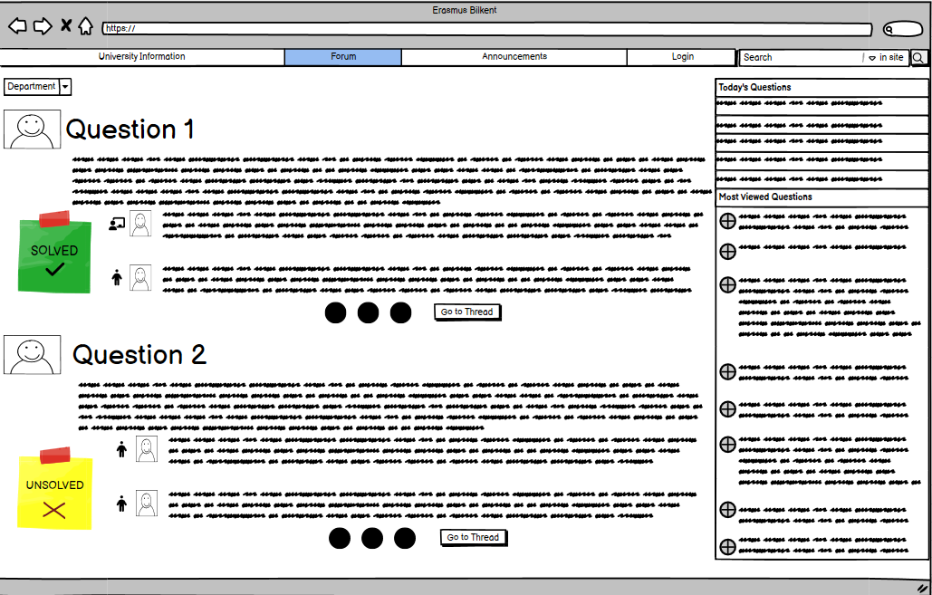

In the forum, users can see the questions. They are separated by departments. On each question, whether it is solved or not will be shown. Users can see the thread of the question by using Go to Thread button. On the right part of the forum, the questions asked today and that are most viewed will be shown. Users can easily jump to that question’s thread.

1. Announcements

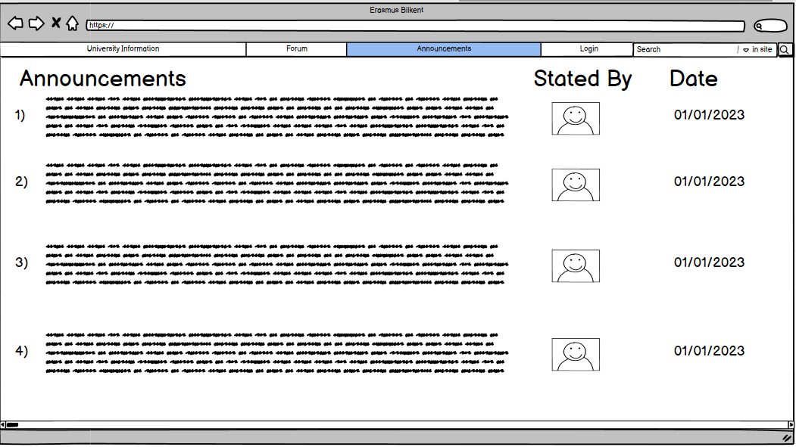

This page will show the announcements, the person who stated them, and the announcement date.

1. Login

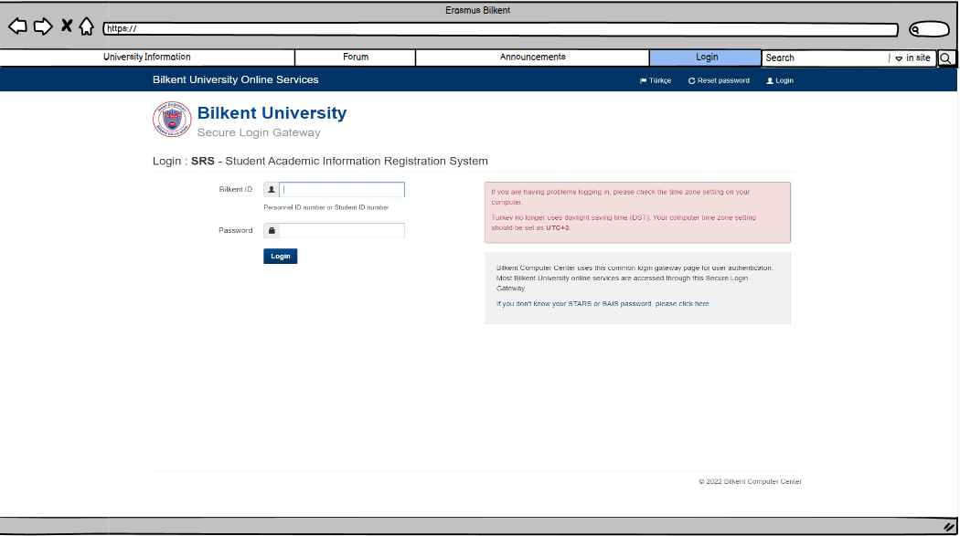

This is the login page. Since the webpage allows users to log in through SRS, the SRS login page will be shown.

1. Student (applying) Profile

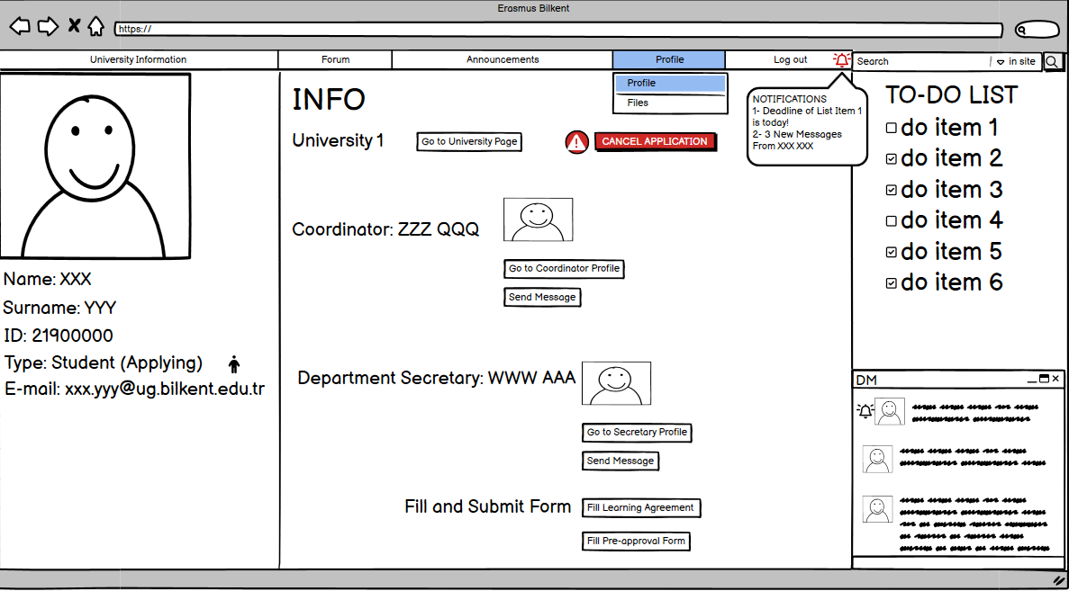

When a student (applying) login, the profile will be opened. On the left part, the personal information will be shown including name, surname, ID, type, and email. On the middle part of the profile page, the general info and related users will be shown. User can also cancel the ERASMUS application, and he/she can go to fill the learning agreement and pre-approval form page by buttons. On the right, there will be To-Do List. Items will be shown one under the other. And there will be DM page. At the top, the notifications and a link to files page will be shown.

1. Files (student applying)

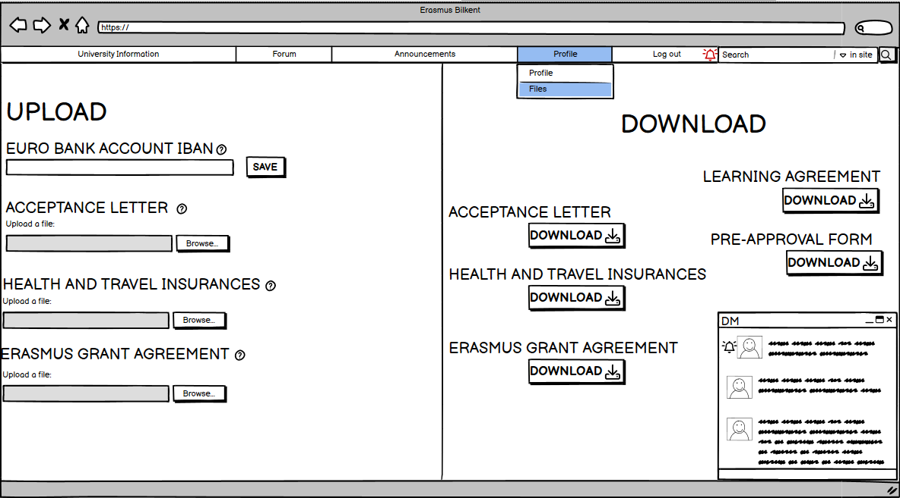 This is the files page. On the left part, the user can add the IBAN of the Euro Bank account, and he/she can upload the acceptance letter, health and travel insurance, ERASMUS Grant Agreement. On the right, the user can download these files, also the learning agreement and pre-approval form.

1. Fill and Submit Learning Agreement

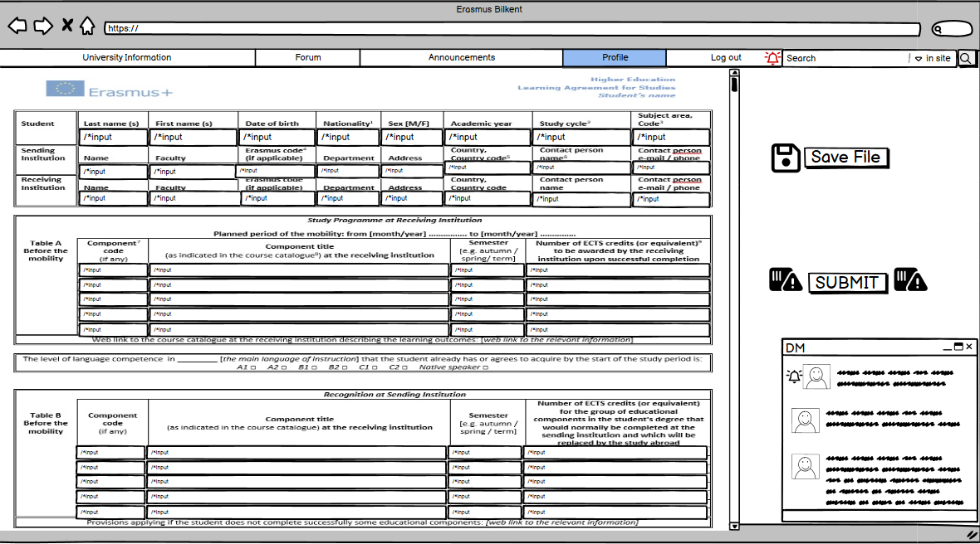

User can fill and submit the learning agreement. Also, if it has not finished yet, user can save the file to complete it later.

1. Fill and Submit Pre-approval Form

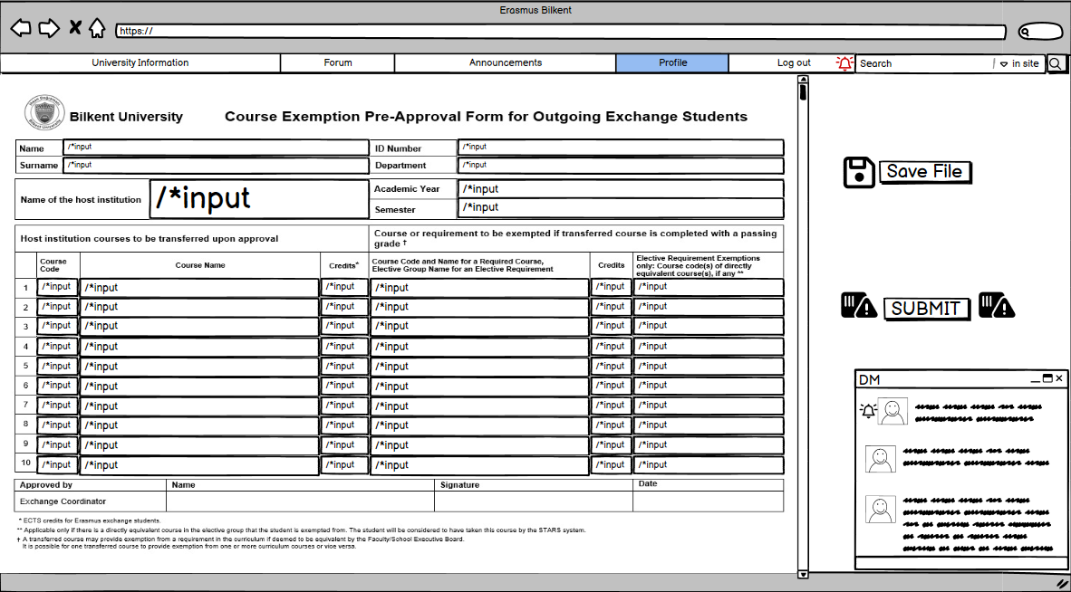

User can fill and submit the pre-approval. If it has not finished yet, user can save the file to complete it later.

1. Student (former) Profile

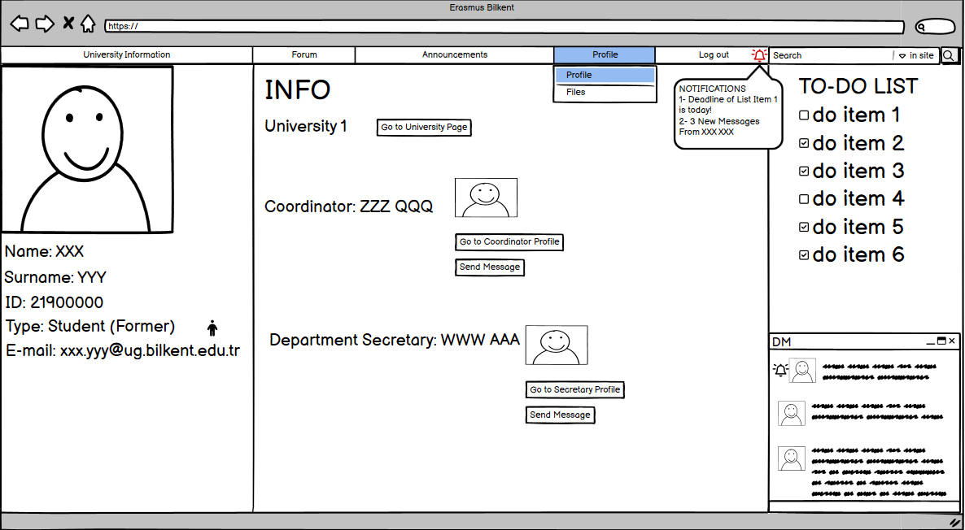

The organization of former student profile is similar to applying student. On the left part, personal information will be shown. In the middle of the page, the general info and related users will be shown. On the right, there will be To-Do List. Items will be shown one under the other. And there will be DM page. At the top, the notifications and a link to files page will be shown

1. Review Your University (Former student)

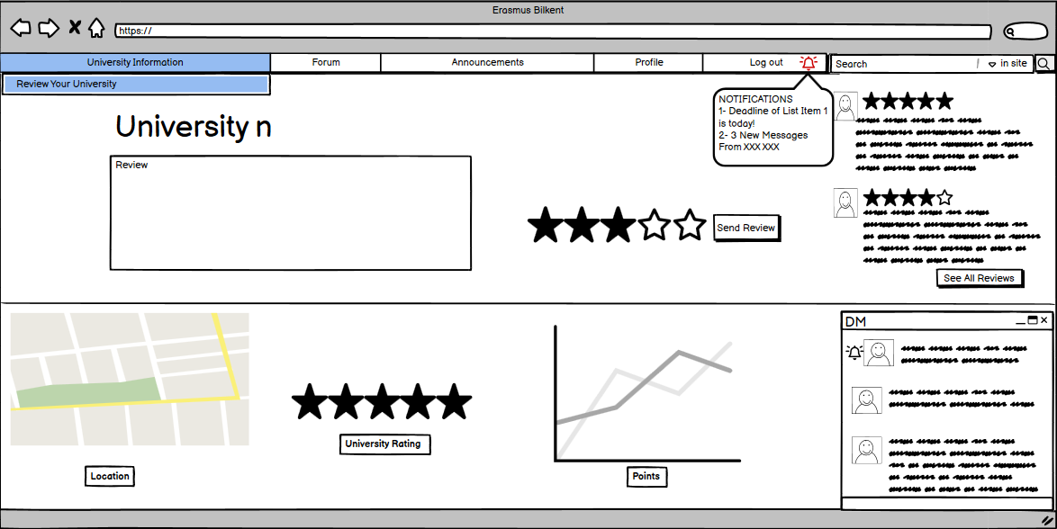

The page of reviewing university is consisted of review part, see all reviews of the university, location, rating and the points.

1. Exchange Office

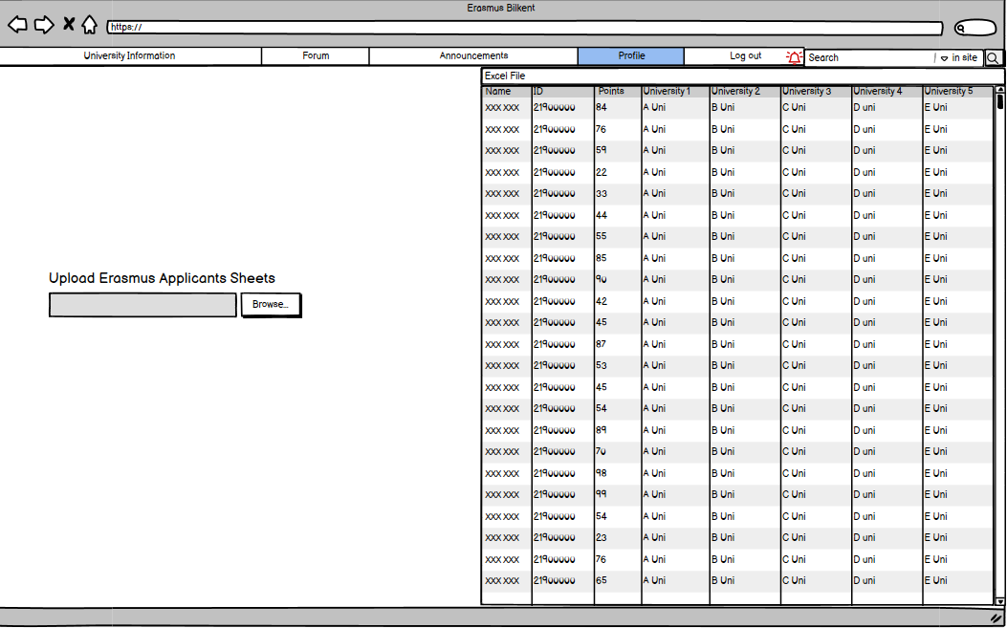

Since the only assignment of the Erasmus Exchange Office is uploading the Erasmus Applicants Sheets, there will be only an upload file part. When this excel file is uploaded, it will be shown on the right part of the page.

1. Instructor Profile

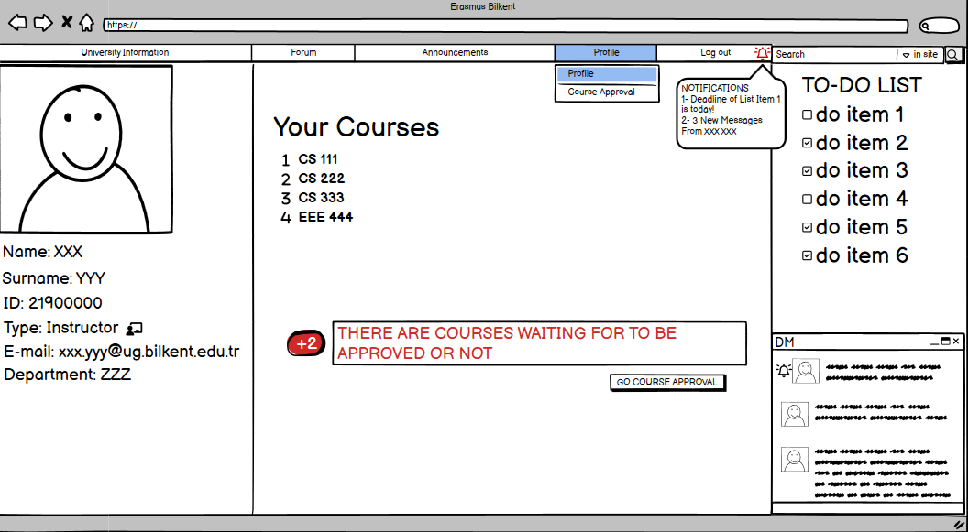

On the left part, personal information will be shown. In the middle of the page, the courses of the instructor and the notifications of coursers waiting for to be approved or not will be shown. The instructor can go to the course approval page by using the button. Lastly, there will be a to-do list of the instructor and a DM panel.

1. Course Approval

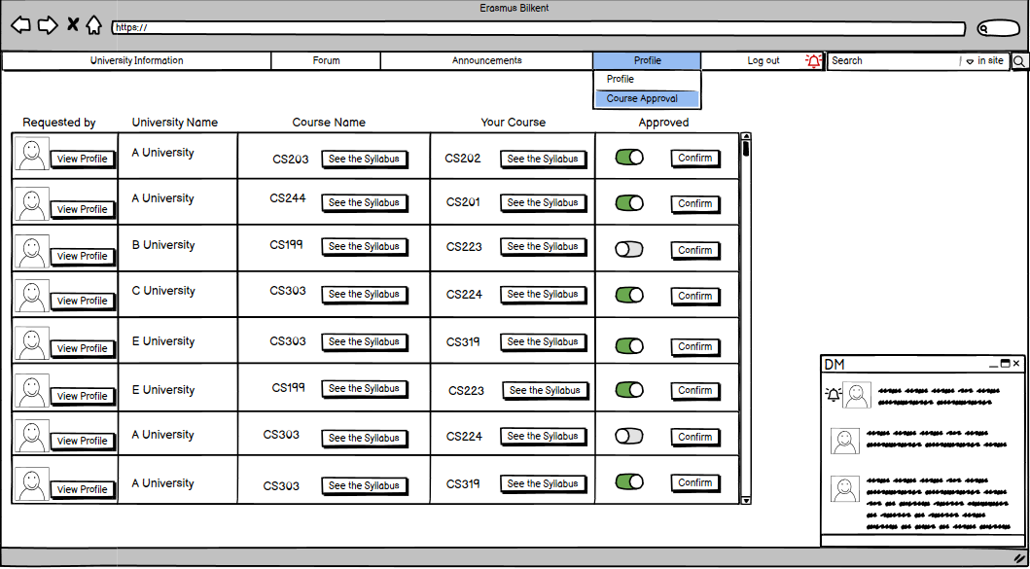

On the course approval page, there will be a list consisting of who requested, the student's university, the course name in the host university, the corresponding course, and the check of whether the instructor approved. When it is done, the instructor can confirm it by using button.

1. Profile View by Other Users

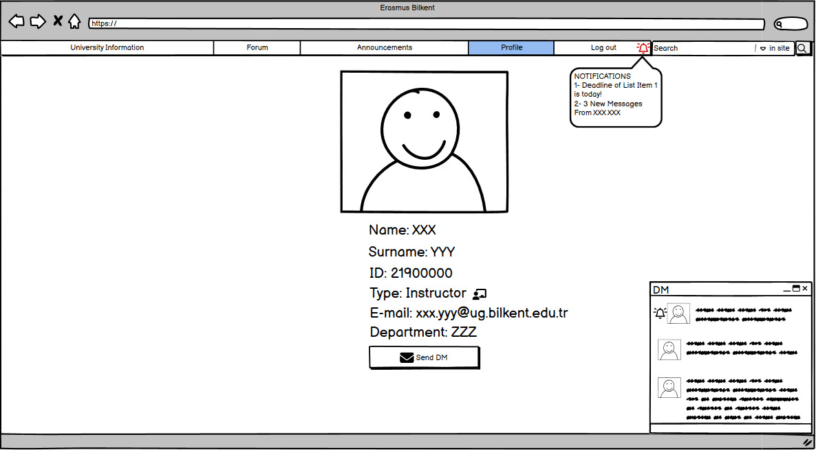When other typed users view the instructor profile, this page will be opened. The information of the instructor will be shown. Under them, there will be a send DM button. User can send a message with this button.

1. Department Coordinator Profile

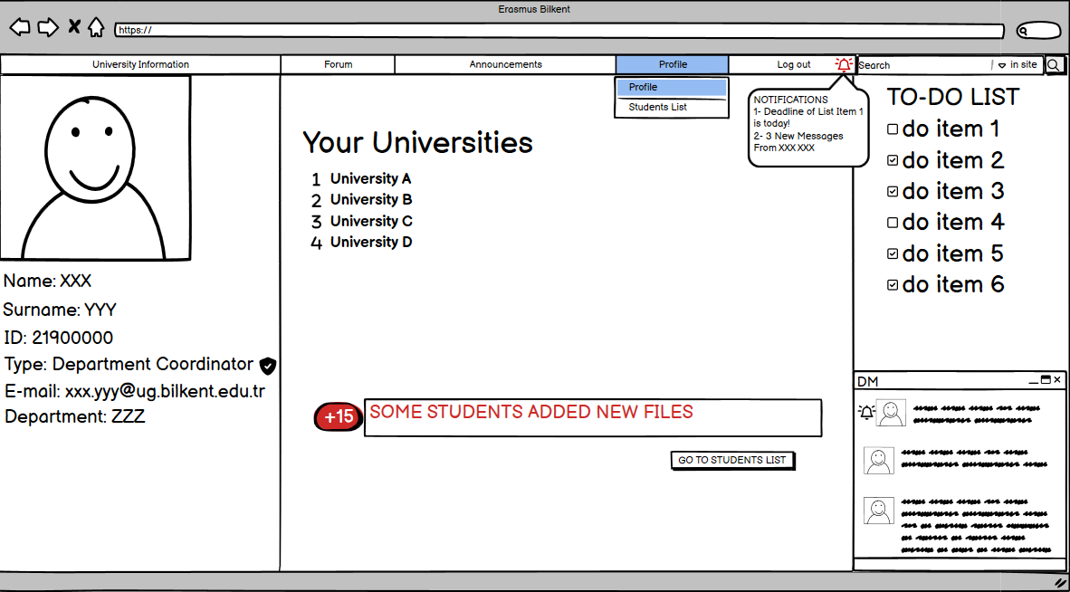

There will be personal information on the left part of the website. The university department coordinator is responsible will be shown in the middle position. Also, the notifications of some students added new files will be shown. The left part of the notification indicates how many files have been added. By using the go to students list button, the department coordinator can go to the students list page. On the right part, the To-Do list and DM panel will be shown.

1. Student List

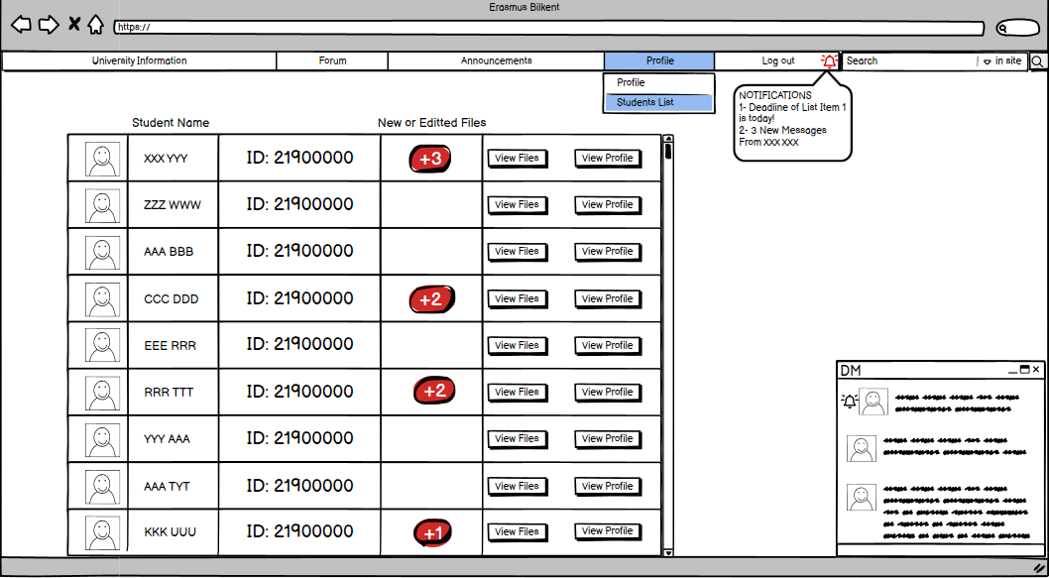There will be a list consisting of the student profile photo, student name, student ID, and/or edited files, view files, and view the student profile. By clicking the buttons view files and view profile, the department coordinator can go to the files of the student and the profile of the student.

1. Choosing Students

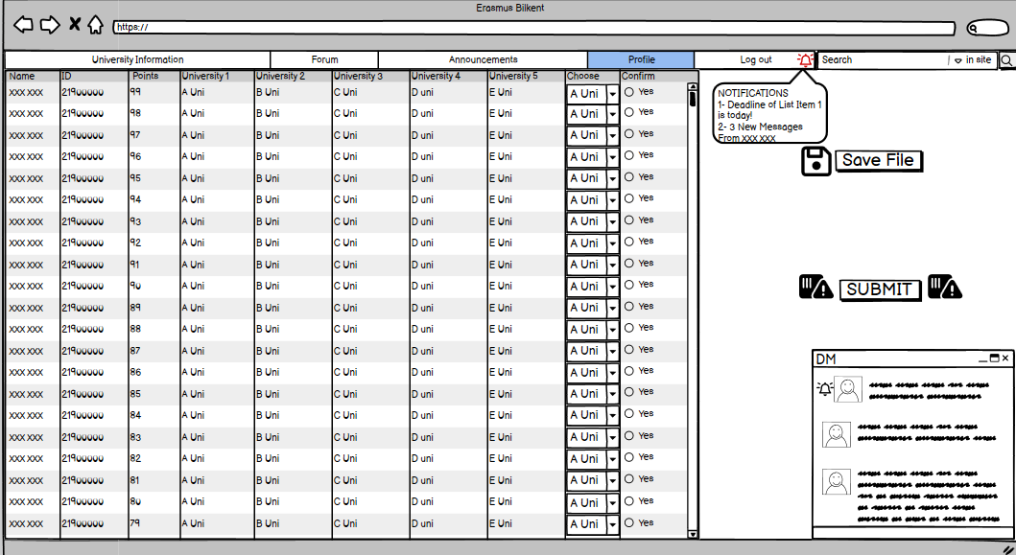

The department coordinator can check the student applications. The list consists of name, id, points, preferred universities, and placed universities. At the end, the department coordinator can confirm by selecting the checkbox yes. He/she can submit it through Submit button, and it can be saved in order to be completed later by clicking the Save File button.

1. Department Secretary Profile

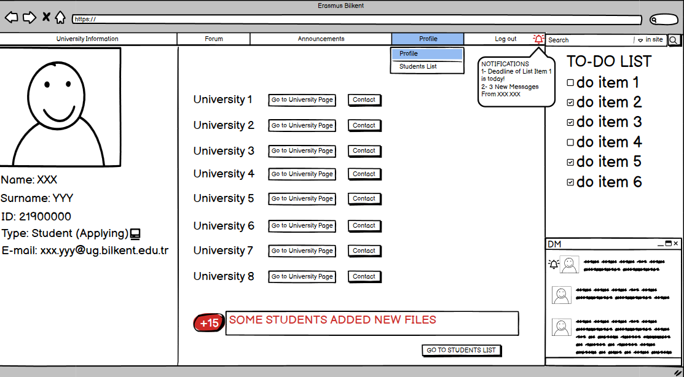On the left, there will be personal information. In the middle of the page, there will be buttons for contacting and going to the university page. Moreover, there will be a notifications part that informs there are new files. The Department secretary can check new files by clicking the students' list button. It will open the students' list page. Lastly, on the right of the page, there will be a To-Do list and a DM panel.