THE UNIVERSITY OF AZAD JAMMU & KASHMIR, MUZAFFARABAD


COURSE TITLE | COMPUTER NETWORKS
COURSE CODE | CS-2203
TITLE | LAB 10
STUDENT NAME | HASEEB SHEIKH
STUDENT ROLL NUMBER | 2024-SE-31
INSTRUCTOR NAME | ENGR. DR. ASMA JAVED
SUBMISSION DATE | SEPTEMBER 20, 2026

DEPARTMENT OF SOFTWARE ENGINEERING
Computer Networking
Lab 10 (Inter VLAN Routing)
- Scenario and Objective
A company has two departments: Development (DEV) and Human Resources (HR). To improve network management and security, these departments are separated into two distinct VLANs. DEV utilizes VLAN 10 on the 192.168.10.0/24 network, while HR utilizes VLAN 20 on the 192.168.20.0/24 network. The objective is to configure a Router-on-a-Stick setup to allow communication between the two VLANs through Inter-VLAN Routing.
- Network Topology
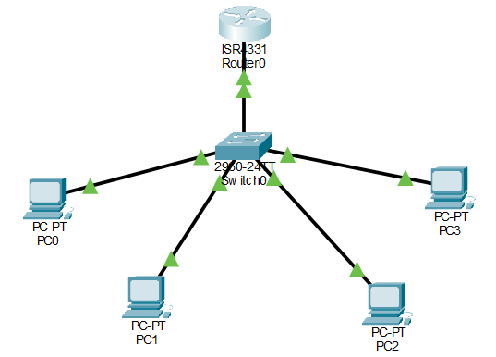

Explanation:
The topology consists of 1 Router, 1 Switch, and 4 PCs. Two PCs are assigned to the DEV department, and two PCs are assigned to the HR department.

3. IP Addressing and VLAN Assignment
The devices were configured with the following parameters to separate them logically while ensuring routing capability:
Device | Interface / Port | Department | VLAN | IP Address | Subnet Mask | Default Gateway
PC1 | FastEthernet0/1 | DEV | 10 | 192.168.10.2 | 255.255.255.0 | 192.168.10.1
PC2 | FastEthernet0/2 | DEV | 10 | 192.168.10.3 | 255.255.255.0 | 192.168.10.1
PC3 | FastEthernet0/3 | HR | 20 | 192.168.20.2 | 255.255.255.0 | 192.168.20.1
PC4 | FastEthernet0/4 | HR | 20 | 192.168.20.3 | 255.255.255.0 | 192.168.20.1
Switch | FastEthernet0/24 | Trunk Link | All | N/A | N/A | N/A
Router | GigEthernet0/0/0.10 | DEV Gateway | 10 | 192.168.10.1 | 255.255.255.0 | N/A
Router | GigEthernet0/0/0.20 | HR Gateway | 20 | 192.168.20.1 | 255.255.255.0 | N/A

4. Switch Configuration (VLAN Creation & Trunking)

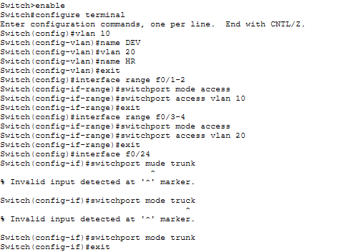

Explanation:
VLAN 10 (DEV) and VLAN 20 (HR) were created on the switch. The PCs were assigned to their respective VLANs by configuring the interfaces as access ports. Finally, the link connecting the switch to the router was configured as an 802.1Q trunk port to carry traffic for both VLANs simultaneously.
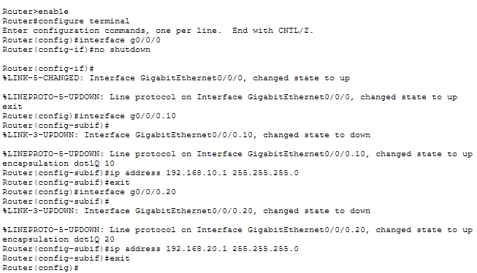
5. Router Configuration (Subinterfaces)

Explanation:
The router's physical interface was activated, and logical subinterfaces were created for both VLANs. Each subinterface was configured with dot1Q encapsulation to understand the tagged traffic from the switch trunk, and assigned the default gateway IP address for its respective subnet.
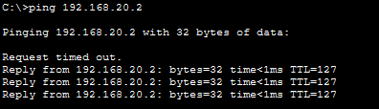
6. Connectivity Testing

Explanation: An ICMP ping test was conducted from a PC in VLAN 10 to a PC in VLAN 20 to verify Inter-VLAN routing. The successful replies confirm that the PCs communicate successfully through the router.

