THE UNIVERSITY OF AZAD JAMMU & KASHMIR, MUZAFFARABAD


COURSE TITLE | COMPUTER NETWORKS
COURSE CODE | CS-2203
TITLE | LAB 2
STUDENT NAME | HASEEB SHEIKH
STUDENT ROLL NUMBER | 2024-SE-31
INSTRUCTOR NAME | ENGR. DR. ASMA JAVED
SUBMISSION DATE | MARCH 5, 2026

DEPARTMENT OF SOFTWARE ENGINEERING
Computer Networking
Lab 2 (Exploring Packet Tracer Interface)
1. Objective
The primary objective of this lab is to explore and familiarize ourselves with the Cisco Packet Tracer user interface. This includes understanding the differences between workspace views, locating the device selection library, and differentiating between Realtime and Simulation modes for network testing.
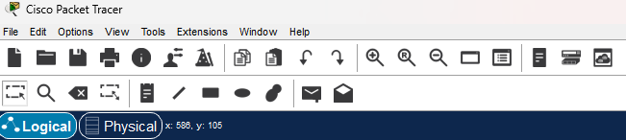
2. Workspace Toggle (Logical vs. Physical)

Explanation:
The workspace toggle allows users to switch between the Logical and Physical views in Packet Tracer. The Logical workspace is primarily used for creating and configuring conceptual network diagrams and topologies. The Physical workspace provides a realistic representation of the network, allowing users to visualize city layouts, building blueprints, and the actual wiring closet racks where physical equipment is installed.
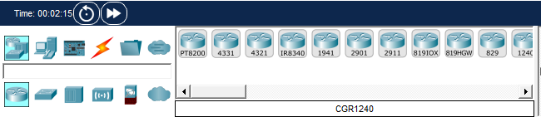
3. Device-Type Selection Box

Explanation:
Located in the bottom-left corner, the Device-Type Selection Box is the component library used to build networks. The top row categorizes hardware into broad groups such as Network Devices (Routers, Switches, Hubs), End Devices (PCs, Laptops, Servers), and Connections (represented by the orange lightning bolt). Clicking a top-category reveals specific hardware models and cable types in the sub-menu below, which can be dragged and dropped directly onto the workspace.
4. Realtime vs. Simulation Modes
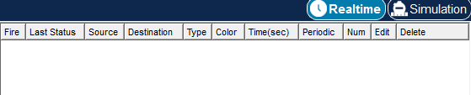

Explanation: Packet Tracer operates in two distinct time modes to aid in network configuration and troubleshooting. Realtime mode is for observing immediate network behavior, running continuously like a live network. Simulation mode is used for step-by-step packet inspection to troubleshoot how data moves through the network, allowing users to pause time and view the exact path and details of individual data packets.

