THE UNIVERSITY OF AZAD JAMMU & KASHMIR, MUZAFFARABAD


COURSE TITLE | COMPUTER NETWORKS
COURSE CODE | CS-2203
TITLE | LAB 5
STUDENT NAME | HASEEB SHEIKH
STUDENT ROLL NUMBER | 2024-SE-31
INSTRUCTOR NAME | ENGR. DR. ASMA JAVED
SUBMISSION DATE | MARCH 16, 2026

DEPARTMENT OF SOFTWARE ENGINEERING
Computer Networking
Lab 5 (Simulating a Star Topology Network)
1. Objective
- To understand the fundamental concept and architecture of a Star Topology network.
- To construct a Star Topology using a central switch and multiple end devices (PCs).
- To configure static IP addresses for network nodes.
- To verify network connectivity using the ping command and packet simulation.
2. Tools & Software Used
- Simulator: Cisco Packet Tracer
3. Network Topology Design
The network was designed using one central Cisco 2960 switch connected to six desktop PCs via copper straight-through cables.
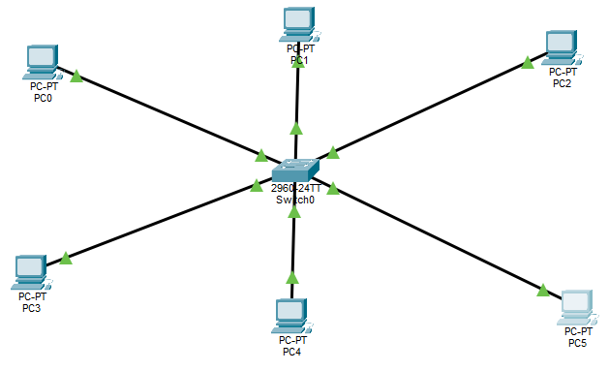

4. IP Configuration
Device Name | IP Address | Subnet Mask
PC0 | 192.168.1.10 | 255.255.255.0
PC1 | 192.168.1.11 | 255.255.255.0
PC2 | 192.168.1.12 | 255.255.255.0
PC3 | 192.168.1.13 | 255.255.255.0
PC4 | 192.168.1.14 | 255.255.255.0
PC5 | 192.168.1.15 | 255.255.255.0
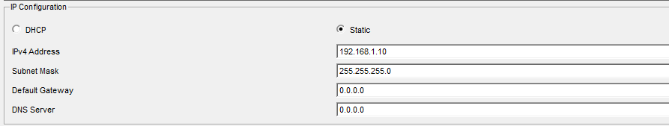

5. Procedure
- Placed a central switch into the logical workspace.
- Added 6 PCs around the switch to form a star arrangement.
- Connected each PC's FastEthernet port to the switch's FastEthernet ports using copper straight-through cables.
- Waited for the Spanning Tree Protocol (STP) to transition the port states from amber to green, indicating active links.
- Opened the Desktop tab on each PC and configured the static IP addresses according to the table above.
6. Verification and Testing
- 6.1. Connectivity Test via Command Prompt
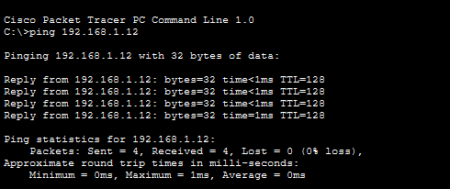
To ensure the devices could communicate, an ICMP echo request (ping) was sent from PC0 to PC2.

- 6.2. Network Traffic Simulation
Packet Tracer's Simulation mode was used to visually track the path of a Protocol Data Unit (PDU). A simple PDU was generated from one PC and sent to another. The simulation successfully demonstrated the packet traveling to the central switch, being forwarded to the correct destination.

- Scenario 1:
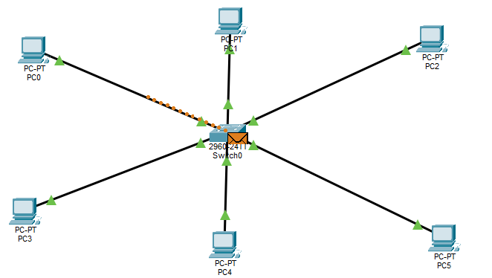

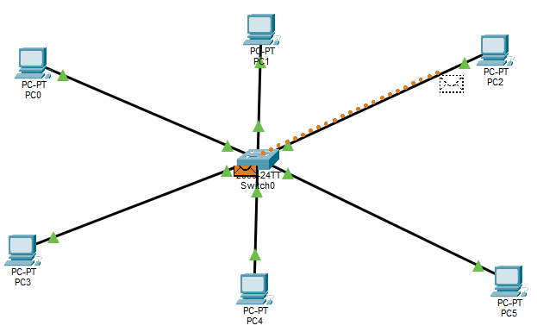

- 5.1. Explanation:

  - Preparation: PC0 packages the data, stamping it with PC2's IP address (192.168.1.12) and MAC address.
  - Transmission: PC0 sends this data frame as an electrical signal down its connected cable to the central switch.
  - Inspection: The central switch receives the frame and reads the destination MAC address.
  - Lookup: The switch checks its internal "MAC Address Table" to figure out exactly which physical port PC2 is plugged into.
  - Targeted Forwarding: The switch sends the frame only out of that specific port toward PC2, rather than broadcasting it to everyone.
  - Delivery: PC2 receives the frame, confirms the destination addresses match its own, and accepts the data.

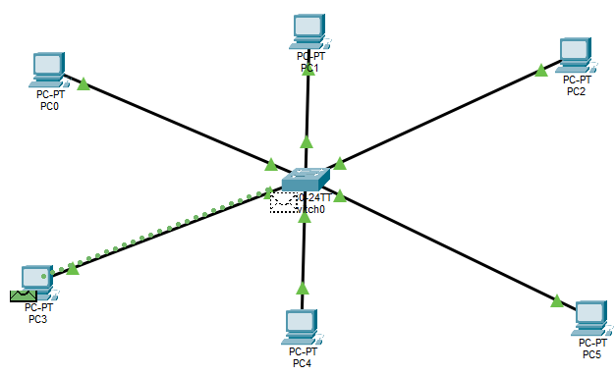
- Scenario 2:
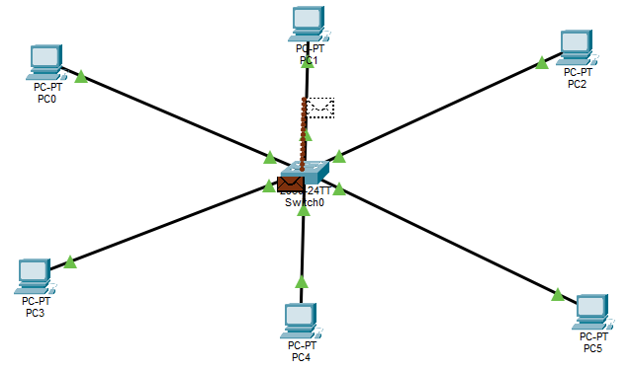

- Conclusion
The lab successfully demonstrated the deployment and functionality of a Star Topology. By configuring the central switch and assigning appropriate IP addresses to the end devices, a functional local area network (LAN) was established. The connectivity tests confirmed that in a star topology, all network traffic passes through the central hub/switch, which efficiently routes the data to its intended destination.

