THE UNIVERSITY OF AZAD JAMMU & KASHMIR, MUZAFFARABAD


COURSE TITLE | COMPUTER NETWORKS
COURSE CODE | CS-2203
TITLE | LAB 6
STUDENT NAME | HASEEB SHEIKH
STUDENT ROLL NUMBER | 2024-SE-31
INSTRUCTOR NAME | ENGR. DR. ASMA JAVED
SUBMISSION DATE | SEPTEMBER 20, 2026

DEPARTMENT OF SOFTWARE ENGINEERING
Computer Networking
LAB 6 (Switch Communication Between Two LANs)
- Objective:
The objective of this lab is to establish communication between two separate Local Area Networks (LANs). Since switches can only communicate within the same network, a central router is configured to route traffic between the different IP subnets.
- Network Topology:
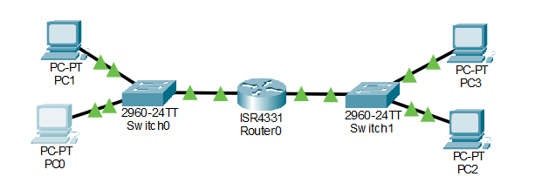

Explanation:
The network consists of a central router connecting two distinct LANs. LAN 1 operates on the 192.168.1.0 network, and LAN 2 operates on the 192.168.2.0 network.
- IP Configuration:
Device (Network) | Interface | IP Address | Subnet Mask | Default Gateway
PC1 (LAN 1) | FastEthernet0 | 192.168.1.2 | 255.255.255.0 | 192.168.1.1
PC2 (LAN 1) | FastEthernet0 | 192.168.1.3 | 255.255.255.0 | 192.168.1.1
PC3 (LAN 2) | FastEthernet0 | 192.168.2.2 | 255.255.255.0 | 192.168.2.1
PC4 (LAN 2) | FastEthernet0 | 192.168.2.3 | 255.255.255.0 | 192.168.2.1
Router (LAN 1 Link) | GigabitEthernet0/0/0 | 192.168.1.1 | 255.255.255.0 | N/A
Router (LAN 2 Link) | GigabitEthernet0/0/1 | 192.168.2.1 | 255.255.255.0 | N/A

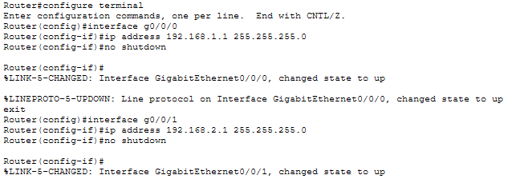
4. Router CLI Configuration:

Explanation:
The router's interfaces were manually assigned IP addresses that serve as the default gateways for their respective LANs. The no shutdown command was executed to activate the physical interfaces.
5. Connectivity Verification
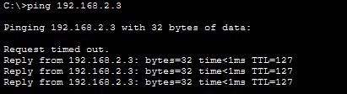

Explanation:
A ping test was initiated from a device on LAN 1 to a device on LAN 2. The successful replies confirm that the router is correctly receiving the packets from the first subnet and routing them to the second subnet.

