THE UNIVERSITY OF AZAD JAMMU & KASHMIR, MUZAFFARABAD


COURSE TITLE | COMPUTER NETWORKS
COURSE CODE | CS-2203
TITLE | LAB 7
STUDENT NAME | HASEEB SHEIKH
STUDENT ROLL NUMBER | 2024-SE-31
INSTRUCTOR NAME | ENGR. DR. ASMA JAVED
SUBMISSION DATE | SEPTEMBER 20, 2026

DEPARTMENT OF SOFTWARE ENGINEERING
Computer Networking
LAB 7 (Basic Switch CLI Commands)
- Objective
The objective of this lab is to establish a local console connection to a Cisco switch and execute basic Command Line Interface (CLI) commands to navigate operational modes, view system information, and apply initial device configurations.
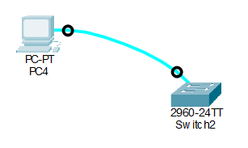
- Network Topology

Explanation:
The network consists of a single desktop PC connected directly to a Cisco 2960 switch. The connection is made using a rollover (console) cable linking the PC's RS-232 serial port to the switch's dedicated Console port, simulating an out-of-band management setup.
- Command Line Interface (CLI) Execution
Various commands were executed within the terminal emulator to navigate the Cisco IOS mode hierarchy and verify device details.
- enable (User EXEC): Elevates the user session to Privileged EXEC mode (Switch#), allowing access to viewing and configuration commands.
- show version (Privileged EXEC): Displays details about the switch's hardware, current IOS software version, and system uptime.
- show running-config (Privileged EXEC): Outputs the current active configuration file running in the device's volatile RAM.
- configure terminal (Privileged EXEC): Transitions the session into Global Configuration mode (Switch(config)#) to make active changes to the device.
- hostname Switch1 (Global Configuration): Changes the system identifier (hostname) of the switch from the default "Switch" to "Switch1".
- Terminal Verification
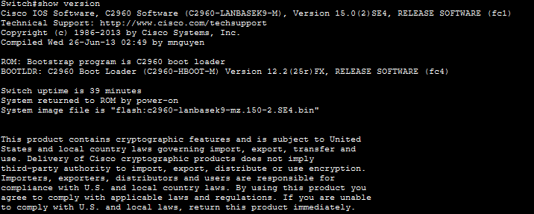
show version (Privileged EXEC):

Show running-config (Privileged EXEC):
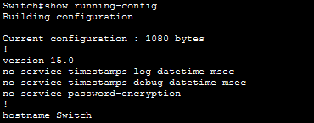

configure terminal (Privileged EXEC):
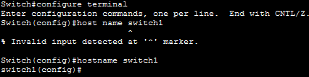
hostname Switch1 (Global Configuration):

Explanation:
The terminal outputs confirm that the PC successfully established a serial session with the switch. Mode transitions were successful, system details were retrieved, and the global configuration change was immediately applied to the device's running memory.

