THE UNIVERSITY OF AZAD JAMMU & KASHMIR, MUZAFFARABAD


COURSE TITLE | COMPUTER NETWORKS
COURSE CODE | CS-2203
TITLE | LAB 8
STUDENT NAME | HASEEB SHEIKH
STUDENT ROLL NUMBER | 2024-SE-31
INSTRUCTOR NAME | ENGR. DR. ASMA JAVED
SUBMISSION DATE | SEPTEMBER 20, 2026

DEPARTMENT OF SOFTWARE ENGINEERING
Computer Networking
LAB 8 (Router Access and CLI Configuration)
- Objective
Understand how to connect networking devices to a computer for configuration. Learn about console ports and console cables. Understand GUI and CLI interfaces and access router CLI in Cisco Packet Tracer. Learn basic Cisco IOS modes, basic commands, configuration files, and basic security settings.
- Part A – Device Connection and Mode Navigation
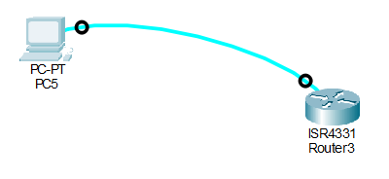
Topology:

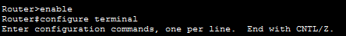
Transition from User EXEC to Global Configuration:

Explanation:
The computer was connected to the router's console port using a rollover cable, and terminal emulator software was utilized to access the CLI. The enable command was used to enter Privileged EXEC mode, followed by configure terminal to enter Global Configuration mode.
- Part B – Basic Security Configuration
- enable password
- enable password encryption
- enable secret class
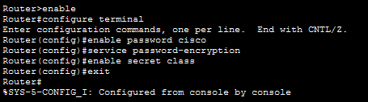

Explanation:
Device security was established by configuring the enable password. The service password-encryption command was executed to encrypt passwords within the configuration file, and the enable secret command was set to create a secure encrypted password for privileged mode access.
- Part C – Configuration Files and Saving
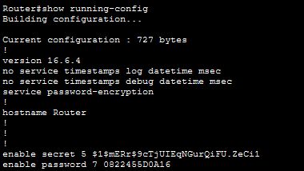
- show running-config

- show startup-config & copy running-config startup-config
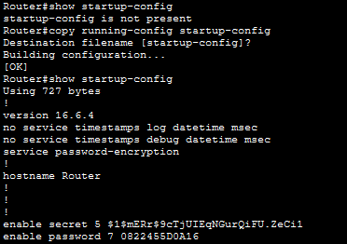

Explanation:
The active running configuration (stored in RAM) and the startup configuration (stored in NVRAM) were displayed using the show running-config and show startup-config commands, respectively. Finally, the active configuration was permanently saved to NVRAM using the copy running-config startup-config command.

