THE UNIVERSITY OF AZAD JAMMU & KASHMIR, MUZAFFARABAD


COURSE TITLE | COMPUTER NETWORKS
COURSE CODE | CS-2203
TITLE | LAB 9
STUDENT NAME | HASEEB SHEIKH
STUDENT ROLL NUMBER | 2024-SE-31
INSTRUCTOR NAME | ENGR. DR. ASMA JAVED
SUBMISSION DATE | SEPTEMBER 20, 2026

DEPARTMENT OF SOFTWARE ENGINEERING
Computer Networking
LAB 9 (Switching and ARP)
- Objective
Understand switching in networks and learn how data travels between PCs via switches. Understand ARP (Address Resolution Protocol), observe MAC address table behavior, and learn to view and clear the MAC address table.

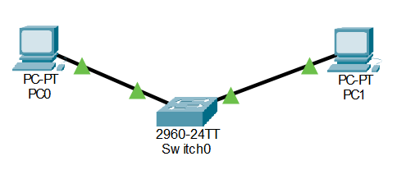
- Part A: Network Topology Creation

Explanation:
A simple local area network was created utilizing a Cisco 2960 switch and two desktop end devices. PC1 was configured with the IP address 192.168.1.10, and PC2 with 192.168.1.11.

- Part B: MAC Address Table State (Before Ping)
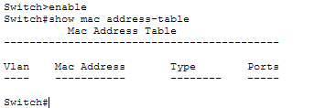

Explanation:
Prior to any data transmission, the show mac address-table command was executed on the switch. The table contained only static, internal CPU MAC addresses. No dynamic entries were present because the switch had not yet received any incoming data frames from the attached PCs to learn their source MAC addresses.

- Part C: Network Communication (Ping Test)
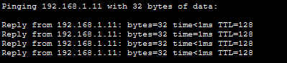

Explanation:
An ICMP echo request (ping) was generated from PC1 to PC2. This forced PC1 to send an ARP request followed by an ICMP packet into the switch, providing the switch with live network traffic to process.

- Part D: MAC Address Table State (After Ping)

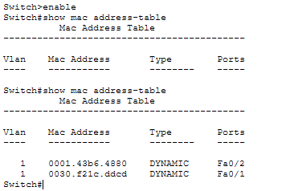

Explanation:
Following the ping test, the show mac address-table command was reissued. The switch successfully inspected the source MAC addresses of the incoming frames from both PCs and dynamically recorded them. The table now actively maps PC1's MAC address to its specific FastEthernet port, and PC2's MAC address to its respective port, allowing for efficient, targeted unicast switching.

- Part E: Clearing the MAC Address Table

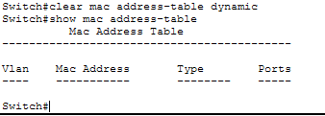

Explanation:
To demonstrate administrative control over the switch's memory, the clear mac address-table dynamic command was executed. A final check of the table verified that all learned MAC addresses were successfully purged from the volatile memory, returning the switch to its initial unlearned state.

