THE UNIVERSITY OF AZAD JAMMU & KASHMIR, MUZAFFARABAD


COURSE TITLE | COMPUTER NETWORKS
COURSE CODE | CS-2203
TITLE | OPEN-ENDED-LAB
STUDENT NAME | HASEEB SHEIKH
STUDENT ROLL NUMBER | 2024-SE-31
INSTRUCTOR NAME | ENGR. DR. ASMA JAVED
SUBMISSION DATE | SEPTEMBER 20, 2026

DEPARTMENT OF SOFTWARE ENGINEERING
Computer Networking
Open Ended Lab Report
1. Network Requirements Analysis
The educational institute requires a reliable and scalable network infrastructure to support its administrative and academic operations. The primary networking needs dictate logical segmentation of traffic to ensure data integrity and organizational efficiency.
- Administration Department: Estimated requirement of 15-20 devices, requiring secure internal communication.
- Academic Department: Estimated requirement of 30-40 devices for faculty and student labs.
- Total Capacity: The architecture accommodates roughly 60 initial end devices and provides future expansion capabilities to support communication between growing departments.
2. Topology Selection
An Extended Star Topology is selected for this network. Justification: This topology connects individual departmental switches to a central router, ensuring high fault tolerance; if an access switch or cable fails, the disruption remains isolated to that specific node. It provides a reliable and scalable foundation, allowing the institute to seamlessly integrate additional switches or access points in the future without rewiring existing infrastructure.
3. Network Cabling Plan
- Access Layer (End Devices to Switches): Cat6 Unshielded Twisted Pair (UTP) copper cables are recommended. Cat6 easily supports Gigabit speeds, ensuring sufficient bandwidth for academic data loads and administrative tasks.
- Distribution Backbone (Switches to Router): Multi-mode Fiber Optic cabling is recommended. Utilizing fiber for the core uplinks eliminates electromagnetic interference and guarantees high-bandwidth inter-departmental communication.
4. IP Addressing Scheme
The network utilizes IPv4 addressing logically divided into two subnets to separate administrative and academic broadcast domains.
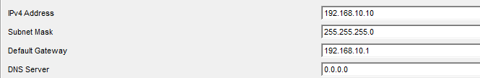
- Administration

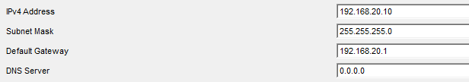
- Academic

Department | Network ID | Subnet Mask | Default Gateway | Usable IP Range
Administration | 192.168.10.0 | 255.255.255.0 (/24) | 192.168.10.1 | 192.168.10.2 - 192.168.10.254
Academic | 192.168.20.0 | 255.255.255.0 (/24) | 192.168.20.1 | 192.168.20.2 - 192.168.20.254

5. Switch & Router Configuration Design
The design requires a central router to handle IP addressing and inter-VLAN routing, and dedicated switches with logically assigned ports for each department.
Switch Configuration Commands:
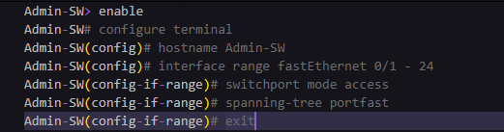
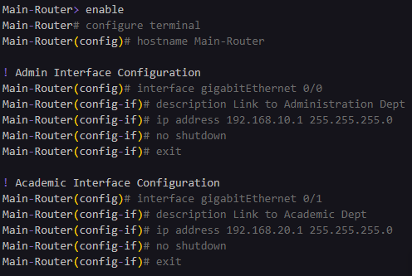
Router Configuration Commands:

- Successful connectivity
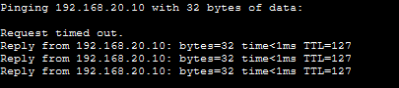

6. Logical Network Diagram Overview
The complete logical network diagram is structured as follows:
- Core Router (Main-Router): The central hub providing inter-departmental connectivity.
  - Port G0/0 (192.168.10.1): Connects downward to the Admin-SW uplink.
  - Port G0/1 (192.168.20.1): Connects downward to the Acad-SW uplink.
- Administration Segment (Admin-SW): Contains administrative PCs and printers with static IPs assigned in the 192.168.10.0/24 network block.
- Academic Segment (Acad-SW): Contains academic lab PCs and faculty devices with static IPs assigned in the 192.168.20.0/24 network block.

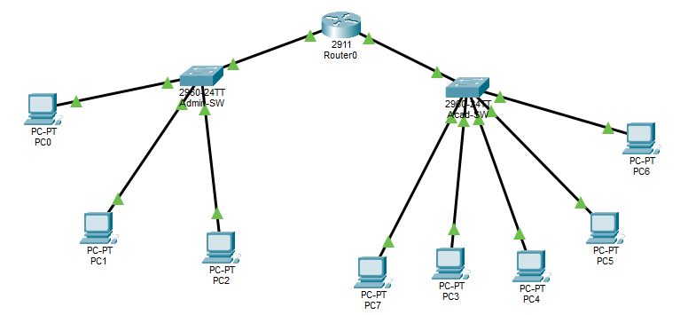
- Topology

7. Future Recommendations
To improve the network in the future, the institute should prioritize these three enhancements:
- Deployment of Wireless Access Points (WAPs): Integrating WAPs will allow faculty and students to connect mobile devices wirelessly, drastically improving campus flexibility and modernizing the academic environment.
- Implementation of a Hardware Firewall: Placing a dedicated hardware firewall outside the core router will safeguard internal academic and administrative databases from external cyber threats and unauthorized access.
- Dynamic Host Configuration Protocol (DHCP) Integration: Configuring a centralized DHCP server will automate IP address distribution, reducing administrative overhead and eliminating IP conflicts as the network expands.

